Supplementary appendix
From Composite to Components: Evaluating the Impact of Domain Differentiation on Bayley-III Cognitive Diagnostic Precision
Leonardo Zaggia, Adele Diederich, Anne Hilgendorff, Axel Heep, Andrea Hildebrandt
Supplementary appendix to the manuscript submitted to The Lancet Child & Adolescent Health. Tables S1–S8 and Figures S1–S8; appendix references are numbered separately from those of the main text. In the tables, .. marks a value that does not apply or was not given.
Contents
Abbreviations 2
Supplementary tables 2
Table S1. Bayley-4 → Bayley-III translation cascade 2
Table S2. Bayley-III cognitive items administered in the dHCP sample 3
Table S3. Confirmatory factor analysis 5
S3a: 3-factor model: standardised loadings (STDYX) 5
S3b: 3-factor model: inter-factor correlations 5
S3c: model fit statistics and nested-model test 5
S3d: unidimensional model: standardised loadings (STDYX) 6
Table S4. MIMIC covariate associations 6
S4a: standardised regression coefficients 6
S4b: factor contrasts (WLSMV DIFFTEST, 1 df) 8
Table S5. Factor–outcome associations 9
Table S6. Per-domain recovery of the Aylward domains by the Bayley-4 clusters 11
Table S7. Pair-level position of the Bayley-4 clusters between the two reference models 11
Table S8. Expert-review ledger 11
S8a: Bayley-4: 16 discordant items 11
S8b: Bayley-III: 60 discordant items 12
Supplementary figures 14
Figure S1. Centroid similarity profiles, unpaired items in the dHCP administration range 14
Figure S2. Centroid similarity profiles, all 52 unpaired items 15
Figure S3. Three-way Bayley-4 alluvial diagram 16
Figure S4. Bayley-III alluvial diagram 17
Figure S5. Embedding cosine similarity vs tetrachoric correlation, 23-item CFA model 18
Figure S6. Three-way correspondence of the Bayley-4 domain structures 18
Figure S7. Within- vs between-cluster cosine similarity by factor 19
Figure S8. Sensitivity of the cascade pairing to the title-similarity threshold 19
Appendix references 19

Abbreviations
ATT Attention · WM Working Memory · GDPS Goal-Directed Problem Solving · FS Flexibility/Shift · HOP Higher-Order Processing. ARI adjusted Rand index; NMI normalised mutual information; CFA confirmatory factor analysis; MIMIC multiple indicators multiple causes; WLSMV weighted least squares, mean- and variance-adjusted; STDYX/STDY Mplus standardisations (fully / semi-standardised); UC unclassified cluster; dHCP developing Human Connectome Project.

Supplementary tables

Table S1. Bayley-4 → Bayley-III translation cascade
The 39 Bayley-4 → Bayley-III item pairs produced by the translation cascade, with full-text and title cosine similarities and the stage at which each pair was locked (27 title-locked, 12 full-text fallback).
Bayley-4 item | Bayley-4 title | Bayley-III item | Bayley-III title | Aylward domain(s) | Transferred domain | Cosine (full text) | Cosine (title) | Stage
COG_002 | Looks at Object | COG_003 | Regards Object for 3 Seconds | ATT | ATT | 0·891 | 0·4 | full-text fallback
COG_003 | Habituates to Rattle | COG_004 | Habituates to Rattle | ATT | ATT | 0·983 | 1·0 | title-locked
COG_008 | Shifts Attention | COG_010 | Shifts Attention | ATT | ATT | 0·96 | 1·0 | title-locked
COG_009 | Shows Visual Preference | COG_011 | Shows Visual Preference | ATT | ATT | 0·933 | 1·0 | title-locked
COG_010 | Habituates to Balloons | COG_014 | Habituates to Picture (Balloons) | ATT | ATT | 0·909 | 0·83 | title-locked
COG_011 | Prefers Ball | COG_015 | Prefers Novel Picture (Ball) | ATT | ATT | 0·833 | 0·704 | full-text fallback
COG_012 | Responds to Surroundings | COG_002 | Responds to Surroundings Series: Inspects | ATT | ATT | 0·91 | 0·598 | full-text fallback
COG_026 | Looks at Pictures | COG_032 | Looks at Pictures | ATT | ATT | 0·973 | 1·0 | title-locked
COG_041 | Listens to Story | COG_059 | Attends to Story | ATT | ATT | 0·887 | 0·839 | title-locked
COG_034 | Removes Pellet | COG_042 | Removes Pellet | FS | FS | 0·919 | 1·0 | title-locked
COG_040 | Pink Board Series: 2 Pieces | COG_049 | Pink Board Series: 1 Piece | FS | FS | 0·963 | 0·959 | title-locked
COG_043 | Blue Board Series: 1 Piece | COG_051 | Blue Board Series: 1 Piece | FS | FS | 0·977 | 1·0 | title-locked
COG_049 | Blue Board Series: 4 Pieces | COG_058 | Blue Board Series: 4 Pieces | FS | FS | 0·974 | 1·0 | title-locked
COG_051 | Rotated Pink Board | COG_060 | Rotated Pink Board | FS + HOP | FS | 0·958 | 1·0 | title-locked
COG_052 | Object Assembly: ball | COG_061 | Object Assembly (Ball) | FS | FS | 0·934 | 0·976 | title-locked
COG_053 | Object Assembly: Ice Cream Cone | COG_063 | Object Assembly (Ice Cream Cone) | FS | FS | 0·953 | 0·99 | title-locked
COG_073 | Object Assembly: Dog | COG_082 | Object Assembly (Dog) | FS | FS | 0·946 | 0·972 | title-locked
COG_074 | Object Assembly: Cat | COG_066 | Blue Board Series: Completes (75 Seconds) | FS | FS | 0·625 | −0·025 | full-text fallback
COG_014 | Brings to Mouth | COG_017 | Carries Object to Mouth | GDPS | GDPS | 0·867 | 0·556 | full-text fallback
COG_022 | Obtains Ring | COG_041 | Suspends Ring | GDPS | GDPS | 0·902 | 0·51 | full-text fallback
COG_035 | Clear Box | COG_043 | Clear Box: Front | GDPS + FS | GDPS | 0·775 | 0·796 | title-locked
COG_048 | Uses Pencil to Obtain Object | COG_057 | Uses Pencil to Obtain Object | GDPS + HOP | GDPS | 0·96 | 1·0 | title-locked
COG_057 | Imitates 2-Step Action | COG_067 | Imitates a Two-Step Action | GDPS | GDPS | 0·96 | 0·981 | title-locked
COG_062 | Grouping: Colour | COG_072 | Concept Grouping: Color | HOP | HOP | 0·564 | 0·828 | title-locked
COG_063 | Grouping: Size | COG_073 | Concept Grouping: Size | HOP | HOP | 0·567 | 0·776 | title-locked
COG_068 | Simple Pattern | COG_077 | Simple Pattern | HOP | HOP | 0·532 | 1·0 | title-locked
COG_081 | Completes Patterns | COG_091 | Completes Patterns | HOP | HOP | 0·958 | 1·0 | title-locked
COG_021 | Searches for Object | COG_025 | Searches for Fallen Object | WM | WM | 0·964 | 0·707 | full-text fallback
COG_024 | Anticipatory Gaze | COG_013 | Prefers Novel Object | WM | WM | 0·703 | 0·17 | full-text fallback
COG_028 | Searches for Missing Objects | COG_034 | Searches for Missing Objects | WM | WM | 0·975 | 1·0 | title-locked
COG_032 | Finds Hidden Object | COG_040 | Finds Hidden Object | WM | WM | 0·755 | 1·0 | title-locked
COG_037 | Finds Hidden Object (Reversed) | COG_045 | Finds Hidden Object (Reversed) | WM | WM | 0·762 | 1·0 | title-locked
COG_042 | Finds Hidden Object (Visible Displacement) | COG_050 | Finds Hidden Object (Visible Displacement) | WM | WM | 0·775 | 1·0 | title-locked
COG_056 | Spatial Memory: 3 Cards | COG_068 | Matches 3 Colors | WM | WM | 0·582 | 0·132 | full-text fallback
COG_060 | Recalls Names | COG_081 | Identifies 3 Incomplete Pictures | WM | WM | 0·66 | 0·162 | full-text fallback
COG_064 | Repeats Words | COG_064 | Matches Pictures | WM | WM | 0·553 | 0·155 | full-text fallback
COG_067 | Discriminates Pictures | COG_076 | Discriminates Pictures | WM | WM | 0·876 | 1·0 | title-locked
COG_076 | Spatial Memory: 6 Cards | COG_084 | Spatial Memory | WM | WM | 0·897 | 0·557 | full-text fallback
COG_080 | Repeats Number Sequences | COG_090 | Repeats Number Sequences | WM | WM | 0·89 | 1·0 | title-locked

Aylward and colleagues assign 39 of the 81 Bayley-4 cognitive items to a domain. Three of these (COG_035, COG_048, COG_051) carry two domains and were transferred to the Bayley-III under their first-listed domain. One further item (COG_047) is assigned only in the empirically derived model; it was retained in the 40-item benchmark comparison (Objective 2) but has no expert domain to transfer. In concordance counts, multi-factor items were scored as concordant when the cluster matched either of their domains.

Table S2. Bayley-III cognitive items administered in the dHCP sample
The 35 items in the administered range (34–68), their assigned factor, and their status in the analysis: 23 retained, 11 excluded for floor or ceiling effects (≥90% identical responses among valid administrations), and 1 dropped as the sole remaining indicator of a factor.
Item | Title | Domain (translated) | Empirical factor | N valid | % pass | % fail | Dominant % | Status
COG034 | Searches for Missing Objects | WM | WM | 739 | 98·2 | 1·8 | 98·2 | ceiling
COG035 | Takes Blocks Out of Cup | FS | FS | 739 | 97·8 | 2·2 | 97·8 | ceiling
COG036 | Block Series: 1 Block | FS | FS | 739 | 98·5 | 1·5 | 98·5 | ceiling
COG037 | Picks Up Block Series: 3 Blocks | GDPS | GDPS | 739 | 90·1 | 9·9 | 90·1 | ceiling
COG038 | Explores Holes in Pegboard | GDPS | GDPS | 739 | 97·6 | 2·4 | 97·6 | ceiling
COG039 | Pushes Car | GDPS | GDPS | 739 | 97·6 | 2·4 | 97·6 | ceiling
COG040 | Finds Hidden Object | WM | WM | 739 | 87·3 | 12·7 | 87·3 | retained
COG041 | Suspends Ring | GDPS | GDPS | 739 | 72·0 | 28·0 | 72·0 | retained
COG042 | Removes Pellet | FS | FS | 739 | 96·6 | 3·4 | 96·6 | ceiling
COG043 | Clear Box: Front | GDPS | GDPS | 739 | 85·7 | 14·3 | 85·7 | retained
COG044 | Squeezes Object | GDPS | GDPS | 739 | 88·8 | 11·2 | 88·8 | retained
COG045 | Finds Hidden Object (Reversed) | WM | WM | 739 | 62·8 | 37·2 | 62·8 | retained
COG046 | Removes Lid From Bottle | GDPS | GDPS | 739 | 48·7 | 51·3 | 51·3 | retained
COG047 | Pegboard Series: 2 Holes | FS | FS | 739 | 96·5 | 3·5 | 96·5 | ceiling
COG048 | Relational Play Series: Self | GDPS | GDPS | 739 | 89·2 | 10·8 | 89·2 | retained
COG049 | Pink Board Series: 1 Piece | FS | FS | 739 | 84·4 | 15·6 | 84·4 | retained
COG050 | Finds Hidden Object (Visible Displacement) | WM | WM | 739 | 72·7 | 27·3 | 72·7 | retained
COG051 | Blue Board Series: 1 Piece | FS | FS | 739 | 88·0 | 12·0 | 88·0 | retained
COG052 | Clear Box: Sides | GDPS | GDPS | 739 | 68·3 | 31·7 | 68·3 | retained
COG053 | Relational Play Series: Others | GDPS | GDPS | 739 | 66·6 | 33·4 | 66·6 | retained
COG054 | Block Series: 9 Blocks | FS | FS | 739 | 66·8 | 33·2 | 66·8 | retained
COG055 | Pegboard Series: 6 Pegs | FS | FS | 739 | 87·8 | 12·2 | 87·8 | retained
COG056 | Pink Board Series: Completes | FS | FS | 739 | 55·9 | 44·1 | 55·9 | retained
COG057 | Uses Pencil to Obtain Object | GDPS | GDPS | 739 | 18·4 | 81·6 | 81·6 | retained
COG058 | Blue Board Series: 4 Pieces | FS | FS | 739 | 56·6 | 43·4 | 56·6 | retained
COG059 | Attends to Story | ATT | .. | .. | .. | .. | .. | excluded: domain with a single indicator
COG060 | Rotated Pink Board | FS | FS | 739 | 38·8 | 61·2 | 61·2 | retained
COG061 | Object Assembly (Ball) | FS | FS | 739 | 24·1 | 75·9 | 75·9 | retained
COG062 | Completes Pegboard: 25 Seconds | FS | FS | 739 | 15·0 | 85·0 | 85·0 | retained
COG063 | Object Assembly (Ice Cream Cone) | FS | FS | 739 | 11·4 | 88·6 | 88·6 | retained
COG064 | Matches Pictures | WM | WM | 739 | 23·7 | 76·3 | 76·3 | retained
COG065 | Representational Play | FS | GDPS | 739 | 3·1 | 96·9 | 96·9 | floor
COG066 | Blue Board Series: Completes (75 Seconds) | FS | FS | 739 | 17·6 | 82·4 | 82·4 | retained
COG067 | Imitates a Two-Step Action | GDPS | GDPS | 739 | 2·7 | 97·3 | 97·3 | floor
COG068 | Matches 3 Colors | WM | WM | 739 | 9·3 | 90·7 | 90·7 | floor

COG059 carries no response statistics because it was dropped before estimation: as the only attention item in the administered range it would have been the single indicator of its factor, which is unidentifiable.

Table S3. Confirmatory factor analysis
Confirmatory factor analysis of the 23 retained Bayley-III cognitive items: standardised (STDYX) loadings and inter-factor correlations for the 3-factor model, model fit statistics, and loadings for the unidimensional comparison model.

S3a: 3-factor model: standardised loadings (STDYX)
Factor | Item | Title | Loading | SE | Est./SE | p
WM | COG040 | Finds Hidden Object | 0·436 | 0·063 | 6·876 | <0·0001
WM | COG045 | Finds Hidden Object (Reversed) | 0·517 | 0·045 | 11·602 | <0·0001
WM | COG050 | Finds Hidden Object (Visible Displacement) | 0·614 | 0·045 | 13·654 | <0·0001
WM | COG064 | Matches Pictures | 0·976 | 0·051 | 19·32 | <0·0001
GDPS | COG041 | Suspends Ring | 0·461 | 0·054 | 8·562 | <0·0001
GDPS | COG043 | Clear Box: Front | 0·621 | 0·062 | 10·006 | <0·0001
GDPS | COG044 | Squeezes Object | 0·577 | 0·066 | 8·726 | <0·0001
GDPS | COG046 | Removes Lid From Bottle | 0·41 | 0·052 | 7·882 | <0·0001
GDPS | COG048 | Relational Play Series: Self | 0·833 | 0·051 | 16·188 | <0·0001
GDPS | COG052 | Clear Box: Sides | 0·594 | 0·046 | 12·87 | <0·0001
GDPS | COG053 | Relational Play Series: Others | 0·699 | 0·038 | 18·167 | <0·0001
GDPS | COG057 | Uses Pencil to Obtain Object | 0·485 | 0·063 | 7·705 | <0·0001
FS | COG049 | Pink Board Series: 1 Piece | 0·829 | 0·03 | 27·476 | <0·0001
FS | COG051 | Blue Board Series: 1 Piece | 0·799 | 0·041 | 19·499 | <0·0001
FS | COG054 | Block Series: 9 Blocks | 0·433 | 0·044 | 9·939 | <0·0001
FS | COG055 | Pegboard Series: 6 Pegs | 0·836 | 0·038 | 22·235 | <0·0001
FS | COG056 | Pink Board Series: Completes | 0·93 | 0·015 | 62·403 | <0·0001
FS | COG058 | Blue Board Series: 4 Pieces | 0·82 | 0·022 | 37·278 | <0·0001
FS | COG060 | Rotated Pink Board | 0·909 | 0·015 | 59·842 | <0·0001
FS | COG061 | Object Assembly (Ball) | 0·815 | 0·025 | 32·052 | <0·0001
FS | COG062 | Completes Pegboard: 25 Seconds | 0·649 | 0·042 | 15·425 | <0·0001
FS | COG063 | Object Assembly (Ice Cream Cone) | 0·835 | 0·031 | 26·956 | <0·0001
FS | COG066 | Blue Board Series: Completes (75 Seconds) | 0·952 | 0·019 | 50·293 | <0·0001

S3b: 3-factor model: inter-factor correlations
Factor pair | Correlation | SE | Est./SE | p
WM-GDPS | 0·616 | 0·05 | 12·402 | <0·0001
WM-FS | 0·705 | 0·041 | 17·259 | <0·0001
GDPS-FS | 0·54 | 0·037 | 14·394 | <0·0001

S3c: model fit statistics and nested-model test
Statistic | 3-factor (WM, GDPS, FS) | Unidimensional (COG)
Items | 23 | 23
χ² | 820·91 | 1193·599
df | 227 | 230
p (χ²) | <0·0001 | <0·0001
RMSEA | 0·06 | 0·075
CFI | 0·929 | 0·885
TLI | 0·921 | 0·874
SRMR | 0·108 | 0·113
90% CI low | 0·055 | 0·071
90% CI high | 0·064 | 0·08
Δχ² vs 3-factor | .. | 246·109
Δdf | .. | 3
p (Δχ²) | .. | <0·0001

S3d: unidimensional model: standardised loadings (STDYX)
Item | Title | Loading | SE | Est./SE | p
COG040 | Finds Hidden Object | 0·328 | 0·058 | 5·683 | <0·0001
COG045 | Finds Hidden Object (Reversed) | 0·401 | 0·042 | 9·616 | <0·0001
COG050 | Finds Hidden Object (Visible Displacement) | 0·483 | 0·042 | 11·617 | <0·0001
COG064 | Matches Pictures | 0·749 | 0·029 | 25·455 | <0·0001
COG041 | Suspends Ring | 0·35 | 0·045 | 7·758 | <0·0001
COG043 | Clear Box: Front | 0·475 | 0·053 | 8·996 | <0·0001
COG044 | Squeezes Object | 0·436 | 0·058 | 7·559 | <0·0001
COG046 | Removes Lid From Bottle | 0·329 | 0·043 | 7·67 | <0·0001
COG048 | Relational Play Series: Self | 0·551 | 0·054 | 10·151 | <0·0001
COG052 | Clear Box: Sides | 0·447 | 0·041 | 10·943 | <0·0001
COG053 | Relational Play Series: Others | 0·465 | 0·039 | 11·983 | <0·0001
COG057 | Uses Pencil to Obtain Object | 0·387 | 0·05 | 7·784 | <0·0001
COG049 | Pink Board Series: 1 Piece | 0·81 | 0·03 | 26·869 | <0·0001
COG051 | Blue Board Series: 1 Piece | 0·776 | 0·041 | 19·08 | <0·0001
COG054 | Block Series: 9 Blocks | 0·429 | 0·042 | 10·184 | <0·0001
COG055 | Pegboard Series: 6 Pegs | 0·819 | 0·037 | 22·382 | <0·0001
COG056 | Pink Board Series: Completes | 0·92 | 0·015 | 61·657 | <0·0001
COG058 | Blue Board Series: 4 Pieces | 0·799 | 0·022 | 36·651 | <0·0001
COG060 | Rotated Pink Board | 0·902 | 0·015 | 59·782 | <0·0001
COG061 | Object Assembly (Ball) | 0·803 | 0·025 | 32·158 | <0·0001
COG062 | Completes Pegboard: 25 Seconds | 0·638 | 0·041 | 15·509 | <0·0001
COG063 | Object Assembly (Ice Cream Cone) | 0·822 | 0·031 | 26·688 | <0·0001
COG066 | Blue Board Series: Completes (75 Seconds) | 0·933 | 0·019 | 49·816 | <0·0001

Nested-model test (S3c): WLSMV-corrected chi-square difference test (Mplus DIFFTEST) of the unidimensional model, in which the three factor correlations are fixed to 1, against the three-factor model on the same 23 items: Δχ²(3) = 246·1, p < 0·0001.

Table S4. MIMIC covariate associations
MIMIC models: standardised associations between 18 perinatal, neonatal and sociodemographic covariates and the latent factors (3-factor model) or the unidimensional composite. Continuous covariates are fully standardised (STDYX) and binary covariates semi-standardised (STDY), the convention used in the text and Figure 4A; the standardisation is stated per row. S4b gives the WLSMV chi-square difference tests (Mplus DIFFTEST) of the factor contrasts quoted in the text.
Covariate instruments. Maternal postnatal depression was assessed with the 10-item Edinburgh Postnatal Depression Scale (EPDS),¹ a maternal self-report. Dysfunctional parenting was assessed with the 30-item Parenting Scale,² which yields overreactivity, laxness, and verbosity subscales and a total score. Cognitively stimulating parenting was assessed with the Cognitively Stimulating Parenting Scale (CSPS).³

S4a: standardised regression coefficients
Model | Factor | Standardisation | Estimate | SE | z | p | Sig.
AntCor Complete
3F | FS | STDY | −0·276 | 0·124 | −2·231 | 0·026 | *
3F | GDPS | STDY | −0·171 | 0·129 | −1·329 | 0·18
3F | WM | STDY | −0·019 | 0·142 | −0·133 | 0·89
UNIDIM | COG (unidimensional) | STDY | −0·242 | 0·121 | −1·995 | 0·046 | *
AntCor Partial
3F | FS | STDY | −0·407 | 0·233 | −1·748 | 0·08 | †
3F | GDPS | STDY | −0·432 | 0·26 | −1·664 | 0·096 | †
3F | WM | STDY | 0·228 | 0·303 | 0·75 | 0·45
UNIDIM | COG (unidimensional) | STDY | −0·363 | 0·238 | −1·521 | 0·13
Birth Wt (g)
3F | FS | STDYX | 0·139 | 0·042 | 3·349 | 0·001 | **
3F | GDPS | STDYX | 0·112 | 0·045 | 2·496 | 0·013 | *
3F | WM | STDYX | 0·073 | 0·051 | 1·434 | 0·15
UNIDIM | COG (unidimensional) | STDYX | 0·138 | 0·04 | 3·416 | 0·001 | **
Paternal Edu (y)
3F | FS | STDYX | −0·046 | 0·042 | −1·105 | 0·27
3F | GDPS | STDYX | −0·135 | 0·054 | −2·503 | 0·012 | *
3F | WM | STDYX | −0·042 | 0·057 | −0·743 | 0·46
UNIDIM | COG (unidimensional) | STDYX | −0·065 | 0·042 | −1·559 | 0·12
Postnatal depression (EPDS)
3F | FS | STDYX | −0·08 | 0·043 | −1·856 | 0·063 | †
3F | GDPS | STDYX | −0·156 | 0·047 | −3·309 | 0·001 | **
3F | WM | STDYX | −0·1 | 0·052 | −1·944 | 0·052 | †
UNIDIM | COG (unidimensional) | STDYX | −0·107 | 0·043 | −2·485 | 0·013 | *
GA (wks)
3F | FS | STDYX | 0·159 | 0·041 | 3·824 | <0·0001 | ***
3F | GDPS | STDYX | 0·111 | 0·043 | 2·588 | 0·01 | *
3F | WM | STDYX | 0·096 | 0·049 | 1·954 | 0·051 | †
UNIDIM | COG (unidimensional) | STDYX | 0·156 | 0·041 | 3·817 | <0·0001 | ***
Gest. Diabetes
3F | FS | STDY | −0·202 | 0·174 | −1·159 | 0·25
3F | GDPS | STDY | −0·028 | 0·215 | −0·132 | 0·90
3F | WM | STDY | −0·296 | 0·239 | −1·236 | 0·22
UNIDIM | COG (unidimensional) | STDY | −0·198 | 0·167 | −1·19 | 0·23
Head Circ (cm)
3F | FS | STDYX | 0·179 | 0·044 | 4·05 | <0·0001 | ***
3F | GDPS | STDYX | 0·118 | 0·045 | 2·599 | 0·009 | **
3F | WM | STDYX | 0·116 | 0·053 | 2·176 | 0·03 | *
UNIDIM | COG (unidimensional) | STDYX | 0·174 | 0·043 | 4·102 | <0·0001 | ***
IUGR (Yes vs No)
3F | FS | STDY | −0·206 | 0·17 | −1·214 | 0·23
3F | GDPS | STDY | 0·063 | 0·211 | 0·297 | 0·77
3F | WM | STDY | −0·057 | 0·21 | −0·271 | 0·79
UNIDIM | COG (unidimensional) | STDY | −0·148 | 0·178 | −0·83 | 0·41
Maternal Age (y)
3F | FS | STDYX | 0·041 | 0·039 | 1·05 | 0·29
3F | GDPS | STDYX | −0·002 | 0·044 | −0·039 | 0·97
3F | WM | STDYX | 0·125 | 0·048 | 2·596 | 0·009 | **
UNIDIM | COG (unidimensional) | STDYX | 0·049 | 0·038 | 1·288 | 0·20
Maternal Edu (y)
3F | FS | STDYX | 0·001 | 0·041 | 0·018 | 0·99
3F | GDPS | STDYX | −0·072 | 0·048 | −1·493 | 0·14
3F | WM | STDYX | 0·027 | 0·052 | 0·51 | 0·61
UNIDIM | COG (unidimensional) | STDYX | −0·009 | 0·042 | −0·216 | 0·83
Maternal English
3F | FS | STDY | 0·198 | 0·083 | 2·378 | 0·017 | *
3F | GDPS | STDY | 0·251 | 0·092 | 2·718 | 0·007 | **
3F | WM | STDY | 0·309 | 0·102 | 3·03 | 0·002 | **
UNIDIM | COG (unidimensional) | STDY | 0·246 | 0·081 | 3·035 | 0·002 | **
Pre-eclampsia
3F | FS | STDY | −0·071 | 0·148 | −0·484 | 0·63
3F | GDPS | STDY | −0·148 | 0·171 | −0·865 | 0·39
3F | WM | STDY | −0·026 | 0·169 | −0·156 | 0·88
UNIDIM | COG (unidimensional) | STDY | −0·091 | 0·152 | −0·595 | 0·55
Parenting laxness
3F | FS | STDYX | −0·034 | 0·043 | −0·795 | 0·43
3F | GDPS | STDYX | −0·057 | 0·05 | −1·151 | 0·25
3F | WM | STDYX | −0·024 | 0·055 | −0·443 | 0·66
UNIDIM | COG (unidimensional) | STDYX | −0·04 | 0·044 | −0·913 | 0·36
Parenting overreactivity
3F | FS | STDYX | 0·021 | 0·043 | 0·485 | 0·63
3F | GDPS | STDYX | −0·011 | 0·056 | −0·202 | 0·84
3F | WM | STDYX | 0·032 | 0·053 | 0·612 | 0·54
UNIDIM | COG (unidimensional) | STDYX | 0·02 | 0·044 | 0·464 | 0·64
Parenting Style
3F | FS | STDYX | −0·005 | 0·043 | −0·116 | 0·91
3F | GDPS | STDYX | −0·068 | 0·052 | −1·305 | 0·19
3F | WM | STDYX | 0·01 | 0·054 | 0·179 | 0·86
UNIDIM | COG (unidimensional) | STDYX | −0·013 | 0·043 | −0·297 | 0·77
Parenting verbosity
3F | FS | STDYX | 0·016 | 0·043 | 0·377 | 0·71
3F | GDPS | STDYX | −0·078 | 0·05 | −1·567 | 0·12
3F | WM | STDYX | −0·039 | 0·053 | −0·725 | 0·47
UNIDIM | COG (unidimensional) | STDYX | −0·008 | 0·044 | −0·183 | 0·85
Sex (M vs F)
3F | FS | STDY | −0·094 | 0·078 | −1·206 | 0·23
3F | GDPS | STDY | −0·365 | 0·085 | −4·274 | <0·0001 | ***
3F | WM | STDY | −0·241 | 0·092 | −2·631 | 0·009 | **
UNIDIM | COG (unidimensional) | STDY | −0·172 | 0·076 | −2·257 | 0·024 | *
Stimulating home environment
3F | FS | STDYX | 0·185 | 0·04 | 4·642 | <0·0001 | ***
3F | GDPS | STDYX | 0·224 | 0·043 | 5·152 | <0·0001 | ***
3F | WM | STDYX | 0·242 | 0·052 | 4·65 | <0·0001 | ***
UNIDIM | COG (unidimensional) | STDYX | 0·221 | 0·038 | 5·753 | <0·0001 | ***

S4b: factor contrasts (WLSMV DIFFTEST, 1 df)
Covariate | Constraint (H0) | Δχ² | df | p | Sig.
AntCor | AntCor_P: WM = GDPS | 8·122 | 1 | 0·0044 | **
AntCor | AntCor_C: WM = FS | 6·798 | 1 | 0·0091 | **
BirthWt | BirthWt: WM = FS | 7·606 | 1 | 0·0058 | **
DadEdu | DadEdu: WM = GDPS | 2·533 | 1 | 0·11 | ns
GA | GA: WM = FS | 8·813 | 1 | 0·003 | **
GDiab | GDiab: WM = GDPS | 1·121 | 1 | 0·29 | ns
HdCirc | HdCirc: WM = FS | 8·406 | 1 | 0·0037 | **
IUGR | IUGR: GDPS = FS | 2·968 | 1 | 0·085 | ns
MomAge | MomAge: WM = GDPS | 5·982 | 1 | 0·015 | *
MomEdu | MomEdu: WM = GDPS | 3·521 | 1 | 0·061 | ns
MomEng | MomEng: WM = FS | 0·215 | 1 | 0·64 | ns
PrEcl | PrEcl: WM = GDPS | 0·597 | 1 | 0·44 | ns
Sex | Sex: GDPS = FS | 2·031 | 1 | 0·15 | ns
StimEnv | StimEnv: WM = FS | 2·114 | 1 | 0·15 | ns
EPDSTot | epds: GDPS = FS | 0·011 | 1 | 0·92 | ns
PrLax | prlax: WM = GDPS | 0·579 | 1 | 0·45 | ns
PrOvr | provr: WM = GDPS | 0·506 | 1 | 0·48 | ns
PrVrb | prvrb: GDPS = FS | 2·519 | 1 | 0·11 | ns
PrSty | prsty: WM = FS | 0·073 | 1 | 0·79 | ns

† p < 0·1 · * p < 0·05 · ** p < 0·01 · *** p < 0·001

Table S5. Factor–outcome associations
Standardised latent correlations between the factors (3-factor model, and the unidimensional composite) and concurrent developmental and behavioural outcomes.
Model | Factor | Estimate | SE | z | p | Sig.
Bayley Language · Bayley
3F | FS | 0·45 | 0·032 | 14·102 | <0·0001 | ***
3F | GDPS | 0·533 | 0·03 | 17·684 | <0·0001 | ***
3F | WM | 0·639 | 0·036 | 17·718 | <0·0001 | ***
UNIDIM | COG (unidimensional) | 0·547 | 0·027 | 20·196 | <0·0001 | ***
Bayley Motor · Bayley
3F | FS | 0·409 | 0·031 | 13·01 | <0·0001 | ***
3F | GDPS | 0·385 | 0·037 | 10·482 | <0·0001 | ***
3F | WM | 0·444 | 0·044 | 10·093 | <0·0001 | ***
UNIDIM | COG (unidimensional) | 0·451 | 0·029 | 15·462 | <0·0001 | ***
CBCL Externalising · CBCL Broad
3F | FS | 0·05 | 0·04 | 1·237 | 0·22
3F | GDPS | −0·02 | 0·045 | −0·444 | 0·66
3F | WM | 0·023 | 0·048 | 0·486 | 0·63
UNIDIM | COG (unidimensional) | 0·037 | 0·04 | 0·924 | 0·35
CBCL Internalising · CBCL Broad
3F | FS | −0·031 | 0·039 | −0·799 | 0·42
3F | GDPS | −0·153 | 0·044 | −3·491 | <0·0001 | ***
3F | WM | −0·119 | 0·047 | −2·544 | 0·011 | *
UNIDIM | COG (unidimensional) | −0·075 | 0·041 | −1·838 | 0·066 | †
CBCL Total Problems · CBCL Broad
3F | FS | −0·005 | 0·04 | −0·123 | 0·90
3F | GDPS | −0·102 | 0·044 | −2·317 | 0·021 | *
3F | WM | −0·076 | 0·047 | −1·604 | 0·11
UNIDIM | COG (unidimensional) | −0·037 | 0·04 | −0·905 | 0·37
CBCL Aggressive Behaviour · CBCL Narrow
3F | FS | 0·209 | 0·039 | 5·355 | <0·0001 | ***
3F | GDPS | 0·121 | 0·041 | 2·968 | 0·003 | **
3F | WM | 0·218 | 0·045 | 4·849 | <0·0001 | ***
UNIDIM | COG (unidimensional) | 0·215 | 0·037 | 5·839 | <0·0001 | ***
CBCL Anxious/Depressed · CBCL Narrow
3F | FS | −0·069 | 0·038 | −1·814 | 0·07 | †
3F | GDPS | −0·119 | 0·044 | −2·727 | 0·006 | **
3F | WM | −0·09 | 0·046 | −1·977 | 0·048 | *
UNIDIM | COG (unidimensional) | −0·088 | 0·039 | −2·268 | 0·023 | *
CBCL Attention Problems · CBCL Narrow
3F | FS | −0·154 | 0·038 | −4·022 | <0·0001 | ***
3F | GDPS | −0·135 | 0·044 | −3·082 | 0·002 | **
3F | WM | −0·227 | 0·047 | −4·856 | <0·0001 | ***
UNIDIM | COG (unidimensional) | −0·177 | 0·038 | −4·662 | <0·0001 | ***
CBCL Emotionally Reactive · CBCL Narrow
3F | FS | 0·042 | 0·039 | 1·075 | 0·28
3F | GDPS | −0·048 | 0·044 | −1·084 | 0·28
3F | WM | −0·011 | 0·047 | −0·234 | 0·81
UNIDIM | COG (unidimensional) | 0·02 | 0·039 | 0·521 | 0·60
CBCL Sleep Problems · CBCL Narrow
3F | FS | 0·019 | 0·04 | 0·478 | 0·63
3F | GDPS | −0·017 | 0·042 | −0·408 | 0·68
3F | WM | 0·009 | 0·047 | 0·197 | 0·84
UNIDIM | COG (unidimensional) | 0·013 | 0·039 | 0·329 | 0·74
CBCL Somatic Complaints · CBCL Narrow
3F | FS | 0·019 | 0·039 | 0·503 | 0·61
3F | GDPS | −0·071 | 0·04 | −1·751 | 0·08 | †
3F | WM | −0·058 | 0·049 | −1·2 | 0·23
UNIDIM | COG (unidimensional) | −0·009 | 0·038 | −0·239 | 0·81
CBCL Withdrawn/Depressed · CBCL Narrow
3F | FS | −0·101 | 0·041 | −2·492 | 0·013 | *
3F | GDPS | −0·233 | 0·045 | −5·236 | <0·0001 | ***
3F | WM | −0·243 | 0·046 | −5·236 | <0·0001 | ***
UNIDIM | COG (unidimensional) | −0·167 | 0·042 | −3·961 | <0·0001 | ***
Effortful Control · Emotion Control
3F | FS | −0·072 | 0·039 | −1·827 | 0·068 | †
3F | GDPS | −0·008 | 0·044 | −0·185 | 0·85
3F | WM | −0·014 | 0·049 | −0·296 | 0·77
UNIDIM | COG (unidimensional) | −0·058 | 0·039 | −1·482 | 0·14
Negative Affect · Emotion Control
3F | FS | −0·042 | 0·041 | −1·03 | 0·30
3F | GDPS | −0·064 | 0·044 | −1·468 | 0·14
3F | WM | −0·044 | 0·051 | −0·876 | 0·38
UNIDIM | COG (unidimensional) | −0·05 | 0·041 | −1·214 | 0·23
Surgency/Extraversion · Emotion Control
3F | FS | −0·019 | 0·04 | −0·478 | 0·63
3F | GDPS | 0·017 | 0·043 | 0·407 | 0·68
3F | WM | 0·005 | 0·049 | 0·106 | 0·92
UNIDIM | COG (unidimensional) | −0·01 | 0·039 | −0·244 | 0·81
Q-CHAT Total · Q-CHAT
3F | FS | −0·276 | 0·037 | −7·552 | <0·0001 | ***
3F | GDPS | −0·39 | 0·034 | −11·382 | <0·0001 | ***
3F | WM | −0·362 | 0·046 | −7·81 | <0·0001 | ***
UNIDIM | COG (unidimensional) | −0·346 | 0·034 | −10·262 | <0·0001 | ***

† p < 0·1 · * p < 0·05 · ** p < 0·01 · *** p < 0·001

Table S6. Per-domain recovery of the Aylward domains by the Bayley-4 clusters
Number of Bayley-4 items in each expert (Aylward) domain whose unsupervised cluster was labelled with that domain, under two scoring rules: any-factor (an item counts as recovered if the cluster matches any of its listed domains; the rule used in the text) and single-domain (the three multi-factor items excluded, so every item has one domain).
Domain | Items (any-factor) | Recovered | % | Items (single-domain) | Recovered | %
ATT | 9 | 9 | 100·0 | 9 | 9 | 100·0
WM | 12 | 5 | 41·7 | 12 | 5 | 41·7
GDPS | 5 | 0 | 0·0 | 3 | 0 | 0·0
FS | 10 | 9 | 90·0 | 8 | 7 | 87·5
HOP | 6 | 1 | 16·7 | 4 | 0 | 0·0
All items | 39 | 24 | 61·5 | 36 | 21 | 58·3

Under the any-factor rule the multi-factor items appear in both of their domains, so the domain rows sum to 42 memberships; the "All items" row counts each of the 39 expert-assigned items once (24 recovered, 61·5%).

Table S7. Pair-level position of the Bayley-4 clusters between the two reference models
Every pair of Bayley-4 items with a domain in both of Aylward's reference models is classified as consensus-apart (both models separate the items), consensus-together (both models join them) or disputed (the models disagree). Columns give three treatments of the multi-factor items: excluded (31 single-domain items), any-factor (two items are together under the expert model if they share any listed domain), and first-listed domain (the resolution used for the transfer to the Bayley-III). COG_047 (no expert domain) and the five items absent from the empirical model (COG_002, 003, 008, 052, 081) are excluded throughout.
 | 31 single-domain items | Any-factor (34 items) | First-listed domain (34 items)
Consensus-apart pairs
Pairs | 299 | 358 | 367
Kept apart by the clusters | 287 (96%) | 345 (96%) | 352 (96%)
Consensus-together pairs
Pairs | 39 | 52 | 46
Kept together by the clusters | 30 (77%) | 40 (77%) | 35 (76%)
Disputed pairs
Pairs | 127 | 151 | 148
Resolved toward the expert model | 67 | 81 | 80
Resolved toward the empirical model | 60 | 70 | 68
Pairs placed together by each model
Expert model | 108 | 137 | 122
Empirical model | 97 | 118 | 118
Detected clusters | 87 | 104 | 104

In the 31-item treatment the nine broken consensus-together pairs all involve COG_024 and COG_067, which the clusters assigned to the attention cluster; the clusters merge 87 pairs against 108 (expert) and 97 (empirical). All values from b4_pair_level_intermediacy.py.

Table S8. Expert-review ledger
Items whose unsupervised cluster disagreed with the reference structure, with the two experts’ independent domain assignments (blind to the algorithmic labels) and their consensus. (a) The 16 Bayley-4 items discordant with the Aylward domain under the any-factor rule (Objective 2). (b) The 60 Bayley-III items whose bottom-up cluster (Objective 3) differs from the final translated structure; the algorithmic label is the Step 1 assignment before the expert overrides, the final label the one carried into the 91-item model. Where an expert listed more than one domain the first-listed one is shown, as used for the kappa statistics; .. marks a blank or no consensus.

S8a: Bayley-4: 16 discordant items
Item | Aylward domain | Detected cluster | Expert 1 | Expert 2 | Consensus
COG_021 | WM | GDPS | ATT | FS | ..
COG_024 | WM | ATT | WM | ATT | ..
COG_028 | WM | GDPS | GDPS | FS | ..
COG_032 | WM | GDPS | WM | WM | WM
COG_037 | WM | GDPS | HOP | WM | ..
COG_042 | WM | GDPS | HOP | WM | ..
COG_067 | WM | ATT | WM | WM | WM
COG_014 | GDPS | HOP | FS | HOP | ..
COG_022 | GDPS | HOP | GDPS | GDPS | GDPS
COG_057 | GDPS | HOP | HOP | GDPS | ..
COG_034 | FS | HOP | GDPS | GDPS | GDPS
COG_062 | HOP | WM | HOP | HOP | HOP
COG_063 | HOP | WM | HOP | HOP | HOP
COG_068 | HOP | WM | HOP | HOP | HOP
COG_081 | HOP | FS | HOP | GDPS | ..
COG_047 | .. | FS | HOP | HOP | HOP

S8b: Bayley-III: 60 discordant items
Item | Algorithmic label | Final label | Bottom-up cluster | Expert 1 | Expert 2 | Consensus
COG_011 | ATT | ATT | WM | ATT | ATT | ATT
COG_015 | ATT | ATT | WM | ATT | ATT | ATT
COG_016 | ATT | ATT | FS | ATT | ATT | ATT
COG_033 | GDPS | ATT | GDPS | ATT | ATT | ATT
COG_013 | WM | WM | FS | WM | ATT | ..
COG_025 | WM | WM | FS | WM | ATT | ..
COG_034 | WM | WM | FS | WM | WM | WM
COG_040 | WM | WM | FS | GDPS | WM | ..
COG_045 | WM | WM | FS | HOP | WM | ..
COG_050 | WM | WM | FS | WM | WM | WM
COG_079 | WM | WM | GDPS | .. | HOP | ..
COG_085 | WM | WM | GDPS | HOP | HOP | HOP
COG_086 | WM | WM | GDPS | HOP | HOP | HOP
COG_089 | WM | WM | GDPS | HOP | HOP | HOP
COG_090 | WM | WM | GDPS | WM | WM | WM
COG_017 | GDPS | GDPS | FS | .. | ATT | ..
COG_021 | GDPS | GDPS | FS | GDPS | ATT | ..
COG_023 | GDPS | GDPS | FS | GDPS | GDPS | GDPS
COG_024 | GDPS | GDPS | FS | .. | GDPS | ..
COG_026 | GDPS | GDPS | FS | .. | GDPS | ..
COG_028 | GDPS | GDPS | FS | GDPS | GDPS | GDPS
COG_029 | GDPS | GDPS | FS | GDPS | GDPS | GDPS
COG_031 | GDPS | GDPS | FS | HOP | GDPS | ..
COG_039 | GDPS | GDPS | FS | .. | GDPS | ..
COG_041 | GDPS | GDPS | FS | GDPS | GDPS | GDPS
COG_043 | GDPS | GDPS | FS | GDPS | ATT | ..
COG_044 | GDPS | GDPS | FS | .. | ATT | ..
COG_046 | GDPS | GDPS | FS | GDPS | GDPS | GDPS
COG_048 | GDPS | GDPS | HOP | FS | GDPS | ..
COG_052 | GDPS | GDPS | FS | GDPS | ATT | ..
COG_053 | GDPS | GDPS | HOP | GDPS | GDPS | GDPS
COG_057 | GDPS | GDPS | FS | GDPS | GDPS | GDPS
COG_067 | GDPS | GDPS | HOP | WM | WM | WM
COG_071 | GDPS | GDPS | HOP | FS | FS | FS
COG_030 | FS | FS | GDPS | ATT | ATT | ATT
COG_035 | FS | FS | GDPS | .. | WM | ..
COG_036 | FS | FS | GDPS | FS | GDPS | ..
COG_047 | FS | FS | GDPS | GDPS | HOP | ..
COG_049 | FS | FS | GDPS | GDPS | HOP | ..
COG_051 | FS | FS | GDPS | GDPS | HOP | ..
COG_054 | FS | FS | GDPS | GDPS | GDPS | GDPS
COG_055 | FS | FS | GDPS | GDPS | HOP | ..
COG_056 | FS | FS | GDPS | GDPS | HOP | ..
COG_058 | FS | FS | GDPS | GDPS | HOP | ..
COG_060 | FS | FS | GDPS | FS | HOP | ..
COG_061 | FS | FS | GDPS | WM | HOP | ..
COG_062 | FS | FS | GDPS | FS | HOP | ..
COG_063 | FS | FS | GDPS | WM | HOP | ..
COG_065 | GDPS | FS | HOP | FS | FS | FS
COG_066 | FS | FS | GDPS | GDPS | HOP | ..
COG_069 | GDPS | FS | HOP | FS | FS | FS
COG_070 | FS | FS | GDPS | HOP | FS | ..
COG_082 | FS | FS | GDPS | WM | HOP | ..
COG_072 | HOP | HOP | WM | ATT | FS | ..
COG_073 | HOP | HOP | WM | ATT | FS | ..
COG_074 | HOP | HOP | WM | FS | FS | FS
COG_075 | HOP | HOP | WM | ATT | FS | ..
COG_077 | HOP | HOP | WM | ATT | FS | ..
COG_078 | HOP | HOP | GDPS | HOP | FS | ..
COG_091 | HOP | HOP | GDPS | HOP | FS | ..

Expert assignments were scored against the algorithmic labels prior to the three expert overrides (κ vs translated 0·27, 0·19); against the final structure, which incorporates those overrides, they are 0·35, 0·25. Of the six UC-flagged items reviewed under Objective 1, COG_027 (reviewed but concordant) is excluded; the other five are discordant under the final structure and are listed in S8b, three of them (COG_033, COG_065, COG_069) carrying the consensus override as their final label. COG_048 (Bayley-4) was on the review sheet but is concordant under the any-factor rule and was not rated.

Supplementary figures

Figure S1. Centroid similarity profiles, unpaired items in the dHCP administration range
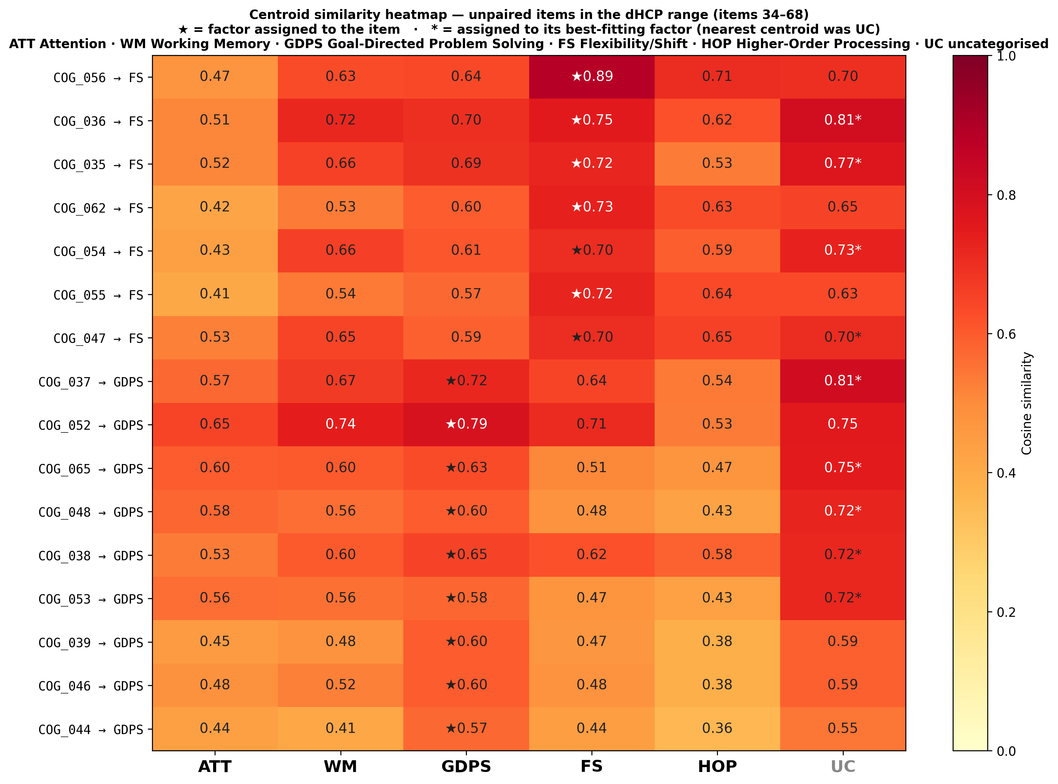
Centroid similarity heatmap for unpaired items in the dHCP administration range (items 34–68).

Figure S2. Centroid similarity profiles, all 52 unpaired items
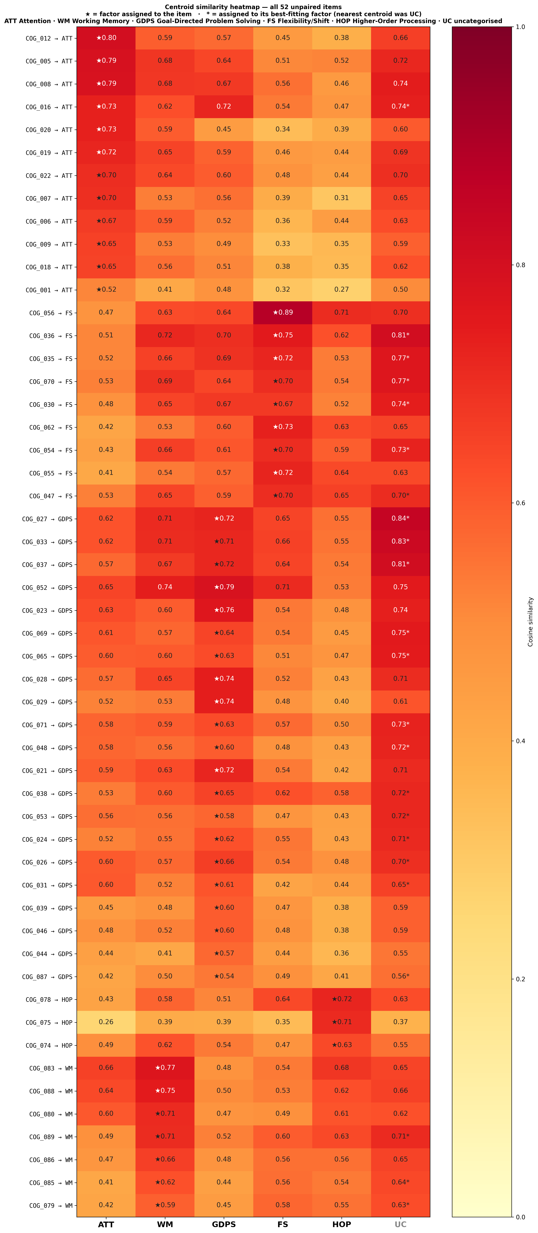
Centroid similarity heatmap for all 52 unpaired items.

Figure S3. Three-way Bayley-4 alluvial diagram
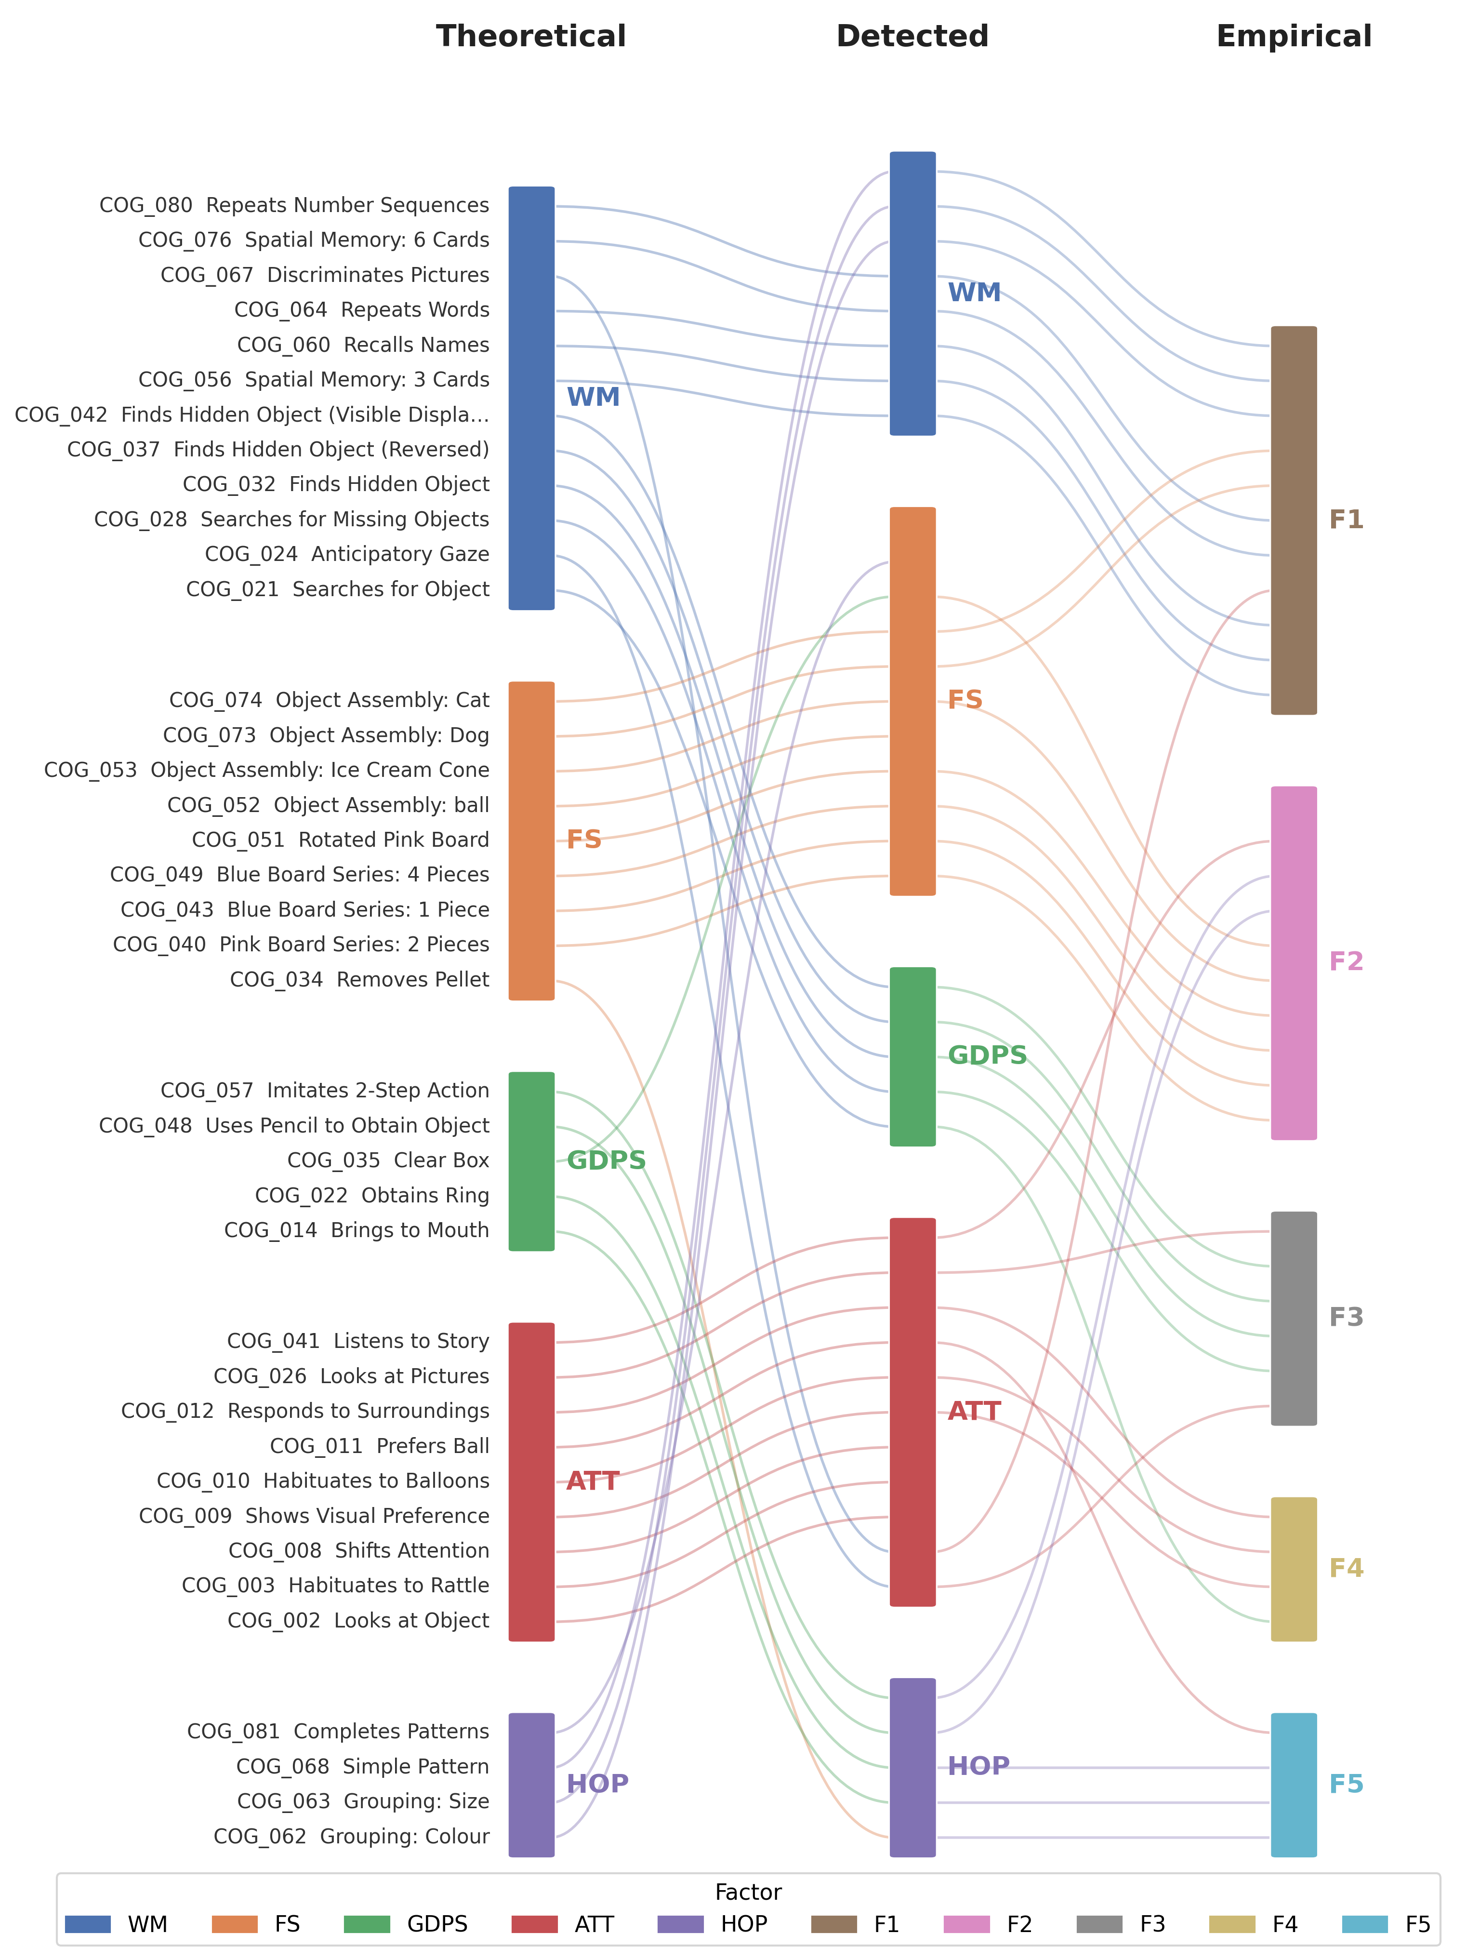
Three-way Bayley-4 alluvial diagram: item flow from the theoretical (Aylward et al. 2022), detected (unsupervised consensus k-means), and empirical (standardisation-sample) domain structures.

Figure S4. Bayley-III alluvial diagram
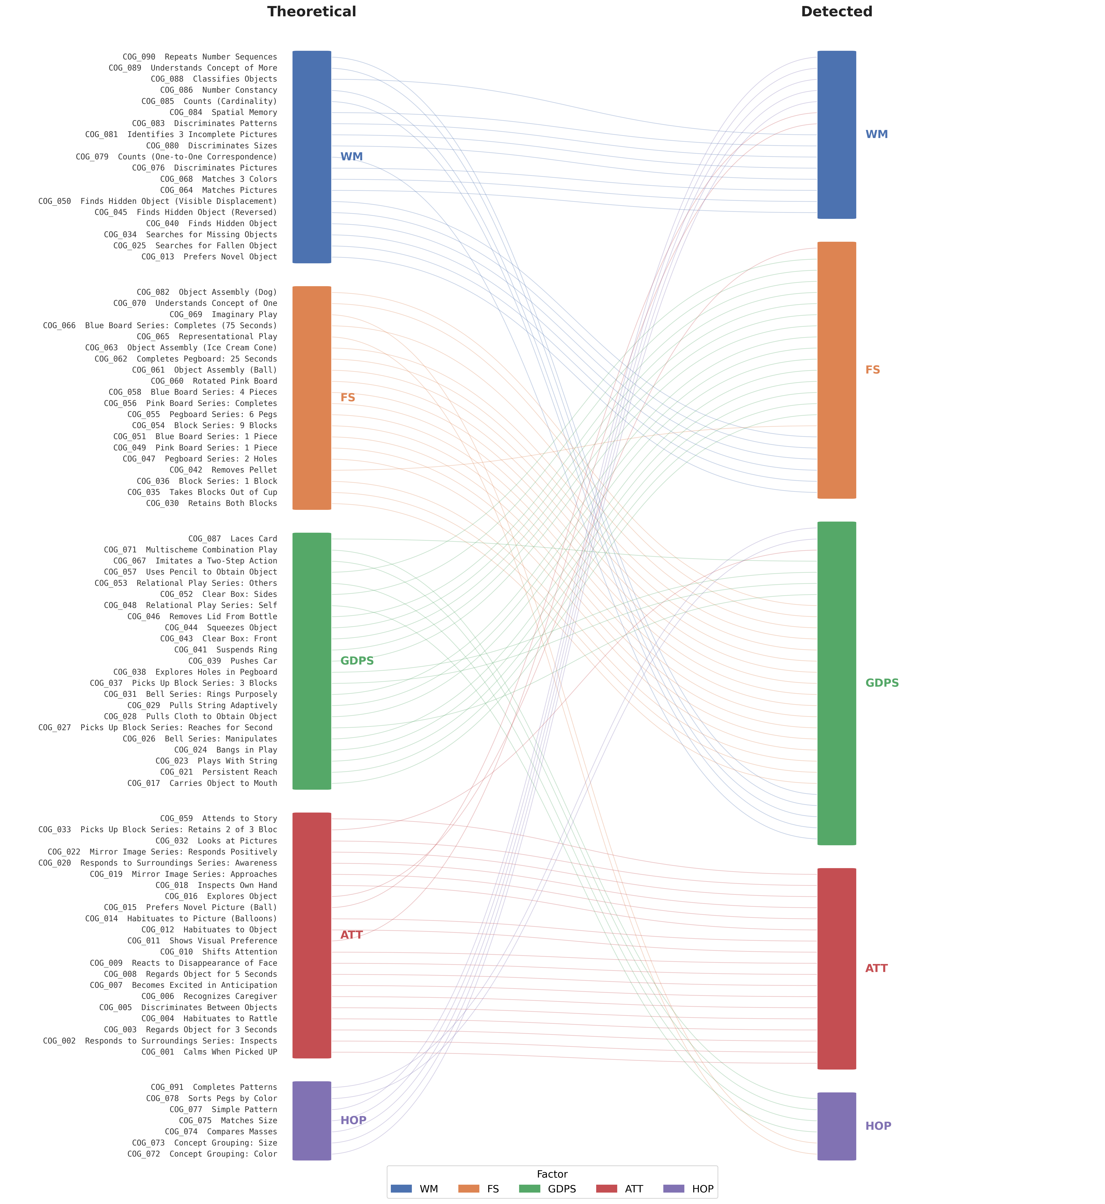
Bayley-III alluvial diagram: item flow from the theoretical (translated, Step 1) to the detected (bottom-up NLP, Step 3) domain structure, all 91 items.

Figure S5. Embedding cosine similarity vs tetrachoric correlation, 23-item CFA model
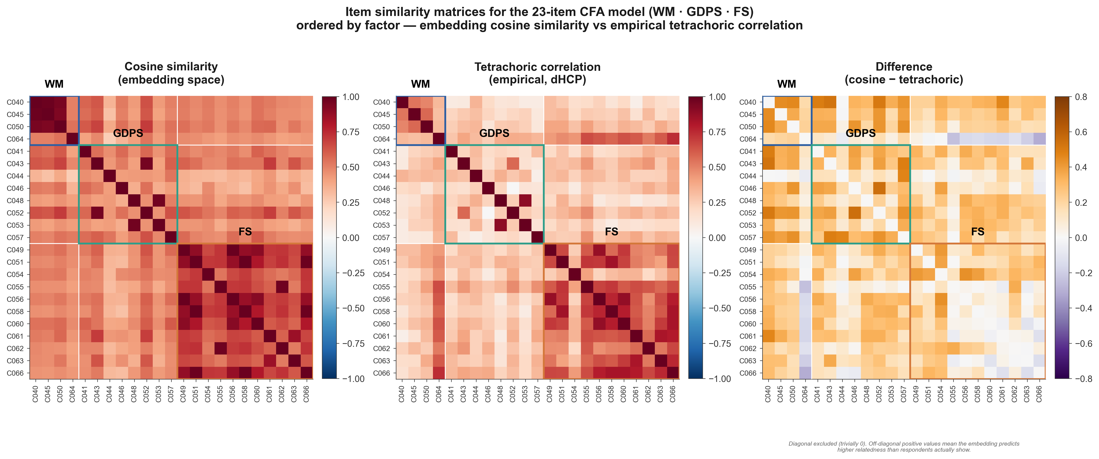
Item similarity matrices for the 23-item CFA model (WM · GDPS · FS): embedding cosine similarity vs empirical tetrachoric correlation, dHCP sample.

Figure S6. Three-way correspondence of the Bayley-4 domain structures
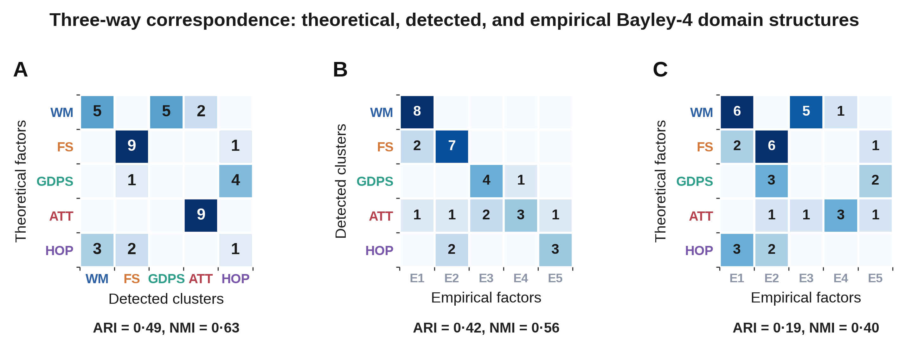
Three-way correspondence between theoretical, detected, and empirical Bayley-4 domain structures.

Figure S7. Within- vs between-cluster cosine similarity by factor
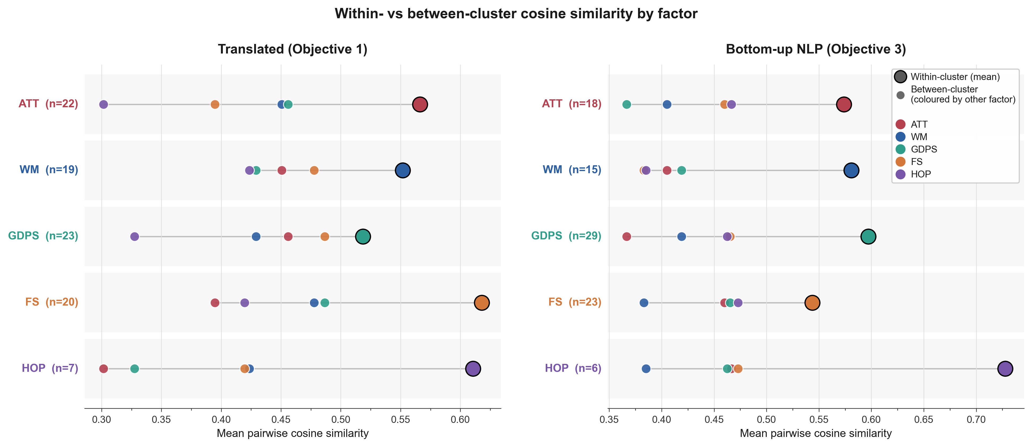
Within- vs between-cluster cosine similarity by factor, theoretical (Step 1) and bottom-up NLP (Step 3) solutions.

Figure S8. Sensitivity of the cascade pairing to the title-similarity threshold
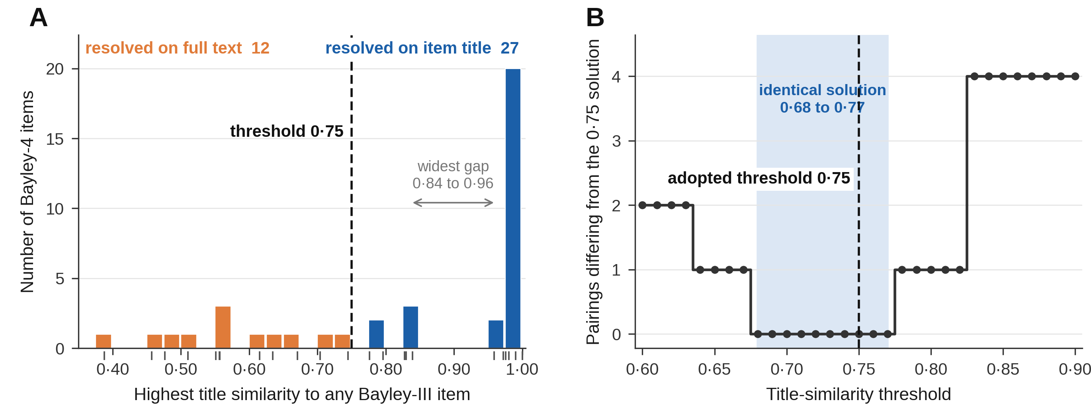
Why cascade item pairing accepts a title match at 0·75. (A) Best title similarity for each of the 39 Bayley-4 cognitive items: 27 clear the threshold and pair on title, 12 fall through to full text. The widest gap is 0·84 to 0·96, so 0·75 marks a sparse region rather than the emptiest one. (B) Pairings differing from the adopted solution across thresholds 0·60 to 0·90. The solution is unchanged throughout 0·68 to 0·77. From 0·78 correct matches between reworded titles are rejected (Grouping: Size with Concept Grouping: Size); from 0·83 four pairings differ; below 0·68 spurious title matches are admitted, two by 0·63. 0·75 is therefore supported by the stability of the solution, not by a clean split in the distribution.

Appendix references
Numbered separately from the references of the main text; cited by superscript in the note to Table S4.
1 Cox JL, Holden JM, Sagovsky R. Detection of postnatal depression: development of the 10-item Edinburgh Postnatal Depression Scale. Br J Psychiatry 1987; 150: 782–86.
2 Arnold DS, O’Leary SG, Wolff LS, Acker MM. The Parenting Scale: a measure of dysfunctional parenting in discipline situations. Psychol Assess 1993; 5: 137–44.
3 Wolke D, Jaekel J, Hall J, Baumann N. Effects of sensitive parenting on the academic resilience of very preterm and very low birth weight adolescents. J Adolesc Health 2013; 53: 642–47.

