City University
MSc in Business Systems Analysis & Design
Project Report
2007

UNISoN: A tool to aid evaluation of sociability in on-line discussion boards

Name: Stephen Thomas Leonard
E-mail address: abbh224@city.ac.uk or steve@sleonard.co.uk
Contact phone number: 0776655 1575
Supervisor: Dr Panayiotis Zaphiris
Declaration

By submitting this work, I declare that this work is entirely my own except those parts duly identified and referenced in my submission. It complies with specified word limits and the requirements and regulations detailed in the coursework instructions and any other relevant programme and module documentation. In submitting this work, I acknowledge that I have read and understood the regulations and code regarding academic misconduct, including that related to plagiarism, as specified in the Programme Handbook. I also acknowledge that this work will be subject to a variety of checks for academic misconduct.

Signed

Stephen Leonard
Abstract
This report presents a tool that can be used to aid the study of online social networks. It builds upon earlier work that studied Usenet groups which were limited by the manual data collection methods used. The main goal of the application is to allow the user to select newsgroups they are interested in, quickly download large numbers of messages and allow them to preview the data. It includes a graphical representation of the networks which clearly shows the clusters and isolated individuals in the network. The report will show that the application will yield the same results as manual data collection methods, but at a much faster rate. The chosen output file format is compatible with Pajek, a popular open source social network analysis tool.

Keywords and Phrases
Social Network Analysis, Pajek, Usenet, online communities, Automated data collection

The author acknowledges the help of his supervisor Dr Panayiotis Zaphiris who suggested the project and gave assistance to the background of the subject, and also the help of his PhD student Ulrike Pfeil who gave feedback on the prototypes.

Contents

1 Introduction and Objectives 6
2 Engagement with Academic Literature 9
1.1. Social Network Analysis 9
1.1. Social Network Analysis 9
1.2.Nodes, cliques and relations: the terminology of SNA 9
1.2. Nodes, cliques and relations: the terminology of SNA 9
1.3.About UseNet and Network Newsgroups 10
1.3. About UseNet and Network Newsgroups 10
2.1.1Technical description of UseNet Messages 11
2.1.2Crossposting and spam 11
1.4.Social Network Analysis Tools 12
1.4. Social Network Analysis Tools 12
2.1.3Netscan 12
2.1.4Netminer 12
2.1.5Pajek 12
2.1.6Structure of Pajek input files 12
1.5.Open Source software used 13
1.5. Open Source software used 13
2.1.7A brief explanation of Open Source 13
2.1.8Java 13
2.1.9Eclipse for code development 13
2.1.10Netbeans IDE for graphical design 14
2.1.11Connection to Usenet groups 14
2.1.12HSQL for database storage 14
2.1.13JUNG for graphical preview 14
1.6.Key Computing concepts used 15
1.6. Key Computing concepts used 15
1.6.1.Data normalisation 15
1.6.1. Data normalisation 15
1.6.2.Multi-threading 15
1.6.2. Multi-threading 15
3 Methodology 16
3 Results 17
1.7.Proof of concept 17
1.7. Proof of concept 17
1.8.Naming the application 18
1.8. Naming the application 18
1.9.Initial prototype 19
1.9. Initial prototype 19
1.10.Improvements to how the data is stored 21
1.10. Improvements to how the data is stored 21
1.10.1.Data cleaning 21
1.10.1. Data cleaning 21
1.10.2.Data Augmentation 21
1.10.2. Data Augmentation 21
1.11.Second version of the prototype 22
1.11. Second version of the prototype 22
1.12.Improving performance with multi-threading 24
1.12. Improving performance with multi-threading 24
1.13.Third Version of the prototype 25
1.13. Third Version of the prototype 25
1.14.Final version of the application 26
1.14. Final version of the application 26
1.15.Validation of output 29
1.15. Validation of output 29
1.15.1.Create a test pajek file 29
1.15.1. Create a test pajek file 29
Discussion 33
4 Evaluation, Reflections and Conclusions 34
5.1Full User Requirements 34
5.1 Full User Requirements 34
1.16.Improvements to the Development process used 35
1.16. Improvements to the Development process used 35
1.17.Further work and Possible Future enhancements: 35
1.17. Further work and Possible Future enhancements: 35
5 References 37
1.18.bibliography 39
1.18. bibliography 39
6 Appendix 1 – the UseNet Message Format 40
7 Appendix 2 – Downloading and running UNISoN 44
9.1Installation instructions 44
9.2Getting Started 44
8 Appendix 3 – Setting up the development environment 47
1.19.Download Java and the code editing tools 47
1.19. Download Java and the code editing tools 47
1.20.10.2 Download or copy the java source from disk 47
1.20. 10.2 Download or copy the java source from disk 47
9 Appendix 4 – the Pajek Network file created for 48
10 Project Definition 53
1. Introduction 53
2. Problem Definition 53
3. Project Description 53
3.1. Objectives 53
3.1. Objectives 53
3.2. Beneficiaries 54
3.2. Beneficiaries 54
3.3. Risk Analysis including Ethical Considerations 54
3.3. Risk Analysis including Ethical Considerations 54
4 Methods and tools 54
5 Evaluation methods 55
6 Work Plan 55
7 Project Feasibility 55
7.1. Experience 55
7.1. Experience 55
7.2. Resources 55
7.2. Resources 55
8 References 56
9 Endorsement 56

Introduction and Objectives
What is Social Network Analysis (SNA)? Social Network Analysis is a way of taking the relationships between various people and modelling them based on the interactions they have with each other (Hanneman & Riddle 2005).

Essentially, each person (known as an actor or node in the network) is linked to some and probably not all the other people in the network and each pair can have different types of relationship to each other and to other people (Hanneman & Riddle 2005).

The study of networks in social groups is not new. Building on earlier work by psychologists, in 1934 Moreno released a book describing the “social configurations” – the friendship networks a person has (SCOTT 2000).

A now common way to represent this information is to show them in a sociogram, a picture showing the people in the network as nodes or circles linked with lines or arrows representing the relationships between them. A report published in 1939 on the famous Hawthorne study (used normally to demonstrate the effect that being observed has on the subject) was the first to use sociograms to describe social networks (SCOTT 2000)

Figure 1 - a Hawthorne sociogram (SCOTT 2000)

We need to collect data on all the relationships between all the actors in order to get an accurate picture of the interactions within the group. Accordingly, this involves collecting a potentially huge amount of information. The analysis of these networks is made possible using mathematical tools and computer software to visualise the results as graphs (Hanneman & Riddle 2005).

The groups could be communities in the traditional sense, or online existing as a result of interactions through the internet. Many such online networks exist, e.g. Facebook and MySpace being amongst the most famous, but before them, before even the internet as we know existed, was UseNet, a collection of discussion boards that are shared amongst many computer servers allowing users to post, read and reply to messages. These interactions can be viewed as a social structure, i.e. when someone replies to a message, they have interacted with the author of the original message. Some people get more replies, some reply only to certain people.

Social structures in UseNet groups have been studied before. The tool Netscan allowed researchers free access to the usenet archive. For example, a 1997 study (SMITH 1997) was an extensive study involving over 3 million messages from over 12,000 newsgroups. Unfortunately, this web site is no longer updated with new messages (Microsoft 2007).

A more recent study at City University (Zaphiris & Sarwar 2006) used SNA techniques to study two age-related on-line discussion groups, soc.senior.issues (Google Groups 2007), and alt.teens (Google Groups 2007), to investigate the different behaviour of different age groups. They had used manual data collection techniques and as a result had had to limit their study to 200 messages from each discussion board.

The study covered two main areas: using Netscan to derive statistics, such as number of messages posted per month; and social network analysis to study the interactions between posters, creating links from the author of a message to the author of the original post they reply to. As manual collection is slow, 200 messages from two newsgroups were studied.

Since the message population was very large (over 15,000 for soc.senior.issues and 50,000 in the case of alt.teens), the small sample size forced the study to follow an ego-centred analysis where the interactions around one individual are studied, rather than the whole population. (Zaphiris & Sarwar 2006). By automating the data collection process a study of the whole population and other on-line groups should be made much more feasible. Automation of this process would free up time for higher level analysis and allow for more valid conclusions.

The overall aim of this project is to help further that research, by developing a software tool for the benefit of SNA researchers at City University, specifically Dr Panayiotis Zaphiris and his team, to automate the collection of data from newsgroups and transform it to a format that the SNA tool used by the HCI department can understand. If it proves successful, this may be given to other teams to use. Being written primarily as a tool for use by others, data collection is limited only to validation of the data and for demonstration purposes.

In order to achieve this, there will the following milestones:
- Create the data collection tool. This has 3 sub-stages :
  - Develop a means to collect data from the on-line discussion boards . this needs to be quick enough to be of practical use to researchers.
  - Store the data in a medium accessible by both the HCI researchers, with both a database front-end and a preview graph showing the interactions in the group.
  - Expand the tool to allow the filtering of data and creation of input files for the chosen SNA modelling tool, i.e Pajek.

- Evaluate the tool by using it to collect data from the earlier City University study (Zaphiris & Sarwar 2006) , i.e. From alt.seniors and alt.teens compare results to original paper. A comparison against manually collected data will be conducted to validate the results.

- Study another on-line group using the tool, alt.support.mult-sclerosis to show a well-connected social group with sufficient data to get a realistic snapshot of activity.

The project proposal had also suggested expanding the tool to study the semantic value of messages, though proved to be too complex. The main focus of the was producing a tool that other people could use, so considerable effort was spent making it efficient and easy to use.

This report will start with an overview of the literature around social network analysis, about UseNet groups and then discuss the approach taken to develop the tool. There was a lot of research into what software to use, as there is much free-to-use software code that may be used, though of varying quality.

Though it had been planned to follow a spiral life cycle to involve the end-users as much as possible, due to the complexity of the development effort, an iterative approach was taken, with initial prototypes being replaced by improved versions of the application, with infrequent releases to the HCI researchers. The requests and suggestions of the HCI team were incorporated as much as possible, subject to technical restraints.

The tool was going to produce files for both Pajek and Netminer but simplified to produce only Pajek files. Pajek is free but Netminer is a licenced product, and can import Pajek files.

There is then a discussion of the findings and results, including a validation of the output files produced by the application. Finally the report concludes with discussion and conclusions and suggestions for further work.

Engagement with Academic Literature

Social Network Analysis

Social scientists and anthropologists would traditionally study communities in terms of a territory or neighbourhood they lived in. Sometimes this was not possible, such as an 1968 study of East York in Canada where the residents did not congregate in public on street corners or front porches, preferring to visit each others homes. To allow for this, they looked at “personal communities” i.e. the interactions between individuals, e.g. of companionship or aid (Wellman, Carrington, Hall 1988). For this community it was better to study them as a network.

This study showed that social networks can have various structures: some personal communities were quite densely knit, i.e. linked by one gregarious character, or a close knit family that often visits each other – so each member has several links within the group; whilst other groups might have only 1 or 2 links per member. The mean number of links between members is called “degree”. There were also instances of isolated members, not connected to anyone else in the study.

Other important terms are to do with integration within the group: Clusters - structures with lots of direct links and can be quite cohesive, and Components – looser groups, e.g. friends of friends. Cliques are small groups where all members are directly linked to each other. Another interesting aspect of the study showed that “sociability” was the main reason for the links, accounting for 75% of people's connections.

Nodes, cliques and relations: the terminology of SNA
Social Network analysis has its own vocabulary and concepts that need to be understood to make use of it. Fundamentally, a social network is made up of people connected to each other by a set of relationships. The people are represented as nodes; the relationships as lines connecting them. These lines can be directed (with arrows showing interaction in one direction only or both directions) or undirected. (SCOTT 2000)

Figure 2 - (left) directed graph and (right) undirected graph

These relationships can be represented by a matrix or by a graph as above, but for the scope of this project, we concentrate on the graph representation only.

Two points that are connected to each other are said to be adjacent. The points that are adjacent (connected to) a node are termed its neighbourhood. The number of nodes in the neighbourhood is called its degree. Therefore the degree is simply an indication of many connections a node has. This can be split by direction to indegree (connections to it) and outdegree (connections from it).

A key concept in SNA is the study of cliques or cohesive sub-groups that appear in networks, and often form part of someone’s identity. In terms of graph theory, a clique is a “sub-set of points where every possible pair of points is connected and not part of any other clique” (SCOTT 2000).

Figure 3 - a 4 member clique

A similar but distinct theme, is that of clusters, areas of high density in the graph, whether by relational or attributes data, e.g. these could be people who have no direct links with each other but always turn up for a certain event. (SCOTT 2000).

Another concept that can be demonstrated well with this project is that of centrality, the notion where a network might have a key figure at its centre, the most popular person, with the most connections to other people. A highly centralised graph will have most of the nodes coming off the centre with short paths. If most of the nodes are in the periphery then the graph has low centralization (SCOTT 2000).

Terms, such as path, length and distance are used for analysing extended connections, (SCOTT 2000) i.e. how one node is related to other nodes via intermediaries (e.g. friends of friends).

About UseNet and Network Newsgroups

Newsgroups, the first popular offshoots of the early success of Internet e-mail, were started by people with common interests collectively maintaining e-mail lists to exchange messages on their subjects. To centrally store the messages to reduce on storage needs and internet traffic, network news groups were devised (Negus 2006).

Network News is a form of online discussion group with discussions covering almost every subject imaginable. Users can browse, read and post messages to either inform or to seek advice or help. Unlike an email newsletter, you can choose how often you access it, controlling use of your internet bandwidth. News servers share messages posted on them to other news hosts. The administrators of the servers decide what groups they are interested in publishing. One of the major sources of news groups is UseNet (Krol 1994). Today, there are more than 41,800 newsgroups are listed officially with the Internet Software Consortium: www.isc.org (Negus 2006)

UseNet – an abbreviation of UNIX Users Network - was started in 1979 with just 3 UNIX sites to enable users to exchange messages via phone links. As it grew some of the higher traffic servers grouped together to form the Backbone, or more sarcastically the Backbone Cabal. As these sites carried the most traffic they essentially governed what was published. As the number of news groups grew, the Backbone decided to organise the existing groups into categories. They decided on 7 (known as the Big 7) : comp (computer science), soc (social issues), rec (recreation and hobbies), sci (science), talk (arguments), news (news about UseNet itself) and misc (miscellaneous). The UseNet software was also used to carry groups not supported by the Cabal, notably alt for alternative groups . There are hierarchies, some commercial (where servers must pay to receive the content) e.g. Clarinet, and some specialised, e.g. bionet for biological researchers (Estabrook, Gregory, Mann, Parker 1995).

Its use expanded rapidly, and after the transport method was changed to be over the internet via NNTP (News Network Transfer Protocol) servers, its use grew even further as groups did not rely on the approval of the Backbone to transmit their messages. This was replaced by the “Interest Poll” (Estabrook, Gregory, Mann, Parker 1995).

In 2001, Google purchased Dejanews, a Usenet server that held Usenet messages dating back to 1985, ensuring their survival (Grobe 2001), creating Google Groups, a web-based News group client. (Google 2007) Unfortunately, Google does not allow direct access to its Usenet archive, allowing only web-based access.

People can access UseNet message by either of two methods: either connecting directly to an NNTP server with client software, or accessing one of the various websites, including Google Groups, that allow viewing and sometimes posting of messages.

Technical description of UseNet Messages

Like email, a UseNet message is split into two main sections - a header (where the subject, sender details and date sent are stored) and a body where the text of the message is stored. The header of an NNTP message contains many extra fields, including details of what server the message was posted on, what newsgroups the message is intended for, and a unique message ID. The body is the text of the message – the actual “news”.

The article can be on a new subject or “thread” or can be a reply to another message, a “follow-on”. News readers allow you to see all the messages that form that thread together (Krol 1994). Full details of the structure of UseNet messages are given in the appendix.

Crossposting and spam

It is possible to post the same message to more than one group rather than simply copying the message and publishing it separately in each desired group (called “multi-posting”), messages can be “crossposted” to appear in the groups you require. This would be done where the message is relevant to readers of each group, though this has been used by unscrupulous posters who “spam” UseNet by publishing their adverts in hundreds of groups, most of which have no relation to the message (Estabrook, Gregory, Mann, Parker 1995).

Social Network Analysis Tools

Netscan
Netscan is a free online tool provided by Microsoft that allows the study of Usenet groups from 1997 till 31 May 2007, when it was no longer updated. It allows users to study traffic in newsgroups, and various other stats. (Microsoft 2006)

Netminer
Netminer is a commercial product that allows you to graphically display and manipulate network data. (Cyram 2007)

Pajek
Pajek (Slovene word for Spider) is a Windows program for analysis of large networks. Pajek is freely available for non-commercial use. It reads in data from files and then displays the data graphically. (Batagelj 2002)
This was chosen as it is free and publishes the format it requires from input files.

Structure of Pajek input files
Pajek can handle 6 types of data structures: network, partition, cluster, permutation, vector, and hierarchy. (Mrvar 2007)
The first of these, network (saved to a file with .net suffix) is used to create a matrix of the interactions. This can be done by supplying a matrix or by listing the links on separate lines: List of neighbours (where all relationships have a value of 1) or Pairs of lines (values can be more than 1).
The version used in this project is “Pairs of Lines”. There are 3 parts to these types of files. First is the line stating the number of Vertices or nodes in the network, eg for 5 points: *Vertices 5
Following this are the actual points in sequence with an optional label.
Eg.
1 “Tom”
2 “Harry”
If there are undirected lines or relations between vertices, these are put in section started with *Edges and then lines starting with the index of the vertice followed by the vertices it connects to, e.g. 1 4 2 means vertices 1 and 4 are connected with a value of 2.
If there are directed lines these are represented by a section started with *Arcs and then lines starting with the index of the vertice followed by the vertices it connects to, e.g. 1 4 1 means vertice 1 connects to 4 with a value of 1. (Mrvar 2007)
The interactions in Usenet are considered directed, as they are from the message author to the poster of the message they have replied to. No link exists if the message is the start of a new thread (I,e is not in reply to someone else.)

Open Source software used

The application being developed involved a large number of components, a GUI for interaction with the user, a database to store data and a graphic to show a preview of how the network looks before loading into specialised social network analysis tools. To develop proprietary versions of these would not only greatly increase development time, it would also lead to inferior end result, as short-cuts would have to be taken.
In order to speed up the development process and improve the overall quality of the product, third-party software libraries were used where possible. Their legal use of code without payment is possible thanks to the rise of Open Source software.

A brief explanation of Open Source

Code that is open source is free to use or amend subject to certain conditions. It’s been released on a “Common Public License” which gives a non-exclusive, worldwide, royalty-free patent license under Licensed Patents to make, use, sell, offer to sell, import and otherwise transfer the code. (OPENSOURCE 2006)

Banks and other large corporates have been using Open Source software for years. Linux, an open source rival to the UNIX operating system is certainly the most famous example, in use at Lehman Brothers and Goldman Sachs. Other projects such as the database MySQL is used by Lloyds bank amongst others. (DUMIAK 2005) Some have even started to release their own applications to the open source community - Dresdner Kleinwort Wasserstein recently released Open Adaptor, a framework for integrating disparate systems (TAFT 2005)..

Java
The application was written in Java, an open source programming language and platform. The language is always the same, but for each operating system that can run Java there is a specific Java Virtual Machine (JVM) which translates the java to code that the machine understands. Developers can write Java code on any machine which is then compiled to a format that any JVM can understand. This can lead to Java being slower than “native code” (Campione and Walrath 2007) i.e. machine code or code written in a language to run on a specific processor. (Whatis.com 2007). This allows the application to be written on a Linux machine but then run on a Windows or Apple Mac, without needing to change it. As a well supported language with over 5 million developers worldwide (java.com 2007) there are plenty of resources available to aid development in it.

Eclipse for code development
Even before any coding began, Eclipse which is the world’s most popular Java IDE (Integrated Development Environment) (Cowley 2006) was chosen as the development editing tool.
This allows the developer to step through the code, find bugs and syntax errors more quickly and generally speed up the code writing process. It was chosen as its Open Source and extensible (Eclipse.org 2007) plus familiarity with the product.

Netbeans IDE for graphical design
Whilst Eclipse is excellent for most coding tasks, development of user GUIs is a very specialised and skill. After much searching, the best free tool was found to be Netbeans, which is written by Sun, the authors of the Java language.

Connection to Usenet groups
A key component of the project was connecting to Usenet servers and downloading messages. Without which, the project could not continue.

Initial searches for Java code to connect to NNTP servers came back with few results, and eventually the Knife project was found (“Knife” 2003) This allowed downloading of complete messages from newsgroups, saving the data as Java classes allowing for easy manipulation of them.

Later versions of the code used the Apache Commons Net package, as this allowed direct manipulation of the underlying NNTP commands, enabling faster processing. (apache 2007)

HSQL for database storage
One user requirement was the ability to store and query the downloaded messages. Since the application was to be standalone, this meant that it had to have an internal database.

The chosen technology was HSQL, a database written entirely in Java which can be run within other java applications and which comes with a DB client.(HSQLDB 2007i) It is the default database used by the leading open source office program Open Office (open office.org 2006) and so is proven to be stable.

JUNG for graphical preview
To enable a preview of the network data is quite a complicated task. There are a number of Java graphing tools available, both free and commercial, but only one of the free ones provided the tools needed.

JUNG (Java Universal Network/Graph Framework) is an open-source java library written for modelling graphs or networks. It specifically handles directed and undirected graphs making it an appropriate tool to represent social network data.(JUNG 2007)

Key Computing concepts used

Data normalisation

Multi-threading
Early computers did not have operating systems; they executed a single program which had access to all the computer’s resources. As operating systems were developed, more programs could be run at one time. This was made possible with the use of processes – isolated, independently executing programs with their own share of resources such as memory. The computer switches between these tasks, moving from one to the other, setting one off then attending to another. (Goetz 2006) Much like a person might “multi-task” by buttering toast while waiting for the kettle to boil. By allowing multiple processes to run at one time, more tasks can be achieved in the same time, improving efficiency and speeding up the program.

Threads are similar to processes, except that they run within a process. They can take advantage of multi-processor computers and share resources with the other threads, though if not controlled this can lead to problems, as one thread can change the data that another relies on unexpectedly. This topic is known as Thread Safety, i.e. a class is thread safe if it behaves as expected when accessed by multiple threads. (Goetz 2006)

To control the modification of data by multiple threads, the notion of locking is used. In java, this is denoted by the term “synchronized”. When a method or code fragment is marked as synchronized, only one thread can access it at one time. The other threads wait until the first one has released the lock. Over eager use of locks can slow the application down, as all threads wait for one thread to release resources.

Methodology
The code was developed in iterative stages, which were then redeveloped to account for problems or limitations discovered with the code or requests made by the team for whom the code was being written. The plan had been to conduct informal meetings, brainstorming sessions , perhaps on-line discussions, and observations following the principles of Contextual Design (Rogers et al. 2002), though the frequency of these reduced as most of the problems faced were purely technical.
The first stage was the proof of concept: a simple Java client that would connect to the internet and download Usenet messages. The downloaded data was then transformed and saved to a file that could be read by either Pajek or Netminer. If neither of these were possible, then the project would have to be abandoned.
With this achieved, initial face-to-face meetings were held with the end-users of the system to discuss what they would like the tool to do and give a background to what it would be used for. It was decided that the application should be able to be run stand-alone, i.e. without access to university supplied or other external databases, preferably having a searchable database locally.
The next stage was producing a simple prototype which stored messages to an internal database and allowed viewing of the data before selection and saving to a Pajek file. This was presented to the HCI researchers for comment. Further feedback was taken, along with refinement of the requirements.
Further iterations aimed to improve the speed of the application and allow features such as top poster stats and ultimately graphing the network data within the program itself. These were released to the HCI team via a web site, http://unison.sleonard.co.uk, created to provide documentation and downloads to the end-users of the system.
To validate the output of the application, a manual data collection was conducted to compare against the results of the programme.
To prevent loss and to show changes, the code and documents were stored on a separate computer using the CVS software (Price 2006). This allows the various versions of the code to be stored, allowing reversion to a previous form if needed.

Results

Proof of concept
The early work focussed on breaking the task down in to workable components and mile-stones. The most important of these was to find a way to connect to the internet and download the UseNet messages. There were two possible routes to take:
- connect to a web-based NNTP client, such as google groups and parse the messages viewed there;
- or connect to a NNTP server, and download messages from there.
The first approach taken was to access web-based interfaces to Newsgroups, initially Googlegroups.
The one suggested by Google (Google 2007) was BottomFeeder (Bottom Feeder 2007). BottomFeeder is released on an “Artistic License” (Open Source 2006), which means for this academic purpose, it can be modified and released, as long as the original is available with the distribution.
Unfortunately this was written in the Small Talk language, and as the developer on this project was a Java and not a Small Talk programmer, a project in this language was sought. One of the major ones ROME (java.net 2006) was considered. This project allows for the reading of RSS and ATOM feeds regardless of version used. ROME relies on another Open Source project JDom (Jdom.org 2004) to handle XML processing. This code worked for one example RSS feed but got a 403 “Forbidden” error when it tried to connect to the Google groups RSS feed. Attempting to view the googlegroups web site in text-based browser Lynx resulted in an error page and referred the user to the Google terms of service (Google Terms of Service 2007).
An attempt was made to use the BottomFeeder app to download the Googlegroups data (with a view to adapting its Google specific code) but despite being recommended by Google, this no longer worked.
Since the code was able to read RSS feeds but Google seemed to be blocking access from text browsers, an attempt was made to find alternate web based UseNet servers ironically by using Google (Google Directory 2007). One free web-based one was http://news-reader.org which covered all the text-based forums (just like Googlegroups) but did seem to suffer from server contention issues as did http://news.interbulletin.com/. It would also have required writing code to interpret each web site used and would create a dangerous dependency on them if ever they changed their interface or even went out of business.
In addition, for Google data, permission may be needed to use the data (Google Groups Terms of Service 2007). Permission was requested but no reply was ever received.
Eventually the decision was made to create an NNTP client to read the messages from free UseNet servers to allow better control over the data. One Open Source project that allowed this Knife (“Knife” 2003) and messages were finally successfully downloaded from servers found listed on web sites that rated free NNTP servers. The one that seemed amongst the best (McCane 2007 and Disenter 2007), was freetext.usenetserver.com.
To store the messages in a searchable medium a relational database was necessary, but to enable the software to be used by users with no access to complex technical infrastructure such as a university database, a local database was used. HSQLDB (HSQLDB 2007i) was chosen as it was Open Source and required no complicated installation procedures nor licence costs.

In this first version of the code, the database contained one table “NewsArticle” to match the fields from the source NNTP messages. The MessageID field was made unique as the NNTP messages share this constraint

Finally the program was extended to produce an output file in the format required for reading by Pajek. With all the three technical issues that could have stopped the project resolved, work started on a GUI based prototype.

Naming the application

The application needed a short name that would encapsulate what it did, but that would be easy to remember.

Unison, meaning “The act or an instance of speaking the same words simultaneously by two or more speakers” (Dictionary.com 2007) is an acronym of “UseNet Incorporated Social Networks” – chosen since the programme exists to show the networks that exist in these UseNet groups.

Initial prototype
To demonstrate what was possible with the application, a prototype was created for displaying to the HCI team for comment. The initial versions of the GUI were created by hand without help from graphical design tools. This resulted in slow progress and disappointing results. This initial version did not work properly as it was in a transitional state, but it did demonstrate what sort of data the application would hold and ways it was displaying it.
There had been a problem with exporting node list in Netminer, as the email addresses have commas in them. Netminer data files comma separate the nodelist entries, but Pajek export was fine.

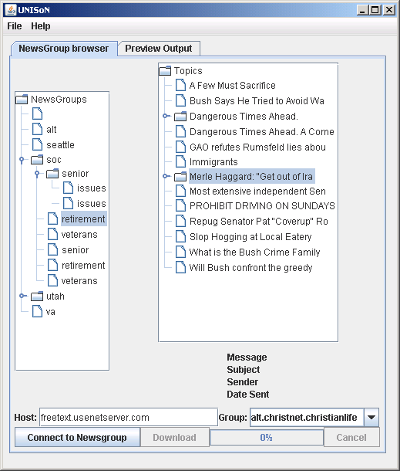
Figure 4 - an early version of the GUI

Though this early prototype was incomplete and buggy, the SNA researchers were able to more clearly envisage what was possible from the application and made a number of requests:

Instead of just linking the author of the current message to the poster of the message they reply to, they would want the choice to be able to link Messages by any of the following:
- Reply to thread creator
- Reply to previous message
- Reply to all previous message contributors

They also wanted to be able to filter by:
- users
- location (e.g. by country)

The download was very slow (one or two messages a second) so they wanted to be able to suspend the download to resume later or to read from a compressed folder of all news messages.

- Allow compression of the newsgroup hierarchy.
- Show updates, give download estimate time.
- Allow wild card searching for news groups.
- Ok to output only to Pajek as Netminer will import from those files too.
- Create a user manual.

Improvements to how the data is stored

To improve efficiency of data storage and querying of the data, it was normalised. Instead of storing everything in one table, repeating data was placed into separate tables. Using a free UML design tool, BoUML (Pages 2007) class diagrams were created to represent the data objects.

Initially was going to create a database schema and manually populate the tables from the code. Then discovered an Open Source tool, Hibernate that would allow the java objects to be mapped directly (behind the scenes) to the database (Tate & Gehtland 2004). To simplify the database updates, Hibernate was used following an example in (Elliot 2004).

This allowed for more flexible design and allow further changes more easy. The mapping file *.hbm.xml needs to match the generated class for the code and DDL generators to work. It is case sensitive, e.g. so UsenetUser needs to be mapped in UseNetUser.hbm.xml.

Once the data classes were created, another open source tool, Hibernator (Bradby 2003) was used. This generates the entire DB schema from the java classes. An example of how to do this is available from IBM (Saracco 2005).

Although the messages arrive as a single entity, the data is then normalised, with repeated sections being broken out into separate tables. This requires the referential integrity to be maintained, I.e. You need to be able return back the same data that entered in the database.
Using hibernate means that all the referential integrity checks are made by the code without explicit coding by the developer.

Data cleaning
The email field sometimes had the name of the poster and some didn't. To clean the data, a number of algorithms were used to strip out the name and email of the poster. Where details were missing, they were constructed with other fields, including the location of the poster.
The postings might miss out the first posting, so it is not always possible to show the whole message thread – do we keep what we can, or ignore all?

Data Augmentation
By using the field “NNTP-Posting-Host” of the message, a rough idea of the location of the sender can be found. Using a web-based lookup service, a geographic location of the poster can be provided.

Second version of the prototype
Using the findings discussion with the HCI team, a new version was developed to incorporate the latest requirements and comments and with the new database structure. A number of bugs were fixed and the application was able to function well, downloading messages, displaying them and exporting to Pajek, but there were two serious areas of concern.

First, the layout of the GUI was extremely difficult to manipulate and led to large areas of wasted space on the GUI and gave a poor impression:

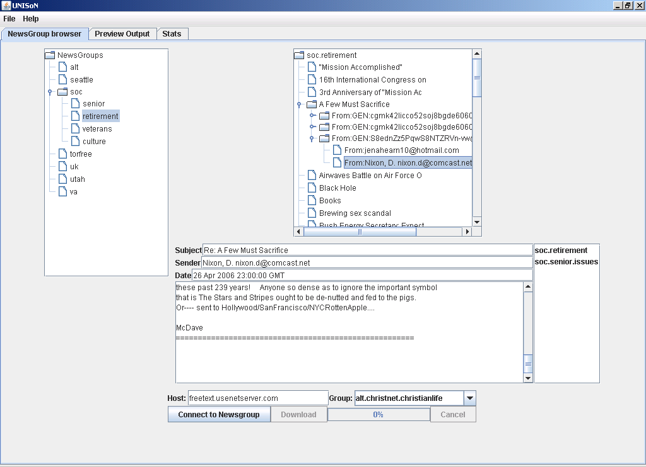
Figure 5 - Layout problems in version two

Second, deploying new versions of the code to the HCI team was tricky. Not being able to easily visit them, and the code too large to email, a web site was created to provide two functions:

- to allow downloads of the code
- to provide documentation as to how to use it

Due to time restraints, the first version of the web site was sparse, covering only the basic details required:
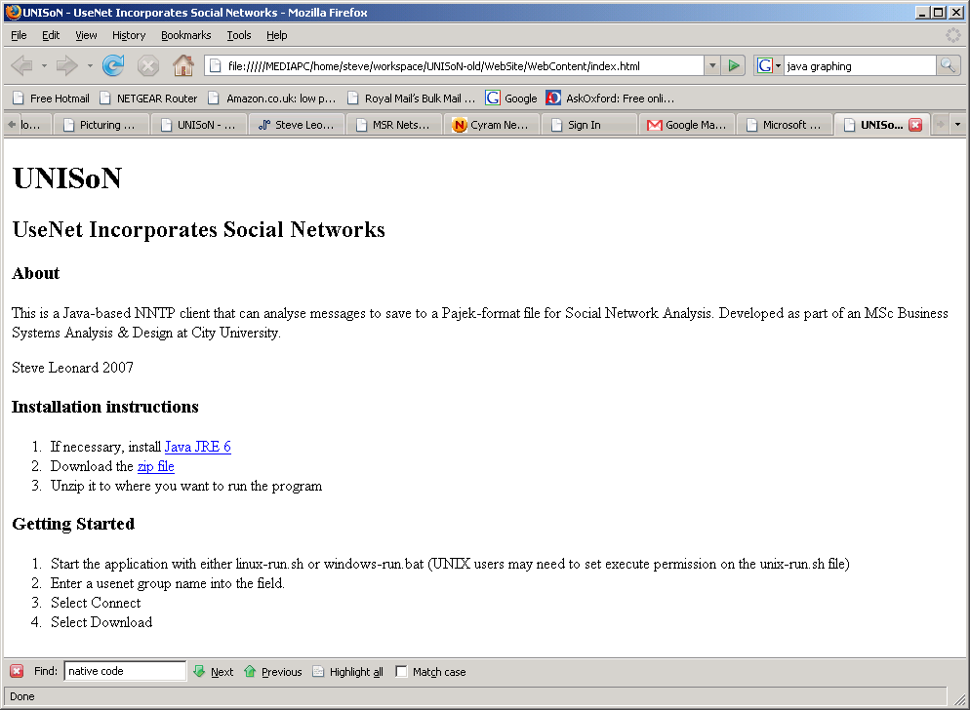
Figure 6 - first version of the project web site

To meet the requirements of providing stats was created, though this was limited to just a list of the posters ordered by the number of messages they had written.

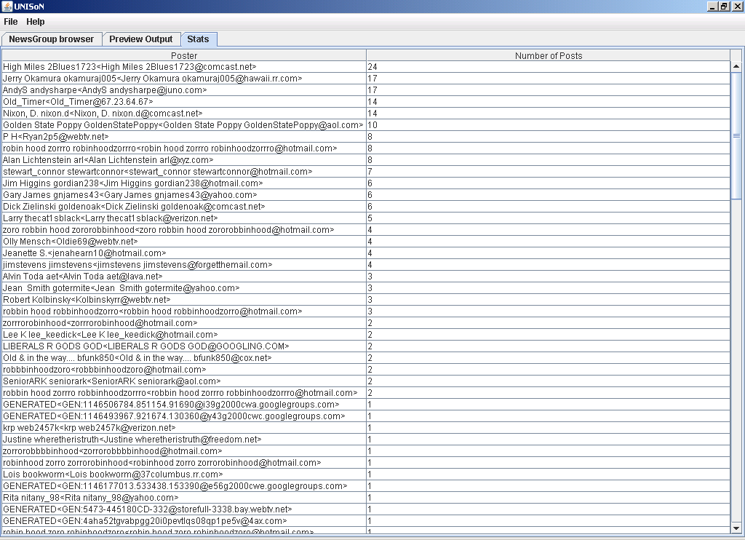
Figure 7 - the new stats panel

Improving performance with multi-threading
There were a number of performance issues with this version of the code:

- The download was still very slow
- The GUI would freeze when downloading the messages

Both of these issues were resolved with the use of separate Threads. To stop the GUI freezing up, the SwingWorker class was used (Daconta et al 2000). This meant that the download was run in a separate Thread, which the GUI could control by setting variables within the SwingWorker class. This meant that the download could run without the GUI having to stop and wait for it to complete.

By moving the downloading to a separate thread, it was then possible to further speed it up by increasing the number of threads used. At first the download was considered the bottle neck, so the download and save to database function was split into two, with separate threads for downloading and for saving the data. This meant that the program did not wait for the message to be stored to the database before downloading the next one.

Messages were downloaded from the internet and put on a queue. The database process then polled this queue, saving messages as it found them, allowing for maximum throughput.

At this stage, the data saving class was not thread-safe, so only one instance of it could run at one time.

Third Version of the prototype

Since the layout of the GUI had been so difficult and wasted so much space, another version was written, this time using the Netbeans IDE. This allowed drag and drop creation of the graphical interface, and so allowed the space to be used better, but looked different when run outside of the Netbeans to when run inside. When run outside, the frame tried to fill the entire screen and did not line up as well as it had in the IDE.

The improved threading was incorporated into this version of the code, though even with these improvements, the downloads were very slow.

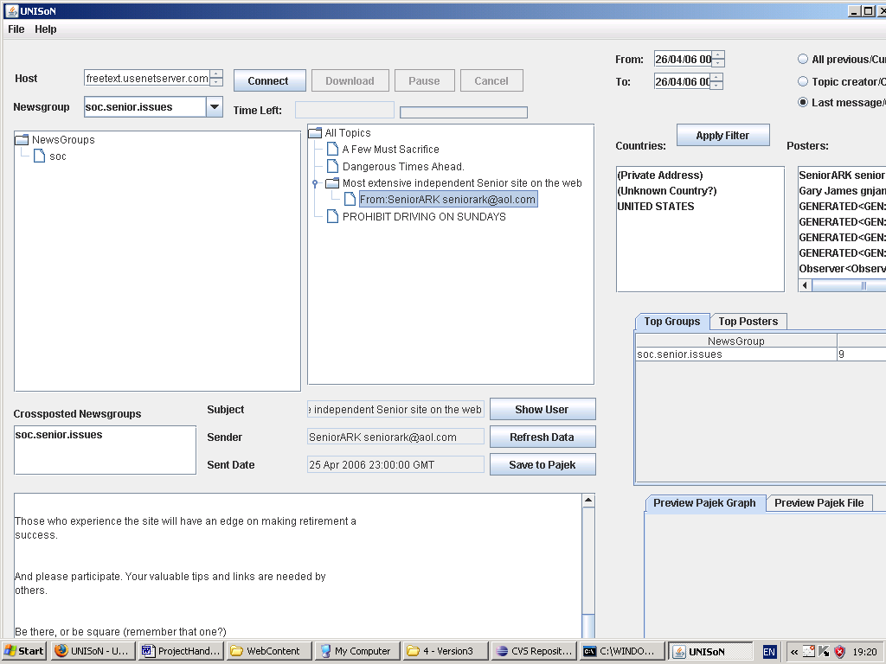
Figure 8 - version 3 of the prototype

This version also incorporated the filter fields on the main screen after attempts to show them on a separate pop-up screen were unsuccessful. It was proving difficult to filter the data, both working out how to represent the options to the user, and how to link the data behind the scenes to return only the required information.

Fourth version of the application
The third version was working better but was still quite slow. It could only download messages at a rate of 2 or 3 a second, which was impractical. It also did not have a data preview diagram. It did show statistics such as top posters, but the GUI itself was taking up the whole screen. To address these issues, a major rewrite of the code was undertaken.

Firstly, to speed up the download of messages and allow filtering of data at the server, the code used was changed. Instead of the knife package, the apache jakarta commons net package was used instead. This package allowed the NNTP command, XOVER to be used, which returns a summary of each message on one line. This is much faster than downloading all of the message, speeds of up to 100 messages per second were realised. This did not include as much information (i.e. cross-posts or location) nor the message text, but for the purposes of SNA research these were not necessary. The code allows further download of these pieces of information if required, but this is much slower.

The download screen was changed to allow the user to select a date range to download. At first the programme sent the NEWNEWS command which searched only for messages from a given date, but soon discovered that the free NNTP servers used had disabled this command to reduce workload. Instead, the application downloads all the messages, but saves only the ones in the required date range. As the downloads were now much faster, this was a realistic option.
Another of the user requirements was met by allowing a search for available newsgroups that match a search string. This used the NNTP listgroups command. By typing in part of a group name using asterisks for wild characters, a list of matching groups is brought back for the user to select and download from.

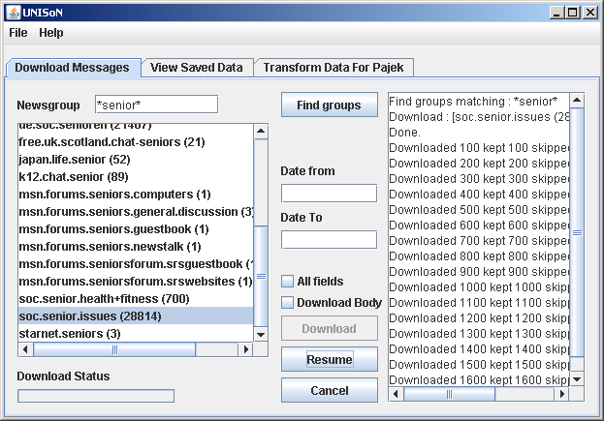
Figure 9 The download panel

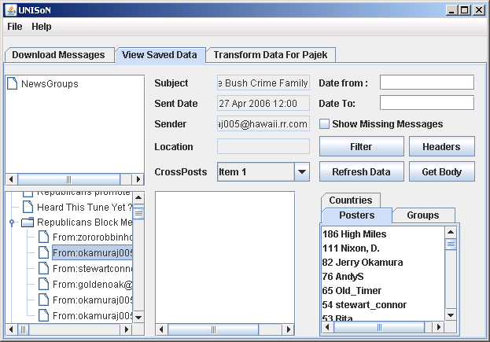
Figure 10 - The View Data panel

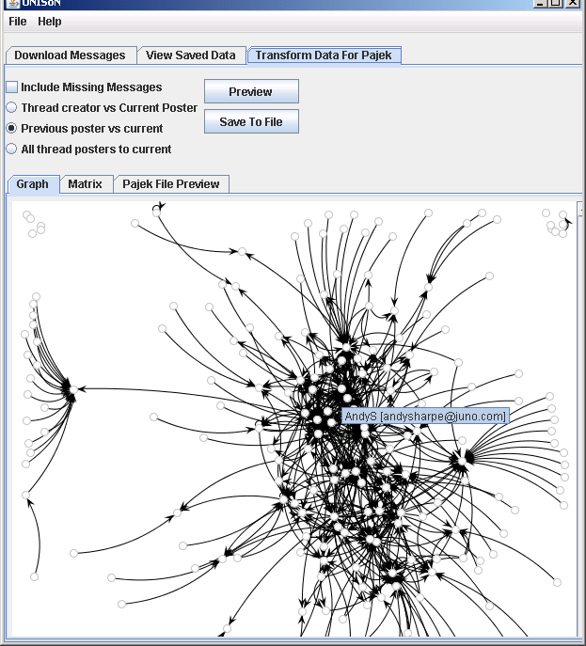
Figure 11 - The Pajek preview panel

Validation of output
Need to manually compare a data set with that produced by the application. The SNA file created should be the same.

An empirical, experimental research methodology (Hart 2005) will be followed. As much data as possible will be collected to try to show the increasing confidence of data as expand from original 400 messages to 15,000 in an attempt to validate original paper assumptions on sample size. Techniques used for researching “Virtual Phenomena” (Hart 2005) may be used.

Create a test pajek file
The first step to validating the output was to create a relatively small output file. First step is the download the messages. The newsgroup “soc.senior.health+fitness” was chosen as it held about 700 messages. The actual number downloaded was 424. The number can differ as the figure 700 is only an estimate given by the server and can be inaccurate after messages are removed. This is an area that could do with improvement.

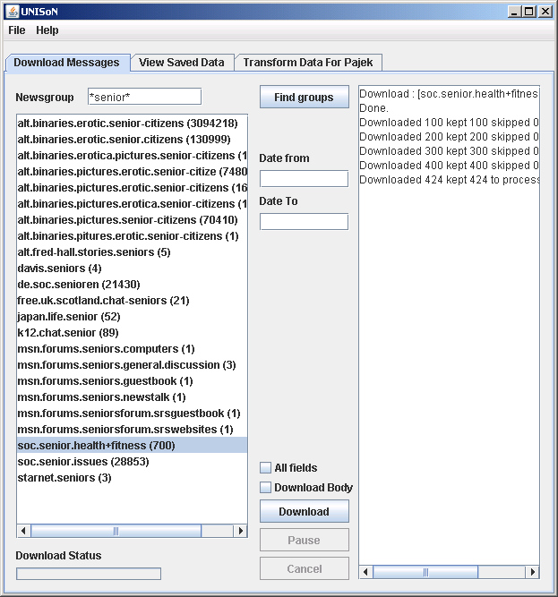

Once that completed, the “Transform Data for Pajek” tab was selected, and the preview button pressed.
This produced the following preview diagram, showing that the newsgroup had low centralization – most of the posters were on the periphery. To zoom in or out, the mouse scroll button is used; to move around, the mouse is dragged.

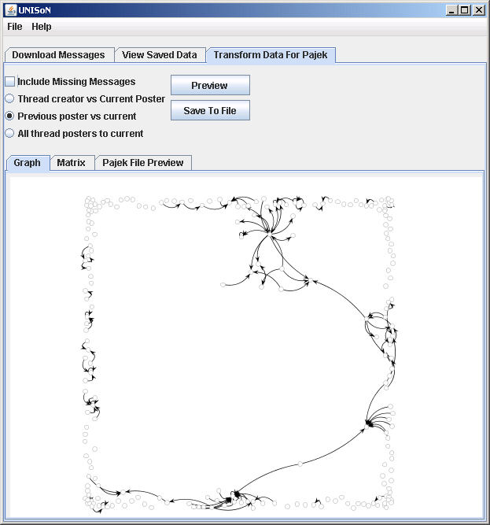

The matrix used to produce this chart was shown in the “Matrix” tab. The rows were selected and copied (using control-C) and pasted into Microsoft Excel. The application could be expanded to allow this functionality.

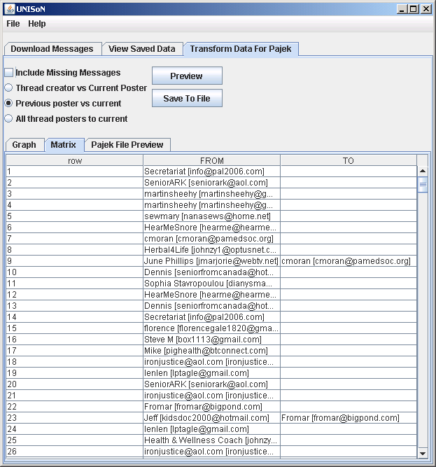

Finally, the “Save To File” button was pressed and the file saved as “soc.senior.health.fitness.net”. It created a pajek file with 226 vertices – being the 226 people in the group. A check of the database showed that this was the correct number. To access the database client, from the File menu, DB GUI is selected. Full Pajek file is in the appendix.

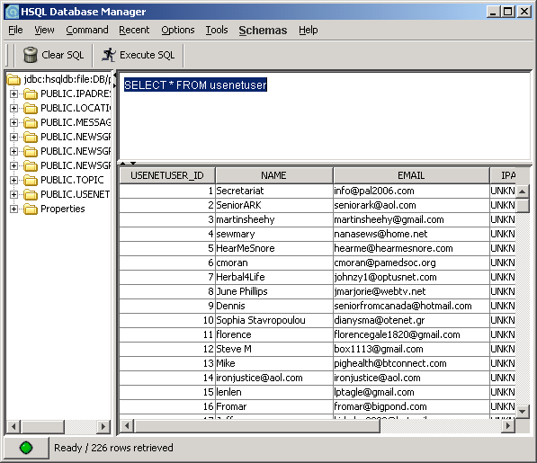
SELECT m.datecreated, m.usenetmessageid, m.subject, m.referencedmessages, u.name, u.email
FROM message m, usenetuser u
where m.usenetuser_id=u.usenetuser_id
order by datecreated desc

Next step was to compare the data to Google Groups to verify that it had collected the correct data. Having logged into Google and going to http://groups.google.co.uk/group/soc.senior.health+fitness/about?hl=en I could see that they stored messages going back to 1997, while the test data ran from April 2006.

Data collection in this way is incredibly time consuming. One way to speed this up is to view the topic list by month in a separate browser tab with a URL like: http://groups.google.co.uk/group/soc.senior.health+fitness/index/browse_frm/month/2007-11 where the last part is the year and month.

These lists were then copied into Excel, one worksheet per month. Topics which had at least one reply in them were highlighted. There were a lot of spam messages and messages with no replies. One month, November 2007 was dominated by the opinions of a paranoid delusional. No one replied to any of their messages.

Discussion

To enable a good start to the project, initially time was taken off work but as it progressed, work commitments started to encroach on the time available for the development of it, resulting in infrequent updates to the HCI team and some bugs and incomplete features in the system.

The development of the GUI.
Development of GUIs is a very specialised skill, and initially caused quite a lot of problems.

Initial effort was spent trying to manually code the interface but this was found to be extremely time consuming yielding mediocre results.

Switching to using the netbeans ide for the gui development allowed a more professional finish with much reduced coding time, though the GUI seemed to look different when run outside netbeans.

Deployment to windows and UNIX.
One of the problems with this project has been reporting back updates to the supervisor. To enable this, a download site, http://unison.sleonard.co.uk was created. In order to provide a useful prototype, a stable build of the code was needed. When one version of the code was complete it was placed on the website for downloading.

When there seemed to be deployment issues

The speed downloading messages
The problem with downloading messages from usenet groups is that there are so many messages to fetch. The original version of the code had a throughput of about 1 message every second or so.

To improve this, the process to download and save the messages was separated, with the messages being stored onto a queue by one download process with another process reading messages from the queue and saving them to the database. This is known as the publish-subscribe design pattern.

By separating the process in this way, it was possible to increase the number of instances downloading messages at any one time, each putting messages onto the queue.

Attempts were made to have more than one process saving messages to the database, but this caused serious problems with the database. It was shown that the download was the bottleneck and whilst adding more download processes increased the throughput, a single database process was able to keep up.

Evaluation, Reflections and Conclusions

Full User Requirements
Requirement | Importance | Date given | Implemented | Comment
Save To Netminer | Critical | onset | Proof of concept but dropped after prototype | Were issues with netminer and email addresses with commas in them so this was dropped
Save To Pajek | Critical | onset | Proof of concept | can be imported into Netminer
Run as stand-alone app | critical | onset | Proof of concept
Able to create links :  - Reply to thread creator  - Reply to previous message  - Reply to all previous message contributors | medium | After prototype | Version 2
They also wanted to be able to filter by:  - users  - location (e.g. by country) |  | After prototype
Speed up download, perhaps from reading a compressed folder |  | After prototype
Pause Download |  | After prototype
Show updates, give download estimate time.
Allow Compression of newsgroup hieararchy |  | After prototype
Show updates

Allow wild card searching for news groups.
Create a user manual.

The final version of the application is now quick enough to practically download large numbers of messages though there are areas where it could be improved.

Improvements to the Development process used
On reflection, more work was needed up front to speed up the development of the GUI. Had the Netbeans IDE been used in initially, a significant amount of time could have been saved.
Also, the method used for downloading the messages was changed late in the project. Had the apache commons library been discovered earlier, some of the repeated work could have been avoided.
The database mapping tool Hibernate was quite fiddly and obscure and perhaps did not give sufficient returns to justify the learning curve required to use it. Given the choice again, this would not have been used.
There were very few releases to the HCI team, as the code was often not stable. On reflection, the work should have been organised such that the deployment process was available early on, and shallow prototypes given more regularly, rather than waiting for fully working applications.

Further work and Possible Future enhancements:

Whilst the programme has lots of functionality it could still be further developed. It also needs a period of intense testing and bug-fixing. Given that though, it has the potential to be quite a powerful tool.

- Allow user to edit the messages, perhaps to edit the email address or to link email addresses that appear to be from the same poster (i.e. same name, but a simple prefix added, e.g. NOSPAM).
- Allow users to manually enter messages sourced from other sources, perhaps having a connection to web-based NNTP clients. HttpUnit could be used for this purpose.
- Allow users to choose to download a specific number of messages, e.g. 5000 from the download tab.
- Improve the database handling to use caching to speed up data handling.

- Allow download of message text, location and crossposts (buttons are there but don't do anything)
- Show missing messages in network (i.e where a message refers to other messages that are no longer on the usenet server)
- Apply filter to "View saved data" and "Transform Data for Pajek" tabs. The buttons are there but they don't do anything. The date filter on the download tab DOES work (enter date in format yyymmdd i.e. 20071012)
- Top countries list is currently showing the top posters as I am yet to add back the location details.
POSSIBLE EXTRAS
- create cluster file based on location or newsgroup
- create file to hold values at the vertices
- save matrix to csv
- import csv for preview and pajek output only
- explain why the message estimate differs from the actual downloaded number
- handle massive email names
- have terms to skip in list like erotic etc
- add more instructions,
  - e.g. for preview panel To zoom in or out, the mouse scroll button is used; to move around, the mouse is dragged.
  - Also preview diagram changes on every refresh.
  - To access the database client, from the File menu, DB GUI is selected.
- Clear pajek file preview on refresh and allow direct save from there, rather than recalculating.
- Create cgi web site to allow download via port 80
- Cluster messages by month
- Order topics by name to help searching
- Have separate table for referenced message ids not a string field
- Configure the number of threads used – release when not in use
- FIX Pajek output – need to start from index 1 not 0

References

JUNG (2007), “JUNG - Java Universal Network/Graph Framework:”, Retrieved 11 December 2007 from http://jung.sourceforge.net/
OPenOffice.org (2006) “Category:HSQLDB - OpenOffice.org Wiki “, Retrieved 11 December 2007 from http://wiki.services.openoffice.org/wiki/Category:HSQLDB
Apache (2007) “Apache Commons Net - Apache Commons/Net “, Retrieved 11 December 2007 from http://commons.apache.org/net/
Cyram (2007) “Cyram NetMiner“, Retrieved 11 December 2007 from http://www.netminer.com/NetMiner/overview_01.jsp
Google (2007) “About Google Groups” Retrieved 11 December 2007 from http://www.google.com/googlegroups/about.html
Grobe, J. (2001) “Google Acquires Deja Usenet Archives “ Retrieved 11 December 2007 from http://groups.google.com/group/news.admin.net-abuse.usenet/msg/51ca842c9fcd437c
Microsoft (2006) “MSR Netscan – About” Retrieved 11 December 2007 from http://netscan.research.microsoft.com/about/
Java.com(2007) “Java Technology: Brief History of Java Technology “ Retrieved 11 December 2007 from http://www.java.com/en/about/
Whatis.com (2007) “What is native code? - a definition from Whatis.com”, Retrieved 11 December 2007 from http://searchsoa.techtarget.com/sDefinition/0,,sid26_gci871064,00.html
Campione, M and Walrath, K. (2007) “About the Java Technology”, Retrieved 11 December 2007 from http://java.sun.com/docs/books/tutorial/getStarted/intro/definition.html
java.net (2006), “How Rome works” , Retrieved 26 June 2007 from http://wiki.java.net/bin/view/Javawsxml/Rome04HowRomeWorks
Bottom Feeder (2007), “BottomFeeder - Cross-platform RSS/Atom News Aggregator” , Retrieved 26 June 2007 from http://www.cincomsmalltalk.com/BottomFeeder/
Schmidt, M (2005i) “Overview: free news servers” , Retrieved 26 June 2007 from
http://schmidt.devlib.org/usenet/free-news-servers.html
Google (2007), “Available Feeds”, Retrieved 26 June 2007 from http://groups.google.com/group/soc.senior.issues/feeds
Google Terms of Service (2007) , Retrieved 27 June 2007 from http://www.google.com/accounts/TOS
Google Terms of Service (2007) , Retrieved 27 June 2007 from http://www.google.com/accounts/TOS
Dictionary.com (2007) “unison - Definitions from Dictionary.com”, Retrieved 10 December 2007 from http://dictionary.reference.com/browse/unison
Google Directory (2007), “Google Directory - Computers > Usenet > Web Based” , Retrieved 27 June 2007 from http://www.google.com/Top/Computers/Usenet/Web_Based/
Open Source (2006), “Open Source Initiative OSI - The Artistic License:Licensing”, Retrieved 26 June 2007 from http://www.opensource.org/licenses/artistic-license.php
Discussions – soc.senior.issues : Google Groups (2007), Retrieved 26 June 2007 from http://groups.google.com/group/soc.senior.issues/topics
Jdom.org (2004), “Jdom : Binaries”, Retrieved 26 June 2007 from http://www.jdom.org/downloads/index.html
Junit.org (2007), “JUnit, Testing Resources for Extreme Programming”, Retrieved 26 June 2007 from http://www.junit.org/index.htm
Eclipse.org (2007) , “About the Eclipse Foundation”, Retrieved 26 June 2007 from http://www.eclipse.org/org/
Batagelj, V (2002) “First Steps to Network Visualization with Pajek”, Retrieved 10 December 2007 from http://vlado.fmf.uni-lj.si/pub/networks/pajek/howto/FirstSteps.PDF
“Post a message on a news server using NNTP protocol”, Retrieved 27 June 2007 from http://www.java-tips.org/java-se-tips/java.net/post-a-message-on-a-news-server-using-nntp-pro.html
“Knife” (2003), Retrieved 27 June 2007 from http://bluezoo.org/knife/
“Using the Database - IP Address Lookup - Community Geotarget IP Addresses Project”, Retrieved 27 June 2007 http://www.hostip.info/use.html
Disenter (2007), “Free Usenet Binary News Servers” , Retrieved 27 June 2007 from http://www.disenter.com/
McCane, W. B. (2007), “Free and Publicly Accessible Usenet News Servers Index and Search Utilities”, Retrieved 27 June 2007 from http://freenews.maxbaud.net/
Wellman, B., Carrington, P. J. and Hall, A. (1988) “Networks as personal communities” from Social Structures : A Network Approach Cambridge University Press, Cambridge
Estabrook, N., Gregory, K., Mann, J., Parker, T. (1995) Using UseNet Newsgroups, Que Corporation, Indianapolis, USA
Krol, E. (1994) The Whole Internet User's Guide & Catalog, O'Reilly , Sebastopol, USA
Negus, C. (2006), “Setting Up a News Server” downloaded 8 July 2007 from http://eu.wiley.com/WileyCDA/WileyTitle/productCd-047008278X,descCd-DOWNLOAD.html
HSQLDB (2007i), “HSQLDB” downloaded 9 July 2007 from http://hsqldb.org/
HSQLDB (2007ii), “Chapter 1. Running and Using Hsqldb” retrieved 9 July 2007 from http://hsqldb.org/doc/guide/ch01.html#N100FF
Kozierok, C. M. (2005), The TCP/IP Guide - Usenet Message Format and Special Headers, retrieved 9 July 2007 from http://www.tcpipguide.com/free/t_UsenetMessageFormatandSpecialHeaders.htm
Freeman, E et al (2004), “Head First Design Patterns”, O'Reilly Media, Sebastopol CA, USA
Cyram (2003) The Structure of NTF v2.4: How to make a NTF data file? (Supplied with Netminer 2.5 software) Cyram Ltd : Seoul, Korea
Mrvar, A (2007) Network Analysis using Pajek Downloaded from http://mrvar.fdv.uni-lj.si/sola/info4/uvod/part1.pdf Retrieved 30 July 2007
Tate, B. A., Gehtland, J. (2004), “Better, Faster, Lighter Java”, O'Reilly Media, Sebastopol CA, USA
Pages, B. (2007) “BOUML - a free UML tool box”, Downloaded from http://bouml.free.fr/ Retrieved 5 August 2007
Saracco, C. M. (2005) “Using Hibernate with WebSphere Information Integrator”. Retrieved 5 August 2007 from http://www.ibm.com/developerworks/db2/library/techarticle/dm-0505saracco/index.html
Bradby, D (2003) “SourceForge.net: Hibernator - Eclipse Plugin”, Retrieved 5 August 2007 from http://sourceforge.net/projects/hibernator
Price, D. R. (2006) “CVS - Open Source Version Control” Retrieved 9 August 2007 from http://www.nongnu.org/cvs/
Schildt, H. (2007), “Swing: A Beginner's Guide”, McGraw-Hill, New York, USA.
Daconta, M. C. et al (2000), “Java Pitfalls : Time Saving Solutions and Workarounds to Improve Programs”, John Wiley & Sons, New York, USA
Elliot, J. (2004) “Hibernate : A Developer's Notebook”, O'Reilly Media, Sebastopol CA, USA
OPENSOURCE.ORG (2006) “Common Public License Version 1.0” < http://www.opensource.org/licenses/cpl1.0.php>
DUMIAK, M (2005) “Will Communal Software Bring a Surfeit of Riches?” Bank Technology News; Feb2005, Vol. 18 Issue 2, p42-44, 3p
TAFT, D (2005) “DrKW open-sources better communication” eWeek;, Vol. 22 Issue 11, pP2-P4, 2p

Cowley, S (2006) “Total Eclipse In Java Development “, Retrieved 11 December 2007 from http://www.crn.com/software/193700624

Zaphiris, P., Sarwar, R. (2006) Trends, Similarities and Differences in the Usage of Teen and Senior Public Online Newsgroups. ACM Transactions on Computer-Human Interaction (TOCHI), ACM Press, Vol.13 , Issue 3, pp 403 – 422

Hanneman, R. A. , Riddle, M (2005) Social Network Analysis Primer : Why Formal Methods? Retrieved 20 June 2007 from http://faculty.ucr.edu/~hanneman/nettext/C2_Formal_Methods.html
Smith, M. A. (1997). "Netscan: Measuring and Mapping the Social Structure of Usenet." [Communication]. International Sunbelt Social Network, February1997, Retrieved 10 December 2007 from http://www.cindoc.csic.es/cybermetrics/pdf/137.pdf

Scott, J (2000) “Social Network Analysis : A Handbook” (2nd Ed) Sage Publications, London, England

Goetz, B (2006) Java Concurrency in Practice, Addison Wesley: Pearson Education, USA

bibliography
McLaughlan, B. D., Pollice, G., West, D. (2007) “Head First Object-Orientated Analysis and Design,” O'Reilly Media, Sebastopol CA, USA
Hunt, A., Thomas, D. (2000) “The Pragmatic Programmer: from journeyman to master”, Addison Wesley Longman Inc, Reading, Massachusetts, USA
- Article about the purchase of Dejanews by Google
Hauben, R. “Culture Clash” (2001), Retrieved 26 June 2007 from http://www.heise.de/tp/r4/artik, l/7/7013/1.html
Globe image Retrieved 17 August 2007 from http://commons.wikimedia.org/wiki/Image:Globe.svg

Appendix 1 – the UseNet Message Format
(from Kozierok 2005)
Header Category | Header Name | Description
Mandatory  Headers | From: | The e-mail address of the user sending the message, as for e-mail.
Mandatory  Headers | Date: | The date and time that the message was originally posted to Usenet. This is usually the date/time that the user submitted the article to his or her local NNTP server.
Mandatory  Headers | Newsgroups: | Indicates the newsgroup or set of newsgroups to which the message is being posted. Multiple newsgroups are specified by separating them with a comma; for example: “Newsgroups: news.onegroup,rec.secondgroup”.
Mandatory  Headers | Subject: | Describes the subject or topic of the message. Note that this header is mandatory on Usenet despite being optional for e-mail; it is important because it is used by readers to decide what messages to open.
Mandatory  Headers | Message-ID: | Provides a unique code for identifying a message; normally generated when a message is sent. The message ID is very important in Usenet, arguably more so than in e-mail. The reason is that delivery of e-mail is performed based on recipient e-mail addresses, while the propagation of Usenet messages is controlled using the message ID header.
Mandatory  Headers | Path: | This is an informational field that shows the path of servers that a particular copy of a message followed to get to the server where it is being read. Each time a server forwards a Usenet article, it adds its own name to the list in the Path header. The entries are usually separated by exclamation points.  For example, if a user on Usenet server A posts a message, and it is transported from A to G, then X, then F and finally to the server Q where a second user reads it, the person on server Q would see something like this in the Path header: “Q!F!X!G!A”.
Optional  Headers  (part 1 of 2) | Reply-To: | It is possible to reply back to a Usenet article author using e-mail, which by default goes to the address in the From: line. If this header is present, the address it contains is used instead of the default From: address.
Optional  Headers  (part 1 of 2) | Sender: | This header indicates the e-mail address of the user who is sending the message, if different from the message originator. This is functionally the same as the Sender: header in e-mail messages, but is used in a slightly different way. Normally, when a Usenet message is posted, the sender's e-mail address is automatically filled in to the From: line. If the user manually specifies a different From: line, the address from which the message was actually sent is usually included in the Sender: line. This is used to track the true originating point of articles.
Optional  Headers  (part 1 of 2) | Followup-To: | A reply to a Usenet message is usually made back to Usenet itself, and is called a follow-up. By default, a follow-up goes to the newsgroup(s) specified in the original message's Newsgroups: header. However, if the Followup-To: header is included, follow-ups to that message go to the newsgroups specified in the Followup-To: header instead.  This header is sometimes used to “route” replies to a message to a particular group. Note, however, that when a user replies to a message, this field only controls what appears in the new message's Newsgroups: line by default. The user can override the Newsgroups: header manually.
Optional Headers  (part 2 of 2) | Expires: | All Usenet messages are maintained on each server for only a certain period of time, due to storage limitations. The expiration interval for each newsgroup is controlled by the administrator of each site. If present, this line requests a different expiration for a particular message; it is usually used only for special articles. For example, if a weekly announcement is posted every Monday morning, each article might be set to expire the following Monday morning, to make sure that people see the most current version.
Optional Headers  (part 2 of 2) | References: | This header lists the message IDs of prior messages in a conversation. For example, if someone posts a question to a newsgroup with message ID “AA207”, and a reply to that message is made, the software will automatically insert the line “References: AA207” into the reply. This is used by software to group together articles into conversations (called threads) to make it easier to follow discussions on busy newsgroups.
Optional Headers  (part 2 of 2) | Control: | Indicates that the article is a control message and specifies a control action to be performed, such as creating a new newsgroup.
Optional Headers  (part 2 of 2) | Distribution: | By default, most messages are propagated on Usenet worldwide. If specified, this line restricts the distribution of a message to a smaller area, either geographical or organizational.
Optional Headers  (part 2 of 2) | Organization: | Describes the organization to which the article sender belongs. Often filled in automatically with the name of the user’s Internet Service Provider.
Optional Headers  (part 2 of 2) | Keywords: | Contains a list of comma-separated keywords that may be of use to the readers of the message. Keywords can be useful when searching for messages on a particular subject matter. This header is not often used.
Optional Headers  (part 2 of 2) | Summary: | A short summary of the message; again, rarely used in practice.
Optional Headers  (part 2 of 2) | Approved: | This header is added by the moderator of a moderated newsgroup to tell the Usenet software that the message has been approved for posting.
Optional Headers  (part 2 of 2) | Lines: | A count of the number of lines in the message.
Optional Headers  (part 2 of 2) | Xref: | While Usenet articles are identified by message ID, they are also given a number by each Usenet server as they are received. These article numbers, which differ from one system to the next, are usually listed in this cross-reference header.  This information is used when a message is cross-posted to multiple groups. In that case, as soon as a user reads the message in one group, it is marked as having been read in all the others where it was posted. This way, if the user later reads one of those other groups, they will not see the message again.

Header Name | Description
NNTP-Posting-Host: | Specifies the IP address or the DNS domain name of the host used to originally post the message. This is usually either the address of the client that the author used for posting the message, or the sender's local NNTP server.
User-Agent:  (or)  X-Newsreader: | The name and version number of the software used to post the message.
X-Trace: | Provides additional information that can be used to trace the message.
X-Complaints-To: | An e-mail address to use to report abusive messages. This header is now included automatically by many Internet Service Providers.

Appendix 2 – Downloading and running UNISoN

These instructions are also at http://unison.sleonard.co.uk

Installation instructions
- If necessary, install Java JRE 6 from http://java.com/en/
- Download the unison.zip file from http://unison.sleonard.co.uk/downloads/unison.zip
- Unzip it to where you want to run the program

Getting Started
- Goto to the directory where you unzipped the file. Start the application with either linux-run.sh or windows-run.bat (UNIX users may need to set execute permission on the unix-run.sh file)

- This will bring up this screen:
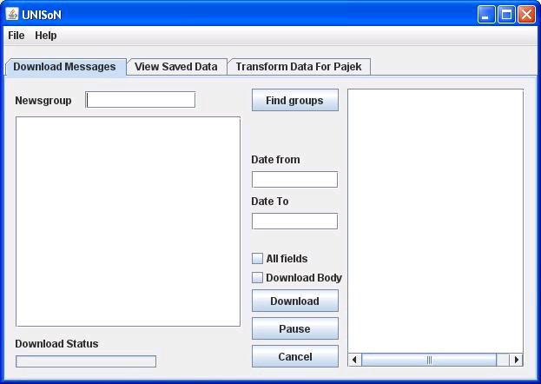

- First download messages.
You will need an active internet connection and your firewall will need to allow you access to port 119. Some intranets block this port, if so this will not work.
  - Enter a usenet group name into the field. You can use asterisk for a wild character. In this example, we look for groups with senior in the name by typing in *senior*
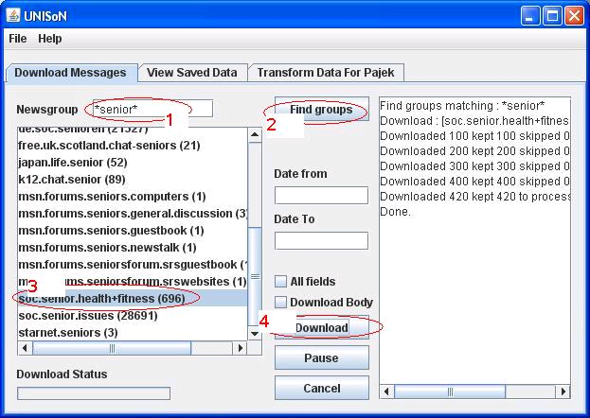
  - Click on "Find Groups" to download a list of groups matching that search string.
  - Select a group to download by clicking on it. We have selected "soc.senior.health+fitness"
  - Click on "Download". After a short while, the messages will be downloaded.
- Next, view the downloading messages by clicking on the "View Saved Data" tab and click on the "Refresh Data" button.
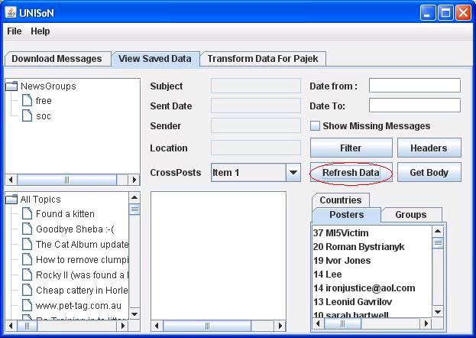
- Show the social network data by clicking on the "Transform Data for Pajek" tab and click on the "Preview" button
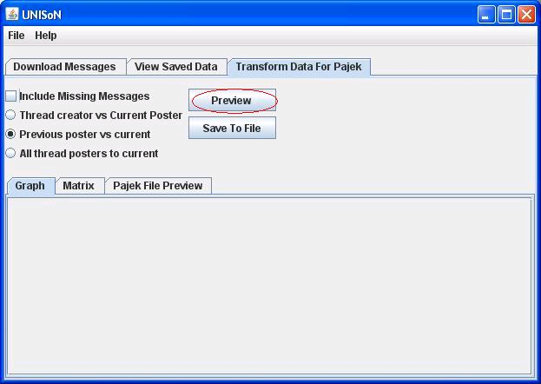
- You may need to click on the "matrix" tab and then back to the "Graph" tab to view a graph showing the network. The graph can be moved around by holding down mouse. The email address of the person is shown if you hold the pointer over the node you are interested in.
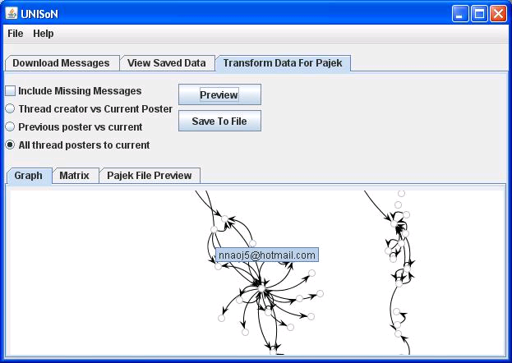

Appendix 3 – Setting up the development environment

Download Java and the code editing tools
The code is based on Java 6 - earlier versions of Java will not work. There are two IDEs (Integrated Development Environments) which are recommended: Netbeans which contains an excellent graphical design tool and Eclipse which is the world’s most popular Java IDE (Cowley 2006)

- Download Java 6 and the Netbeans IDE from http://java.sun.com/javase/downloads/index.jsp
Click on JDK 6 Update 3 with NetBeans 6.0 and follow the install instructions once it is downloaded

- Download the latest version of Eclipse from http://www.eclipse.org/downloads/
Unzip the archive folder and save to an area on your hard disk, e.g. C:\eclipse

10.2 Download or copy the java source from disk
The source code can be downloaded at http://unison.sleonard.co.uk/downloads/. Look for the latest file with the suffix unison-src. You will also need to download unison.zip, as it includes all the jar files needed for the application.
Start eclipse by clicking on the Eclipse icon in the directory where it is installed. Create a new Java project and import the code. For a tutorial on how to use Eclipse try http://www.vogella.de/articles/Eclipse/article.html , thought there are many other suitable resources on the internet.

Appendix 4 – the Pajek Network file created for

*Vertices 226
0 "Secretariat [info@pal2006.com]"
1 "SeniorARK [seniorark@aol.com]"
2 "martinsheehy [martinsheehy@gmail.com]"
3 "sewmary [nanasews@home.net]"
4 "HearMeSnore [hearme@hearmesnore.com]"
5 "cmoran [cmoran@pamedsoc.org]"
6 "Herbal4Life [johnzy1@optusnet.com]"
7 "June Phillips [jmarjorie@webtv.net]"
8 "Dennis [seniorfromcanada@hotmail.com]"
9 "Sophia Stavropoulou [dianysma@otenet.gr]"
10 "florence [florencegale1820@gmail.com]"
11 "Steve M [box1113@gmail.com]"
12 "Mike [pighealth@btconnect.com]"
13 "ironjustice@aol.com [ironjustice@aol.com]"
14 "lenlen [lptagle@gmail.com]"
15 "Fromar [fromar@bigpond.com]"
16 "Jeff [kidsdoc2000@hotmail.com]"
17 "Health & Wellness Coach [johnzy1@optusnet.com.au]"
18 "Ron Peterson [ron@shell.core.com]"
19 "adjuster [adjuster@myway.com]"
20 "BJ in Texas [bjtexas@hotmale.con]"
21 "sebastian czondi [szabolcsczondi@yahoo.com]"
22 "HearMeSnore [awake@hearmesnore.com]"
23 "yonniekr [yonniekr@webtv.net]"
24 "BUZZ2U .COM [bryregoli@webtv.net]"
25 "edwardeap [edwardeap@lantic.net]"
26 "Mike [michael.meredith@btconnect.com]"
27 "Jack W [windswept@home.net]"
28 "BU2U .INFO [lwod1@webtv.net]"
29 "Smart_book [smart_book2001@yahoo.com]"
30 "Roman Bystrianyk [rbystrianyk@gmail.com]"
31 "Wanadoo [mike.turner@wanadoo.fr]"
32 "~Peach [peachypotchy@webtv.net]"
33 "JackieMOM [JackieMOM@gmail.com]"
34 "Tom [tgliang@eskimo.com]"
35 "yagottabob [yagottabob@gmail.com]"
36 "Betsy [Betsy-Boop620@webtv.net]"
37 "mrsrrIII [mrsrrIII@webtv.net]"
38 "Matti Narkia [mna@mbnet.fi]"
39 "jnonpifi [jnonpifi@email.adr]"
40 "studyandhealth [studyandhealth@yahoo.com]"
41 "Howard McCollister [nospam@nospam.net]"
42 "slave [starshine_022@yahoo.com]"
43 "Pete [pete@nospam.net]"
44 "vjp2.at [vjp2.at@at.BioStrategist.dot.dot.com]"
45 "Peter Moran [pmoran@bordernet.com.au]"
46 "Mr. Natural-Health [johngohde@naturalhealthperspective.com]"
47 "jennifer.jakubiak [jennifer.jakubiak@gmail.com]"
48 "High Miles [2Blues17@comcast.net]"
49 "Cormac Foster [cormac@cormac.com]"
50 "michaelbflynn [michaelbflynn@gmail.com]"
51 "Pat in Atlanta [patga@comcast.net]"
52 "Sylv [Sylv772003@yahoo.com]"
53 "GoldenMan54 [DurianGoldBar@webtv.net]"
54 "Robert [sabu77@comcast.net]"
55 "phyllis collier [phyllis759@webtv.net]"
56 "Dan Mikel [dmikel1@surewest.net]"
57 "nospam [nospam@isp.com]"
58 "Starvin'Marv [marv002@hotmail.com]"
59 "AndyS [andysharpe@juno.com]"
60 "Marshall Price [d021317c@yahoo.com]"
61 "Kenneth Kraft [massageman_4ladies@webtv.net]"
62 "hanspetersen8638 [hanspetersen8638@yahoo.dk]"
63 "Leon Taylor [LeonTaylor@webtv.net]"
64 "Polish Beauty Clinic [info@polishbeautyclinic.eu]"
65 "Lee [glog@sympatico.ca]"
66 "SB [sb@no.thanks]"
67 "Gloria James [Marlanbulbrite@webtv.net]"
68 "junebug924 [junebug924@webtv.net]"
69 "Terry Shreve [a3587s@worldnet.att.net]"
70 "enjaytee [enjaytee@gmail.com]"
71 "Leona Mcguire [maggy22@webtv.net]"
72 "Ken Kraft [kenmed@webtv.net]"
73 "Bud [bud@romance.org]"
74 "Shirley ann [shirleyann2@webtv.net]"
75 "boot [carollombard@gmail.com]"
76 "nana wilson [nnaoj5@hotmail.com]"
77 "worldbuilders2002 [worldbuilders2002@hotmail.com]"
78 "FRH F.R.H. [Frack101@webtv.net]"
79 "Gordon [gordonmuir2003google@yahoo.com]"
80 "babawali [babawali@world.com]"
81 "CrazyAsALoon [mentalillness@psycho.com]"
82 "Glen Davis [GADavis777@graceba.net]"
83 "Joe Doe [None@mail.utexas.edu]"
84 "Hougan [ghougan@yahoo.com]"
85 "Jacqueline Stigman at www.tpoth.com & www.cafepress.com/tpoth [PowerOfTheHeart@aol.com]"
86 "Steve [hawke@nym.komite.net]"
87 "WP [nothnx@nospam.com]"
88 "kristina [cheermailer@gmail.com]"
89 "Dick Monahan [dick@dickmonahan.com]"
90 "lobo [lobo@lobo.com]"
91 "julia999 [juliajensen888@yahoo.com]"
92 "highnoone [highnoone@webtv.net]"
93 "Joe [joe-homebiz@yahoo.com]"
94 "Out There [captainstardust@webtv.net]"
95 "joan [joan@adeqres.po.my]"
96 "VisualDxHealth [VisualDxHealth@gmail.com]"
97 "IanW [whoami@whereami.net]"
98 "Vernon [anere@anhere]"
99 "IanW [whoami@whereami.com]"
100 "Bert Hyman [bert@iphouse.com]"
101 "Willy Skass [dinner@ate.org]"
102 "oxyaman [oxyaman@atmosphere.com]"
103 "R P [vn1500@webtv.net]"
104 "godani [payal.maheshwari@netlinkis.com]"
105 "Rita [nitany_98@yahoo.com]"
106 "naveenkumar8585 [naveenkumar8585@gmail.com]"
107 "Les [cowelch@sbcglobal.net]"
108 "Scott [scott@scotthughes.biz]"
109 "Chris Beckett [chris.beckett50@ntlworld.com]"
110 "Coleman E. Howard [cehowardrx7@netzero.net]"
111 "G.fried [noname@invalider.invalid]"
112 "Tom Miller [torpeau@mac.com]"
113 "vernon [here@there]"
114 "GeorgeWashingtonAdmirer [GeorgeWashingtonAdmirer@RuleOfLaw.net]"
115 "Pat Evans [PatEvans447@webtv.net]"
116 "rmkeller@comcast.net [rmkeller@comcast.net]"
117 "chet [chet@epix.net]"
118 "goran [goran_nMAKNIOVO@net4u.hr]"
119 "dimis [info@ceosec.com]"
120 "toci [gina39d@yahoo.com]"
121 "quelab22 [raquel_b22@hotmail.com]"
122 "Allen Teal [allenteal@centurytel.net]"
123 "klibros [klibros10@yahoo.com]"
124 "selig [alfonso@padosan.nz]"
125 "Stuart [stuartpitt7878@hotmail.com]"
126 "gremlin12 [patc19523@hotmail.com]"
127 "Paul [PaulRFowler@gmail.com]"
128 "yota [sssikes@msn.com]"
129 "chandler [strickle@celinda.uk]"
130 "mahsie.oss [mahsie.oss@gmail.com]"
131 "norak [k.norak@gmail.com]"
132 "AntMasters [AntMasters@gmail.com]"
133 "Edwin Chew [export@salesnet.com.my]"
134 "Uplifter [mint@intel.net]"
135 "MI5Victim [MI5Victim@mi5.gov.uk]"
136 "hankr [hankr@msn.com]"
137 "Tim Silva [Tim.Silva2@gmail.com]"
138 "ronald loranger [bengie@sympatico.ca]"
139 "healthwriter [dadalby@yahoo.com]"
140 "gifer [gifer@comcast.net]"
141 "Henry [Henryindivideo@webtv.net]"
142 "Dottie [Dorot29701@aol.com]"
143 "JOY [JFH333@webtv.net]"
144 "fleming [GTELabs@postable.uk]"
145 "Ken Young [kennethyoung@bellsouth.net]"
146 "kaash [kashifraza.tbm@gmail.com]"
147 "sryan [sryan@oise.utoronto.ca]"
148 "Kenneth Kraft [elvisrocks_today@webtv.net]"
149 "chiron [Chiron@chiron-communications.com]"
150 "sanwan [kejiyuanqu@gmail.com]"
151 "Jonine [jonine@earthlink.net]"
152 "G RH [G R H @sbcglobal.net]"
153 "smv_sg [smv_sg@yahoo.com]"
154 "JOHN R KOBYLARZ [KOBYJR@webtv.net]"
155 "Twittering One [mournenwould@aol.com]"
156 "ProfHenryHiggins [lycquan@hotmail.com]"
157 "William Rose [rosefam@sonic.net]"
158 "jstanley98 [jstanley98@austin.rr.com]"
159 "Elio Valarezo [valarezo@netzero.com]"
160 "jecho [zymomin@iandoli.org]"
161 "Mooshee.com: Knowledge is Health! [news@mooshee.net]"
162 "i.am [i.am@contrarytoordinary.com]"
163 "Leonid Gavrilov [longevity.science@gmail.com]"
164 "Niall [niall2006@katamail.com]"
165 "nucleus [rose122550@yahoo.com]"
166 "Spammers_Should_Be_Shot [NoSpam@MyEmail.com]"
167 "Howard and Hope [hopehowie@webtv.net]"
168 "todayssr [todayssenior@gmail.com]"
169 "Bongo Jim [bongojim@aol.com]"
170 "Niall [niall206@katamail.com]"
171 "fede.gabon [fede.gabon@gmail.com]"
172 "MMcG [belfast@ix.netcom.com]"
173 "Dave in Lake Villa [DaveInLakeVilla@webtv.net]"
174 "press [press@neo-call.it]"
175 "ArtIdeas [ArtIdeas@webtv.net]"
176 "info [info@agoldpalace.com]"
177 "tully.lanter [tully.lanter@gmail.com]"
178 "Yesterdays Wafflez [YesterdaysWafflez@webtv.net]"
179 "Jean Smith [gotermite@yahoo.com]"
180 "Phii [rajeshdiwakar03@yahoo.com]"
181 "thesak [don.saklad@gmail.com]"
182 "FDA [FDA@optonline.net]"
183 "worldbiz4u@gmail.com [worldbiz4u@gmail.com]"
184 "supernews [supernews@soc.senior.health+fitness]"
185 "William SCHEK [MONJIRO_7@webtv.net]"
186 "bob fusillo [rfusillo@comcast.net]"
187 "Reggie [Reggie501@optonline.net]"
188 "Don Saklad [dsaklad@nestle.csail.mit.edu]"
189 "vicki2000 [vicki2000@gmail.com]"
190 "judith.lea@googlemail.com [judith.lea99@googlemail.com]"
191 "John Carmen [JandC805@webtv.net]"
192 "geethu [geethakarunakaran@yahoo.com]"
193 "michael3902 [michael3902@sbcglobal.net]"
194 "watcher [watcher@moog.netaxs.com]"
195 "honeybunch [doro_iams@yahoo.com]"
196 "jingles [mommabear@mail.com]"
197 "kutti [sarvan002@gmail.com]"
198 "Charlie Allen [Richard066@webtv.net]"
199 "gile [draganve@gmail.com]"
200 "My Bad [earthtoBill@webtv.net]"
201 "moondog [moondog@Nospam.net]"
202 "Bob M [molab@ww.co.nz]"
203 "Juhana Harju [nope@mail.fi]"
204 "Ivan Goh [ivangoh@hotmail.com]"
205 "health-biz [health_biz@hotmail.com]"
206 "gerd-lpr [healthy_one@hotmail.com]"
207 "Richelle [richelle_honeycutt@yahoo.com]"
208 "NormaK [njb904@charter.net]"
209 "Marko [marko@gmnet.com]"
210 "McFerg [cbferg801@att.net]"
211 "gopplc [gopplc@gmail.com]"
212 "Info [info@nwfirst.com]"
213 "MargoRosenbach [MargoRosenbach@hotmail.com]"
214 "jennyjenny [meetjennyjenny@gmail.com]"
215 "Kindrick Ownby [kownby@sonic.net]"
216 "aliana.scherer@gmail.com [aliana.scherer@gmail.com]"
217 "cvb222 [cvb222@nyu.edu]"
218 "jj206 [jj206@remoooooooooooovethisdrizzle.com]"
219 "Freedom [jorma.persson@gmail.com]"
220 "Geezerguy [jonhansen44@comcast.net]"
221 "Weight Loss [louie10_nospam@charter.net]"
222 "healthwriter [david.dalby@googlemail.com]"
223 "louie10_noSpam [louie10_noSpam@charter.net]"
224 "Luan Pham [louieph@charter.net.net]"
225 "fitness [fitness@BlissGym.com]"
*Edges
7 5 1
16 15 1
20 19 1
23 15 1
33 32 1
34 32 1
38 13 1
41 42 1
43 42 1
44 42 1
45 30 1
46 42 1
47 13 1
13 13 3
48 13 2
49 27 1
51 13 1
18 13 2
52 13 2
53 54 1
55 53 1
57 56 1
58 56 2
59 56 1
34 57 1
60 13 1
62 50 1
65 66 1
65 63 1
65 50 1
65 67 1
65 68 1
70 67 1
71 70 1
71 68 1
71 65 1
72 72 1
73 13 1
74 68 1
75 68 1
75 50 1
65 76 1
74 78 1
79 79 1
80 13 1
81 79 1
65 82 1
83 78 1
65 84 1
78 74 1
78 83 1
65 86 1
54 42 1
65 92 1
74 90 1
97 13 3
98 13 3
99 13 1
65 101 2
101 101 1
102 13 1
103 65 2
65 65 1
105 101 1
110 101 1
112 90 1
113 13 1
117 110 1
120 30 1
123 30 1
127 125 1
132 131 1
142 140 1
110 110 1
110 117 1
148 72 1
152 79 1
154 151 1
155 30 4
156 151 1
157 30 3
163 163 6
166 165 1
165 165 1
171 165 1
157 169 1
173 169 1
74 172 1
100 175 1
18 30 1
178 100 1
179 163 1
190 163 4
191 74 1
194 193 1
195 193 1
196 163 2
202 30 1
203 30 2
208 163 1
65 215 1
100 200 1
218 198 1
215 215 1

Project Definition
Project Definition for MSc in Business Systems Analysis & Design

Name: Stephen Thomas Leonard
E-mail address: abbh224@city.ac.uk or steve@sleonard.co.uk
Contact phone number: 0776655 1575
Project Title: Evaluating sociability in on-line discussion boards
Supervisor: Dr Panayiotis Zaphiris

1. Introduction
What is Social Network Analysis (SNA)?
A Social Network is a way of taking the relationships between various people and modelling them based on the interactions they have with each other. Essentially, each person (known as an actor or node in the network) is linked to some and probably not all the other people in the network and each pair can have different types of relationship to each other and to other people. Ideally we would need to collect data on all the relationships between all the actors in order to get an accurate picture of the interactions within the group. Accordingly, this involves collecting a potentially huge amount of information. The analysis of these networks is made possible using mathematical tools and computer software to visualise the results as graphs (Hanneman & Riddle 2005) .

2. Problem Definition
An earlier study at City University (Zaphiris & Sarwar 2006) had used SNA techniques to study two on-line discussion groups, soc.senior.issues (soc.senior.issues : Google Groups 2007), and alt.teens (alt.teens : Google Groups 2007), both UseNet groups. They had used manual data collection techniques and as a result had had to limit their study to 200 messages from each discussion board.
Since the message population is was very large (over 15,000 for soc.senior.issues and 50,000 in the case of alt.teens), the sample of 200 forced the study to follow an ego-centred analysis where the interactions around one individual are studied, rather than the whole population. (Zaphiris & Sarwar 2006). By automating the data collection process a study of the whole population and other on-line groups should be made much more feasible. Automation of this process would free up time for higher level analysis and allow for more valid conclusions.

3. Project Description

3.1. Objectives
The overall aim of this project is to develop a software tool to automate the collection of data from Google newsgroups and transform it to a format that the SNA tool used by the HCI department can understand. In order to achieve this, there will the following milestones:
- Create the data collection tool. This has 3 sub-stages :
  - Develop a means to collect data from the on-line discussion boards, perhaps using the Google open source code libraries available ( #REF).
  - Store the data in a medium accessible by both the HCI researchers and by me, perhaps a university supplied database, or one local to the person running the software
  - Expand the tool to allow the filtering of data and creation of input files for the chosen SNA modelling tool, i.e NetMiner
- Evaluate the tool by using it to collect data from the earlier City University study (Zaphiris & Sarwar 2006) , i.e. From alt.seniors and alt.teens compare results to original paper.
- Study another on-line group using the tool, perhaps MS
- Optional milestones (depending on how project progresses) would be to expand the tool to gather quantitative data to get a semantic sense of the messages. This may be too complicated, and will rely on getting rules from the HCI team which can then be automated. The study of Dunbar's Number (where social groups have a natural limit of 150) could also be studied.

3.2. Beneficiaries
The tool is being written for the benefit of SNA researchers at City University, specifically for Dr Panayiotis Zaphiris and his team, though if it proves successful, this may be given to other teams to use.

3.3. Risk Analysis including Ethical Considerations
The main issue is getting data from the web site, without this, there can be no project. Initial research shows that there is a certain amount of open-source code available for reading RSS feeds, and since these discussion groups can be provided as RSS, then this should not prove to be a problem.
The next issue is technical, and concerns whether or not a suitable database can be found for the tool. If City University cannot provide this, MySQL databases are available at http://sleonard.co.uk.
The third issue is identification of the correct metrics for the SNA. All the data from the source bulletin board messages will be stored so that after consultation with Dr Zaphiris, he can be supplied with only the information he needs.
Another potential area of concern is user expectation management (Rogers p283). The tool that should be intuitive yet feature rich. It will be built in stages, implementing functionality in order of priority.
The data being used in on-line but its use may be limited. For Google data, permission may need to be given to use the data (Google Groups Terms of Service 2007). Permission has been requested.

Methods and tools
There are 2 key stages to this project: the development of the tool, and its use in analysing some on-line groups.
For the design and code stage, either the Rapid applications development or Spiral life cycle (Rogers et al. 2002) will be used. In either case, the design and build of the application is iterative and encourages user interaction. As the progress of the tool will be determined partly by technical factors and partly by the needs of the SNA researchers
This will be conducted by informal meetings, brainstorming sessions , perhaps on-line discussions, and observations following the principles of Contextual Design (Rogers et al. 2002). Google’s open source software (gdata-java-client : Gdata Java Client Library 2007) may be used.
For the second stage, where the tool will be used for data collection and analysis, an empirical, experimental research methodology (Hart 2005) will be followed. As much data as possible will be collected to try to show the increasing confidence of data as expand from original 400 messages to 15,000 in an attempt to validate original paper assumptions on sample size. Techniques used for researching “Virtual Phenomena” (Hart 2005) may be used.

Evaluation methods
The evaluation of the tool will be part of the data collection process. It should provide files that can be loaded into Net Miner and yield similar results to those determined by manual data collection methods by Zaphiris and Sarwar.

Work Plan
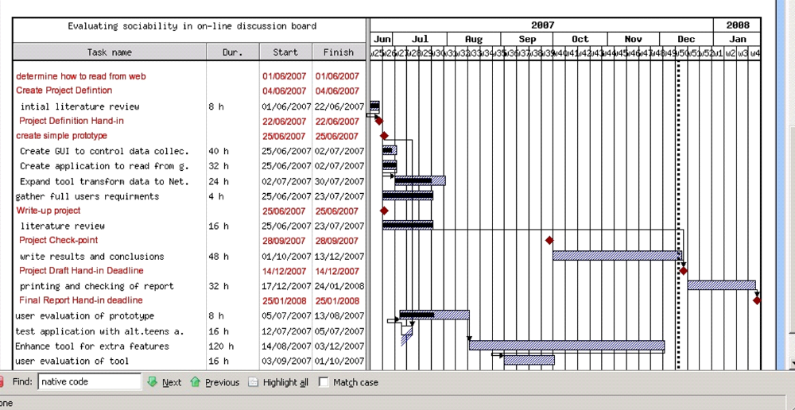

Project Feasibility

7.1. Experience
I have over 7 years experience as a computer programmer mostly in investment banks and have developed and supported various data feeds. I have used various programming technologies which may be used in the project, including Java, XML, SQL.

7.2. Resources
I have several computers at home, including 2 dual-boot Linux/Windows desktop machines and one Linux based laptop. I will discuss with Dr Zaphiris what resources he wants to use to store the research data when it becomes available, though I expect I would be able to use a MySQL database server from the school of Informatics, as one was made available for an earlier coursework.

References
Hart, C (2005) “Doing Your Masters Dissertation”, SAGE Publications Ltd, London
Zaphiris, P., Sarwar, R. (2006) Trends, Similarities and Differences in the Usage of Teen and Senior Public Online Newsgroups. ACM Transactions on Computer-Human Interaction (TOCHI), ACM Press, Vol.13 , Issue 3, pp 403 – 422
Hanneman, R. A. , Riddle, M (2005) Social Network Analysis Primer : Why Formal Methods? Retrieved 20 June 2007 from http://faculty.ucr.edu/~hanneman/nettext/C2_Formal_Methods.html
gdata-java-client : Gdata Java Client Library (2007), Retrieved 20 June 2007 from http://code.google.com/p/gdata-java-client/
Discussions – soc.senior.issues : Google Groups (2007), Retrieved 20 June 2007 from http://groups.google.com/group/soc.senior.issues/topics
Discussions – alt.teens: Google Groups (2007), Retrieved 20 June 2007 from http://groups.google.com/group/alt.teens/topics
Google Groups Terms of Service (2007), Retrieved 20 June 2007 from http://www.google.com/googlegroups/terms_of_service.html
Rogers, Y; Sharp, H; Preece, J; (2002), “Interaction Design : beyond human-computer interaction”, Wiley, New York
Wikipedia: The Free Encyclopedia, “Dunbar’s number”.. 20 October 2006, <http://en.wikipedia.org/wiki/Dunbar’s_number>.

Endorsement
I have read the relevant project scheme and agree to ensure fulfilment of all academic
Supervisor responsibilities for the project outlined above:

_____________________ ______________ ____________
Signature Name Date

_____________________ ____________________________
Department Email Address

