SCOUTING SYSTEM REPORT: A FULL OVERHAUL
A mentor-facing explanation of the changes, the math, and the reason behind each design decision
What this report is: This report will detail what changes I made and why. I am not trying to say “look, I added a lot of buttons.” I am trying to explain the scouting problems we actually face at events, the logic behind the solutions, and how the new system helps us make better match strategy and alliance-selection decisions.

The questions that drove the rebuild
- How do we calculate defense, when defense usually does not show up directly in a robot’s own score? The core logic is: We need to know how many points the team knocked off the other side, but how can we know how many points the defended team would’ve gotten?
- How do we tell the difference between a team that is truly strong and a team that only had one great match? This is the problem of normal OPR. A single match could bring a team up by a lot.
- How do we predict upcoming matches without blindly trusting one model like OPR, EPA, or our own scouting average? Or in other words, which do we trust more/how do we combine them?
- How do we catch missing or wrong scouting data before it becomes a bad strategy call? This is about catching anomalies.
- How do we keep scouting data safe when Firebase, TBA, or event Wi-Fi fails? We need data backups.
- How do we make scouts care enough to collect better data all day? We don’t want scouting to be “Boring” or for the “Leftovers”. We want it to be fun and we want team members to look forward to scouting.
- How do we turn scouting into a real alliance-selection tool instead of just a table of numbers? With different alliances, different stances, and under different conditions, alliance selection strategies are entirely different. Can we use code to help us make the actually logical decisions?
The changes below are my answers to those questions.

1. Defense has to be measured as points denied
The first big problem is defense. If a defensive robot does its job well, it may not score many points itself. That makes it look weak in a normal point-count system, even though it may have changed the match. So I changed the scouting logic to record not only what our robot scored, but also who defended, who they defended, how intense the defense was, and what happened to the target team’s output.
ExpectedOutput(team, match) = model estimate before the match
ActualOutput(team, match) = observed or calibrated output after the match
DefenseDenied(defender → target, match) = confidence × max(0, ExpectedOutput − ActualOutput)
DefenseImpact(defender) = Σ DefenseDenied(defender → target, match) across matches

This matters because it lets us treat defense as something real: points removed from the opponent, not just a comment like “played good defense.” DPR(the Defensive Power Rating stat from TBA) stays separate because DPR is official-score-derived and lower is better; scouting-based Defense Impact is about the specific defender-target relationship we observed.
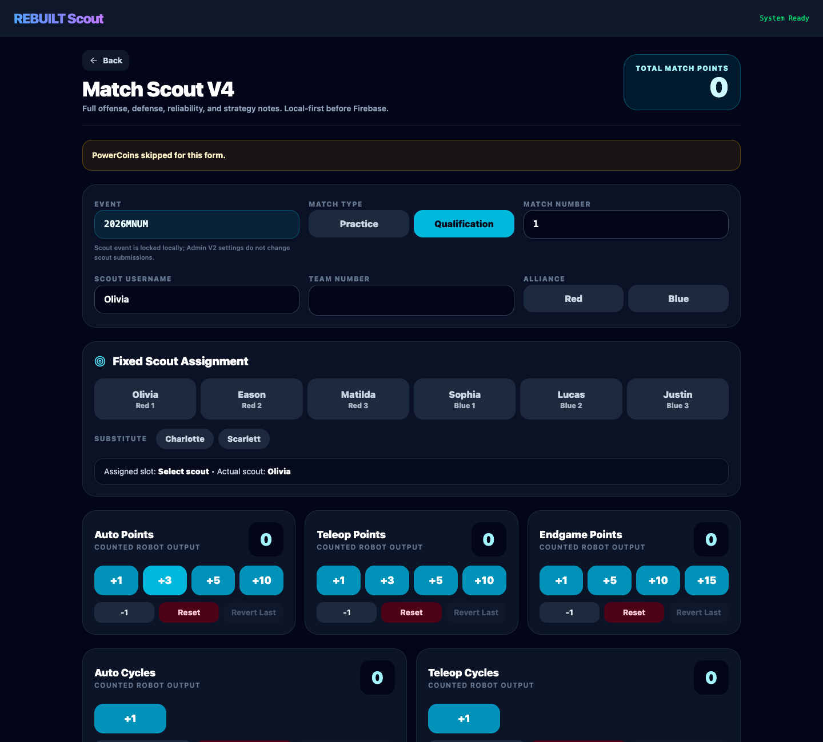
V4 scout form with fixed scout buttons, local-first wording, PowerCoins, and point counters.

2. Averages are not enough; we need curves, floors, peaks, and volatility
A team’s average score is useful, but it can lie. A team with scores 20, 20, 20 is very different from a team with 0, 0, 60, even though the average is the same. For alliance selection, especially from different seeds, that difference is huge. High seeds usually want reliability. Low seeds may need upset potential.
Average μ = (1/n) Σ xᵢ
StandardDeviation σ = sqrt((1/n) Σ (xᵢ − μ)²)
Reliability ≈ high floor + low σ
UpsetPotential ≈ high peak + high ceiling, even if σ is larger
Trend(t) = fitted curve over time, not just one event-wide average

That is why Team Profiles now include peak score, floor score, average, standard deviation, recent trend, projected next score, normal-style distribution views, and model curves. The point is not to worship a complicated model. The point is to ask: is this team stable, improving, declining, risky, or secretly dangerous?

3. Prediction should be model-aware, not model-blind
We now have three main scoring lenses in Admin V2: PPC, OPR, and EPA (PPC is our own scouting-based Powerhouse Point Count). OPR is official-score-based, especially strong when uploaded COPR data exists. EPA is Statbotics, which gives an external prior. I changed the UI so PPC, OPR, and EPA are global model buttons instead of separate prediction tabs.
PPC(team) = average scouted total match points for that team
AllianceScore(model) = Σ Rating_model(team) for the teams on that alliance
PredictedWinner = red if Score_red > Score_blue, blue if Score_blue > Score_red, otherwise tie
Component model: cPPC, cOPR, cEPA = Auto + Teleop components when the source can provide them cleanly

The important design decision is that the prediction task is now separate from the rating model. “Ranking Prediction,” “Quals Prediction,” and “Finals Prediction” are the questions. PPC, OPR, and EPA are the scoring lenses used to answer them.
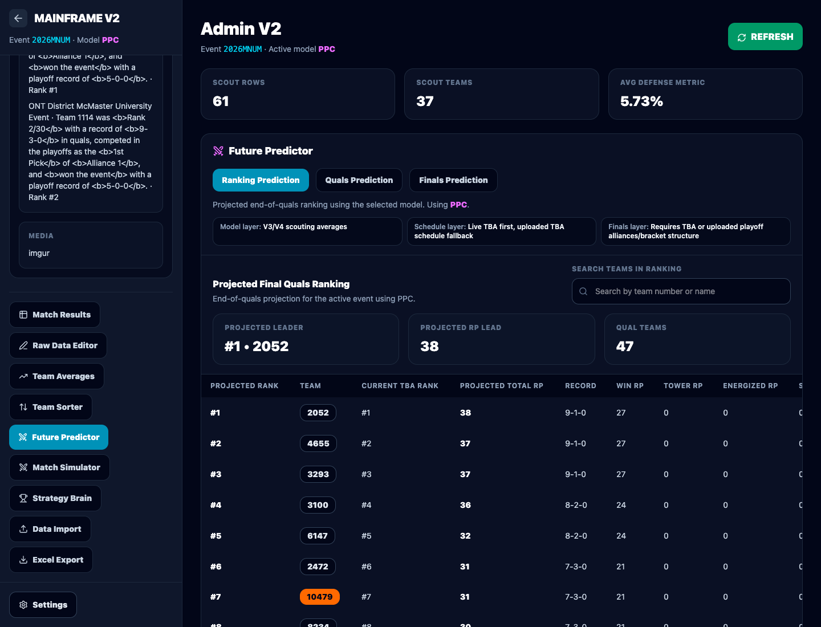
Admin V2 Future Predictor with model selection, projected ranking, and team highlighting.

4. Missing data must be visible before it becomes strategy
Another major problem is that a spreadsheet full of data can still hide the most dangerous thing: missing or wrong data. A missing scouting row is obvious only if the system knows what should have existed. So the Raw Data Editor now compares the schedule’s expected six slots against actual scouting records.
ExpectedSlots(match) = {Red1, Red2, Red3, Blue1, Blue2, Blue3}
MissingSlots(match) = ExpectedSlots − PresentSlots
WrongTeamForSlot if scheduledTeam(slot) ≠ submittedTeam
ScoutMismatch if scoutName ≠ assignedScoutName and scoutName ≠ substituteScoutName

This is why the Raw Data Editor groups by match and shows missing Red/Blue station rows directly. It also flags wrong team for slot, scout assignment mismatch, substitute mismatch, unexpected team, and duplicate record. The goal is simple: catch bad data before it can poison predictions.
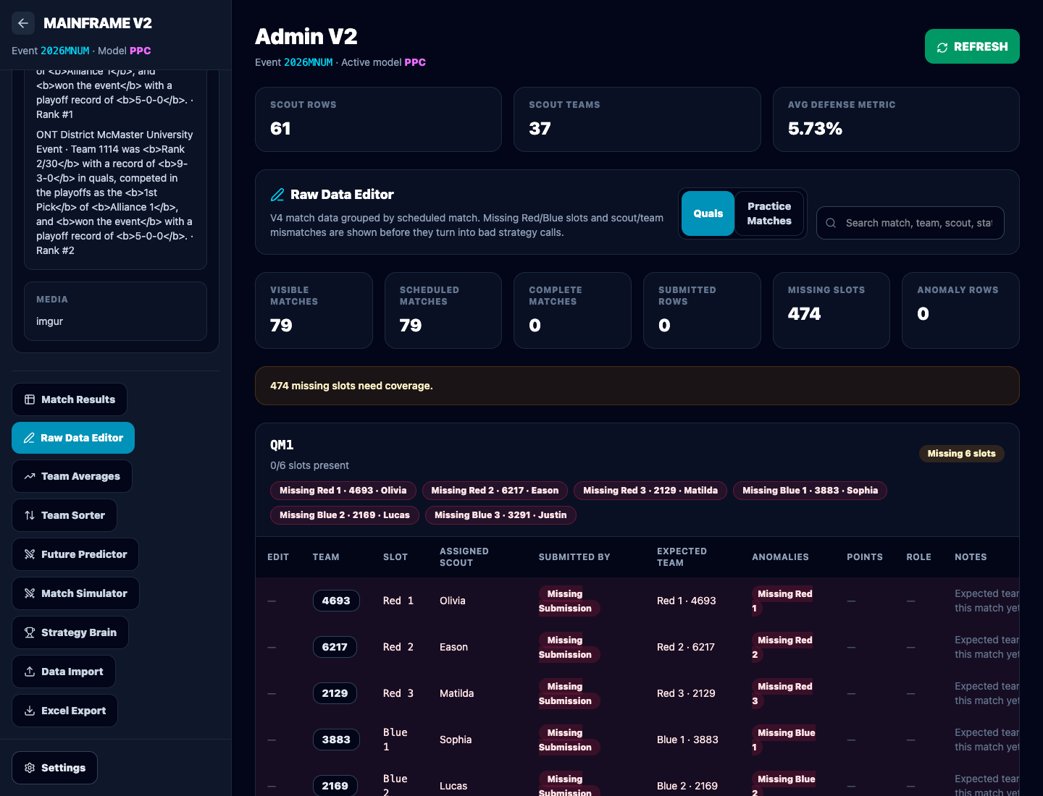
Raw Data Editor showing missing match slots before the data enters strategy decisions.

5. Data safety has to come before Firebase
At an event, the internet is not trustworthy. Firebase can fail. TBA can fail. Statbotics can fail. QR scans can be repeated. Scouts can send the same JSON file five times. So I changed the system around one rule: a scout submission is successful locally first, then Firebase is attempted second.
SubmitFlow = normalize → save IndexedDB → mark pending_sync → attempt Firebase → mark synced or unsynced
ExactDuplicate = same logical document + same substantive data, ignoring timestamp/deviceId/editHistory
Conflict = same logical document + different substantive data
Rule: duplicate is skipped; conflict is preserved and reported; no silent overwrite

This also explains the new Data Import and Source Freshness views. Admin V2 can take QR, JSON, TBA CSV, TBA JSON, cached FIRST/TBA/Statbotics data, and local backups. It reports what is fresh, what is cached, what is missing, and what failed.
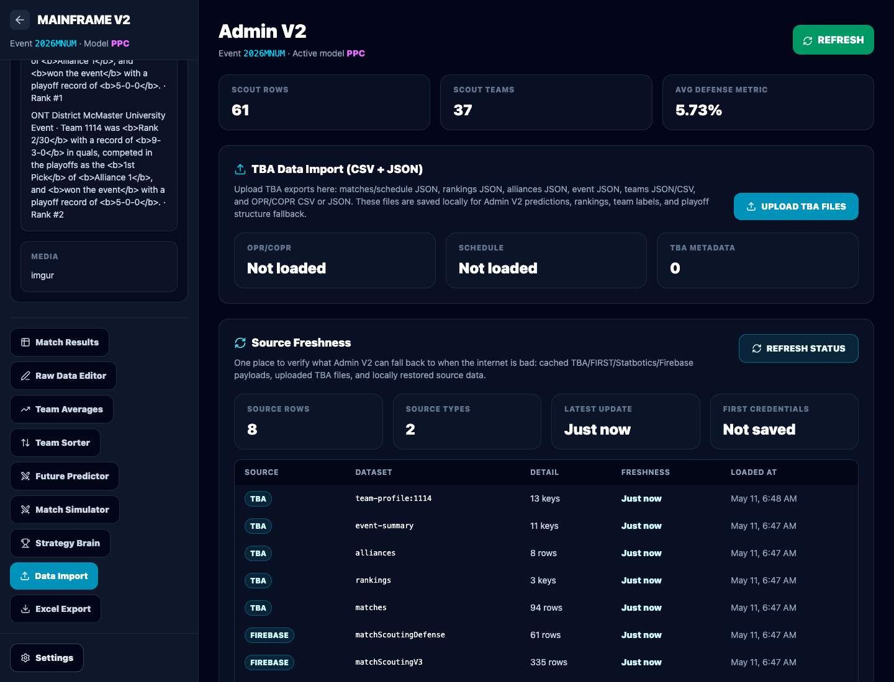
Data Import and Source Freshness board for QR, JSON, TBA files, and cached API data.

6. Scouting should be fun enough that scouts stay awake
One of the most important non-math problems is motivation. If scouting feels like punishment, the data gets worse. So I added PowerCoins: scouts can place optional fake-money bets before scouting a match, and Admin V2 can settle those bets from official results. This is not gambling for money; it is a game layer to make scouts pay attention to the match. Also, the top 3 scouts on the leaderboard get to eat McDonald’s, on me.
StartingBalance(scout, event) = 1000 PowerCoins
If result is tie/unknown: refund stake
If scout picks winner: payout = stake + proportional share of losing-side pool
Better attention → better scouting → better strategy

The other scout-ops idea is repeated exposure. The assignment optimizer tries to make each scout watch fewer different teams more times, instead of randomly switching every match. That way each scout develops a real feel for their assigned teams, which matters during strategy discussions.

7. Alliance selection needs different logic depending on seed
Alliance 1 and Alliance 8 should not use the same pick-list logic. A top seed can often win by choosing reliability: high average, high floor, low variance, and good role fit. A low seed may need a team with a huge ceiling, even if that team is volatile. That is why the new Strategy Brain includes seed-aware alliance selection.
PickScore(seed, team) = w_avg(seed)·Average + w_floor(seed)·Floor + w_peak(seed)·Peak
+ w_def(seed)·DefenseImpact − w_vol(seed)·StandardDeviation
High seed: w_floor and w_avg increase
Low seed: w_peak and upset potential increase

The pick list can also mark teams as picked, declined, unavailable, or still available, then recalculate. This is important because alliance selection is dynamic. A good list before the first pick is not enough; the list needs to react live.
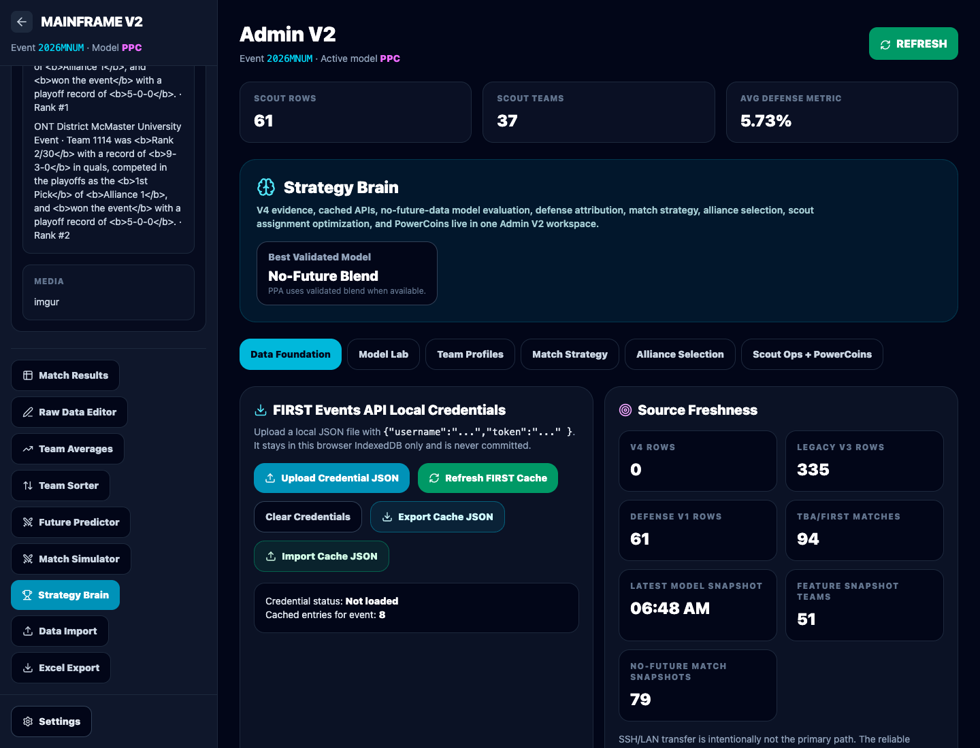
Strategy Brain showing source cache, model lab entry, scout ops, and PowerCoins.

8. The main changes I made, in plain English
Area | What I changed | Why I changed it
Scout form | Built the active V4 scout flow with fixed scout buttons, substitutes, offense/defense/reliability fields, PowerCoins gate, QR export, edit mode, and local-first saving. | To collect richer evidence while preventing data loss when internet fails.
Admin V2 | Moved Admin V2 toward a command center: settings gear, event controls, own-team highlighting, global model buttons, global team search, sticky spreadsheet headers, and source freshness. | To make admin work faster and reduce mistakes during live competition.
Prediction | Changed the predictor from PPC/EPA/OPR subtabs into Ranking Prediction, Quals Prediction, and Finals Prediction, all using the selected global model. | To separate the question we are asking from the model we use to answer it.
Data quality | Made raw data match-sorted, schedule-aware, and able to show missing slots and mismatch badges. | To reveal missing or wrong data before strategy depends on it.
Import/export | Added QR/JSON import staging, TBA CSV/JSON imports, local backups, source freshness, and one multi-sheet Excel export. | To make the system survive bad Wi-Fi and preserve evidence for review.
Strategy Brain | Added Model Lab, team profiles, defense attribution, match strategy, alliance selection, scout ops, and PowerCoins tools. | To turn scouting data into decisions, not just storage.

9. What I would tell my mentor directly
I rebuilt the system because scouting should answer competition questions, not just collect rows. We need to know who is improving, who is reliable, who has upset potential, who plays real defense, whether our data is missing, and which model we should trust right now.
The math does not need to be flashy to be powerful. The important part is that each model has a reason: PPC tells us what our scouts directly observed, OPR tells us what official scores imply, EPA gives us an external prior, DPR separates official defensive rating, and Defense Impact tries to measure points denied from actual defender-target observations.
The bigger idea is that scouting becomes a feedback loop: collect data, protect it, audit it, model it, test the model, use it for strategy, and then collect better data next match. That is the direction I want this system to move in.

