DBSchema – Community Cleanup Tracker
MongoDB Group Assignment – Part 1: Database Schema Design
Group 5: Edouard Dupuch, Leonart Heurteux, Brice Laurent, Mael Mangata
City: Dublin Database: cleanupDB

1. What our database does
Dublin City Council wants to organise community cleanups. Our database keeps track of two things:
- cleanupEvents – each cleanup operation: where and when it happens, who organises it, who comes, and how many kilos of each waste type were collected.
- volunteers – the people who take part: contact details, skills, hours volunteered and the events they attended.
With this data the council can answer questions like “How many kilos of plastic did we collect this year?” or “Which zones need more cleanups?”.

2. Schema diagram
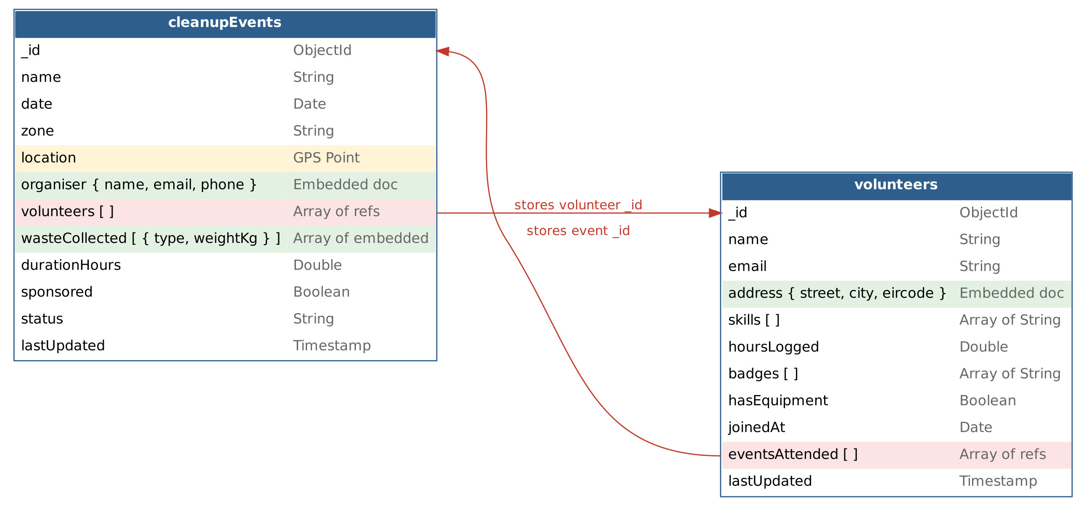
Colour key: green = embedded (denormalised) pink = reference (normalised) yellow = GPS location
The red arrows show the link between the two collections: an event stores the _id of its volunteers, and a volunteer stores the _id of the events they attended.

3. Collection 1: cleanupEvents
Field | Data type | What it stores
_id | ObjectId | Unique ID, created automatically by MongoDB
name | String | Name of the cleanup, e.g. "Phoenix Park Litter Pick"
date | Date | Day and time of the cleanup
zone | String | Dublin area, e.g. "Dublin 8"
location | GPS location (GeoJSON Point) | Exact meeting point: { type: "Point", coordinates: [longitude, latitude] }
organiser | Embedded document | { name, email, phone } of the person running the event
volunteers | Array of ObjectId (references) | List of _id values from the volunteers collection
wasteCollected | Array of embedded documents | One entry per waste type: { type: String, weightKg: Double }
durationHours | Double | How long the cleanup lasted, e.g. 2.5
sponsored | Boolean | true if a company sponsors the event
status | String | "planned", "completed" or "cancelled"
lastUpdated | Timestamp | When the document was last changed

Example document
{
name: "Phoenix Park Litter Pick",
date: ISODate("2026-10-04T10:00:00Z"),
zone: "Dublin 8",
location: { type: "Point", coordinates: [-6.3298, 53.3559] },
organiser: { name: "Aoife Byrne", email: "aoife@dcc.ie",
phone: "0871234567" },
volunteers: [ ObjectId("..."), ObjectId("...") ],
wasteCollected: [
{ type: "plastic", weightKg: 18.5 },
{ type: "glass", weightKg: 7.2 }
],
durationHours: 2.5,
sponsored: true,
status: "completed",
lastUpdated: Timestamp()
}

4. Collection 2: volunteers
Field | Data type | What it stores
_id | ObjectId | Unique ID, created automatically by MongoDB
name | String | Full name of the volunteer
email | String | Contact email
address | Embedded document | { street, city, eircode }
skills | Array of String | e.g. ["first aid", "driving"]
hoursLogged | Double | Total hours volunteered, e.g. 12.5
badges | Array of String | Rewards earned, e.g. ["First Cleanup", "10 Hours"]
hasEquipment | Boolean | true if they bring their own gloves / picker
joinedAt | Date | Date they signed up
eventsAttended | Array of ObjectId (references) | List of _id values from the cleanupEvents collection
lastUpdated | Timestamp | When the document was last changed

Example document
{
name: "Sean Murphy",
email: "sean.murphy@gmail.com",
address: { street: "12 Thomas St", city: "Dublin",
eircode: "D08 X2Y3" },
skills: [ "first aid", "driving" ],
hoursLogged: 12.5,
badges: [ "First Cleanup", "10 Hours" ],
hasEquipment: true,
joinedAt: ISODate("2025-03-15T00:00:00Z"),
eventsAttended: [ ObjectId("..."), ObjectId("...") ],
lastUpdated: Timestamp()
}

5. Data types used
The assignment asks for varied data types. Here is where each one appears:
- String: name, zone, status, email
- Boolean: sponsored, hasEquipment
- Double: durationHours, weightKg, hoursLogged
- Date: date, joinedAt
- Timestamp: lastUpdated (both collections)
- GPS location: location (GeoJSON Point, so we can search for cleanups near a place)
- Embedded document: organiser, address, and each item of wasteCollected
- Array: skills, badges, wasteCollected, volunteers, eventsAttended
- ObjectId: _id, and the references between the two collections

6. Why we designed it this way
In MongoDB we can either put data inside a document (embedding) or store only an ID that points to another document (referencing). We used both, depending on the data.

Embedded documents (denormalisation)
We embed data when it belongs to only one document and is always read with it:
- organiser – we always want to see who runs the event when we open it, and the organiser details are short. No need for a separate collection.
- wasteCollected – the waste amounts only make sense for that one event. Keeping them inside the event makes it easy to calculate the total weight per waste type with one aggregation.
- address – a volunteer has one address and it is never shared with another document.
Advantage: one query returns everything we need, so reading is fast and simple.

References (normalisation)
Volunteers and events have a many-to-many relationship: one event has many volunteers, and one volunteer goes to many events. If we copied the full volunteer inside every event, the same person would be repeated many times, and changing their email would mean updating every event.
So instead each event keeps a list of volunteer _id values (volunteers), and each volunteer keeps a list of event _id values (eventsAttended). The volunteer’s details are stored only once.
Advantage: no duplicated data, easy updates. When we need the full details we join the two collections with $lookup.

Summary
- Small data that belongs to one document → embedded
- Data shared between many documents (many-to-many) → referenced

