a. Architectural Characteristics
 | Characteristic
Availability | The system must be available 24/7 for customers and experts to submit and track tickets.
Scalability | The system must handle spikes in ticket volume and user access during high-demand periods.
Reliability / Fault Tolerance | The system should continue operating even when one microservice or component fails.
Performance | Responses (ticket creation, assignment, updates) must happen within seconds.
Modifiability / Maintainability | The system should support frequent changes without affecting other components.
Security | Authentication and authorization for customers, experts, and admins; secure payments and personal data.
Auditability | All ticket updates, assignments, and billing transactions should be logged.
Usability | Web and mobile apps must be user-friendly for both customers and Sysops experts.
Interoperability | Integration with SMS, email notification, and payment systems.

b. Scenarios per Characteristic
Characteristic | Scenario
Availability | If one microservice fails (ex. Notification Service), others like Ticket or Expert Service should continue running; retry mechanism for notifications.
Scalability | During a product recall, when thousands of customers submit tickets, the system auto-scales via container orchestration (Kubernetes).
Reliability | When a database replica fails, the service continues using a secondary replica.
Performance | Ticket assignment occurs within 2 seconds after a customer submits a request.
Modifiability | A new “priority level” field can be added to tickets without redeploying all services.
Security | Only registered customers can create tickets; only authorized experts can access them.
Auditability | Admin can query the system to see which expert handled which ticket on which date.
Usability | Experts access tickets easily via a responsive mobile app interface.
Interoperability | The system integrates seamlessly with Twilio (SMS) and Mailgun (email).

c. Architecture Definition (Diagrams)
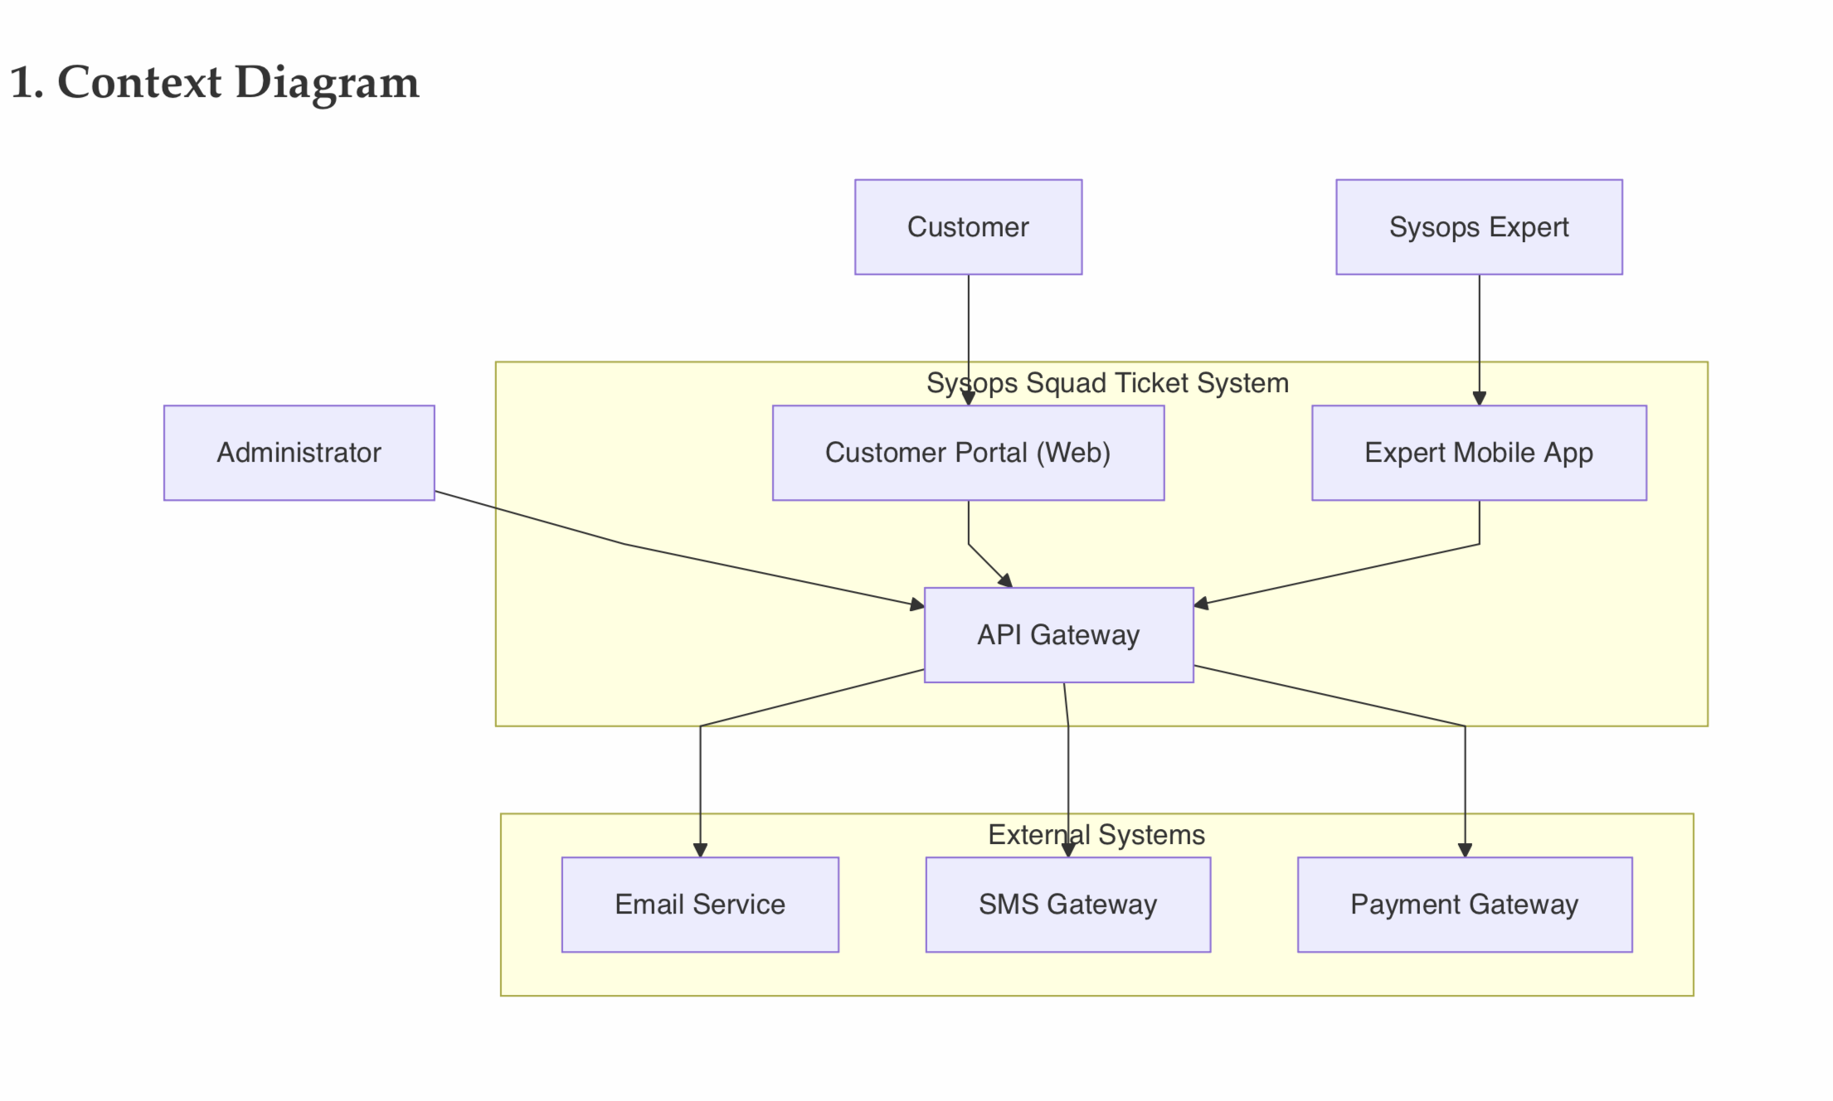
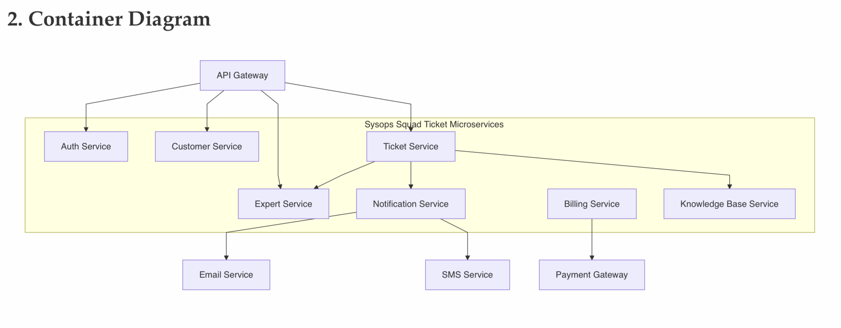
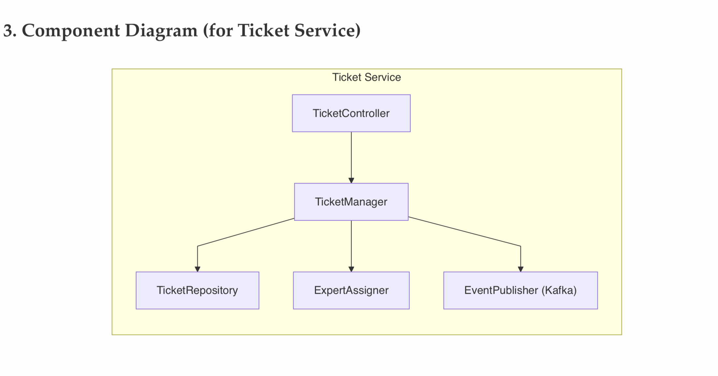

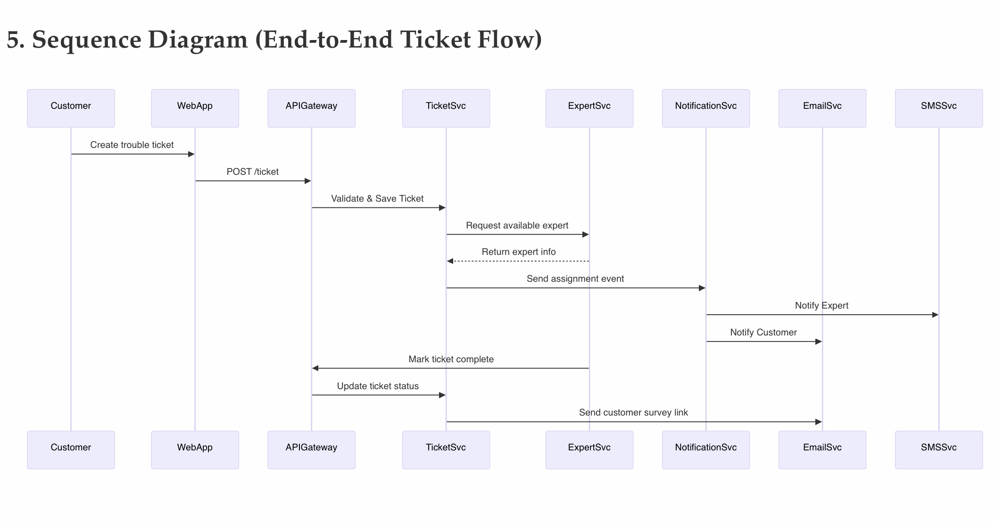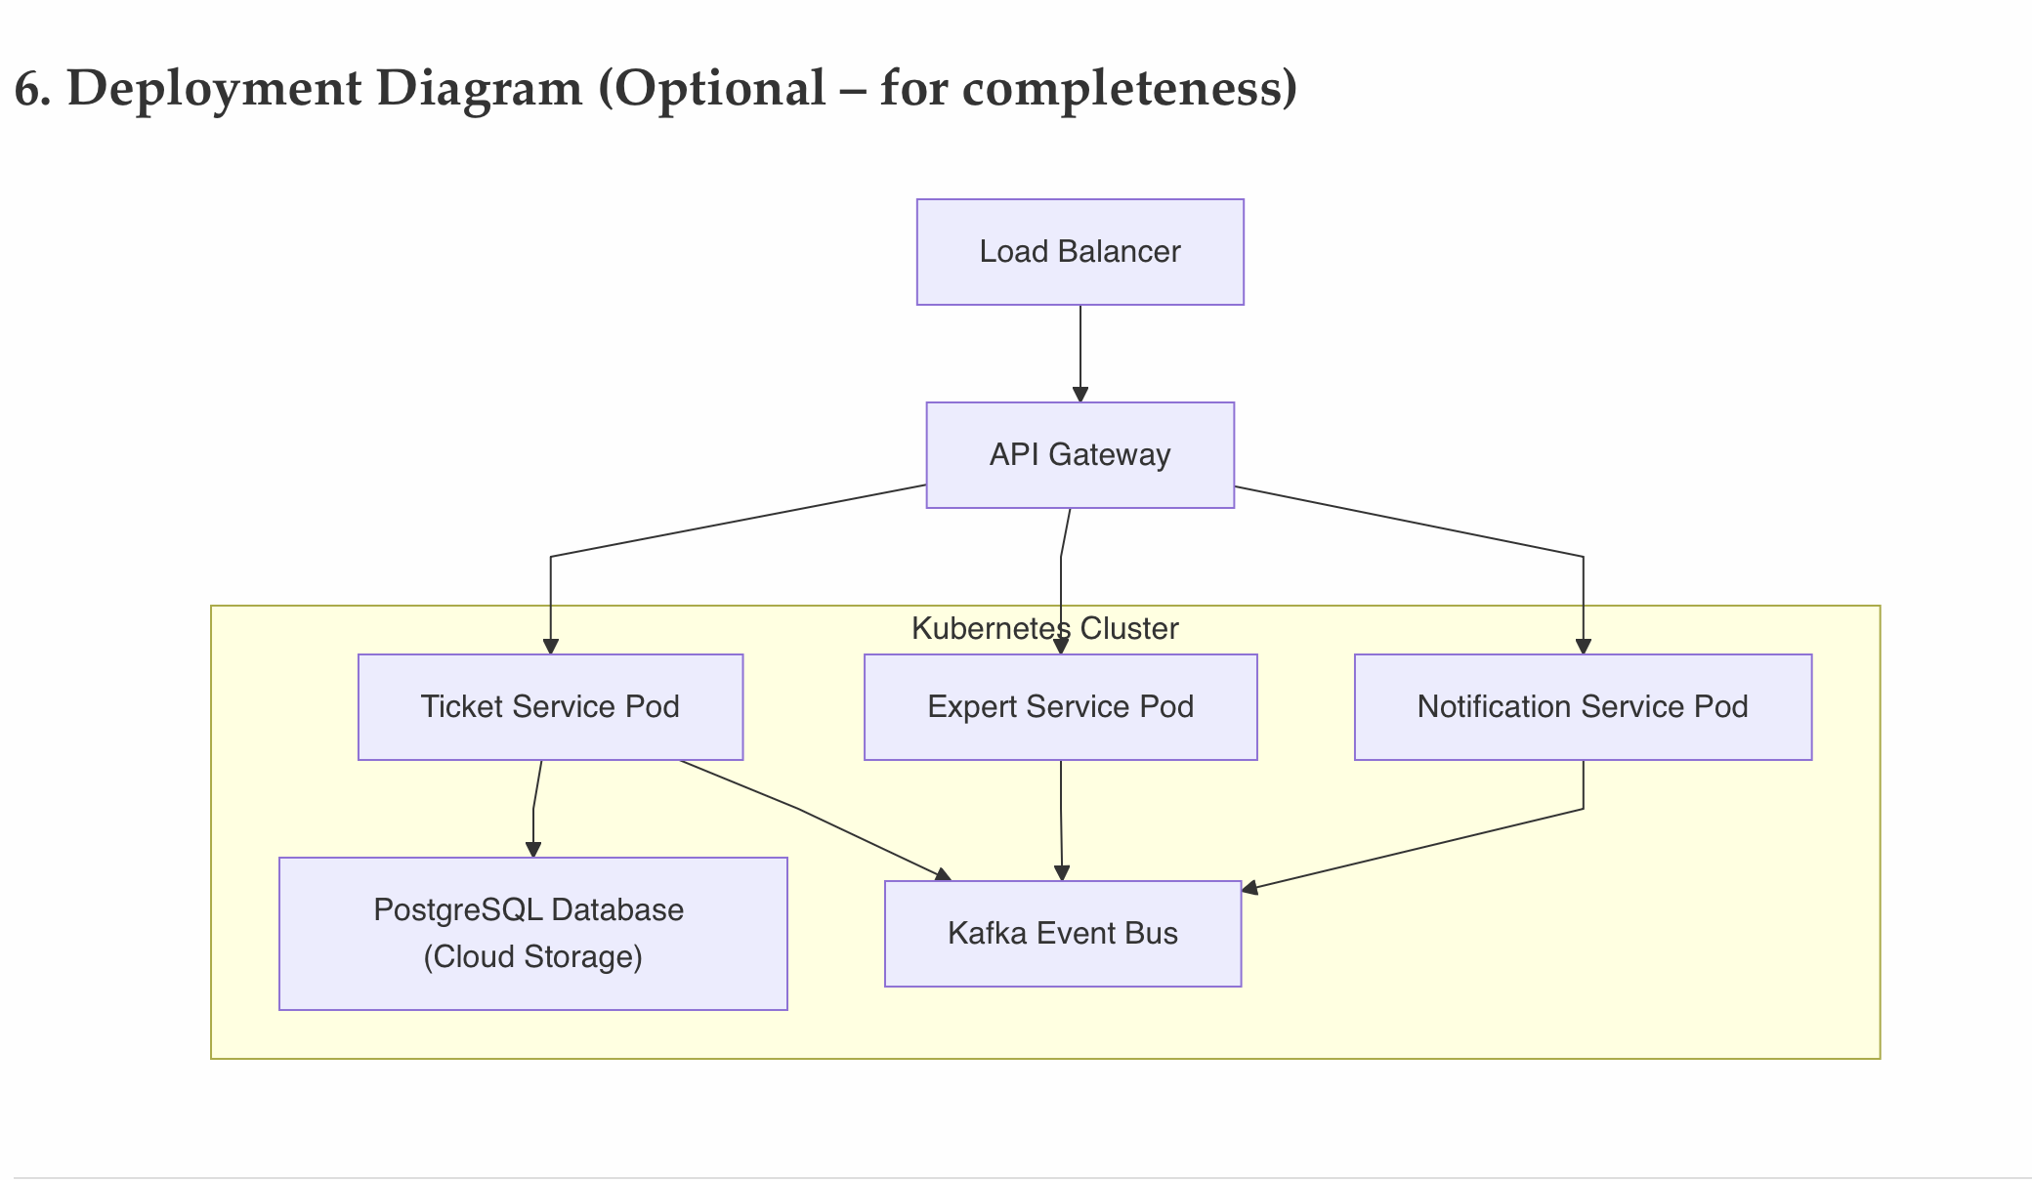

d. Risks of the Proposed Architecture

Risk | Description | Impact
Integration Failure | Email/SMS/Payment services may be unavailable or slow. | Missed notifications or delayed billing.
Data Inconsistency | Ticket or expert data may become inconsistent if services fail mid-transaction. | Wrong assignments or lost tickets.
Performance Bottlenecks | Improperly scaled Ticket Service could delay responses. | Customer dissatisfaction.
Security Breach | Unauthorized access or data leakage. | Legal and financial penalties.
Complex Deployment | Microservices increase deployment complexity. | DevOps overhead and potential downtime.
Message Loss in Queue | Kafka event loss or duplication. | Missed expert notifications or duplicate assignments.

e. Risk Mitigation Options
Risk | Mitigation Strategy
Integration Failure | Implement retry policies, circuit breakers, and service fallback responses.
Data Inconsistency | Use distributed transactions (Saga pattern) and event-driven consistency.
Performance Bottlenecks | Apply horizontal auto-scaling and caching layers (Redis).
Security Breach | Use OAuth2, JWT authentication, TLS encryption, and RBAC.
Complex Deployment | Automate CI/CD pipeline with Docker + Kubernetes + Helm charts.
Message Loss | Enable Kafka message persistence, acknowledgments, and dead-letter queues.

