Detection and Tracking of Sport Players
on Videodata Using Deep Learning Methods

Leonid Ivanovsky
AI-center
P.G. Demidov Yaroslavl State University
Yaroslavl, Russia
l.ivanovskiy1@uniyar.ac.ru
Vladimir Khryashchev
Digital technology and machine learning department
P.G. Demidov Yaroslavl State University
Yaroslavl, Russia
v.khryashchev@uniyar.ac.ru
Dmitry Matveev
AI-center
P.G. Demidov Yaroslavl State University
Yaroslavl, Russia
diman@uniyar.ac.ru
Alexander Semenov
RUDN University
Innovation Management Department
Moscow, Russia
semenov.venture@mail.ru

Abstract—This article presents the research results of JDE algorithm for detection and tracking athletes in video data. The developed convolutional neural network was trained and tested on the NVIDIA DGX-1 supercomputer. To analyze the quality of the model, MOTA metric was used, which is related to how the human eyes track targets in the video stream. The detection and tracking people on video data is relevant to many tasks of computer vision, in particular, in sport to collect statistics about players. The quality of JDE algorithm was assessed by the video fragments of basketball games filmed in the sports halls at P.G. Demidov Yaroslavl State University.
Keywords—detection task, tracking, computer vision, machine learning

Introduction
Nowadays, one of the key areas of research in computer vision is algorithms for detection and tracking objects on video data. Object detection is the search of locations of targets on video frames. The main difference between tracking algorithms and object detection models is the fact that after processing the first video frame where target objects are detected, the tracking algorithm does not need to know anything about detected objects on the preceding video frames, except locations obtained earlier. In other words, on the new video sequence frame, search for rectangular frames surrounding objects is carried out in their neighborhoods.
The issue of detection and tracking objects on video data remains one of the most actively studied in the field of algorithm development in artificial intelligence. It is relevant to many tasks of computer vision, such as video surveillance, car tracking and collecting statistics about sports players during competitions.
A person, without much effort, is able to track athletes during the broadcast of matches. However, it is complicated for artificial intelligence (AI) to implement such a computer vision task. Its complexity is determined by:
- the dynamics of sport events, namely the high speed of movement of players,
- athletes interaction in the field (there are situations where players can be very close to each other during the matches),
- optical obstacles on video frames: shadows, distortions etc.
This article presents the research results of the convolutional neural network (CNN) to solve the problem of detection and tracking sport players. Although CNNs have been known for decades, only recent developments in the field of computers with high-performance videocards have allowed researchers to work with algorithms having millions of parameters. Today, to solve modern computer vision problems, approaches based on the usage of CNNs outperform not only classical machine learning algorithms, but also experts in relevant fields [1].
This article consists of eight parts. The first part introduces readers to the problem of detection and tracking. The second section provides an overview of related works. The third part is devoted to available databases of video data and computer vision competitions among researchers to solve the problem of automatic detection and tracking in real time. The fourth section describes the developed architecture of CNN. In the fifth part, some peculiarities of training are presented, as well as the results of its testing. In conclusion, we infer the quality of algorithm of detection and tracking sport players and set the tasks for the further research. At the end of this article we add acknowledgements and references.

RELATED WORKS
Modern systems of object detection and tracking follow the tracking-by-detection paradigm [2] which includes:
- detection stage, during which bounding boxes determining localizations of target objects on the frame are highlighted,
- data association (embedding) stage, when detected objects are reidentified with the motion trajectories obtained earlier.
Following the tracking-by-detection paradigm means that the system of object detection and tracking requires consequent implementation of two separate computational components: the detection algorithm and the embedding model. This peculiarity can lead to some problems with the efficiency of such systems in real time.
To save computation time, it is expedient to integrate a detection algorithm and an embeding model into one unified network. Thus, two models can use the same set of low-level features that allow to avoid recalculations.
One of the options for the integration detection and identification models is to use two-stage detectors. At the first stage of such AI systems Faster R-CNN [3] is used as an object detection algorithm, while at the second stage, transformed Faster R-CNN [3] is used as a data association model. Despite the fact that in this two-stage algorithm, the embedding model operates with some calculations that were given at the stage of object detection, the algorithm remains limited in terms of speed due to two-stage structure of such a system. Hence, this model can work only with video recordings with a frame rate of less than 10 FPS, which is too far from the requirements for the modern computer vision systems.
JDE (Joint Detection and Embedding) algorithm is a joint model for object detection and tracking, which combines both steps of the tracking-by-detection paradigm into a common model. It is able to detect and associate obtained bounding boxes with targets from the previous frames at the same time. JDE model allows to work with video recordings with a frame rate of 18 FPS in real time. The quality of this algorithm is comparable to the best two-stage detectors that follow the tracking-by-detection paradigm [4].

OVERVIEW OF DATABASES
A dataset of images is an important part for training and estimation of the quality of different machine learning algorithms. Some datasets of labeled video data have been recently published. This allows computer vision researchers to train and test various CNNs for detection and tracking people in video stream.
The Caltech Pedestrian dataset consists of video files with a frame resolution of 640x480 pixels. The video recordings with a frequency of 30 Hz were filmed on the camera of a car moving around streets. There are about 250000 frames where 350000 bounding boxes with 2300 pedestrians were annotated [5]. Examples of video frames from this dataset are shown in Fig. 1.
The CUKL-SYSY dataset contains 18184 frames with 8432 people and 99809 bounding boxes annotated. The content of this dataset can be divided into two parts according to the image source: street videos and movie frames which makes data variable in terms of lighting, background and output resolutions [6]. Examples of video frames from this dataset are shown in Fig. 2.
The PRW dataset was collected to solve the task of detection and tracking of pedestrians on the video frames and evaluate the quality of reidentification models. This dataset contains a total of 932 different people captured on 11816 frames where pedestrians are annotated with bounding boxes and corresponding ID numbers [7]. Examples of images from the PRW dataset are shown in Fig. 3.
Various competitions are held annually among data scientists to obtain new detection and tracking algorithms. Below we introduce some examples:
- CVPR19 Tracking and Detection Challenge [8] is a computer vision contest that was held in 2019 during IEEE Conference on Computer Vision and Pattern Recognition in California, USA in order to create brand-new machine learning algorithms for the detection and tracking of pedestrians on squares and streets. This dataset consists of 8 video files, three of which captured crowded squares in American cities. There are up to 246 pedestrians who can be found in one video frame at the same time. All video sequences were filmed both indoors and outdoors during day and night time. Examples of these video frames from the CVPR19 Tracking and Detection Challenge dataset are shown in Fig. 4.
- MOT-16 Challenge (Multiple Object Tracking Challenge) dataset is one of such contests for detection and tracking pedestrians on video data taken in the streets. Apart from the development of new deep learning models, the goal of this competition is to create a unified tool to evaluate the quality of object detection and tracking algorithms. The MOT-16 Challenge dataset contains six video recordings with a frame rate of 14, 25 or 30 FPS and image resolution from 640×480 to 1920×1080 pixels [9]. Examples of the video frames from the MOT-16 Challenge dataset are shown in Fig. 5.
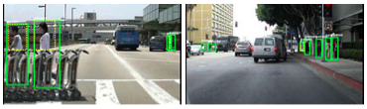
- Examples of video frames from the Caltech Pedestrian dataset

- Examples of video frames from the CUKL-SYSY dataset
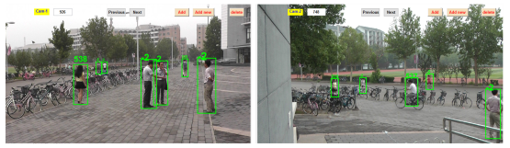
- Examples of video frames from the PRW dataset
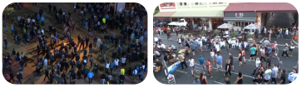
- Examples of video frames from the CVPR19 Tracking and Detection Challenge dataset
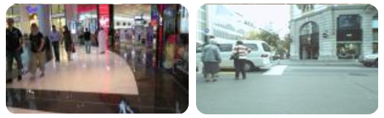
- Examples of video frames from the MOT-16 Challenge dataset

DEEP LEARNING ALGORITHM
The task of detecting and tracking people (in particular, sport players) on video data was solved by means of JDE algorithm. One of the varieties of feature pyramid networks (FPNs), namely DarkNet-53 [10], was used as a backbone network. FPNs have pyramid model architecture to extract features of different scales [11] that improves the quality of detection of objects whose size varies on video frames.
After the forward step there are extracted feature maps with scales 1/32, 1/16, 1/8 from the backbone (FPN) network. Then the features with the smallest scale (i.e., semantically strongest features) are upsampled and merged with the feature map with the second smallest scale by means of skip connection, the same operation happens with greater scale feature maps. In Fig. 6 we demonstrate the process of generation of feature maps by means of backbone network.
Prediction heads were added to each of 3 outputs of backbone network. Each prediction head includes several convolutional layers and output a dense prediction map – a tensor with a size of (6A+D)×H×W, where A=4 is the number of anchors corresponded to this scale, and D is the dimension of the embedding, H and W determine the size of input image. At the end, the output is divided into three parts:
- the results of box classificationcollected in a tensor with a size of 2A×H×W for the classification of detected objects,
- the box regression coefficients collected in a tensor with a size of 4A×H×W for the adjustment of bounding boxes,
- the dense embedding map collected in a tensor with a size of D×H×W.
The scheme of prediction head is illustrated in Fig. 7.

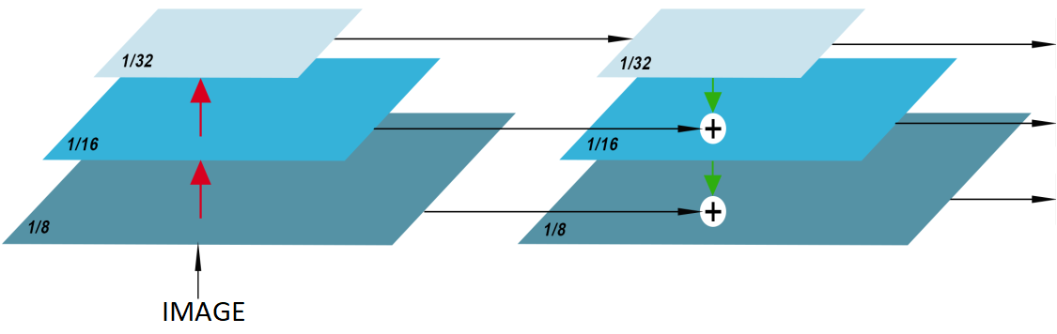
- Generation of feature maps by means of backbone network
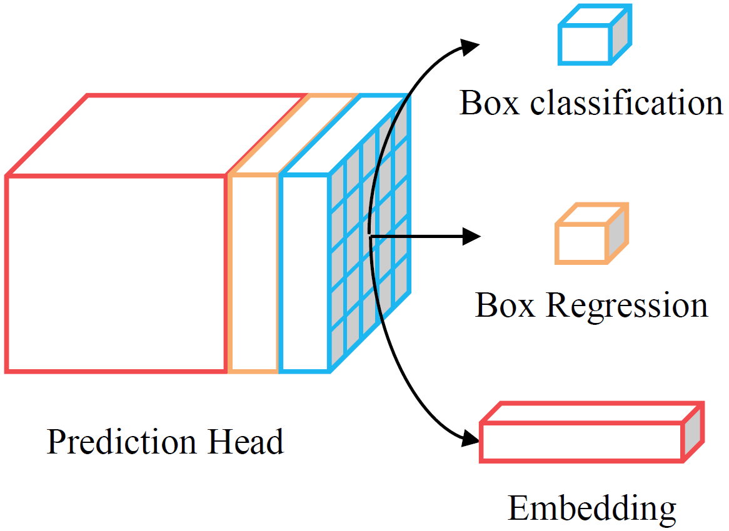
- Prediction head of algorithm
The developed network was created using PyTorch framework written on Python programming language. This open source library provides accelerated tensor computing on graphics processing units (GPUs) and deep neural networks. This framework has a large number of built-in modules for data preprocessing and supports third-party machine learning libraries [12].
Python is a high-level general-purpose programming language which is applicable to a wide range of tasks. This language supports the paradigms of structured, functional object-oriented programming. The minimalistic syntax, an ability to automatically manage memory, and dynamic data typing can be considered as the main advantages of Python [13].

TRAINING AND TESTING
Training of deep learning algorithm on small datasets often leads to incorrect, unsatisfactory and biased results. Consequently, to resolve this issue, a collection of four public datasets for detection and tracking pedestrians was combined to train JDE algorithm:
- the CalTech Pedestrian dataset,
- the CUHK-SYSU dataset,
- the PRW dataset,
- the MOT-16 Challenge dataset.
Training samples of all these datasets formed a large training sample. JDE algorithm was tested on a set of validation video files from the MOT-16 Challenge dataset. The total size of training and test video data from the MOT-16 Challenge dataset was about 1.9 GB. In addition, to check the quality of developed model, the algorithm was also tested on 12 video recordings of parts of basketball games filmed on GV-EVD3100 dome camera located in the sports hall at the P.G. Demidov Yaroslavl State University. An example of video frame taken on the GV-EVD3100 dome camera is shown in Fig. 8.
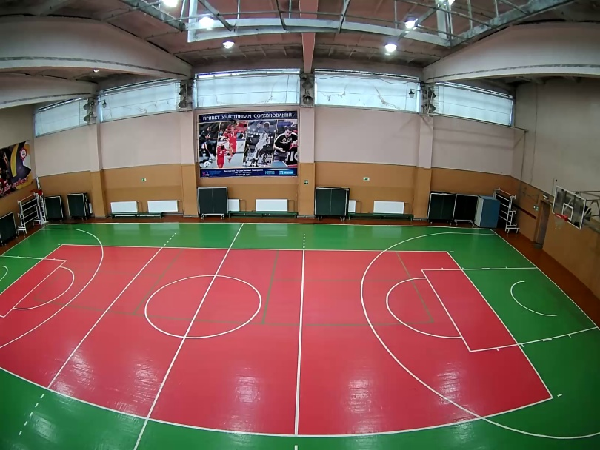
- The video frame taken from the GV-EVD3100 dome camera located in the sports hall of the P.G. Demidov Yaroslavl State University
Stochastic gradient descent with an initial learning rate of 0.01 was used as an optimizer for the developed algorithm. To make model convergence faster the learning rate of optimizer decreased by 10 times on the 15th and 23rd training epochs. The training process ended after completing 30 epochs. The developed CNN was launched on NVIDIA DGX-1 supercomputer using the parallel computing technology NVIDIA CUDA. This cross-platform technology is supported by all modern NVIDIA graphics cards [14].
To avoid overfitting problem, several data augmentation techniques, such as random rotation, random scale and color jittering, are applied [15]. If it is necessary, the input data of the model was reduced to a resolution of 1088x608 pixels.
To evaluate the quality of JDE algorithm the MOTA (Multiple Object Tracking Accuracy) coefficient was used. The key feature of this metric is that it reflects how human eyes track target objects on video data. Based on the formula of the coefficient, the MOTA value penalizes the algorithm for making false positive and false negative errors, as well as ID switches errors meaning switches to other objects during tracking [16]. In practice, the MOTA value, which belongs to [0, 1], is usually translated into percentages.
According to the results of training and testing, JDE algorithm was comparably qualitative as the other modern object detection and tracking models. In articles [17, 18] DeepSort_2 with WRN (Wide Residual Connection) as a prediction head (DeepSort_2 + WRN), as well as CNNMTT with a prediction head of 5-layer CNN (CNNMTT + 5 layer CNN) achieved the MOTA values of 61.4% and 65.2% respectively. For the test sample of the MOT-16 Challenge dataset, the quality of JDE algorithm was 62.6%. At the same time, the DeepSort_2 + WRN and CNNMTT + 5 layer CNN algorithms demonstrated significantly slower performance: 8 and 6 FPS correspondingly versus 18 FPS. The comparison of the quality of object detection and tracking algorithms evaluated on the test sample of the MOT-16 Challenge dataset is presented in Table 1.
The visual results of JDE algorithm for sports videos taken on the GV-EVD3100 dome camera in the sports hall at the P.G. Demidov Yaroslavl State University are shown in Fig. 9, 10. According to them JDE algorithm has more ID switches than other types of errors. This fact can be explained by inaccurate detections of athletes on the ground, when one player has sufficiently overlapped another one. The example of ID switches error of JDE algorithm is shown in Fig. 11.

- comparison of the quality of object detection and tracking algorithms
Model | Metrics of quality
Model | MOTA | FPS
DeepSort_2 + WRN | 61.4% | 8
CNNMTT + 5-layer CNN | 65.2% | 6
JDE | 62.6 % | 18

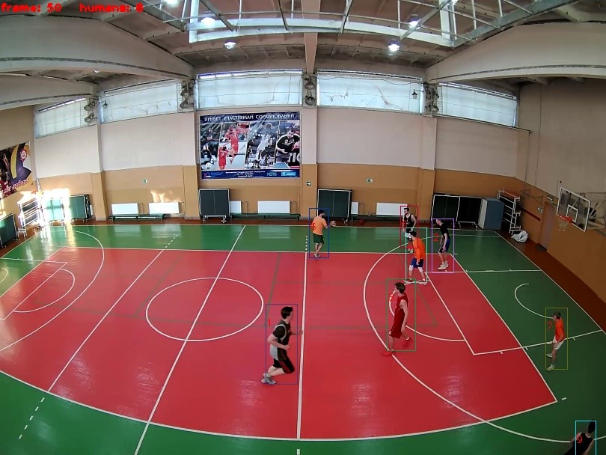
- Visual results of JDE algorithm for sports videos taken on the GV-EVD3100 dome camera
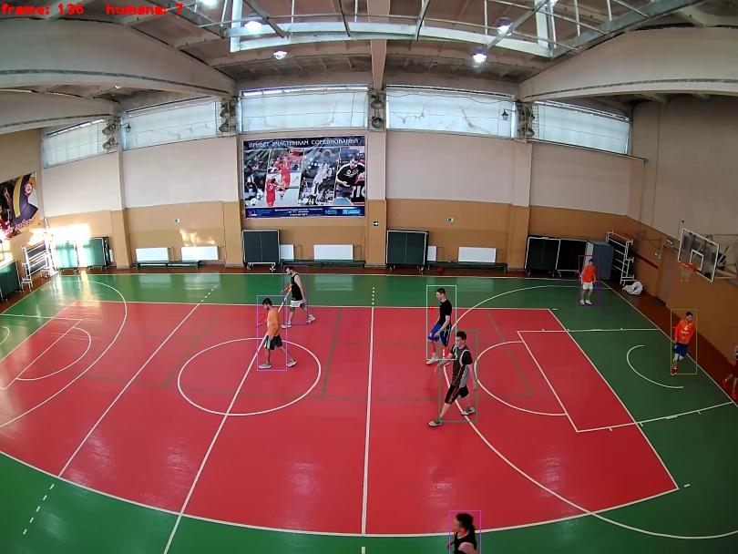
- Visual results of JDE algorithm for sports videos taken on the GV-EVD3100 dome camera
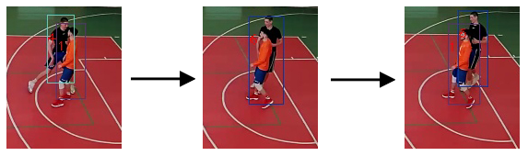
- Example of ID switches error of JDE algorithm

CONCLUSION
This article presents the research results of JDE algorithm for detection and tracking people, in particular athletes, on video data in real time. The main peculiarity of this deep learning algorithm is that the stage of data association, when detected objects are reidentified with the motion trajectories obtained earlier, is combined with the stage of detection algorithm in a way that the algorithm is able to detect and track target objects simultaneously. The developed model was trained and tested on GPUs of the NVIDIA DGX-1 supercomputer. The developed model was tested on video frames extracted from video files of the MOT-16 Challenge dataset. To analyze the quality of the model, we used MOTA metric reflecting how human eyes track targets in the video stream. The quality of the JDE model was also evaluated on the collected base of video recordings of basketball matches, filmed on the dome camera GV-EVD3100, located in the sports hall at YarSU. P.G. Demidov. For video files of the MOT-16 Challenge dataset, the value of the MOTA metric was 62.6%. However, according to the visual results of video recordings of sports events, the JDE algorithm has incorrect switching between target objects during the tracking. For the future it is planned to improve the quality of the JDE algorithm by training it on video frames of sports events filmed on the dome camera GV-EVD3100, as well as by tuning the model's hyperparameters.

Acknowledgment
The authors are grateful to the support from the federal academic leadership program Priority 2030 of P.G. Demidov Yaroslavl State University and project “Development of fundamental basis and scientific and methodological support for the management of creating new competences for modern Russian corporation of the machine-building industry and the formation of requests for competencies", funded by the Russian Foundation for Basic Research (project number 20-010-00572 A)

References
- Y. Goodfellow, Y. Bengio, A. Courville. Deep Learning. The MIT Press, 2016, 800 p.
- F. Yu, W. Li, Q. Li, Y. Liu, X. Shi, J. Yan, “Poi: Multiple object tracking with high performance detection and appearance feature”, Web: https://arxiv.org/pdf/1610.06136.pdf.
- R. Gandhi, “R-CNN, Fast R-CNN, Faster R-CNN, YOLO – Object Detection Algorithms”, Web: https://towardsdatascience.com/r-cnn-fast-r-cnn-faster-r-cnn-yolo-object-detection-algorithms-36d53571365e
- Z. Wang, L. Zheng, Y. Liu, S. Wang, “Towards Real-Time Multi-Object Tracking”, Web: https://arxiv.org/pdf/1909.12605.pdf.
- P. Dollar, C. Wojek, B. Schiele, P. Perona, “Pedestrian detection: A benchmark”, 2009 IEEE Conference on Computer Vision and Pattern Recognition, pp. 304-311, 2009.
- T. Xiao, S. Li, B. Wang, L. Lin, X. Wang, “Joint Detection and Identiﬁcation Feature Learning for PersonSearch”, Proceedings of the IEEE Conference on Computer Vision and Pattern Recognition (CVPR 2017), Honolulu, HI, USA, pp. 3376–3385, 2017.
- L. Zheng, H. Zhang, S. Sun, M. Chandraker, Y. Yang, Q. Tian, “Person Re-identification in the Wild”, Web: https://arxiv.org/pdf/1604.02531.pdf.
- CVPR Tracking and Detection Challenge, Web: https://arxiv.org/pdf/1906.04567.pdf.
- A. Milan, L. Leal-Taixe, I. Reid, S. Roth, K. Schindler, “MOT16: A Benchmark for Multi-Object Tracking”, Web: https://arxiv.org/pdf/1603.00831.pdf.
- J. Redmon, A. Farhadi, “YOLOv3: An Incremental Improvement”, Web: https://arxiv.org/pdf/1804.02767v1.pdf.
- T.-Y. Lin, P. Dollar, R. Girshick, K. He, B. Hariharan, S. Belongie, “Feature Pyramid Networks for Object Detection”, Web: https://arxiv.org/pdf/1612.03144.pdf.
- I. Pointer. Programming PyTorch for Deep Learning: Creating and Deploying Deep Learning Applications. O'Reilly Media, 2019, 220 p.
- M. Lutz. Learning Python, 5th ed. O'Reilly Media, 2013, 1643 p.
- J. Sanders, E. Kandrot, CUDA by Example: An Introduction to General-Purpose GPU Programming, Addison-Wesley Professional, 2010, 320 p.
- R. Gonzalez, R. Woods. Digital Image Processing, 4th ed. Pearson, 2017, 1192 p.
- J. Valmadre, A. Bewley, J. Huang, C. Sun, C. Sminchisescu, C. Schmid. Local Metrics for Multi-Object Tracking, Web: https://arxiv.org/pdf/2104.02631.pdf.
- S. Zagoruyko, N. Komodakis, “Wide Residual Networks”, Web: https://arxiv.org/pdf/1605.07146.pdf.
- N. Mahmoudi, S. M. Ahadi, M. Rahmati, “Multi-target tracking using CNN-based features: CNNMTT”, Multimedia Tools and Applications, vol. 78, No. 6, pp. 7077-7096, 2019.

