PROJECT TITLE

DESIGN AND IMPLEMENTATION OF AN AUTOMATED TIME TABLE SYSTEM FOR THE UNIVERSITY OF BUEA

INTRODUCTION

Timetabling concerns all activities with regard to producing a schedule that must be subjective to different constraints. Timetable can be defined as the optimization of given activities, actions or events to a set of objects in space-time matrix to satisfy a set of desirable constraints. A key factor in running an educational center or basically an academic environment is the need for a well-planned, well-throughout and clash-free timetable. Back in the days when technology was not in wide use, (lectures)
timetables were manually created by academic institution. Every school year, tertiary institutions are faced with the tedious task of drawing up academic timetables that satisfies the various courses being offered by the different departments with respect to the available classrooms.

A timetabling problem consists of four (4) parameters and they are:
- T (set of time)
- R (set of available resources i.e classrooms)
- M (set of scheduled contacts i.e lecturers )
- C (set of constraints).

This problem assigns time and resources to the contacts in such a
way that the constraints will be satisfied. In various timetabling problems,
educational timetabling has been generally examined from practical standpoint.
Academic timetable is very crucial but it consumes time due to its frequent
occurrences and usage among higher institution of learning. Another reason for the difficulty is because of the great complexity as regards to the lack of sized classrooms in response to the scheduling size of the lectures plus a high number of constraints and criteria of allocation which is usually circumvented with the use of little strict heuristics, based on solutions from previous year.
The quality of the timetable determines the quality of time dedicated by lecturers, students and administrators to academic activities.

Various academic timetabling includes:
i. School timetable
ii. Lecture timetable
iii. Examination timetable and
iv. Assignment timetable.
This academic timetable must meet a number of requirements and should satisfy the desires of all entities involved simultaneously as wee as possible. The timings of events must be such that nobody has more than one event at the same time

PROBLEM STATEMENT

Most educational institutions have resorted to manual generation of their timetables which according to statistics takes much time to get completed and optimal. Even at the optimal stage of the manually generated timetable, there are still a few clashes and it is the lecturer who takes a clashing course that works out the logistics of the course so as to avoid the clash.

PROBLEMS OF THE CURRENT SYSTEM

The traditional manual generations of timetables encounters a lot of problems which may include the following:

• Repeated time allocations may be made for a particular course thereby
leading to data redundancy.
• A lot of administrative error may occur as a result of confusing time
requirements.
• Timetable generation by administrative staff may have a slow turnaround.
• Final generated timetable may not be near optimal as a result of clashing
course requirements and allocations.
• It generates a lot of paperwork and is very tasking.
• It is not flexible as changes may not be easily made.

Moreover a timetable is feasible if and only if the following hard constraints are satisfied:

• Each lesson m ∈ M is scheduled to exactly one period.
• There are no clashes at all: Neither a class nor a teacher nor a room is assigned to more than one lesson in the same period.
• Teacher unavailabilities are considered.
• All allocated rooms are large enough to hold the students.
• Specific room requirements are taken into account.
• Lessons are blocked, if so required.
Furthermore,there is also a list of second-order (or: soft) constraints which should be taken into account if possible. Some of them are listed below:

• Students, as well as some lecturers, do not like to have many ‘holes’ (empty periods between two lessons) in their timetables.
• Lessons should be spread uniformly over the whole week, in general.
• Some teachers, by contrast, wish to have all their lessons scheduled to consecutive periods.
• Some teachers wish to have a special equipped classroom.
• In order to avoid much movement, lecture rooms should be close to the host department.
• Some lessons should not take place late in the evening.
• Rooms should be just large enough to hold the students.

We decided not to separate classroom assignment from time scheduling because one of the main goals consists in achieving efficient room utilization rates. This is accomplished in a more promising way by trying to do (or modify) time and room assignments simultaneously.

PROPOSING A NEW SYSTEM

The proposed system is develop to provide a near optimal solution to the timetabling problem being faced by the university of Buea every academic year and during each semester to reduce high cost and slow turn around involve in the generation of near-optimal timetables.
The system has capabilities for input and updates of various courses, halls of lectures,departments, programs, buildings, lecturers and the specification of a few constraints from which the timetable is constructed when needed.
The proposed timetabling system for this project seeks to generate near optimal timetables.

ADVANTAGES OF THE PROPOSED SYSTEM

The timetable generation process by the administration of the university is:

• Unlike the manual timetabling system, the system offers flexibility.
• It greatly reduces the time needed to generate near-optimal timetables.
• It provides an easy means for data entry and revision through an intuitive
interface when needed.
• It increases productivity.
• It almost eliminates paperwork.
• It simplifies the timetabling problems

- REQUIREMENTS ENGINEERING
The requirements engineering process activities include feasibility study, requirements elicitation and analysis, requirements specification and requirements validation. The application of some of these activities are clearly illustrated below using the Timetabling System to be developed taking the University of Buea as a Case Study.

- REQUIREMENT SPECIFICATIONS

This specification gives vivid and detailed informations on the services provided by this timetable system at various levels solving most of the constraints faced by the University of Buea . It’s required to serve the administration of the university of Buea,Faculties, Departments ,lecturers, students and thereby freeing them from the stress that arise due to clashes. This system is required to fulfill a certain number of requirements which can be classified under User Requirements and System Requirements. These requirements are clearly stated and enunciated below.

- User Requirements
The user requirements will clearly enunciate the different privileges or tasks that the different actors of the system will be able to perform on the system once authenticated through their accounts. Before diving into these requirements,we will first give a diagrammatic representation of the different users of this timetabling system which are Administration,Faculties,Departments,Students,and Lecturers.

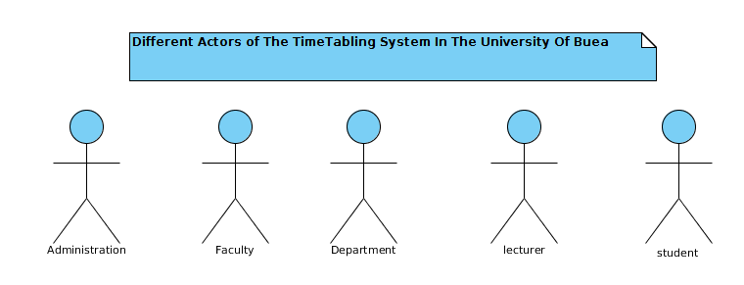
The requirements provided by the system to these various actors are clearly stated and explained below.
- Administration
At the administrative level,the system should give the administration the ability to do the following number operations as regards to the timetable system after authentication into the system.

- Generate a general timetable for the whole university including all faculties and departments meeting allocation constraints just by one click based on the predefined classrooms,lecturers,and students available at different semesters (first and second semesters) of the academic year using mapping algorithms with the help of chromosome representation.
- Add and or update courses in the database through a user friendly interface
- Add and or update courses taken by lecturers
- Add ,update,allocate and unallocate classrooms to various Faculties in case of new Constructions,
Nevertheless,the administration has predefined allocations made in the database such as allocating various classroom blocks to particular degree programs.
- Faculties and Departments
At the faculty level,this system enables each faculty of the university of Buea to do the following:
- Each Faculty will be able to view her faculty timetable as well as her departmental timetable
- Swap lectures to meet up with the needs of the lecturers based on hierarchy and in line with the courses already assigned to them.
- Lecturers
The system will allow the various lecturers in the university to do the following:
- Each lecturer who has an account in to go-student will be able to view his or her lectures timetable
- On the other hand if the lecturer does not have an account into go-student,his or her lectures timetable system will be given to him by the administration.
- Students

- Each student of the university will have access to his or her lectures timetables through their accounts in go-student
Moreover,the requirements above are as per semester and each student will have access to the the course timetable of previous years,departmental timetable and faculty timetable. This system will enable all it’s actors to their various timetables just by one click.

- SYSTEM REQUIREMENTS
The system requirements is divided in to two sub-requirements which are functional and non-functional requirements. Here we will specify some of the basic functional requirements of the systems only.

- Functional Requirements
- The system will provide a login interface that enables all the users to log into the system.
- Once logged in, the system will provide an interface that will enable administrative staffs to generate the university timetable by a button click.
- This interface will also allow them to view and download the general timetable of previous years.
- The system will allow faculty staffs to view and download faculty time tables,departmental timetable,and do some course swapping.
- An interface will be provided that will allow the lecturers to view and download their lectures timetable from their accounts.
- Also,an interface will be provided for each student to access student,faculty and departmental timetables.

- REQUIREMENTS ANALYSIS

Our analysis will focus on the different functionalities that this timetable system will provide to its users. Here we seek the tasks the different actors will perform with the aid of the system. In this analysis,we adopt the use-case modeling of UML. The formation of the system is determined by considering a number of use-cases.
Before proceeding,a use-case is a single task that a user needs the system to perform.
In our document we will describe users as actors and each actor has a role which is packaged with a set of privileges for interaction with the system.
Furthermore,we will use use-case diagrams to depict just two of the requirements specifications mentioned above will respect to some of the constraints solved by the system at various levels.

Figure1.1 Use-Case Diagram For Administrative Staffs
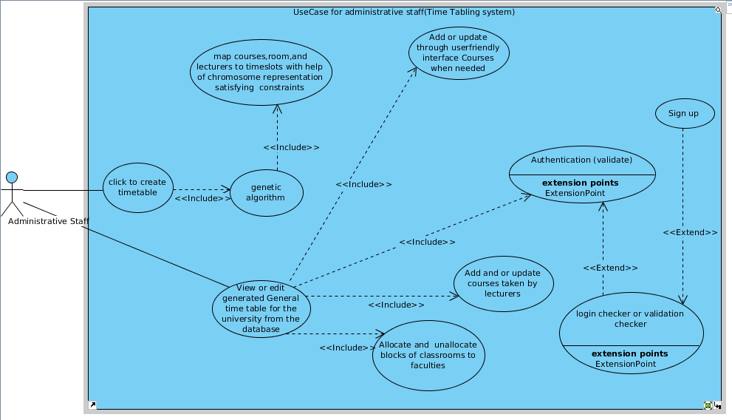

Figure 1.2: UseCase Diagram For Lecturers

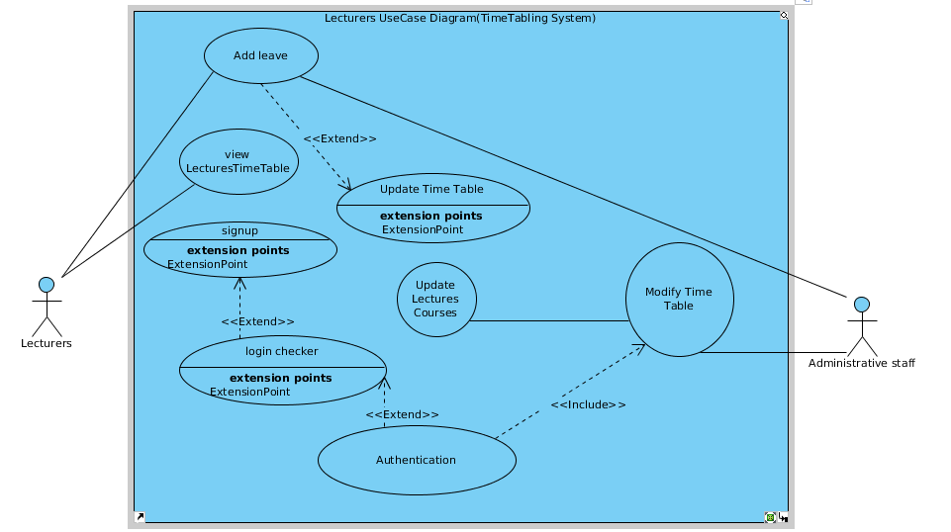

- PROJECT DESIGN

In our design of the Time Table system for the university of Buea,we will use laravel 5.5 which uses the MVC design pattern which is a robust architectural design pattern for building robust systems.

The Model-View-Controller (MVC) is an architectural pattern design that separates an application into three main logical components: the model, the view, and the controller. Each of these components are built to handle specific development aspects of an application. MVC is one of the most frequently used industry-standard web development framework to create scalable and extensible projects.

MVC Components
Following are the components of MVC
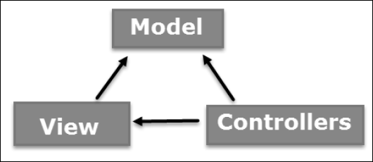

Model
The Model component corresponds to all the data-related logic that the user works with. This can represent either the data that is being transferred between the View and Controller components or any other time tabling logic-related data. For example, an administrator object will retrieve the administrator information from the database, manipulate it and update its data back to the database or use it to render data.

View
The View component is used for all the User Interface logic of our application(Time Table System). For example, the Administrator view will include all the User Interface components such as text boxes, dropdowns, etc. that the final Administrator interacts with. This is according to the privilege given to him.

Controller
Controllers act as an interface between Model and View components to process all the time tabling logic and incoming requests, manipulate data using the Model component and interact with the Views to render the final output. For example, the Administrator controller will handle all the interactions and inputs from the Administrator View and update the database using the Administrator Model. The same controller will be used to view the Administrator data.
Under this design pattern, we will discuss two different design concepts namely the database design and the logical design. For the logical design we will use sequence diagrams to do the analysis.

- LOGICAL DESIGN
  - Sequence Diagrams
We will use sequence diagrams to show the sequence of events that take place between some of the interacting objects.
- Authentication
The sequence diagram below will briefly express the sequence of events that happens when each actor of the system log in to their account irrespective of their role in the system. It should be noted that all actors of the system pass through these sequence of events.

Figure2.1a: User Authentication
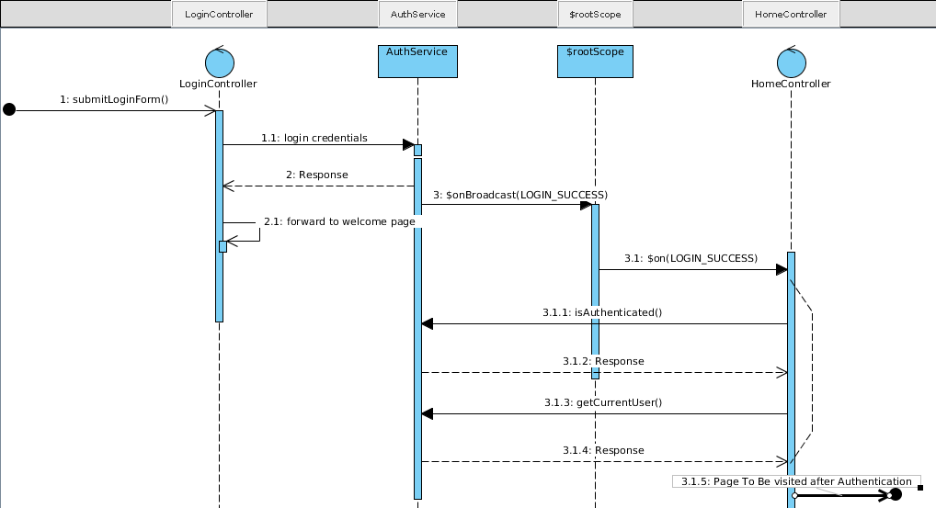

- Administration Sequence Diagram(Add Courses,Generate Timetable)

Coming next, are sequence diagrams that will show the sequences of events or messages that occurs when the administration add courses into the system and generate the whole university time table.
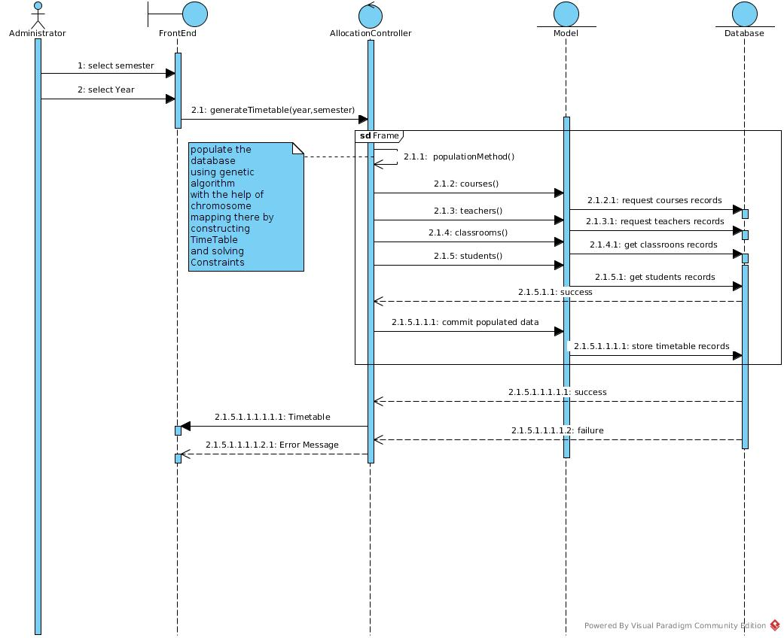
Figure 2.2: Generate Time Table

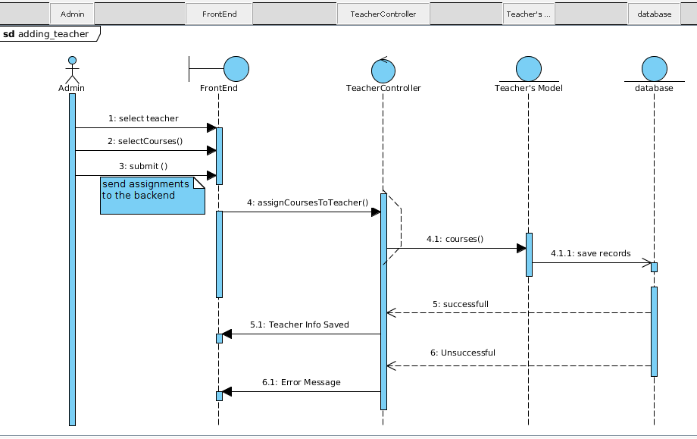
Figure 2.2: Adding Teachers To Courses

- Students Sequence Diagram
The sequence diagram below will illustrate the events that take place when each student of the university of buea opt to view their time table. In the back-end of this events,the system get all courses offered by a student and strip them off the entire university time table to get his or her time table. We call this method the selection method.

- Figure 2.2: Student Time Table
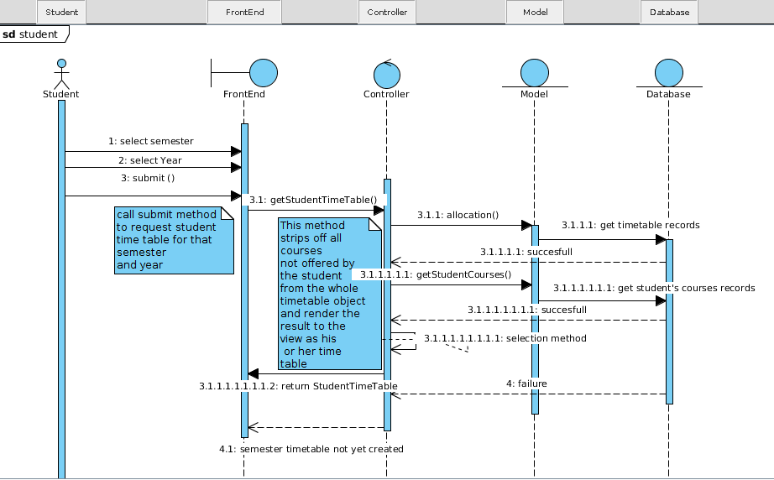
Moreover,the above sequence of events also occur when the lecturers,faculties and departments opt to view their timetable through selection of semester,year and by clicking to view the timetable.
In the case of the faculty timetable,the selection algorithm strips off courses that are not offered by the faculty from the timetable object and returns the result as the faculty time table.

On the other hand ,the selection algorithm strips off courses not taught by lecturers, and courses not offered by a department to get the lecturer’s and department’s timetable respectively.

- DATABASE TABLE DESIGN
We will give a diagrammatic representation of the database table design of our system. For this, we represent this using the mysql database schema below.
Figure 2.2 : Time Table System Schema
