# **Team composition and name**

## **1.** **Game name:**

Resonance-Temple

## **2.** **Where the game will be hosted:**

GitHub, leonellalevy

<https://github.com/leonellalevy/Resonance-Temple>

## **3.** **Main communication platform for the team:**

* · Instagram Groupchat / Direct Messaging
* · MIO

# **Game Design Document (GDD)**

## **Executive Summary:**

### **What the game is about:**

Resonance Temple is a game where you are playing as a brave explorer in a land infested with the creepy undead who are out for your blood! Even though your life may be in danger, you are determined to steal the jewel from the mysterious skeleton king who wields the ancient blade of Anubis!

### 

### **Character’s goal:**

There are three levels. The first level, you must collect the jewels and defeat the skeleton warriors. The second room is a general question puzzle about Math, Science, Geography, History, and Music where they must press the levers and answer the questions all correctly! Finally, the last level is where you must defeat the almighty fearsome skeleton king and acquire the treasured blade of anubis. The player has a certain amount of lives per room and can pick up weapons to defend himself.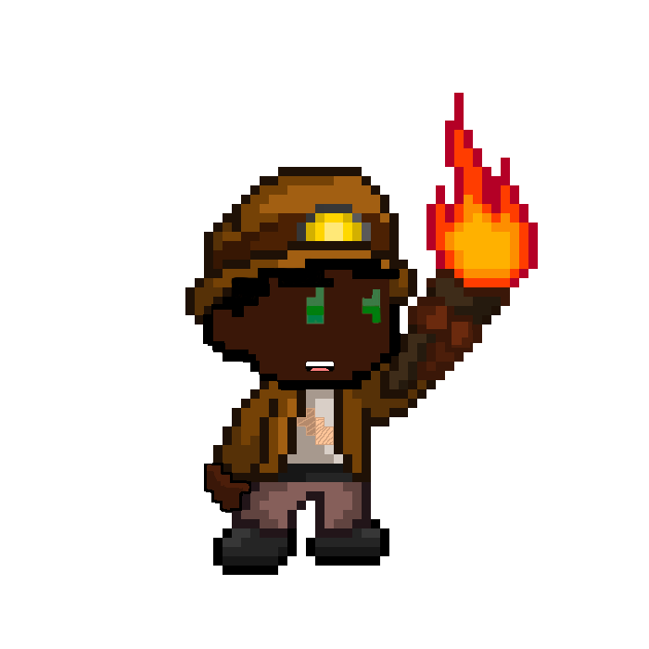

### **The main character:**

The main character Bob, is a treasure hunter / explorer who is searching for a rare treasure known as the ancient blade of anubis. Little does Bob know, it is wielded by the almighty undead! He must get the sword and save humanity!



Image on the right (Source: <https://pixelfrog-assets.itch.io/treasure-hunters> ) shows a kind of hunter’s character that we can be inspired to make our game.

### **Win/lose conditions:**

The player loses when they die by a skeleton soldier / king or get a wrong answer and they have remaining lives. The user wins the game once he acquires the ancient blade of anubis which the skeleton king can only have.

### **Related games:**

Quiz games / Indiana Jones

### 

### **User Interface Mock-up(s):**

The game ended up being different than we originally expected. Some key changes are that on the first level, you can pick up a gun to help kill the skeleton soldiers, the skeleton aspect remained the same, the second level still follows the original design with the lever puzzle that asks you questions, whilst the final level now has a skeleton king boss battle who you must defeat. There is also a choose your own requirement, we chose the buttons and timers.

### **Controls:**

The game allows the user to move in all directions using the arrow keys. Also, once the user acquires a firearm, the space button can be used to shoot bullets.

### **Developer roles:**

Project Manager (RETIRED): Trevor Obodoechina

Programmer: Leonella Levy

Artist / Graphic Designer: Ariel Jacob Wazana

### **Schedule of releases:**

* 11/16: Prototype (initial draft)
* 11/23: First playable (look and gameplay integrated)
* 11/30: Pre-Alpha (all characters and levels integrated)
* 12/07: Alpha (will be shared for testing)
* 12/13: Gold Master (final version)

. <https://github.com/leonellalevy/Resonance-Temple>