Change Control
This page shows the status of changes made in this document. With each change, a new edition is being released.
Version | Revision | Author | Date
0.1 | Create Document | Aks | 02.03.16
0.2 | Define Search Features | Aks | 07.03.16
0.3 | Added Admin Features and UseCases | Aks | 08.03.16
0.4 | Added URL Feature for detail Page | Mero/aks | 09.03.16
0.5 | Update after review maan, mero | aks | 11.03.16
0.6 | Review MAAN | maan | 14.03.16
0.7 | Removed Email Notification | aks | 21.03.16
0.8 | Updated to the new Specs (Premium Account and Free Account and their features) | aks | 19.04.16
0.9 | Review MAAN | maan | 19.04.2016

Property Rights
This document is the intellectual property of ERNI Consulting AG, without whose consent it must not be copied, reproduced, forwarded or used.
According to Article 23 together with Article 5 UWG, unauthorized use will lead to prosecution.
The item is also protected by copyright. The from it resulting justified rights, in particular the right of translation, reprint and reproduction by photo-mechanical or similar means, storing in data processing equipment, remain, even by only partial use, reserved.
The functions, data and illustrations described in this document are valid on the condition that a change is always possible. They provide a deeper understanding of the matter, without any claim on completeness and accuracy of details.
Copyright © 2016 by ERNI Consulting AG
All rights reserved

Table of Contents
1. Document 5
1.1 Objective 5
1.2 Referenced Documents 5
2. Project 6
2.1 Project Goal 6
2.2 Unique selling proposition 6
2.3 Target Groups 6
2.4 Project Scope 6
2.4.1 Topics not covered by the Project 6
3. Project Management 7
3.1 Roles & Responsibilities 7
3.2 Development Roadmap 7
4. Sitemap 8
5. Buyer Requirements 9
5.1 Landing Page after Registration 9
5.2 Paying Module 10
5.3 Landing Page After successful Payment 11
5.4 Email Notification in Register and MyProfile 11
5.5 Update MyMarket 12
5.5.1 Rating of internal Offers 12
5.5.2 Searchabo Dropbox: 12
5.5.3 Menu Strip for the MyMarket Page 13
5.5.4 Rating Displaying 13
5.5.5 Display Offer 13
5.5.6 Ordering Offer View: 15
5.5.7 Intern Offer Detail Page 15
5.5.8 Free Text Search: 17
5.5.9 Branche Selector 17
5.5.10 Country selector 18
5.5.11 Region selector 18
5.5.12 Price “From”-“To” Slider 19
5.5.13 Legends, Counter and Saving 19
5.5.14 Save Searchabo 19
5.6 Searchabo Overview 20
5.6.1 New Offers since last visit 21
5.6.2 Delete Searschabo 21
5.7 Offer Favourites 22
5.7.1 Delete Favourites 22
5.8 E-Mail Notification 23
5.8.1 E-Mail Notification for new External Offers 23
5.8.2 E-Mail Notification for new Internal Offers 23
5.8.3 E-Mail Notification For Updating Searchabo Lifetime 23
5.8.4 Delete Searchabo if not extended 23
5.9 Update My Profile Page 24
6. Admin Requirements 25
6.1 The admin can change account type 25
6.2 Public Offer Details 25
6.2.1 Company Description Text 25
6.2.2 Public Branche Selector 25
6.2.3 Public Region Selector 25
6.2.4 Searchabo Settings 26
7. UPGRADING DATA 27
7.1 1 Year Free Premium for all Existings accounts 27
8. Use Cases 28
8.1 UC Buyer1: View Internal Offer 28
8.2 UC Buyer2: Create New Searchabo 29
8.3 UC Buyer3: Update Searchabo 30

Document

Objective
This project handbook describes the project, the organization and the proceeding in the project NexOwn V2.3 Multiple Searchabos as cooperation between the contractual partners ERNI Consulting AG and NexOwn Holding AG.

This project offers the following new features to all registered users:
-the possibility to save up to 10 different Searchabos.
-the possibility to save favorites as in the app.
-a detail page (again) with more info about the internal offers (short description).
-adaption of the MyMarket page for a better user experience.
-mapping possibilities and ranking for internal offers.

Referenced Documents
Reference | Name | Version | Date | Owner
[1] | msa_buyer_mockup.pdf | 1 | 02.03.16 | Aks
[2] | msa_admin_mockup.pdf | 1 | 02.03.16 | Aks
[3] | Mapping_Platform_Swiss_bordering_kantons.xls | 1 | 08.03.16 | Maan
[3] | Mapping_areas_swiss.xlsx | 1 | 08.03.16 | Aks
[4] | Mail Notification Template for internal offer (Vorlage Notification-Mail intern.docx) | 1 | 11.03.16 | aks
Table 1 Referenced Documents

Project

Project Goal
- Offer registered buyers possibility to save up to 5 searchabos
- Offer a better user experience for the MyMarket Page
- Offer the admin a better public relation with internal offers

Unique selling proposition
- Handle up to 5 Searchabo on the biggest succession platform
- Have favorites over internal and external offers
- Have an easy access to the succession market
- Premium Account which offers a lot of additional “comfort” feature
- Free Account: A overview of the swiss market for free

Target Groups
- Persons who want to buy a company
- Persons who want to get an overview of the swiss succession market
- Persons who want to trigger if their dream company is for sale
- Persons who want to expand their business
- Persons who want to get succession consulting

Project Scope
- Refactor the MyMarket Place
- Refactor the behaviour of the actual Searchabo creation
- Improve the public offer details for internal offers

Topics not covered by the Project
- NexOwn Platform with higher or lower Version Numbers

Project Management

Roles & Responsibilities
Role | Name
Product Owner | Team NexOwn (Reto Meli, Andreas Matti, Daniel Erni, Selim Akyol)
Requirements Engineer | Selim Akyol
Project Manager | Selim Akyol, Faith Coremo
Scrum Master | Marcelo Barretto
Development | Team Manila
Account Manager ERNI

Development Roadmap
Phase | Features | Release Dates
Phase 1 | -Prototype  -Requirements | 20.04.16
Phase 2 | -Estimation  -Design Template  -Contract  -Project Setup | 29.04.16
Phase 3 | -Implementation | 30.05.16
Phase 4 | -Change Request implemented  -Bugfixing | 10.06.16
Phase 5 | Go Live | 13.06.16

Sitemap

Abbildung 1: Sitemap with changed and new pages
Legends:

BLUE: No Changes on this page
Orange: Changes on this page
Green: New Page
Red: Removed / no longer needed

Buyer Requirements

Landing Page after Registration
After the registration the buyer lands on the page where he can choose if he wants to have a free account or a premium account.
This page display a table which feature is available for which account.
Free Account:
If the user choose the free account he will be forwarded to the MyMarket Page with the light functionalities.
Premium Account:
If the user choose a premium account he can choose between:
-3 Months for 14.70 CHF/Month
-6 Months for 9.90 CHF/Month
-12 Months for 7.70 CHF/Month
Abbildung 2: Landing Page after Registration

Paying Module
For the payment we would like to use the swiss postfinance module, which is also an customer of ERNI. So if the buyer has selected a premium account with the duration, he will be forwarded to the payment module, where he can do the payment with a selected payment method.
Following Payment Methods should be supported by Postfinance:
-Postfinance
-Postcard
-eFinance
-VISA
-MasterCard
-American Express
-PayPal
Abbildung 3: Postfinance Drupal Payment Moudle

Landing Page After successful Payment
If the user has successfully made the payment he lands on a page, where he sees the nexown confirmation.
Abbildung 4: Landing Page after sucessfull payment

Email Notification in Register and MyProfile
Due that for every searchabo the buyer can select if he wants to receive notifications, we don’t need any more to ask about that in the register page or in the “Mein Profile” page. So we can remove this question with the radio boxes.

Update MyMarket
After a lot of positive and constructive feedback, it’s time to refresh the MyMarket page with new features.
Also we make a difference between free account and premium account. Summarized following feature are only available for premium:
Feature | Free | Premium
Free Text Search |  | X
Saving Searchabo |  | X
Ordering Offers |  | X
Published Date |  | X
Internal and external Offer Rating |  | X
Allready clicked Offer |  | X

Buried the Features in Free Account:
To make all the premium features “tasty” for the free user, the features are visible but buried.
If he clicks on it, he see a message where we explain that this feature is only available for premium members including a link to the account overview page, where he has the upgrade options.
Abbildung 5: Upgrade Message

Rating of internal Offers
To increase the reachability of buyers, we want to offer a rating system for the internal offers. This rating has an impact on the behaviour of the filters.
Mostly on the region:
-All offers that are in the adjacent region will be shown with a rating of 2. (All other criteria have still to match.)
-If the admin has selected an area instead of a region, then the rating will be set to the value set in the mapping keyword.

Searchabo Dropbox:
On top of the page, the user can now switch between all saved searchabo. The drobox displays the name of the searchabo that the user has created.
Switching between the different searchabos, will load the page with all saved criteria and display the matching offers.

Menu Strip for the MyMarket Page
Next to the Searchabo drop box we have two buttons for:
-Favoriten: Links to the Offers Favourite Page
-Verwalten: Links to the Searchabo Overview Page
Abbildung 6: MyMarket Updated

Rating Displaying
For internal and external offers we want to change how we display the rating. Now we don’t display the labels anymore and put all 7 fields together.
So if an offer fulfils all criteria, it will display 7 red filled squares.
If an offer only fulfils 5 criteria points, we display 5 red filled and 2 white squares.
Abbildung 7: New Rating Display

Display Offer
Favourite Star:
Internal and external can now be saved as favorites by clicking on the star icon. This will then change from a white star to a filled yellow star. This offer will then be visible on the favorites page.
Published Date:
For internal offers: The date when we first publish the offer by filling in the public detail page.
For external offers: The date when we send the notification.
Rating:
For internal offers: Due that fact that the admin can set areas in the regions (like in the external offers), we also offer rating points in the internal offers.
Displaying:
Additionally to the “New” icon we would offer a second visibility. All offers that have been clicked once will be lighten/transparent.
The display order will be :
1. Internal Offer:
1.1 Newest and unread first
1.2 all unread sorted by newest first
1.3 all read (lighten/transparent) sorted by newest first
2. External Offers:
2.1 Newest and unread first
2.2 all unread sorted by newest first
2.3 all read (lighten/transparent) sorted by newest first
Abbildung 8: Displaying internal & external offers

Ordering Offer View:
The buyer has the possibility to change the order of the view by the following criteria.
As soon as he changes the order in the offer view, we don’t prioritize the internal offers. Then the order will be sorted without differing between internal and external.
-Price: Ascending and Descending without making a difference between internal and external
-Date: Ascending and Descending
-Already read: First unread or first already read
-Ranking: Ascending and Descending
Abbildung 9: Ordering View Features

Intern Offer Detail Page
The buyer has now an additional view, where he sees more information.
This information is also visible if he doesn’t have an NDA approved yet, so it’s not necessary to have an approved NDA to see this page.
This page displays all public offer details:
-<public offer title>,-<public offer pic>,-<public offer description text>,-<public offer price>,
-<public offer branche>, -<public offer region>
Favourite Star:
The buyer can add this item to the favourite page or request more information.
More Information Button
The more information button will activate the actual process with the management summary and adds the company to the observer list and fails if the buyer has not an approved NDA.
(Same functionality like the more information in Version 2.1)
Back Button
The back button is leading back to the place where the offer was clicked (MyMarket or Favourite Page)
URL:
For marketing purposes, we would like to have an url to a specific detail page, where we can use the link. (User has still to login and then get forwarded to the detail page)
(example: we post on facebook: “Best onlineshop of the world for sale click here” and then user should be linked to the mymarket login and after login to the detail page)
Abbildung 10: Intern Offer Detail Page

Free Text Search:
The free text search field allows the buyer to enter free text.
This free text has an auto-complete function which gives suggestions.
Functionality:
-The text proposals are titles or words found in the <intern public offer title> or <intern public offer description> or <extern offer title>
-After pressing Enter the search starts
-Search respects all filters if set (region, branche, price)
-the MyMarket page shows only offers that contain the search text and match the filters.
-Results are still ordered by first internal then external and newest first
Button:
For DAU’s we also offer the Search Button. For those who don’t understand that they could press enter.
Abbildung 11: Free Text Function

Branche Selector
The content of the selector should not pop over, it should extend the page. (typical javascript effect)
The branch selector has the same behaviour as now and has the same functionality as now:
-User can select up to 5 industry sectors
-User receives a pop-up if he selects more, and the selected value is unchecked again
New functionality:
-All selected values are listed in the head of the dropdown box
-Selecting a branche displays immediately the results and updates the counter
-The industry sectors are displayed in the dropdown box in 3 columns in the desktop version
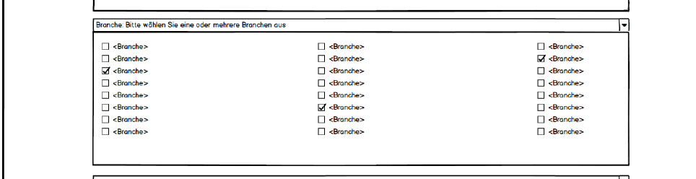
Abbildung 12: Branche DropDown Selector

Country selector
The content of selector should not pop over, it should extend the page. (typical javascript effect)
Like in 2.1 we still offer the user the possibility to select multiple countries. Also he still has an overall selection of max. 10 regions.
Switzerland is selected by default and all Swiss regions are loaded in the region selector.
Changing the country will update the region selector with the specific region. (like in 2.1)
Following Country can be chosen:
-Schweiz
-Deutschland
-Österreich
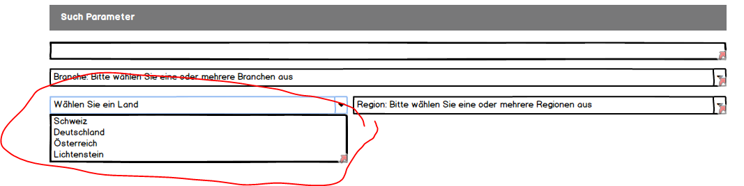
Abbildung 13: Country Selector

Region selector
The content of the selector should not pop over, it should extend the page. (typical javascript effect)
Same behavior as in the industry selector.
-User can select up to 10 regions
-User receives a pop-up if he selects more, and the selected value is unchecked again
New functionality:
-All selected values are listed in the head of the dropdown box
-Selecting a region displays immediately the results and update the counter
-The regions are displayed in the dropdown box in 3 columns in the desktop version
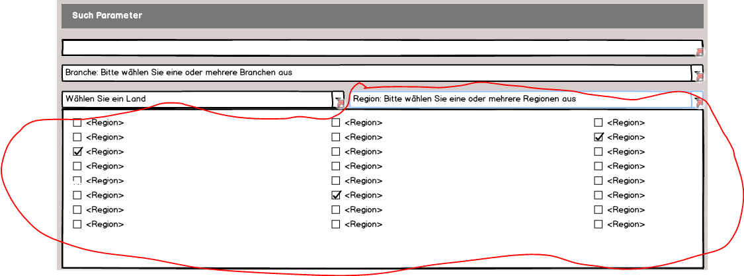
Abbildung 14: Country Specific Region Selector

Price “From”-“To” Slider
The prise should now be selectable in a slider with 2 pointers. One represents the “from” and the other the “to”. The Price range is still from “0 CHF” to “>10’000’000 CHF”.
The slider should jump over the same defined values like in 2.1. Other values are not allowed.
Also the slider should show on which position he’s actually pointing.
Max value cannot be lower than min value and 0-0 is also not allowed.
Abbildung 15: Price Slider

Legends, Counter and Saving
-This section explains with a legend, which offers are internal or external.
-A counter which reacts to every change that the user makes in the filter criteria, shows the total amount of internal and external offers.
-A button is for saving a searchabo.
Abbildung 16: Legend, Counter and SaveButton Panel

Save Searchabo
The buyer has the possibility to save his configuration (only Premium Account). For that he has 2 possibilities:
Saving a new Searchabo:
If there are no searchabo selected and the user presses “Parameter als Suchabo speichern”
-The save popup window appears and asks for entering a searchabo name
-User can save or cancel the process
-Searchabo is created with the default values. (see 5.6)
Updating a Searchabo:
- Abo is selected in the searchabo dropbox
- User clicks on “Parameter als Suchabo speichern” button
- Popup window appears with the searchabo name
- User has the possibility to give a new name (creates a new searchabo)
- default values are taken
- User keeps the name searchabo is updated and saved.
-all configured values for the searchabo are kepts

Free Account: Secretly Save Searchabo
Due that the free member cannot save the searchabo we would like to save the last search of the user as “secret” searchabo, that is not visible for the free user but helps for the statistics for the admin.
So the statistics has a new type of searchabo and the admin can still see what the people are looking for, but the free member sees nothing of all that. For that we always save the last 50 searches of the buyer.
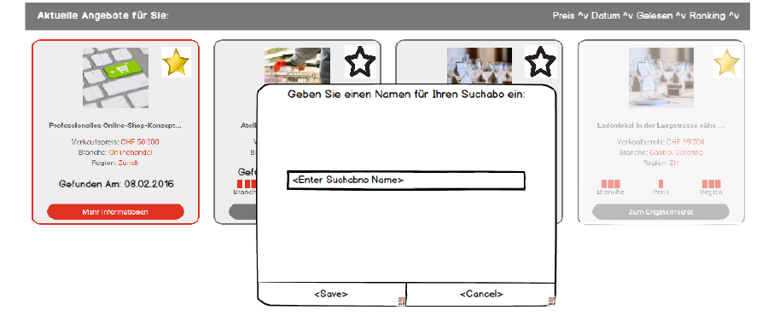
Abbildung 17: Save/Update Suchabo

Searchabo Overview
This page gives the user the possibility to see which searchabos he has. Also he can change some settings for each searchaboo:
Column 1:
-Searchaboname: User can directly change the name of the searchabo in this text field
-Branchen: Lists all selected industry sectors coma separated.
-Regionen: List all selected Regions coma separated.
-Price: Displaytext: “von <selectedFromPrice> bis <selectedToPrice>”
Column 2:
-Email Notification: User can choose if he wants to receive an email notification.
-If notification is set to yes, then the radio buttons are enabled:
-Notification interval: User can choose if he wants go get notified:
-Daily
-Once per Week (always on Monday)
-Once per Month (always first Day of Month)
-Arrow to Offers:
-Loads the MyMarket Page with the searchabo dropbox selected with the specific searchabo.
-All parameters are set like in the searchabo
-The offers are filtered due the searchabo criterias
-New Offer since last visit:
-Displays the amount of new offers since the last visit.
-Delete Button:
The Delete Button offers the possibility to delete the searchabo. (see 5.6.1)
The Default values when saving a new searchabo are:
-Email notification is set to “ON”
-Notification interval is set to “daily”
Abbildung 18: Searchabo Overview Page

New Offers since last visit
This number shows the user the amount of new offers since his last visit to this searchabo.
The idea is, that when landing on his searchabo overview page, he directly sees which searchabo has how many new offers.
Abbildung 19: New Offers since last visit

Delete Searschabo
By clicking on the trash icon, the buyer has the possibility to remove a specific searchabo.
A popup Window will then appear and ask if he really wants to delete the searchabo.
If the user clicks on yes searchabo will be deleted and removed from the list. Also all notification for this specific searchabo will be then removed.
If he clicks on cancel, the buyers returns back to the searchabo list.

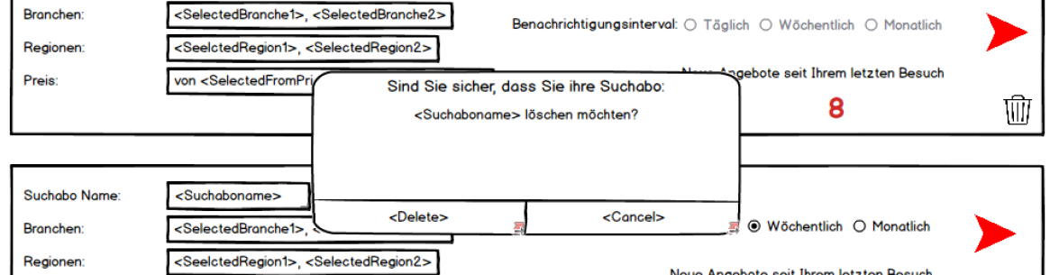
Abbildung 20: Delete Searchabo PopUp-Window

Offer Favourites
All added favourites will be displayed on this page.
The buyer can access this page via the button on the MyMarket overview.
The offers will be order by:
-First Internal Offers and then external offers
-Ordered by Newest First.
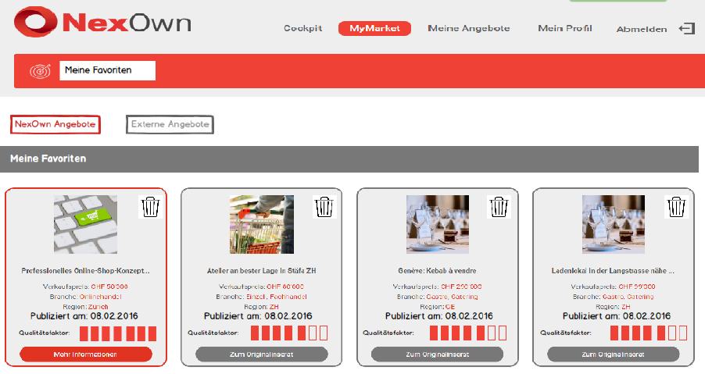
Abbildung 21: MyMarket Favourites Page

Delete Favourites
By clicking on the trash icon, the buyer has the possibility to remove a specific offer.
A popup Window will then appear and ask if he really wants to delete the offer.
If the user clicks on yes offer will be deleted and removed from the list.
If he clicks on cancel, the buyer returns to the favorite list.

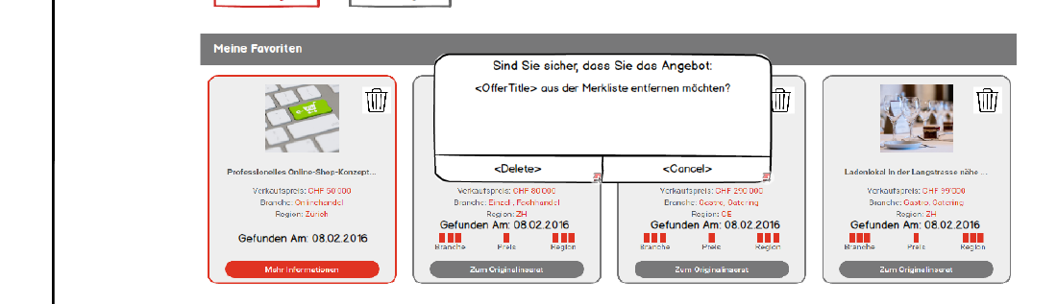
Abbildung 22: Delete Offer from Favourites

E-Mail Notification

E-Mail Notification for new External Offers
The same like now. No changes needed.

E-Mail Notification for new Internal Offers
This email should also have the same structure as the external offers and should be sent when saving the public offer detail. But it also includes the public offer description.
For that please see the mail template under the attached documents (1.2)

E-Mail Notification For Updating Searchabo Lifetime
After <X> months (time is set by administrator in the settings), the user receives an e-mail notification, which allows him to extend the searchabo.
The E-Mail comes <X> days before (time is set by administrator) the searchabo expires.
By clicking on the link, the user lands (after successfully logged in) on the searchabo page and a message appears that his searchabo has been successfully extended.
If the user doesn’t extend his searchabo he receives a second mail for extending and a remark that the searchabo will be deleted if not extended.
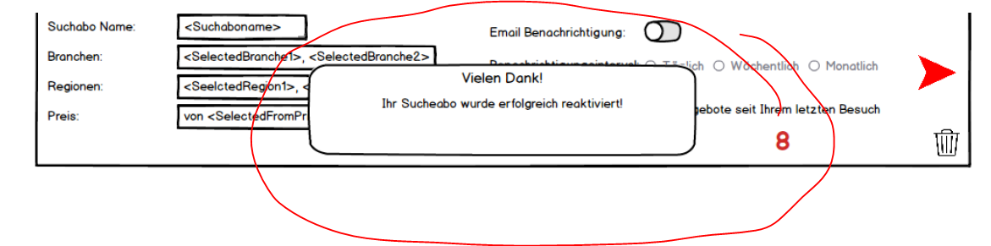
Abbildung 23: Searchabo successfully extended message

Disable Searchabo if not extended
If the user doesn’t extend the searchabo during the X days the searchabo will be then disabled.
Following template displays the content of the email subject and body.
Abbildung 24: E-Mail Template to extend Searchabo

Update My Profile Page
This page also show now the account type next to the salutation of the user. Also he can directly click on the account type to upgrade or change his account type.
This link will redirect him to the account overview page.
Abbildung 25: Mein Profil Page updated

Admin Requirements

The admin can change account type
The admin can change the account type of each buyer. He can choose if he wants to put this account for 3,6,12 Months as premium for free.

Public Offer Details
The public offer details page has now some new fields, due to the new internal detail page.

Company Description Text
The company description text should allow to make simple html tags for formatting the text. (Bold, Italic, font-size, font-color).
The text area should be big enough, so that the admin can add context of half a page size (A4).

Public Branche Selector
The selector takes by default the industry sector that the seller has chosen and puts in the data of the company.
For marketing reasons, the admin should be able to change this industry sector. The buyer will always only see the value selected in the public branche selector.

Public Region Selector
The public region selector takes by default the region that the seller has chosen.
For marketing reasons, the admin can select areas to increase the reachability of buyers.
Bordering Regions:
-If an offer is in the adjacent region where the buyer is looking for, then the offer will be displayed, but with a ranking of 2. (please see in the referred docs 1.2)
Areas:
-Also we want to offer areas (that includes more than 1 region). This is 1:1 the same mapping that we took for different external platform like “firmenhandelsplatz.ch” (please see in the referred docs 1.2)
Abbildung 26: Intern Public Offer Details

Searchabo Settings
In the admin settings page the admin can set the different time intervals:
Searchabo Default Life time:
-The amount of days of a lifetime of a searchabo. (default 3 Months)
-The amount of days when the FIRST email searchabo extension is sent (20 days)
-The amount of days when the SECOND email searchabo extension is sent (50 days)
-The default notification radio button value (daily)
-The default of searchabo notification (active)
Abbildung 27: Admin Settings Page

UPGRADING DATA
A very important step is, that all registered user from 2.2 should then keep their searchabo when upgrading to 2.3.
This means, every buyer will have after the upgrading already 1 searchabo.
The default parameter will then be:
-The selected regions that the buyer already have.
-The selected branche that the buyer already have.
-The selected price range that the buyer have.
-The E-Mail Notification that he has settled.
-The notification interval will be set to daily.

1 Year Free Premium for all Existings accounts
Also we want to offer all already existing accounts a 1 year premium account for free.

Use Cases

UC Buyer1: View Internal Offer
ID: | UC B1
Title: | View Internal Offer
Description: | User clicks on the mymarket page on an internal offers because his interested in this offer.
Primary Actor: | -Buyer (Who wants to receive more information about this offer)
Preconditions: | -Buyer has successfully logged in  -Buyer has set some search details in the MyMarket Page  -Buyer sees an internal offer that interests him
Postconditions: | -Buyer has now access to the management summary  -Buyer has the company added in the observer list
Main  Success Scenario: | 1. Buyer clicks on the internal offers  2. System redirects the buyer to the internal offer detail page  3. Buyer reads the internal offer details  4. Buyer clicks on more information  5. Buyer is forwarded to the MeinKaufen Page and has now access to the Management Summary
Extensions: | 4a Buyer has no NDA approved  - Message appears that he has no NDA approved  - System forwards the Buyer to Mein Profil Page  - Buyer downloads, signs and uploads the NDA  - Admin approves the NDA  - Back to Step 4  4b. Buyer clicks on “Add to Favourites”  - System forward the buyer to the Favourites Pages  - Buyer sees the offer added in the list of favourites
Frequency of Use: | Everyday
Status: | Pending Review
Owner: | aks
Priority: | 1 (High)
Tabelle 1: UCB1 View internal Offer

UC Buyer2: Create New Searchabo
ID: | UC B2
Title: | Create a new Searchabo
Description: | Buyers selects different search criteria and wants to save this searchabo and set the notification settings.
Primary Actor: | -Buyer (Who wants to get notified when new offers matches his searchabo)
Preconditions: | -Buyer has successfully logged in  -Buyer is on the MyMarket Page  -No searchabo are selected in the searchabo drobox
Postconditions: | -Buyer has a searchabo with a self chosen name  -Buyer has set the notification interval  -Buyer receives mail as soon new offers match his criteria
Main  Success Scenario: | - Buyer selects up to 5 industry sectors  - Buyer selects up to 10 regions  - Buyer set the slider in the price range he wants  - The systems shows the amount of offer  - The systems displays the offer in the specific Order (see 0)  - Buyer press on the save button  - Buyer give an searchabo name  - System forwards the buyer to the searchabo overview  - Buyer enters the notification interval
Extensions: | 6a. Buyer press cancel  - Popup Window disappear  - No Searchabo has been saved
Frequency of Use: | Everyday
Status: | Pending Review
Owner: | aks
Priority: | 1 (High)
Tabelle 2: UCB2 Create new searchabo

UC Buyer3: Update Searchabo
ID: | UC B3
Title: | Update Searchabo
Description: | Buyers select different search criteria and wants to update this searchabo
Primary Actor: | -Buyer (Who wants to update his searchabo)
Preconditions: | -Buyer has successfully logged in  -Buyer is on the MyMarket Page  -a searchabo is selected in the searchabo drobox
Postconditions: | -Buyer has update the searchabo with the self-chosen name  -Buyer receives mail as soon new offers matches the updated criteria
Main  Success Scenario: | - Buyer selects new criteria  - System updates the offer list  - Buyer press on the update/save button  - Popup Windows appears with the given name  - Buyer press save  - Systems saves the changes  - System gives a message to the buyer that the changes are saved  - System keeps all settings
Extensions: | 4a. Buyer select a new name  - New Searchabo is saved  - Buyer is forwarded to the searchabo overview  - Buyer select the notification settings
Frequency of Use: | Everyday
Status: | Pending Review
Owner: | aks
Priority: | 1 (High)
Tabelle 3: UCB3 Update searchabo

