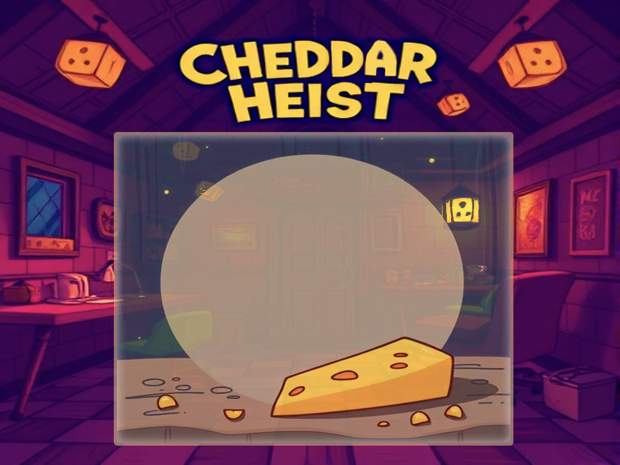

***AI PROJECT CI5525***

***Kingston University London***

***LEONIDS GUROCKINS  
K1908148***

***Teacher: Dr Jarek Francik***

**CHEDDAR HEIST**

***Game Plot:***

You play as a mouse whose main goal in life is to stay well-fed, and a big piece of cheddar lying in the kitchen is supposed to help you achieve this desired dream.

Each room in the house has its own level of difficulty. The main game aspects are stealth, strategy, and various types of combats or avoiding them while you are navigating through the house.

Hide, fight the enemies use all the game potential and take that cheese back to the mouse hole without getting killed.

|  |  |
| --- | --- |
| **SELF ASSESSMENT** | |
| My project is: | nearly finished |
| My scene is: | meeting all the coursework requirements |
| My effort was: | I worked hard and I am proud of my results |

**Type your PROJECT title here**

**Your name here (or names if it is a team project)**

**Kingston University London**

**- date -**

|  |
| --- |
| **BRIEF DESCRIPTION OF THE PROJECT** |
|  |
| **MAIN AI CONCEPTS USED:** |
| Path Finder  Player detection  following player using path finder  enemies call for help if low health  AI player are acting on change in environment, if lught is off ,human AI will go to switch it back on  If light is off mouse is invisible |
| **OTHER ACHIEVEMENTS:** |
|  |

**Game ScreensHots**

**- Your YouTube URL here -**

## GAME CONCEPT

Describe the objective (or plot) of the game, or anything else the player needs to know.

## GAME INSTRUCTIONS

Provide instructions on how to play the game.

## AI TECHNIQUES AND ALGORITHMS

Elaborate on the techniques and algorithms you have used in your game.

## OTHER ACHIEVEMENTS

Anything else?

## DISCUSSION

Brief discussion of any issues you have encountered whilst developing the project, things that do not work as intended, decisions or choices you made to succeed with this project, features you are particularly proud of, and major lessons learnt.

G***ame Features:***

* Enemy Patrols & Visual and Hear Detection - The AI-controlled enemies patrol the house dynamically. Cats have excellent listening capabilities while dogs use their sense of smell to track your movements. If the enemies see or smell you, they will attack you or call for help.
* Path finder – will be used to navigate players and enemies.
* Various baffs -   finding any food will grant the mouse special effects like health regeneration, health increase, movement speed, and invisibility.
* Combat - Low HP cats and dogs call for help or will hide.

***Enemies:***

* Dogs - patrolling areas attack or bark to alert the others if they find you. Have great hearing and smell.
* Cats - are masters of shadow, you will not see them till the moment is too late very aggressive and likely will attack you immediately.
* Human - House owners wander through the rooms. If they see strange pet behaviours, they investigate. If they see the mouse, they set new traps or (if this repeating) call pest control (game over).

***Player and abilities***

* Survival instinct – reveals all hidden enemies nearby.
* Stun - a loud scream to stun enemies and run away or attack them.
* Attack – primitive bite attack.
* Life saver - a speed ability to run away and hide if things went out of control.
* Use of the environment: the player can find various objects which can be knocked or thrown (like cups, books, or food) to distract enemies’ attraction.  Also, you can chew the cables and win some time to get game objectives done.

## Credits and References

Apart of Sprites references showed below, all the rest are purely AI generated or are bought under license which do not require any references to it

<https://img.itch.zone/aW1hZ2UvMjkzNjg5LzEyMjEyMTUzLnBuZw==/original/m01ztu.png>

https://penzilla.itch.io/top-down-retro-interior