Assessment 1:

Assessing and Securing Systems on a Wide Area Network (WAN)

Leo Newton

IT-FPX4071 - Cyber Attack & Ethical Hacking

Capella University

Professor Kuhlman

03/18/2024

**Table of Contents**

Scan Type….…..……………………………………………………………………..3

MS08-067…………………...………………………………………………………..4

Vulnerabilities……………………..…………………………………………………4

Securing the WAN…….……………………………………………………..………5

References.…………………………………...……………………………………... 6

**Scan Type**

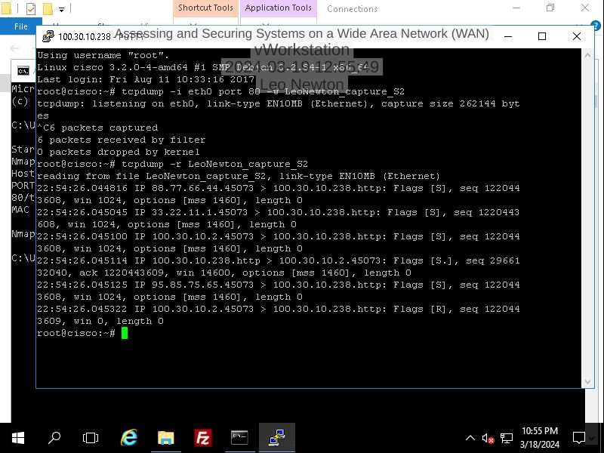Figure 1: TCP Dump during Nmap Scan.

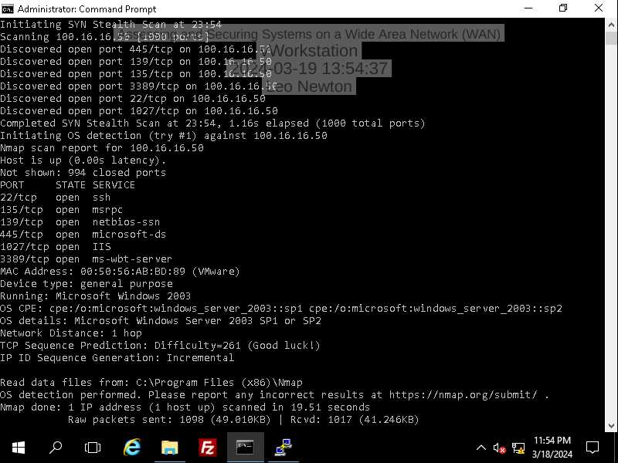Figure 2: Nmap Scan showing Open Ports and OS information.

Explain why the type of scan done in the lab is important for an organization.

**MS08-067**

Describe the MS08-067 vulnerability.

**Vulnerabilities**

Explain how performing the steps of the scan helped to identify the vulnerability.

**Securing the WAN**

Explain why assessing and securing systems on a wide area network (WAN) is important for an organization.

**References**

Andrews, J., Dark, J., & West, J. (2018)*CompTIA A+ Guide to IT Technical Support Ninth Edition.*Massachusetts: Cengage Learning.