**Screenshots**

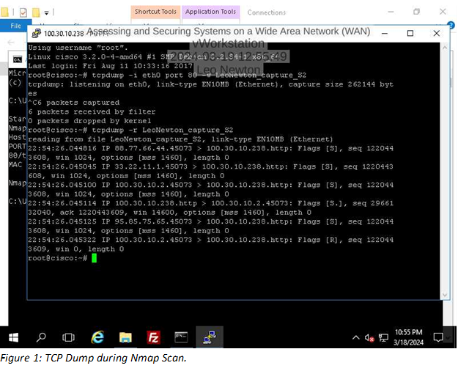

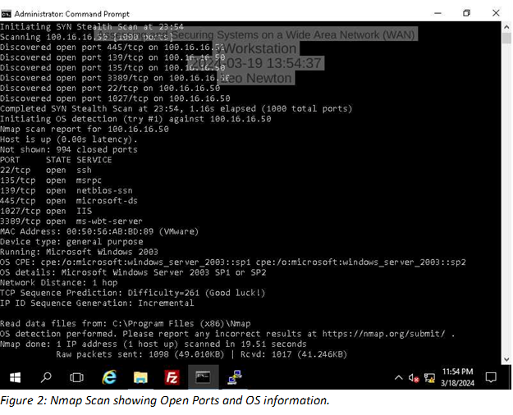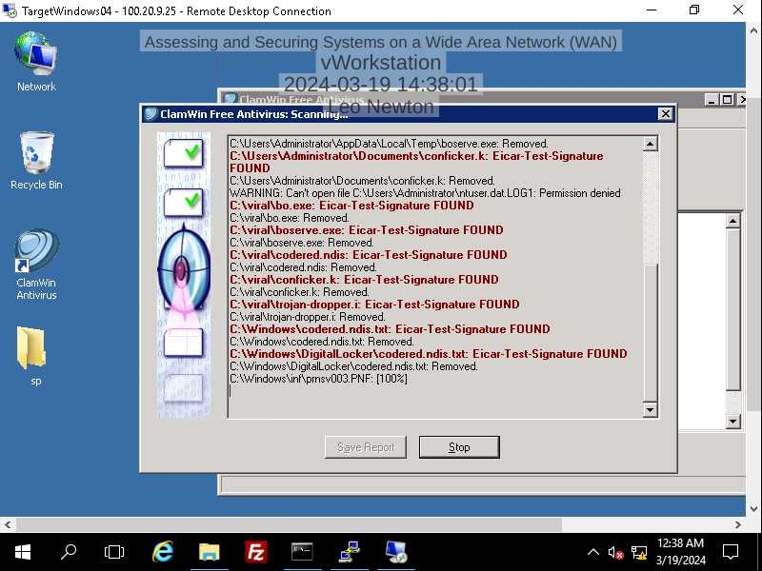 *Figure 3. Clam AV Scan on Target Machine 4*

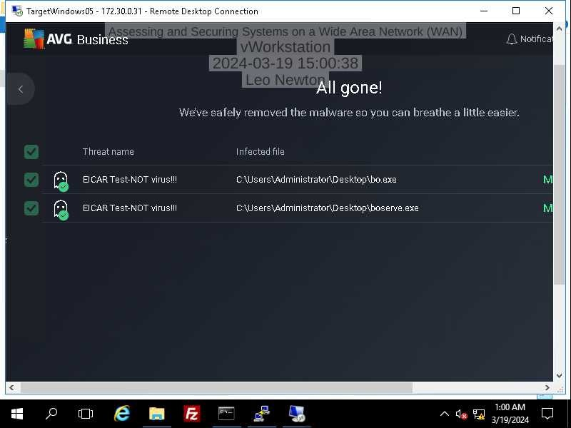 *Figure 4. AV Business Edition Scan on Target Machine 5.*

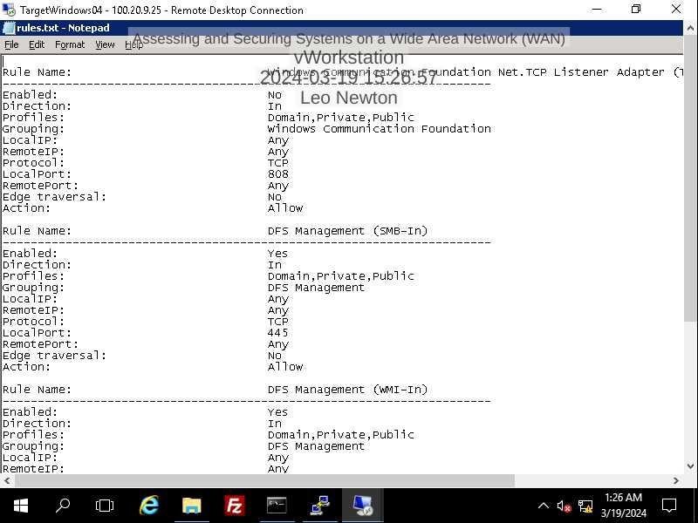 *Figure 5. Netsh output of firewall Rules*

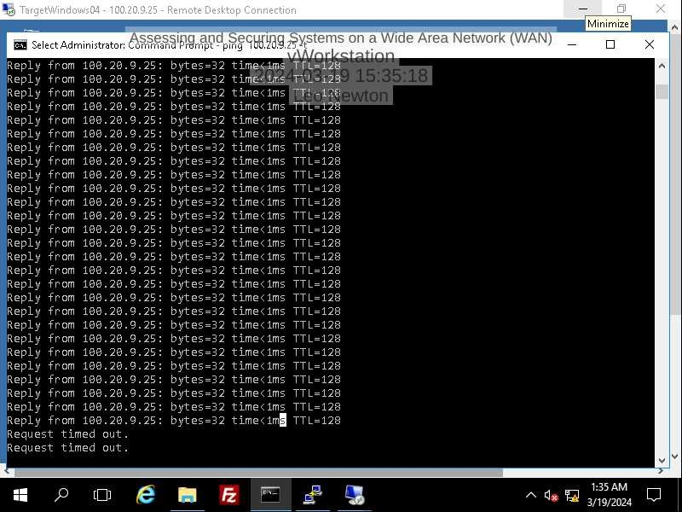 *Figure 6. Ping timeout caused by blocking ICMP packets in firewall on Target Machine 4.*

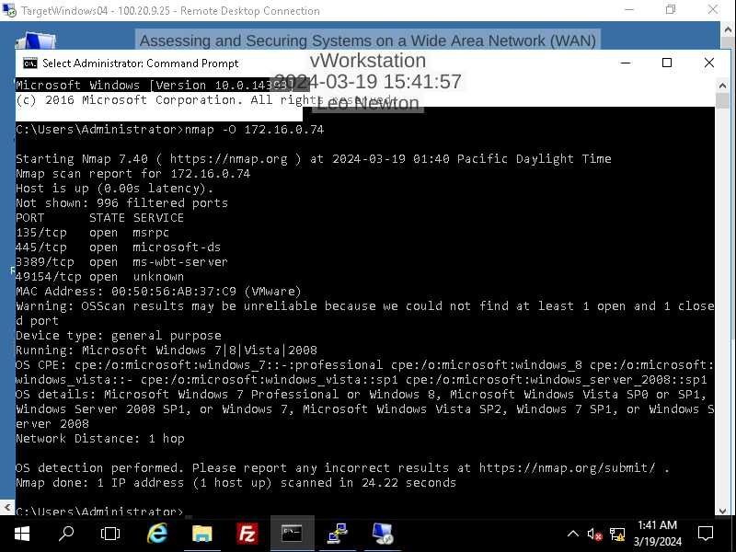 *Figure 7. Nmap OS detection scan after activating firewall with ICMP blocking rule. Ambigous OS Information caused by blocked packets. This hardens the system by hiding OS information.*