URL: <https://4b0b13f8.homepage-a4.pages.dev/gallery>

Chrome:

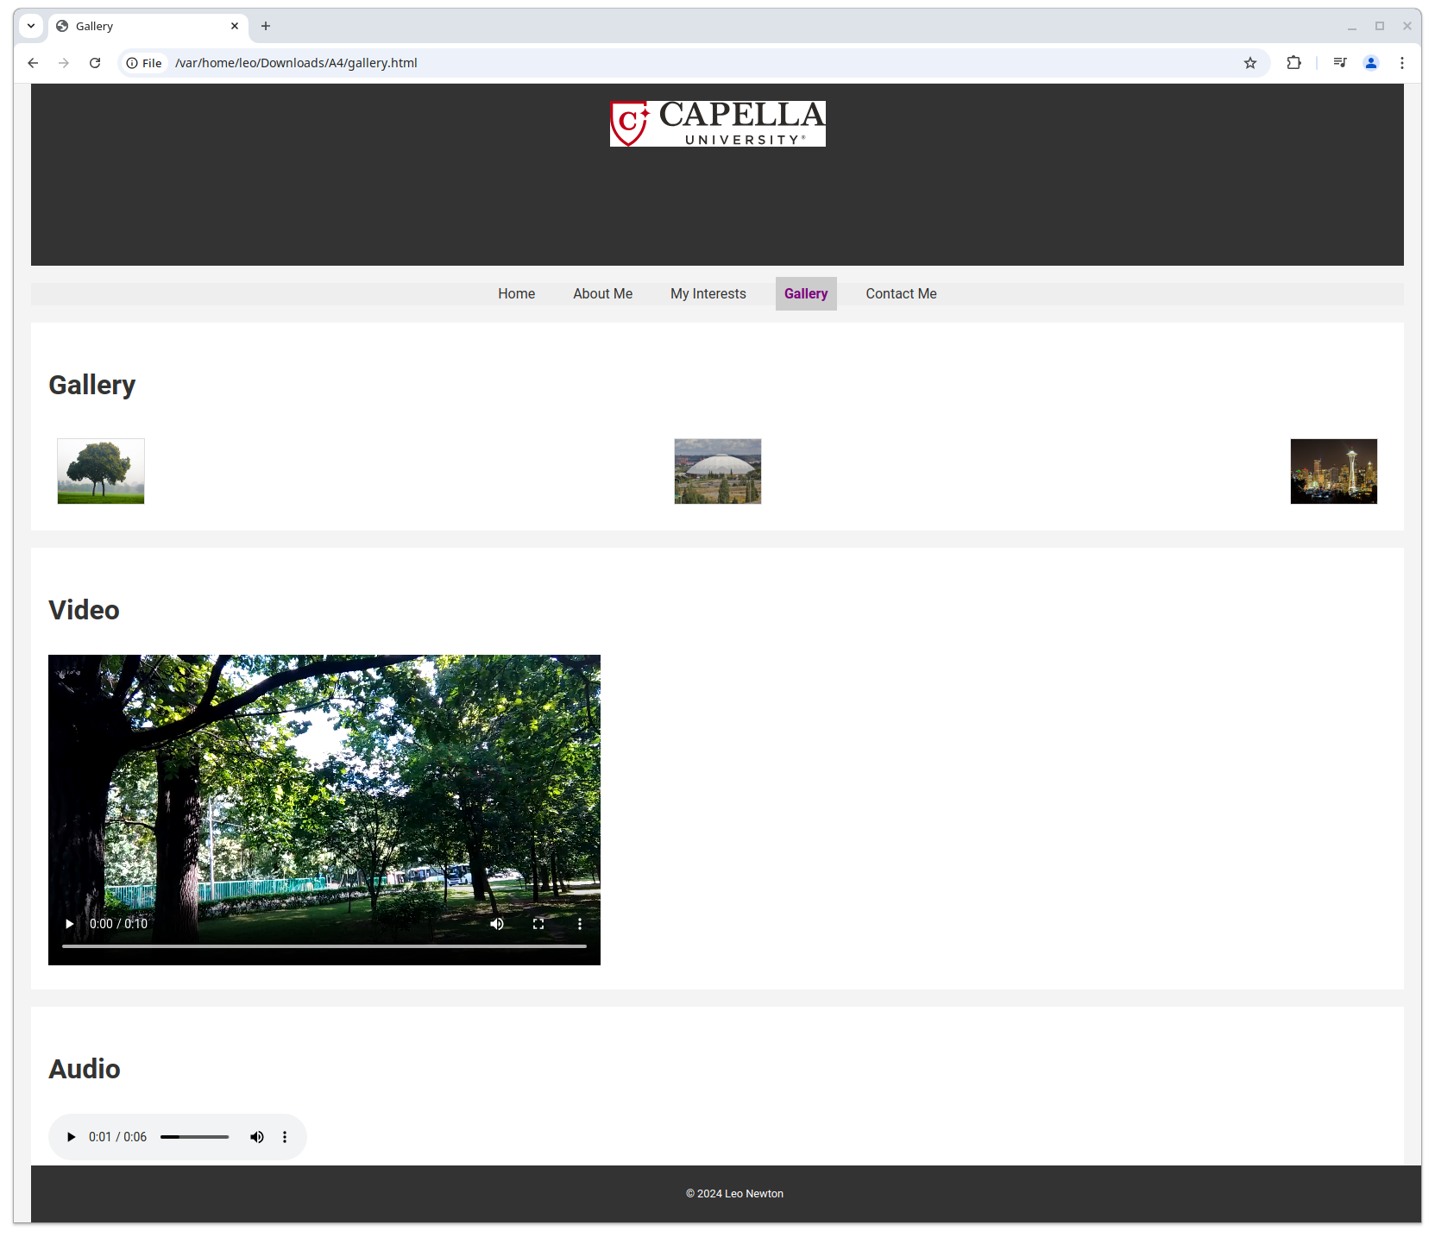

Firefox:

