URL: <https://8a98d34e.homepage-a5.pages.dev/contact>

Chrome: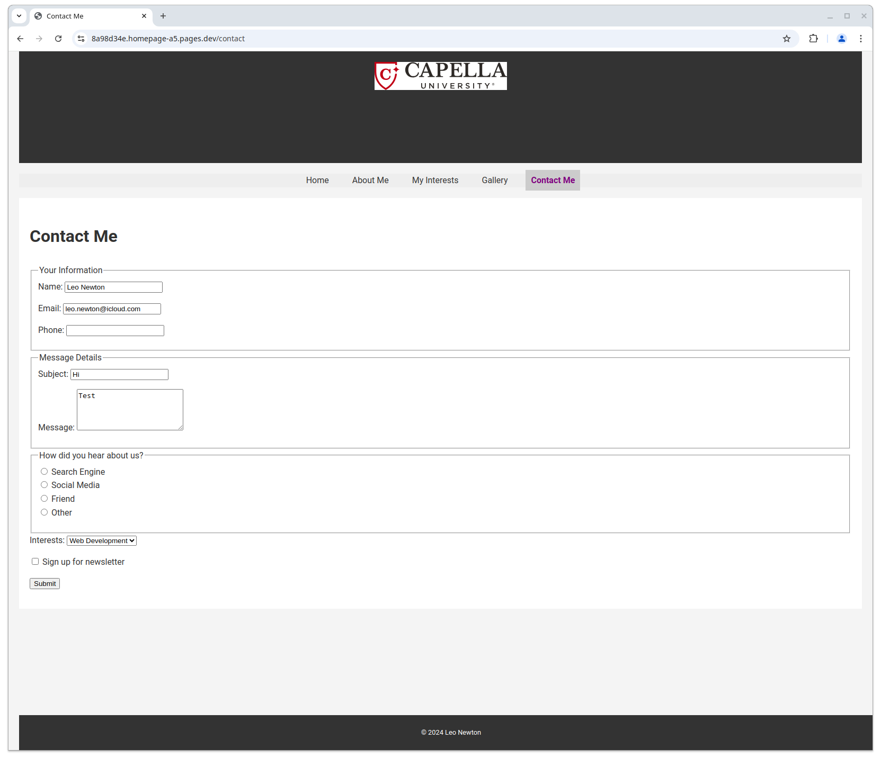

Firefox:

