**1. Which paywalls have the best conversion rate?**

The best conversion rate paywall is **Analytics**, which has a conversion rate of 12.95%.

Based on Ebbinghaus weighted average, the conversion rate chart is as follows:

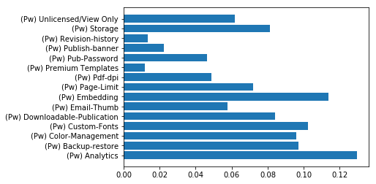

**2. Which paywalls contribute most to revenue?**

The paywall contributing most to revenue is **Storage**, which contributes $11798.02 in total.

Based on Ebbinghaus weighted average, the revenue chart is as follows:

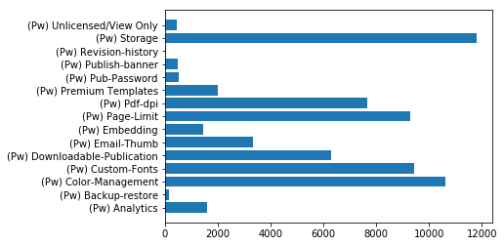

**3. Based on your findings, do you have any recommendations for product changes or further analysis?**

* Recommendations on product:

1. Paywalls with **higher conversion rate** but **lower revenue** (e.g. Analytics, Embedding, Unlicensed/View Only, and Backup-restore) correspond to features which are very attractive for customers but receive very few clicks. The reason might be the following:
   1. low frequency of paywall
   2. ill-design of paywall
   3. feature attracts a portion of customers very much

Product team should increase the frequency of the corresponding paywall or redesign the popup window so that it shows the most attractive and accurate feature. Or customize the paywall display for different customers.

1. Paywalls with **lower conversion rate** but **higher revenue** (e.g. storage and pdf-dpi) correspond to features which receive a bunch of click but only a small portion of them really paid. The reason might be the following:
   1. customers care the topic of the features very much.
   2. customers are not very satisfied with the detailed features.

Product team should pay attention to the topic and develop more features under those topics.

1. Paywalls with **low conversion rate and revenue** (e.g. revision history, premium templates, publish banner, and sub-password) correspond to features that are not important for most of the customers.
2. Paywalls with **high conversion rate and revenue** (e.g. custom-fonts, and color-management) correspond key features that require continuous attentions and efforts.

* Recommendations on analysis:

1. Group customers based on their **subscription status** and make analysis respectively. This gives us more accurate results.
2. Group customers with **clustering algorithms** (based on their information). Perform analysis and apply different paywall display strategies to customers in different clusters respectively.
3. Based on historical data (basic information, geographic data, device data, software usage data, paywall data, and payment data), use **machine learning algorithms** to make real-time prediction on the most interesting paywall for each customer.