* Go to **telegram-bot** directory

Then you will see directory like this image.

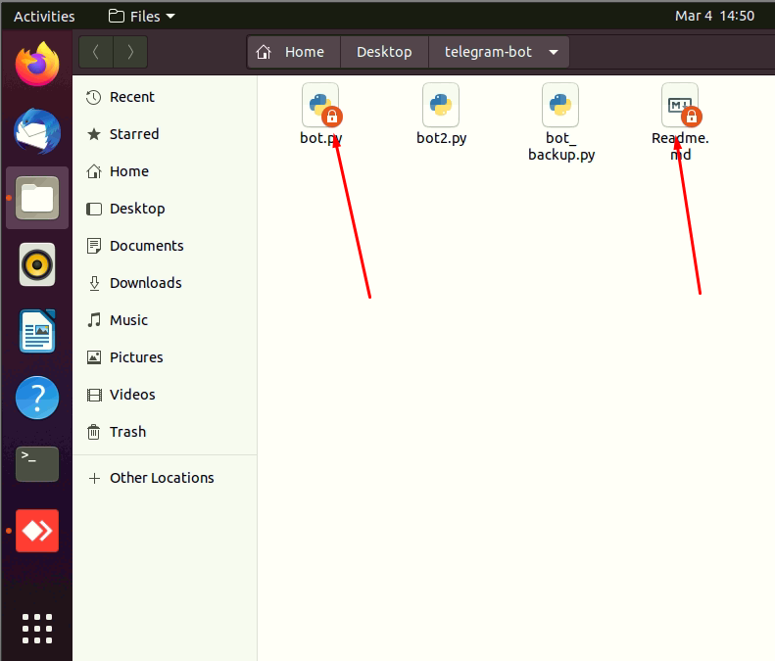

That means currently you don’t have permission to edit that files.

So you need to have admin permission.

* To get admin permission, in that directory press **Ctrl+L**

Then you will see something like this below image.

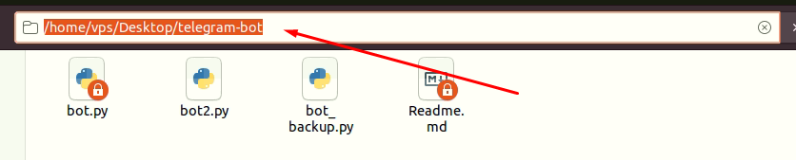

Then type at the first like this **admin:///home/vps/Desktop/telegram-bot**

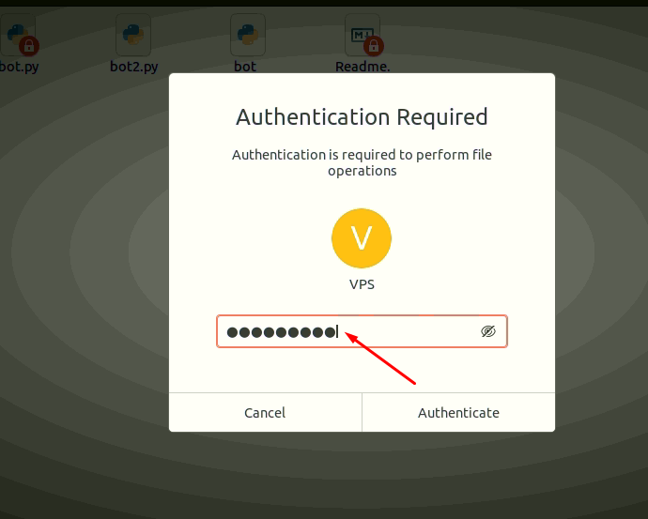

Then type your password for VPS user(PWD is Vps123!@#)

* Success!

Now you have the permission that can edit that files

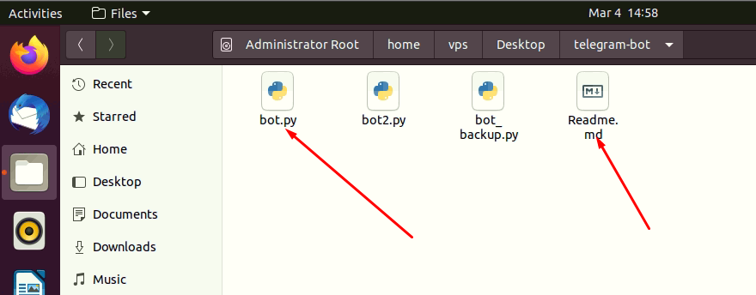

* After you update the file and save it, then do like below
* Open terminal
* Stop your service using this command “sudo systemctl stop telegram-bot-py.service”
* Restart your service using this command “sudo systemctl restart telegram-bot-py.service”
* Done!

To create another new service

!!! Assume your new service name is telegram-bot2-py.service and your script is in same path “/home/VPS/Desktop/telegram-bot/bot2.py”

* Open terminal
* Type su root

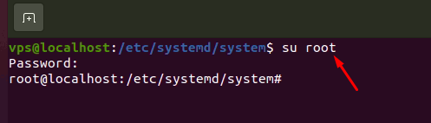

* Type like this “sudo nano /lib/systemd/system/telegram-bot2-py.service“

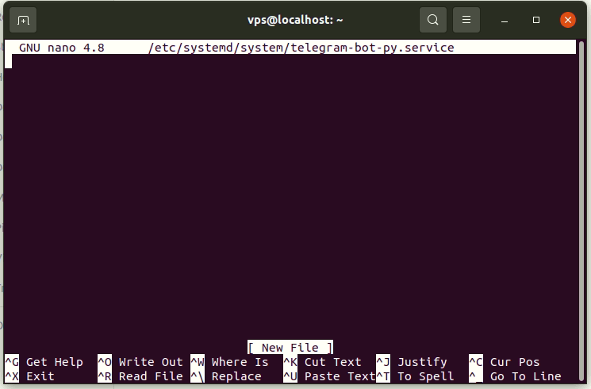

* Type the some command

[Unit]

Description=Telegram bot2 service

After=multi-user.target

Conflicts=getty@tty1.service

[Service]

Type=simple

ExecStart=/usr/bin/python /home/vps/Desktop/telegram-bot/bot2.py

StandardInput=tty-force

[Install]

WantedBy=multi-user.target

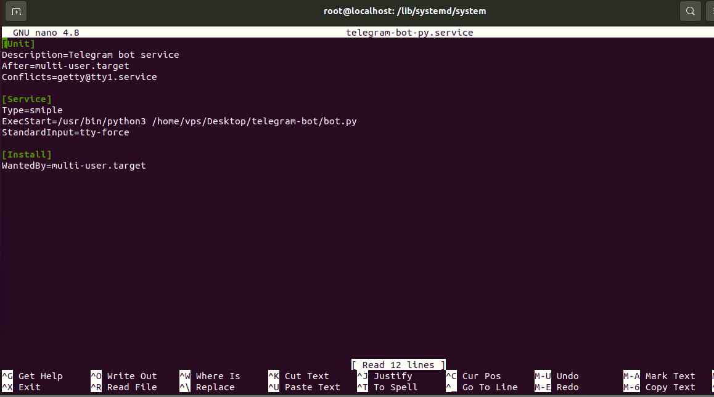

Then press “Ctrl+X” to save.

* Then you can run your service using this command

Sudo systemctl start telegram-bot2-py.service

All Done!