Software Requirements Specification (SRS)
& Initial Use Case Model
Micro-Investment Behaviour Simulation & Peer Benchmarking Dashboard (Mobile App)
Version 1.0
Prepared for: Final Year Project CCDS25-1124
Prepared by: Leong Hao Jie
Supervisor: Dr Gu Chloe
Date: 12 January 2026

Revision History
Version | Date | Author(s) | Reason for Changes
1.0 | 12 Jan 2026 | Leong Hao Jie | Initial SRS and Use Case Model — Phase 0 / Lab #1 deliverable

1. Introduction

1.1 Purpose
This document specifies the requirements, initial use case model, and low-fidelity UI mockups for a mobile application that simulates micro-investment behaviour and provides peer benchmarking insights via an interactive dashboard. It is the first formal work product of the project (Phase 0 of the FYP roadmap, aligned with SE course Lab #1: Requirements Elicitation) and is intended to support requirements traceability and later verification via test cases in subsequent phases.

1.2 Scope / Project Statement
Young investors, especially students, often start with small amounts (micro-investing) but face a benchmarking gap: they lack feedback on whether their investing habits and outcomes are comparable to peers with similar goals and budgets. Existing investment apps typically focus on individual performance, while peer comparison features are limited or absent.
This project develops a mobile app that (1) allows a user to set up a micro-investment plan and run an investment simulation, and (2) visualises the user's behaviour and simulated outcomes against an anonymised peer group using percentile-based benchmarking. The system generates simple insights that encourage healthy, consistent investing habits.

1.3 Intended Audience and Reading Suggestions
Intended audiences include the project supervisor (Dr Gu Chloe), lab TAs / examiners, and the author acting as sole developer. Readers wanting an overview should read Sections 1–2; implementers should focus on Sections 3–6; testers should use the traceability and verifiability notes embedded in Sections 3 and 6.

1.4 Phase 0 Work Products Overview
This SRS is one of several work products completed during Phase 0 — Requirements Lock (January 2026), which corresponds to SE course Lab #1: Requirements Elicitation. Phase 0 as a whole consists of:
- roadmap.md — the FYP project roadmap, mapping Phases 0–9 of the project onto the Lab #1–#5 sequence and the semester timeline.
- Assignment 1 (HW0288 Engineering Communication) — the project introduction and background research write-up, covering the micro-investment market context, competitor apps (Acorns, Stash), and the behavioural-finance rationale for peer benchmarking.
- This document — SRS v1.0, Data Dictionary, initial Use Case Model, and low-fidelity UI mockups (Lab #1 §3.2–3.4).
- The AI Critique Report — a short review of the use case diagram against these requirements (Lab #1 §3.5), submitted as a companion document.

1.5 References
- C. Fox, Introduction to Software Engineering Design: Processes, Principles and Patterns with UML2.
- SC2006 Lab #1 Manual: Requirements Elicitation (course material).
- IEEE SRS Template (Wiegers).
- FYP Project Introduction — "Micro-Investment App with Peer Comparison Dashboard" (CCDS25-1124).
- Assignment 1 project write-up (Engineering Communication, HW0288).

2. Overall Description

2.1 Product Perspective
The system is a standalone mobile application backed by a web API and a relational database. Core computations (simulation, peer benchmarking, insight generation) occur on the backend; the mobile frontend focuses on data entry and visualisation.

2.2 Product Functions (High-level)
- User registration and login
- Profile setup (risk level, goal type, budget band)
- Portfolio template selection and simulation configuration
- Investment simulation run and history viewing
- Dashboard visualisation (growth, behaviour metrics, peer percentile)
- Anonymised peer comparison and insight cards

2.3 User Classes and Characteristics
Primary user class: students and young adults (18–30) with limited investing experience, preferring simple explanations, low cognitive load UI, and mobile-first access. Users may invest small amounts and benefit from habit-focused feedback.

2.4 Operating Environment
Frontend: Mobile (Android/iOS) built with a cross-platform framework (Expo / React Native).
Backend: Web API server (Node.js / Express / TypeScript).
Database: PostgreSQL, accessed via Prisma ORM.
Network: HTTPS over typical mobile / Wi-Fi connections.

2.5 Design and Implementation Constraints
- MVP uses a simplified returns model; live market-data APIs are treated as a future extension.
- Peer comparisons must be privacy-preserving: only aggregated statistics are shown, never raw peer records.
- System must remain implementable by a single developer within the FYP timeline and capacity (see roadmap.md).

2.6 Assumptions and Dependencies
- Users will provide approximate budget and preference inputs.
- Synthetic / anonymised peer data is available for benchmarking (generation strategy is an open item, tracked in Appendix C).
- If market-data integration is implemented later, external API reliability and rate limits will apply.

3. Requirements Specification

3.1 Document Conventions
Functional requirements are labelled FR-xx. Non-functional requirements are labelled NFR-xx. Each requirement is atomic, unambiguous, and verifiable. Trace links are provided to Use Cases (UC-xx) and UI Screens (S-xx), following the heuristics in Fox pp.126–130.

3.2 Functional Requirements
ID | Actor | Trigger / Input | System Response | Output | Pri. | Trace
FR01 | User | Email + password (register) | Create account, store credentials securely | Account created + session | High | UC-01/S-01
FR02 | User | Email + password (login) | Authenticate user | Token/session granted | High | UC-01/S-01
FR03 | User | Risk level, goal type, budget | Save profile, derive budget band | Profile stored | High | UC-02/S-02
FR04 | User | Request templates | Return available portfolio templates | Template list | High | UC-03/S-03
FR05 | User | Template + freq + amount + duration | Validate & create simulation run | Simulation created | High | UC-03/S-03
FR06 | System | Simulation parameters | Compute simulated portfolio value series | Time-series values | High | UC-03/S-04
FR07 | System | Simulation results | Store contributions per period | Contribution records | High | UC-03/S-04
FR08 | User | Open dashboard | Retrieve latest simulation summary | Value/growth chart | High | UC-04/S-04
FR09 | System | User profile attributes | Assign user to peer group | Peer group ID | High | UC-05/S-05
FR10 | System | Peer group data | Compute aggregated benchmark stats | Median, percentiles | High | UC-05/S-05
FR11 | User | Open peer comparison | Compare user vs peer benchmarks | Percentile + median | High | UC-05/S-05
FR12 | User | Open insights | Generate insight cards from gaps | Insight messages | Med | UC-06/S-06
FR13 | User | View history | List past simulations | History list | Med | UC-07/S-04

3.3 Non-Functional Requirements
ID | Category | Requirement | Target / Measure | Pri.
NFR-01 | Performance | Dashboard shall load within acceptable time | < 2s under normal network | High
NFR-02 | Usability | UI usable by novice investors | ≥80% task success in usability test | High
NFR-03 | Privacy | Peer comparisons shall not reveal PII | Only aggregated stats shown | High
NFR-04 | Reliability | System shall handle invalid inputs gracefully | No crash; meaningful errors | Med
NFR-05 | Maintainability | System shall be modular & documented | Clear API separation | Med
NFR-06 | Security | Passwords shall not be stored in plaintext | Stored as salted hash | High

4. Data Dictionary
Term | Description | Attributes (examples) | Relationships
User | A registered individual using the application | user_id, email, created_at | Has one UserProfile; has many Simulations
UserProfile | User preferences for simulation and peer grouping | risk_level, goal_type, budget_band | Belongs to User; determines PeerGroup
PortfolioTemplate | Predefined investment strategy option | name, risk_level, expected_return, volatility | Used by Simulation
Simulation | A simulation run configured by the user | frequency, contribution_amount, duration_months, final_value | Belongs to User; uses PortfolioTemplate; has many Contributions
Contribution | A per-period simulated contribution record | period_index, amount, portfolio_value | Belongs to Simulation
PeerGroup | A logical grouping definition for benchmarking | risk_level, budget_band, goal_type, tier | Has PeerGroupStats
PeerGroupStats | Aggregated statistics for a peer group | median_value, p25, p50, p75, median_consistency | Belongs to PeerGroup
Dashboard | Main UI visualising performance, behaviour, peer stats | portfolio_value, charts, peer_percentile | Consumes Simulation + PeerGroupStats
Insight Card | Short explanation + suggestion from comparisons | message, suggestion, type | Derived from Simulation + PeerGroupStats

5. Initial Use Case Model

5.1 Actors
- User (primary actor — sole actor at this stage; the system has no admin-facing functionality in the MVP)

5.2 Use Cases (Preliminary)
- UC-01 Register/Login
- UC-02 Set Up Profile
- UC-03 Configure & Run Simulation
- UC-04 View Dashboard
- UC-05 View Peer Comparison
- UC-06 View Insights
- UC-07 View Simulation History

5.3 Use Case Diagram
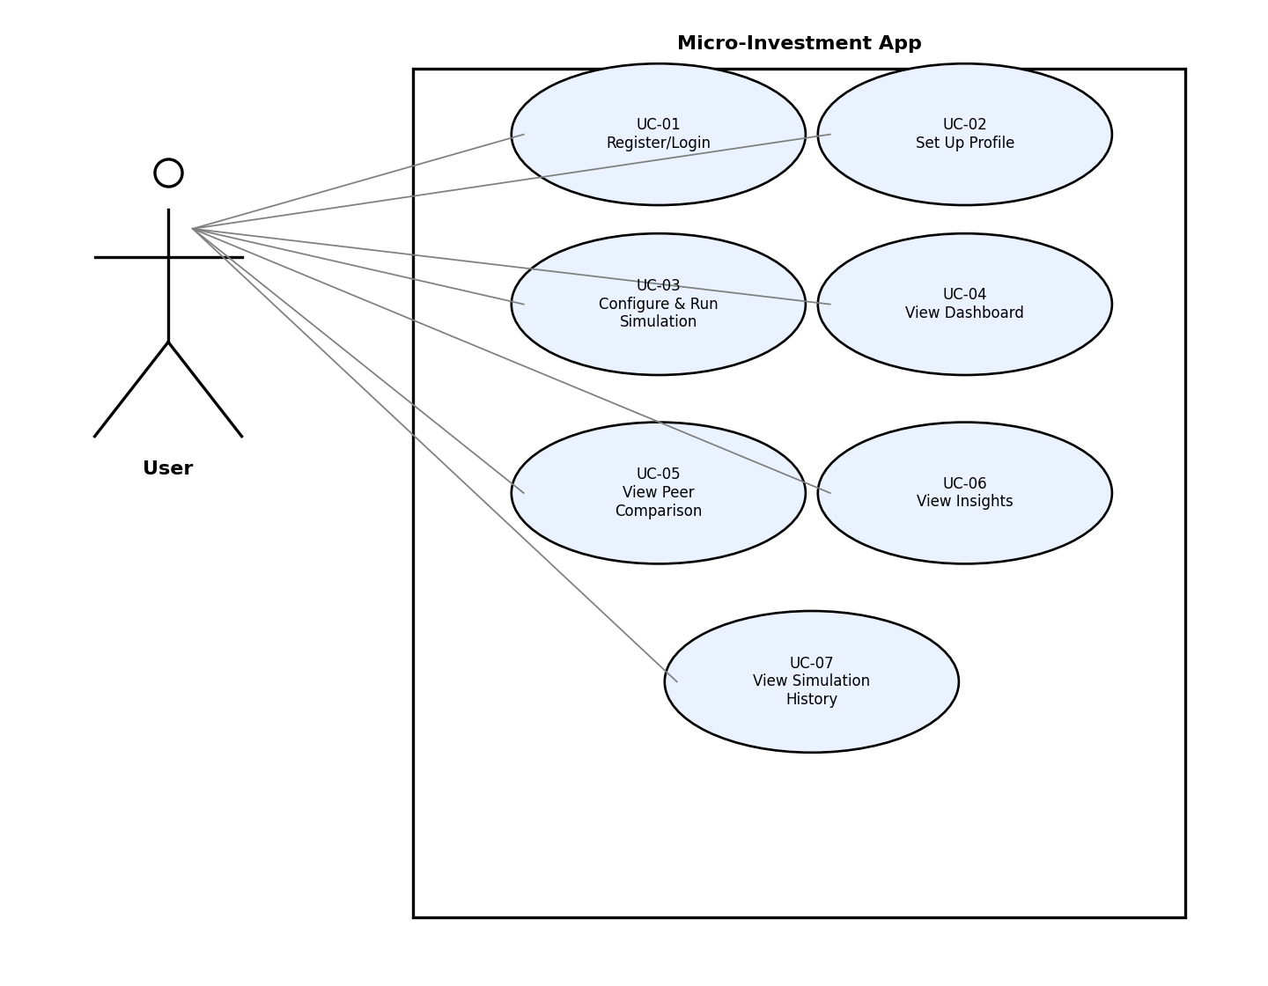

6. Use Case Descriptions

UC-01 Register/Login
Actor: User
Description: User creates an account or logs in to access simulation and dashboard features.
Preconditions:
1. User has the mobile app installed.
2. User has network connectivity.
Postconditions:
1. User is authenticated and has access to the main navigation.
Priority: High Frequency of Use: Low (register), High (login)
Flow of Events (Main Success Scenario):
1. User opens the app and selects Register or Login.
2. User enters email and password.
3. System validates input format.
4. System creates a new account (Register) or verifies credentials (Login).
5. System establishes an authenticated session/token.
6. System navigates to Profile Setup (first-time) or Dashboard (returning user).
Alternative Flows:
- If the user is already logged in, system bypasses login and opens Dashboard.
Exceptions:
- Invalid credentials: system displays error and allows retry.
- Email already used during registration: system prompts user to log in instead.
Special Requirements: Passwords shall be stored as salted hashes (NFR-06).

UC-02 Set Up Profile
Actor: User
Description: User defines investing preferences used for simulation and peer grouping.
Preconditions:
1. User is authenticated.
Postconditions:
1. User profile is stored with risk level, goal type, and budget band.
Priority: High Frequency of Use: Medium
Flow of Events (Main Success Scenario):
1. User selects a risk level (low/medium/high).
2. User selects a goal type (learn/habit/growth).
3. User inputs a monthly budget amount.
4. System maps the budget to a budget band (B1–B4).
5. System stores the profile.
6. System confirms setup completion and navigates to Simulation Setup.
Alternative Flows:
None identified at this stage.
Exceptions:
- Missing required fields: system highlights missing inputs and blocks submission.

UC-03 Configure & Run Simulation
Actor: User
Description: User configures a micro-investment plan and runs a simulation to obtain portfolio growth over time.
Preconditions:
1. User is authenticated.
2. User profile exists.
Postconditions:
1. A new simulation run and its time-series contribution records are stored.
Priority: High Frequency of Use: High
Flow of Events (Main Success Scenario):
1. User opens the Simulate tab.
2. System displays portfolio templates.
3. User selects a portfolio template.
4. User sets contribution amount, frequency (weekly/monthly), and duration.
5. System validates inputs and runs the simulation model.
6. System stores simulation summary and per-period contribution records.
7. System navigates to Dashboard with the latest simulation results.
Alternative Flows:
None identified at this stage.
Exceptions:
- Invalid amount/duration: system displays error and requests correction.
- Network failure during submission: system prompts to retry.
Includes: View Portfolio Templates
Special Requirements: Simulation should be reproducible for the same inputs when using fixed parameters (NFR-04).

UC-04 View Dashboard
Actor: User
Description: User views a summary of simulated performance and behaviour on the dashboard.
Preconditions:
1. User is authenticated.
2. At least one simulation exists.
Postconditions:
1. Dashboard metrics are displayed.
Priority: High Frequency of Use: High
Flow of Events (Main Success Scenario):
1. User opens the Dashboard tab.
2. System retrieves the latest simulation summary (portfolio value, total contributed).
3. System retrieves growth time-series for charting.
4. System computes or retrieves behaviour metrics (consistency score, risk level).
5. System displays metrics and charts in a single scrollable view.
6. User may navigate to Peer Comparison or Insights from the dashboard.
Alternative Flows:
None identified at this stage.
Exceptions:
- No simulation exists: system prompts user to create a simulation.
Special Requirements: Dashboard load time target < 2 seconds (NFR-01).

UC-05 View Peer Comparison
Actor: User
Description: User compares their investing behaviour and performance against an anonymised peer group.
Preconditions:
1. User is authenticated.
2. User profile exists.
3. At least one simulation exists.
Postconditions:
1. Peer percentile and comparison metrics are displayed.
Priority: High Frequency of Use: Medium
Flow of Events (Main Success Scenario):
1. User taps Peer Comparison from the dashboard.
2. System assigns the user to a peer group (risk level + budget band + goal type).
3. System retrieves aggregated peer statistics (median, percentiles).
4. System calculates the user's percentile rank relative to peers.
5. System displays peer percentile and peer median comparisons.
6. System displays a brief peer group description for transparency.
Alternative Flows:
None identified at this stage.
Exceptions:
- Peer group too small: system relaxes grouping rules and recomputes stats.
Special Requirements: Peer comparisons must not expose any peer identities (NFR-03).

UC-06 View Insights
Actor: User
Description: User views short insight cards and suggested actions derived from user vs peer comparisons.
Preconditions:
1. User is authenticated.
2. Peer comparison metrics are available.
Postconditions:
1. Insights are displayed and can influence subsequent simulation configurations.
Priority: Medium Frequency of Use: Medium
Flow of Events (Main Success Scenario):
1. User taps Insights from the dashboard.
2. System retrieves user behaviour metrics and peer benchmark stats.
3. System applies insight rules to detect meaningful gaps (e.g., below peer median consistency).
4. System generates 1–3 insight cards with a short message and suggestion.
5. System displays insight cards in a list.
6. User may tap Adjust Plan to return to Simulation Setup.
Alternative Flows:
- If no significant gaps are detected, system displays a positive reinforcement insight.
Exceptions:
None identified at this stage.

UC-07 View Simulation History
Actor: User
Description: User reviews past simulation runs to compare scenarios and outcomes.
Preconditions:
1. User is authenticated.
Postconditions:
1. A list of simulations is shown; user can open one for details.
Priority: Medium Frequency of Use: Low
Flow of Events (Main Success Scenario):
1. User opens Simulation History from the dashboard or profile.
2. System fetches simulation run summaries sorted by date.
3. System displays a list of past simulations.
4. User selects a simulation run.
5. System displays that run's summary and growth chart.
6. User returns to dashboard or starts a new simulation.
Alternative Flows:
None identified at this stage.
Exceptions:
None identified at this stage.

7. UI Mockups (Low-Fidelity)
A storyboard-style sequence of screens is provided to visualise and refine requirements. Mockups are low-fidelity and focus on layout and information hierarchy, per Lab #1 §3.4.

7.1 Screen List
Screen ID | Screen Name | Purpose
S-01 | Welcome / Login | Authenticate user and enter system
S-02 | Profile Setup | Collect risk, goal, and budget band
S-03 | Simulation Setup | Select portfolio template and plan parameters
S-04 | Dashboard | Show performance summary and growth chart
S-05 | Peer Comparison | Show percentile and peer medians
S-06 | Insights | Provide actionable suggestions

7.2 Wireframe Sketches
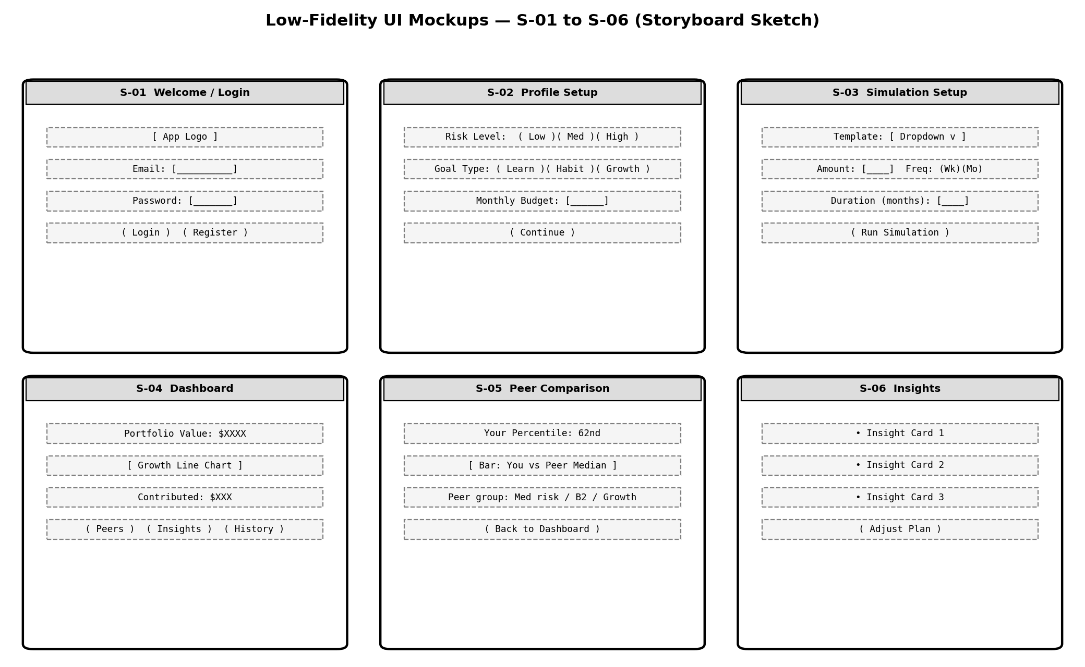

Appendix A: Backend API Summary (MVP, indicative)
- /auth/register, /auth/login
- /user/profile (GET/POST)
- /portfolio/templates
- /simulation/run, /simulation/history
- /dashboard/summary, /dashboard/growth, /dashboard/behaviour
- /peers/summary, /peers/distribution
- /insights

Appendix B: Database Tables (MVP, indicative)
- users
- user_profiles
- portfolio_templates
- simulations
- contributions
- peer_groups
- peer_group_stats

Appendix C: To-Be-Determined List
- TBD-01: Exact simulation return model (fixed-rate vs. stochastic) — to be locked in Phase 1 (Analysis).
- TBD-02: Peer grouping fallback hierarchy when a group is too small — to be detailed in Phase 2 (Design).
- TBD-03: Synthetic peer data generation strategy for seeding — to be resolved before Phase 4/5 testing.
- TBD-04: ConsistencyScore formula — currently undefined.

