Analysis Model
Conceptual Model, Dialog Map & Locked Algorithm Decisions
Micro-Investment Behaviour Simulation & Peer Benchmarking Dashboard (Mobile App)
Version 1.0
Prepared for: Final Year Project CCDS25-1124
Prepared by: Leong Hao Jie
Supervisor: Dr Gu Chloe
Date: 09 February 2026

Revision History
Version | Date | Author(s) | Reason for Changes
1.0 | 09 Feb 2026 | Leong Hao Jie | Initial Analysis Model — Phase 1 / Lab #2 deliverable

1. Introduction
This document is the Phase 1 (Analysis, February 2026) deliverable, aligned with SE course Lab #2: Requirements Analysis. It builds directly on the Phase 0 SRS v1.0 and Use Case Model (January 2026) and on the AI Critique Report, one finding of which is acted on here (Section 2).
Phase 1 covers three things, per the FYP roadmap: (1) the conceptual model — entity, boundary, and control classes derived from FR01–FR13; (2) the dynamic model — a dialog map of UI screens S-01→S-06; and (3) the single most important technical decision in the project, the simulation returns algorithm, which is locked and documented in Section 5. The peer-grouping minimum-size decision that depends on the same trade-off discussion is also recorded here (Section 6), ahead of its full detailed design in Phase 2.

2. Use Case Model Refinement
The AI Critique Report (Lab #1 §3.5) flagged that the Phase 0 use case diagram omitted the <<include>> and <<extend>> relationships already implied by the use case descriptions. Both are now added:
- UC-03 (Configure & Run Simulation) <<include>> a new UC-08 (View Portfolio Templates), matching the “Includes” field already present in the UC-03 description.
- UC-05 (View Peer Comparison) gains an <<extend>> point for the “peer group too small → relax grouping rules” exception flow.
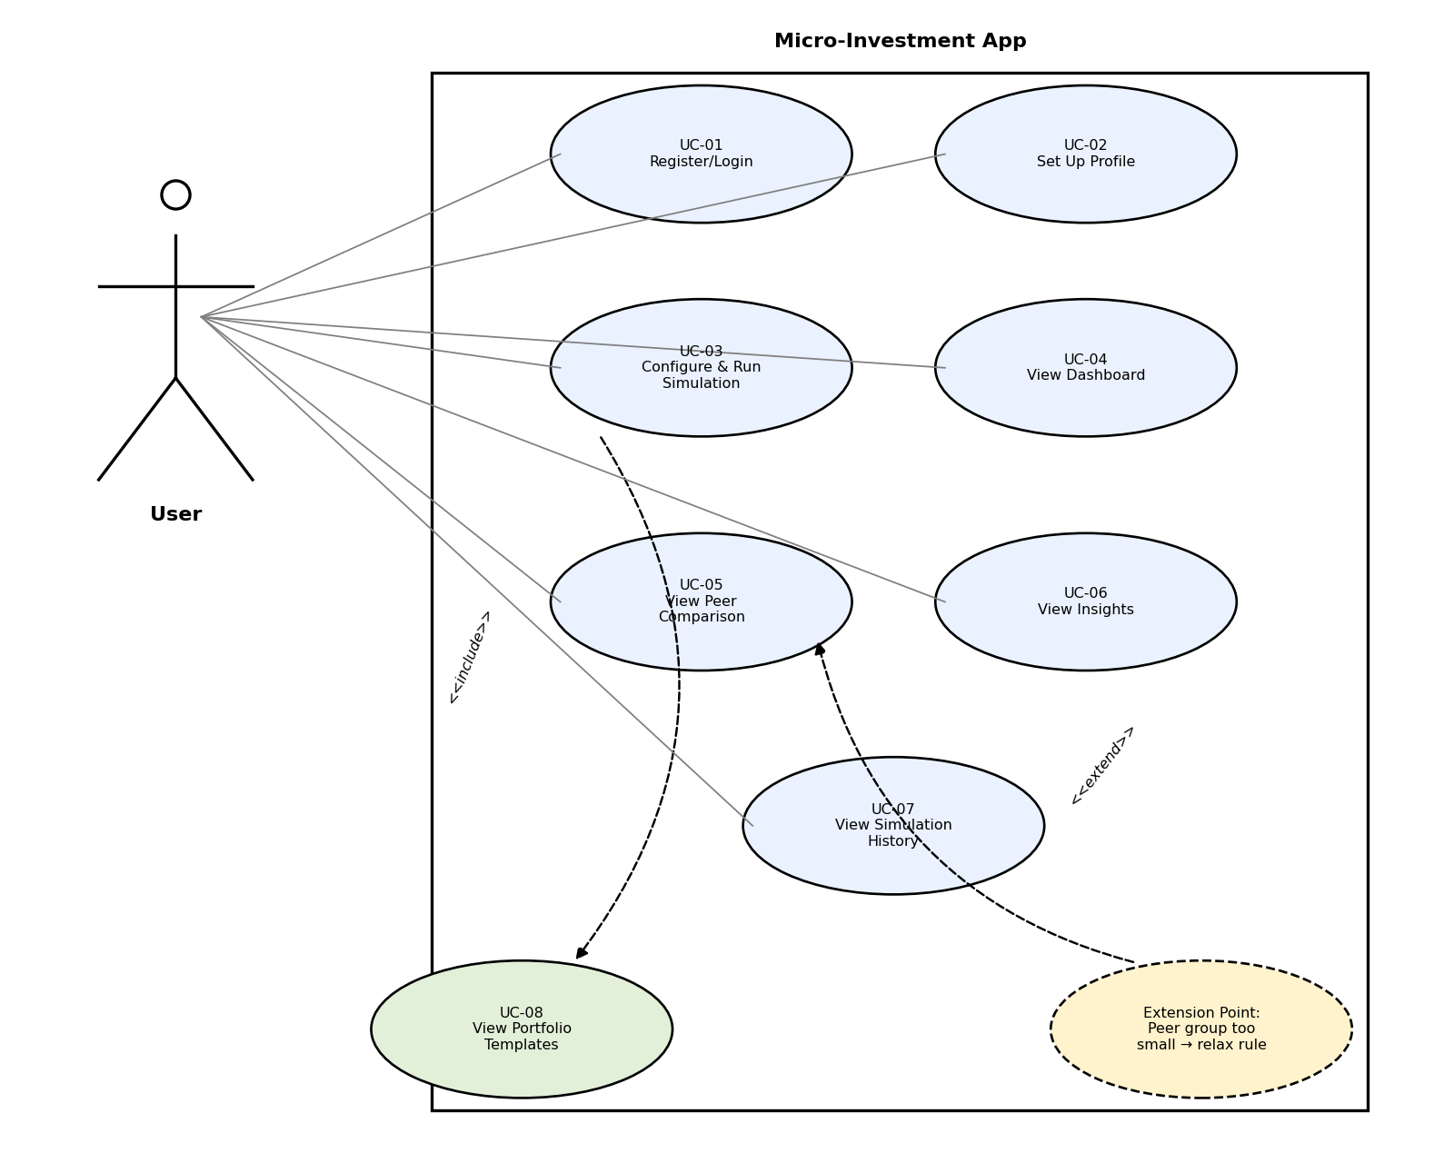
No other use cases changed. UC-01–UC-07 descriptions from the Phase 0 SRS remain valid as written; UC-08 is a short, self-contained use case (system displays available portfolio templates on request) and is not written out in full since it has no independent trigger — it only ever runs as part of UC-03.

3. Conceptual Model (Entity / Boundary / Control)
Following Bruegge Ch.5 and the Lab #2 procedure, classes are identified from the Use Case Descriptions and the Data Dictionary, then stereotyped as entity, boundary, or control.

3.1 Class Inventory
Stereotype | Classes | Source
«boundary» | WelcomeLoginUI, ProfileSetupUI, SimulationSetupUI, DashboardUI, PeerComparisonUI, InsightsUI | One per screen S-01–S-06
«control» | AuthController, ProfileController, SimulationController, PeerGroupingService, PeerBenchmarkService, InsightService | One per major system response in the FR table
«entity» | User, UserProfile, PortfolioTemplate, Simulation, Contribution, PeerGroup, PeerGroupStats, InsightCard | Data Dictionary (SRS §4)

3.2 Class Diagram
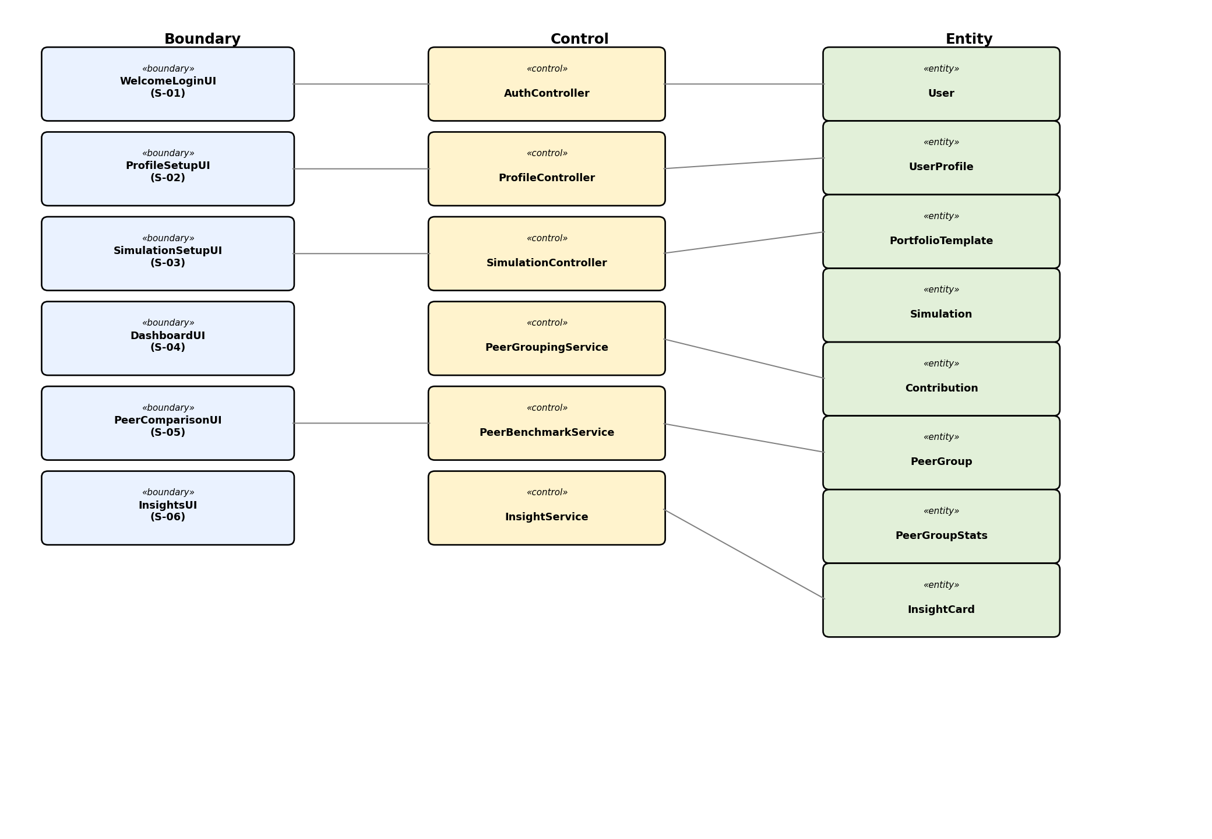
Associations shown are illustrative rather than exhaustive (e.g. AuthController–User, SimulationController–Simulation, PeerGroupingService–PeerGroup, InsightService–InsightCard); the full multiplicities and attribute lists are carried over unchanged from the Data Dictionary and will be elaborated into a design-level class diagram in Phase 2.

4. Dynamic Model (Dialog Map)
The dialog map models the UI as a state machine, built from the Phase 0 low-fidelity mockups (S-01–S-06) plus one additional state (Simulation History list view, FR13/UC-07) that was implicit in the mockups but not drawn as its own screen.
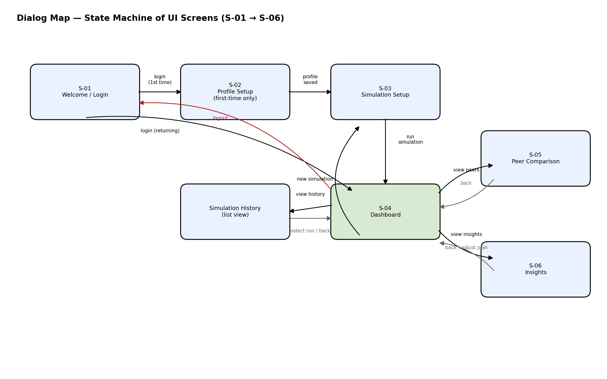
Key transitions: a first-time login routes through Profile Setup before Simulation Setup; a returning user goes straight to the Dashboard. The Dashboard is the hub state, with direct transitions out to Peer Comparison, Insights, and Simulation History, and back again. Logout (grey/red path) is reachable from the Dashboard hub and returns to Welcome/Login from any authenticated state — this closes a gap the Phase 0 SRS review had flagged (no logout/session-expiry requirement); it is now added to the dialog map and should be written up as a new FR/UC in the next SRS revision.

5. Locked Decision 1 — Simulation Returns Model (FR06)
This is the single most important technical decision in the project (roadmap.md, Phase 1) and is now locked.

5.1 Decision
Deterministic fixed-rate periodic compounding.
Each portfolio grows every period by a periodic rate derived from the portfolio template's annualised expected return, compounded on top of that period's contribution. The same inputs always produce the same output — this satisfies NFR-04 (reproducibility) by construction, with no random seeding required.

5.2 Formula
periodicRate = (1 + expectedReturn) ^ (1 / periodsPerYear) − 1
balance[n] = (balance[n-1] + contributionAmount) × (1 + periodicRate)
periodsPerYear is 12 for monthly contributions and 52 for weekly. Duration is expressed in months and converted to a whole number of periods (weekly duration is rounded to the nearest week).

5.3 Alternatives Considered
Option | How it works | Why not chosen
Deterministic + volatility smoothing | Fixed rate ± a seeded, smoothed variation curve derived from template.volatility | Still testable, and would have used every Data Dictionary field, but added complexity not justified for an MVP on a single-developer timeline
Stochastic seeded random walk | True random-walk simulation, seeded per run for reproducibility | Harder to unit test cleanly (Lab #4 black-box target) and harder to justify “why these numbers” in the demo

5.4 Consequence for the Data Dictionary
PortfolioTemplate.volatility is retained in the schema for a possible future extension but is intentionally unused by the MVP simulation function — flagged in code so it is not accidentally wired in without re-opening this decision. Suggested SRS wording: “FR06: the system shall compute portfolio value as a deterministic function of contribution amount, frequency, duration, and the selected template's annualised expected return, using fixed periodic compounding; the same inputs shall always yield the same output (NFR-04).”

6. Locked Decision 2 — Peer Group Minimum Size & Fallback (FR09)
This decision was made alongside Decision 1, since both flow from the same trade-off conversation (accuracy of matching vs. how much synthetic seed data is needed). The full grouping/percentile algorithm design belongs to Phase 2 (roadmap.md); this section locks only the threshold and fallback shape so Phase 2 design has a fixed starting point.

6.1 Decision
MIN_GROUP_SIZE = 10, with a three-tier fallback:
- FULL — riskLevel + budgetBand + goalType (most specific match)
- RISK_BUDGET — riskLevel + budgetBand (goalType relaxed)
- RISK_ONLY — riskLevel only (floor tier; returned even if still below MIN_GROUP_SIZE, since there is nothing broader to fall back to)
The system walks FULL → RISK_BUDGET → RISK_ONLY and stops at the first tier whose member count meets the threshold. A small threshold (10) was chosen deliberately so groups are reachable without heavy synthetic seeding, at the cost of looser peer matches for users in sparsely-populated segments.

6.2 Consequence for the Data Dictionary
PeerGroup.budgetBand and PeerGroup.goalType become nullable (null once relaxed past FULL / RISK_BUDGET respectively), and a tier field (FULL | RISK_BUDGET | RISK_ONLY) is added so the UI can show “peer group description” transparency text (UC-05 step 6) that reflects which tier actually matched.

6.3 Note for Phase 2
The percentile computation itself (median, p25/p75) is deferred to Phase 2 detailed design, where PostgreSQL's native PERCENTILE_CONT/PERCENTILE_DISC window functions will be used directly in SQL rather than hand-rolled in application code.

7. Open Items Carried Forward
Unchanged from the Phase 0 SRS Appendix C, still unresolved:
- ConsistencyScore formula — still undefined; blocks the medianConsistency half of computePeerGroupStats().
- Synthetic peer data generation strategy for seeding — needed to make MIN_GROUP_SIZE=10 reliably reachable in demo/test data; to be resolved before Phase 2 design closes.

