Design Model
Design Class Diagram, System Architecture, DB Schema & Detailed Peer-Grouping Algorithm
Micro-Investment Behaviour Simulation & Peer Benchmarking Dashboard (Mobile App)
Version 1.0
Prepared for: Final Year Project CCDS25-1124
Prepared by: Leong Hao Jie
Supervisor: Dr Gu Chloe
Date: 09 March 2026

Revision History
Version | Date | Author(s) | Reason for Changes
1.0 | 09 Mar 2026 | Leong Hao Jie | Initial Design Model — Phase 2 / Lab #3 deliverable

1. Introduction
This is the Phase 2 (Design, March 2026) deliverable, aligned with SE course Lab #3: Design and Implementation. It transforms the Phase 1 analysis model (entity/boundary/control classes, dialog map) into a design model: system architecture, a design-level class diagram with a start-up class and design patterns, the full database schema, and the detailed peer-grouping/benchmarking algorithm design that Phase 1 deferred.
The tech stack decision from Phase 0/1 is reaffirmed here rather than re-litigated (Section 6), and the skeleton repository referenced throughout this document was scaffolded directly from this design — it already exists and is not being regenerated from scratch (see Lab3_AI_Project_Init_Report.docx for the companion AI-based project-initialisation exercise required by Lab #3 §3.3).

2. System Architecture
The system is a four-layer architecture: mobile client, backend API, ORM, and database, communicating strictly downward (each layer only talks to the one directly below it).
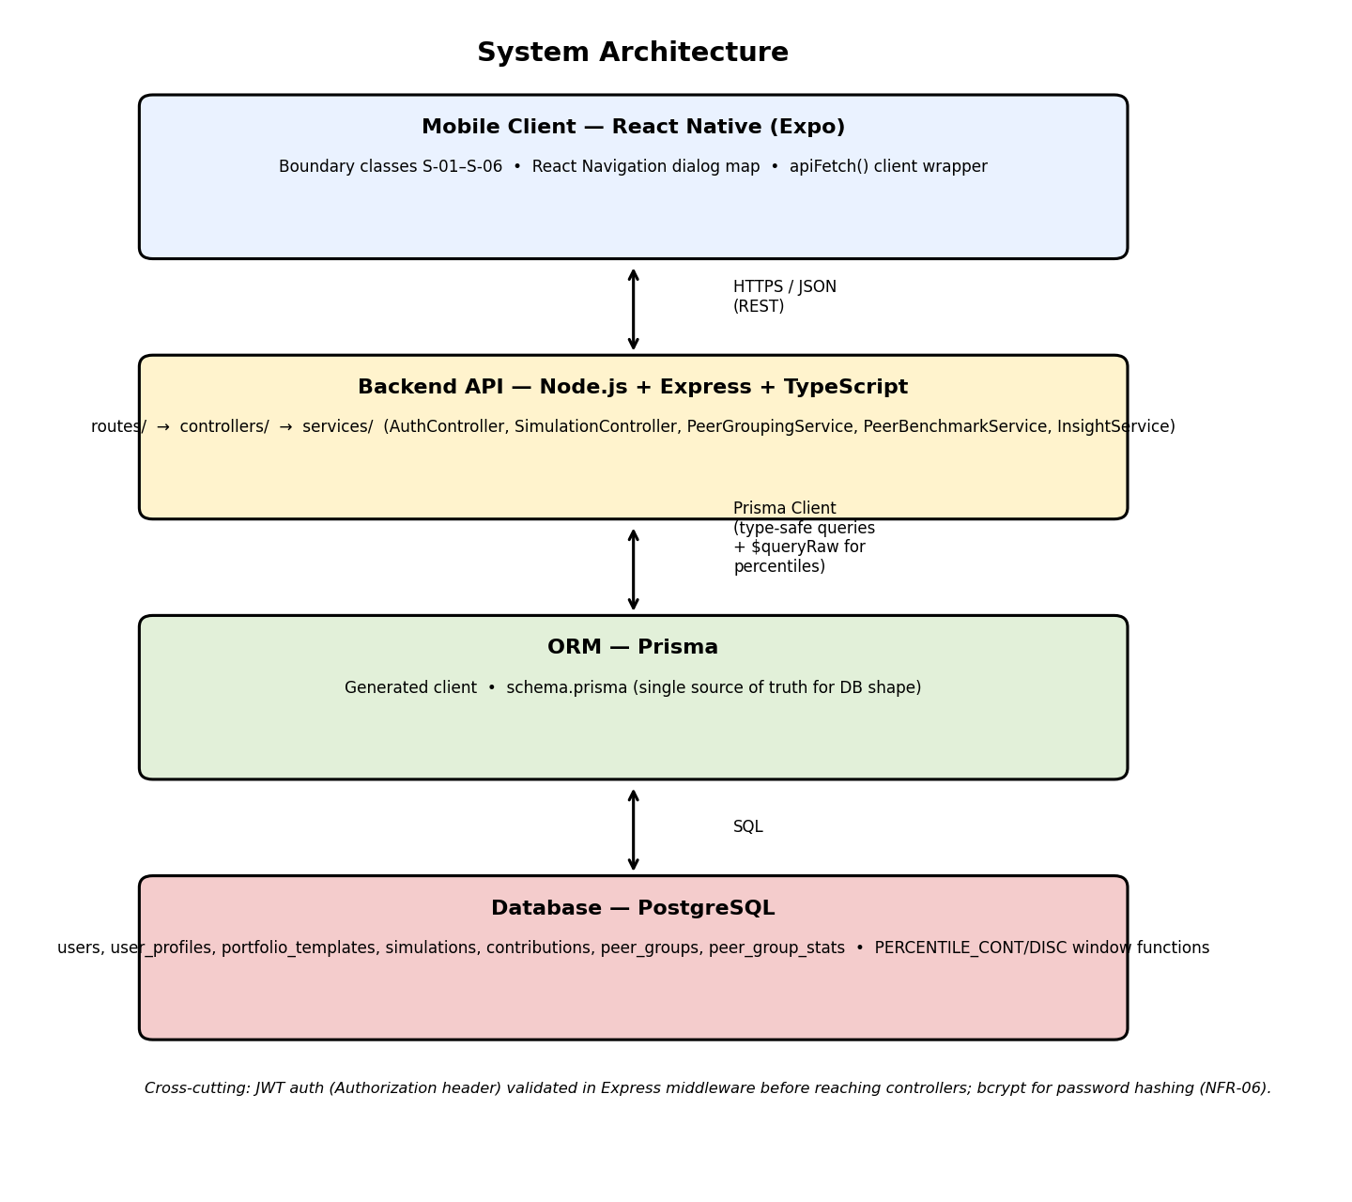

3. Design Class Diagram
Per Fox pp.341–345, the analysis model is extended with a start-up class (AppServer, wiring Express routes and middleware) and a container/repository class (PrismaClient) that mediates all access to entity data — this keeps controllers and services free of raw SQL/ORM calls scattered across the codebase. PeerGroupingService is marked «strategy»: it walks a fixed sequence of matching strategies (FULL → RISK_BUDGET → RISK_ONLY) and returns the first one that satisfies the minimum-group-size constraint, which is the Strategy pattern applied to a fallback chain.
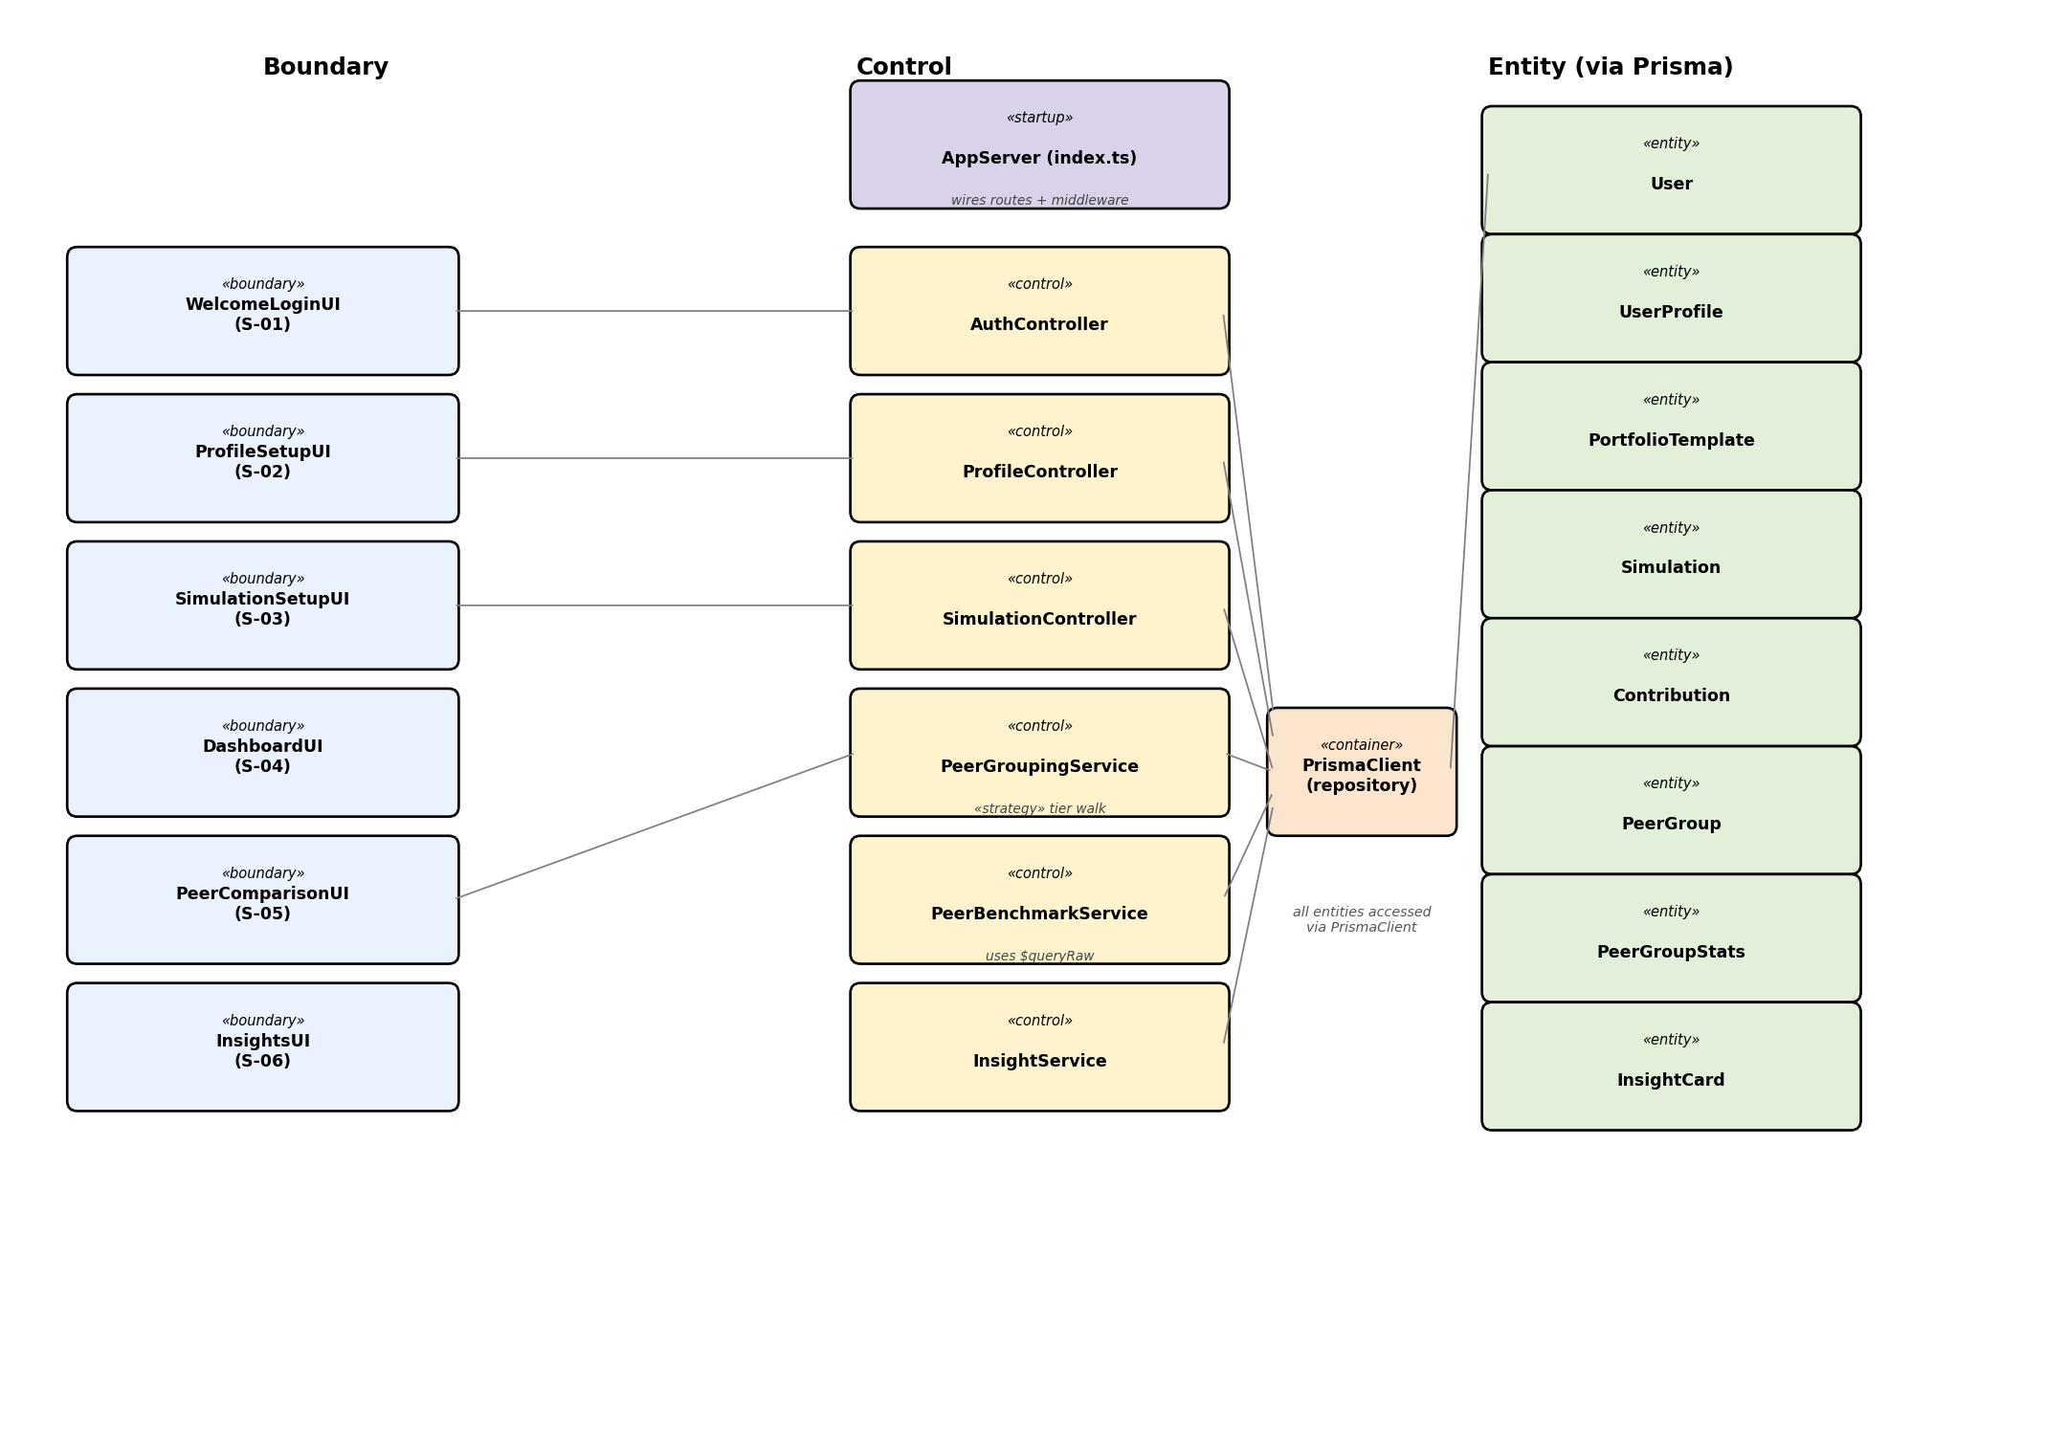

3.1 Key Design Decisions
- Access control: all routes except /auth/register and /auth/login require a valid JWT, checked once in Express middleware (requireAuth) before any controller runs — controllers never re-check auth themselves.
- Persistent data: all persistence goes through Prisma; no controller or service issues raw SQL except PeerBenchmarkService, which uses $queryRaw specifically for PERCENTILE_CONT/PERCENTILE_DISC (Section 5.3).
- Repository pattern: PrismaClient is instantiated once (backend/src/config/prisma.ts) and imported wherever needed, rather than each service creating its own connection.

4. Database Schema
Derived directly from the SRS Data Dictionary (§4) and the Phase 1 locked decisions. Enums first, then tables.

4.1 Enums
Enum | Values
RiskLevel | LOW, MEDIUM, HIGH
GoalType | LEARN, HABIT, GROWTH
BudgetBand | B1, B2, B3, B4
ContributionFrequency | WEEKLY, MONTHLY
PeerGroupTier | FULL, RISK_BUDGET, RISK_ONLY

4.2 Tables
Table | Key Columns | Notes
users | id (PK), email (unique), passwordHash, createdAt | passwordHash is a bcrypt salted hash (NFR-06); never stores plaintext
user_profiles | id (PK), userId (FK→users, unique), riskLevel, goalType, budgetBand | 1:1 with users; budgetBand derived server-side from raw monthly budget input
portfolio_templates | id (PK), name, riskLevel, expectedReturn, volatility | volatility is unused by the MVP simulation (locked Phase 1 decision); retained for a possible future extension
simulations | id (PK), userId (FK), templateId (FK), frequency, contributionAmount, durationMonths, finalValue?, createdAt | finalValue populated once the run completes
contributions | id (PK), simulationId (FK), periodIndex, amount, portfolioValue | one row per period; ordered by periodIndex
peer_groups | id (PK), riskLevel, budgetBand?, goalType?, tier | budgetBand/goalType nullable — null once relaxed past FULL/RISK_BUDGET (Phase 1 §6)
peer_group_stats | id (PK), peerGroupId (FK→peer_groups, unique), medianValue, p25, p50, p75, medianConsistency, memberCount, lastComputedAt | medianConsistency still blocked on the ConsistencyScore formula (open item)

5. Peer-Grouping & Benchmarking Algorithm — Detailed Design
Phase 1 locked the threshold and fallback shape (MIN_GROUP_SIZE = 10, FULL → RISK_BUDGET → RISK_ONLY). This section completes the design: the exact grouping keys, the walk implementation, and the percentile computation strategy.

5.1 Grouping Keys per Tier
Tier | riskLevel | budgetBand | goalType
FULL | ✓ | ✓ | ✓
RISK_BUDGET | ✓ | ✓ | relaxed (null)
RISK_ONLY | ✓ | relaxed (null) | relaxed (null)

5.2 Fallback Walk (assignPeerGroup)
Implemented as three separable branches on purpose — this is the Lab #4 basis-path testing target (roadmap.md, Phase 5), so each branch needs to be independently exercisable in a test:
countFull = count(riskLevel, budgetBand, goalType)
if countFull >= MIN_GROUP_SIZE: return { tier: FULL, ... }
countRiskBudget = count(riskLevel, budgetBand, null)
if countRiskBudget >= MIN_GROUP_SIZE: return { tier: RISK_BUDGET, ... }
countRiskOnly = count(riskLevel, null, null)
return { tier: RISK_ONLY, ... } // floor tier — returned even if still below threshold
RISK_ONLY is deliberately not an error case: with nothing broader left to fall back to, the design treats a below-threshold RISK_ONLY result as “best available”, and leaves it to PeerComparisonUI (S-05) to show the tier-appropriate transparency text from UC-05 step 6 (e.g. a caption noting the match was broadened).

5.3 Percentile Computation Strategy (computePeerGroupStats)
Rather than pulling every peer's simulation rows into application memory and computing percentiles in JavaScript, this design pushes the computation into PostgreSQL directly, using its native window functions — the reason Postgres was chosen over the alternatives in the first place (Lab2_AI_TechStack_Report.docx):
SELECT
PERCENTILE_CONT(0.25) WITHIN GROUP (ORDER BY finalValue) AS p25,
PERCENTILE_CONT(0.5) WITHIN GROUP (ORDER BY finalValue) AS p50,
PERCENTILE_CONT(0.75) WITHIN GROUP (ORDER BY finalValue) AS p75,
COUNT(*) AS memberCount
FROM simulations s
JOIN user_profiles up ON up."userId" = s."userId"
WHERE up."riskLevel" = $1
AND ($2::text IS NULL OR up."budgetBand" = $2)
AND ($3::text IS NULL OR up."goalType" = $3);
The three WHERE clauses are parameterised so the same query serves all three tiers — budgetBand/goalType are passed as null once a tier has relaxed them, matching the fallback walk in §5.2. medianConsistency is deliberately left out of this query; it is still blocked on the ConsistencyScore formula (Section 7).
This is issued via Prisma's $queryRaw, since PERCENTILE_CONT is not exposed through Prisma's query builder — the one place in the codebase where raw SQL is intentional rather than a workaround (see §3.1).

6. Technology Stack (Reaffirmed)
Unchanged from Phase 0/1: React Native (Expo) · Node.js/Express/TypeScript · Prisma · PostgreSQL · JWT + bcrypt · Jest. See Lab3_AI_Project_Init_Report.docx §2 for the repeated AI recommendation exercise against this design-level class diagram, required by Lab #3 §3.3.1.

7. Skeleton Repository Structure
The application skeleton was scaffolded from this design and already exists as a monorepo:
micro-invest-app/
├─ backend/
│ ├─ prisma/schema.prisma (Section 4 schema)
│ ├─ src/routes/ (auth, profile, simulation, peers, insights)
│ ├─ src/controllers/ (thin — delegate to services)
│ ├─ src/services/ (simulation.service.ts, peerGrouping.service.ts, ...)
│ ├─ src/middleware/auth.middleware.ts
│ └─ src/config/prisma.ts (PrismaClient singleton)
└─ mobile/
├─ src/screens/ (S-01 – S-06)
├─ src/navigation/AppNavigator.tsx (dialog map, Phase 1 §4)
└─ src/api/client.ts (apiFetch wrapper)
DECISIONS.md at the repo root records the Phase 1 locked decisions (Sections 5–6 of this document) with the exact SRS wording suggested for each.

8. Open Items Carried Forward
- ConsistencyScore formula — still undefined; blocks medianConsistency in the query in §5.3.
- Synthetic peer data generation strategy for seeding — needed so MIN_GROUP_SIZE=10 is reliably reachable across all three tiers during Lab #4 testing and the final demo.

