
Interim Report
Micro-Investment App with Peer Comparison Dashboard
Leong Hao Jie

Supervisor:
Dr Gu Chloe
College of Computing and Data Science
Submitted in Partial Fulfillment of the Requirements for
The Degree of Bachelor of Engineering (Computer Engineering)
Nanyang Technological University
2026

ABSTRACT
Micro-investment platforms have made small, regular investing accessible to young adults, but the feedback they give is almost entirely individual: a balance, a return, and a contribution history. A novice investor has no reference point against which to judge whether those figures, or the habits producing them, are reasonable. Behavioral finance research established that peer information changes financial decisions substantially, yet separate evidence shows that presenting peer information competitively, through leaderboard, copy trading or gamified interfaces, increases risk-taking and lowers satisfaction, particularly among the least experienced user. The two literatures point in opposite directions, and no deployed micro-investment platform offers peer benchmarking as a core feature.
This project designs and implements a mobile application that simulates micro-investment plans and benchmarks a user’s simulated outcomes and contribution behavior against an anonymised peer group, in a form intended to support habit formation rather than performance chasing. The system is a four-layer architecture comprising a React Native client, a Node.js and TypeScript service layer, the Prisma object-relational mapper and PostgreSQL. A user composes a portfolio from a catalogue of real funds with user-set weights, funds it by scheduled deposit or by round-up, and receives a deterministic simulation that replays each fund’s real historical annual returns rather than assuming a rate of return. Peer groups are formed on profile similarity, and benchmark statistics are computed as percentiles inside the database. Only aggregated statistics ever reach the client

ACKNOWLEDGEMENTS
I would like to express my deep gratitude to the College of Computing and Data Science, NTU, for providing the resources and guidance to assist in my Final Year Project. I also extend my thanks to Dr Gu Chloe, my final year project supervisor. I am also grateful to the online community for providing free access to open source tools that allowed me to complete this project.

TABLE OF CONTENTS
ABSTRACT 2
ACKNOWLEDGEMENTS 3
TABLE OF CONTENTS 4
LIST OF FIGURES 6
LIST OF TABLES 7
CHAPTER 1: INTRODUCTION 8
1.1 Background 8
1.2 Problem Statement / Research Gap 9
1.3 Objectives 10
1.4 Scope 10
CHAPTER 2: LITERATURE REVIEW 13
2.1 Micro-Investment Platforms 13
2.2 Peer Effects in Financial Decision-Making 13
2.3 Related Systems / Existing Solutions 13
2.4 Summary of Research Gap 14
CHAPTER 3: METHODOLOGY 15
3.1 Development Methodology 15
3.2 Requirements Specification 15
3.3 Analysis Model 15
3.4 Tools and Technologies 15
CHAPTER 4: SYSTEM DESIGN & IMPLEMENTATION 17
4.1 System Architecture 17
4.2 Authentication, Profile and Portfolio Composition 18
4.3 Simulation Engine 19
4.4 Database Design 19
4.5 User Interface Design 19
4.6 Challenges & Troubleshooting 19
CHAPTER 5: RESULTS, TESTING & DISCUSSION 21
5.1 Testing Methodology 21
5.2 Results 21
5.2.1 Differentiation between portfolios 21
5.2.2 Equivalence of the two contribution mechanisms 22
5.3 Discussion 23
CHAPTER 6: CONCLUSION & FUTURE WORK 25
6.1 Conclusion 25
6.2 Future Work 25
REFERENCES 27

LIST OF FIGURES
Figure 1: Four-layer system architecture of the implemented system 17
Figure 2: Worked example of the implemented simulation engine 22

LIST OF TABLES
Table 1: Project Timeline 12
Table 2: Feedback provided by representative micro-investment platforms 14
Table 3: Tools and technologies used in the implementation 16
Table 4: Fund catalogue and real historical return series 18
Table 5: Simulated outcomes for an identical plan across portfolios 22
Table 6: Functional requirements tested 24
Table 7: Planned work for the remainder of the project 26

CHAPTER 1: INTRODUCTION

1.1 Background
Digital financial services have reduced the cost of entry to investing. Micro-investment platforms allow a user to commit very small sums, a few dollars at a time, either by purchasing fractional shares or by automating regular contributions. A fractional share is a proportional slice of a whole share, so an investor no longer needs the full market price of a security in order to hold a position in it [1]. Removing that price barrier matters most to students and young adults with irregular incomes and small investable balances.
Two contribution mechanisms have made frequent, small investing practical. The first is the round-up, in which the difference between a card purchase and the next whole dollar is swept into an investment account; Acorns built its product around this mechanism [2]. The second is the scheduled deposit, a fixed sum transferred on a fixed schedule, which platforms such as Stash pair with fractional-share access and a round-up facility of their own [3]. Both mechanisms convert investing from a deliberate, occasional decision into a background habit.
The same pattern exists in Singapore in a more conservative form. Regular savings plans (RSPs) offered by retail banks, POSB/DBS Invest-Saver, for example, allow an investor to commit a fixed monthly sum to a selection of SGX-listed exchange-traded funds and unit trusts, with the bank purchasing fractional units on the investor's behalf [4]. The local platforms are different, but the underlying proposition is identical: small amounts, contributed regularly, into a diversified holding.
Adoption, however, does not imply competence. A nationally representative study of financial literacy in Singapore found that only 39 per cent of respondents answered all three of the standard "Big Three" financial literacy questions correctly, with risk diversification the weakest area of the three, and that financially literate individuals were roughly three times more likely to actively choose their investment options rather than default into them [5]. A 2025 survey of 1,011 Singapore retail investors reported that younger investors held smaller allocations to Singapore equities than older cohorts, that 31 per cent of those with little local exposure cited unfamiliarity as the reason, and that beginner investors ranked guidance and educational resources well above other needs [6]. The population that micro-investment apps serve best is therefore also the population least equipped to interpret what those apps show them.

1.2 Problem Statement / Research Gap
Existing micro-investment platforms provide feedback that is almost entirely individual. A user sees a portfolio balance, a return figure, and a contribution history, an accurate account of what happened to their own money, and nothing else. For an experienced investor with a sense of what a reasonable outcome looks like, that is sufficient. For a novice, it is not. A user who has contributed S$900 over a year and holds S$940 has no basis on which to judge whether that outcome is good, poor, or unremarkable, and no basis at all on which to judge the behavior that produced it. The absolute number answers "what happened" but leaves "how am I doing" unanswered.
Behavioral finance offers a well-evidenced source of the missing reference point: other people. Peer information changes financial decisions, through mechanisms that have been experimentally isolated and are quantitatively large [7], [8]. Yet peer information is not automatically useful. The same broad literature shows that peer information presented competitively, as a ranking against top performers, as a portfolio to copy, or through a gamified interface, increases risk-taking, increases trading and lowers satisfaction, and does so most strongly among the least experienced users [9] - [11].
The problem this project addresses is narrower and harder than "micro-investment apps lack peer comparison". It is this: peer comparison is a powerful and evidenced lever, can peer information be delivered in a form that supports habit formation rather than performance chasing, and what does a system that does so actually look like?
The position taken in this project is that it can, provided four constraints are followed: the comparison is made against a group aggregate rather than a named individual; behaviour, and specifically contribution consistency, is benchmarked alongside outcome; users are grouped by genuine similarity so that the comparison is informative; and only aggregated statistics ever leave the server, so no peer's individual record is exposed. Implementing those constraints raises the engineering problems that form the substance of the project. Peer groups must be assigned from profile attributes and must degrade gracefully when a group is too sparse to be meaningful. Aggregate statistics must be computed efficiently over a growing user base. Simulated outcomes must be reproducible, so that a user comparing two plans is seeing a real difference between the plans and not the residue of a random draw. And the entire benchmarking path must be constructed so that individual peer records are structurally unavailable to the client, not merely omitted from it.

1.3 Objectives
The project’s objectives are:
- To design and implement a mobile application that allows a user to configure a micro-investment plan – choosing a contribution mechanism, amount, frequency and duration, and to run a reproducible simulation of that plan’s outcome.
- To ground the simulation in real market history rather than an abstract assumed rate of return, so that the outcomes shown to a user correspond to the behaviour or real, identifiable funds.
- To design and implement a peer-grouping algorithm that assigns users to comparison groups on profile similarity.
- To compute percentile-based benchmarks over those groups efficiently, and to expose only aggregated statistics to the client.
- To generate rule-based insights from the gap between a user's own behaviour and their peer group's aggregate, framed to encourage consistency rather than return-chasing.
- To verify the resulting system through a documented programme of black-box and white-box testing, and to evaluate it against the non-functional requirements set out in the specification.

1.4 Scope
The system is a simulation. It does not execute trades, hold client money, connect to a brokerage, or constitute financial advice, and no part of the design assumes a regulated financial service. This is a deliberate boundary: it allows the behavioural and architectural questions above to be studied without the licensing, custody and settlement obligations that a real investment product would attract.
Four limitations follow from that boundary and from the resources available to a single-developer final year project, and are stated here so that the results in later chapters are read correctly:
- Returns are historical, not predictive. The engine replays real annual returns recorded for real funds; it does not forecast, and a simulated outcome is a statement about how a plan would have performed over a past period, not an expectation about the future.
- Peer data is partly synthetic. With no real user base, peer groups are intended to be populated by generated peers so that the grouping and benchmarking logic can be exercised. Benchmarks are therefore demonstrably correct but not empirically meaningful.
- Market data is static seed data. A live market-data feed was researched during implementation and the provided catalogue is fixed at build time.
- No behavioural evaluation is attempted. Whether the dashboard actually changes saving behaviour is an empirical question requiring a longitudinal study with human subjects, which is outside the scope of an engineering final year project. What is evaluated here is whether the system correctly and privately delivers the comparison the literature motivates.

Period | Milestones
January 2026 | Phase 0 – Requirements lock. Specification v1.0, data dictionary, use case model, low fidelity UI mockups
February 2026 | Phase 1 – Analysis. Conceptual class diagram dialog map, simulation model, peer grouping fallback (v1.1)
March 2026 | Phase 2 – Design. Architecture, database schema and peer-grouping algorithm designed, synthetic peer data strategy locked (v1.2)
April 2026 | Phase 3 – Core Implementation. Auth, Profile setup, Portfolio template
May 2026 | Phase 4 – Simulation Engine. Simulation configuration, Profile setup, Portfolio template
June 2026 | Phase 5 – Peer Benchmarking Engine. Peer group assignment logic, aggregate stats computation, percentile comparison endpoint
July 2026 | Phase 6 – Insight Generation. Rule-based insight cards from user vs peer gaps, User interface
August 2026 | Phase 7 – Core Implementation Round 2. Simulation model amended twice and contribution mechanism added (v1.3-v1.5)
September 2026 | Phase 8 – History, polish and non-functional verification. Simulation history (FR13), performance and usability measurement
October 2026 | Phase 9 – Formal black-box and white-box testing programme
November – December 2026 | Phase 10 – Documentation realignment, demonstration preparation and final report
Table 1: Project Timeline

CHAPTER 2: LITERATURE REVIEW

2.1 Micro-Investment Platforms
Micro-investing depends on two enabling capabilities. The first is fractional-share ownership, which allows an order smaller than the price of one share to be filled as a proportional slice of that share. The second is automation of the contribution itself, which removes the need for a repeated decision.
Acorns is an example of automated contribution. Its round-up mechanism links to a user’s payment cards, rounds each transaction up to the next whole dollar, and invests the accumulated difference [2]. The design insight is that the contribution decision is made once, at setup, and thereafter the contribution stream is a by-product of spending. Stash combines fractional-share access with a comparable round-up facility and scheduled recurring deposits [3].
The Singapore market reaches a similar outcome through bank-intermediated regular savings plans rather than app-native round-ups. POSB/DBS Invest-Saver allows a fixed monthly sum to be committed to a selected list of SGX-listed exchange-traded funds and unit trusts, with the bank purchasing fractional units on the investor’s behalf [4]. This project’s fund catalogue draws on the SGX counters available through such plans, so that the outcome it simulates corresponds to how a Singapore-based user could actually access.

2.2 Peer Effects in Financial Decision-Making
Research shows that comparing ourselves to others can affect how we make financial decisions, and the causal evidence is unusually good for a behavioural finance question. Bursztyn and co-authors, working with a Brazilian brokerage and 150 pairs of socially connected clients, used a lottery to break the correlation between a peer’s decision to buy an asset and their actually acquiring it, which separates the effect of learning that a peer chose an asset from the effect of that peer possessing it [7]. Take-up among second investors was 42 per cent with no peer information, 71 per cent when told the peer had chosen to buy but the lottery had denied the purchase, and 93 per cent when told the peer had both chosen and acquired. Both channels are significant, and both are large.
Observational work at national scale points the same way. Lin and co-authors, using the 2019 China Household Finance Survey, reported that peer effects significantly raise household stock market participation, with social interaction and information diffusion identified as the operative pathways [8]. People are more likely to change their investment choices when they know about the financial behaviour of those around them, and the way information spreads through a social network also affects whether someone decides to participate at all [8]. This suggests that adding peer information could influence how people use financial systems. However, most micro-investment platforms do not include benchmarking dashboards as a main feature.

2.3 Risks of Social Features in Investment Interfaces
A second and equally well-evidenced literature establishes that peer information presented as competition damages the decisions of the people exposed to it, and it constrains this project’s design directly. Andraszewicz and co-authors ran a controlled experiment on a simulated stock market with 807 experienced retail investors: those shown the results of the best-performing investors subsequently took more portfolio risk, traded more, and reported substantially lower satisfaction with their own performance than a control group that saw only its own results [9]. Apesteguia, Oechssler and Weidenholzer examined the stronger case where imitation is possible: 35 per cent of participants chose to copy another participant, and of those, 88 per cent copied someone who had selected the riskiest available asset, producing excessive risk-taking concentrated among otherwise risk-averse investors [10]. Chapkovski, Khapko and Zoican found that gamified trading interfaces disproportionately attract investors with lower financial knowledge, which matters here because the target user of this project is precisely a low-experience investor [11]. A fourth constraint comes from the privacy literature: Sweeney’s k-anonymity model requires that a released record be indistinguishable from at least k−1 others with respect to the quasi-identifiers it exposes, and risk level, budget band and goal type are exactly such quasi-identifiers [12]. Together these findings rule out an entire family of designs.

2.4 Related Systems / Existing Solutions
Even though more people are using deployed micro-investment platforms, these apps focus on tracking individual portfolios. All of them report, to each user, their position: current balance, returns, and a contribution history. None of them, as a main feature, tells the user how their position compares with the positions of comparable users. Table 4 sets out the comparison and positions of the present system against this project.

Platform | Contribution mechanism | Feedback to the user | Peer comparison
Acorns [2] | Card round-ups; recurring deposits | Balance, return, contribution history | Not a core feature
Stash [3] | Recurring deposits; round-ups; fractional shares | Balance, return, holdings breakdown | Not a core feature
POSB/DBS Invest-Saver [4] | Fixed monthly plan into SGX ETFs and unit trusts | Units held, average cost, market value | Not offered
This project | Scheduled deposit or derived round-up (simulated) | Simulated value, growth, consistency score | Percentile and median against an anonymised peer group
Table 2: Feedback provided by representative micro-investment platforms

2.5 Summary of Research Gap
The literature reviewed above establishes three findings that do not currently meet. First, peer information changes financial behaviour, through mechanisms that are experimentally separable and quantitatively large [7], [8]. Second, the deployed micro-investment platforms that would be best placed to act on that finding provide individual-only feedback and do not offer peer benchmarking as a core feature [2] - [4]. Third, the implementations of social features that do exist in the wider investment market (performance rankings, copy trading and gamified interfaces) are associated with increased risk-taking, noisier trading and reduced satisfaction, particularly among the least experienced users [9] - [11].
The gap is therefore not simply that peer comparison is missing from micro-investment apps, which would be a product observation rather than a research one. It is that there is no well-documented design for peer comparison in this context that takes the evidence for peer influence seriously while also taking the evidence about competitive framing seriously. The two bodies of work point in opposite directions, and the engineering question is what a system looks like that respects both.
This project answers that question with a concrete system built on four commitments, each traceable to the evidence above. Comparison is against group aggregates and never against a named individual, which removes the upward comparison and imitation mechanisms that Section 2.3 identifies as harmful [9], [10]. A behavioural metric, contribution consistency, is benchmarked alongside outcome, so that the comparison is a habit the user controls rather than a return they largely do not. Peer groups are formed on genuine similarity, with a documented fallback for when a group is too sparse to be either informative or privacy-preserving [12]. And outcomes are simulated deterministically, so that a user comparing two plans observes a real difference between the plans rather than the residue of a random draw. Chapters 4 and 5 document how each of these is realised and what the implemented system currently achieves.

CHAPTER 3: METHODOLOGY

3.1 Development Methodology
The project follows a phased, document-driven process adapted from the software engineering design method of Fox [13] and structured to align with the SC2006 Software Engineering course. Ten phases were defined at the start, running from requirements lock through to demonstration and submission, each with a named deliverable. The process is not strictly waterfall, implementation has been changed, and those amendments are documented. The Software Requirements Specification (SRS) is the controlled document that manage the process, and it is constantly revised rather than replaced.

3.2 Requirements Specification
Phase 0 produced SRS v1.0, comprising the functional and non-functional requirements, a data dictionary, an initial use case model, and low fidelity mockups. Thirteen functional requirements (FR01 to FR13) and six non-functional requirements (NFR01 to NF06) were specified, each expressed to be individually verifiable and each carrying a trace link to a use case and a screen. The non-functional requirements set the targets against which the final evaluation will be made, a dashboard load under two seconds, at least 80 per cent task success in usability testing, aggregate only peer statistics, reproducible simulation output for identical inputs, modular separation of concerns, and salted password hashing.

3.3 Analysis Model
Phase 1 produced the analysis model: a conceptual class diagram partitioned into entity, boundary and control classes derived from the functional requirements, and a dialog map expressing the navigation between the six screens as a state machine.

3.4 Tools and Technologies
Table 3 lists the technologies used and the reason each was selected.
Layer | Technology | Reason for selection
Mobile client | React Native (Expo) | Single codebase for iOS and Android within a single-developer budget
Backend/API | Node.js, Express, TypeScript | Static typing across the service layer; shared language with the client
Object-relational mapping | Prisma | Typed database access and versioned migrations
Database | PostgreSQL 16 | Open source free to use
Authentication | JSON Web Tokens, bcrypt | Stateless sessions; salted password hashing (NFR-06)
Local environment | Docker Compose | Reproducible local PostgreSQL instance
Table 3: Tools and technologies used in the implementation

CHAPTER 4: SYSTEM DESIGN & IMPLEMENTATION

4.1 System Architecture
The implemented system uses a four-layer architecture in which each layer communicates only with the layer directly below it (Figure 1). The mobile client is responsible for data entry and visualisation only. Every computation (simulation, peer grouping, benchmarking and insight generation) occurs in the backend service layer. This division ensures the client cannot expose individual peer records because it never receives them.
Within the backend, requests pass from route definitions through controllers to a service layer that holds all business logic, and reach the database only through a single shared Prisma client instantiated once and imported wherever needed. Authentication is enforced once, in Express middleware, for every route except registration and login, so no controller re-checks authorisation for itself.
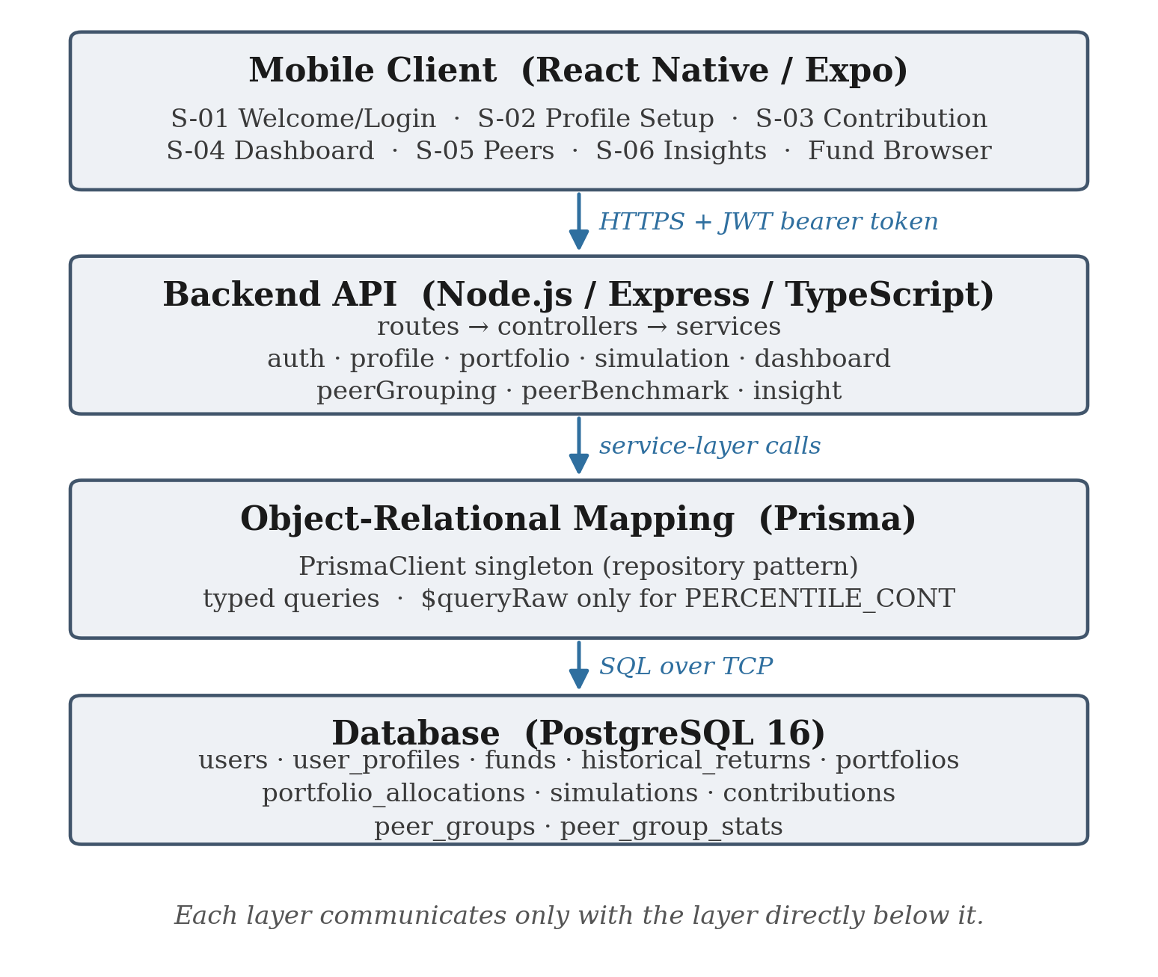
Figure 1: Four-layer system architecture of the implemented system

4.2 Authentication, Profile and Portfolio Composition
Registration and login are implemented with bcrypt password hashing and JSON Web Token session establishment, satisfying NFR06. Profile setup collects risk level, goal type and a monthly budget figure, from which a budget band is derived. The band, not the raw figure, is what peer grouping keys on. One gap is outstanding here, the exact monetary thresholds separating the four budget bands are not fixed. The implementation currently uses a placeholder quartile split. Because peer grouping keys on the band, an incorrect threshold would misgroup users.
A user composes a portfolio by selecting one or more funds from a catalogue and assigning each a percentage weight. The weights are validated to sum to 100 percent at the service layer. Preset portfolios remain available as single-fund full weight quick starts. The catalogue currently holds seven real funds such as bonds, Singapore and United States equity, emerging market equity, real estate investment trusts and gold, each carrying its own series of real dated annual returns, listed in Table 4. The three SGX counters are drawn from the counter list of a real Singapore regular savings plan, so that a simulated portfolio corresponds to the actual behaviour of a real Singapore bond fund rather than to an assumed rate.
Ticker | Fund | Exchange | Asset class
A35 | ABF Singapore Bond Index Fund ETF | SGX | Bonds
CFA | Amova/NikkoAM-StraitsTrading Asia ex Japan REIT ETF | SGX | REITs
ES3 | SPDR Straits Times Index ETF | SGX | SG equity
SPY | SPDR S&P 500 ETF Trust | US | US equity
AGG | iShares Core U.S. Aggregate Bond ETF | US | US bonds
VWO | Vanguard FTSE Emerging Markets ETF | US | EM equity
GLD | SPDR Gold Shares | US | Gold
Table 4: Fund catalogue and real historical return series

4.3 Simulation Engine
A simulation runs against a composed portfolio for a chosen frequency and duration, with the per-period contribution arriving from one of two mechanisms. A scheduled deposit takes the amount directly from the user. A round-up derives it once, as the product of the average number of card transactions per week, the number of weeks in one contribution period, and the average round-up per transaction. The derived figure is then applied uniformly to every period and sent back to the user so that they can see what their spare change inputs actually amount to.
For each period the engine looks up every allocated fund’s annual return for the corresponding year of its series and converts it to a periodic rate, as (1 + annualReturn)^(1/periodsPerYear) – 1. The conversion is what makes a full year of compounding reproduce that year’s real annual return.

4.4 Database Design
The schema was derived directly from the data dictionary and comprises ten tables: users and user profiles, a fund catalogue with an associated historical return series, portfolios and their weighted fund allocations, simulations and their contribution record, and peer groups with their computed statistics. The fund, portfolio and allocation tables are a consequence of the design amendment and did not exist in the original design, which modelled a portfolio as a fixed template rather than a user composed set of weighted holdings.

4.5 User Interface Design
The client is a React Native application built with Expo, implementing the six screens specified in the requirements plus a fund browser added with the portfolio composition amendment. It was restricted during implementation from a linear screen by screen flow into a persistent tab bar presented after login and profile setup, with five destinations (dashboard, fund browser, contribution setup, peer comparison and insights) that a user moves between directly. A stored token is checked once at start up so a returning user reaches the dashboard without re-entering credentials.

4.6 Challenges & Troubleshooting
Two amendments were made to the specification raising technical challenges during implementation. The first replaced the constant rate simulation model with deterministic replay of real historical fund returns. The original model satisfied the reproducibility requirement but produced outcomes with no external referent. A growth figure derived from an assumed rate is only as meaningful as the assumption. Linking each portfolio to a real fund’s actual annual returns makes the output realistic in a way an assumed rate is not, and reproducibility survives intact because a static recorded series is as deterministic as a constant. However, most real fund data require payment or a subscription to be retrieved.
The second amendment replaced three fixed single fund templates with user composed multi fund portfolios. It removed the portfolio template entity from the schema, introduced fund, portfolio and allocation entities in its place, and required the return model to become a weighted mix. It also engaged diversification concept that Section 2.4 identifies as the weakest area of financial literacy in the target population, which is an argument for the feature.
Attempting this amendment surfaced the technical challenge. The plan was to source a wider catalogue from a commercial market data API. However, two limitations were found both confirmed against the live service. The free source API in use covered seventy exchanges but not the Singapore Exchange at all with limited number of usage per day. Other real fund data that covers Singapore Exchange like SGX required payment or a subscription to be retrieved. The catalogue currently in use was sourced by web search instead. The figures are real and citable but are search summarised rather than taken from downloaded raw price data, and should be re-verified against the primary sources before being relied on beyond demonstration. This is a genuine constraint on the strength of the results in Chapter 5.

CHAPTER 5: RESULTS, TESTING & DISCUSSION

5.1 Testing Methodology
Testing at this stage of the project consists of a unit test covering every backend service, together with four numerical experiments run directly against the implemented simulation engine. The unit tests runs each service in isolation, with the database access layer and test for exact expected values.
The tests were written alongside the implementation to catch regressions rather than derived systematically from a documented test design. A test that happens to cover the branches is not the same as a documented path analysis that derives the required test cases from the control flow graph and demonstrates their sufficiency.

5.2 Results

5.2.1 Differentiation between portfolios
An identical plan (S$150 per month for 60 months, funded by scheduled deposit) was simulated against each preset single-fund portfolio and against a composed portfolio of 60 per cent ES3 and 40 per cent A35. Figure 2 shows the value series for the composed portfolio, and Table 5 reports the outcome for every portfolio tested. The engine differentiates portfolios substantially, from a loss of 8.39 per cent on the real estate investment trust fund to a gain of 73.19 per cent on gold, which confirms that the weighted historical replay produces materially different outcomes from materially different holdings rather than converging on a single growth path.
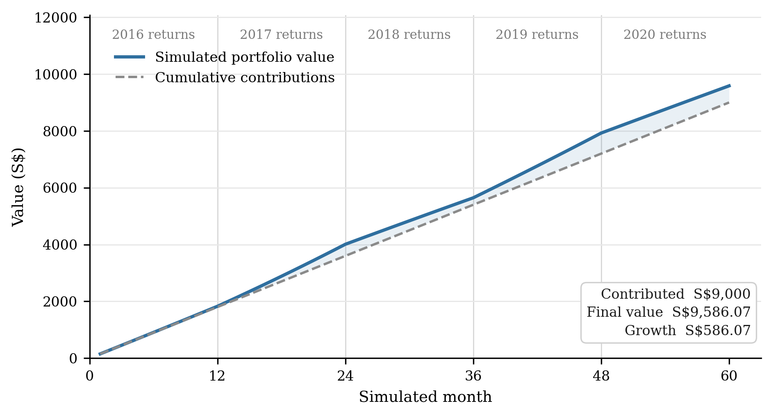
Figure 2: Worked example of the implemented simulation engine

Portfolio | Final value | Growth | Growth % | Series wrapped
A35 100 % (bonds) | S$10,206.62 | S$1,206.62 | +13.41 % | no
CFA 100 % (REITs) | S$8,245.09 | −S$754.91 | −8.39 % | no
ES3 100 % (SG equity) | S$9,193.03 | S$193.03 | +2.14 % | no
SPY 100 % (US equity) | S$13,604.25 | S$4,604.25 | +51.16 % | no
AGG 100 % (US bonds) | S$10,339.14 | S$1,339.14 | +14.88 % | no
VWO 100 % (EM equity) | S$12,014.30 | S$3,014.30 | +33.49 % | no
GLD 100 % (gold) | S$15,587.36 | S$6,587.36 | +73.19 % | yes
60 % ES3 / 40 % A35 (composed) | S$9,586.07 | S$586.07 | +6.51 % | no
Table 5: Simulated outcomes for an identical plan across portfolios

5.2.2 Equivalence of the two contribution mechanisms
Section 4.6 claims that the round-up mechanism composes with the blending logic without modification because it produces a single constant per-period figure. This was verified numerically. A round-up configuration of 12 transactions per week at an average round-up of S$0.60, on a monthly frequency, derives a per-period contribution of 12 × (52/12) × 0.60 = S$31.20. A scheduled-deposit plan of S$31.20 per month over the same portfolio and duration produced an identical value series at every one of the 60 periods, and an identical final value of S$1,993.90. The two mechanisms are therefore indistinguishable downstream of the derivation, as designed.

5.3 Discussion
Measured against the objectives in Section 1.3, the results support Objectives 1 to 5 and leave Objective 6 open by design at this stage. The simulation engine is implemented, reproducible and grounded in real market history (Objectives 1 and 2); the peer-grouping algorithm and its fallback are implemented and independently exercisable (Objective 3); percentile benchmarks are computed in the database and only aggregates reach the client (Objective 4); and insight generation is implemented against both a behavioural and an outcome gap (Objective 5). Objective 6, the documented verification programme, is scheduled work rather than completed work. Table 6 states the tests done on each requirement level.

ID | Requirement | Trace
FR01 | Register an account with credentials stored | UC-01 / S-01
FR02 | Authenticate an existing user | UC-01 / S-01
FR03 | Store profile and derive budget band | UC-02 / S-02
FR04 | Return the available fund catalogue | UC-03 / S-03
FR05 | Validate parameters and create a simulation run | UC-03 / S-03
FR06 | Compute the simulated portfolio value series | UC-03 / S-04
FR07 | Persist per-period contribution records | UC-03 / S-04
FR08 | Return dashboard summary and consistency score | UC-04 / S-04
FR09 | Assign a user to a peer group via the fallback logic | UC-05 / S-05
FR10 | Compute aggregated benchmark statistics | UC-05 / S-05
FR11 | Compare the user against peer benchmarks | UC-05 / S-05
FR12 | Generate insight cards from detected gaps | UC-06 / S-06
Table 6: Functional requirements tested

CHAPTER 6: CONCLUSION & FUTURE WORK

6.1 Conclusion
This interim report has set out a design for peer benchmarking in a micro-investment context that answers two literatures pointing in opposite directions: the evidence that peer information substantially changes financial behaviour, and the evidence that presenting it competitively harms the least experienced users. The design answers both through four commitments (aggregate-only comparison, a behavioural rather than purely outcome-based benchmark, grouping on genuine similarity with a documented fallback, and deterministic simulation) and Chapter 4 shows each of them realised in a working system.
Twelve of the thirteen functional requirements are implemented end to end across a React Native client and a Node.js service layer, supported by unit tests. The simulation engine has been verified to reproduce real annual returns, to differentiate materially between portfolios, to treat the two contribution mechanisms equivalently. Six of the ten project phases are complete and a seventh is substantially complete, which places the project at the halfway point.

6.2 Future Work
Table 7 sets out the planned work for the remainder of the project. The ordering reflects two dependencies: the budget band decision must precede the synthetic peer generator, since generated peers must be assigned to bands; and the documentation realignment must follow all implementation work, since the analysis-level class diagram and the dialog map both predate the multi-fund portfolio amendment and the interface restructure and must be brought forward to describe the system as built.
Phase | Task | Deliverable
Aug 2026 | Resolve the replay-window question raised in Section 5.3 | Design decision and specification amendment
Aug 2026 | Fix the budget band (B1–B4) thresholds | Specification revision v1.6
Aug 2026 | Implement the synthetic peer data generator | Populated peer groups at all three tiers
Sep 2026 | Implement simulation history (FR13) on the dashboard | Working endpoint and dashboard section
Sep 2026 | Verify NFR-01, NFR-02 and NFR-05 by measurement | Measured performance and usability results
Oct 2026 | Derive and document a basis-path analysis of the peer-grouping walk | Control flow graph, derived test cases, results
Oct 2026 | Derive and document equivalence-class and boundary-value tests for the simulation engine | Test design and results
Nov 2026 | Realign the class diagram, dialog map and use case model with the system as built | Updated design documentation
Nov - Dec 2026 | Prepare the demonstration and write the final report | Demonstration and final report
Table 7: Planned work for the remainder of the project

REFERENCES
[1] U.S. Securities and Exchange Commission, “Investor Bulletin: Fractional Share Investing — Buying a Slice Instead of the Whole Share,” SEC.gov, 2020. [Online]. Available: https://www.investor.gov/introduction-investing/general-resources/news-alerts/alerts-bulletins/investor-bulletins/fractional-share-investing-buying-slice-instead-whole-share [Accessed: Feb. 21, 2026].
[2] Acorns, “Round-Ups,” Acorns Official Website, 2026. [Online]. Available: https://www.acorns.com/round-ups/ [Accessed: Feb. 22, 2026].
[3] Stash, “Fractional Shares Investing,” Stash Official Website, 2026. [Online]. Available: https://www.stash.com/invest/fractional-shares [Accessed: Feb. 22, 2026].
[4] POSB, “Ride the Market Steadily with Invest-Saver,” POSB Singapore. [Online]. Available: https://www.posb.com.sg/personal/investments/other-investments/invest-saver [Accessed: Aug. 22, 2026].
[5] A. Sconti and D. Fernandez, “The importance of financial literacy: Evidence from Singapore,” Journal of Financial Literacy and Wellbeing, vol. 1, no. 2, pp. 225–243, 2023, doi: 10.1017/flw.2023.11.
[6] Securities Investors Association (Singapore) and Beansprout, “Singapore Retail Investor Pulse Survey: Reviving the Singapore Equities Market,” Mar. 2025. [Online]. Available: https://sias.org.sg/wp-content/uploads/2025/03/Singapore-investor-survey-2025.pdf [Accessed: Aug. 22, 2026].
[7] L. Bursztyn, F. Ederer, B. Ferman, and N. Yuchtman, “Understanding mechanisms underlying peer effects: Evidence from a field experiment on financial decisions,” Econometrica, vol. 82, no. 4, pp. 1273–1301, 2014, doi: 10.3982/ECTA11991.
[8] Z. Lin, M. Kong, G. Li, and X. Wang, “The peer effects of resident stock market participation: Evidence from 2019 CHFS,” PLoS ONE, vol. 19, no. 4, Art. no. e0298894, 2024, doi: 10.1371/journal.pone.0298894.
[9] S. Andraszewicz, D. Kaszás, S. Zeisberger, and C. Hölscher, “The influence of upward social comparison on retail trading behaviour,” Scientific Reports, vol. 13, Art. no. 22713, 2023, doi: 10.1038/s41598-023-49648-3.
[10] J. Apesteguia, J. Oechssler, and S. Weidenholzer, “Copy trading,” Management Science, vol. 66, no. 12, pp. 5608–5622, 2020, doi: 10.1287/mnsc.2019.3508.
[11] P. Chapkovski, M. Khapko, and M. Zoican, “Trading gamification and investor behavior,” Management Science, vol. 72, no. 1, pp. 32–56, 2026, doi: 10.1287/mnsc.2022.02650.
[12] L. Sweeney, “k-anonymity: A model for protecting privacy,” International Journal of Uncertainty, Fuzziness and Knowledge-Based Systems, vol. 10, no. 5, pp. 557–570, 2002, doi: 10.1142/S0218488502001648.
[13] N. Dragoni, S. Giallorenzo, A. L. Lafuente, M. Mazzara, F. Montesi, R. Mustafin, and L. Safina, “Microservices: Yesterday, today, and tomorrow,” in Present and Ulterior Software Engineering, B. Meyer and M. Mazzara, Eds. Cham, Switzerland: Springer, 2017, pp. 195–216, doi: 10.1007/978-3-319-67425-4_12.
[14] C. Fox, Introduction to Software Engineering Design: Processes, Principles and Patterns with UML2. Boston, MA: Addison-Wesley, 2006.

