NANYANG TECHNOLOGICAL UNIVERSITY
MICRO-INVESTMENT APP WITH PEER COMPARISON DASHBOARD
Interim Report
Submitted in Partial Fulfilment of the Requirements
for the Degree of Bachelor of Engineering
of the Nanyang Technological University
by
Leong Hao Jie
U2322022H
Supervisor: Dr Gu Chloe
Project Code: CCDS25-1124
College of Computing and Data Science
2026

ABSTRACT
Micro-investment platforms have made small, regular investing accessible to young adults, but the feedback they give is almost entirely individual: a balance, a return, and a contribution history. A novice investor has no reference point against which to judge whether those figures, or the habits producing them, are reasonable. Behavioural finance research establishes that peer information changes financial decisions substantially, yet a separate body of evidence shows that presenting peer information competitively — through leaderboards, copy trading or gamified interfaces — increases risk-taking and lowers satisfaction, particularly among the least experienced users. The two literatures point in opposite directions, and no deployed micro-investment platform offers peer benchmarking as a core feature.
This project designs and implements a mobile application that simulates micro-investment plans and benchmarks a user's simulated outcomes and contribution behaviour against an anonymised peer group, in a form intended to support habit formation rather than performance chasing. The system is a four-layer architecture comprising a React Native client, a Node.js and TypeScript service layer, the Prisma object-relational mapper and PostgreSQL. A user composes a portfolio from a catalogue of seven real funds with user-set weights, funds it by scheduled deposit or by round-up, and receives a deterministic simulation that replays each fund's real historical annual returns rather than assuming a rate of return. Peer groups are formed on profile similarity with a three-tier fallback that relaxes the grouping keys when a group falls below ten members, and benchmark statistics are computed as percentiles inside the database. Only aggregated statistics ever reach the client.
At the interim stage, twelve of the thirteen functional requirements are implemented end to end across the backend and mobile client, supported by 83 unit tests. Preliminary results confirm that the geometric periodic-rate conversion reproduces each fund's real annual return to within 6 × 10⁻¹⁵, that identical inputs produce identical output across repeated runs, and that the two contribution mechanisms compose without divergence. The results also expose a limitation of the current replay design: because every fund's series is replayed from its start, a plan shorter than a fund's recorded history never reaches that fund's later years. Remaining work comprises simulation history, synthetic peer data generation, a formal structural testing programme, and verification of the non-functional requirements.

TABLE OF CONTENTS
PAGE
ABSTRACT ii

1. INTRODUCTION 1
1.1 Background 1
1.2 Problem Statement 2
1.3 Motivation and Significance 3
1.4 Objectives 3
1.5 Scope and Limitations 4
1.6 Organisation of the Report 5

2. LITERATURE REVIEW AND RELATED WORK 6
2.1 Micro-Investment Platforms 6
2.1.1 Round-up and fractional-share platforms 6
2.1.2 Regular savings plans in Singapore 6
2.1.3 The feedback these platforms provide 7
2.2 Peer Effects in Financial Decision-Making 8
2.2.1 Evidence that peers change financial behaviour 8
2.2.2 Mechanisms: social learning and social utility 8
2.3 The Risks of Social Features in Investment Interfaces 9
2.4 Financial Literacy and the Young Investor in Singapore 11
2.5 Privacy-Preserving Peer Benchmarking 11
2.6 Research Gap and Positioning 12

3. METHODOLOGY AND SYSTEM DESIGN 14
3.1 Development Methodology 14
3.2 Requirements Specification 14
3.3 Analysis Model 15
3.4 System Architecture 15
3.5 Database Design 16
3.6 Simulation Model Design 17
3.7 Peer Grouping and Benchmarking Design 17

4. IMPLEMENTATION AND PRELIMINARY RESULTS 19
4.1 Implementation Overview 19
4.2 Authentication and Profile Management 19
4.3 Fund Catalogue and Portfolio Composition 19
4.4 Simulation Engine 20
4.5 Peer Benchmarking Engine 21
4.6 Insight Generation 22
4.7 Mobile Client 22
4.8 Design Amendments and Technical Challenges 22
4.9 Preliminary Results 24
4.9.1 Accuracy of the geometric rate conversion 24
4.9.2 Differentiation between portfolios 25
4.9.3 Equivalence of the two contribution mechanisms 26
4.9.4 Reproducibility 26
4.10 Verification to Date 26

5. PROJECT TIMELINE AND REMAINING WORK 28
5.1 Progress Against the Project Plan 28
5.2 Requirement Status 28
5.3 Outstanding Gaps and Risks 29
5.4 Plan for the Remainder of the Project 30

REFERENCES 32

LIST OF FIGURES
Figure Page
1 Four-layer system architecture of the implemented system 16
2 Three-tier peer-group fallback walk (MIN_GROUP_SIZE = 10) 18
3 Worked example of the implemented simulation engine 21
4 Project timeline against the phase plan 28

LIST OF TABLES
Table Page
1 Feedback provided by representative micro-investment platforms 7
2 Empirical evidence on peer effects in financial decision-making 9
3 Design responses to the risks identified in the literature 10
4 Seeded fund catalogue and real historical return series 20
5 Verification of the geometric periodic-rate conversion 24
6 Simulated outcomes for an identical plan across portfolios 25
7 Functional requirements and implementation status 28
8 Planned work for the remainder of the project 30

1. INTRODUCTION

1.1 Background
Digital financial technology has steadily lowered the cost of entry to investing. Micro-investment platforms allow a user to commit very small sums — a few dollars at a time — either by purchasing fractional shares or by automating regular contributions. A fractional share is a proportional slice of a whole share, so an investor no longer needs the full market price of a security in order to hold a position in it [1]. Removing that price barrier matters most to the group least able to clear it: students and young adults with irregular incomes and small investable balances.
Two contribution mechanisms have made frequent, small investing practical. The first is the round-up, in which the difference between a card purchase and the next whole dollar is swept into an investment account; Acorns built its product around this mechanism [2]. The second is the scheduled deposit, a fixed sum transferred on a fixed cadence, which platforms such as Stash pair with fractional-share access and a round-up facility of their own [3]. Both mechanisms convert investing from a deliberate, occasional decision into a background habit.
The same pattern exists in Singapore in a more conservative form. Regular savings plans (RSPs) offered by retail banks — POSB/DBS Invest-Saver, for example — allow an investor to commit a fixed monthly sum to a selection of SGX-listed exchange-traded funds and unit trusts, with the bank purchasing fractional units on the investor's behalf [4]. The local instruments are different, but the underlying proposition is identical: small amounts, contributed regularly, into a diversified holding.
Adoption, however, does not imply competence. A nationally representative study of financial literacy in Singapore found that only 39 per cent of respondents answered all three of the standard "Big Three" financial literacy questions correctly, with risk diversification the weakest area of the three, and that financially literate individuals were roughly three times more likely to actively choose their investment options rather than default into them [5]. A 2025 survey of 1,011 Singapore retail investors reported that younger investors held smaller allocations to Singapore equities than older cohorts, that 31 per cent of those with little local exposure cited unfamiliarity as the reason, and that beginner investors ranked guidance and educational resources well above other needs [6]. The population that micro-investment apps serve best is therefore also the population least equipped to interpret what those apps show them.

1.2 Problem Statement
Existing micro-investment platforms provide feedback that is almost entirely individual. A user sees a portfolio balance, a return figure, and a contribution history — an accurate account of what happened to their own money, and nothing else. For an experienced investor with an internalised sense of what a reasonable outcome looks like, that is sufficient. For a novice it is not. A user who has contributed S$900 over a year and holds S$940 has no basis on which to judge whether that outcome is good, poor, or unremarkable, and no basis at all on which to judge the behaviour that produced it. The absolute number answers "what happened" but leaves "how am I doing" unanswered.
Behavioural finance offers a well-evidenced source of the missing reference point: other people. Peer information demonstrably changes financial decisions, through mechanisms that have been experimentally isolated and are quantitatively large [7]–[9]. Yet peer information is not automatically benign. The same broad literature shows that peer information presented competitively — as a ranking against top performers, as a portfolio to copy, or through a gamified interface — increases risk-taking, increases trading, lowers satisfaction, and does so most strongly among the least experienced users [10]–[12]. Presenting a novice with a leaderboard is therefore not a neutral design choice; it is a documented mechanism for pushing that novice towards risk they did not choose.
The problem this project addresses is consequently narrower and harder than "micro-investment apps lack peer comparison". It is this: peer comparison is a powerful and evidenced lever, but the obvious implementations of it are precisely the implementations the evidence warns against. Can peer information be delivered in a form that supports habit formation rather than performance chasing, and what does a system that does so actually look like?
The position taken in this project is that it can, provided four constraints are respected: the comparison is made against a group aggregate rather than a named individual; behaviour, and specifically contribution consistency, is benchmarked alongside outcome; users are grouped by genuine similarity so that the comparison is informative; and only aggregated statistics ever leave the server, so no peer's individual record is exposed. Implementing those constraints raises the engineering problems that form the substance of the project. Peer groups must be assigned from profile attributes and must degrade gracefully when a group is too sparse to be meaningful. Aggregate statistics must be computed efficiently over a growing user base. Simulated outcomes must be reproducible, so that a user comparing two plans is seeing a real difference between the plans and not the residue of a random draw. And the entire benchmarking path must be constructed so that individual peer records are structurally unavailable to the client, not merely omitted from it.

1.3 Motivation and Significance
The motivation for the project is the mismatch between what the behavioural evidence supports and what deployed systems actually do. Peer effects in financial decision-making are among the better-identified findings in the field, resting on randomised field experiments rather than on observational correlation alone, and the effect sizes are substantial. Despite this, none of the major micro-investment platforms surfaces peer benchmarking as a core feature. The gap is not a lack of evidence but the absence of a design that can act on the evidence without also importing the harms that competitive framings carry.
The project is significant in three respects. First, it produces a concrete, documented design for privacy-preserving peer benchmarking in a consumer financial context — grouping keys, a minimum viable group size, a generalisation fallback, and an aggregate-only data path — that is reusable independently of this particular application. Second, it demonstrates that the behavioural constraints can be enforced structurally rather than by convention: because the client never receives individual peer records, a future developer cannot accidentally build a leaderboard on top of the existing API. Third, it targets a population for which the intervention is most likely to matter. The Singapore evidence in Section 1.1 describes young investors who are willing to participate but lack confidence and familiarity, and who rank guidance above every other need; a benchmark against comparable peers is a form of guidance that requires no adviser and discloses no one's finances.
The system is also a substantial software engineering exercise in its own right. It spans a mobile client, a service-layer API, a relational schema, two non-trivial algorithms, and a full requirements and design documentation trail, and it is delivered by a single developer within one academic year.

1.4 Objectives
The project's objectives are:
- To design and implement a mobile application that allows a user to configure a micro-investment plan — choosing a contribution mechanism, amount, frequency and duration — and to run a reproducible simulation of that plan's outcome.
- To ground the simulation in real market history rather than an abstract assumed rate of return, so that the outcomes shown to a user correspond to the behaviour of real, identifiable funds.
- To design and implement a peer-grouping algorithm that assigns users to comparison groups on profile similarity and degrades predictably when a group falls below a minimum viable size.
- To compute percentile-based benchmarks over those groups efficiently, and to expose only aggregated statistics to the client.
- To generate rule-based insights from the gap between a user's own behaviour and their peer group's aggregate, framed to encourage consistency rather than return-chasing.
- To verify the resulting system through a documented programme of black-box and white-box testing, and to evaluate it against the non-functional requirements set out in the specification.

1.5 Scope and Limitations
The system is a simulation. It does not execute trades, hold client money, connect to a brokerage, or constitute financial advice, and no part of the design assumes a regulated financial service. This is a deliberate boundary: it allows the behavioural and architectural questions above to be studied without the licensing, custody and settlement obligations that a real investment product would attract.
Four limitations follow from that boundary and from the resources available to a single-developer final year project, and are stated here so that the results in later chapters are read correctly:
- Returns are historical, not predictive. The engine replays real annual returns recorded for real funds; it does not forecast, and a simulated outcome is a statement about how a plan would have performed over a past period, not an expectation about the future.
- Peer data is partly synthetic. With no real user base, peer groups are intended to be populated by generated peers so that the grouping and benchmarking logic can be exercised. Benchmarks are therefore demonstrably correct but not empirically meaningful.
- Market data is static seed data. A live market-data feed was investigated during implementation and rejected for concrete reasons documented in Section 4.8; the shipped catalogue is fixed at build time.
- No behavioural evaluation is attempted. Whether the dashboard actually changes saving behaviour is an empirical question requiring a longitudinal study with human subjects, which is outside the scope of an engineering final year project. What is evaluated here is whether the system correctly and privately delivers the comparison the literature motivates.

1.6 Organisation of the Report
Chapter 2 reviews the relevant literature in four strands: the existing micro-investment platform landscape and the feedback it provides; the empirical evidence for peer effects in financial decision-making; the documented risks of social features in investment interfaces; and privacy models for aggregate benchmarking. It closes by stating the research gap the project addresses.
Chapter 3 presents the methodology and system design: the phased development process, the requirements and analysis work products, the four-layer architecture, the database design, and the detailed design of the two principal algorithms — the simulation model and the peer grouping and benchmarking scheme.
Chapter 4 documents the implementation and reports preliminary results. It covers each implemented component, the design amendments and technical challenges encountered during implementation, numerical results obtained from the implemented simulation engine, and the verification carried out to date.
Chapter 5 sets out the project timeline against the original phase plan, the status of each functional requirement, the outstanding gaps and their associated risks, and the plan for the remainder of the project.

2. LITERATURE REVIEW AND RELATED WORK
This chapter surveys the work the project builds on. Section 2.1 examines existing micro-investment platforms and characterises the feedback they give users. Section 2.2 reviews the empirical evidence that peer information changes financial behaviour, and the mechanisms by which it does so. Section 2.3 reviews the countervailing evidence on the risks of social features in investment interfaces, which constrains how peer information may responsibly be presented. Section 2.4 situates the work in the Singapore context. Section 2.5 covers privacy models applicable to aggregate benchmarking. Section 2.6 states the resulting gap.

2.1 Micro-Investment Platforms

2.1.1 Round-up and fractional-share platforms
Micro-investing depends on two enabling capabilities. The first is fractional-share ownership, which allows an order smaller than the price of one share to be filled as a proportional slice of that share; the U.S. Securities and Exchange Commission's investor bulletin on the practice sets out both the mechanism and its consequences for the investor, notably that fractional positions are typically not transferable between brokers and may carry different voting arrangements [1]. The second is automation of the contribution itself, which removes the need for a repeated decision.
Acorns is the canonical example of automated contribution. Its round-up mechanism links to a user's payment cards, rounds each transaction up to the next whole dollar, and invests the accumulated difference [2]. The design insight is that the contribution decision is made once, at setup, and thereafter the contribution stream is a by-product of ordinary spending. Stash combines fractional-share access with a comparable round-up facility and scheduled recurring deposits [3]. Both platforms deliberately minimise the cognitive load of investing, and both succeed at it.

2.1.2 Regular savings plans in Singapore
The Singapore market reaches a similar outcome through bank-intermediated regular savings plans rather than app-native round-ups. POSB/DBS Invest-Saver allows a fixed monthly sum to be committed to a selected list of SGX-listed exchange-traded funds and unit trusts, with the bank purchasing fractional units on the investor's behalf [4]. The instruments differ — the Straits Times Index, Asian bonds and Asian REITs rather than broad U.S. index funds — but the behavioural structure is the same: a standing instruction that converts an intermittent decision into a recurring one. This project's fund catalogue draws deliberately on the SGX counters available through such plans, so that the outcomes it simulates correspond to instruments a Singapore-based user could actually access.

2.1.3 The feedback these platforms provide
What these platforms have in common is more instructive than what distinguishes them. All of them report, to each user, that user's own position: current balance, return since inception, and a contribution history. None of them, as a headline feature, tells a user how that position compares with the positions of comparable users. Table 1 summarises the pattern.
The omission is not an oversight. Comparison features carry regulatory and reputational risk, they require a user base large enough to make comparison meaningful, and — as Section 2.3 shows — implemented carelessly they demonstrably harm the users they are meant to inform. But the result is that the feedback loop available to a novice micro-investor is closed on itself: the only reference point is their own past.
Table 1 Feedback provided by representative micro-investment platforms. Characterisation is based on each platform's public product documentation [2]–[4].
Platform | Contribution mechanism | Feedback to the user | Peer comparison
Acorns [2] | Card round-ups; recurring deposits | Balance, return, contribution history | Not a core feature
Stash [3] | Recurring deposits; round-ups; fractional shares | Balance, return, holdings breakdown | Not a core feature
POSB/DBS Invest-Saver [4] | Fixed monthly RSP into SGX ETFs and unit trusts | Units held, average cost, market value | Not offered
This project | Scheduled deposit or derived round-up (simulated) | Simulated value, growth, consistency score | Percentile and median against an anonymised peer group

2.2 Peer Effects in Financial Decision-Making

2.2.1 Evidence that peers change financial behaviour
The claim that peers influence financial decisions is supported by evidence at several levels of rigour, and the causal identification is unusually good for a behavioural finance question.
The strongest early evidence is experimental. Duflo and Saez randomised financial incentives to attend a university benefits fair across departments, then measured enrolment in a tax-deferred retirement plan among both the individuals encouraged and their untreated colleagues [7]. Enrolment rose in treated departments among employees who received no incentive at all, which isolates a peer channel from the direct effect of the information. Because the randomisation was at the department level, the finding cannot be explained by treated and untreated employees simply being different kinds of people — the standard confound in observational studies of peer influence.
Bursztyn and co-authors then separated the mechanisms. Working with a Brazilian brokerage and 150 pairs of socially connected clients, they used a lottery to break the correlation between a peer's decision to buy an asset and their actually acquiring it, which allows the effect of learning that a peer chose an asset to be distinguished from the effect of that peer possessing it [8]. Take-up among second investors was 42 per cent with no peer information, 71 per cent when told the peer had chosen to buy but the lottery had denied the purchase, and 93 per cent when told the peer had both chosen and acquired. The design is the cleanest available separation of the two channels, and both are large.
Observational work at national scale points the same way. Lin and co-authors, using the 2019 China Household Finance Survey, report that peer effects significantly raise household stock market participation, with social interaction and information diffusion identified as the operative pathways [9]. The magnitude of such estimates should be treated with the usual caution attaching to observational data, but the direction is consistent with the experimental record.

2.2.2 Mechanisms: social learning and social utility
The distinction Bursztyn et al. draw matters for design, not merely for theory [8]. Social learning treats a peer's action as information: if someone comparable chose this, it is probably reasonable. Social utility treats a peer's holding as directly affecting one's own satisfaction, whether through relative standing or through the value of a shared experience. A system that intends to support good habits wants to engage the first channel and to be careful with the second, because relative-standing concerns are exactly what upward comparison exploits.
This has a concrete consequence for the present design. Benchmarking a user against a group median engages social learning — it communicates what comparable people typically do — while giving the user no individual to be ranked below. Benchmarking against a leaderboard of top performers engages social utility in its least helpful form. The choice of aggregate over individual is not merely a privacy decision; it is a behavioural one. Table 2 summarises the evidence base.
Table 2 Empirical evidence on peer effects in financial decision-making.
Study | Method | Setting | Principal finding
Duflo & Saez (2003) [7] | Randomised field experiment | University retirement plan enrolment | Untreated colleagues of encouraged employees also increased enrolment, isolating a peer channel
Bursztyn et al. (2014) [8] | Field experiment with lottery-based identification | Brazilian brokerage, 150 socially connected pairs | Take-up rose from 42 % to 71 % (learning) to 93 % (learning plus possession); both channels significant
Lin et al. (2024) [9] | Observational, national survey | 2019 China Household Finance Survey | Peer effects significantly raise household stock market participation via social interaction

2.3 The Risks of Social Features in Investment Interfaces
A second and equally well-evidenced literature establishes that peer information presented as competition damages the decisions of the people exposed to it. This literature constrains the design directly and is treated here as a requirements source rather than as background.
Andraszewicz, Kaszás, Zeisberger and Hölscher ran a controlled experiment on a simulated stock market with 807 experienced retail investors [10]. After a first trading round, the treatment group was shown the results of the best-performing investors while the control group saw only their own. Those exposed to the upward comparison subsequently took more portfolio risk, executed greater trading volume, and reported substantially lower satisfaction with their own performance. The last of these is worth emphasising: the intervention made people both worse off and less happy, using information that was entirely truthful.
Apesteguia, Oechssler and Weidenholzer examined the stronger case where imitation is possible rather than merely visible [11]. In their experiment 35 per cent of participants in the copy condition chose to copy another participant, and of those, 88 per cent copied someone who had selected the riskiest available asset — a direct consequence of the fact that the highest observed outcomes are generated disproportionately by the riskiest choices. They characterise the result as excessive risk-taking, concentrated among participants whose own elicited risk preferences were conservative.
Chapkovski, Khapko and Zoican studied gamified trading interfaces and found that gamification is associated with a roughly 5 per cent increase in trading volume, but that around 70 per cent of that effect is attributable to self-selection rather than to the interface itself: gamified platforms disproportionately attract investors with lower financial knowledge [12]. For the present project, whose target user is precisely a low-experience investor, this is a warning about the population a competitive interface would preferentially attract.
Taken together, these three results rule out an entire family of designs. Table 3 records how each finding is answered by a specific design decision in the system built for this project; the decisions themselves are described in Chapters 3 and 4.
Table 3 Risks identified in the literature and the corresponding design responses adopted in this project.
Finding in the literature | Risk if ignored | Design response adopted
Upward comparison raises risk-taking and lowers satisfaction [10] | A leaderboard would push novices towards risk they did not choose | Comparison is against the group median and quartiles only; no individual peer is ever displayed or ranked
Imitation concentrates on the riskiest choices [11] | Any copy or follow feature would propagate the highest-variance portfolios | No copying, following or portfolio disclosure between users exists in the design
Gamified interfaces attract lower-knowledge investors [12] | Competitive framing would preferentially attract the users least able to interpret it | Insight cards benchmark contribution consistency, a controllable habit, rather than return
Small quasi-identifier groups permit re-identification [13] | A three-attribute group can become one person's data | Minimum group size of ten with a documented generalisation fallback; aggregates only leave the server

2.4 Financial Literacy and the Young Investor in Singapore
The project targets students and young adults in Singapore, and two sources characterise that population. Sconti and Fernandez, using a nationally representative sample, found that only 39 per cent of Singaporeans answered all three standard financial literacy questions correctly [5]. Their age-cohort result is notable: unlike the hump-shaped pattern common elsewhere, financial knowledge in Singapore was relatively flat across cohorts, so young adults were not markedly less literate than older ones — but the whole distribution sat lower than the country's income and education levels would predict. Risk diversification was the weakest of the three concepts, with roughly half the sample unable to answer it correctly. Since diversification is exactly the concept a multi-fund portfolio builder asks a user to exercise, this is directly relevant to the interface design.
The 2025 SIAS and Beansprout retail investor survey, covering 1,011 Singapore retail investors between November 2024 and January 2025, adds a behavioural picture [6]. Younger investors held smaller allocations to Singapore equities than older cohorts; 31 per cent of those with limited local exposure cited unfamiliarity as the reason; and beginner investors ranked access to guidance and educational resources markedly higher than experienced investors did. Over 80 per cent of respondents nonetheless expressed interest in Singapore equities, which suggests the barrier is confidence and familiarity rather than absence of intent.
The design consequence is that the system must explain as well as report. A percentile is a compact summary but an opaque one to a user who does not routinely think in distributions, which is why the peer comparison screen states the composition of the comparison group and the insight cards translate a percentile into a sentence and a suggested action.

2.5 Privacy-Preserving Peer Benchmarking
Any system that reports statistics about a group of users must consider whether those statistics permit an individual to be re-identified. The foundational treatment is Sweeney's k-anonymity model, which requires that any record released be indistinguishable from at least k−1 others with respect to the quasi-identifiers it exposes [13]. The relevance here is direct: risk level, budget band and goal type are quasi-identifiers, and a group formed by intersecting all three can become small enough that its median is effectively one person's data.
This is the reason the peer-grouping design carries a minimum group size rather than simply grouping on all available attributes. When the fully-specified group is too small, the system relaxes the grouping keys and reports the broader group instead, which is a direct application of the generalisation strategy k-anonymity prescribes. The threshold adopted, ten members, is a design choice rather than a derivation from a formal privacy budget; the system provides no differential-privacy guarantee, and no claim to one is made in this report. What it does provide is a structural guarantee that no endpoint returns an individual peer's record, and a grouping rule that prevents an aggregate from being computed over an arbitrarily small set.
It should be noted that the residual disclosure risk in this specific application is low relative to the general case, because the quantity being aggregated — a simulated portfolio value derived from user-entered plan parameters — is not a real financial position. The protections are nonetheless implemented as though it were, since the architecture is intended to remain sound if the system were ever extended to real data.

2.6 Research Gap and Positioning
The literature reviewed above establishes three findings that do not currently meet. First, peer information changes financial behaviour, through mechanisms that are experimentally separable and quantitatively large [7]–[9]. Second, the deployed micro-investment platforms that would be best placed to use that finding provide individual-only feedback and do not offer peer benchmarking as a core feature [2]–[4]. Third, the implementations of social features that do exist in the wider investment market — performance rankings, copy trading, gamified interfaces — are associated with increased risk-taking, noisier trading and reduced satisfaction, particularly among the least experienced users [10]–[12].
The gap is therefore not "peer comparison is missing from micro-investment apps", which would be a product observation rather than a research one. It is more specific: there is no well-documented design for peer comparison in a micro-investment context that takes the behavioural evidence for peer influence seriously while also taking the evidence about competitive framing seriously. The two literatures point in opposite directions, and the engineering question is what a system looks like that respects both.
This project answers that question with a concrete system and treats the answer as consisting of four commitments, each traceable to the evidence above: comparison is against group aggregates and never against a named individual [10], [11]; a behavioural metric — contribution consistency — is benchmarked alongside outcome, so that the salient comparison is a habit the user controls rather than a return they largely do not; peer groups are formed on genuine similarity, with a documented fallback when a group is too sparse [13]; and outcomes are simulated deterministically, so that a user comparing two plans observes a real difference between the plans rather than the residue of a random draw. Chapters 3 and 4 document how each of these is realised.

3. METHODOLOGY AND SYSTEM DESIGN
This chapter presents the process by which the system was developed and the design that resulted. Section 3.1 describes the methodology. Sections 3.2 and 3.3 summarise the requirements and analysis work products. Sections 3.4 to 3.7 present the architecture, the database design, and the detailed design of the two principal algorithms.

3.1 Development Methodology
The project follows a phased, document-driven process adapted from the software engineering design method of Fox [15] and structured to align with the laboratory sequence of the accompanying software engineering course. Ten phases were defined at the outset, running from requirements lock through to demonstration and submission, each with a named deliverable. The process is not waterfall in the strict sense: implementation has fed back into the specification on three occasions, and those amendments are documented rather than absorbed silently (Section 4.8).
Two artefacts carry the process. The Software Requirements Specification (SRS) is the controlled document; it is revised rather than replaced, each revision retaining and colour-coding the superseded text so that the decision history stays legible to an examiner. A companion decision log in the source repository records the rationale for each locked algorithmic decision and quotes the exact specification wording it implements, which prevents the code and the specification from drifting apart without that drift being visible. Five SRS revisions, v1.0 through v1.5, have been issued to date.

3.2 Requirements Specification
Phase 0 produced SRS v1.0 (January 2026), comprising the functional and non-functional requirements, a data dictionary, an initial use case model of seven use cases, and low-fidelity mockups of six screens. Thirteen functional requirements (FR01–FR13) and six non-functional requirements (NFR-01 to NFR-06) were specified, each expressed to be individually verifiable and each carrying a trace link to a use case and a screen. The non-functional requirements set the targets against which the final evaluation will be made: a dashboard load under two seconds, at least 80 per cent task success in usability testing, aggregate-only peer statistics, reproducible simulation output for identical inputs, modular separation of concerns, and salted password hashing.
Four decisions were explicitly deferred at this stage and recorded as a to-be-determined list rather than being resolved arbitrarily: the simulation return model, the peer-group fallback hierarchy, the synthetic peer data strategy, and the formula for the consistency metric. Recording them as open was a deliberate choice — each is an algorithmic decision with downstream consequences, and settling them prematurely in a requirements document would have concealed the design work rather than exposing it.

3.3 Analysis Model
Phase 1 (February 2026) produced the analysis model: a conceptual class diagram partitioned into entity, boundary and control classes derived from the functional requirements, and a dialog map expressing the navigation between the six screens as a state machine. Three of the four deferred decisions were resolved in SRS v1.1: the simulation return model, the peer-grouping fallback hierarchy, and the consistency metric.
The consistency metric was defined as the proportion of months since a user's first simulation in which they ran at least one simulation, expressed as a percentage, with a single-simulation user scoring 100 as a defined cold-start case. This metric measures engagement cadence rather than investment performance, which is deliberate: it is the behavioural quantity that Section 2.2.2 argues should be the salient comparison, and unlike a return figure it is entirely within the user's control.

3.4 System Architecture
The system is a four-layer architecture in which each layer communicates only with the layer directly below it (Figure 1). The mobile client is responsible for data entry and visualisation only; every substantive computation — simulation, peer grouping, benchmarking and insight generation — occurs in the backend service layer. This division is what makes the privacy guarantee structural rather than conventional: the client cannot expose individual peer records because it never receives them.
Within the backend, requests pass from route definitions through thin controllers to a service layer that holds all business logic, and reach the database only through a single shared Prisma client instantiated once and imported wherever needed. Authentication is enforced once, in Express middleware, for every route except registration and login, so no controller re-checks authorisation for itself. The peer-grouping service is designated a strategy class: it walks a fixed sequence of grouping strategies and returns the first that satisfies its constraint.
The backend is deployed as a single process rather than as a set of independently deployed services. Microservice decomposition offers independent scaling, independent deployment and technology heterogeneity per capability [14], but those benefits accrue at an operating scale this system will not reach, and they are paid for in distributed transaction handling, inter-service failure modes and operational overhead that a single developer cannot reasonably carry. The separation of concerns that motivates the microservice style is instead realised at the module boundary: the service layer is partitioned by capability, with no shared mutable state between services and no service reaching into another's tables. This leaves extraction of any one capability into a separate process available as a future step without requiring it now.
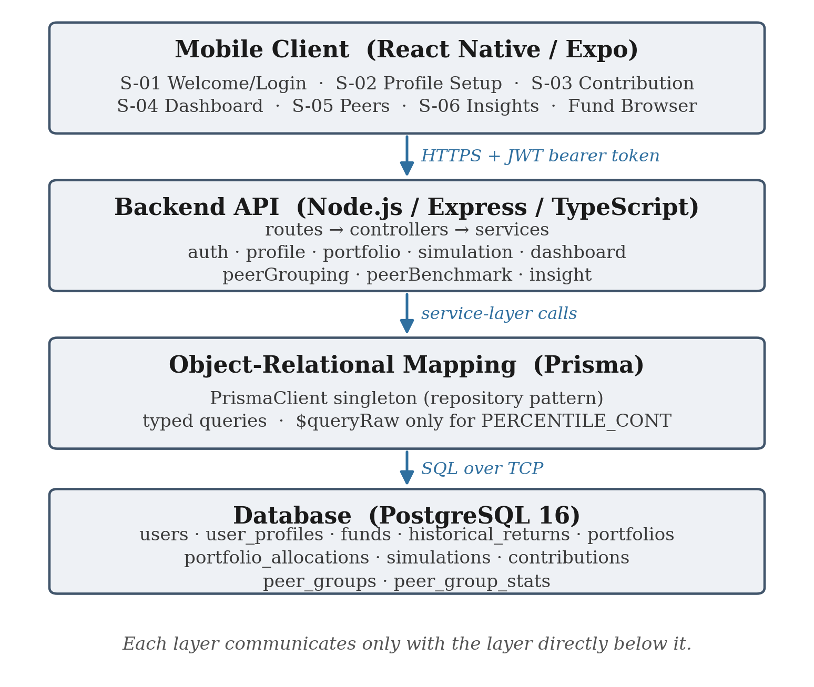
Figure 1 Four-layer system architecture of the implemented system.

3.5 Database Design
The schema was derived directly from the data dictionary and comprises ten tables: users and user profiles; a fund catalogue with an associated historical-return series; portfolios and their weighted fund allocations; simulations and their per-period contribution records; and peer groups with their computed statistics. The fund, portfolio and allocation tables are a consequence of the design amendment described in Section 4.8 and did not exist in the original design, which modelled a portfolio as a fixed template rather than as a user-composed set of weighted holdings.
Two schema decisions are worth noting. First, per-period contribution records are persisted rather than recomputed on demand, so that the growth chart on the dashboard is a database read rather than a re-execution of the simulation. Second, peer group statistics are stored in their own table rather than computed per request, which allows the expensive percentile aggregation to be amortised across the members of a group.

3.6 Simulation Model Design
The simulation model was fixed in Phase 1 as deterministic compounding of the form balance[n] = (balance[n−1] + contribution) × (1 + periodicRate), with no stochastic component. The decision was made primarily to satisfy NFR-04: a deterministic model is reproducible by construction, so a user comparing two plans is comparing the plans and not two random draws, and test cases can assert exact expected values without a tolerance window.
What the periodic rate is derived from changed twice during implementation, for reasons given in Section 4.8. In its current form each allocated fund contributes its own periodic rate, derived from that fund's real annual return for the corresponding year of its series by the geometric conversion (1 + annualReturn)^(1/periodsPerYear) − 1, and the rates are blended by portfolio weight. The geometric conversion is what makes a full year of compounding reproduce that year's real annual return exactly; dividing the annual figure linearly across periods, as the original constant-rate model did, is only meaningful for an abstract expected return and would not reproduce a specific real figure. Blending rates rather than tracking a separate balance per fund encodes the simplifying assumption that the portfolio rebalances to its target weights every period, which keeps a single value series per simulation.

3.7 Peer Grouping and Benchmarking Design
Peer grouping resolves a tension between specificity and viability. A group defined on all three profile attributes — risk level, budget band and goal type — produces the most meaningful comparison but is also the most likely to be too small to be either statistically informative or privacy-preserving. The design resolves this with a three-tier fallback walk, shown in Figure 2. The fully-specified group is tried first; if it holds fewer than ten members the goal type is dropped; if the resulting group is still short the budget band is dropped as well, leaving risk level alone.
The final tier is a floor rather than a further test. If the risk-level-only group is still below the threshold it is returned regardless, because there is nothing broader to relax to and returning an error would leave the user with no comparison at all. Instead the design treats a below-threshold floor result as the best available answer and requires the interface to state which tier was used, so a user comparing themselves against a broad group knows that the group is broad. This transparency is the same principle applied elsewhere in the system: the user is told what produced the number, not just the number.
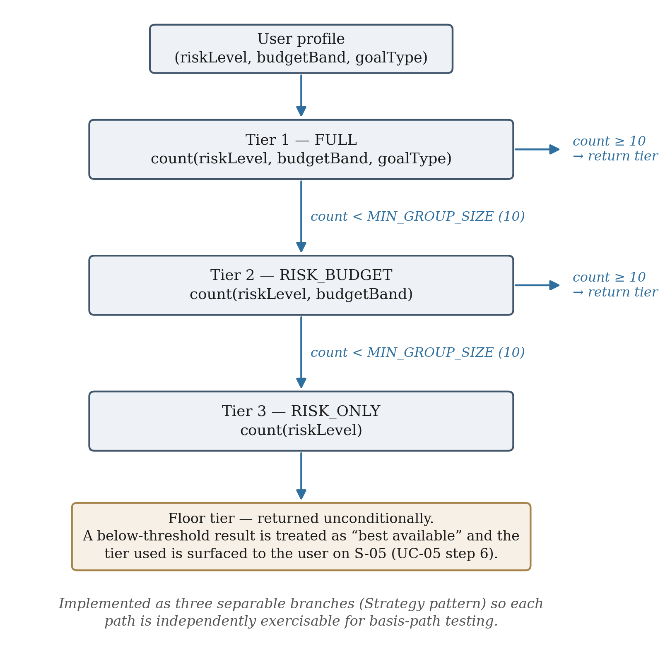
Figure 2 Three-tier peer-group fallback walk. Each tier is implemented as a separable branch so that all three paths can be exercised independently in basis-path testing.
Benchmark statistics are computed in the database rather than in application code. Rather than loading every peer's simulation rows into memory and computing percentiles in JavaScript, the design issues a single parameterised query using PostgreSQL's PERCENTILE_CONT ordered-set aggregate to obtain the 25th, 50th and 75th percentiles and the member count in one pass. The same query serves all three fallback tiers, with the relaxed grouping keys passed as nulls. This is the one place in the codebase where raw SQL is used deliberately rather than as a workaround, since the function is not exposed through the object-relational mapper's query builder, and it is the reason PostgreSQL was selected over the alternatives during the technology stack decision.

4. IMPLEMENTATION AND PRELIMINARY RESULTS

4.1 Implementation Overview
Implementation of the core functional requirements is complete: FR01 through FR12 are implemented end to end, backend and mobile client, with unit test coverage for each service. The technology stack is React Native with Expo on the client, Node.js with Express and TypeScript on the server, Prisma as the object-relational mapper, and PostgreSQL 16 as the database, with JSON Web Tokens and bcrypt for authentication and Jest for testing. Sections 4.2 to 4.7 describe the implemented components, Section 4.8 the amendments and challenges that arose, and Sections 4.9 and 4.10 the results and verification obtained so far.

4.2 Authentication and Profile Management
Registration and login are implemented with bcrypt password hashing and JSON Web Token session establishment, satisfying NFR-06. Profile setup collects risk level, goal type and a monthly budget figure, from which a budget band is derived; the band, not the raw figure, is what peer grouping keys on. One gap is outstanding here and is recorded honestly: the exact monetary thresholds separating the four budget bands were never fixed in any revision of the specification. The implementation currently uses a placeholder quartile split, flagged in the source. Because peer grouping keys on the band, an incorrect threshold would silently misgroup users rather than raise an error, which makes this a requirements defect rather than a cosmetic one; it is scheduled for resolution as a new to-be-determined item.

4.3 Fund Catalogue and Portfolio Composition
A user composes a portfolio by selecting one or more funds from a catalogue and assigning each a percentage weight; the weights are validated to sum to 100 per cent at the service layer. Preset portfolios remain available as single-fund, full-weight quick starts. The catalogue holds seven real funds spanning bonds, Singapore and United States equity, emerging-market equity, real estate investment trusts and gold, each carrying its own series of real dated annual returns (Table 4). The three SGX counters are drawn from the counter list of a real Singapore regular savings plan, so that a simulated conservative portfolio corresponds to the actual behaviour of a real Singapore bond ETF rather than to an assumed rate.
The series lengths differ between funds, and are not padded to match. One fund has eight years rather than ten because the real fund launched in March 2017 and has no complete year before 2018; two others are shorter because the sourcing pass did not recover every year. Recording the real length rather than extending the series is a correctness decision: the engine's behaviour when a plan outlasts its data is defined and surfaced to the user, so padding would misrepresent the data rather than simplify it. Section 4.9 shows that this choice has a measurable effect on comparability between funds.
Table 4 Seeded fund catalogue and the real historical annual return series held for each fund. All series are static seed data; none is fetched at run time.
Ticker | Fund | Exchange | Asset class | Return series
A35 | ABF Singapore Bond Index Fund ETF | SGX | Bonds | 2016–2025 (10 yrs)
CFA | Amova/NikkoAM-StraitsTrading Asia ex Japan REIT ETF | SGX | REITs | 2018–2025 (8 yrs)
ES3 | SPDR Straits Times Index ETF | SGX | SG equity | 2016–2025 (10 yrs)
SPY | SPDR S&P 500 ETF Trust | US | US equity | 2016–2025 (10 yrs)
AGG | iShares Core U.S. Aggregate Bond ETF | US | US bonds | 2016–2025 (10 yrs)
VWO | Vanguard FTSE Emerging Markets ETF | US | EM equity | 2016–2024 (9 yrs)
GLD | SPDR Gold Shares | US | Gold | 2022–2025 (4 yrs)

4.4 Simulation Engine
A simulation runs against a composed portfolio for a chosen frequency and duration, with the per-period contribution arriving from one of two mechanisms. A scheduled deposit takes the amount directly from the user. A round-up derives it once, as the product of the average number of card transactions per week, the number of weeks in one contribution period, and the average round-up per transaction; the derived figure is then applied uniformly to every period and is echoed back to the user so that they can see what their spare-change inputs actually amount to.
For each period the engine looks up every allocated fund's annual return for the corresponding year of its series, converts it to a periodic rate geometrically as described in Section 3.6, and blends the resulting rates by portfolio weight before applying the blended rate to the running balance. Where a plan outlasts a fund's real history the series wraps to its start, and a flag is set and surfaced through the API and the interface so the user knows part of the result is a replay. If any allocated fund holds no historical data at all the simulation fails validation with an explicit error rather than silently substituting a default rate — once a fund exists specifically to carry real returns, there is no defensible constant to fall back to.
The whole path is deterministic: no random number generator is involved anywhere, and every return series is static seed data rather than a live fetch, so identical inputs produce identical output and NFR-04 is satisfied by construction. Figure 3 shows a worked example computed with the shipped algorithm and the seeded series.
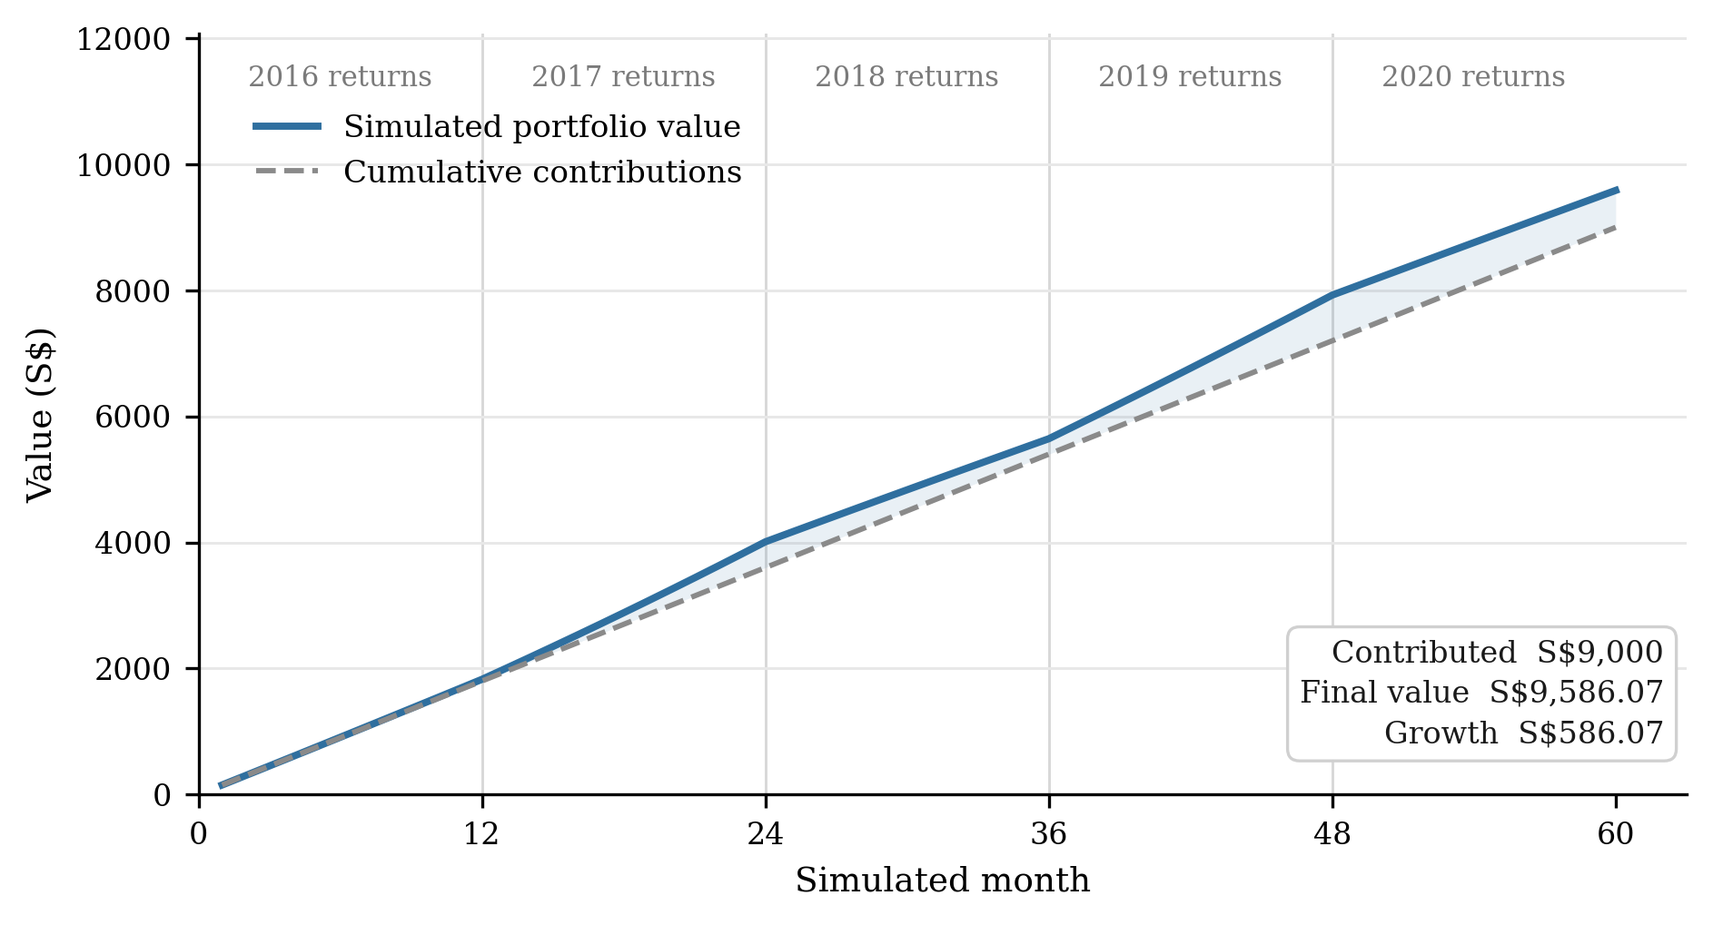
Figure 3 Worked example of the implemented simulation engine: S$150 per month for 60 months into a portfolio of 60 % ES3 (Straits Times Index ETF) and 40 % A35 (ABF Singapore Bond Index Fund ETF), computed using the shipped blending algorithm against the seeded 2016–2020 return series. The visible slope changes at each year boundary are the real annual returns of those years.

4.5 Peer Benchmarking Engine
The grouping walk and the percentile computation designed in Section 3.7 are both implemented. A user is assigned to a group, the group's quartile statistics and member count are computed in a single database query, and the user's own percentile position within the group is derived from those statistics. The group's median consistency score is computed alongside, using the same shared function that produces the individual user's score on the dashboard rather than a reimplementation, so the two figures cannot diverge.
One component of this phase is not complete: the synthetic peer generation script seeds the fund catalogue and preset portfolios but does not yet generate the synthetic peer users. The grouping and benchmarking logic is correct and tested without it — the floor tier and the small-sample transparency messaging are designed precisely to handle sparse data — but peer groups will stay thin until the generator is written.

4.6 Insight Generation
Insight generation converts benchmark output into one to three short cards. Two gap types are implemented. The first compares the user's consistency score against the peer group's median, which is the gap type the specification names explicitly and the one aligned with the behavioural argument of Section 2.2.2. The second compares the user's simulated final value against the group's quartile boundaries. Where no meaningful gap is found the system emits a positive-reinforcement card rather than manufacturing a criticism.
The suggested contribution figures on these cards are exact rather than approximate. Because the compounding recurrence has no additive term other than the per-period contribution, the final value is exactly proportional to the contribution for a fixed rate and period count, so the contribution required to reach a target value can be solved directly rather than searched for. The percentile boundary treated as the threshold for a meaningful gap, by contrast, remains a judgement call and is flagged as such in the source.

4.7 Mobile Client
The client is a React Native application built with Expo. It was restructured during implementation from a linear screen-by-screen flow into a persistent tab bar presented after login and profile setup, with five sibling destinations — dashboard, fund browser, contribution setup, peer comparison and insights — that a user moves between directly. A stored token is checked once at start-up so a returning user reaches the dashboard without re-entering credentials. The change was a user experience decision with no backend consequence: the original flow suited a first-time setup wizard but made a returning user step through screens they had already completed to reach the dashboard, which is the screen they open the app for.

4.8 Design Amendments and Technical Challenges
Three amendments were made to the specification during implementation. They are reported here rather than folded silently into the design chapter because the reasoning behind them is itself part of the work, and because two of them reopened a decision the specification had recorded as closed.
The first amendment replaced the constant-rate simulation model with deterministic replay of real historical fund returns. The original model satisfied the reproducibility requirement but produced outcomes with no external referent — a growth figure derived from an assumed rate is only as meaningful as the assumption. Anchoring each portfolio to a real fund's actual annual returns makes the output defensible in a way an assumed rate is not, and reproducibility survives intact because a static recorded series is as deterministic as a constant.
The second amendment replaced three fixed single-fund templates with user-composed multi-fund portfolios. This was a substantive scope change: it removed the portfolio template entity from the schema, introduced fund, portfolio and allocation entities in its place, and required the return model to become a weighted blend. It also engaged the diversification concept that Section 2.4 identifies as the weakest area of financial literacy in the target population, which is an argument for the feature independent of the flexibility it adds.
Attempting this amendment surfaced the principal technical challenge of the implementation phase. The plan was to source a wider catalogue from a commercial market-data API. Two limitations were found, both confirmed against the live service rather than assumed: the subscription in use covered seventy exchanges but not the Singapore Exchange at all, and, separately, capped historical depth at one year on every exchange it did cover — too short to derive even a single year-over-year annual return. The ingestion pipeline written against that API is complete and functional, fetching monthly adjusted closes, deriving annual returns and upserting the results, and it is retained in the repository; it simply has nothing to ingest under this subscription. The catalogue actually shipped was sourced by structured web search instead. The provenance and its limitations are documented at the point of use: the figures are real and citable but are search-summarised rather than taken from downloaded raw price data, and should be re-verified against primary sources before being relied on beyond demonstration. This is a genuine constraint on the strength of the results in Section 4.9, and is recorded as such rather than presented as a completed data pipeline.
The third amendment added the contribution mechanism, allowing a plan to be funded by round-up as well as by scheduled deposit. This is new scope rather than a reopened decision. A more realistic implementation — a synthetic per-transaction spending stream whose round-ups are summed — was considered and rejected, on the grounds that it would introduce a second source of reproducible-only-because-seeded behaviour alongside the historical replay, in service of a figure that could not be validated against any real spending data. The derived-constant approach produces a per-period contribution indistinguishable in shape from a scheduled one, which is why it composes with the existing blending logic without modification, as Section 4.9 confirms numerically.

4.9 Preliminary Results
Four preliminary results were obtained from the implemented engine. All figures below were produced by executing the shipped algorithm against the shipped seed data, and are reproducible from the repository.

4.9.1 Accuracy of the geometric rate conversion
The engine's correctness claim is that a full year of compounding at the derived periodic rate reproduces that year's real annual return exactly. This was verified across every year of every fund's series, at both monthly and weekly period frequencies. Table 5 reports, for each fund, the compound annual growth rate of its recorded series, its best and worst recorded years, and the largest reconstruction error observed. The maximum error across all 61 fund-years and both frequencies was 5.85 × 10⁻¹⁵, which is floating-point rounding rather than model error, and confirms the conversion is exact to the precision of the arithmetic.
Table 5 Verification of the geometric periodic-rate conversion. CAGR is the compound annual growth rate of the recorded series. The reconstruction error is the largest observed difference between a fund's recorded annual return and the return obtained by compounding its derived periodic rate over a full year, taken across monthly and weekly frequencies.
Fund | Years | Span | CAGR | Best / worst year | Max error
A35 | 10 | 2016–2025 | 2.15 % | +8.03 % / −7.18 % | 5.85 × 10⁻¹⁵
CFA | 8 | 2018–2025 | 0.72 % | +18.02 % / −12.72 % | 5.17 × 10⁻¹⁵
ES3 | 10 | 2016–2025 | 8.76 % | +28.14 % / −7.51 % | 4.77 × 10⁻¹⁵
SPY | 10 | 2016–2025 | 14.72 % | +31.22 % / −18.17 % | 4.33 × 10⁻¹⁵
AGG | 10 | 2016–2025 | 1.97 % | +8.45 % / −13.02 % | 5.58 × 10⁻¹⁵
VWO | 9 | 2016–2024 | 6.45 % | +31.48 % / −17.99 % | 5.68 × 10⁻¹⁵
GLD | 4 | 2022–2025 | 23.39 % | +63.68 % / −0.77 % | 5.33 × 10⁻¹⁵

4.9.2 Differentiation between portfolios
An identical plan — S$150 per month for 60 months, funded by scheduled deposit — was simulated against each preset single-fund portfolio and against the composed 60 % ES3 / 40 % A35 portfolio of Figure 3. Table 6 reports the results. The engine differentiates portfolios substantially, from a loss of 8.39 per cent on the REIT fund to a gain of 73.19 per cent on gold, which confirms that the weighted historical replay produces materially different outcomes from materially different holdings rather than converging on a single growth path.
Two results in Table 6 require comment, and both expose limitations rather than successes. First, the Straits Times Index fund returns only 2.14 per cent over the plan despite having the third-highest compound annual growth rate in Table 5. This is because the engine replays every fund's series from its start, so a 60-month plan against a ten-year series experiences only 2016 to 2020 — a period containing two negative years — and never reaches the fund's strong 2024 and 2025 results. The replay window is therefore an unstated determinant of every simulated outcome, and a user comparing two funds of different series lengths is not comparing like with like. Second, the gold fund's 73.19 per cent gain is inflated by exactly this effect in the opposite direction: with only four years of recorded history, its series wraps within the plan and its exceptional 2025 return is replayed twice. The wrap is correctly flagged by the engine and surfaced to the user, but the flag communicates that a replay occurred, not that the resulting figure is inflated by it.
This finding is the most useful outcome of the preliminary results. It was not visible from the design or from the unit tests, which verify that the engine computes what it is specified to compute, and it identifies a design question — whether the replay should be anchored to the start of the series, to the most recent years, or to a window the user selects — that must be resolved before the system can present cross-fund comparisons as meaningful. It is added to the outstanding items in Section 5.3.
Table 6 Simulated outcomes for an identical plan — S$150 per month for 60 months, scheduled deposit — across each preset portfolio and the composed portfolio of Figure 3. Total contributed is S$9,000 in every case.
Portfolio | Final value | Growth | Growth % | Series wrapped
A35 100 % (bonds) | S$10,206.62 | S$1,206.62 | +13.41 % | no
CFA 100 % (REITs) | S$8,245.09 | −S$754.91 | −8.39 % | no
ES3 100 % (SG equity) | S$9,193.03 | S$193.03 | +2.14 % | no
SPY 100 % (US equity) | S$13,604.25 | S$4,604.25 | +51.16 % | no
AGG 100 % (US bonds) | S$10,339.14 | S$1,339.14 | +14.88 % | no
VWO 100 % (EM equity) | S$12,014.30 | S$3,014.30 | +33.49 % | no
GLD 100 % (gold) | S$15,587.36 | S$6,587.36 | +73.19 % | yes
60 % ES3 / 40 % A35 (composed) | S$9,586.07 | S$586.07 | +6.51 % | no

4.9.3 Equivalence of the two contribution mechanisms
Section 4.8 claims that the round-up mechanism composes with the blending logic without modification because it produces a single constant per-period figure. This was verified numerically. A round-up configuration of 12 transactions per week at an average round-up of S$0.60, on a monthly frequency, derives a per-period contribution of 12 × (52/12) × 0.60 = S$31.20. A scheduled-deposit plan of S$31.20 per month over the same portfolio and duration produced an identical value series at every one of the 60 periods, and an identical final value of S$1,993.90. The two mechanisms are therefore indistinguishable downstream of the derivation, as designed.

4.9.4 Reproducibility
NFR-04 requires that identical inputs produce identical output. The 60-month composed-portfolio plan was executed 1,000 times and produced exactly one distinct final value. This is expected — the implementation contains no random number generator and no live data fetch — but it is worth confirming empirically rather than asserting from inspection of the code, since the requirement is what permits test cases to assert exact expected values without a tolerance window.

4.10 Verification to Date
A unit test suite covering every backend service is in place, comprising 83 tests at the time of writing. Two components were identified in the project plan as the targets for formal structural testing, and both were written to be testable in the required form. The peer-grouping walk is the basis-path target: its three tiers are implemented as separable branches specifically so each path can be exercised independently, and the test suite covers all three. The simulation engine is the black-box target: its numeric inputs — contribution amount, frequency, duration and allocation weights — have clear valid ranges, making it suited to equivalence-class and boundary-value analysis, and the current tests exercise those partitions.
This existing coverage is not yet the formal testing deliverable. The tests were written alongside the implementation to catch regressions rather than derived systematically from a documented test design, and the distinction matters: a test suite that happens to cover the branches is not the same artefact as a documented basis-path analysis that derives the required test cases from the control flow graph and demonstrates their sufficiency. Producing that documentation, and the corresponding equivalence-class analysis for the simulation engine, is scheduled for Phase 8.
The non-functional requirements have not yet been formally verified, with the exception of NFR-04, addressed in Section 4.9.4. The dashboard load target (NFR-01), the usability success rate (NFR-02) and the error-handling behaviour under adverse network conditions all require measurement rather than inspection, and none of those measurements has been taken.

5. PROJECT TIMELINE AND REMAINING WORK

5.1 Progress Against the Project Plan
The project plan defined ten phases mapped onto the academic year. Figure 4 shows the phases completed and those remaining. Phases 0 to 2 — requirements lock, analysis and design — were completed in January, February and March 2026 respectively, each concluding with a dated document deliverable. Phases 3 to 6, covering the whole of the core implementation, were carried out as a concentrated block through August 2026, evidenced by the repository history and by SRS revisions v1.3 to v1.5 dated 19 and 20 August 2026.
The project is therefore at or slightly ahead of the halfway point by deliverable count: six of the ten phases are complete, a seventh is substantially complete, and the work that remains is verification, documentation realignment and submission rather than new feature development. The principal schedule risk is not the volume of remaining work but its character — Phase 8 requires a formal testing programme that has no partial credit, in the sense that a partially documented basis-path analysis demonstrates nothing.
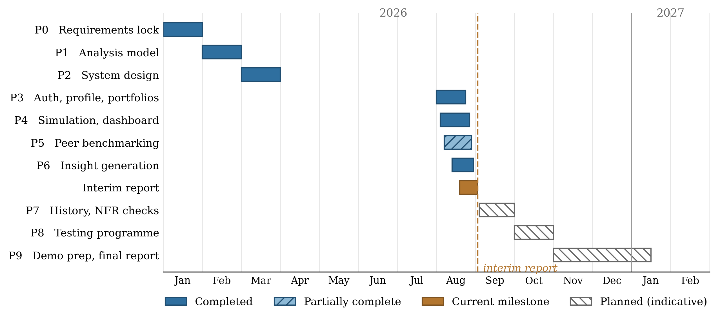
Figure 4 Project timeline against the phase plan. Completed phases are dated from their document deliverables and repository history; the schedule for Phases 7 to 9 is indicative and subject to confirmation of the final submission deadline.

5.2 Requirement Status
Table 7 states the implementation status of each functional requirement. Twelve of the thirteen are implemented; the exception is simulation history.
Table 7 Functional requirements and their implementation status at the interim stage.
ID | Requirement | Trace | Status
FR01 | Register an account with credentials stored securely | UC-01 / S-01 | Implemented
FR02 | Authenticate an existing user | UC-01 / S-01 | Implemented
FR03 | Store profile and derive budget band | UC-02 / S-02 | Implemented (band thresholds undefined)
FR04 | Return the available fund catalogue | UC-03 / S-03 | Implemented (amended to fund catalogue)
FR05 | Validate parameters and create a simulation run | UC-03 / S-03 | Implemented (extended with mechanism)
FR06 | Compute the simulated portfolio value series | UC-03 / S-04 | Implemented (historical replay)
FR07 | Persist per-period contribution records | UC-03 / S-04 | Implemented
FR08 | Return dashboard summary and consistency score | UC-04 / S-04 | Implemented
FR09 | Assign a user to a peer group via the fallback walk | UC-05 / S-05 | Implemented
FR10 | Compute aggregated benchmark statistics | UC-05 / S-05 | Implemented
FR11 | Compare the user against peer benchmarks | UC-05 / S-05 | Implemented
FR12 | Generate insight cards from detected gaps | UC-06 / S-06 | Implemented
FR13 | List past simulation runs | UC-07 / S-04 | Not started

5.3 Outstanding Gaps and Risks
Four items are outstanding, listed here with the risk each carries.
- Simulation history (FR13) is unimplemented; its endpoint is a stub and no interface exists for it. The specification places this on the dashboard rather than on a new screen, so the work is bounded and the risk is low.
- The synthetic peer generator is specified but unwritten, which leaves peer groups sparse. The risk is moderate: the benchmarking logic is correct without it, but a demonstration in which every peer group falls back to the floor tier does not exhibit the behaviour the project is about.
- The budget band thresholds remain undefined in the specification (Section 4.2). The risk is that peer grouping keys on a placeholder, so users may be misgrouped silently. This blocks the synthetic peer generator, since generated peers must be assigned to bands.
- The replay window question raised by the preliminary results (Section 4.9.2) is unresolved. The risk is to the interpretation of results rather than to correctness: cross-fund comparisons are not currently like-for-like, which would undermine the peer benchmark if different users held funds with different series lengths.

5.4 Plan for the Remainder of the Project
Table 8 sets out the planned work. The ordering reflects two dependencies: the budget band decision must precede the synthetic peer generator, since generated peers must be assigned to bands; and the documentation realignment must follow all implementation work, since the analysis-level class diagram and the dialog map both predate the multi-fund portfolio amendment and the navigation restructure and must be brought forward to describe the system as built.
Table 8 Planned work for the remainder of the project.
Phase | Task | Deliverable | Dependency
— | Fix the budget band (B1–B4) thresholds and record them as a new TBD resolution | SRS revision v1.6 | Supervisor input
5 | Implement the synthetic peer data generator | Populated peer groups at all three tiers | Budget band thresholds
— | Resolve the replay-window question raised in Section 4.9.2 | Design decision and SRS amendment | None
7 | Implement simulation history (FR13) on the dashboard | Working endpoint and dashboard section | None
7 | Verify NFR-01, NFR-02 and NFR-05 by measurement | Measured performance and usability results | Synthetic peer data
8 | Derive and document a basis-path analysis of the peer-grouping walk | Control flow graph, derived test cases, results | None
8 | Derive and document equivalence-class and boundary-value tests for the simulation engine | Test design and results | None
9 | Realign the class diagram, dialog map and use case model with the system as built | Updated design documentation | All implementation work
9 | Prepare the demonstration and write the final report | Demonstration video and final report | All of the above

Beyond the tabulated work, the final report will add the chapters this interim report does not attempt: a full results and evaluation chapter reporting the outcome of the testing programme and the non-functional verification, a discussion of those results against the objectives in Section 1.4, and conclusions and recommendations for future work.

REFERENCES
[1] U.S. Securities and Exchange Commission, “Investor Bulletin: Fractional Share Investing — Buying a Slice Instead of the Whole Share,” SEC.gov, 2020. [Online]. Available: https://www.investor.gov/introduction-investing/general-resources/news-alerts/alerts-bulletins/investor-bulletins/fractional-share-investing-buying-slice-instead-whole-share [Accessed: Feb. 21, 2026].
[2] Acorns, “Round-Ups,” Acorns Official Website, 2026. [Online]. Available: https://www.acorns.com/round-ups/ [Accessed: Feb. 22, 2026].
[3] Stash, “Fractional Shares Investing,” Stash Official Website, 2026. [Online]. Available: https://www.stash.com/invest/fractional-shares [Accessed: Feb. 22, 2026].
[4] POSB, “Ride the Market Steadily with Invest-Saver,” POSB Singapore. [Online]. Available: https://www.posb.com.sg/personal/investments/other-investments/invest-saver [Accessed: Aug. 22, 2026].
[5] A. Sconti and D. Fernandez, “The importance of financial literacy: Evidence from Singapore,” Journal of Financial Literacy and Wellbeing, vol. 1, no. 2, pp. 225–243, 2023, doi: 10.1017/flw.2023.11.
[6] Securities Investors Association (Singapore) and Beansprout, “Singapore Retail Investor Pulse Survey: Reviving the Singapore Equities Market,” Mar. 2025. [Online]. Available: https://sias.org.sg/wp-content/uploads/2025/03/Singapore-investor-survey-2025.pdf [Accessed: Aug. 22, 2026].
[7] E. Duflo and E. Saez, “The role of information and social interactions in retirement plan decisions: Evidence from a randomized experiment,” The Quarterly Journal of Economics, vol. 118, no. 3, pp. 815–842, 2003, doi: 10.1162/00335530360698432.
[8] L. Bursztyn, F. Ederer, B. Ferman, and N. Yuchtman, “Understanding mechanisms underlying peer effects: Evidence from a field experiment on financial decisions,” Econometrica, vol. 82, no. 4, pp. 1273–1301, 2014, doi: 10.3982/ECTA11991.
[9] Z. Lin, M. Kong, G. Li, and X. Wang, “The peer effects of resident stock market participation: Evidence from 2019 CHFS,” PLoS ONE, vol. 19, no. 4, Art. no. e0298894, 2024, doi: 10.1371/journal.pone.0298894.
[10] S. Andraszewicz, D. Kaszás, S. Zeisberger, and C. Hölscher, “The influence of upward social comparison on retail trading behaviour,” Scientific Reports, vol. 13, Art. no. 22713, 2023, doi: 10.1038/s41598-023-49648-3.
[11] J. Apesteguia, J. Oechssler, and S. Weidenholzer, “Copy trading,” Management Science, vol. 66, no. 12, pp. 5608–5622, 2020, doi: 10.1287/mnsc.2019.3508.
[12] P. Chapkovski, M. Khapko, and M. Zoican, “Trading gamification and investor behavior,” Management Science, vol. 72, no. 1, pp. 32–56, 2026, doi: 10.1287/mnsc.2022.02650.
[13] L. Sweeney, “k-anonymity: A model for protecting privacy,” International Journal of Uncertainty, Fuzziness and Knowledge-Based Systems, vol. 10, no. 5, pp. 557–570, 2002, doi: 10.1142/S0218488502001648.
[14] N. Dragoni, S. Giallorenzo, A. L. Lafuente, M. Mazzara, F. Montesi, R. Mustafin, and L. Safina, “Microservices: Yesterday, today, and tomorrow,” in Present and Ulterior Software Engineering, B. Meyer and M. Mazzara, Eds. Cham, Switzerland: Springer, 2017, pp. 195–216, doi: 10.1007/978-3-319-67425-4_12.
[15] C. Fox, Introduction to Software Engineering Design: Processes, Principles and Patterns with UML2. Boston, MA: Addison-Wesley, 2006.

