TEMPLATE FOR THEMATIC PROGRESSION (TP) DIAGRAMS
Information Sheet

Leong Ping Alvin
Nanyang Technological University

PREAMBLE

- This template was created using Microsoft Excel. It is intended to help you produce TP diagrams, such as those in the following publications:

Leong, P. A. (2015). Topical themes and thematic progression: The ‘picture’ of research articles. Text & Talk, 35(3), 289–315.

Leong, P. A. (2016). Thematic density of research-article abstracts: A systemic-functional account. Word, 62(4), 209–227.

- A description of the thematic-density index (TDI) is available in Leong (2016).

PRELIMINARY ACTION

Before using the template, you should do the following:

- Convert the document that you want to analyze into a text file (e.g., by using Notepad). Otherwise, the template can become very sluggish or non-responsive.

- Break the text up into appropriate units of analysis. These can be clauses or t-units, depending on your preferred approach. Ensure that each unit of analysis is separated by a hard return (i.e., use the ‘Return’ or ‘Enter’ key). Do not number the units of analysis, or insert a blank line between them. Hence, your text should not look like Fig 1, but Fig 2.

The text here is a simple one. It will serve as our example text in this information sheet. The unit of analysis in this text is the ranking clause. Downranked clauses are not considered. Before you use the template and assign labels to your topical themes, you should convert your document into a text file. Also, each ranking clause should be on a new line. If you do not do this, the template may produce errors, and you may need to make numerous tiresome corrections. The corrections may in turn lead to migraines. And the migraines may in turn lead to your giving up on SFG analysis. The philosopher among us will no doubt have noticed a slippery-slope fallacy here. And you may now be further bothered by this. But you do not need to worry about migraines or fallacies if you follow the instructions carefully. |  | The text here is a simple one.  It will serve as our example text in this information sheet.  The unit of analysis in this text is the ranking clause.  Downranked clauses are not considered.  Before you use the template  and assign labels to your topical themes,  you should convert your document into a text file.  Also, each ranking clause should be on a new line.  If you do not do this,  the template may produce errors,  and you may need to make numerous tiresome corrections.  The corrections may in turn lead to migraines.  And the migraines may in turn lead to your giving up on SFG analysis.  The philosopher among us will no doubt have noticed a slippery-slope fallacy here.  And you may now be further bothered by this.  But you do not need to worry about migraines or fallacies  if you follow the instructions carefully.
Fig 1. Wrongly prepared text Fig 2. Correctly prepared text
USING THE TEMPLATE

The template has two worksheets—Data and Diagram.

DATA WORKSHEET

- The Data worksheet has been preset to display 1,000 rows as Clauses. These rows are marked out using ‘R0001’, ‘R0002’, ‘R0003’, etc. If you have a very long text and need additional rows, please contact me. This is because inserting additional rows requires changes to the settings for the TP diagram. My email address is as follows:

alvin.leong@ntu.edu.sg

- The second column of the Data worksheet is where the text goes. Copy and paste the text into this column.

- Your Data worksheet should now look like Fig 3.

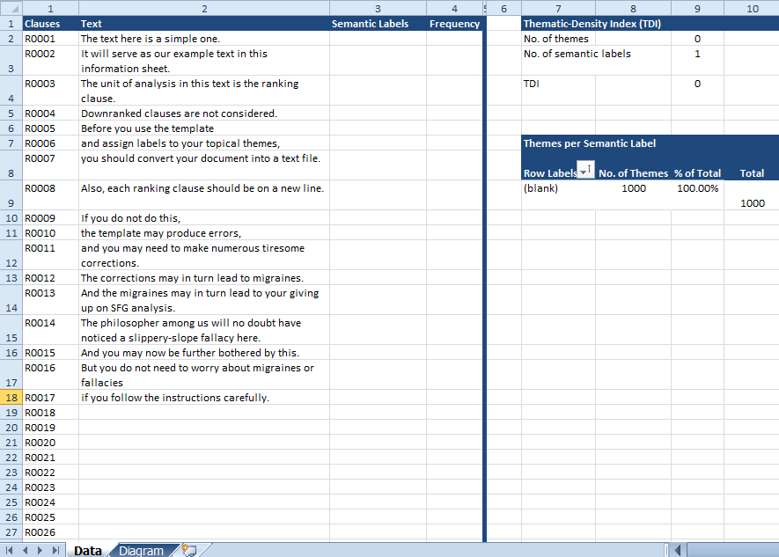
Fig 3. Data worksheet with example text

- The third column—Semantic Labels—is where you assign appropriate labels to the topical themes. You are free to come up with any label to describe the semantic content of each topical theme. But please take note of the following:

  - Insert a number in front of each label. This is obligatory. The numbers should be ordered sequentially—so use ‘1’ for the first label, ‘2’ for the second, etc. For e.g., if you want to use ‘Text’ as your very first label, you should write ‘1 Text’.

The numbers are critical to prevent sorting errors. If you do not include a number in front of the label, the program will sort the labels alphabetically, thus producing an inaccurate TP diagram.
  - Assign a new number only to new labels. For e.g., if another topical theme corresponds to the same idea of text, simply re-use ‘1 Text’ as the label. But if it corresponds to a new idea—e.g., analytical unit—then create a new label as follows: ‘2 Analytical Unit’.

  - Keep track of the semantic labels by consulting the table titled Themes per Semantic Label (on the right of the Data worksheet). This table is automatically updated whenever you create a new label. As the semantic labels in this table are automatically sorted, it also helpfully indicates which number you should use if you need to create a new label.

  - Do not create a new label when there is already an existing one in the table—i.e., do not write ‘1 Text’ and ‘8 Text’. Always check the table first to decide whether to create a new label.

  - The fourth column—Frequency—is automatically populated whenever a semantic label is inserted. You do not need to bother with this column.

  - Once you have assigned semantic labels to the topical themes, the Data worksheet should look like Fig 4. Here, each topical theme is in bold and underlined (you can choose your own preferred formatting in Microsoft Excel).

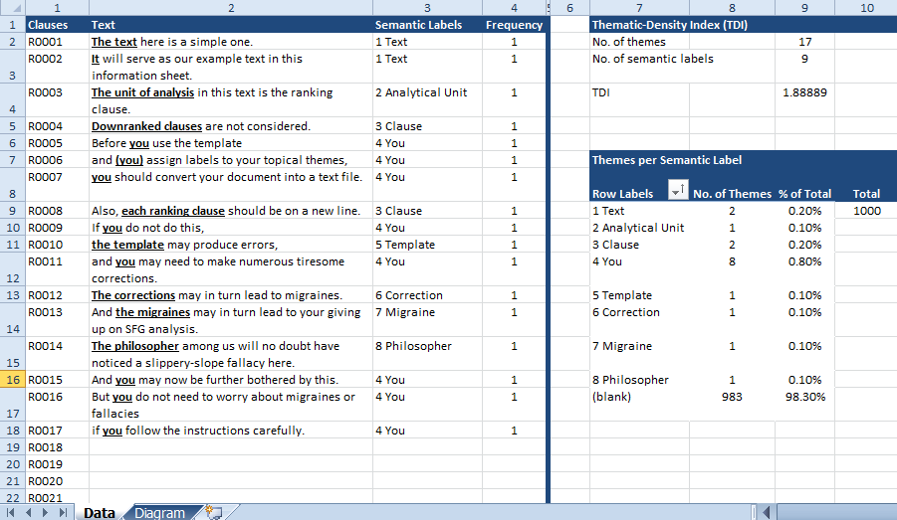
Fig 4. Data worksheet with example text, including semantic labels

  - You will have noticed that the Themes per Semantic Label table in Figs. 3–4 has a curious ‘(blank)’ entry. This is because the template has 1,000 preset rows, of which only 17 rows have been filled with the example text and semantic labels. We need to therefore delete the unused rows. Please note:

    - Deleting the rows is not simply deleting the entries in the Clauses column from ‘R0018’ onwards. This achieves nothing.

    - Instead, you should do the following:

      - Select all the unused rows (by selecting the first cell, ‘R0018’, and then pressing Shift-Ctrl-↓).

      - Right-click, and select ‘Delete’ followed by ‘Entire row’ (see Fig 5a–b).

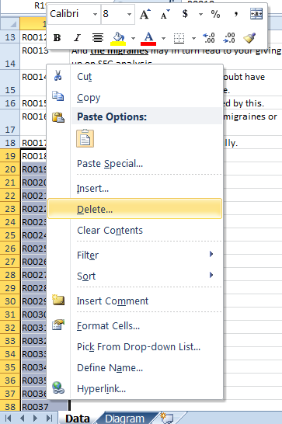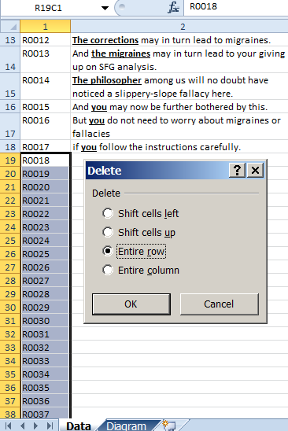
(a) (b)
Fig 5. Deleting unused rows

      - Once you have deleted the unused rows, your Data worksheet should look like Fig 6. Notice that ‘(blank)’ is now no longer reflected in the Themes per Semantic Label table.

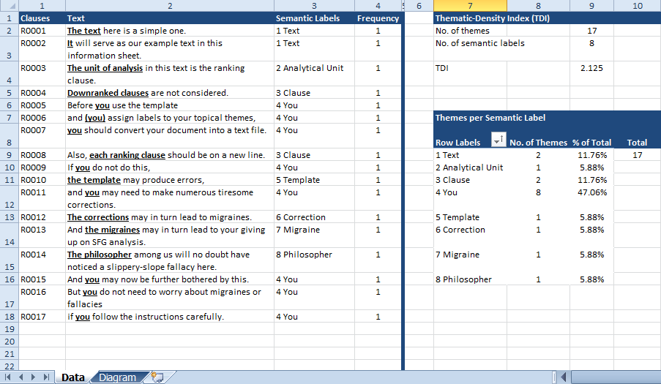
Fig 6. Data worksheet with deleted unused rows

      - On the right of the Data worksheet, summary statistics are provided, as follows:

        - TDI—this is calculated by dividing the number of themes by the number of semantic labels used.

        - Themes per semantic label—the numbers are also expressed as percentage figures (of the total number of themes).

        - In summary, the only two columns in which action is required from you are the Text and Semantic Labels columns. There is no need for you to change anything else in the other columns (apart from deleting unused rows at the end of your analysis).

DIAGRAM WORKSHEET

- The Diagram worksheet captures the TP diagram of the analyzed text. The diagram is automatically refreshed to reflect all the labels in the Data worksheet.

- The TP diagram of the example text is given in Fig 7.

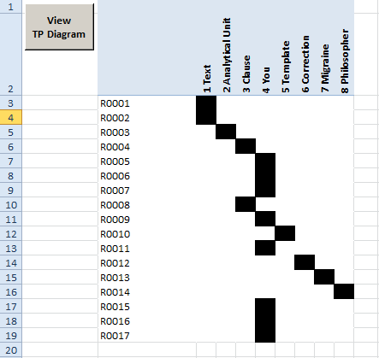
Fig 7. TP diagram of example text

- In a longer text, you may want to press the ‘View TP Diagram’ button at the top left corner of the worksheet to display the entire diagram on a single screen.

QUERIES

- I have tried to make the template as user-friendly as possible. Drop me an email message if you encounter any issues. Or if you simply need to rant about theme.

