VISUAL DISCOURSE ANALYSIS
Brief Notes

Leong Ping Alvin
Nanyang Technological University

READINGS

- Young, Lynne & Fitzgerald, Brigid. 2006. The Power of Language: How Discourse Influences Society. London: Equinox. (Chapter 6)

- Kress, Gunther & van Leeuwen, Theo. 2006. Reading Images: The Grammar of Visual Design. 2nd ed. London: Routledge.

BASICS

- ‘Constructed’ images are just like texts.

- Representational ~ Ideational
Modal ~ Interpersonal
Compositional ~ Textual

- Some adjustments to the following:
Representational Modal Compositional
Narrative themes: Rhythm, gaze, Gestalt:
▪ Actions, events, agents, perspective, prominence, ▪ Framing
patients, etc. characterization ▪ Horizontals
▪ Act, stance, gesture, ▪ Verticals
clothing ▪ Diagonals
▪ Relative position of
object(s) or people
▪ Parallelism or
opposition

Ideational meaning

- Processes, participants, and circumstances.

- Transactional action — where action is directed at another participant.
- Non-transactional action — where action is not directed at any participant.

 | 
Mixture:

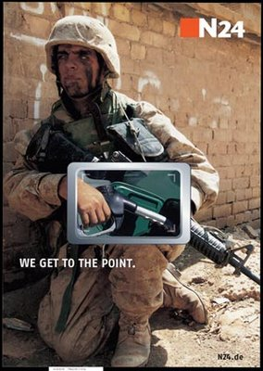

- Portrait — conceptual and timeless.
- Snapshot — specific moment in time.

 | 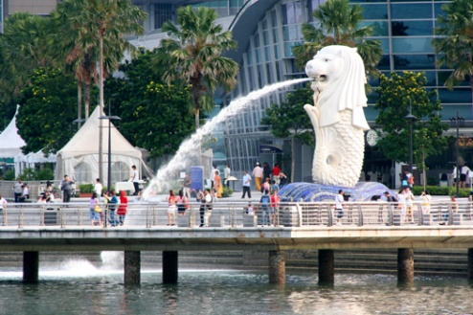

Interpersonal meaning

- Gaze (towards the reader):

  - Demand — gaze is established.
  - Offer — no gaze.

 | 

- Prominence

  - Close-up
  - Medium
  - Long-shot

  - Distance

 | 

Prominence also achieved through:

  - Focus
  - Colour

 | 

- Perspective

  - Frontal shot
  - Oblique-angle shot

 | 

Angle

  - High angle — reader looks down
  - Low angle — reader looks up
  - Eye-level angle

  - Power

 | 

- Modality — how committed?

  - Realism (contextualization) vs. Abstraction (generic)

 | 

Textual meaning

- Framing — (vector) lines (horizontals, verticals, diagonals, etc.).



- Information flow

    - Given
    - New

    - Ideal
    - Real



- Parallelism vs. opposition



FOR DISCUSSION

 | 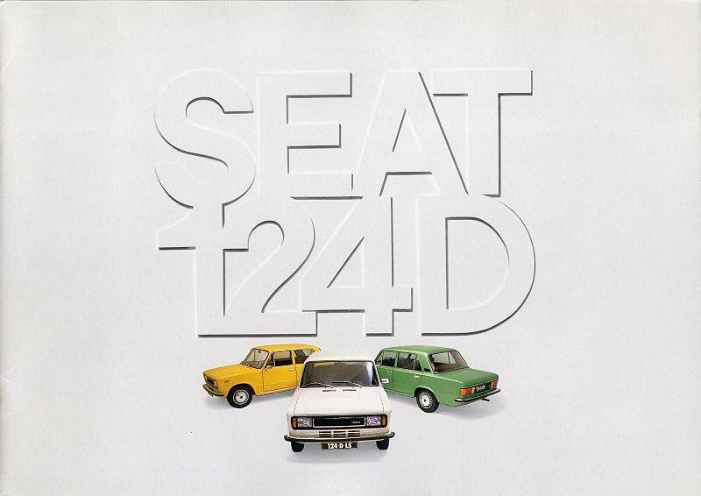

SO, BASICALLY, WHAT ALVIN IS SAYING IS …

Ideational

- Look at the participant in the picture and determine his/her/its action or state, and by extension his/her/its transactional or non-transactional status. Is the represented participant or event captured as a portrait or a snapshot?

Interpersonal

- Check if the participant is looking directly at you, and so determine if the image is a demand or an offer.

- Assess the way the participant is represented and angled in the image, and so determine its prominence and perspective.

- Determine if the participant or event is represented as ‘real’ or ‘abstract’, and so assess its modality.

Textual

- Search for lines that either divide up the image into various portions or serve a rhetorical purpose (i.e., pointing you in a certain direction).

- Assess if there are given and new components in the image.

- Assess if there are ideal and real components in the image.

- Search for all forms of parallelism and opposition in the image. These may involve positioning, color, size, race, gender, etc.

And finally …

- Ask yourself what all these imply. In other words, interpret the features of the image; show how these features allow you to say something sensible about the meaning of the image.

