Largemouth Bass Aquaculture
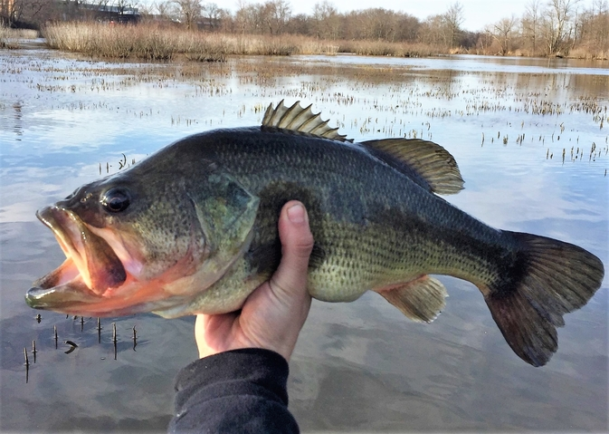

Environmental Setup

1. Largemouth Bass Aquaculture Model & Environmental Setup
The Paper 1: Environmental requirements for the culture of largemouth bass (ResearchGate)
- What we care about: The primary statistics in bass aquaculture are Survival Rate (heavily impacted by cannibalism), Feed Conversion Ratio (FCR), and Specific Growth Rate (SGR).
- The Environment: They are typically raised in freshwater ponds, intensive Recirculating Aquaculture Systems (RAS), or lake cages. They thrive in warm water; fry grow best at 25–27°C (77–80°F).
- The Conditions: Dissolved Oxygen (DO) and Total Ammonia Nitrogen (TAN) are the primary chemical constraints. Bass are highly sensitive to sudden temperature drops, which can trigger fungal infections.
The Paper 2: An Environmental Impact Assessment of Largemouth Bass (Micropterus salmoides) Aquaculture (Published in Sustainability/MDPI, 2023)
- The Environment: They are highly adaptable and are farmed in freshwater ponds, land-based recirculating aquaculture systems (RAS), and open-water enclosures.
- The Conditions: The paper notes their optimal growth temperature is between 20°C and 25°C. They require highly oxygenated water (typically above 3 mg/L).
- Feeding & Diet: In intensive aquaculture, they are transitioned from live food to formulated, high-protein commercial floating pellets. They are highly aggressive eaters, which means feeding schedules must be strictly monitored to prevent massive amounts of uneaten feed from sinking and causing localized pollution (eutrophication).
The Paper 3: Comparison of the survival rate of largemouth bass (Micropterus salmoides) fingerlings...
- The Validation: This paper explicitly tracks the environmental baseline required for farming largemouth bass in enclosed aquaculture setups. It documents that Dissolved Oxygen (DO) must be maintained safely above 3.7 mg/L, and pH should remain stable between 7.4 and 7.6.
- Simulation Link: This provides the exact mathematical thresholds your Evolutionary Algorithm needs to evaluate whether a bass particle is "suffocating" in the simulation's low-oxygen benthic zone, allowing you to mathematically justify the energy drain in your code.

2. Gape-Limited Predation & Intracohort Cannibalism
The Paper: Morphological constraints on intracohort cannibalism in age-0 largemouth bass (Johnson & Post, published in Transactions of the American Fisheries Society)
- The Proof: This is the absolute gold-standard paper for your inner PSO loop. It scientifically proves that largemouth bass are "gape-limited"—meaning their ability to eat a sibling is dictated entirely by the physical width of the cannibal's mouth versus the body depth of the prey.
- The Impact: The research establishes that if even a slight size variation occurs within the same age group (cohort), cannibalism immediately arises. In a farming environment, this intracohort cannibalism will rapidly decimate the population unless the farmer manually grades and separates the fish by size. This perfectly justifies your swarm particles constantly calculating a "Fear Vector" against larger members of their own school!

3. Natural Disease
The Paper: Controlling Mortality Caused by External Columnaris in Largemouth Bass and Bluegill with Chloramine-T or Hydrogen Peroxide (Published in the Journal of Aquatic Animal Health)
- The Threat: This peer-reviewed article confirms that Flavobacterium columnare (Columnaris disease) is one of the most severe bacterial threats to largemouth bass.
- The Mechanic: The disease is highly opportunistic. It thrives when the bass are crowded or stressed by poor water quality (like diving into the low-oxygen, high-waste benthic zone to hide from cannibalistic siblings). It causes necrotic lesions on the gills and skin, which mathematically translates perfectly to a severe energy and fitness drain in your EA's scoreboard.

4. Natural Parasite
The Paper: Common diseases of largemouth bass (Researchgate)
- The Proof of Parasites: The text documents that largemouth bass are highly susceptible to ectoparasites in aquaculture environments, specifically listing Ichthyophthirius (Ich) and Trichodina as frequent threats found on their gills and skin.
- The Proof of Rubbing: This paper gives you the absolute biological proof for your inner loop mechanic. It explicitly states: "Fish infected with Ich are often seen rubbing on the pond bottom or hard objects. This is called 'flashing' because of the sporadic exposure of the light-colored belly of the fish." This means your instinct to code a mechanic where an infected bass must "grub" or rub against a physical obstacle (like the edge of the lake cage or a structure) to cure itself is 100% biologically accurate for this species!

5. Artificial Supports (Probiotics)
The Paper: Multiple effects of dietary supplementation with Lactobacillus reuteri and Bacillus subtilis on the growth, immunity, and metabolism of largemouth bass (Published in Frontiers in Immunology / PubMed, 2024)
- The Support: This recent study directly proves your exact artificial support mechanic.
- The Proof: It demonstrates that when Bacillus subtilis (a live probiotic) is mixed directly into the commercial feed pellets, it significantly increases the specific growth rate of the bass. More importantly, it actively upregulates their antioxidant genes and strengthens their intestinal immunity, making them highly resistant to the exact types of bacterial infections (like Columnaris) mentioned above.
- The Mechanic: This exact paper proves that feeding bass these specific probiotics significantly improves their intestinal structure, strengthens their immune system, and increases their specific growth rate, perfectly validating your simulation's "immunity buff" mechanic!

