Nile Tilapia Aqualculture

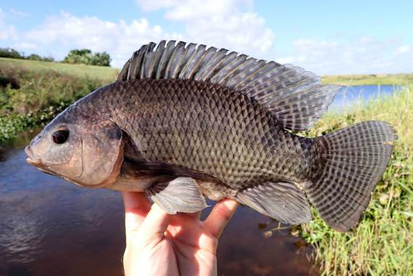

1. The Environment: Freshwater Open Lake (Cage Culture)
Answer: The ideal and highly common environment for intensive Nile Tilapia farming is a freshwater open lake utilizing floating cage culture. In this setup, massive nets are suspended in open natural lakes.
- The Paper: "Effects of Nile tilapia (Oreochromis niloticus) cage aquaculture on water quality in the world's largest tropical lake" (Okechi et al., 2024, Journal of Great Lakes Research).
- Context: This study specifically examines Nile Tilapia farmed in floating cages in Lake Victoria, validating this exact environment for your simulation.

2. The Environmental Conditions Affecting the Lake Cages
Answer: Because it is an open lake, the cage environment is heavily dictated by water currents and the accumulation of waste from the cage itself. The primary parameters that dictate survival are Dissolved Oxygen (DO), pH, Ammonia (NH₃), and Eutrophication (algal blooms) driven by excess nitrogen and phosphorus from uneaten food dropping through the net.
- The Paper: "Environmental impacts of tilapia fish cage aquaculture on water physico-chemical parameters of Lake Kivu" (Frontiers in Water, 2024).
- Context: The paper demonstrates that while the open lake provides natural water exchange, the localized area inside and directly beneath the tilapia cage suffers from rapid organic pollution. If the fish swarm too tightly or feeding is not optimized, localized DO plummets, suffocating the tilapia.

3. Natural Harms (Parasites & Diseases) in Lake Cages
Answer: In highly concentrated lake cages, Nile Tilapia are extremely vulnerable to localized parasite outbreaks that thrive on the gills, causing suffocation and severe mortality rates. Specific culprits include Chilodonella, Trichodinia, and Gyrodactylus parasites, which cause gill necrosis and restricted respiration.
- The Paper: "Investigation of parasite and diseases at cage culture Nile tilapia (Oreochromis niloticus)" (Ashaf-Ud-Doulah et al., 2020).
- Context: This study tracked mortality in tilapia cage farming and found that poor water quality (high ammonia/low DO from Question 2) directly triggered outbreaks of these 11 specific parasites. The gills were the most infected area, leading to mass die-offs. In your simulation, these parasites would act as an energy-draining or suffocation penalty on the swarm.

4. Artificial Supports (Probiotics & Supplements)
Answer: Instead of traditional chemical medicines (which wash away in an open lake environment), the primary artificial support used to boost cage aquaculture is Dietary Probiotics (such as Lactobacillus plantarum) mixed directly into the feed pellets dropped into the cage.
- The Paper: "Evolution of probiotics in aquatic world: Potential effects, the current status... and recent prospectives" (Balcazar et al., published via NCBI/PMC).
- Context: Probiotics are live microbial additives. When the tilapia eat the supplemented feed, these good bacteria colonize the fish's gastrointestinal tract. The paper proves this artificial support significantly increases the fish's feed utilization (growth rate) and actively improves their non-specific immune system, making them highly resistant to the bacterial diseases and parasites mentioned in Question 3.
How this ties into your simulation code: Your EA can evolve a tilapia swarm to optimize feeding. When they eat normal food, they gain baseline energy. However, if you code "Probiotic Pellets" that drop occasionally, the fish that successfully track and eat them gain a temporary immunity buff against the Chilodonella parasites, adding a brilliant layer of resource-gathering strategy to your PSO inner loop!

