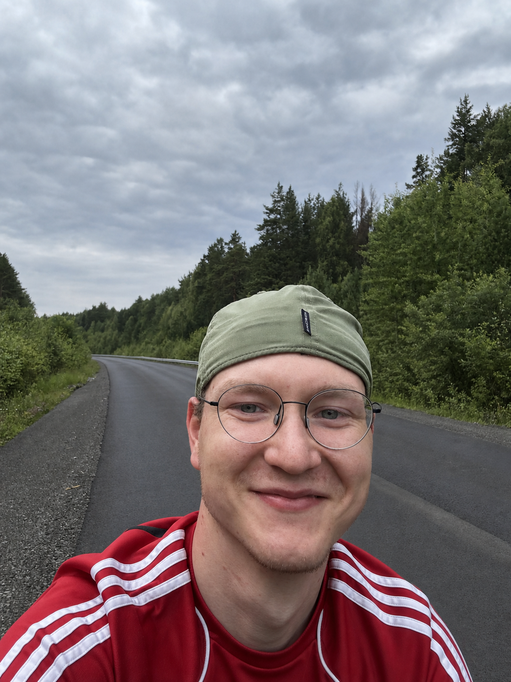
Leonid Saidulin
Product Lead / Product Manager | B2B SaaS, PropTech, Voice AI
Yekaterinburg, Russia | remote / relocation | +7 (911) 836-39-71 | lsajdul@mail.ru | Telegram: @leonidsaidulin

PROFESSIONAL SUMMARY
Product Lead taking B2B SaaS products from customer research through go-to-market and first revenue. Seeking an international SaaS, PropTech, or Voice AI role where I can apply this experience and grow with a global team.
I lead product development at My Dom Online, software that automates work for property-management and utility-company employees. Its primary differentiator is a voice dispatcher that receives service requests and meter readings without staff involvement. I also identify and launch new directions that increase account value, create upsell opportunities, and strengthen the sales proposition.

PRODUCT SCALE
159 active B2B customers | RUB 2.85M MRR | about 2M customer accounts | about 50K users. Apartments connected to the resident app grew 44% between Oct 2025 and May 2026. These figures describe company scale and team outcomes; the bullets below show my contribution.

CORE SKILLS
- Research: qualitative interviews, quantitative CRM, SQL and product analysis, segmentation, ICP definition, hypothesis testing, and AI-assisted synthesis.
- Product and economics: B2B SaaS, 0-to-1 launches, go-to-market, first sales, roadmaps, P&L, MRR, ARPU, payback, churn, and business-model design.
- Data and AI: Bitrix24, AppMetrica, n8n, Codex, OpenAI/LLM, SpeechKit, and MCP; AI sales-call analysis and evidence-based product hypothesis management.
- Leadership and integrations: cross-functional leadership, external vendors, SLA management, APIs, integration negotiations, expert content, and organic blog growth.

EXPERIENCE

My Dom Online / SmartF LLC

Product Manager / Product Lead | Apr 2025 – Present
PropTech SaaS for property managers and utility suppliers: dispatcher CRM, voice dispatcher, resident and employee apps, web portal, MAX, GIS ЖКХ, and utility billing.

Selected product outcomes
- Focused the product on service-oriented property managers. Conducted 22 interviews and tested about six hypotheses. Selected companies investing in resident service and automation, repackaged MDO around their workflows, and made the voice dispatcher the primary differentiator.
- Validated the positioning with a paid-services marketplace. Built a resident-app module for services from the property manager and its partners. Three organizations joined the pilot; I closed one upsell and stopped standalone monetization when the pilot did not validate demand.
- Launched utility billing from zero. Ran about 17 interviews with customers, external experts, billing specialists, and accountants, plus a mystery purchase and competitor reverse engineering. Chose in-house development, wrote the specification, selected 66bit and a billing expert, and accepted each MVP stage.
- Built the utility-billing go-to-market motion. Created the pilot, content, landing page, and proposals; helped hire and onboard a sales manager and lead every technical call. In two months, the team covered 176 companies: 73 substantive conversations, 19 technical calls, five contract-stage or won deals, and two sales totaling RUB 18K MRR.

My Dom Online / SmartF LLC (continued)

Research and product strategy
- Run an annual market study. Compare active and churned customers, non-buyers, prospects, service-oriented property managers, and competitor employees. Using eight interviews in 2026, I identified the risk of resident communication moving to GIS ЖКХ and selected an “AI dispatcher + human” model.
- Reconstruct real customer workflows. Define hidden hypotheses, ask respondents to replay their latest case, and compare answers with CRM, support, SQL, product behavior, and willingness to pay. AI transcribes and clusters the material; I store conclusions with links to the original evidence.

Team leadership
- Coordinate five functions and a two-person external engineering team: sales, support and integrations, engineering, finance, and legal. Weekly reviews with the CEO remove customer and delivery blockers; monthly reviews cover revenue, payback, SLA, availability, churn, and usage; quarterly reviews cover P&L, strategy, and stop/go decisions.
- Improved engineering efficiency. Found a specialist to audit the team and introduced AI tools into the delivery workflow. The backend/frontend team moved from five people to two and maintained release output.
- Introduced early churn-risk detection. I use SQL exports to flag a 20%+ decline in service requests, voice-bot usage, or dispatcher usage versus the previous three-month average, prompting the team to contact customers before cancellation.

AI automation
- Built Sales X-Ray. The Bitrix24 and AI workflow processed 1,501 unique calls and 290 client profiles and found 1,089 candidate signals; 265 were approved and published, including 57 manually approved.
- Automated respondent and partner discovery. Built an hh.ru MCP and Telegram bot for interview recruitment; agency sales uses the same workflow to find partners.
- Automated market monitoring. Built bots that collect relevant tenders and compare 15 competitor websites every day, tracking changes in products, pricing, and positioning.
- Built an expert-content workflow. Every two weeks, I collect recurring industry topics, prepare drafts with AI, and verify facts and professional accuracy before publication and organic distribution.

Spasibo Sosedu LLC

Founder / Product Owner | Apr 2024 – Apr 2025
- Built a local-services product for residential communities and took it from concept to MVP and pilots with developers and property managers. Closed it when the market did not validate willingness to pay for the added workflow.

Saidulin L.I., Sole Proprietor

E-commerce business owner | Jun 2021 – Apr 2024
- Built sales on Ozon and Wildberries and owned assortment, procurement, advertising, logistics, unit economics, and P&L; sold the operating business to move into product development.

EDUCATION AND LANGUAGES
Ural Federal University | Tourism, 2026; Foreign Regional Studies (China), 2023.
Russian: native | English: B2 | Chinese: A2 / HSK2

