**Facing trade-offs: The variability of public support for climate change policies**

# Abstract

Policy support is often measured by asking respondents to evaluate policies linked to an isolated policy goal. However, in real-world settings, policies usually have multiple implications. We study how people react when policies have negative implications for other valued goals, considering both their level of support and the certainty of their choices. Using survey experiment data collected in Germany in 2020 (N = 2233) that measures people’s support for climate policies with or without information about negative implications for different societal groups, we find that people decrease their policy support and become less certain about their choices when faced with negative implications for vulnerable groups. This effect is partially moderated by people’s climate change concern and their support for government assistance for such groups. We thus contribute to the understanding of people’s policy decision-making, with implications for the measurement of public support and the development of effective climate policies.

Keywords: goal conflict; policy goals; climate policy; public support; trade-offs; survey experiment

# **Introduction**

In democracies, sustainable and successful policy implementation depends heavily on public support, but this support may be more volatile than commonly assumed. Like other policies, measures to reduce emissions and adapt to changing climatic conditions require public backing (Beiser-McGrath & Bernauer, 2021). Existing research shows that the majority of people are concerned about climate change and support climate action in general (Flynn et al., 2021), yet, this support does not seem to translate into actual policy implementation (Beiser-McGrath & Bernauer, 2021). Instead, people’s support varies across specific climate policies (e.g., Dietz et al., 2007; Leviston et al., 2015; Rhodes et al., 2017; Rosentrater et al., 2013; Smith et al., 2020; Stoutenborough et al., 2015), and support for individual policies depends on the available information (Beiser-McGrath & Bernauer, 2019; Bernauer & Gampfer, 2015; Fesenfeld, 2022; Jang, 2013; Unsworth & Fielding, 2014). While there is a large body of research on changes in support for climate mitigation policies (e.g., Beiser-McGrath & Bernauer, 2021; Bernauer & Gampfer, 2015; Fesenfeld & Rinscheid, 2021; Jagers et al., 2019), we still know rather little about the variability of the support for specific climate policies. Policies routinely involve multiple intended or unintended implications (Schneider & Ingram, 1990). Because citizens’ policy attitudes tend to reflect a range of relevant considerations (Schneider & Ingram, 1990; Tetlock, 1986; Wildavsky, 1987), salient policy implications influence people’s level of support for climate-related policies (e.g., Beiser-McGrath & Bernauer, 2019; Coleman et al., 2023; Jagers et al., 2021).To obtain a realistic estimate of public climate policy support it is thus important to understand the conditions under which people consistently support specific climate policies.

We add to the existing literature on changes in climate policy support by examining the variability of people’s policy attitudes in the face of implications perceived as detrimental to other valued policy goals. Provided that such implications imply real trade-offs, alerting people to their existence may affect their level of support but also the certainty with which they hold their attitudes. Such a lack of certainty may prevent the formation of stable majorities required for the implementation of climate policies. We explore effects for a range of climate policies with implications for different societal groups, which evoke trade-offs. While recent literature highlights how social and climate policies can co-benefit each other (Cohen et al., 2021; Markkanen & Anger-Kraavi, 2019; Patterson et al., 2018), budget constraints often force policy makers to prioritise goals (Armingeon & Bürgisser, 2021). Thus, climate action may impair social goals (e.g., Markkanen & Anger-Kraavi, 2019). People account for distributional consequences, and concerns about disadvantages for specific groups in their climate policy support (Brannlund & Persson, 2012; Carlsson et al., 2012; Shwom et al., 2010). Similar to the decrease in public support when climate policies are perceived as unfair (M. Bergquist et al., 2022; Maestre-Andrés et al., 2019; Thaller et al., 2023), individuals’ beliefs about climate change and their endorsement of conflicting goals may change their evaluation of climate policies when they learn about negative implications. Importantly, the strength of people’s conflicting predispositions may also affect their response certainty. People who strongly value both climate action and the conflicting goal likely experience an internal conflict that makes them feel uncertain, may lead to more volatile decisions, and may make them hesitant to form attitudes.

We tested how people react to information about negative implications with novel data from a survey experiment fielded in Germany in 2020, using ordered logistic and ordered logistic heteroscedastic regression models. In the experiment, respondents were asked to express their support for various climate mitigation and adaptation policies. The control group received no additional information, whereas negative implications for different societal groups were made salient for the experimental group. Our results show that individuals’ support for climate policies, as well as their response certainty, are negatively influenced by the salience of such implications and that this effect depends on the strength of relevant predispositions toward the conflicting goals. This suggests that understanding the variability of public support is important for the implementation of climate policies and that policy makers may be most successful with proposals that consider and address negative implications for disadvantaged groups.

# **Theory**

Public policies usually have implications beyond their intended goals, which are not commonly considered in citizens’ policy evaluations. Policies aimed at dealing with climate change are no exception. Yet, not all implications are equally covered in public debates preceding binding decisions about policies, be it due to a lack of knowledge or for political considerations. For example, policy proponents may highlight implications that are likely to increase public support, while downplaying others. Some people are aware of such implications when deciding, however, many people will not consider all effects and implications of a policy. Instead they rely on a selection of cognitively available considerations that is likely based on recently provided information (Feldman & Zaller, 1992; Zaller, 1992), including media coverage and public discourse (Harring et al., 2019), as well as personal experiences and idiosyncratic factors (Eagly & Chaiken, 1993; Lavine et al., 1996). In consequence, only the first group can be expected to express the same level of support for a policy when informed about further implications, because they have already considered this information in their decision-making. In contrast, information about negative implications may alter the policy support of people, whose initial level of support did not incorporate this information. Hence, abstract measures may systematically overestimate the public support for climate policies.

Given that individuals’ policy support builds on a limited set of considerations, it can be expected to respond to changes in the available information about policies’ implications (Beiser-McGrath & Bernauer, 2019; Fesenfeld & Rinscheid, 2021; Jang, 2013; McGrath & Bernauer, 2017; Unsworth & Fielding, 2014). Depending on the evaluation of already considered and newly learned policy effects, different patterns may emerge. People who do not care about the conflicting policy goals have no reason to weigh one against the other and thus cannot be expected to change their policy evaluation. Yet, someone who supports a policy may become less supportive when learning about negative consequences for another valued goal. According to the literature on ambivalence, people may also become hesitant about their decisions, feel torn, and become volatile in their evaluations if they deem both the intended positive and the incidental negative effects equally important (Feldman & Zaller, 1992; Rudolph, 2005; van Harreveld et al., 2015). Hence, citizens may react very differently to new information about a policy depending on their predispositions towards the potentially conflicting goals.

As climate policies routinely involve high costs and come with palpable consequences for other policy goals (Cohen et al., 2021; Liu et al., 2019; Markkanen & Anger-Kraavi, 2019; M. Nilsson et al., 2016; Soergel et al., 2021),[1] the likelihood that people will experience conflicts between climate goals and unintended implications is comparatively high. Many policy domains, like agriculture and environment, can co-benefit from climate policy. However, other policy goals such as redistribution are not generally compatible, mainly because budgets are limited, and benefits and costs are unequally distributed (Armingeon & Bürgisser, 2021; Markkanen & Anger-Kraavi, 2019; Soergel et al., 2021).[2] Moreover, social equity preferences and the perceived fairness of climate policies have been highlighted as predictors of public climate policy support (Jagers et al., 2019; Klinsky et al., 2012; Svenningsen, 2019). Given their shared value base (Spies-Butcher & Stebbing, 2016), support for climate protection and preferences for government assistance can be expected to coincide for many people. This suggests that people perceive conflicts between their climate policy preferences and social goals as trade-offs.

Compared to adaptation, conflicts between mitigation and social goals may be especially hard to resolve as both goals can be traced back to care for others (sometimes labelled self-transcendence: Cheung et al., 2014; Harring & Jagers, 2013; Kulin & Svallfors, 2013; A. Nilsson et al., 2004; A. Nilsson & Biel, 2008; Smith et al., 2020; or altruistic care: Dimick et al., 2018; Feinberg & Willer, 2013; Rhodes et al., 2017). People who care strongly about the welfare of others should find it difficult to reconcile their concern about the impacts of climate change with their concern about possible negative implications of climate policies for disadvantaged groups. In contrast, support for (local) adaptation projects that benefit residents directly can be expected to link back to self-interest rather than care for others (Blennow et al., 2020; Singh et al., 2017; Yazar & York, 2022). Yet, many (global) adaptation policies benefit others and may therefore be based on the same values as mitigation policies. In summary, social and climate goals are at times incompatible, forcing people to choose between two equally valued goals.

Building on the notion that people evaluate policies based on currently available considerations (Lau, 1989; Lavine et al., 1996), we expect that people will assess policies differently when negative implications are salient, and the intended aim of a policy and the conflicting goal are both supported. Hence, we expect that *individuals who are concerned about climate change are more supportive of climate policies when negative implications are salient* (H1a) because they weigh the benefits for the climate against the expected disadvantages.[3]. Inversely, *individuals who support government assistance for specific groups should be less supportive of climate policies when negative implications for those groups are salient* (H1b). These effects should be larger when people clearly value one goal over the other and smaller when people perceive climate protection and governmental support for a specific societal group as equally important. Thus, *the climate policy support of* *individuals with more unambiguous priorities should be more strongly affected by* *the respective predispositions* (H1c)*.* In summary, pre-existing priorities in conflicting goals are decisive for the resilience of people’s climate policy support levels.

Furthermore, people’s policy priorities likely influence their response certainty. Assuming that people weigh conflicting goals against each other, someone who values both government assistance and climate protection is likely less certain about their response when trade-offs are salient because they are “unwilling or unable to sacrifice one value for the sake of the other” (Rudolph, 2005, p. 911). In consequence, this group may exhibit symptoms of ambivalence like insecurity or hesitance when forced to decide between valued goals, and randomly decide for one option or the other (Alvarez & Brehm, 2002; Steenbergen & Brewer, 2004), leading to more volatile policy support over time (Lindstam et al., 2021).[4] On the other hand, respondents who clearly prioritize one goal over the other should have no difficulties reconciling their preferences and their policy support should thus be comparatively consistent. Consequently, we expect that *individuals with more balanced preferences towards conflicting goals are more volatile in their climate policy support when implications are salient* (H2). In the extreme case that people attach considerable importance to both conflicting goals, this implies that people may be unable to resolve the tension and make a choice. Hence, learning about negative implications may ultimately inhibit policy decision-making and thus undermine public support for both conflicting goals.

# **Data and methods**

To examine how conflicts between the goals of climate policies and their negative implications influence people’s level of support for these policies and the certainty of their responses, we draw on data from a survey experiment with 2,233 respondents fielded in Germany between March 17 and April 19, 2020.[5] As the seventh largest emitter of carbon dioxide in the world and the largest economy of the European Union, support for climate policies in Germany has a decisive impact on European, and ultimately global, mitigation and adaptation efforts (Crippa et al., 2020; Szulecki et al., 2016). Since respondents were recruited from an online access panel using socio-demographic quotas (gender, age, education), the sample is not fully representative of the German electorate. However, potential biases should not affect the validity of the results, as the respondents were randomly assigned to receive the experimental treatment or the control treatment, and additional analyses focus on intra-individual rather than inter-individual differences.

For the survey experiment, all respondents were asked to what extent they agreed or disagreed with three statements endorsing mitigation policies and two statements advocating adaptation policies (see Table 1 for question wording and coding).[6] For respondents in the experimental group, these statements disclosed negative implications of the rated policies for specific societal groups, whereas respondents in the control group received no additional information. The queried policies represent a variety of measures that were publicly discussed in Germany at the time of the survey, allowing us to discern whether the expected effect is limited to specific policies or can be observed across the board. The items refer to conflicts between proposed climate protection measures and negative implications for specific societal groups that were salient in the public debate.[7]

Discussed measures intended to reduce emissions included a ban on combustion engines, prominently advocated by the Green parliamentary faction and widely discussed in the media; renovations to save energy, ultimately codified in the new Buildings Energy Act; and the transition to paperless government services (Balser, 2019; Deutscher Bundestag, 2020). The adaptation items relate to flood protection, an issue that is relevant across Germany and received attention in the context of rising insurance rates; and funding for innovative adaptation solutions, pushed as an alternative to costly mitigation measures (Bundesparteitag FDP, 2019; Tagesspiegel, 2019). The selected climate policies are diverse beyond the distinction between mitigation and adaptation policies, as different groups are affected more or less directly by their implications.[8] For instance, a ban of combustion engines mostly affects the car industry in Germany, whereas the promotion of digital government services primarily affects administrative bodies and the funding of innovative technologies likely plays a role for research but is not directly associated with a most affected group. Hence, the chosen policies are well-suited to gauge people’s reactions to diverse policies and trade-offs.

**Table 1:** Experimental treatments

|  |  |
| --- | --- |
| No combustion engines after 2030 | "From 2030 on, first-time registrations for cars with combustion engines should be discontinued, *(even if that would limit the mobility of people in rural areas)."* |
| Energy-efficient renovations | "All buildings should be renovated to save energy, *(even if this would significantly increase rents)."* |
| Promote digitalization | "Government services should be managed digitally, *(even if this presented senior citizens with considerable difficulties)."* |
| Increase flood protection | "Flood protection for endangered areas should be significantly strengthened, *(even if the cost would burden financially weak households)."* |
| Fund innovative technologies | "Innovative projects that explore ways to adapt to climate change should be financed by tax revenues, *(even if pensions can no longer be subsidized)."* |

Apart from personal cost considerations, which have been previously studied (Armingeon & Bürgisser, 2021; Groh & Ziegler, 2018), moral concerns about the impact for disadvantaged groups are an important consideration in the evaluation of climate policies (Shwom et al., 2010). We thus included information about potential negative consequences for specific societal groups in the experimental items.[9] To ensure that observed changes are not bound to attitudes towards one specific group, negative implications for several different societal groups were chosen from a range of publicly discussed unintended consequences.

Figure 1 displays the mean level of agreement with the five climate policies in the experimental group and the control group, respectively. In line with our theoretical expectations, people in the experimental group are consistently less supportive of the climate protection policies than people in the control group, indicating that the treatment succeeded to raise awareness for previously unconsidered outcomes. For the mitigation policies (first three rows in Figure 1), the difference ranges between 8 and 24 percentage points. This cannot be explained by the varying base levels of support in the control group, as the means are not particularly close to the end points of the scale. Some of the variation may be due to different levels of sympathy towards the different societal groups. However, the means for the items measuring support for government assistance for these groups differ by less than 0.15 scale points and the differences do not correspond to the observed pattern, as larger means do not imply larger differences between the groups (see Appendix 2).[10] Alternatively, the differences may reflect respondents’ prior awareness of negative implications as the smallest difference is observed for people’s willingness to support the discontinuation of first-time registrations for cars with combustion engines after 2030, the measure most prominently discussed at the time of the survey. Respondents in the control group may thus have been similarly aware of potential consequences as respondents who received information about negative implications for the mobility of people in rural areas in the survey. With 28 percentage points for funding innovative technologies and 30 percentage points for increasing flood protection, the differences are slightly larger for the two adaptation policies, which were less salient in the public debate.

**Figure 1:** Average support for climate protection measures by item.

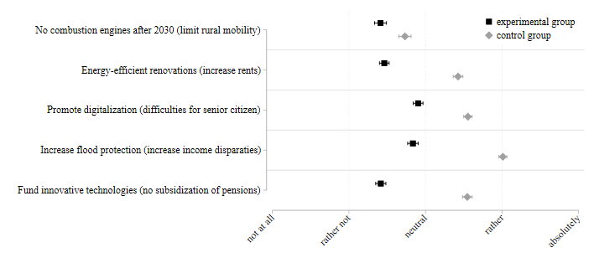

Notes: Depicted are mean support scores for climate protection measures with 95-percent confidence intervals for respondents in the control group (grey diamonds) and the experimental group (black squares).

To test whether the differences in the level of support for climate policies between respondents in the experimental group and the control group are statistically significant, we used ordered logistic regressions to regress respondents’ climate policy support on their reception of the experimental treatment, including their predispositions on climate change and the conflicting goal as independent variables. Furthermore, we controlled for respondents’ age[11], their income, and their residence to rule out that conflicts between respondents’ desire to protect the climate and support vulnerable groups are actually driven by self-interest. When people indicated that they favour government assistance for a specific group, we can therefore be confident that their motives are altruistic rather than self-serving.

We drew on respondents’ concern about climate change to measure their predisposition on climate change (see Appendix 1 for question wording and coding). Unlike the mere belief in the existence of climate change, concern about the issue implies that respondents should generally favour policies aimed at coping with its consequences. Yet, it does not equal support for any specific climate policy and is therefore well-suited to capture respondents’ general position on climate action. To measure predispositions on conflicting goals, we relied on a battery of items querying respondents’ support for government assistance for rural areas, low income households, and senior citizens.

Support for assisting specific societal groups, like support for most climate policies, is based firmly on care for others (Kulin & Svallfors, 2013). In consequence, people who care strongly about the welfare of others can be expected to express support for both climate policies and government assistance for vulnerable societal groups. To better understand the empirical link between these goals, Figure 2 displays the percentage of respondents in favour of the respective assistance measure separately for those with low and high climate change concern. Government assistance is almost universally endorsed among respondents who are concerned about climate change, and even respondents with low climate change concern largely support assistance measures. In contrast, respondents who are concerned about climate change but oppose government support measures only constitute between 15 and 35 percent of the respondents with high climate change concern (between 7 and 17 percent of the total sample). In other words, the overwhelming majority of respondents who are concerned about climate change also endorse government support for vulnerable societal groups.

**Figure 2:** Percentage of respondents who favour government assistance over levels of climate change concern.

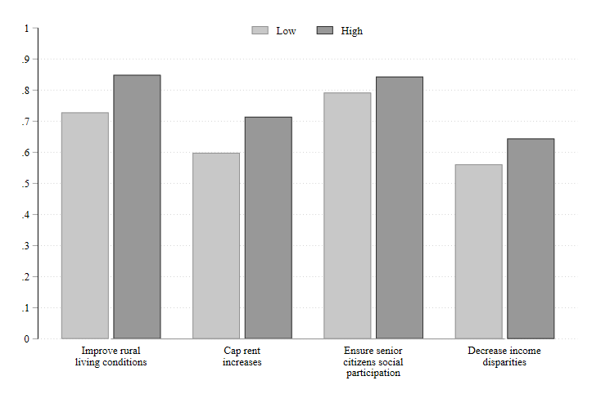

Notes: Depicted is the percentage of respondents in favour of the respective government assistance measure (answer above the mid-point of the scale) among respondents with low (including the mid-point of the scale) and high climate change concern.

To capture the strength of the conflict between policy goals, we constructed an additional variable subtracting respondents’ evaluation of the government assistance measures from their climate change concern (both rescaled between 0 and 1). The resulting difference variable ranges from -1 (strongly supports assistance and not concerned about climate change), over 0 (indifferent or ambivalent), to 1 (very concerned about climate change and unsupportive of assistance), and thus captures the strength of the conflict as well as respondents’ priorities. Since the difference variable is 0 when respondents attach equal importance to both goals, irrespective of the level of their predispositions, this measure cannot distinguish respondents who do not care about either policy goal, and can thus be expected to be indifferent about the proposed climate policies, from those who care equally strongly about both policy goals, and may therefore feel torn when the two goals are in conflict.

We included respondents’ age, per capita household income, and their residence to control for self-interest (see Appendix 1 for question wording and coding). In addition, we controlled for gender because women tend to be more concerned about climate change, commonly express higher support for climate policy than men (Dietz et al., 2007; Rhodes et al., 2017), and react differently to internal conflicts (Bouckenooghe et al., 2007). Highly educated citizens may consider a broader range of policy outcomes in their decision-making processes (Bruine de Bruin et al., 2007), and party identification is related to climate policy support (Drews & van den Bergh, 2016; McCright et al., 2016) as well as positions on social equality and redistribution (Petring, 2015), prompting us to control for education and party identification.

In a second model, we included interaction terms between the experimental dummy and respondents’ predispositions to assess whether concern about climate change has the same impact on answers in both conditions, and whether support for government assistance is more relevant in the experimental group than in the control group. In a third step, we included an interaction between the experimental dummy and the directional distance between the two predispositions to test whether conflict strength conditions the level of support.[12]

To learn how the experimental treatments influence response certainty, we relied on ordered logistic heteroscedastic regression models, which compare the response variance in the experimental group to the control group. While such heterogeneous choice models cannot capture individual-level variance, they allow us to compare the response variance of respondents with similar characteristics across different groups (Albertson et al., 2005; Williams, 2010). By estimating one equation explaining the choice, or the level of the dependent variable, and another equation explaining the residual variance, we can infer whether respondents in the experimental group have, on average, more variable responses than respondents in the control group.

In addition to the experimental treatment, the personal importance of conflicting goals may influence response certainty and, hence, the potential variability of the answers. To test the expectation that people with clear policy priorities are more certain in their responses, we included the squared directional distance between the two predispositions in the variance component of the model. In a second model, we directly tested the effect of conflicting values which are held with equally high importance by adding a three-way interaction between the experimental dummy, respondents’ climate change concern, and their support for government assistance. Here, a positive interaction coefficient would indicate that respondents in the experimental group are more uncertain about their answer if they have strong predisposition on both climate change and government support for specific societal groups.

# **Results**

We argued above that the salience of negative implications influences respondents’ level of support for climate policies as well as their response certainty. To test the first expectation, Figure 3 displays the results of an ordered logistic regression, which explains respondents’ level of support for different mitigation and adaptation measures as a function of their assignment to the experimental or control group, their concern about climate change, and their endorsement of government assistance for specific societal groups (control variables included but not shown; see Appendix 3, Model A3.1 for the full regression results). The experimental treatment includes information about negative implications for these specific societal groups. Therefore, respondents’ support for government assistance is expected to influence their level of support for the respective climate policies in the experimental but not the control condition.

The results show that respondents who received additional information about implications of climate policies are between 4 and 28 percentage points less supportive of these policies than respondents for whom implications were not made salient, supporting the initial expectation.[13] Moreover, the level of support is clearly correlated with respondents’ concern about climate change. Respondents who are very concerned about climate change are between 12 and 30 percentage points more supportive of climate policies than their unconcerned counterparts. In contrast, government assistance preferences have no direct effects on respondents’ support for climate policies, with the exception of flood protection policies, which respondents in favour of income redistribution support even more strongly. Hence, the baseline model largely confirms our assumptions about the isolated influence of these variables, allowing us to turn to the interaction between respondents’ predispositions and their inclusion in the experimental or control group.

**Figure 3:** Average marginal effects on climate policy support.

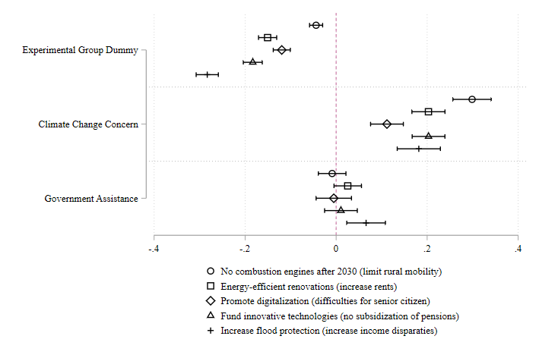

Notes: Depicted are average marginal effects with 95-percent confidence intervals estimated using an ordered logistic regression model including controls for respondents’ age, gender, education level, income, residence, and party identification (not depicted). Full regression results are shown in Appendix 3, Model A3.1.

To test our first hypothesis that individuals who are concerned about climate change are more supportive of climate policies when negative implications are salient, we added an interaction between the experimental treatment and climate change concern (see Appendix 3, Model A3.2 for the full regression results). Figure 4 shows the predicted probability that respondents in the experimental group and the control group fully support the different climate policies across varying levels of climate change concern. As expected, climate change concern tends to affect respondents’ support for climate policies more strongly in the control group than in the experimental group, as respondents in the latter group had to weigh their climate change concern against their concern for the welfare of vulnerable groups. While respondents who are particularly concerned about climate change are still more supportive than their unconcerned counterparts when confronted with negative implications, the difference only amounts to roughly 5 percentage points for almost all climate policies. The exception is the discontinuation of the registration of cars with combustion engines, which may behave differently because the surveyed measure has been especially salient in the public discussion. In comparison, the differences between respondents with varying levels of climate change concern are more than three times higher in the control group, where they range between 16 and 32 percentage points. Given that the difference between concerned citizens in the experimental and control conditions is larger than the difference between unconcerned citizens in the two groups, the findings do not support the expectation that the climate policy preferences of respondents who are particularly concerned about climate change are more resilient to information about negative implications. However, this pattern may be driven more by the very low support for climate policies among respondents who are not concerned about climate change than by differential dynamics in the experimental group. Rather than clearly disconfirming the first hypothesis, the results could thus indicate a floor effect.

**Figure 4:** Predicted probabilities for climate policy support across levels of climate change concern.

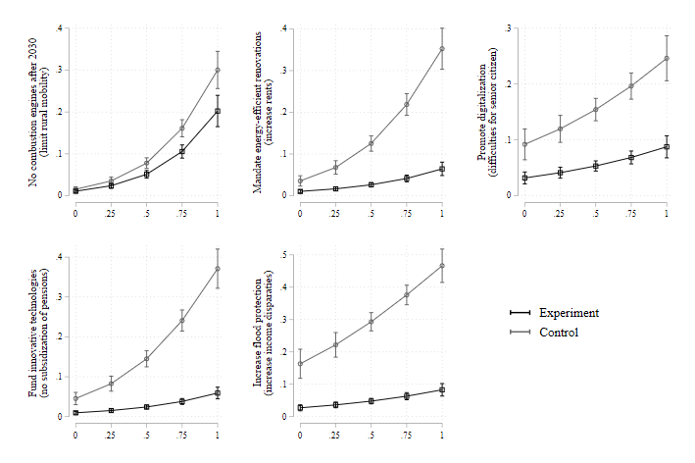Notes: Depicted are predicted probabilities to support climate policies across different levels of climate change concern with 95-percent confidence intervals. Estimates are based on an ordered logistic regression model including interactions between the experimental treatment and climate change concern, and between the experimental treatment and support for government assistance measures, as well as controls for respondents’ age, gender, education level, income, residence, and party identification (not depicted). Full regression results are shown in Appendix 3, Model A3.2.

The same model offers evidence regarding our second hypothesis that individuals who support government assistance for specific groups should be less supportive of climate policies when negative implications for those groups are salient. Figure 5 illustrates the results from the interaction between the experimental treatment and support for government assistance measures, which corroborate the hypothesis. In the experimental condition, the level of support for climate policies decreases when respondents strongly support government assistance for the affected societal groups. These effects are reversed in the control group, where respondents who prefer more government support are also more supportive of climate policies. This fits our expectation that support for climate policies and assistance measures is based on care for others and thus runs in the same direction unless potential trade-offs between these goals are made salient. This pattern can be observed for adaptation as well as mitigation, suggesting that adaptation policies, too, may be perceived as altruistic rather than self-serving.

**Figure 5:** Predicted probabilities for climate policy support across levels of government assistance preferences.

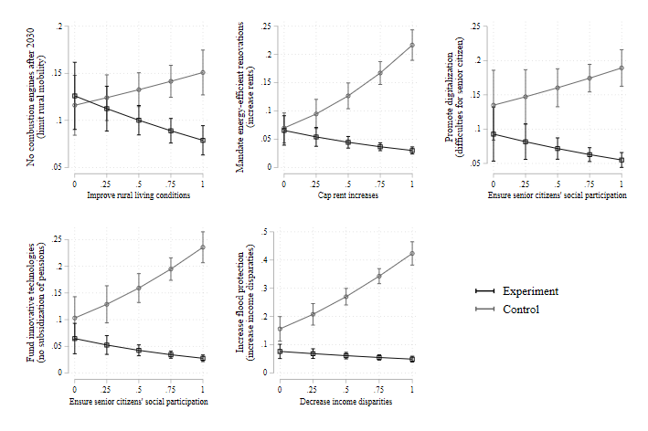

Notes: Depicted are predicted probabilities to support climate policies across different levels of support for assistance measures with 95-percent confidence intervals. Estimates are based on an ordered logistic regression model including interactions between the experimental treatment and climate change concern, and between the experimental treatment and support for government assistance measures, as well as controls for respondents’ age, gender, education level, income, residence, and party identification (not depicted). Full regression results are shown in Appendix 3, Model A3.2.

We additionally argue that the climate policy support of individuals with more unambiguous priorities should be more strongly affected by the respective predispositions. To understand how the strength of conflicting predispositions influences respondents’ level of policy support, we ran an additional model including an interaction between the directional distance variable and the experimental treatment. Figure 6 illustrates the effect of an increasing climate change priority on respondents’ support for the different climate policies in the experimental and control conditions (see Appendix 3, Model A3.3 for the full regression results). In the experimental group, support for the respective climate policy increases when respondents more clearly prioritize climate change over government assistance for specific societal groups. The difference between respondents who support government assistance and are unconcerned about climate change and those who are concerned about climate change and do not endorse government assistance is substantial, ranging between 9 (flood protection) and 31 percentage points (registration of cars with combustion engines after 2030). The upward slope suggests that respondents weighed the importance of the conflicting goals against each other and adapted their level of policy support accordingly. Since lower directional distance values imply weaker climate change concern, it is unsurprising that we find similar slopes at a higher level of policy support for the control group, where increased climate change concern raised support for climate policies in the relative absence of government assistance considerations (cf. Figure 4).[14] Overall, the observed effects thus support our expectation.

**Figure 6:** Predicted probabilities for climate policy support across different strengths of conflicting predispositions (climate concern - support for named government assistance measure).

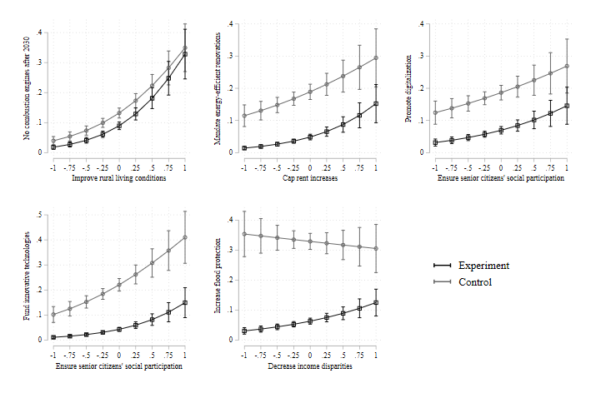

Notes: Depicted are predicted probabilities to support climate policies across different strengths of conflicting predispositions ranging from -1 (clearly prioritizes named government assistance goal) to 1 (clearly prioritizes climate concern) with 95-percent confidence intervals. Estimates are based on an ordered logistic regression model including interactions between the experimental treatment and the directional distance between climate change concern and support for government assistance measures, as well as controls for respondents’ age, gender, education level, income, residence, and party identification (not depicted). Full regression results are shown in Appendix 3, Model A3.3.

For the second part of our analysis, we used ordered logistic heteroscedastic regression models to capture differences in the response variance in the experimental and control conditions and learn how the presence of conflicting considerations affects respondents’ certainty about their level of support. Reflecting our expectation that more balanced preferences should lead to less response certainty, we added a variance component including the experimental treatment, the directional distance between climate change concern and government assistance preferences, and the squared directional distance as independent variables to Model 1 (see Appendix 3, Model A3.4 for the full regression results). In line with the expectations, the results show that respondents in the experimental group tend to exhibit higher response variance, suggesting that people are more uncertain about their answers when confronted with information about negative implications.

Based on the same estimation, Figure 7 shows how the response variance varies across groups of respondents with different priorities. Contrary to our expectation, people who value both policy goals equally are not more volatile in their answers than those who clearly prioritize either climate change or government support towards a societal group.[15] In fact, we observe that respondents who support government assistance but are unconcerned about climate change exhibit greater response variance than ambivalent or indifferent respondents on the two adaptation items. These differences are statistically significant despite very small sample sizes towards the end-points of the scale. Considering that these effects emerge independent of the experimental treatment,[16] the observed differences may stem from the specific characteristics of respondents who are extremely unconcerned about climate change but endorse governmental assistance. In this group, we find comparatively more climate change sceptics, who may be more volatile than other groups in their responses to adaptation items because their benefits are more certain and less clearly related to anthropogenic causes of climate change.

**Figure 7:** Predicted response variance across different strengths of conflicting predispositions.

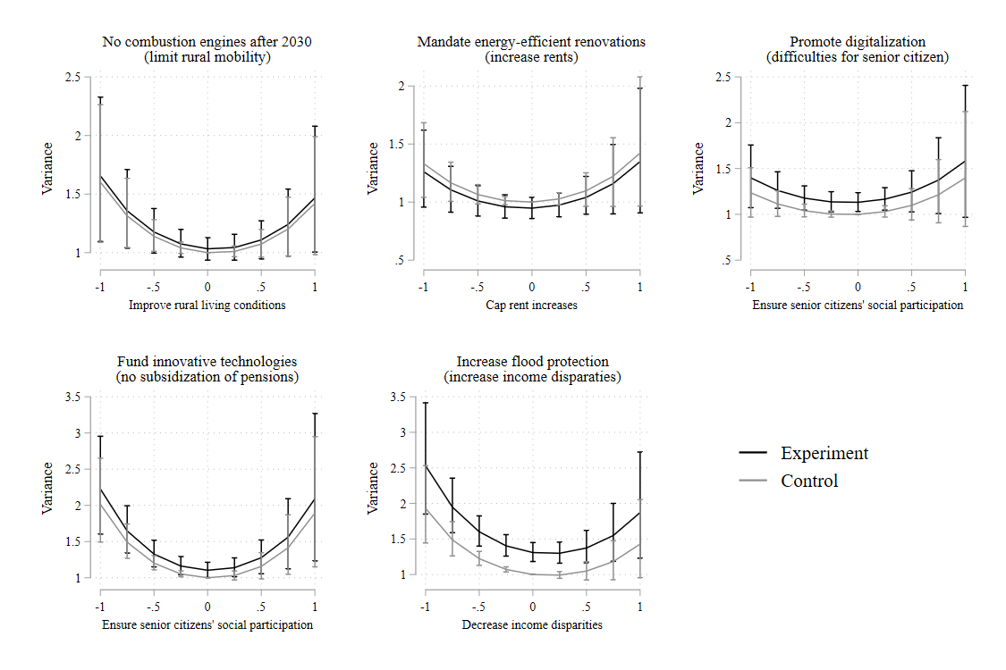

Notes: Depicted is the expected response variance across different strengths of conflicting predispositions ranging from -1 (clearly prioritizes named government assistance goal) to 1 (clearly prioritizes climate concern) with 95-percent confidence intervals. Estimates are based on the variance component of an ordered logistic heteroscedastic regression model including the same independent variables and controls as Model 1 in the main equation (not depicted), and the experimental treatment as well as the directional distance between climate change concern and support for government assistance measures in the variance equation. Full regression results are shown in Appendix 3, Model A3.4.

Although respondents with equally strong predispositions are not generally more insecure about their responses, conflicts between two highly valued goals may still induce greater response uncertainty. However, the three-way interaction between the experimental treatment, climate change concern, and support for assistance measures is statistically insignificant across all climate policies, and visual inspection of the predicted variance reveals no differences between respondents in the experimental and control condition, irrespective of their predispositions (see Appendix 3, Model A3.5). Hence, we cannot confirm our expectation that respondents with balanced preferences become more insecure about their choices, even when the conflicting predispositions are strong.

In short, learning about negative implications from climate policies decreases individuals’ level of support for such measures. Although concern about climate change generally increases climate policy support, the attitudes of more concerned respondents are not more resilient to negative outcomes for specific societal groups than the attitudes of less concerned respondents. On the other hand, government assistance preferences moderate the level of support for climate policies in the experimental group, where respondents who strongly support government assistance express lower support for climate policies than respondents with weaker attitudes. Moreover, the experimental treatment increases response uncertainty, but this effect is not systematically moderated by the strength of respondents’ predispositions.

# **Conclusion**

When learning about negative implications from policies, people may change their attitudes or become more uncertain about their evaluations. Using a survey experiment, we examined the variability of citizens’ climate policy attitudes when negative implications for specific societal groups are salient, accounting for relevant predispositions on climate change and governmental assistance towards these groups. Information about negative implications generally reduces support for climate policies, especially among people who value governmental support for a specific group more than climate protection. High levels of climate change concern could not attenuate such decreases when respondents perceived a trade-off between the two goals. Instead, respondents tended to become more uncertain about their choice when confronted with negative implications for an equally important goal irrespective of relevant predispositions.

The findings show that citizens’ attitudes towards climate policy are not resilient to trade-offs and that estimations of public support for climate protection thus need to account for potential policy goal conflicts. Importantly, given the wide range of policy implications involved in climate policy making, public support may shift with the salience of potential trade-offs, and many people may find it difficult to make up their minds when implications are salient. Therefore, the results of public opinion surveys on climate-related policies should be interpreted with caution. To learn about public policy support in different communication environments, it is helpful to explicitly measure the variability and sensitivity of policy support. By making people aware of various implications, scholars can learn about the range of public support for policies in realistic settings, which commonly highlight more than one (unintended) consequence at a time.

Looked at from a different angle, the analysis suggests that, for many people, support for climate protection and vulnerable societal groups go hand in hand. Under these conditions, learning about further implications can decrease people’s policy support or at least make them hesitant about their policy evaluation. While we analyse policies and implications that are specific to the German context, the underlying mechanism that support for climate policies may be undermined when people learn about negative implications can be expected to pertain across national contexts. The findings should thus generalize to other contexts where the majority of individuals still perceive climate change consequences as a distant and often intangible threat. This condition is frequently found in Western democracies, which continue to be major carbon dioxide emitters and whose successful implementation of climate policies would have a decisive impact on global mitigation efforts. Understanding the variability of public support for climate policies in these countries is an important prerequisite for successful policy implementation, and thus for combatting climate change on a global scale. Since opponents of specific policies have incentives to highlight negative implications in order to fragment policy support, policy makers may be most successful with proposals that already include measures to alleviate negative outcomes in other domains. Such policy bundles may help gain sustainable support for climate-related policies, although the role of predispositions requires further research.

Our research design comes with several limitations. First, the observed effects may represent an upper bound for likely decreases in policy support because the experimental treatment emphasized negative consequences for vulnerable groups, but did not offer any additional information about the intended positive consequences of the respective climate policy that may offset negative implications. Future research should thus include several experimental conditions to understand how real-world information campaigns may influence public opinion towards climate protection. Second, we only examined negative implications that put climate protection into conflict with support for vulnerable groups. While this comparison constitutes an interesting and relevant case, the shared value base of these policies may conceal moderating effects from predispositions because the preference distribution is biased towards strong concern about both issues. Hence, further research is required to test whether climate change concern may affect attitude variability when negative implications relate to less closely related policy domains, or when positive implications are included. Third, we can only compare the response variance of different groups, potentially concealing intra-individual changes. Here, panel designs that allow us to trace changes in respondents’ response certainty more directly may be preferable. Lastly, our findings exhibit different patterns for mitigation and adaptation support, which future research should explore to understand the potentially different dynamics for these strategies and develop targeted communication strategies.

# References

Albertson, B., Brehm, J., & Alvarez, R. M. (2005). Ambivalence as Internal Conflict. In S. C. Craig & M. D. Martinez (Eds.), *Ambivalence and the Structure of Political Opinion* (pp. 15–32). Palgrave Macmillan. https://doi.org/10.1057/9781403979094_2

Alvarez, R. M., & Brehm, J. (2002). *Hard choices, easy answers: Values, information, and American public opinion*. Princeton University Press.

Armingeon, K., & Bürgisser, R. (2021). Trade-offs between redistribution and environmental protection: The role of information, ideology, and self-interest. *Journal of European Public Policy*, *28*(4), 489–509. https://doi.org/10.1080/13501763.2020.1749715

Balser, M. (2019, April 8). Grüne wollen von 2030 an Diesel und Benziner verbieten. *Süddeutsche Zeitung*. https://www.sueddeutsche.de/auto/klimaschutz-gruene-verbot-verbrennungsmotoren-elektroautos-1.4399722

Beiser-McGrath, L. F., & Bernauer, T. (2019). Could revenue recycling make effective carbon taxation politically feasible? *Science Advances*, *5*(9), eaax3323. https://doi.org/10.1126/sciadv.aax3323

Beiser-McGrath, L. F., & Bernauer, T. (2021). Current surveys may underestimate climate change skepticism evidence from list experiments in Germany and the USA. *PLOS ONE*, *16*(7), e0251034. https://doi.org/10.1371/journal.pone.0251034

Bergquist, M., Nilsson, A., Harring, N., & Jagers, S. C. (2022). Meta-analyses of fifteen determinants of public opinion about climate change taxes and laws. *Nature Climate Change*, *12*(3), 235–240. https://doi.org/10.1038/s41558-022-01297-6

Bergquist, P., Mildenberger, M., & Stokes, L. C. (2020). Combining climate, economic, and social policy builds public support for climate action in the US. *Environmental Research Letters*, *15*(5), 054019. https://doi.org/10.1088/1748-9326/ab81c1

Bernauer, T., & Gampfer, R. (2015). How robust is public support for unilateral climate policy? *Environmental Science & Policy*, *54*, 316–330. https://doi.org/10.1016/j.envsci.2015.07.010

Blennow, K., Persson, J., Gonçalves, L. M. S., Borys, A., Dutcă, I., Hynynen, J., Janeczko, E., Lyubenova, M., Merganič, J., Merganičová, K., Peltoniemi, M., Petr, M., Reboredo, F., Vacchiano, G., & Reyer, C. P. O. (2020). The role of beliefs, expectations and values in decision-making favoring climate change adaptation—Implications for communications with European forest professionals. *Environmental Research Letters*, *15*(11), 114061. https://doi.org/10.1088/1748-9326/abc2fa

Bouckenooghe, D., Vanderheyden, K., Mestdagh, S., & van Laethem, S. (2007). Cognitive Motivation Correlates of Coping Style in Decisional Conflict. *The Journal of Psychology*, *141*(6), 605–626. https://doi.org/10.3200/JRLP.141.6.605-626

Brannlund, R., & Persson, L. (2012). To tax, or not to tax: Preferences for climate policy attributes. *Climate Policy*, *12*(6), 704–721. https://doi.org/10.1080/14693062.2012.675732

Bruine de Bruin, W., Parker, A. M., & Fischhoff, B. (2007). Individual differences in adult decision-making competence. *Journal of Personality and Social Psychology*, *92*(5), 938–956. https://doi.org/10.1037/0022-3514.92.5.938

Bundesparteitag FDP. (2019). *Beschluss: Liberale Klimapolitik* (No. 70). https://www.fdp.de/sites/default/files/import/2019-05/7393-2019-04-27-bpt-liberale-klimapolitik.pdf

Carlsson, F., Kataria, M., Krupnick, A., Lampi, E., Lofgren, A., Qin, P., Chung, S., & Sterner, T. (2012). Paying for Mitigation: A Multiple Country Study. *Land Economics*, *88*(2), 326–340. https://doi.org/10.3368/le.88.2.326

Cheung, W.-Y., Luke, M. A., & Maio, G. R. (2014). On attitudes towards humanity and climate change: The effects of humanity esteem and self-transcendence values on environmental concerns: Humanity esteem and climate change. *European Journal of Social Psychology*, *44*(5), 496–506. https://doi.org/10.1002/ejsp.2037

Cohen, B., Cowie, A., Babiker, M., Leip, A., & Smith, P. (2021). Co-benefits and trade-offs of climate change mitigation actions and the Sustainable Development Goals. *Sustainable Production and Consumption*, *26*, 805–813. https://doi.org/10.1016/j.spc.2020.12.034

Coleman, E. A., Harring, N., & Jagers, S. C. (2023). Policy attributes shape climate policy support. *Policy Studies Journal*, psj.12493. https://doi.org/10.1111/psj.12493

Converse, P. E. (2006). The nature of belief systems in mass publics (1964). *Critical Review*, *18*(1–3), 1–24. https://doi.org/10.1080/08913810608443650

Crippa, M., Guizzardi, D., Muntean, M., Schaaf, E., Solazzo, E., Monforti-Ferrario, F., Olivier, J. G. J., & Vignati, E. (2020). *Fossil CO2 and GHG emissions of all world countries: 2020 Report: Vol. EUR 30358 EN*. Publications Office of the European Union. https://data.europa.eu/doi/10.2760/143674

Deutscher Bundestag. (2020). *Entwurf eines Gesetzes zur Vereinheitlichung des Energieeinsparrechts für Gebäude* (No. 19/20148). https://dserver.bundestag.de/btd/19/201/1920148.pdf

Dietz, T., Dan, A., & Shwom, R. (2007). Support for Climate Change Policy: Social Psychological and Social Structural Influences. *Rural Sociology*, *72*(2), 185–214. https://doi.org/10.1526/003601107781170026

Dimick, M., Rueda, D., & Stegmueller, D. (2018). Models of Other-Regarding Preferences, Inequality, and Redistribution. *Annual Review of Political Science*, *21*(1), 441–460. https://doi.org/10.1146/annurev-polisci-091515-030034

Drews, S., & van den Bergh, J. C. J. M. (2016). What explains public support for climate policies? A review of empirical and experimental studies. *Climate Policy*, *16*(7), 855–876. https://doi.org/10.1080/14693062.2015.1058240

Eagly, A. H., & Chaiken, S. (1993). *The psychology of attitudes*. Harcourt Brace Jovanovich College Publishers.

Feinberg, M., & Willer, R. (2013). The Moral Roots of Environmental Attitudes. *Psychological Science*, *24*(1), 56–62. https://doi.org/10.1177/0956797612449177

Feldman, S., & Zaller, J. (1992). The Political Culture of Ambivalence: Ideological Responses to the Welfare State. *American Journal of Political Science*, *36*(1), 268–307. https://doi.org/10.2307/2111433

Fesenfeld, L. P. (2022). The effects of policy design complexity on public support for climate policy. *Behavioural Public Policy*, 1–26. https://doi.org/10.1017/bpp.2022.3

Fesenfeld, L. P., & Rinscheid, A. (2021). Emphasizing urgency of climate change is insufficient to increase policy support. *One Earth*, *4*(3), 411–424. https://doi.org/10.1016/j.oneear.2021.02.010

Flynn, C., Yamasumi, E., Fischer, S., Snow, D., Grant, Z., Kirby, M., Browning, P., Rommerskirchen, M., & Russell, I. (2021). *Peoples’ Climate Vote*. UNDP and University of Oxford. https://www.undp.org/publications/peoples-climate-vote

Groh, E. D., & Ziegler, A. (2018). On self-interested preferences for burden sharing rules: An econometric analysis for the costs of energy policy measures. *Energy Economics*, *74*, 417–426. https://doi.org/10.1016/j.eneco.2018.06.026

Harring, N., & Jagers, S. (2013). Should We Trust in Values? Explaining Public Support for Pro-Environmental Taxes. *Sustainability*, *5*(1), 210–227. https://doi.org/10.3390/su5010210

Harring, N., Jagers, S. C., & Matti, S. (2019). The significance of political culture, economic context and instrument type for climate policy support: A cross-national study. *Climate Policy*, *19*(5), 636–650. https://doi.org/10.1080/14693062.2018.1547181

Hoberg, N., & Baumgärtner, S. (2017). Irreversibility and uncertainty cause an intergenerational equity-efficiency trade-off. *Ecological Economics*, *131*, 75–86. https://doi.org/10.1016/j.ecolecon.2016.08.015

Jagers, S. C., Lachapelle, E., Martinsson, J., & Matti, S. (2021). Bridging the ideological gap? How fairness perceptions mediate the effect of revenue recycling on public support for carbon taxes in the United States, Canada and Germany. *Review of Policy Research*, *38*(5), 529–554. https://doi.org/10.1111/ropr.12439

Jagers, S. C., Martinsson, J., & Matti, S. (2019). The impact of compensatory measures on public support for carbon taxation: An experimental study in Sweden. *Climate Policy*, *19*(2), 147–160. https://doi.org/10.1080/14693062.2018.1470963

Jang, S. M. (2013). Framing responsibility in climate change discourse: Ethnocentric attribution bias, perceived causes, and policy attitudes. *Journal of Environmental Psychology*, *36*, 27–36. https://doi.org/10.1016/j.jenvp.2013.07.003

Klinsky, S., Dowlatabadi, H., & McDaniels, T. (2012). Comparing public rationales for justice trade-offs in mitigation and adaptation climate policy dilemmas. *Global Environmental Change*, *22*(4), 862–876. https://doi.org/10.1016/j.gloenvcha.2012.05.008

Kulin, J., & Svallfors, S. (2013). Class, Values, and Attitudes Towards Redistribution: A European Comparison. *European Sociological Review*, *29*(2), 155–167. https://doi.org/10.1093/esr/jcr046

Lau, R. R. (1989). Construct accessibility and electoral choice. *Political Behavior*, *11*(1), 5–32. https://doi.org/10.1007/BF00993365

Lavine, H., Sullivan, J. L., Borgida, E., & Thomsen, C. J. (1996). The Relationship of National and Personal Issue Salience to Attitude Accessibility on Foreign and Domestic Policy Issues. *Political Psychology*, *17*(2), 293–316. https://doi.org/10.2307/3791812

Leviston, Z., Greenhill, M., & Walker, I. (2015). *Australian attitudes to climate change and adaptation: 2010-2014*. CSIRO. https://doi.org/10.4225/08/584af21158fe9

Lindstam, E., Mader, M., & Schoen, H. (2021). Conceptions of National Identity and Ambivalence towards Immigration. *British Journal of Political Science*, *51*(1), 93–114. https://doi.org/10.1017/S0007123418000522

Liu, J.-Y., Fujimori, S., Takahashi, K., Hasegawa, T., Wu, W., Takakura, J., & Masui, T. (2019). Identifying trade-offs and co-benefits of climate policies in China to align policies with SDGs and achieve the 2 °C goal. *Environmental Research Letters*, *14*(12), 124070. https://doi.org/10.1088/1748-9326/ab59c4

Maestre-Andrés, S., Drews, S., & Van Den Bergh, J. (2019). Perceived fairness and public acceptability of carbon pricing: A review of the literature. *Climate Policy*, *19*(9), 1186–1204. https://doi.org/10.1080/14693062.2019.1639490

Markkanen, S., & Anger-Kraavi, A. (2019). Social impacts of climate change mitigation policies and their implications for inequality. *Climate Policy*, *19*(7), 827–844. https://doi.org/10.1080/14693062.2019.1596873

McCright, A. M., Dunlap, R. E., & Marquart-Pyatt, S. T. (2016). Political ideology and views about climate change in the European Union. *Environmental Politics*, *25*(2), 338–358. https://doi.org/10.1080/09644016.2015.1090371

McGrath, L. F., & Bernauer, T. (2017). How strong is public support for unilateral climate policy and what drives it? *WIREs Climate Change*, *8*(6), 8:e484. https://doi.org/10.1002/wcc.484

Nilsson, A., & Biel, A. (2008). Acceptance of climate change policy measures: Role framing and value guidance. *European Environment*, *18*(4), 203–215. https://doi.org/10.1002/eet.477

Nilsson, A., von Borgstede, C., & Biel, A. (2004). Willingness to accept climate change strategies: The effect of values and norms. *Journal of Environmental Psychology*, *24*(3), 267–277. https://doi.org/10.1016/j.jenvp.2004.06.002

Nilsson, M., Griggs, D., & Visbeck, M. (2016). Policy: Map the interactions between Sustainable Development Goals. *Nature*, *534*, 320–322. https://doi.org/10.1038/534320a

Patterson, J. J., Thaler, T., Hoffmann, M., Hughes, S., Oels, A., Chu, E., Mert, A., Huitema, D., Burch, S., & Jordan, A. (2018). Political feasibility of 1.5°C societal transformations: The role of social justice. *Current Opinion in Environmental Sustainability*, *31*, 1–9. https://doi.org/10.1016/j.cosust.2017.11.002

Petring, A. (2015). Parteien, hört Ihr die Signale? In W. Merkel (Ed.), *Demokratie und Krise* (pp. 221–244). Springer VS. https://doi.org/10.1007/978-3-658-05945-3_8

Rhodes, E., Axsen, J., & Jaccard, M. (2017). Exploring Citizen Support for Different Types of Climate Policy. *Ecological Economics*, *137*, 56–69. https://doi.org/10.1016/j.ecolecon.2017.02.027

Rosentrater, L. D., Sælensminde, I., Ekström, F., Böhm, G., Bostrom, A., Hanss, D., & O’Connor, R. E. (2013). Efficacy Trade-Offs in Individuals’ Support for Climate Change Policies. *Environment and Behavior*, *45*(8), 935–970. https://doi.org/10.1177/0013916512450510

Rudolph, T. J. (2005). Group Attachment and the Reduction of Value-Driven Ambivalence. *Political Psychology*, *26*(6), 905–928. https://doi.org/10.1111/j.1467-9221.2005.00450.x

Schneider, A., & Ingram, H. (1990). Policy Design: Elements, Premises and Strategies. In S. S. Nagel (Ed.), *Policy theory and policy evaluation: Concepts, knowledge, causes, and norms* (pp. 77–102). Greenwood Press.

Shwom, R., Bidwell, D., Dan, A., & Dietz, T. (2010). Understanding U.S. public support for domestic climate change policies. *Global Environmental Change*, *20*(3), 472–482. https://doi.org/10.1016/j.gloenvcha.2010.02.003

Singh, A. S., Zwickle, A., Bruskotter, J. T., & Wilson, R. (2017). The perceived psychological distance of climate change impacts and its influence on support for adaptation policy. *Environmental Science & Policy*, *73*, 93–99. https://doi.org/10.1016/j.envsci.2017.04.011

Smith, E. K., Lacy, M. G., & Hastings, O. P. (2020). Beliefs, Ideologies, Contexts and Climate Change: The Role of Human Values and Political Orientations in Western European and Transition States (PhD Dissertation). In *ProQuest Dissertations Publishing* (Issue 28022539). Colorado State University.

Soergel, B., Kriegler, E., Bodirsky, B. L., Bauer, N., Leimbach, M., & Popp, A. (2021). Combining ambitious climate policies with efforts to eradicate poverty. *Nature Communications*, *12*(1), 2342. https://doi.org/10.1038/s41467-021-22315-9

Spies-Butcher, B., & Stebbing, A. (2016). Climate change and the welfare state? Exploring Australian attitudes to climate and social policy. *Journal of Sociology*, *52*(4), 741–758. https://doi.org/10.1177/1440783315584209

Steenbergen, M. R., & Brewer, P. R. (2004). The Not-So-Ambivalent Public: Policy Attitudes in the Political Culture of Ambivalence. In W. E. Saris & P. M. Sniderman (Eds.), *Studies in Public Opinion: Attitudes, Nonattitudes, Measurement Error, and Change* (pp. 93–130). Princeton University Press. https://doi.org/10.1515/9780691188386-006

Stoutenborough, J. W., Bromley-Trujillo, R., & Vedlitz, A. (2014). Public Support for Climate Change Policy: Consistency in the Influence of Values and Attitudes Over Time and Across Specific Policy Alternatives. *Review of Policy Research*, *31*(6), 555–583. https://doi.org/10.1111/ropr.12104

Stoutenborough, J. W., Vedlitz, A., & Liu, X. (2015). The Influence of Specific Risk Perceptions on Public Policy Support: An Examination of Energy Policy. *The ANNALS of the American Academy of Political and Social Science*, *658*(1), 102–120. https://doi.org/10.1177/0002716214556472

Svenningsen, L. S. (2019). Social preferences for distributive outcomes of climate policy. *Climatic Change*, *157*(2), 319–336. https://doi.org/10.1007/s10584-019-02546-y

Szulecki, K., Fischer, S., Gullberg, A. T., & Sartor, O. (2016). Shaping the ‘Energy Union’: Between national positions and governance innovation in EU energy and climate policy. *Climate Policy*, *16*(5), 548–567. https://doi.org/10.1080/14693062.2015.1135100

Tagesspiegel. (2019, September 25). Umbau zu „stabilen Klimawäldern“: Staatliche Millionenhilfe soll Forste gegen Klimawandel wappnen. *Tagesspiegel*. https://www.tagesspiegel.de/politik/staatliche-millionenhilfe-soll-forste-gegen-klimawandel-wappnen-4663492.html

Tetlock, P. E. (1986). A value pluralism model of ideological reasoning. *Journal of Personality and Social Psychology*, *50*(4), 819–827. https://doi.org/10.1037/0022-3514.50.4.819

Thaller, A., Fleiß, E., Brohmer, H., Köstenbaumer, D., Posch, A., & Athenstaedt, U. (2023). When perceived fairness and acceptance go hand in hand–Drivers of regulatory and economic policies for low-carbon mobility. *PLOS Climate*, *2*(5), e0000157. https://doi.org/10.1371/journal.pclm.0000157

Unsworth, K. L., & Fielding, K. S. (2014). It’s political: How the salience of one’s political identity changes climate change beliefs and policy support. *Global Environmental Change*, *27*(1), 131–137. https://doi.org/10.1016/j.gloenvcha.2014.05.002

van Harreveld, F., Nohlen, H. U., & Schneider, I. K. (2015). *The ABC of Ambivalence: Affective, Behavioral, and Cognitive Consequences of Attitudinal Conflict* (J. M. Olson & M. P. Zanna, Eds.; Vol. 52, pp. 285–324). Academic Press. https://doi.org/10.1016/bs.aesp.2015.01.002

Wildavsky, A. (1987). Choosing Preferences by Constructing Institutions: A Cultural Theory of Preference Formation. *American Political Science Review*, *81*(1), 3–21. https://doi.org/10.2307/1960776

Williams, R. (2010). Fitting Heterogeneous Choice Models with Oglm. *The Stata Journal*, *10*(4), 540–567. https://doi.org/10.1177/1536867X1101000402

Yazar, M., & York, A. (2022). Disentangling justice as recognition through public support for local climate adaptation policies: Insights from the Southwest US. *Urban Climate*, *41*, 101079. https://doi.org/10.1016/j.uclim.2021.101079

Zaller, J. (1992). *The nature and origins of mass opinion*. Cambridge University Press.

Zhang, K. (2019). Encountering Dissimilar Views in Deliberation: Political Knowledge, Attitude Strength, and Opinion Change. *Political Psychology*, *40*(2), 315–333. https://doi.org/10.1111/pops.12514

1. High costs are amplified by the uncertainty of benefits and the irreversibility of action or inaction, they resemble the kind of distributional dilemmas known from social policy (Hoberg & Baumgärtner, 2017).
2. This does not imply that social and climate policy are generally incompatible (see proposals like the ‘Green New Deal’; (P. Bergquist et al., 2020)). Yet, policy implementation is commonly bound to budgetary resources, which means here that, for example, money spent on climate protection cannot be spent on the support of vulnerable groups.
3. In addition, because concern is positively related to policy support, concerned people should also be more supportive of climate action (e.g., Stoutenborough et al., 2014).
4. The greater volatility in policy support expected for indifferent respondents refers to the larger variance of their responses when queried several times and should not be confused with the larger response variance for this group compared to respondents with clear policy preferences examined in the analysis.
5. The first lockdown to contain the Covid-19 pandemic in Germany was imposed during the survey period and the financial burden of this measure for low income households was salient at the time. In consequence, respondents in both the control and the experimental condition may have been more considerate of hardships for low income households, decreasing the potential for changes in the experimental condition. On the other hand, if respondents were largely unaware of potential implications from specific climate policies, the effect of experimental treatments addressing disadvantages for low income households may be more pronounced than usual.
6. The battery included two more items, which were not used here since the implied conflicts related to people’s risk affinity rather than disadvantageous outcomes for others.
7. While information about positive implications may reinforce people’s support and increase the certainty of their responses, we are primarily interested in the influence of factors that destabilize support for climate policies. Therefore, the impact of positive implications is beyond the scope of this paper.
8. While all of the policies, except the promotion of digital government services, will have implications for low income households, the treatments were chosen to evoke plausible implications for a range of societal groups to uncover systematic rather than idiosyncratic patterns.
9. We focus on broad conflicts rather than more specific trade-offs with known consequences because real-world policy debates seldom involve certain outcomes and people tend to possess limited information about policy details (Converse, 2006; Zhang, 2019).
10. While it is conceivable that the observed variation in the base level of support are driven by the different shares of the population who are personally affected by implications, this should not influence the differences between respondents in the control and experimental conditions. In the regression analyses, controls for self-interest are included.
11. We further re-calculated the main models with a categorial age variable, to control for possible changes based on different reaction towards some statements based on age groups in particular. We could not find significant differences between models (see Appendix 9).
12. Additional analyses excluding indifferent respondents supported the same conclusions, suggesting no difference between indifferent and ambivalent respondents. Since our theoretical discussion does not offer expectations about differences between indifferent and ambivalent respondents’ level of support for climate policies, we refrained from using three-way interactions here.
13. As an additional robustness check, we used an item battery asked earlier in the survey that queried respondents’ support for climate policies with slightly different wording than the battery used in the survey experiment as a lagged dependent variable. Adding an interaction between this lagged measure and the experimental dummy, we find that the two measures of climate policy support are more strongly correlated in the control group than in the experimental group, further confirming that respondents in the experimental group change their preferences when confronted with negative implications (see Appendix 4 for the regression results).
14. As an additional test how conflicting predispositions with differing importance influence respondents’ policy support, we added a three-way interaction between the experimental treatment, climate change concern, and support for redistributive measures based on model 2 (see Appendix 5). Although this interaction remains statistically insignificant across all climate policies, the results tendentially support the same conclusions as model 3.
15. To preclude the possibility that this finding is driven by indifferent respondents, we excluded respondents with answers below the mid-point on both predispositions from the sample and re-ran the analysis, with substantially unchanged results (see Appendix 6).
16. The interactions between experimental treatment and squared directional distance are insignificant for all climate policies except funding innovative technologies (see Appendix 7). Moreover, the same variation can be observed when using the initial items without the experimental split as the dependent variables (see Appendix 8).