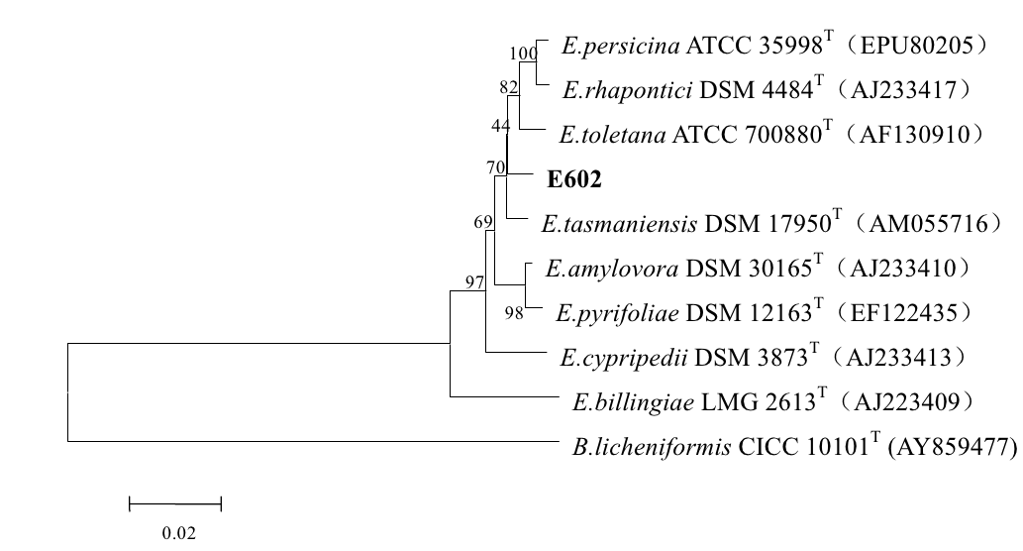
Fig.1 The phylogenetic tree based on 16 S rRNA gene sequences.
This tree was obtained using software MEGA3.1 by the Neighbor-Joining method. Numbers at branch nodes indicate bootstrap values of 1,000 trials (only values 50% were shown). Bar: 0.02 substitutions per nucleotide position.

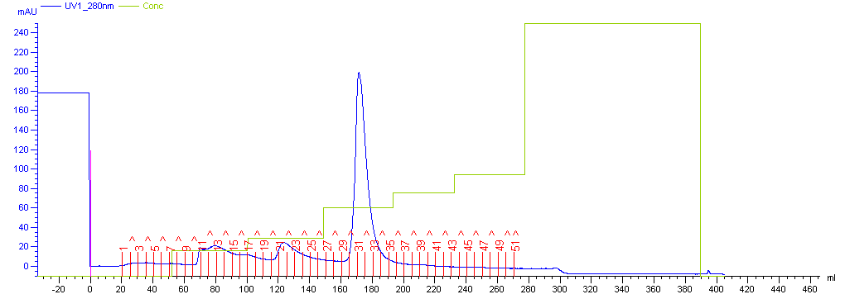

Fig. 2 Results of anion exchange chromatography of β-galactosidase

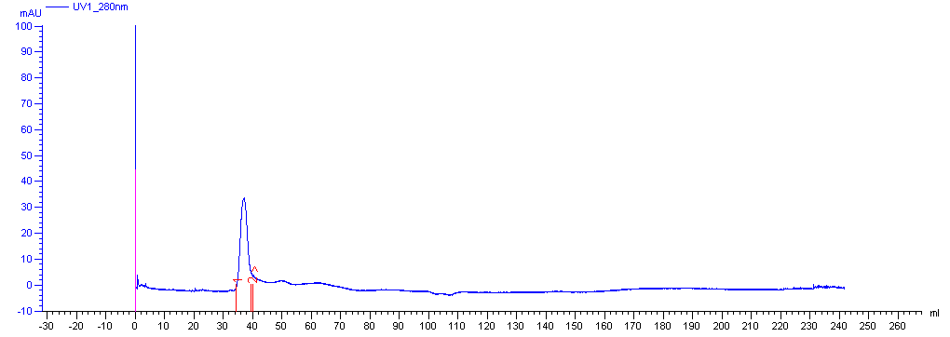
Fig.3 Results of gel filtration chromatography of β-galactosidase

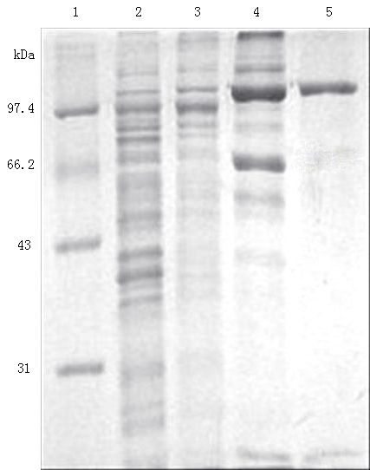
Fig. 4 SDS-PAGE analysis of the purified β-galactosidase from different stages.
Lane 1: protein marker, lane 2: cell-free extracts, lane 3: fraction of (NH₄)₂SO₄ precipitation, lane 4: fraction of AKTA DEAE column, lane 5: fraction of AKTA Sephacryl S-100 column.

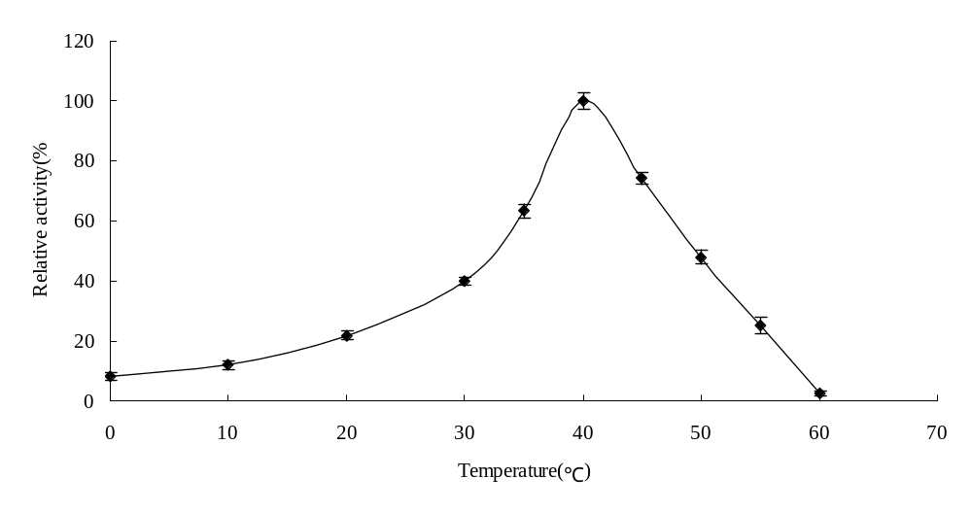
Fig. 5 Effect of temperature on activity of β-galactosidase. Error bars represent the standard deviation from 3 separate experiments.

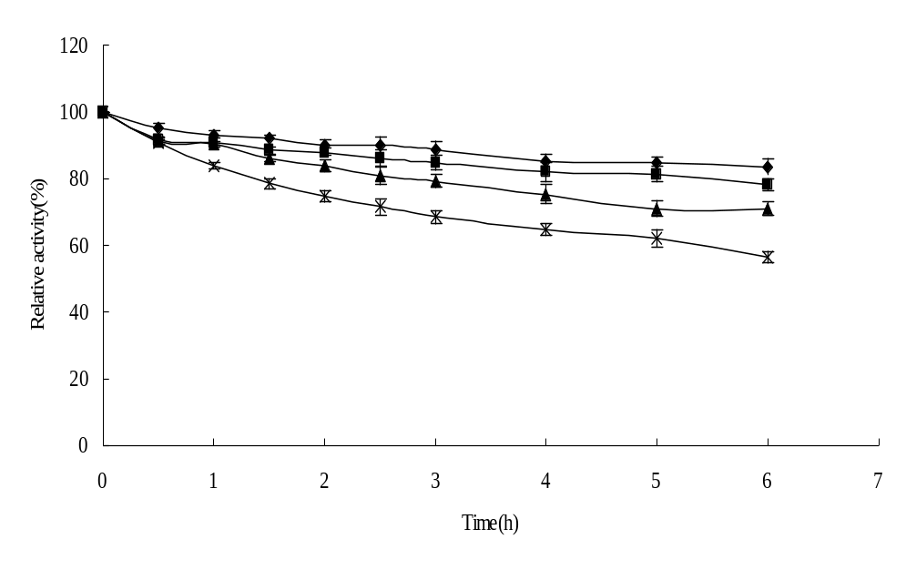
Fig. 6 The thermostability of the β-galactosidase at different temperatures. ◆ 10℃; ■ 20℃;▲30℃; × 40℃. Error bars represent the standard deviation from 3separate experiments.

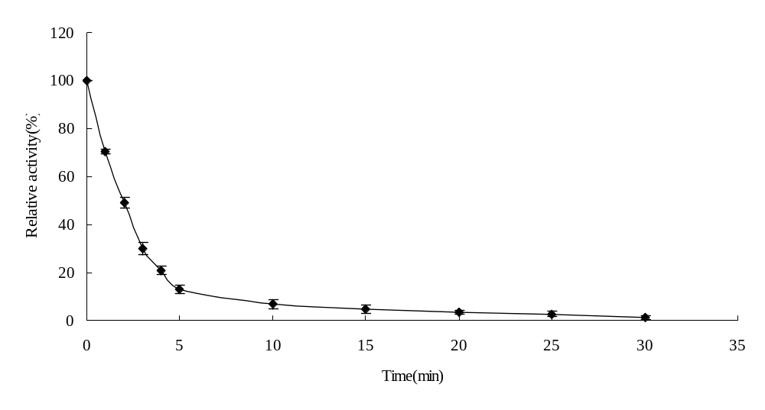
Fig.7 The thermostability of the β-galactosidase at 50℃. Error bars represent the standard deviation from 3separate experiments.

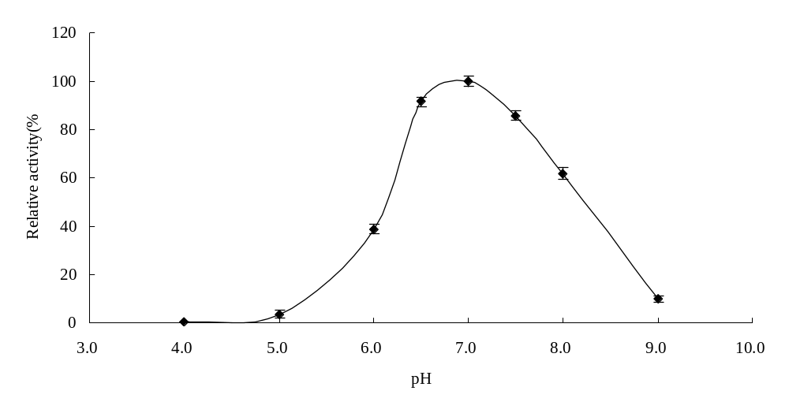
Fig.8 Effect of pH on activity of the β-galactosidase. Error bars represent the standard deviation from 3 separate experiments.

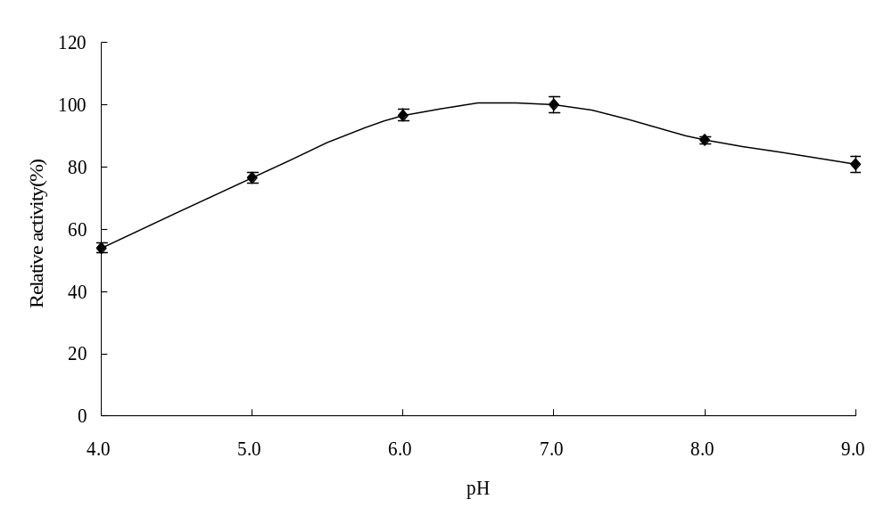
Fig. 9 The pH stability of the β-galactosidase. Error bars represent the standard deviation from 3 separate experiments.

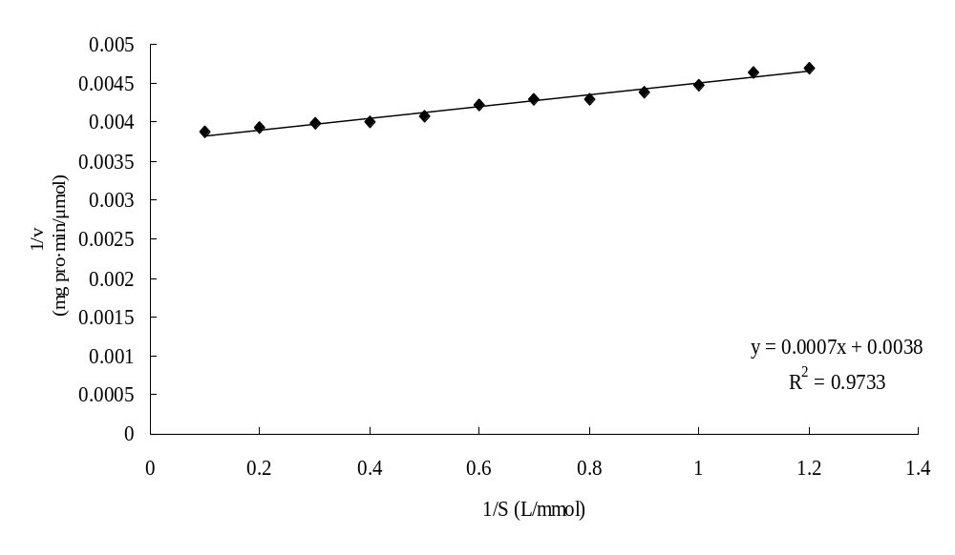
Fig. 10 Lineweaver-Burk plot of the β-galactosidase

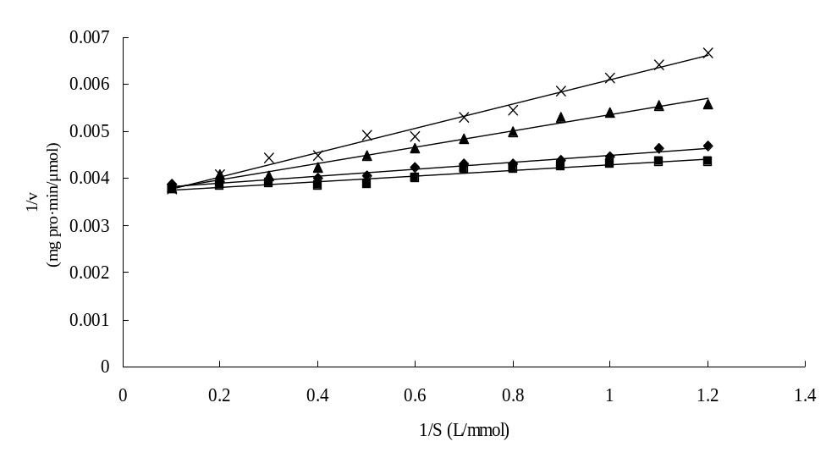
Fig. 11 Effect of substrate-like inhibitores on the activity of β-galactosidase
- control; ■ glucose (100 mmol/L); ▲ lactose (10 mmol/L); × galactose (100 mmol/L)

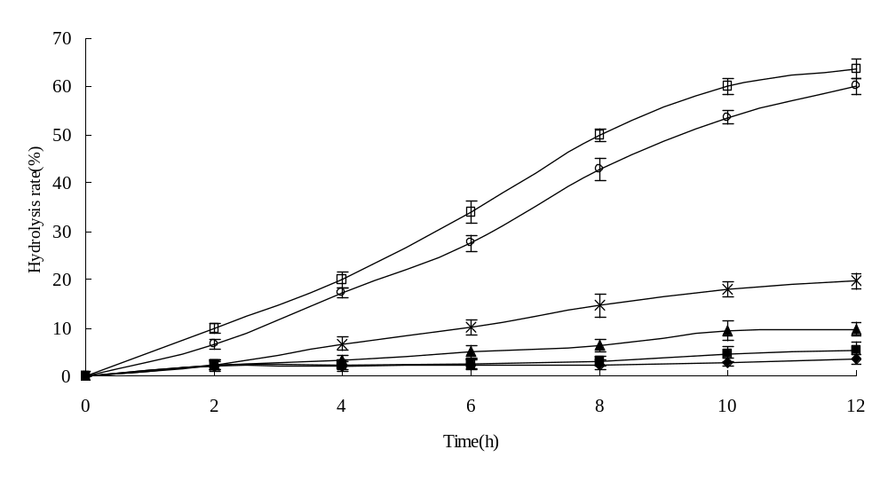
Fig. 12 Hydrolysis of lactose in milk by β-galactosidase. Error bars represent the standard deviation from 3 separate experiments.
- 0℃; ■ 4℃; ▲ 10℃; × 20℃; ○ 30℃; □ 40℃

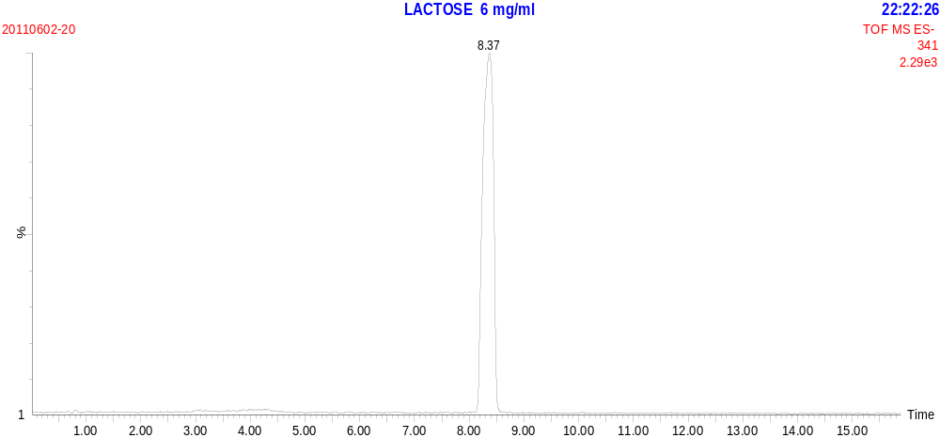
Fig. 13 MS spectrum of lactose standard

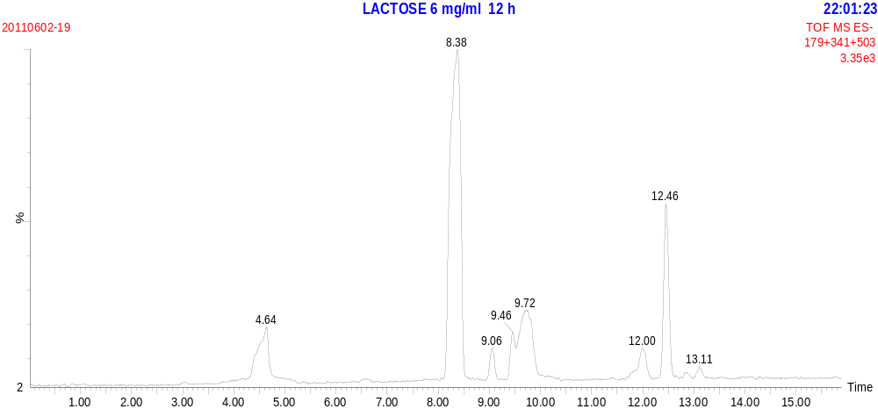
Fig. 14 MS spectrum of lactose hydrolysis for 12 h

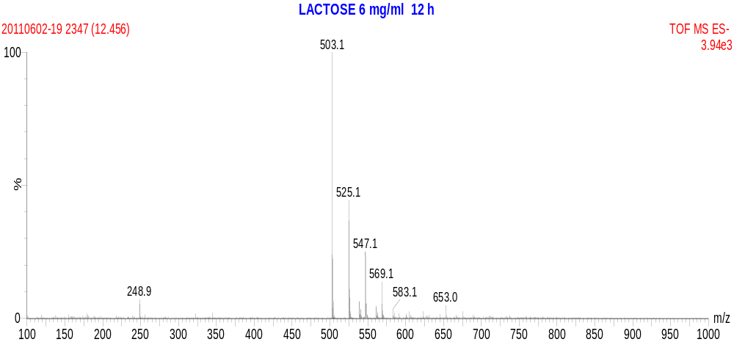
Fig. 15 Product ion spectrum of lactose hydrolysis at t=12.46 min

