Purification and Characterization of a novel β-galactosidase from the newly isolated strain Erwinia rhapontici E602
Yike Jiang, Yu Xia
School of Food Science and Technology, Jiangnan University, Wuxi 214122, China

Abstract
A β-galactosidase producing bacterial strain E602 was isolated from frozen soil and identified to be Erwinia rhapontici. This strain was cultured at 26℃ with the induction of lactose for production of the β-galactosidase. This enzyme was then purified with ammonium sulfate fractionation, ion exchange and gel filtration chromatography for further studies of the enzymatic characteristics. The purified enzyme had a molecular weight of about 100 kDa. The optimum reaction temperature and pH of this enzyme was 40℃ and pH 7.0 respectively, indicating that this enzyme was a mesophilic neutral β-galactosidase. However, the enzyme retained about 15% activity at 10℃, which also suggested cold-adaptive property of this enzyme. Kinetics of this enzyme was studied and the K_{m} and V_{max} of this enzyme was 0.21 mmol/L and 263.16 µmol/mg min⁻¹. Metal ions such as Li⁺, K⁺, Mg²⁺ and Zn²⁺ can activate the enzymatic activity obviously, while Cu²⁺ and Fe²⁺ inhibited the activity. The lactose hydrolysis in milk had been also investigated and results suggested that this enzyme may be suitable for milk processing.

Key Words: β-Galactosidase; Erwinia rhapontici; Isolation and Purification; Enzymatic Characteristics
- Introduction
β-galactosidase (EC3.2.1.23) is a kind of glycoside hydrolase which can hydrolyze β-1,4-D-galactosidic linkage in lactose^{[1]}. This enzyme is applied in dairy industry for elimination of milk lactose in order to prevent the symptom of lactose-intolerance in human beings ^{[2]}, and it is also widely used in other food industrial areas. Microorganisms are the main sources of β-galactosidase. At present, studies mainly focus on the β-galactosidase from Kluyveromyces lactis, Aspergillus niger, Escherichia coli, Lactobacillus and so on. In industry, the β-galactosidases are mainly mesophilic enzymes from Kluyveromyces and Aspergillus ^{[3-5]} so that the lactose hydrolysis treatments processing are usually carried out at moderate temperatures, which might cause undesired microbial contaminations during the time of processing ^{[6]}. In recent years, cold-active enzymes is attractive in food processings in order to eliminate microbial spoilages ^{[7-8]}. The β-galactosidases which have good enzymatic activities under low or cold temperatures are now been a research focus in recent years[9].
In this work, we report a novel isolated β-galactosidase which has relative good activity in low temperatures. This enzyme was obtained from the newly isolated Erwinia rhapontici strain E602 which was screened from frozen soil. The β- galactosidase was massively obtained by fermentation of the strain E602 and purified by salting-out, dialysis, ion-exchange chromatography and gel filtration chromatography. The enzymatic activity and the ability for hydrolysis of lactose in milk and the transgalactosylation activity were also investigated.
- Materials and Methods
  - Bacterial strains, media and culture conditions
The Erwinia rhapontici strain E602 used in this experiment was screened from frozen soil. The TSA (tryptone 15 g/L, soya peptone 5 g/L, K₂HPO₄ 2.5 g/L, lactose 2.5 g/L, NaCl 5 g/L，yeast extract 3 g/L, pH 7.3-7.5) liquid medium was used for cultivation of E602 in fermenter for production of β-galactosidase. E. rhapontici were grown at 26℃ in LB (Luria-Bertani) liquid medium for 12 h. Seed was then taken and inoculated at the ration of 1% (volume) into 50 mL TSA medium in a flask and cultured at 26℃ for 15 h. Then the seed was taken and inoculated into fermenter at a ratio of 1% (volume) and fermented at 26℃ for 18 h.
2.2 Reagents
Ortho-Nitrophenyl-β-D-Galactopyranoside (ONPG) and dithithreitol was purchased from Sangon Biotech (Shanghai, China). Acetonitrile was purchased from Sigma-Aldrich (Shanghai, China). Molecular weight protein marker was purchased from Fermentas (Shanghai, China). Protein determination kit was purchased from Zoman Biotechnology (Beijing, China). Glucose determination kit was purchased from Rongsheng Biotech (Shanghai, China). Other reagents were of AR grade.
2.3 Purification of β-Galactosidase
The E. rhapontici strain E602 was collected from the fermenter and then subjected to centrifugation at 4℃ and 10,000 g for 30 min on Beckman Avanti J-26xp centrifuge (Beckman Coulter Inc., Fullerton, CA) and then treated with sonication. The supernatant was collected after centrifugation at 4℃ and 21,000 rpm for 30 min on Beckman Avanti J-26xp centrifuge, and then the ammonium sulfate salting out was performed. The supernantant was brought to 20% ammonium sulfate saturation and centrifuged at 4℃ and 10,000 g for 10 min. After centrifugation, the sediment was discarded and the supernatant was brought to 40% ammonium sulfate saturation and centrifuged at 4℃ and 10,000 g for 10 min again, and the sediment was dissolved in 10 mmol/L PBS buffer (pH 7.0), and dialyzed at 0℃ for 12 h. Further purification was done by anion exchange chromatography followed by gel filtration chromatography.
Anion exchange chromatography was performed on an AKTA purifier system (GE Healthcare, Sweden) using a HiPrep 16/10 DEAE column and equilibrated with 20 mmol/L Tri-HCl (pH 7.0). The target enzyme was eluted by gradient (volume) of 10%, 15%, 27%, 33% and 40% of 2 mol/L NaCl in 20 mmol/L Tri-HCl (pH 7.0) at 5 mL/min. Gel filtration chromatography was also performed on AKTA purifier system using a HiPrep 16/60 Sephacryl S-100 column (GE Healthcare, Sweden). The β-galactosidase was eluted in 50 mmol/L PBS buffer (150 mmol/L NaCl, pH 7.0) at 0.5 mL/min.
2.4 Enzymatic Assay
The β-galactosidases activity was determined as described by Gist-Brocades^{[10]}, except that the incubation temperature of the enzyme was adjusted to 40℃ and pH was adjusted to 7.0. One unit of enzyme activity was defined as the amount of enzyme hydrolyzing 1 μmol of substrate ortho-nitrophenyl-β-D-galactopyranoside (ONPG) per minute. The specific activity of β-galactosidases was expressed in units per milligram of enzyme protein.
2.5 Effect of Temperature, pH and Various Reagent on Enzyme Activity
The effect of temperature on enzyme activity was determined at temperatures ranging from 0 to 60℃. The thermostability of the enzyme was tested by incubation at temperatures ranging from 10-50℃ for 6 h. The effect of pH on enzyme activity was determined at 40℃ in buffers of pH 4.0 to 9.0. The pH stability profile of enzyme was determined by initial inculabtion of this enzyme at 4℃ for 1 h in PBS buffer (pH 4.0-9.0), followed by activity determination under standard conditions described above.
The effect of various reagents on enzyme activity was determined by assaying the residual activity after incubating the enzyme with 1 to 10 mmol/L of various reagents dissolved in PBS buffer (pH 7.0) for 20 min at 25℃. The cations tested were Li⁺, Na⁺, K⁺, Mg²⁺, Ca²⁺, Zn²⁺, Cu²⁺, Fe²⁺, Mn²⁺, and Pb²⁺. The thiol reagents 2- mercaptoethanol and dithiothreitol, the enzyme inhibitors p-chloromercuribenzoic acid and the chelating agent ethylene diamine tetraacetic acid (EDTA) were also examined. Relative activity was estimated in above experiments by comparison to the highest activity (100%).
2.6 Kinetic Analysis
The kinetic parameters (K_{m} and V_{max}) were calculated from Lineweaver-Burk plots using ONPG as a substrate (concentration range of 0.80 mmol/L to 10 mmol/L). All the experiments were carried out at 40℃ and pH 7.0.
2.7 Hydrolysis of Lactose in Milk
Fifteen units of the purified β-galactosidase was added to 5 mL fresh milk (containing 5% (w/v) lactose). The solution was incubated at different temperatures ranging from 0 to 40℃ for 12 h. Aliquotes (0.10 mL) were withdrawn every 2 h of incubation. The aliquots containing the soluble enzyme were deproteinated by adding 10% trichloroacetic acid. After centrifugation, the supernatant was subjected to glucose analysis.
2.8 Trans-Glycosylation of Lactose and the Galactooligosaccharide Assay
Forty-five units of the purified β-galactosidase was added to 5 mL lactose solution (300 mg/mL). The solution was incubated at 40℃ for 12 h. Aliquotes (0.5 mL) were withdrawn at every 2 h of incubation. The aliquotes were incubated in boiling water for 2 min to inactive the enzyme followed by detection with LC-MS.
- Results and Discussion
3.1 Purification of β-Galactosidase
E. rhapontici is a kind of gram-negtive bacterium which can be used for production of enzymes and additives for food industry ^{[11]}, and this strain is not pathogenic to animals and human beings. In this work, the strain E. rhapontici E602 was cultivated with induction of IPTG for production of β-galactosidase. After ammonium sulfate precipitation, the enzyme was futher separated by 2-step purification in which the anion exchange chromatography (Fig. 1) was followed by gel filtration chromatography (Fig. 2). The final enzyme activity reached 177.00 U/mg protein. The purification procedures and results of the β-galactosidase are summarized in Table 1, which depicts specific activity and the purification fold of every step. The enzyme samples of every purification step were subjected to 12% SDS-PAGE analysis and the final purified β-galactosidase showed a single band of about 100 kDa (Fig. 3).

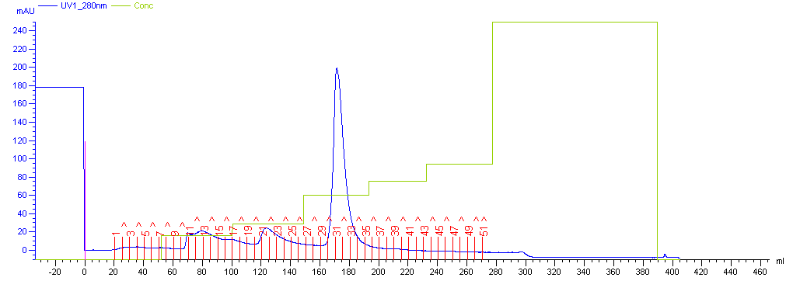
Fig. 1 Results of anion exchange chromatography

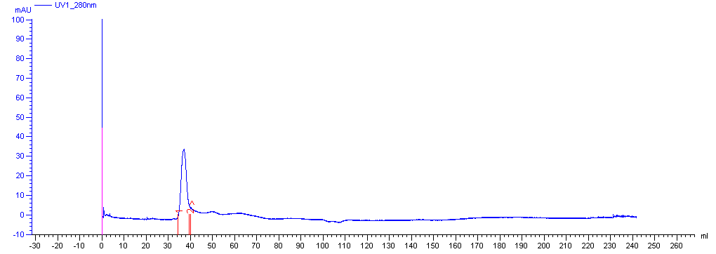
Fig.2 Results of gel filtration chromatography

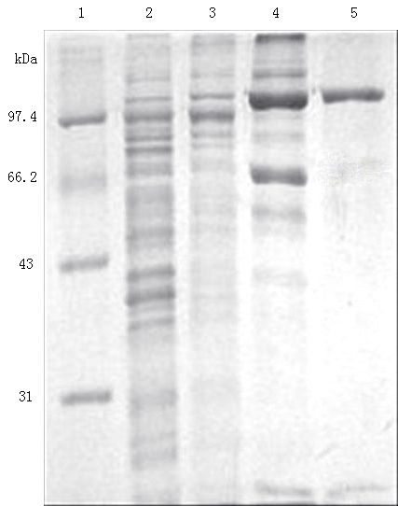
Fig. 3 SDS-PAGE analysis of the purified β-galactosidase from different stages.
Lane 1: protein marker, lane 2: cell-free extract, lane 3: fraction of (NH₄)₂SO₄ precipitation, lane 4: fraction of AKTA DEAE column, lane 5: fraction of AKTA Sephacryl S-100 column.

Table 1 Summary of β-galactosidase purification from Erwinia rhapontici E602
Steps | Total protein  (mg/mL) | Enzyme activity  (U/mL) | Specific activity  (U/mg) | Purification  (fold)
Cell-free extract  20 to 40% ammonium sulfate precipitation  Anion exchange  Gel filtration | 3.50  0.66  0.03  0.02 | 6.12  2.22  1.63  3.54 | 1.75  3.36  54.33  177.00 | 1.00  1.93  31.04  101.14

3.2 Temperature and pH Profiles of β-Galactosidase
The effect of temperature on the enzyme activity was studied at temperatures ranging from 0 to 60℃ at pH 7.0 (Fig. 4). This enzyme showed the maximum activity at 40℃. However, the enzyme retained about 15% of the activity at 10℃, which also suggested cold-adaptive property of this enzyme. Thermostability of the enzyme was determined by incubation at 10, 20, 30, and 40℃ for 6 h (Fig. 5) and at 50℃ for 30 min (Fig. 6). Results showed that the enzymatic half-life of the β-galactosidase at 10, 20, 30, 40, and 50℃ were 13 h, 11 h, 8 h, 7 h and 2 min respectively.
The pH profiles of the enzyme were shown in Fig. 7 and Fig. 8. The enzyme displayed its maximum activity at pH 7.0 (Fig. 7) and retained more than 80% of its activity at the pH range of 6.5 to 7.5, which is a good preperty with respect to milk processing because the pH of milk is near to 6.7. The pH stability was determined by initial incubation at 4℃ for an hour in PBS buffer (pH 4.0-9.0), followed by activity determination under standard conditions (Fig. 8).
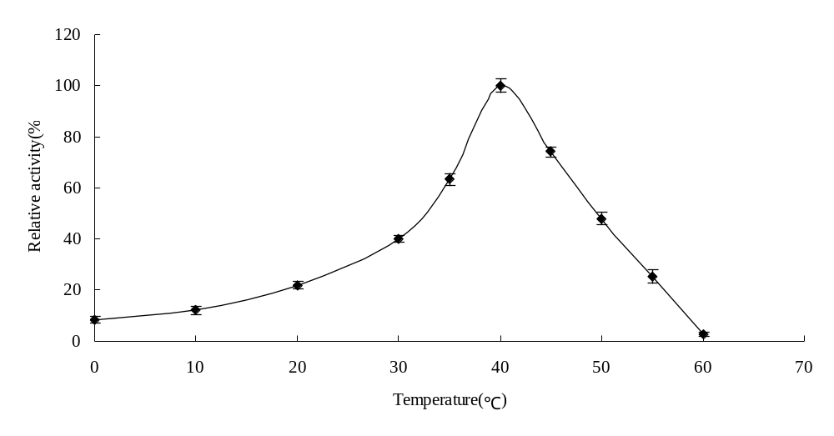
Fig. 4 Effect of temperature on activity of β-galactosidase. Error bars represent the standard deviation from 3 separate experiments.

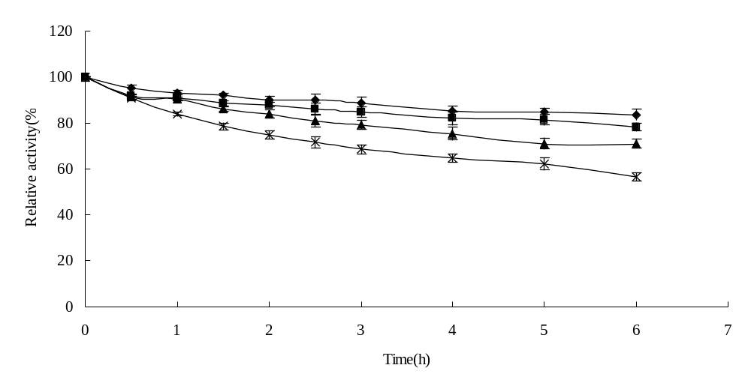
Fig. 5 The thermostability of the β-galactosidase at different temperatures. ◆ 10℃; ■ 20℃;▲30℃; × 40℃. Error bars represent the standard deviation from 3separate experiments.

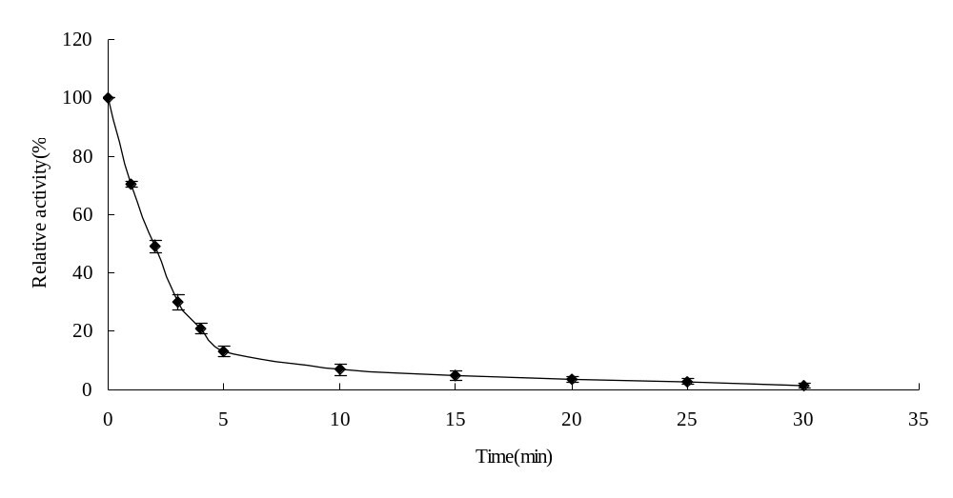
Fig.6 The thermostability of the β-galactosidase at 50℃. Error bars represent the standard deviation from 3separate experiments.

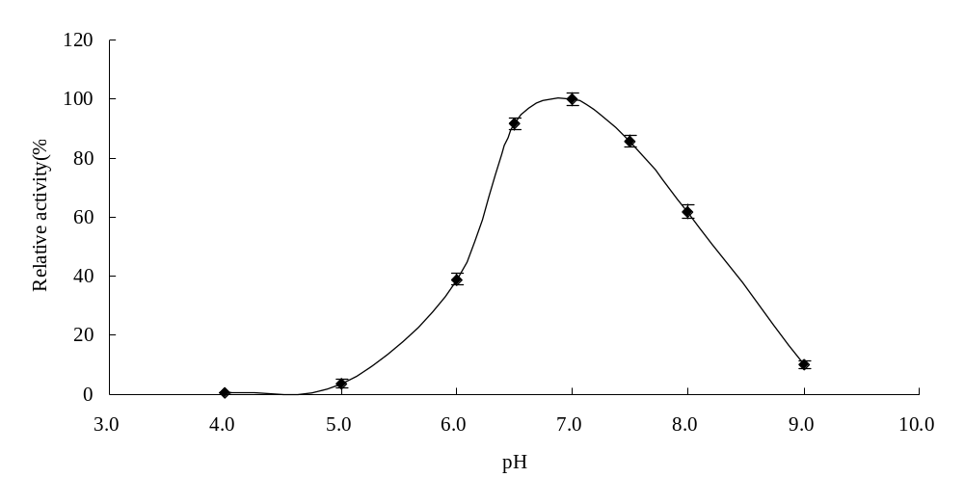
Fig.7 Effect of pH on activity of the β-galactosidase. Error bars represent the standard deviation from 3 separate experiments.

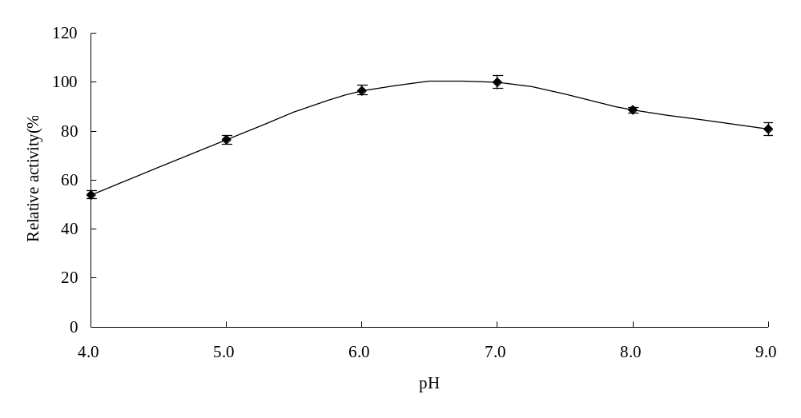
Fig. 8 The pH stability of the β-galactosidase. Error bars represent the standard deviation from 3 separate experiments.

3.3 Effects of Metal Cations, EDTA, Thiol Reagents, and Enzyme Inhibitors on Enzyme Activity
According to the results listed in Table 2, the cations Li⁺, K⁺, Mg²⁺ activated the enzyme activity and Cu²⁺, Fe²⁺, Pb²⁺ inhibited the enzyme activity. Chelating agent EDTA inhibited the enzyme activity. Enzyme inhibitors displayed inhibition against the enzyme while thiol reagents revealed some promotion effects.
3.4 Kinetic Properties with Substrate or Substrate-Like Activation
The enzyme kinetic parameters for ONPG or other substrate-like inhibitors were calculated from a Lineweaver-Burk plot. The K_{m} and V_{max} values for ONPG were 0.184 mmol/L and 263.16 μmol/mg pro·min (Fig. 9). The substrate-like inhibitores, glucose (100 mmol/L), lactose (10 mmol/L) and galactose (100 mmol/L) were added to obtain the inhibitor constant value K_{i} according to the inhibitor substrate concentration. The results showed that latose and galactose had a competitive inhibitor effect against ONPG (Fig. 10). The inhibitory activity of lactose was greater than galactose. The K_{i} for lactose and galactose was 7 mmol/L and 36.84 mmol/L, respectively.
3.5 Hydrolysis of Lactose in Milk
The lactose hydrolysis ability of the purified β-galactosidase was tested with fresh milk at different temperatures (Fig. 11). Result showed that the hydrolysis rate of lactose reached 60% after 12 h of hydrolysis at 30℃. When the reaction was carried out at 40℃, 8 h was needed for hydrolyzing 50% of the lactose.

Table 2 Effects of metal cations, EDTA, thiol reagents, and enzyme inhibitors on the β-galactosidase activity
 | Concentration(mmol/L) | Relative Activity (%)
Control  Cations  Li⁺  Na⁺  K⁺  Mg²⁺  Ca²⁺  Zn²⁺  Cu²⁺  Fe²⁺  Mn²⁺  Pb²⁺  Thiol reagents  2-mercaptoethanol  Dithithreitol  Enzyme inhibitor  PCMB  Chelating agent  EDTA | 0  10  10  10  10  10  5  5  5  2  2  1  1  1  1 | 100.0  131.3  104.3  133.6  124.8  88.4  28.7  4.9  32.5  105.3  2.8  121.2  124.5  18.7  74.3

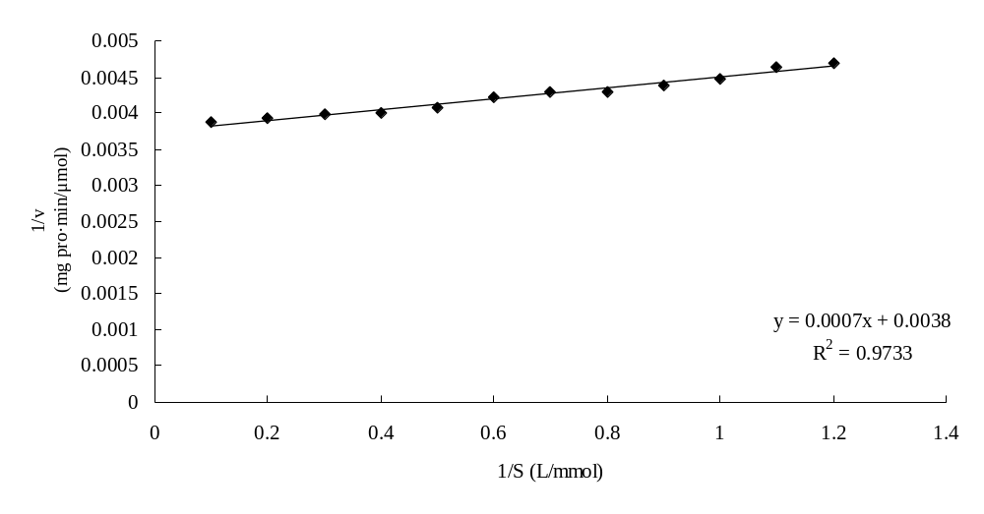
Fig. 9 Lineweaver-Burk plot of the β-galactosidase
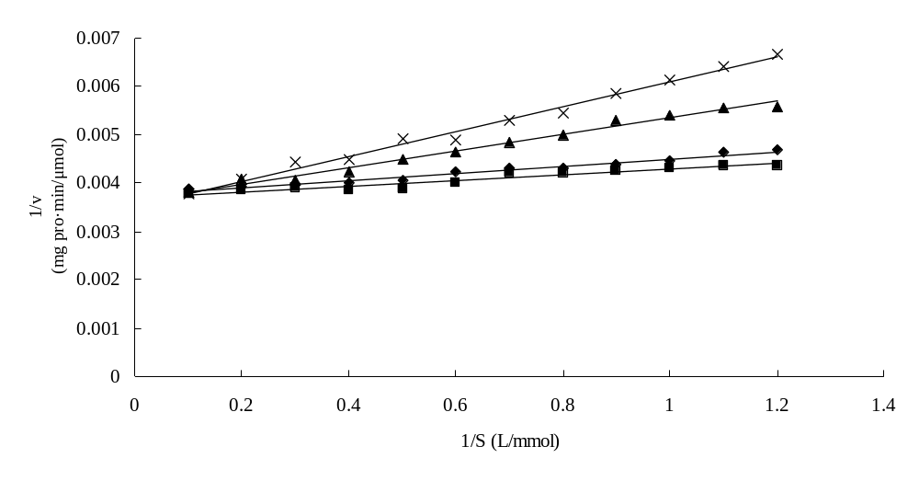
Fig. 10 Effect of substrate-like inhibitores on the activity of β-galactosidase
- control; ■ glucose (100 mmol/L); ▲ lactose (10 mmol/L); × galactose (100 mmol/L)

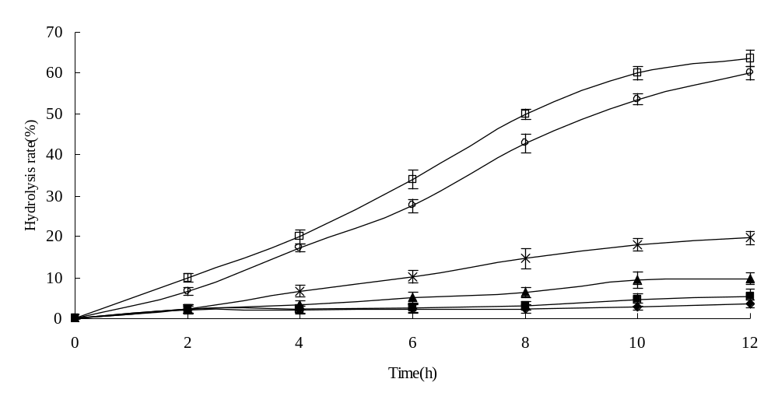
Fig. 11 Hydrolysis of lactose in milk by β-galactosidase. Error bars represent the standard deviation from 3 separate experiments.
- 0℃; ■ 4℃; ▲ 10℃; × 20℃; ○ 30℃; □ 40℃

3.6 Galactooligosaccharide Assay
The galactooligosaccharide produced by trans-glycosylation reaction of lactose was determined by LC-MS. The sample of lactose standard and the lactose hydrolysis solution were showed in Fig. 12 and Fig. 13, respectively. The component which showed a peak at 12.46 min in Fig. 12 was determined to be a kind of trisaccharide and its molecular weight was 504 (Fig. 14). These results showed that the β-galactosidase produced by strain E602 can effectively transform the lactose into galactooligosaccharide.
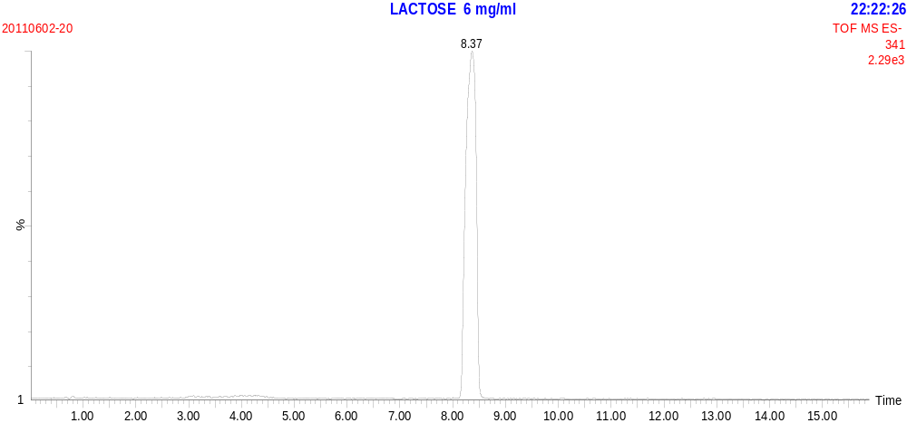
Fig. 12 Single MS spectrum of lactose standard

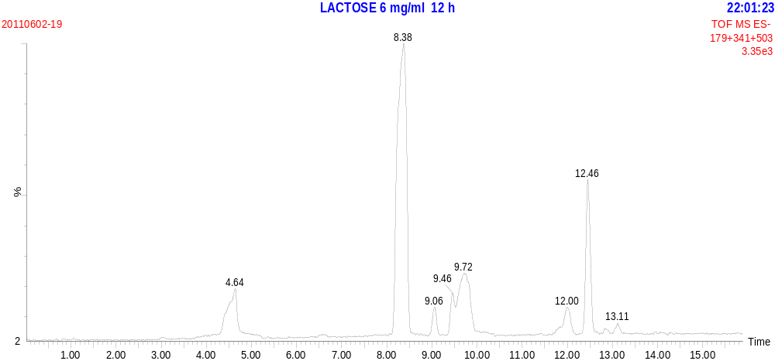
Fig. 13 Single MS spectrum of lactose hydrolysis for 12 h

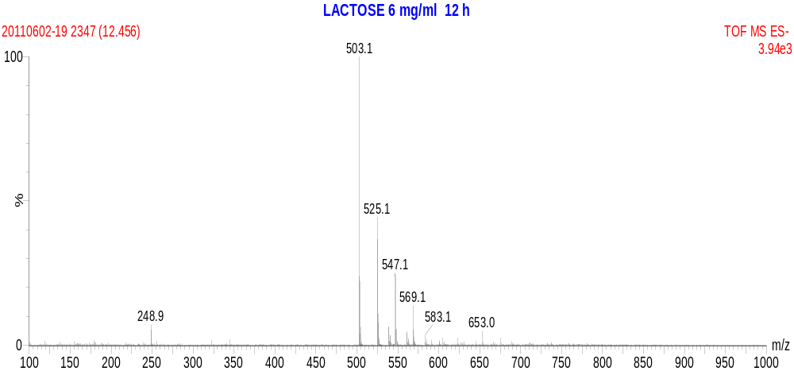
Fig. 14 Product ion spectrum of lactose hydrolysis at t=12.46 min from Figure 13

Conclusion
In this work, the β-galactosidase was produced by E. rhapontici E602 and was efficiently purified with several procedures. The optimum temperature of the enzyme is 40℃ and its optimum pH is 7.0 and the enzyme was stable from pH 5.0 to 8.0. Its thermostability was good from 10 to 40℃ and its thermostability was poor at 50℃. The metal ions Li⁺、K⁺、Mg²⁺ activated the enzyme activity and Cu²⁺, Fe²⁺, Pb²⁺ inhibited the enzyme activity. The K_{m} and V_{max} of this β-galactosidase was 0.184 mmol/L and 263.16 μmol/mg pro·min respectively using ONPG as substrate. These results indicated that this enzyme was proper for hydrolysis of milk lactose and production of low lactose milk product. Trisaccharide was efficiently formed during the process of lactose hydrolysis so that this enzyme may also be applied for galactooligosaccharide production.
Acknowledgement
This work was supported by the National Natural Science Foundation of China (Beijing) under Grant No. 31000752, The National Research Foundation for the Doctoral Program of Higher Education of China (Beijing) under Grant No. 200802951022, and the the Science and Nature Foundation in Jiangsu Province (Nanjing, China) under Grant No. BK2008103.

References
1. Hirata H, Negoro S, and Okada H. High production of thermostable β-galactosidase of Bacillus stearothermophilus in Bacillus subtilis. Appl. Environ. Microbiol., 1985, 49:1547-549.
2. Sieber R, Stransky M, de Vrese M. Lactose intolerance and consumption of milk and milk products. Ernahrungswiss, 1997, 36(4): 375-393.
3. Chen W, Chen H, Xia Y, Zhao J, Tian F, and Zhang H. Production, purification, and characterization of a potential thermostable galactosidase for milk lactose hydrolysis from Bacillus stearothermophilus. J. Dairy. Sci., 2008, 91:1751-1758.
4. Ganeva V, Galutzov B, and Eynard N. Electroinduced extraction of β-galactosidase from Kluyveromyces lactis. Appl. Microbiol. Biotechnol., 2001, 56:411-413.
5. Rodriguez A P, Leiro R F, Cerdan M E, Gonzalez Siso MI, and Fernandez M B. Kluyveromyces lactis β-galactosidase crystallization using full-factorial experimental design. J. Mol. Catal., B: Enzym, 2008, 52-53:178-182.
6. Wanarska M, Kur J, Pladzyk R, and Turkiewicz M. Thermostable Pyrococcus woesei β-D-galactosidase-high level expression, purification and biochemical properties. Acta. Biochim. Pol. 200552:781-787.
7. Turkiewicz M, Kur J, Bislkowska A, Cieslinski H, Kalinowska H, Bielecki S. Antarctic marine bacterium Pseudoalteromonas sp. 22b as a source of cold-adapted β-galactosidase. Biomol. Eng. 2003, 20:317-324.
8. Cieslinski H, Kur J, Bialkowska A, Baran I, Makowski K, Turkiewicz M. Cloning, expression, and purification of a recombinant cold-adapted β-galactosidase from Antarctic bacterium Pseudoalteromonas sp. 22b. Protein. Expr. Purif., 2005, 39: 27-34.
9. Nakagawa T, Ikehate R, Myoda T, Miyaji T, and Tomizuka N. Overexpression and functional analysis of cold-active β-galactosidase from Arthrobacter psychrolactophilus strain F2. Protein. Expr. Purif., 2007, 54:295-299.
10. Xia Y, Chen W, Fu X Y, Zhang H, Yang S, and Ding XL. Construction of an integrative food-grade expression system for Bacillus subtilis. Food. Res. Int., 2005, 38:251-256.
11. Ren B, Li S, Xu H,Feng XH, Cai H, Ye Q. Purification and characterization of a highly selective sucrose isomerase from Erwinia rhapontici NX-5. Bioprocess. Biosyst. Eng., 2011, 34:629-637.

