Supporting Information

Diana Buitrago-Garcia, Aziz Mert Ipekci, Leonie Heron, Stefanie Hossmann, Hira Imeri, Georgia Salanti, Nicola Low

27/10/21

## PRISMA 2020 Checklist

*Shiny app can be used to complete checklist here:* <https://prisma.shinyapps.io/checklist/>

## Search strings

From: Living Evidence on COVID-19 (<https://ispmbern.github.io/covid-19/living-review/collectingdata.html>, accessed 31.01.2021)

We retrieve data from [EMBASE](http://www.embase.com/) via OVID, [MEDLINE](https://www.ncbi.nlm.nih.gov/pubmed/) via PubMed, BioRxiv and MedRxiv.

**Search terms**

When searches are updated, references that are identified that were not in the database before, are inserted by date (**date_entrez**) they were indexed in remote database, the date they are inserted in OUR database is formatted as the ‘**strategydate**’ (raw data is available [here](https://github.com/leonieheron/LSRworkflow%3E)).

**30.10.2020**

EMBASE:

(exp SARS-related coronavirus/ or severe acute respiratory syndrome/ or coronavirus disease 2019/ or (coronavir* or corona virus* or HCoV* or ncov* or 2019 cov or covid or covid19 or sars-cov* or sarscov* or sars-coronavirus* or Severe Acute Respiratory Syndrome Coronavirus* or nCoV).mp.) and 20191101:20301231.(dc).

MEDLINE:

(“severe acute respiratory syndrome coronavirus 2”[Supplementary Concept] OR “COVID-19” [Supplementary Concept] OR “coronavirus” OR “corona virus” OR “HCoV” OR “nCoV” OR “2019 CoV” OR “covid” OR “covid19” OR “Severe Acute Respiratory Syndrome Coronavirus 2” OR “SARS-CoV2” OR “SARS-CoV 2” OR “SARS Coronavirus 2”) AND (2019/11/01:3000/12/31[PDAT])

**01.05.2021**

EMBASE:

(SARS coronavirus/ or middle east respiratory syndrome/ or severe acute respiratory syndrome/ or (coronavirus* or corona virus* or HCoV* or ncov* or covid or covid19 or sars-cov* or sarscov* or Sars-coronavirus* or Severe Acute Respiratory Syndrome Coronavirus*).mp.) and 20191201:20301231.(dc).

**29.04.2020**

MEDLINE:

(“coronavirus”[MH] OR “coronavirus infections”[MH] OR “coronavirus”[TW] OR “corona virus”[TW] OR “HCoV”[TW] OR “nCov”[TW] OR “covid”[TW] OR “covid19”[TW] OR “Severe Acute Respiratory Syndrome Coronavirus 2”[TW] OR “SARS-CoV2”[TW] OR “SARS-CoV 2”[TW] OR “SARS Coronavirus 2”[TW] OR “MERS- CoV”[TW]) AND (2019/1/1:3000[PDAT])

**01.04.2020**

From 01.04.2020, we retrieve the [BioRxiv/MedRxiv dataset](https://connect.medrxiv.org/relate/content/181).

**26.03.2020**

MEDLINE:

(“Wuhan coronavirus” [Supplementary Concept] OR “COVID-19” OR SARS-CoV-2 OR “2019 ncov”[tiab] OR ((“novel coronavirus”[tiab] OR “new coronavirus”[tiab]) AND (wuhan[tiab] OR 2019[tiab])) OR 2019-nCoV[All Fields] OR (wuhan[tiab] AND coronavirus[tiab]))

EMBASE:

(nCoV or 2019-nCoV or ((new or novel or wuhan) adj3 coronavirus) or covid19 or covid-19 or SARS-CoV-2).mp.

BioRxiv/MedRxiv:

ncov or corona or wuhan or COVID or SARS-CoV-2

With the kind support of the [Public Health & Primary Care Library PHC](https://www.unibe.ch/university/services/university_library/faculty_libraries/medicine/public_health_amp_primary_care_library_phc/index_eng.html), and following guidance of the [Medical Library Association](https://www.mlanet.org/p/cm/ld/fid%3D1713)

**01.01.2020**

MEDLINE:

(“Wuhan coronavirus” [Supplementary Concept] OR “COVID-19” OR “2019 ncov”[tiab] OR ((“novel coronavirus”[tiab] OR “new coronavirus”[tiab]) AND (wuhan[tiab] OR 2019[tiab])) OR 2019-nCoV[All Fields] OR (wuhan[tiab] AND coronavirus[tiab])))))

EMBASE:

ncov OR (wuhan AND corona) OR COVID

BioRxiv/MedRxiv:

ncov or corona or wuhan or COVID

We retained publications that used the keywords listed below in the title or abstract.

“asymp*" OR "pre-symp*” OR “presymp*" OR "preclinical" OR "pre-clinical" OR "without symptoms" OR "no symptoms" OR "free of symptoms" OR "non-symp*” OR "nonsymp*" OR “symptom-free” OR “symptomfree”

## PRISMA 2020 Flowchart

*In progress.* ***

## Risk of bias in studies included in review question 1 and review question 2.

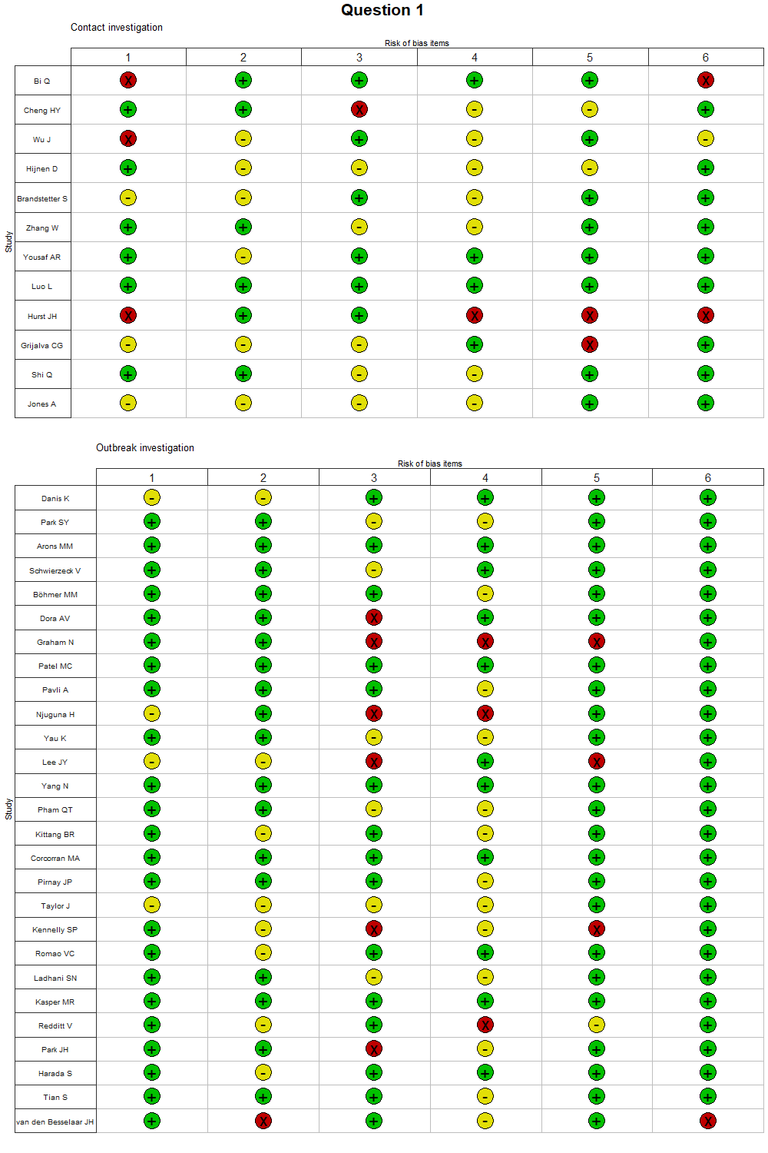 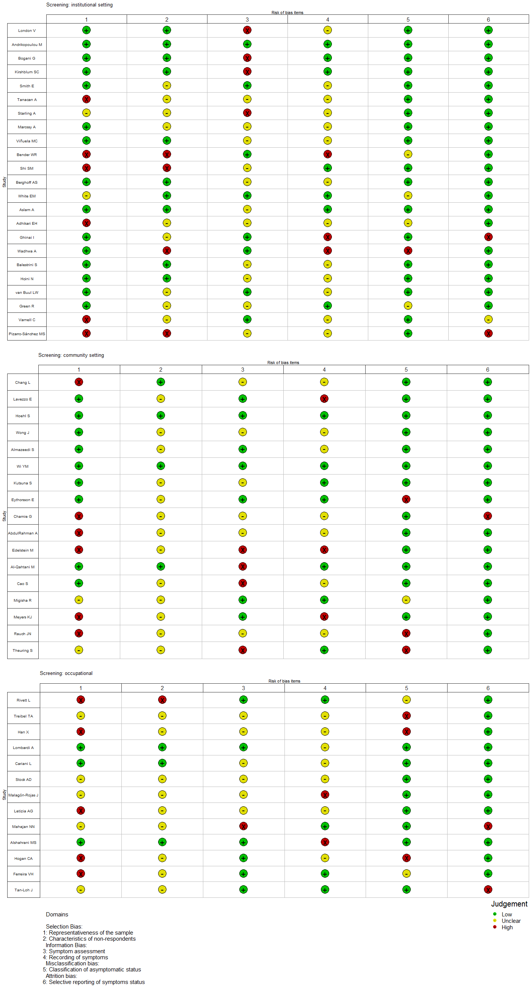 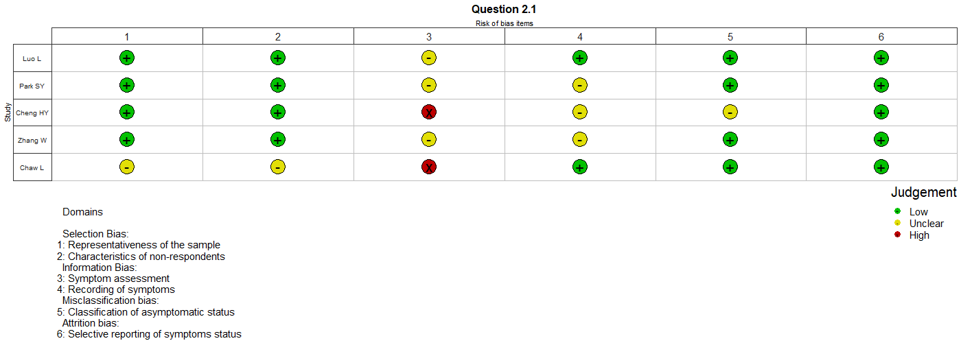

## Review question 1, subgroup analysis comparing studies of hospitalised patients with all other settings.

*Sub-group analysis to be decided*

## Review question 1, sensitivity analysis, omitting studies that were preprints at the time of literature search.



Figure 4. Review question 1, sensitivity analysis, omitting studies that were preprints at the time of literature search

## Assessment of credibility of mathematical modelling studies.

*In progress.*

## Types of study included in successive versions of the living systematic review, as of 10 June 2020.

*Settings to be reviewed. Some studies have been reclassified into different settings.*

## Location of studies contributing data to review questions 1 and 2.1.

Table :Table 1. Location of studies contributing data to review questions 1

| **Country** | **Total SARS-CoV-2, n** | **Total asymptomatic SARS-CoV-2, n** | **Total number of studies** |
| --- | --- | --- | --- |
| United States of America | 9,029 | 3,682 | 28 |
| China | 812 | 422 | 10 |
| United Kingdom | 618 | 289 | 10 |
| Germany | 100 | 9 | 6 |
| Italy | 413 | 88 | 4 |
| South Korea | 928 | 95 | 4 |
| Canada | 53 | 15 | 3 |
| Bahrain | 194 | 119 | 2 |
| Japan | 84 | 36 | 2 |
| Netherlands | 192 | 11 | 2 |
| Spain | 46 | 13 | 2 |
| Austria | 4 | 2 | 1 |
| Belgium | 9 | 4 | 1 |
| Brunei | 138 | 16 | 1 |
| Colombia | 35 | 11 | 1 |
| France | 12 | 1 | 1 |
| French Guyana | 137 | 87 | 1 |
| Greece | 46 | 7 | 1 |
| Iceland | 178 | 25 | 1 |
| India | 467 | 58 | 1 |
| Ireland | 1,105 | 290 | 1 |
| Kuwait | 1,096 | 473 | 1 |
| Malaysia | 46 | 6 | 1 |
| Norway | 40 | 0 | 1 |
| Other | 22 | 4 | 1 |
| Portugal | 14 | 0 | 1 |
| Saudi Arabia | 18 | 12 | 1 |
| Turkey | 3 | 0 | 1 |
| Uganda | 54 | 20 | 1 |
| Vietnam | 208 | 89 | 1 |

*Table 2 in progress.*