Occurrence and transmission potential of asymptomatic and pre-symptomatic SARS-CoV-2 infections: a living systematic review and meta-analysis

Diana Buitrago-Garcia, Aziz Mert Ipekci, Leonie Heron, Stefanie Hossmann, Hira Imeri, Georgia Salanti, Nicola Low

28/10/21

**We included a total of 99 studies that reported empirical data about 22,766 people with SARS-CoV-2 infection (8,103 defined as having asymptomatic infection), 8 studies for Q2.1, and 22 studies for Q2.2.**

**We included 99 studies that reported empirical data about 22,766 people with SARS-CoV-2 infection (8,103 defined as having asymptomatic infection) (Table 1).**



Figure 1. Forest plot of proportion of people with asymptomatic SARS-CoV-2 infection, stratified by setting and ordered by precision

The main risks of bias across all categories of empirical studies were in the selection and enrolment of people with asymptomatic infection and mismeasurement of asymptomatic status because of absent or incomplete definitions (S3 Fig). Sources of bias specific to studies in particular settings are discussed with the relevant results.

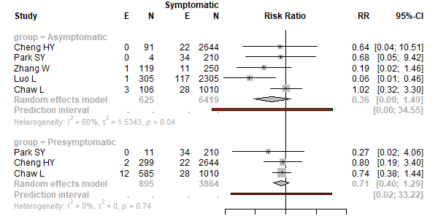

Figure 2.1. Forest plot of secondary attack rate comparing infections in contacts of asymptomatic and presymptomatic index cases with infections in contacts of symptomatic cases, ordered by precision

Table :Table 1. Characteristics of studies included for Q2.2

| **Study** | **Setting** |
| --- | --- |
| Ferretti L (2020) |  |
| Ganyani T (2020) | Tianjin, China; Singapore |
| Zhang W (2020) | Early Transmission in Wuhan; Imported Cases Outside Wuhan |
| He X (2020) |  |
| Emery, JC (2020) | Diamond Princess |
| Casey M (2020) | GI; SI |
| Pham, TQ (2020) | Vietnam |
| Kim, Y (2020) |  |
| Peak CM (2020) | Short SI; Long SI |
| Tindale LC (2020) | Singapore; Tianjin |
| Moghadas SM (2020) | New York City, United States of America |
| Hu, S (2020) | Households; workplace; healthcare facilities |
| Ren X (2020) | Throughout China outside Hubei |
| Chun JY (2020) | Government data, linked clusters such as religious groups, hospitals, or long-term healthcare facilities in South Korea |
| Sun (2020) |  |
| Emery JC (2020) | Diamond Princess Cruiseship |
| Bushman (2020) | China, surveillance data |
| Johansson MA (2021) |  |
| Nakajo K (2021) | Tokyo and Kanagawa, Japan |
| Hu S (2021) | Hunan, China |
| Bushman M (2021) | China, surveillance data |
| Sun K (2020) |  |

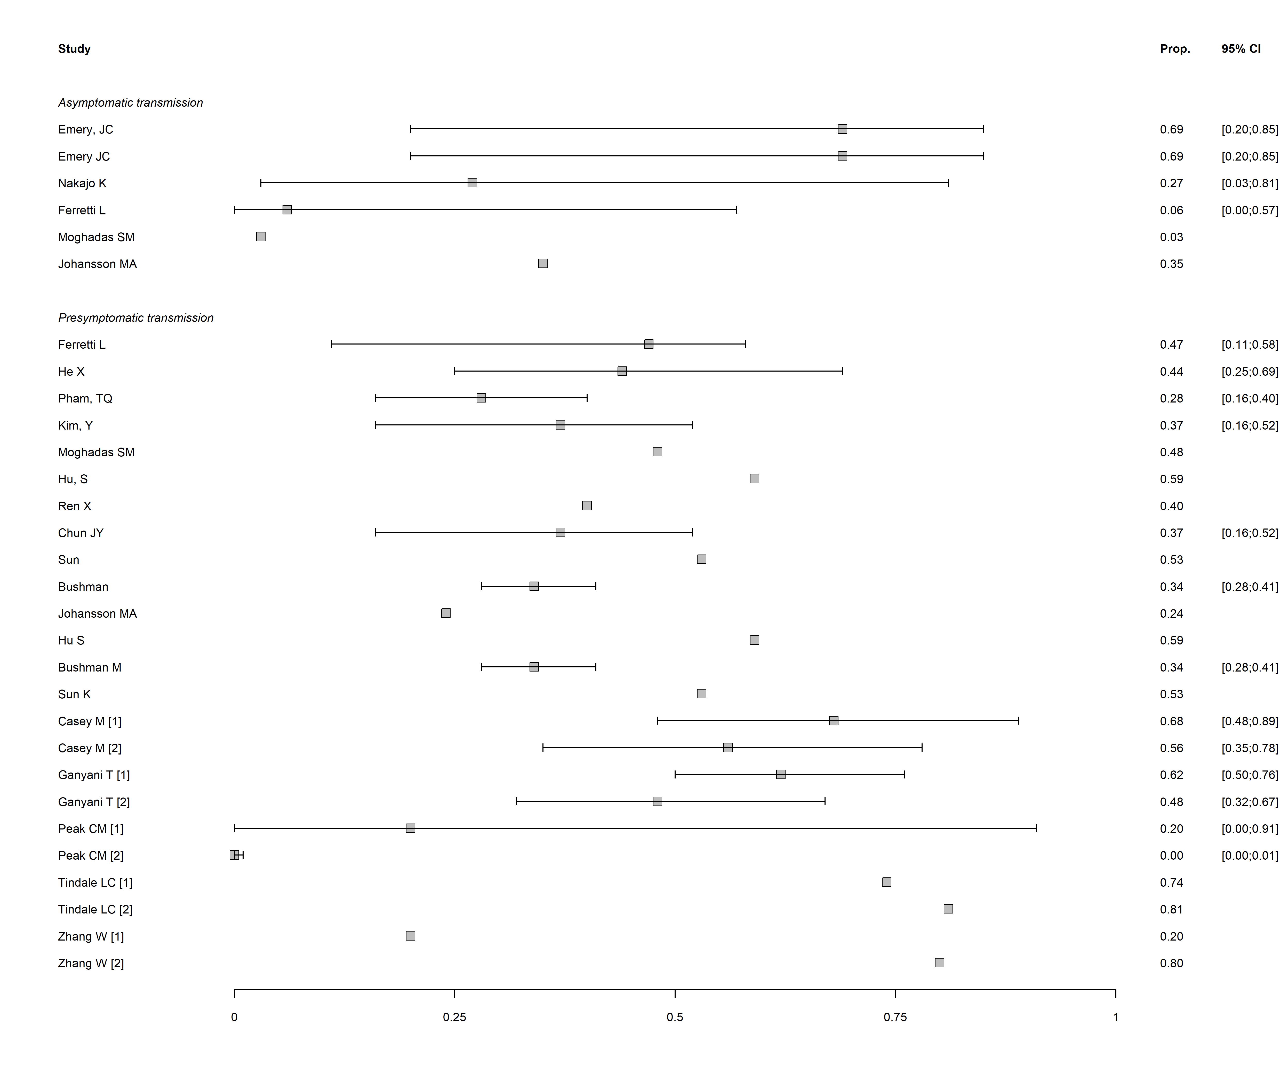

Figure 4. Forest plot of proportion of SARS-CoV-2 infection resulting from asymptomatic or presymptomatic transmission