Methods and Results

L Heron

27 May 2021

## Methods

### Data analysis

We used the ‘metaprop’ and ‘metabin’ functions from the ‘meta’ package (version 4.18.1) **(REF)** in R (version 4.0.4) to display the study findings in forest plots and synthesise their findings.

The 95% confidence intervals (CIs) for each study are estimated using the Clopper-Pearson method **(REF)**.

We examined heterogeneity visually in forest plots.

We stratified studies according to the methods used to identify people with asymptomatic SARS-CoV-2 infection and the study setting.

To synthesise proportions from comparable studies, in terms of design and population, we used stratified random-effects meta-analysis.

For the stratified and overall summary estimates, we calculated prediction intervals, to represent the likely range of proportions that would be obtained in subsequent studies conducted in similar settings **(REF)**.

## Results

### Q1: Proportion of asymptomatic cases

We included 86 studies that reported empirical data about 15,901 people with SARS-CoV-2 infection (4,304 defined as having asymptomatic infection).



Figure 1. Forest plot of proportion of people with asymptomatic SARS-CoV-2 infection, stratified by setting

### Q2.1: Secondary attack rate from asymptomatic and presymptomatic cases

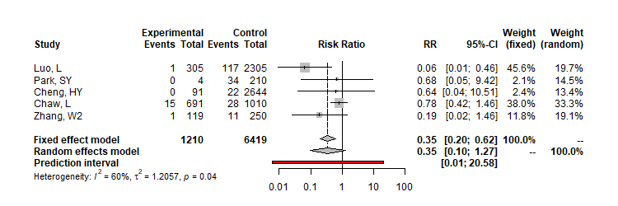

Figure 2. Forest plot of secondary attack rate comparing infections in contacts of asymptomatic index cases with infections in contacts of symptomatic cases

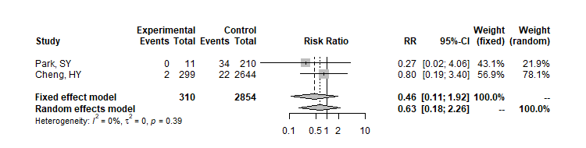

Figure 3. Forest plot of secondary attack rate comparing infections in contacts of presymptomatic index cases with infections in contacts of symptomatic cases