Wine Quality Classification Project

Goal
Develop a classification model to classify the quality of Vinho Verde wines (red and white) from Northern Portugal.
Dataset Source: UCI Wine Quality Dataset.
- Objective: Predict wine quality as:
  - Class 0 (Low quality: scores 0-5)
  - Class 1 (High quality: scores 6-10)
- Approach: Previously modeled as a regression problem, now reframed as a classification problem.

Business Problem
- Quality Assurance:
  - Ensure only high-quality wines proceed to bottling and distribution.
  - Reduce the risk of releasing low-quality wines to the market.
- Process Adjustments:
  - Identify significant chemical properties affecting wine quality.
  - Adjust production parameters like fermentation and ingredient proportions to enhance quality.

Dataset Overview
Combined red (1,599 samples) and white (4,898 samples) wines with a new category column:
- wine_type = 'red' or 'white'.
The dataset includes 13 attributes, with 12 independent features and 1 target feature.
Features
- Fixed acidity
- Volatile acidity
- Citric acid
- Residual sugar
- Chlorides
- Free sulfur dioxide
- Total sulfur dioxide
- Density
- pH
- Sulphates
- Alcohol
- Wine type
Target Variable
- Replaced original quality score (0-10) with a binary quality_class:
  - Class 0: Low quality (scores 0-5).
  - Class 1: High quality (scores 6-10).

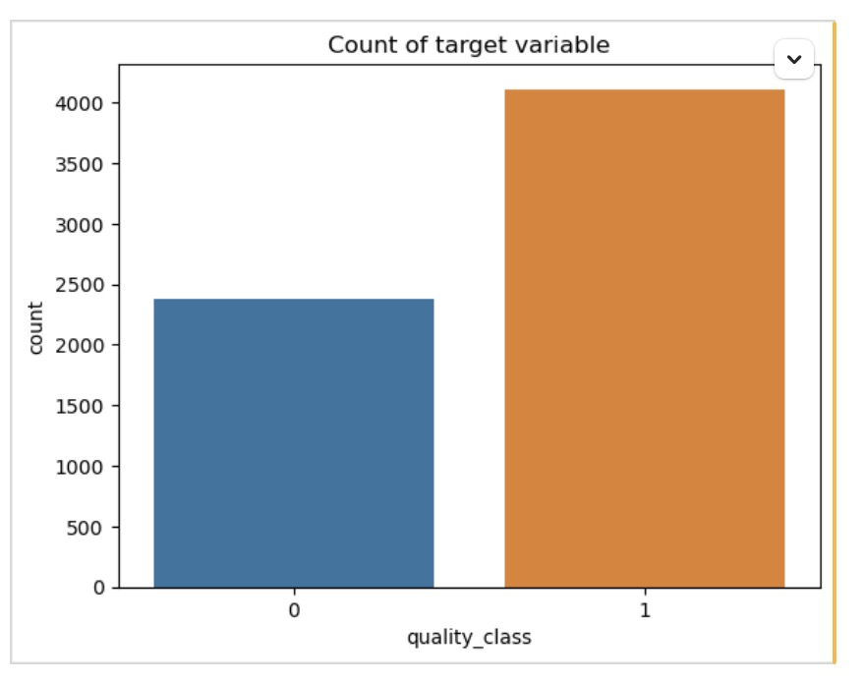
quality_class
1 0.633231
0 0.366769

Modeling Process

1. Data Splitting
- Split data into training (80%) and testing (20%) sets.
- Used stratification to maintain class proportions.

2. Feature Transformation
- Encoded wine_type (categorical feature) using OneHotEncoder.
- Scaled numeric features for uniformity.

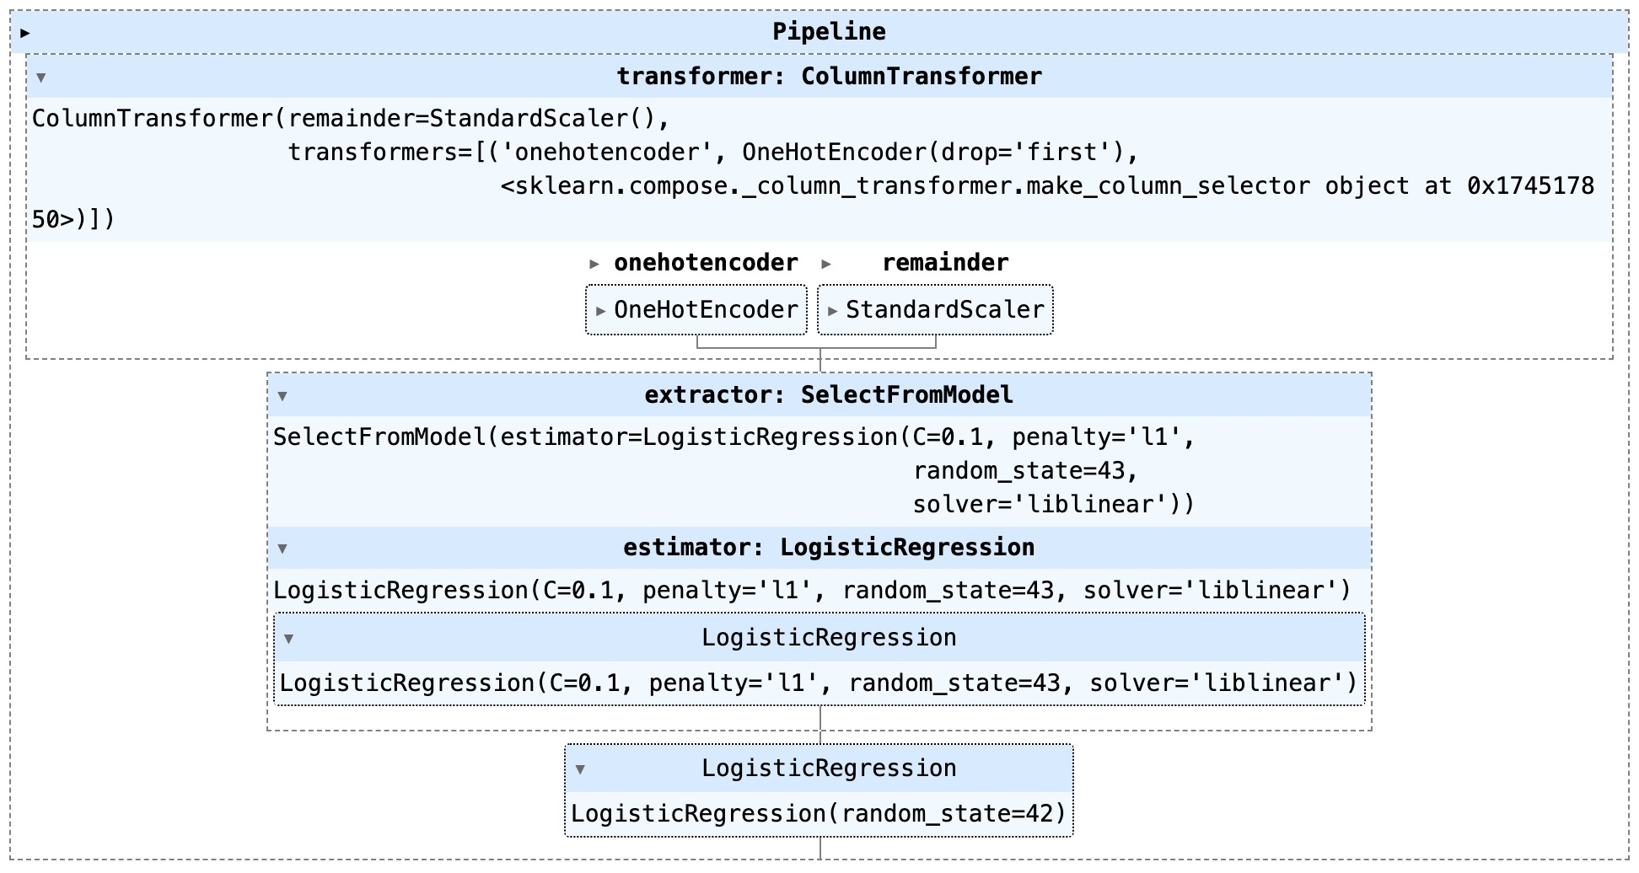

3. Classification Model
- Logistic Regression used for binary classification.
- Evaluation Metrics:
  - F1 Score = 0.8068.
  - AUC Score = 0.8030.

Best Parameters: {'extractor__estimator__C': 1.0, 'model__C': 1.0, 'model__penalty': 'l2'}
Best F1 Score: 0.8068173486174984

Model Results

Confusion Matrix
- Reliable classification of both high and low-quality wines.

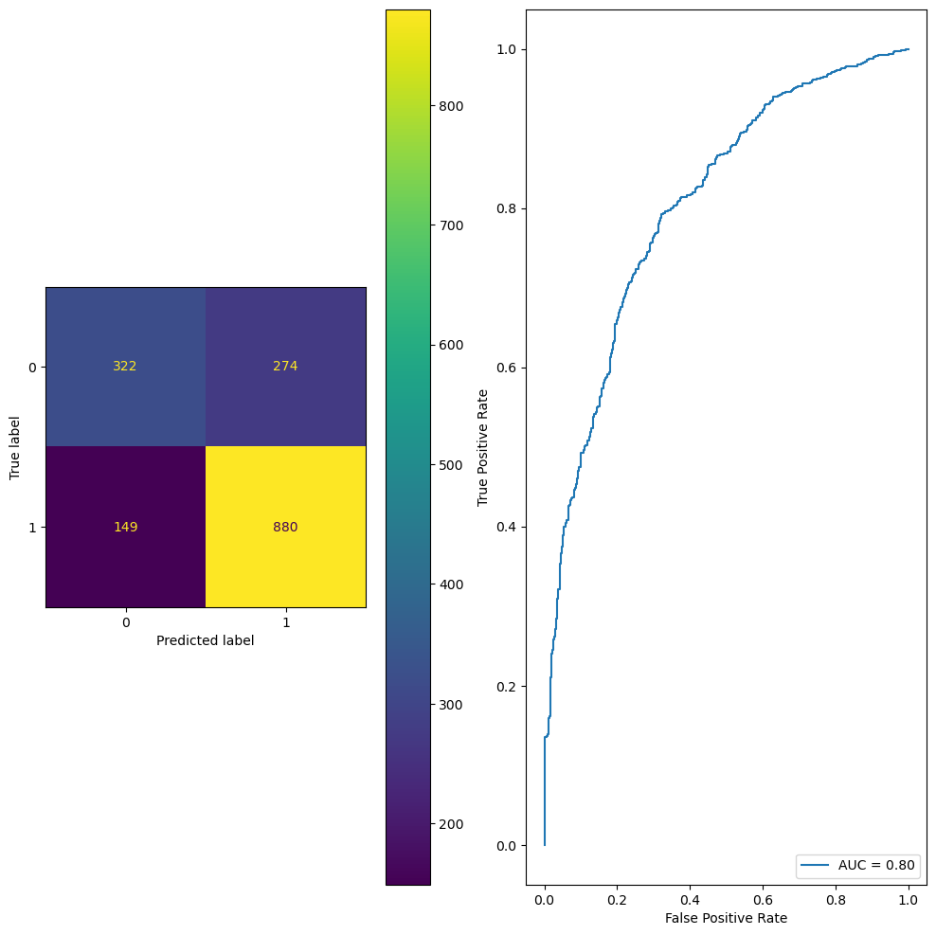

Selected Features and Coefficients
Feature | Coefficient
Alcohol | 0.922
Residual sugar | 0.609
Sulphates | 0.342
Free sulfur dioxide | 0.263
pH | 0.139
Fixed acidity | 0.128
Chlorides | -0.026
Citric acid | -0.059
Total sulfur dioxide | -0.316
Density | -0.482
White wine (encoded) | -0.675
Volatile acidity | -0.782

Key Insights
- Alcohol is the most significant predictor of high-quality wine.
- Residual sugar and sulphates positively influence wine quality.
- Volatile acidity and density negatively affect wine quality.
- Wine type (white vs. red) slightly negatively impacts high-quality classification.

Conclusion
The logistic regression model effectively classifies wine quality, aiding quality assurance and enabling process adjustments in wine production. Its high F1 score and AUC demonstrate reliable performance in distinguishing high and low-quality wines.

