New Wave Technologies Ltd.
|| Business Proposal

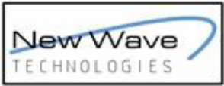

Table of Contents
1.0 EXECUTIVE SUMMARY........................................................................................4
2.0 THE OBJECTIVES.................................................................................................5
3.0 THE TARGET AUDIENCE .....................................................................................5
4.0 PROPOSED SYSTEM – agroSOFTTM ...................................................................6
5.0 CONCLUSION .....................................................................................................10

DEFINITIONS

The Proposal:
Addresses the client’s problem and suggests a solution to the problem.

Definitions:
Product/Solution An Agricultural Management Solution
Client Afro Alpine Pharma Ltd (AAPL) who will own the final Solution.

Responsibilities:
Client – Financial support for Product/Solution development and maintenance.
New Wave Technologies Ltd (NWT) – Provides business strategy and advice on the solution as well as developing, deploying and maintaining the Solution.

1.0 EXECUTIVE SUMMARY

Afro Alpine Pharma Ltd (AAPL) is a private limited company incorporated in Uganda with a mission to with a mission to enable Uganda to produce world standard, locally grown, affordable anti-malarial treatments, for distribution in the local, regional and international markets within Africa.

AAPL needs to take full advantage of Information and Communication Technologies (ICTs) to ease its operations. New Wave Technologies Limited (NWT) has noted that AAPL requires software that tracks important information on their farms as well as the outgrowers’ farms, i.e. harvest data, crops, chemicals, etc.

This software allows you to generate custom-made reports for a specific outgrower, year, field, commodity, for record keeping.
This proposal represents NWT’s proposed approach for AAPL to fully capitalize on the opportunities that the software offers, based on our experience, and expertise derived from formulating and delivering some of the most comprehensive Software and Internet Solutions in East and North East Africa.

This proposal presents a solution tailored to suit AAPL’s operations.

2.0 THE OBJECTIVES

The following statement will serve as our guiding light in developing a cutting edge solution for AAPL:

“To restock Africa and Uganda with a malaria medicine that works and is affordable, and to make Uganda the centre of activity for Anti-Malarial treatments”

In line with the above statement, the main objectives for AAPL implementing agricultural software are as follows:

- Improve the day-to-day operations of the firm
- Improve record keeping
- Reduce costs
- Automatic generation of reports

3.0 THE TARGET AUDIENCE

In broad terms, the target audience for AAPL putting into operation this software is as follows:

- AAPL administration,
- AAPL employees,
- AAPL stakeholders.

4.0 PROPOSED SYSTEM – agroSOFTTM

AAPL is clearly operating in a global arena under the watchful eye of its stake holders. AAPL's
principle concern is production of world standard, locally grown, affordable anti-malarial treatments services to some of the poorest in the world.

AAPL is required to report annually to its stakeholders on the projects it has carried out and performance of the company. In this respect, it is therefore highly critical that the approach for this solution be one that takes cognizance of this reality. To put this into context, we looked at other companies and realised that the industry is fiercely competitive and that new services are rapidly being created, and innovated, changing how customers perceive their overall services.

To develop better insight of how leading companies are using ICTs to add value to their businesses, we looked at the software they have adapted and took note of key trends and conventions. In the process, we gained a much better appreciation of the strategic Internet convergence of technologies and their presentation as resulting in new perceptions.

The key elements to point out leading to the success of these solutions which have features that would be commensurate to what AAPL may be interested in are:

- A focus on their core business/activity (i.e. consistency between core business objectives and customer requirement
- Quality and relevance of content for the target audiences, e.g. reports for different levels of management
- Professional and high quality secure solution that enables the AAPL use it without any skepticism
- Well defined Information Architecture that is intuitive and usercentric ensuring maximum comfort and efficiency.

NWT has developed quality work for our clients as illustrated below:

smartALERT TM – This is an SMSbased instant alert system. It notifies the property
owner, via SMS, if their property has had a breach or intrusion. It can monitor several
physical parameters like pressure, temperature, motion, etc.

smartSURVEY TM – The companion of surveyors. It helps in tracking land surveys,
prepare reports, save real estate information among other functions. It also provides the
surveyor an interface to make calculations of the land measurements.

smartPAY TM Automate the way you pay your employees. It is a simple, easytouse
application with inbuilt features for calculating overtime.

smartSCHOOL TM For school proprietors, we developed a solution that eases their
operations. With more than seven modules, smartSCHOOL TM this is the best solution of
its kind in the Ugandan market. Forget about the trouble of writing student reports all
you have to do is purchase this product and your problems will be solved.

For more information about these and other solutions we offer, see the link below.
http://www.newwavetech.co.ug/products.htm#smartpackage

System and Software Design

The system is separated into software and hardware:

Hardware requirements

Server Machine with:
• Intel PIV Processor,
• 1 GB Ram
• 40 GB hard Disk

Client Machines with:
• Intel PIV Processor
• 256 MB Ram
• 20 GB HDD (10 MB Install Space)

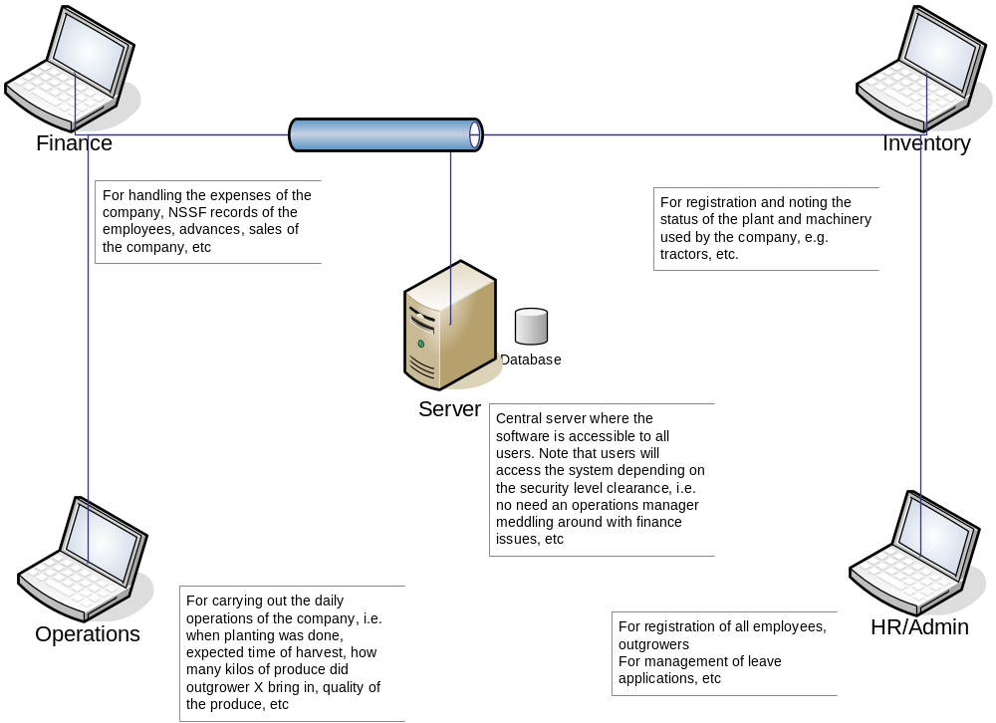

The above diagram illustrates the interaction between the different users of the software.

5.0 CONCLUSION

It is our philosophy to provide quality implementation support. NWT will provide full support during the entire life of all its products. We have highly trained and skilled IT personnel in our team who will be attached to your organization through all phases of the project to completion. Our accessibility is unlimited and our common approach to providing support at point of need is unrivalled synergy.

