
ASSAM SKILL UNIVERSITY
Skill for Prosperity
PROJECT REPORT
A report submitted in partial fulfillment of the requirements for the award of the degree of
BACHELOR OF TECHNOLOGY
in
Computer Science & Engineering (Hons.) Cybersecurity
on the topic
DATA BREACH COST PREDICTOR
A Machine Learning approach to estimate the financial cost of data breaches at Indian companies
Submitted By
Name | : | Leon Kaushik Deka
Roll No. | : | IT25B0233
Course | : | B.Tech CSE '29 (Hons.) Cybersecurity
Semester | : | Third
Subject | : | Machine Learning
Academic Year | : | 2026 to 2027
Department of Computer Science & Engineering
Assam Skill University
Academic Year 2026 to 2027

INDEX
Sr. No. | Description | Page No.
 | Abstract | 1
1 | Introduction | 1
2 | Problem Statement | 1
3 | Objectives | 1
4 | Why Machine Learning and Linear Regression? | 1
5 | Dataset Description | 2
6 | Theory: Linear Regression | 2
7 | Evaluation Metrics | 2
8 | Methodology / Workflow | 3
9 | Results | 3
10 | Visualisation | 4
11 | Limitations | 4
12 | Future Scope | 4
13 | Conclusion | 4
14 | References | 4

Abstract
Data breaches are one of the costliest cybersecurity incidents faced by organisations today. According to the IBM “Cost of a Data Breach” report, the average breach in India costs around ₹19.5 crore. This project builds a Machine Learning model that predicts the financial cost of a data breach (in crore rupees) from four measurable security factors: the number of records exposed, the time taken to detect the breach, the time taken to contain it, and the organisation’s security maturity score. The project builds and compares two models: Simple Linear Regression, which uses a single factor, and Multiple Linear Regression, which uses all four. The multiple regression model explains about 96 percent of the variation in breach cost (R² = 0.964) with an average error of only about ₹1.19 crore, and it clearly shows that faster detection and stronger security lower the cost of a breach.

1. Introduction
A data breach occurs when sensitive, protected, or confidential data is accessed or stolen without authorisation. For Indian businesses such as banks, hospitals, IT firms and e-commerce platforms, a breach causes both direct financial losses (investigation, legal fees and regulatory penalties under the DPDP Act 2023) and indirect losses (customer churn and reputational damage).
The cost of a breach is not random. It depends on factors such as how much data was lost and how quickly the organisation reacted. If we can express this relationship mathematically, we can predict the likely cost of a breach in advance and use it to justify security spending. This is a classic regression problem, the task of predicting a continuous numeric value, which is exactly what Linear Regression is designed to solve.

2. Problem Statement
Given measurable details about a data breach, predict its total financial cost (in ₹ crore). Manual estimation is slow and subjective; a regression model gives a fast, consistent, data-driven estimate.

3. Objectives
- Collect/prepare a dataset of data breaches with their costs.
- Build a Simple Linear Regression model using a single predictor.
- Build a Multiple Linear Regression model using all predictors.
- Evaluate both models using R² score and Mean Absolute Error (MAE).
- Interpret the coefficients to find which factors drive breach cost.
- Use the final model to predict the cost of a new, unseen breach.

4. Why Machine Learning and Linear Regression?
Machine Learning lets a computer learn patterns from past data instead of being explicitly programmed with rules. Here the target value (cost) is a continuous number, so this is a regression task (not classification, which predicts categories like spam/not-spam). Linear Regression is chosen because it is simple, fast and highly interpretable: every coefficient states, in rupees, how much each factor adds to or removes from the cost. This interpretability is valuable in cybersecurity, where decisions often have to be explained and justified to management.

5. Dataset Description
The dataset (cyber_breach.xlsx) contains 200 data-breach records from Indian companies. It is synthetically generated and calibrated to the IBM “Cost of a Data Breach” report for India, where the real average is about ₹19.5 crore and this dataset averages ₹17.5 crore, so the magnitudes are realistic. Synthetic data is used because real breach-cost figures are confidential and are not published for individual companies.
Column | Type | Range | Meaning
records_exposed | Input | 10 to 500 | Records leaked (in thousands)
detection_time | Input | 10 to 300 | Days taken to detect the breach
response_time | Input | 5 to 120 | Days taken to contain the breach
security_score | Input | 20 to 95 | Security maturity (0 to 100, higher is better)
breach_cost | Target | about 1 to 38 | Total breach cost in ₹ crore

The relationships built into the data match real-world intuition: more records lost raises cost, slow detection and slow response raise cost, and a higher security score lowers cost. Random noise is added so the data is not perfectly linear, making the modelling task realistic.

6. Theory: Linear Regression
Simple Linear Regression fits a straight line through the data using one input:
y = m·x + c
where y is the predicted cost, x is the input (records exposed), m is the slope (how much cost rises per unit of x), and c is the intercept (cost when x = 0).
Multiple Linear Regression extends this to several inputs:
y = b₀ + b₁x₁ + b₂x₂ + b₃x₃ + b₄x₄
Each b is a coefficient (weight) learned for that feature, and b₀ is the intercept. A positive coefficient means the feature increases cost; a negative one means it decreases cost.
How the model learns (cost function): the model chooses the coefficients that make its predictions as close as possible to the actual cost. The error is measured by the Mean Squared Error (MSE), the average of the squared differences between actual and predicted cost. scikit-learn finds the coefficients that minimise this error using the Ordinary Least Squares (OLS) method, which solves for the best-fit line directly.

7. Evaluation Metrics
R² score (coefficient of determination): the fraction of the variation in cost that the model explains. It ranges from 0 to 1; 1.0 is a perfect fit. R² = 0.964 means the model explains 96.4% of why breach costs differ.
Mean Absolute Error (MAE): the average size of the prediction error, measured in the same units as the target (₹ crore). It is the average of the absolute differences between actual and predicted cost. A lower value is better, and it is easy to explain because it is a direct rupee error.

8. Methodology / Workflow
- Load the dataset using pandas.
- Separate inputs (X) from the target (y = breach_cost).
- Split data into 80% training and 20% testing (train_test_split, random_state=2 for reproducibility).
- Train Simple Linear Regression on one feature (records_exposed).
- Train Multiple Linear Regression on all four features.
- Evaluate both on the unseen test set using R² and MAE.
- Inspect coefficients to interpret each factor’s effect.
- Predict the cost of a new hypothetical breach.
Tools used: Python, pandas (data handling), scikit-learn (modelling and metrics), and matplotlib (visualisation).

9. Results
Model | Features used | R² score | MAE (₹ crore)
Simple Linear Regression | 1 (records only) | 0.807 | 2.79
Multiple Linear Regression | 4 (all) | 0.964 | 1.19

The multiple regression model is clearly more accurate, because breach cost depends on several factors rather than the number of records alone. It explains about 96 percent of the variation, with an average error of only about ₹1.19 crore.
Learned coefficients (Multiple Linear Regression):
Factor | Coefficient | Interpretation
records_exposed | +0.050 | each extra 1,000 records adds ~₹0.05 crore
detection_time | +0.021 | each extra day to detect adds ~₹0.02 crore
response_time | +0.041 | each extra day to contain adds ~₹0.04 crore
security_score | -0.088 | each extra security point saves about ₹0.09 crore
intercept (b₀) | 4.419 | baseline cost of ~₹4.42 crore

Key insight: the negative coefficient on security_score shows that investing in security maturity directly reduces breach cost, which is a strong, data-backed argument for a security budget.
Example prediction: for a breach with 300k records exposed, 200 days to detect, 90 days to contain, and a weak security score of 40, the model predicts a cost of ≈ ₹23.57 crore.

10. Visualisation
Figure 1: Records exposed vs breach cost, with the Simple Linear Regression best-fit line (red).
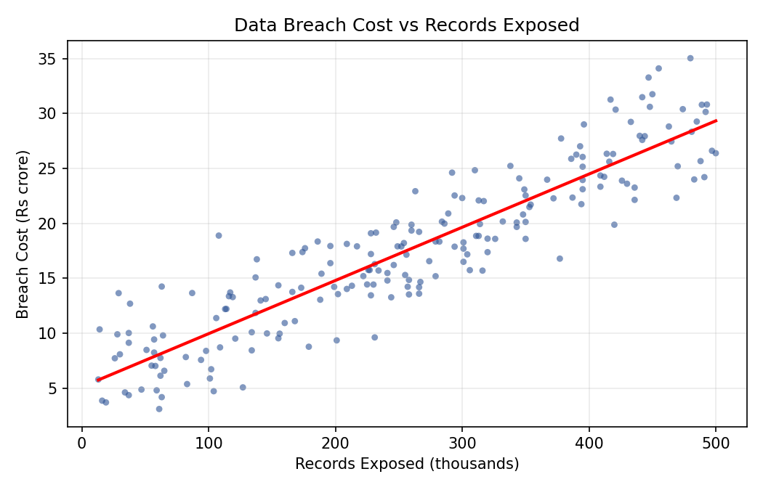

11. Limitations
- Uses synthetic (not real) data, because real breach costs are confidential.
- Assumes a linear relationship; real costs may be partly non-linear.
- Only four factors are used; real cost also depends on industry, region, etc.
- Outliers (very large breaches) can reduce accuracy.

12. Future Scope
- Add more features: industry type, company size, encryption used, attack type.
- Try advanced models (Random Forest, Gradient Boosting) and compare.
- Deploy as a simple web app where a user enters details and gets a cost estimate.
- Use real anonymised breach datasets when available.

13. Conclusion
This project built and compared two linear regression models to predict the cost of a data breach for Indian organisations. The Multiple Linear Regression model achieved a strong R² of 0.964. Beyond prediction, the model is easy to interpret and carries a clear cybersecurity message: faster detection, faster response and stronger security maturity all measurably lower the financial impact of a breach.

14. References
- IBM Security, Cost of a Data Breach Report (India figures).
- scikit-learn documentation: LinearRegression, train_test_split and metrics.
- Digital Personal Data Protection (DPDP) Act, 2023, Government of India.

