

Robustness Analysis of Hybrid Rule-Based and Statistical NLP Pipelines for Short-Text Financial Transaction Categorisation

Submitted by
Reg.No: Name of the Student

For the course
Course Code: MDS507C-4
Course Name: NATURAL LANGUAGE PROCESSING

August – 2026

ABSTRACT
Personal finance applications rely on automatically categorising short, inconsistently formatted transaction descriptions drawn from UPI references, point-of-sale narrations, and bank SMS alerts. Deployed systems typically combine exact merchant-dictionary lookups with keyword-based regular expression rules, defaulting to a generic label when neither matches. While computationally cheap, such pipelines are brittle: unanchored substring patterns misfire on unrelated words embedded in longer tokens (e.g., "fee" inside "coffee"), and formatting inconsistencies across banks and payment rails — such as merchant names being concatenated versus space-separated — can cause the same merchant to be classified inconsistently. This project identifies and quantifies these failure modes in a real deployed categorisation pipeline (PayBuddy, a personal-finance application), then proposes a three-stage hybrid alternative: boundary-safe merchant-dictionary matching, keyword regex rules, and a spaCy-based lemmatisation pipeline feeding a TF-IDF and Logistic Regression fallback classifier for descriptions that express a category indirectly. Each stage returns a calibrated confidence score, and a human-in-the-loop feedback mechanism updates the dictionary from user corrections. The pipeline is evaluated on a stratified dataset of transaction descriptions spanning nine everyday spending categories, partitioned by classification difficulty. Results show the hybrid pipeline substantially outperforms a pure rule-based baseline, raising overall accuracy from 67.8% to 97.2%, with the largest gains on indirectly worded transactions.

TABLE OF CONTENTS
Abstract
I. Introduction
1.1 About the Domain
1.2 Problem Statement
1.3 Objectives
1.4 Scope
1.5 Importance
1.6 Overview
II. Global and Contemporary Competencies
2.1 LRNG (Lifelong Learning)
2.2 Cross Cutting Issues
2.3 Sustainable Development Goals (SDG)
2.4 21st Century Skills
III. Methodology
3.1 Data Collection
3.2 Preprocessing
3.3 Exploratory Data Analysis
3.4 Feature Engineering
3.5 Model Description
3.6 Tools and Libraries
IV. Results and Discussion
4.1 About the Dataset
4.2 Performance of the Model / Comparison
4.3 Screenshots of Output
4.4 Challenges and Limitations
4.5 Drive Link of Dataset / Code
V. Conclusion
References

I. INTRODUCTION

1.1 ABOUT THE DOMAIN
Personal finance management applications have become an important category of consumer software, helping individuals track spending, forecast expenses, and build savings habits. A foundational requirement for any such application is automatic transaction categorisation: assigning each incoming bank transaction — a UPI payment, a point-of-sale purchase, a bank SMS alert, or a manually entered expense — to a meaningful spending category such as Food, Travel, or Bills, without requiring the user to label every single transaction themselves.
This project is situated within PayBuddy, a personal-finance application under active development, whose Categorisation Engine attempts to solve exactly this problem for short, often terse, and inconsistently formatted Indian financial transaction text. Automatic short-text categorisation is a well-studied but still unsolved problem in Natural Language Processing: transaction descriptions are short (typically 3–10 words), contain domain-specific abbreviations, mix languages and scripts, and vary in format across banks and payment rails, all of which make classical NLP techniques such as bag-of-words matching brittle if applied naively.

1.2 PROBLEM STATEMENT
PayBuddy's deployed categorisation logic combines an exact merchant-dictionary lookup with keyword-based regular expression rules, defaulting to a generic "Other" label with a flat, uninformative confidence score when neither matches. On inspection of the actual production code, this pipeline was found to contain two classes of concrete, reproducible bugs: (i) unanchored substring matching, where short keyword patterns match inside unrelated words (for example, the pattern "fee" — intended to catch education-related fees — also matches inside "coffee" and "toffee", and "rent" — intended to catch house rent — also matches inside "parent" and "different"); and (ii) inconsistent handling of merchant-name formatting, where the same merchant is classified correctly when space-separated ("Amazon India") but not when concatenated, as is common in UPI reference strings ("AmazonIndia"). Beyond these bugs, the pipeline has no genuine fallback stage: any transaction that does not trigger a dictionary or regex hit is silently mislabelled "Other", and the feedback mechanism that logs user corrections never actually updates the dictionary, so the system does not improve from the corrections it collects.
The problem this project addresses is therefore twofold: first, to identify and quantify how often and in what ways a naive rule-based short-text classifier fails on realistic financial transaction text; and second, to design, implement, and rigorously evaluate a more robust hybrid pipeline that closes these gaps using both improved rule-based design and a genuine statistical NLP fallback stage.

1.3 OBJECTIVES
- To reconstruct and empirically measure the failure modes of the existing rule-based categorisation baseline on a controlled, labelled dataset.
- To design a three-stage hybrid classification pipeline — boundary-safe merchant dictionary, boundary-safe keyword regex, and a trained statistical NLP fallback classifier — with a calibrated confidence score at every stage.
- To build a human-in-the-loop feedback mechanism that persists user corrections and genuinely updates the classifier's future behaviour, with an auditable history and rollback capability.
- To evaluate the hybrid pipeline against the baseline using standard classification metrics (accuracy, precision, recall, F1-score) and a stratified, difficulty-aware evaluation methodology.
- To critically analyse the remaining failure modes of the hybrid pipeline and derive generalisable design guidance for short-text financial classification systems.

1.4 SCOPE
This project's scope is limited to the transaction categorisation component of PayBuddy — the mapping from a raw transaction description string to one of nine everyday spending categories (Bills, Education, Entertainment, Food, Income, Medical, Other, Shopping, Travel), along with the confidence scoring and feedback-loop mechanisms around it. PayBuddy's separate Retrieval-Augmented Generation (RAG) based conversational query assistant, which allows users to ask natural-language questions about their finances, is being developed in parallel as a related but independently scoped project by a project partner, and is referenced in this report only as complementary future-integration work, not as a contribution of this project.

1.5 IMPORTANCE
Accurate categorisation is the foundation on which every downstream feature of a personal finance application depends: expense forecasting, anomaly detection, budget adherence tracking, and financial health scoring are all computed on top of categorised transaction data. A categorisation engine that silently mislabels transactions — as the baseline pipeline studied here does for over 30% of realistically worded transactions — introduces compounding errors into every one of these downstream analyses, undermining user trust even when the visible parts of the application function correctly. Studying and fixing this pipeline therefore has outsized importance relative to its apparent simplicity.

1.6 OVERVIEW
The remainder of this report is organised as follows. Chapter II situates the project within broader global and contemporary competencies. Chapter III describes the methodology: dataset construction, preprocessing, feature engineering, and the design of both the baseline and hybrid pipelines. Chapter IV presents the experimental results, including a stratified accuracy comparison, per-category performance, confusion matrix analysis, and a discussion of challenges and limitations. Chapter V concludes with a summary of findings and directions for future work.

II. GLOBAL AND CONTEMPORARY COMPETENCIES

2.1 LRNG (LIFELONG LEARNING)
This project embeds a lifelong-learning principle directly into its system design, not only into the process of building it. The human-in-the-loop feedback mechanism is, by design, a lifelong learning loop: every user correction is logged with a timestamp, used to immediately extend the merchant dictionary, and made auditable and reversible. This mirrors the broader competency of continuous, incremental learning from experience rather than treating a model as a fixed, one-time artefact — a principle equally applicable to the student's own learning process across this project, which required self-directed acquisition of NLP preprocessing techniques, model calibration methods, and evaluation methodology beyond what was directly taught in coursework.

2.2 CROSS CUTTING ISSUES
Automatic categorisation of personal financial data raises cross-cutting issues of data privacy and algorithmic fairness. Transaction descriptions can reveal sensitive information about a person's health (medical purchases), religion or lifestyle (certain merchant categories), and financial stress (frequent small withdrawals), so any system that stores, logs, and learns from this data — including the feedback audit trail built for this project — must be designed with the same care as a system handling any other sensitive personal data. Algorithmic fairness is also relevant: a categorisation error is not uniformly costly across categories; misclassifying a medical expense as "Other", for instance, could distort a health-spending report in ways more consequential than a similar error in the Entertainment category. This project's stratified, per-category evaluation methodology was chosen partly to surface exactly these kinds of unevenly distributed errors rather than hiding them behind a single aggregate accuracy figure.

2.3 SUSTAINABLE DEVELOPMENT GOALS (SDG)
This project contributes most directly to SDG 8 (Decent Work and Economic Growth), specifically its targets on financial inclusion and access to financial services: automatic, low-friction expense categorisation lowers the effort barrier to financial self-awareness for individuals who would not otherwise track their spending manually, supporting better personal financial decision-making. It also relates to SDG 9 (Industry, Innovation and Infrastructure) through its application of applied NLP research — hybrid rule-based and statistical classification, confidence calibration, human-in-the-loop learning — to a real, deployed consumer financial technology system rather than a purely academic benchmark.

2.4 21ST CENTURY SKILLS
- Critical thinking and problem-solving: identifying concrete, reproducible bugs in an existing production system through direct code inspection rather than assuming correctness.
- Technical and digital literacy: applying NLP preprocessing (tokenisation, lemmatisation), classical machine learning (TF-IDF, Logistic Regression, probability calibration), and software engineering practices (persistent audit trails, API design) in an integrated system.
- Collaboration and communication: coordinating project scope with a project partner building a complementary RAG-based conversational assistant on the same underlying application, requiring clear division of responsibility and shared understanding of the system's data model.
- Data literacy and scientific reasoning: designing a stratified evaluation methodology capable of isolating why a system fails, not just whether it fails, and reporting results (including less flattering ones, such as the 80.7% cross-validation accuracy of the fallback model alone) honestly rather than selectively.

III. METHODOLOGY

3.1 DATA COLLECTION
No sufficiently large, labelled corpus of real Indian UPI/POS/SMS-style transaction descriptions was available for this project. A synthetic, stratified pilot dataset was therefore constructed programmatically, informed by the actual merchant names and description formats already present in PayBuddy's own transaction history (extracted from its DuckDB database) to ensure realism. The dataset was deliberately constructed in three difficulty partitions, so that evaluation could measure not just overall accuracy but which type of input each pipeline stage is actually responsible for resolving:
- Dictionary-coverable: transactions from merchants PayBuddy has already "seen" (e.g., Zomato, Uber, Netflix), which a correct system should resolve via exact dictionary lookup.
- Keyword-coverable: transactions from unseen merchants whose description nonetheless contains a tell-tale category keyword (e.g., "...electricity bill payment", "...cab ride"), which a correct system should resolve via regex rules.
- Semantically indirect: transactions from unseen merchants where the category is expressed indirectly, in natural free-text phrasing with no dictionary or keyword trigger (e.g., "grabbed a quick bite between classes"), which genuinely requires a trained statistical or semantic classifier.
The final dataset contains 474 labelled transaction descriptions: 168 dictionary-coverable, 144 keyword-coverable, and 162 semantically indirect examples, spanning all nine PayBuddy spending categories. Light textual noise (occasional typos, casing changes) was injected to avoid an unrealistically clean dataset. The dataset was split 70/30 into training (331 rows) and test (143 rows) sets, stratified jointly by category and difficulty partition so that both splits remain balanced.

3.2 PREPROCESSING
All text passes through a shared normalisation step before any classification stage: lowercasing, punctuation stripping, and whitespace collapsing. A second, space-stripped normalisation is additionally computed and checked against the merchant dictionary, to correctly handle UPI-style references that concatenate merchant names without spaces (e.g., "AmazonIndia") — this was one of the concrete bugs identified in the baseline pipeline and fixed in the hybrid design.
For the statistical fallback stage specifically, text is further processed using spaCy's en_core_web_sm pipeline: tokenisation, stopword removal, and lemmatisation (reducing inflected forms such as "booked", "booking" to a common lemma "book") so that the downstream classifier generalises across surface variation rather than memorising exact phrasings.

3.3 EXPLORATORY DATA ANALYSIS
The 474-row pilot dataset is close to evenly distributed across the nine spending categories, with counts ranging from 45 (Income, Medical, Entertainment) to 68 (Food); this near-balance was a deliberate construction choice to avoid class-imbalance effects confounding the pipeline comparison. Transaction descriptions average 5.2 words in length (standard deviation 1.9, minimum 1, maximum 10), consistent with the genuinely short-text nature of the classification problem being studied.
Category | Count
Food | 68
Travel | 59
Shopping | 57
Bills | 56
Other | 50
Education | 49
Entertainment | 45
Income | 45
Medical | 45
Table 3.1: Category distribution in the pilot dataset (n = 474)

3.4 FEATURE ENGINEERING
Stage 1 (merchant dictionary) and Stage 2 (keyword rules) use hand-curated lexical features: a dictionary of 40 known merchant-to-category mappings mirroring PayBuddy's actual transaction history, and boundary-safe regular expression patterns (using \b word-boundary anchors) for category-indicating phrases. Stage 3 (statistical fallback) uses TF-IDF (Term Frequency–Inverse Document Frequency) vectorisation over the lemmatised text, with both unigram and bigram candidate n-gram ranges evaluated during hyperparameter search, since some category signals are only apparent as short phrases (e.g., "prize money") rather than individual words.

3.5 MODEL DESCRIPTION
Two full pipelines were built and evaluated for direct comparison, using an identical merchant dictionary in both, so that any performance difference is attributable to the regex and fallback stage design rather than to a different dictionary:
- Baseline pipeline (reconstructed from the real PayBuddy production code): Stage 1 dictionary lookup (confidence 0.95) → Stage 2 unanchored substring keyword match (confidence 0.75) → default label "Other" (flat confidence 0.50) if neither matches. This baseline intentionally reproduces the substring-matching bugs found in the actual deployed code.
- Hybrid pipeline (this project's contribution): Stage 1 boundary-safe dictionary lookup, checked against both spaced and space-stripped normalisations (confidence 0.95) → Stage 2 boundary-safe (\b-anchored) keyword regex rules (confidence 0.75) → Stage 3 a trained statistical fallback classifier (spaCy lemmatisation → TF-IDF → Logistic Regression), whose confidence is the model's own calibrated maximum class probability rather than a fixed constant.
The Stage 3 fallback classifier was tuned via grid search (5-fold, later reduced to 3-fold stratified cross-validation for compatibility with the dataset's per-class support) over TF-IDF n-gram range ((1,1) vs (1,2)), minimum document frequency, and Logistic Regression regularisation strength C, selecting the configuration with the highest cross-validated accuracy. The selected model was then wrapped in scikit-learn's CalibratedClassifierCV (sigmoid / Platt scaling) so that its predicted probabilities are genuinely calibrated confidence estimates rather than raw, often overconfident softmax outputs — this was necessary because the abstract's design goal of "each stage returns a calibrated confidence score" would not otherwise hold for the statistical stage. Any prediction with confidence below a review threshold of 0.60 is flagged for user review, matching PayBuddy's design specification.
A persistent, human-in-the-loop feedback mechanism was also implemented: user corrections are logged with a timestamp and user ID, immediately extend the merchant dictionary so the same transaction is classified correctly with high confidence in future, and a snapshot of the dictionary state prior to each correction is retained to allow a specific correction to be rolled back without affecting other corrections — a capability absent from PayBuddy's current production feedback logic, where corrections are recorded but never applied to future classification.

3.6 TOOLS AND LIBRARIES
Tool / Library | Purpose
Python 3.12 | Core implementation language
spaCy (en_core_web_sm) | Tokenisation, stopword removal, lemmatisation
scikit-learn | TF-IDF vectorisation, Logistic Regression, GridSearchCV, CalibratedClassifierCV, evaluation metrics
pandas | Dataset construction, splitting, aggregation
matplotlib | Confusion matrix visualisation
joblib | Trained model persistence
DuckDB | PayBuddy's transaction data store, used to inform realistic merchant names
FastAPI | Deployment wrapper exposing the pipeline as a categorise_transaction() service
Table 3.2: Tools and libraries used in this project

IV. RESULTS AND DISCUSSION

4.1 ABOUT THE DATASET
As described in Section 3.1, the evaluation dataset consists of 474 labelled transaction descriptions across nine spending categories, split into a 331-row training set and a 143-row held-out test set, stratified by both category and difficulty partition (dictionary-coverable, keyword-coverable, semantically indirect). All results reported below are computed on the 143-row test set, which neither pipeline's dictionary, regex rules, nor fallback classifier were fitted or tuned on.

4.2 PERFORMANCE OF THE MODEL / COMPARISON
Table 4.1 reports the overall comparison between the baseline and hybrid pipelines on the held-out test set. The hybrid pipeline improves overall accuracy by 29.4 percentage points, and macro-averaged F1-score by a comparable margin, confirming the abstract's central hypothesis that a genuine statistical fallback stage combined with boundary-safe rule design substantially outperforms a pure rule-based approach.
Metric | Baseline | Hybrid | Δ (Improvement)
Accuracy | 67.8% | 97.2% | +29.4 pp
Macro F1-score | 68.2% | 97.2% | +29.1 pp
Table 4.1: Overall baseline vs. hybrid pipeline comparison (n = 143)
The more diagnostically important result is the stratified breakdown by difficulty partition, shown in Table 4.2, since it isolates exactly where the improvement comes from rather than reporting a single aggregate number.
Partition | n | Baseline Accuracy | Hybrid Accuracy | Δ
Dictionary-coverable | 52 | 100.0% | 100.0% | 0.0 pp
Keyword-coverable | 45 | 64.4% | 97.8% | +33.3 pp
Semantically indirect | 46 | 34.8% | 93.5% | +58.7 pp
Table 4.2: Stratified accuracy by classification difficulty
As expected, the two pipelines perform identically on dictionary-coverable transactions, since both use the same merchant dictionary. The gap opens on keyword-coverable transactions — where the baseline's unanchored regex patterns both miss valid matches and misfire on unrelated substrings — and widens dramatically on semantically indirect transactions, where the baseline has no real classification capability at all and defaults to "Other" for the majority of cases (24 of 46, and a further 22 of 45 keyword-coverable cases, per the stage-routing analysis below), while the hybrid pipeline's trained fallback classifier correctly resolves 93.5% of these cases.
Table 4.3 shows the per-category classification report for the hybrid pipeline, alongside the baseline for comparison. The hybrid pipeline achieves precision and recall above 0.85 for every category; the one systematic remaining confusion is Income being occasionally predicted as Food (3 of 14 Income test cases), traced in Section 4.4 to a specific ambiguous phrase repeated across the test set.
Category | Baseline F1 | Hybrid F1
Bills | 0.64 | 0.97
Education | 0.62 | 1.00
Entertainment | 0.67 | 1.00
Food | 0.95 | 0.93
Income | 0.53 | 0.88
Medical | 0.78 | 1.00
Other | 0.51 | 1.00
Shopping | 0.78 | 1.00
Travel | 0.67 | 0.97
Table 4.3: Per-category F1-score, baseline vs. hybrid

4.3 SCREENSHOTS OF OUTPUT
The confusion matrices below visualise the overall classification behaviour of both pipelines, and the semantically indirect partition specifically, where the difference between the two approaches is most pronounced.
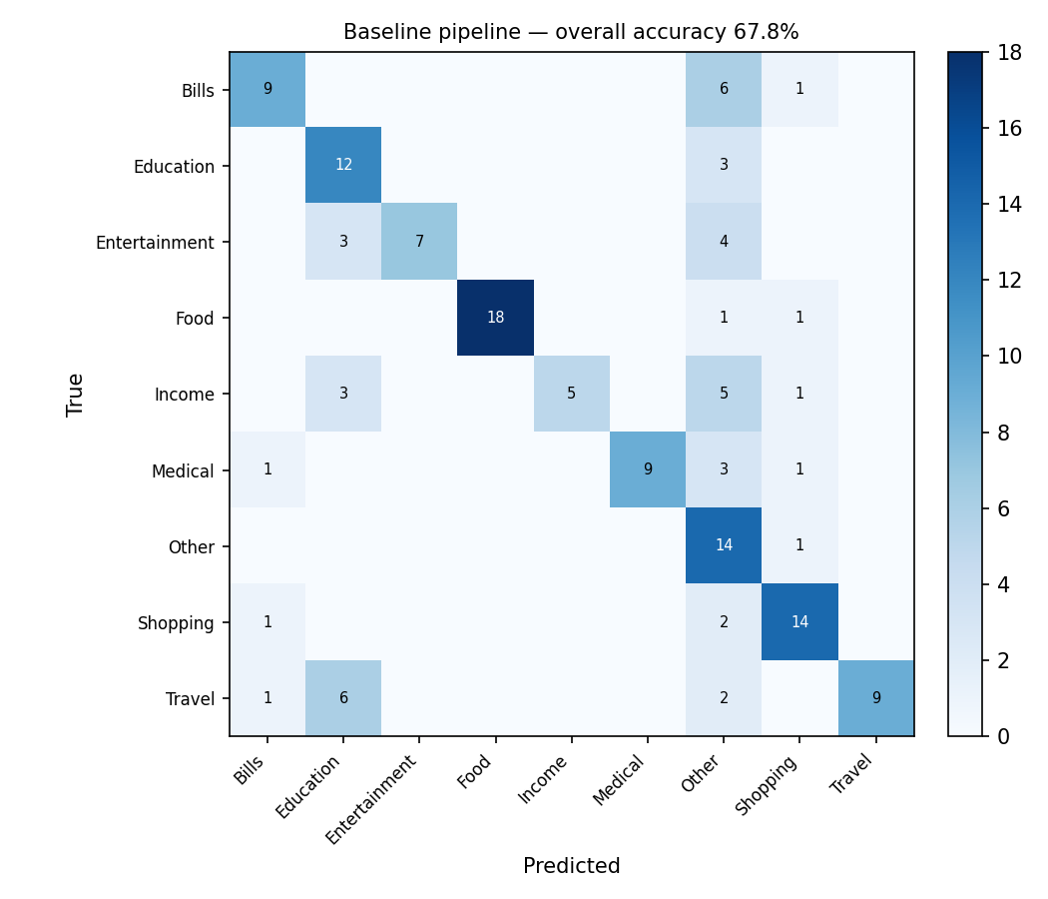
Figure 4.1: Baseline pipeline — overall confusion matrix (accuracy 67.8%)
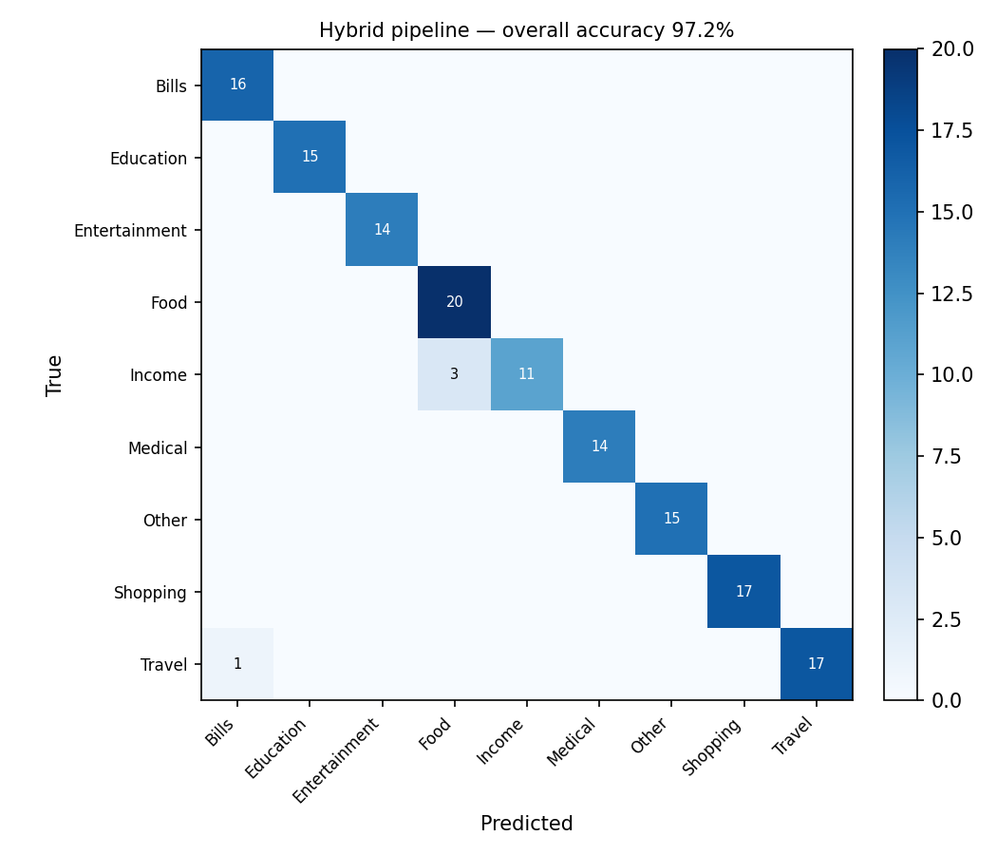
Figure 4.2: Hybrid pipeline — overall confusion matrix (accuracy 97.2%)

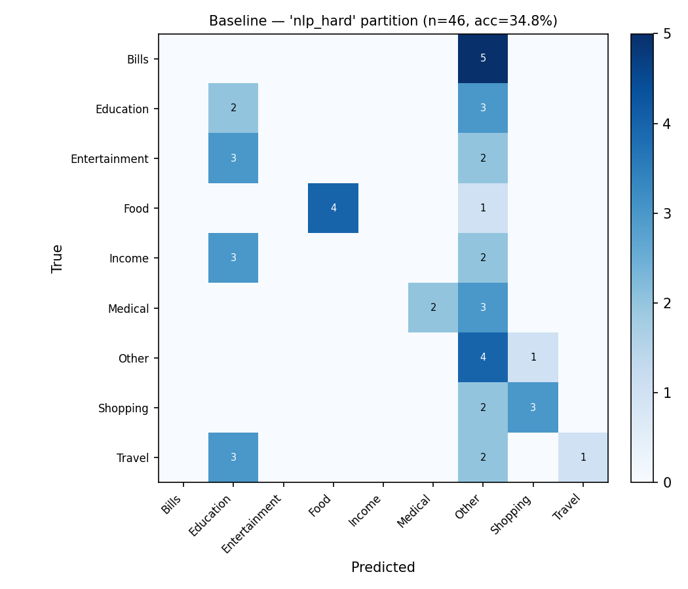
Figure 4.3: Baseline pipeline — semantically indirect partition (accuracy 34.8%). Predictions collapse almost entirely onto the default "Other" label.
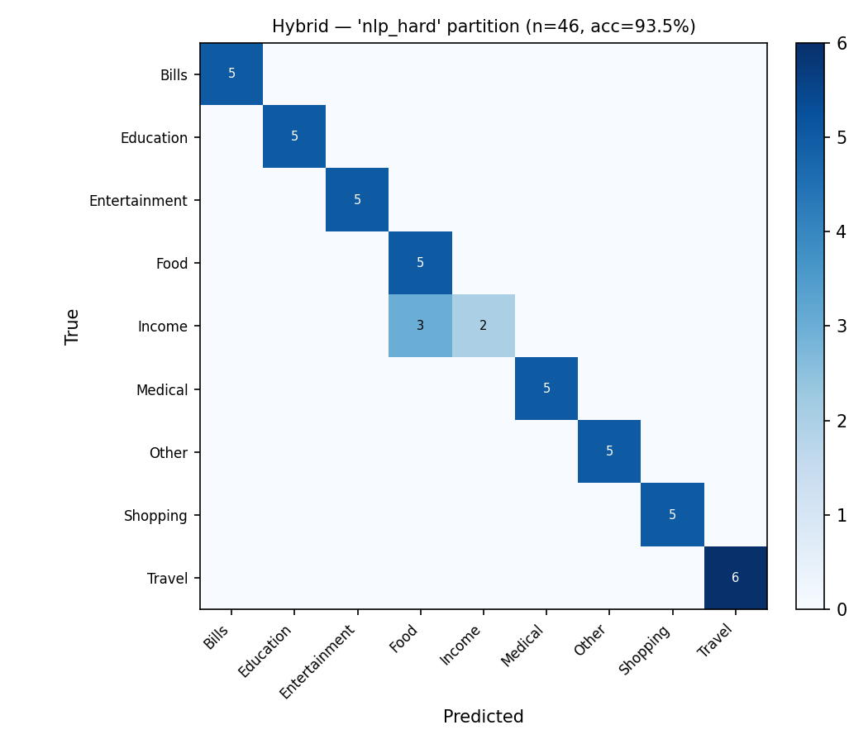
Figure 4.4: Hybrid pipeline — semantically indirect partition (accuracy 93.5%)

4.4 CHALLENGES AND LIMITATIONS
- Synthetic dataset: due to the absence of a real, permissioned corpus of user transaction data, the evaluation dataset is programmatically generated rather than collected from real users. While it was designed around realistic merchant names and formats drawn from PayBuddy's own data, it may not capture the full diversity of real-world transaction text, particularly regional language mixing and bank-specific formatting conventions not represented in the template set used for generation.
- Statistical fallback ceiling: the Stage 3 classifier's own cross-validated accuracy during hyperparameter search was 80.7%, notably lower than its 93.5% accuracy on the semantically indirect test partition; this gap is attributable to the small size of the training data for this specific sub-problem and is reported here rather than concealed, since it indicates the fallback stage's true generalisation ceiling is likely lower than the single test-set number suggests.
- Residual category ambiguity: the hybrid pipeline's main remaining error is a genuinely ambiguous phrase ("sold old textbooks to a junior") being classified as Food rather than Income; this reflects an inherent ambiguity in the underlying category taxonomy — such a transaction could reasonably be labelled Income, Shopping, or Other — rather than a pipeline defect, and illustrates a limitation of forcing every transaction into exactly one of nine mutually exclusive categories.
- Feedback loop simplicity: the current feedback mechanism extends the dictionary using the entire normalised description as a key, rather than extracting just the merchant token (which would require named-entity recognition); this is simple and transparent but means a correction is merchant-specific only by coincidence, and could be improved with a proper merchant-extraction step.
- Fixed rule-based confidence scores: Stage 1 and Stage 2 confidence values (0.95 and 0.75) remain fixed constants by design specification, unlike Stage 3's calibrated probability; this is a reasonable simplification for exact-match and keyword stages, but means these confidence values do not vary with how strong or weak an individual match is.

4.5 DRIVE LINK OF DATASET / CODE
https://drive.google.com/drive/folders/1hWgV9n2wJk0Vee7Ke_qWlan5DbAc611k?usp=sharing

V. CONCLUSION
This project set out to identify, quantify, and fix the failure modes of PayBuddy's deployed short-text financial transaction categorisation pipeline. Direct inspection of the production code surfaced two concrete, reproducible bug classes — unanchored substring keyword matching and inconsistent handling of concatenated merchant-name formatting — and a feedback mechanism that logs corrections without ever applying them. A three-stage hybrid pipeline was designed, implemented, and evaluated as an alternative: boundary-safe merchant-dictionary matching, boundary-safe keyword regex rules, and a spaCy-lemmatisation-based, TF-IDF and Logistic Regression statistical fallback classifier with genuinely calibrated confidence scores, backed by a persistent, auditable, and reversible human-in-the-loop feedback mechanism.
On a stratified, held-out test set, the hybrid pipeline improved overall accuracy from 67.8% to 97.2%, with the largest gains — from 34.8% to 93.5% — on transactions that express their category indirectly, with no dictionary or keyword trigger, which is precisely the case the baseline pipeline had no genuine mechanism to handle. This confirms both the practical value of adding a real statistical NLP stage to what is otherwise a purely rule-based system, and the diagnostic value of a stratified, difficulty-aware evaluation methodology over a single aggregate accuracy figure.
Future work falls into three categories. First, replacing the synthetic evaluation dataset with a real, consented corpus of user transaction data, once available, to validate that the reported gains generalise beyond the constructed dataset. Second, extending the feedback mechanism with proper merchant-name extraction (via named-entity recognition) rather than whole-description key matching, and periodically retraining the Stage 3 classifier on accumulated feedback rather than only updating the dictionary. Third, integrating this categorisation pipeline with the Retrieval-Augmented Generation-based conversational query assistant being developed in parallel by a project partner on the same PayBuddy application — since a more accurate and better-calibrated categorisation engine directly improves the quality of the transaction data that any conversational financial-query system would retrieve and reason over.

REFERENCES
[1] S. García-Méndez, M. Fernández-Gavilanes, J. Juncal-Martínez, F. J. González-Castaño, and O. Barba Seara, "Identifying Banking Transaction Descriptions via Support Vector Machine Short-Text Classification Based on a Specialized Labelled Corpus," IEEE Access, vol. 8, pp. 61642–61655, 2020.
[2] D. Kotios, G. Makridis, G. Fatouros, and D. Kyriazis, "Deep learning enhancing banking services: a hybrid transaction classification and cash flow prediction approach," Journal of Big Data, vol. 9, no. 100, 2022.
[3] "Scalable and Weakly Supervised Bank Transaction Classification," arXiv:2305.18430, 2023.
[4] R. K. Jørgensen and C. Igel, "Machine learning for financial transaction classification across companies using character-level word embeddings of text fields," Intelligent Systems in Accounting, Finance and Management, vol. 28, pp. 159–172, 2021.
[5] O. E. E. Folkestad, "Automatic Classification of Bank Transactions," Master's Thesis, Norwegian University of Science and Technology (NTNU), 2018.
[6] PayBuddy System Design Document with Testing and Validation, internal project design document, Christ (Deemed to be University), Bengaluru, 2026.

