

**Demonstration Guide**

**Fault Tolerance**

Grupo T08

**Setup:**

1. **Obtain code from git repository (download or clone):**

<https://github.com/tecnico-distsys/T08-SD18Proj.git>

1. **Open terminal on project root** T08-SD18Proj.  **To install project run:**
   * mvn install -DskipTests

**Note:** If running windows, running demoTest.bat will preform steps 1 to 3.

**F1 - Success**

1. **Open 3 terminals on folder** T08-SD18Proj /station-ws **and run the following command to run on each a *station server*:**
   * *T08_Station1*: mvn exec:java
   * *T08_Station2*: mvn exec:java -Dws.i=2
   * *T08_Station3*: mvn exec:java -Dws.i=3
2. **Open a terminal on folder** T08-SD18Proj/binas-ws **and run the following command to execute the *binas server*:**

* *T08_Binas*: mvn exec:java

1. **Open a terminal on folder** T08-SD18Proj/binas-ws-cli **and run the following command to execute the *binas client*:**

* *BinasClient:* mvn exec:java

1. **Verify that the *binas client* returned the following output:**

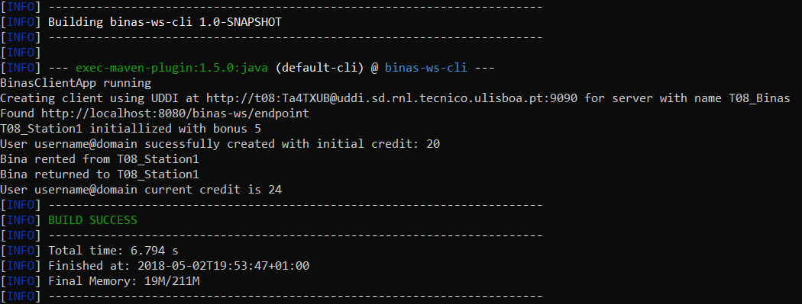

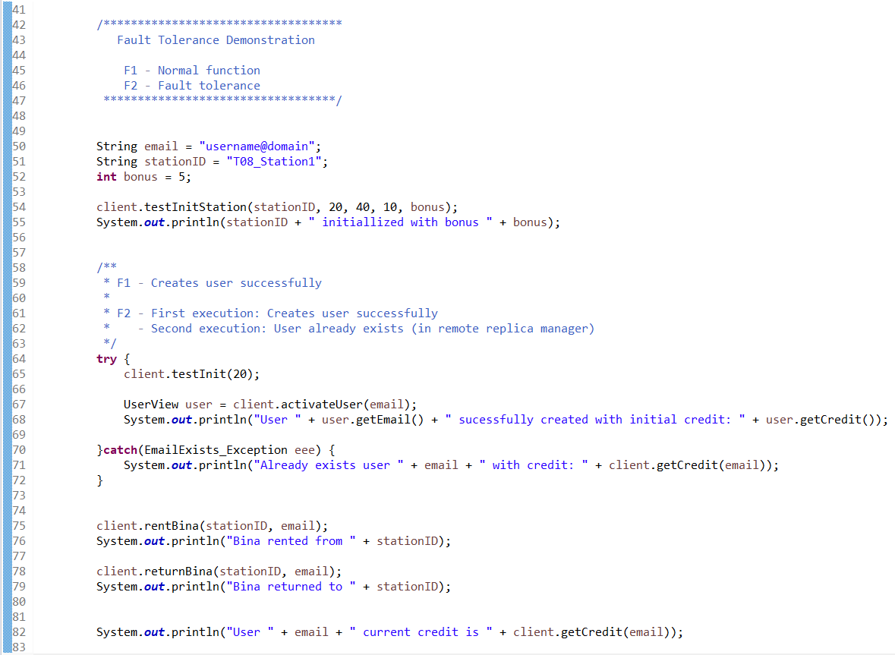

**The code above is executed by *binas client* main class:**

1. Tries to activate the user with email “username@domain”. There is no register of user in the binas server nor in the stations, therefore the operation is successful, and a new user is created with initial credit of 20;
2. The user rents a bina, therefore its credit is updated in binas server and all stations to 19.
3. The user returns the bina, and its credit is update in binas server and all stations to 24.
4. **Repeat step 3** (Run the binas client)
5. **Verify that the *binas client* returned the following output:**

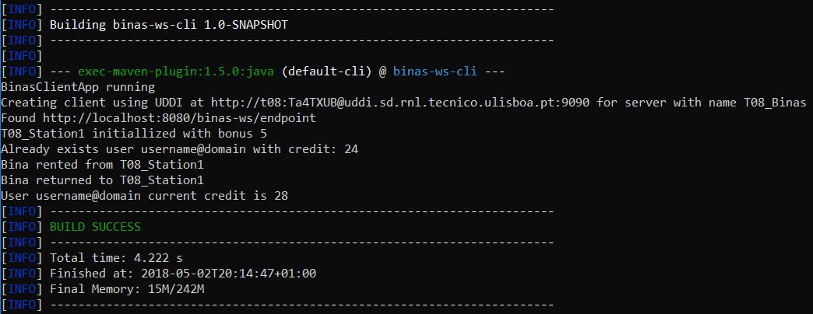

**The same code is executed by binas client main class:**

1. Tries to activate the user with email “username@domain”. There is a register of the user in the binas server (cache hit), with credit of 24. Therefore UserNotExists_Exception is returned by the binas server. Its created a local user register with the most recent credit info in the stations.
2. The following reads of the user’s credit result in cache hits, avoiding the remote invocations on the stations.
3. The following updates of the user’s credit also result in a cache hits, therefore the execution of the read phase is avoided. However, both the local user register in the binas server and the remote user registers are updated in all stations.

**F2 – Fault Tolerance**

1. **Stop the *binas server* by pressing enter in the respective terminal.**
2. **Repeat steps 3 and 4** (Run binas server and binas client, in that order)
3. **Verify that the *binas client* returned the following output:**

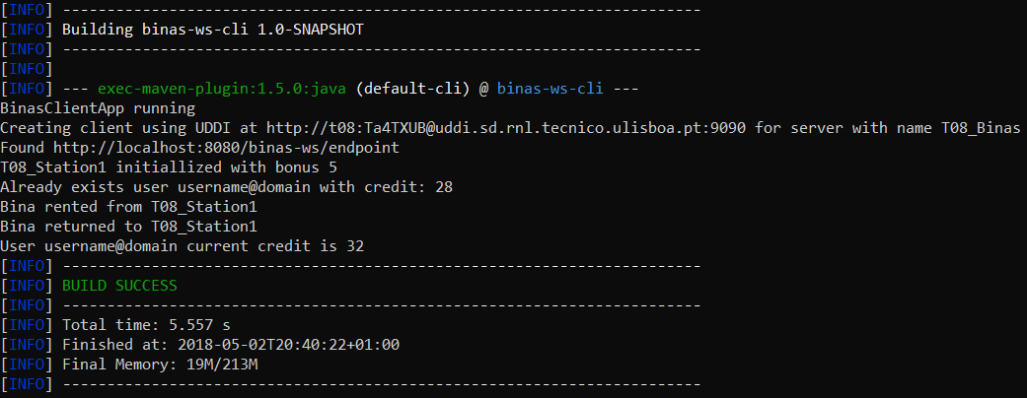

**The same code is executed by binas client main class:**

1. Tries to activate the user with email “username@domain”. There no a register of the user in the *binas server* (cache miss), however there are remote replicas of user with credit of 28. Therefore UserNotExists_Exception is returned by the *binas server*. Its created a local user register with the most recent credit info in the stations.
2. **Stop *station*** T08_Station3 ***server*, in order to verify that the protocol still works with a minimum of quórum (2) stations available.**
3. **Stop the *binas server* by pressing enter in the respective terminal.**
4. **Repeat steps 3 and 4.** (Run binas server and binas client, in that order)
5. **Verify that the *binas client* returned the following output:**

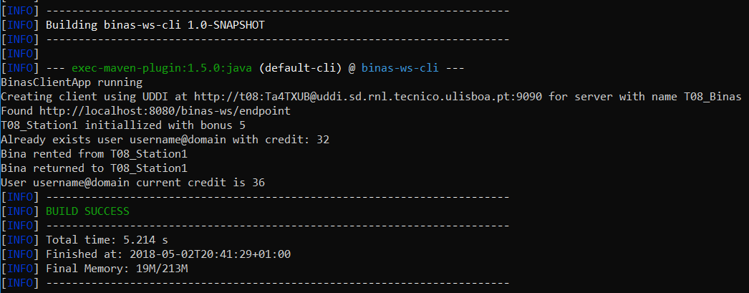

**The same code is executed by binas client main class:**

1. Tries to activate the user with email “username@domain”. There no a register of the user in the *binas server* (cache miss), however there are remote replicas of user with credit of 32, in T08_Station1 and T08_Station2. Therefore UserNotExists_Exception is returned by the *binas server*. Its created a local user register with the most recent credit info in the stations.