Gender differences in the labor market in the 2010s

Data Analytics Capstone Course

Leonor Gutierrez 500925488

Table of Contents

Introduction 3

Literature Review 3

Conclusions 6

References 6

Dataset 6

Labor Force Survey Sampling 7

Data set for this project 7

Attributes 8

Dataset descriptive statistics 14

Approach 19

Step 1: Build data set 19

Step 2: Variable Analysis by Groups 19

Step 3: Hourly Wages by Sector, Industry and Occupation 20

Step 4: Multiple Regression Analysis 20

Step 5: Gender Proportions by Sector, Industry and Occupation 20

Results 21

Step 1: Build data set 21

Step 2: Variable Analysis by Groups 21

Descriptive statistics 21

Outliers 21

Distribution of numeric variables 24

Correlation 30

Hourly Wages Relationship to Other Variables 32

Step 3: Hourly Wages by Sector, Industry and Occupation 41

Mann-Whitney U Test 41

Kruskal Wallis Test 42

Sector Analysis 43

Industry Analysis 46

Occupation Analysis 57

Step 4: Multiple Regression Analysis 66

Normalization 66

Training and Test Set 66

Variables excluded 67

Stepwise Regression 67

Step 5: Hypotheses Testing for Proportions 95

Two Proportions Z-Test 95

Sector Analysis 99

Industry Analysis 100

Occupation Analysis 103

Conclusions 106

Appendix 108

Post-Hoc Analysis 108

Industry 108

Gender differences in the labor market in the 2010s

# Introduction

The main objective of this project is to explore differences by gender in the Canadian labor market with a focus on wages and participation by sector, industry, and job occupation at the beginning and ending of the 2010s decade. The specific research questions to solve are:

* What variables were relevant to explain hourly wages by gender when the decade started?
  + After 10 years, are these variables still important?
  + Are they the same for women and for men?
* What were the sectors, industries, and job occupations with highest hourly wages by gender at the beginning of the decade?
  + Are these the same by the end of 2019?
  + Which of these groups show more equality in wages by gender?
* What is the gender distribution by sector, industry, and job occupation?
  + What groups are more uneven?
  + Was there a change in the distribution over time?

The data source will be the “Labor Force Survey” records of September 2009 and September 2019 published by the government agency Statistics Canada. The analysis will require the application of statistical techniques such as multiple regression, and tests of hypothesis to compare distributions and proportions.

# Literature Review

Differences in the labor market by gender in Canada and internationally have been studied extensively over the last decades. One of the more discussed topics within this subject is the gender pay gap, which is defined as the difference between women’s and men’s earnings from paid employment, expressed as a proportion of men’s earnings (Statistics Canada, 2019). Other variables that have been analyzed by researchers to describe differences by gender found in the labor market are educational attainment, marital status and motherhood, hours worked, job tenure, and participation by industry and occupations.

Regarding the gender pay gap, Statistics Canada (2019) states that there are several methods to calculate it. One of them consists of comparing the annual earnings of all employed women and men, which captures gender differences both in pay and in hours and weeks worked. In other words, it takes into consideration not only the net difference in wage, but also the impact in women’s earnings of having less disposable time to work due to home and family duties that have historically been covered by them. Measured this way, employed women aged 16 and older earned an average of $0.69 for every dollar earned by men in 2017.

Another way to estimate the gender pay gap consists of calculating the average hourly wages. It only captures the per unit (hour) price of labor, so it produces a smaller estimate than the method of comparing annual earnings. This approach is more appropriate to explore pay equity issues, that is, equal pay for work of equal or comparable value to the employer. In Canada, employed women aged 15 and older earned an average of $0.87 for every dollar earned by employed men on an hourly basis.

Moyser (2017) analyzed the relationship between wage inequality and occupations, and found that men out‑earned women in every occupational group, except for managers and professionals in art, culture, recreation and sport (i.e., librarians, archivists, conservators and curators; writing, translating and related communications professionals; and creative and performing artists) and middle management occupations in production. Even in traditionally‑female occupations like teaching, nursing, clerical, sales and services, the average hourly wages earned by men were greater than those earned by women. If women earned the same amount as men within occupations, the gender wage ratio would nearly reach equality at 0.97.

Motherhood has a persistent impact in wage disparity, although it has lessened in the last years. According to Statistics Canada (2017), in 1997, mothers with at least one child under the age of 18 earned $0.79 for every dollar earned by fathers, while women without children earned $0.88 for every dollar earned by men without children. By 2015, mothers earned $0.85 for every dollar earned by fathers, and women without children earned $0.90 for every dollar earned by men without children.

Drolet and Mumford (2012), with data from Statistics Canada Workplace and Employee Survey (WES) for private sector employees, discuss the relevance of age, fields of study and type of workplace on gender pay differentials.

Regarding age, they mention that is often assumed to be related to wages for several reasons, not least of which is the ability to acquire skills over time. Nevertheless, the results need to be interpreted with caution if women are more likely than men to have taken time out of the labor market; women's age may not accurately reflect the relationship between their actual work experience and earnings. At the same time, working part‐time may be associated with less accumulated work experience. Of note, it has been identified that gender wage gap is seen to be smallest among young workers (those aged below 40 years) with little significant difference

About fields of study, many continue to be dominated by either men or women. While there have been notable changes in some discipline areas (such as biology, medicine, management and law), men and women tend to choose traditional disciplines, and this choice may also explain part of the gender differences in earnings.

Concerning the type of workplace, women are more commonly employed in low‐paying workplaces than men. These results provide evidence that part of the variation in individual earnings attributable to, for example, differing levels of education may arise because high‐wage workplaces disproportionately employ high‐skilled workers.

Aside from gender pay gap, there are other aspects that show discrepancies and disparity between men and women at the workplace. Moyser (2017), mentions that over the last decades, it has become more likely for women to work. In 1950, only 22% of women in the core working ages of 25 to 54 years participated in the labour market, whereas in 2015 this number reached 82%. However, though women participation in the workforce have largely increased, their experiences of paid work still tend to differ from those of men, being shaped to a greater extent by their caregiving roles and/or their employers’ presumptions of these roles. Based on Statistics Canada Labor Force Survey (LFS) data of 2015, she describes these differences from the optics of several variables:

* *Educational attainment.* The more educated, the more likely is that a woman works, though this likelihood is higher for a man with the same level of education. For example, in 2015, the employment rate of women with a high school diploma was 69% compared 83% for those with a university degree. The employment rate of men with a high school diploma was 82% compared to 90% for those with a university degree.
* *Hours worked.* Women generally perform fewer paid hours than men, as they spend more time on housework and childcare. They are also more likely than men to work part-time.
* *Long and short work absences.* Women’s careers are interrupted more frequently than men’s careers and for longer durations. These absences are frequently related to the role of women at home. In 2015, 22% of women who were absent attributed their absence to family or personal responsibilities, compared to only 9.3% of men who also cited those reasons.
* *Job tenure.* Women have nearly equivalent job tenure with current employer as men. Their average was 93.7 months, close to men’s 94.9 months.
* *Self-employment.* Self-employment is less common among women than men, who represented close to two thirds of the self-employed population.
* *Industry.* There are clear differences in men and women participation across industries. Men are majority in the goods-producing sector, which includes industries related to the exploitation of natural resources, utilities, construction, and manufacturing. In contrast, women outnumber men in the services-producing sector, that consists of industries like wholesale and retail trade, finance, insurance, real estate, business, educational services, healthcare and social assistance, accommodation and food services, public administration, among others.
* *Occupation.* Women and men occupy distinct occupations, with women’s typically being at lower levels than men’s, even in industries dominated by women. For example, in the accommodation and food services industry, 59.7% of chefs and cooks were men, while 71.6% of food counter attendants, kitchen helpers and related support personnel were women.
* *Leadership and high-paying positions.* Women are underrepresented in leadership positions in the private sector, although not in the public sector. In 2015, 54% of legislators and senior government managers and officials were women, whereas in the private sector they represented only 26% of senior managers.

## Conclusions

There are many instances where differences by gender in the labor market have been identified. The relationship or possible impact of some variables to wage disparity has also been studied. When analyzing these attributes and their relevance to explain hourly wages by gender, we will see whether educational attainment, worked hours, job tenure, age, industry, and occupation have the same level of influence on the wages of men and women. Regarding wages disparity calculation, we will focus on pay equity, meaning that the method that compares average hourly wages will be applied. Furthermore, it will be explored whether some of the discrepancies by gender found in the past, have been persistent as of the end of the last decade.

## References

Statistics Canada. 2019. “Measuring and analyzing the gender pay gap: A conceptual and methodological overview”. Studies on Gender and Intersecting Identities. Ottawa: Statistics Canada.

<https://www150.statcan.gc.ca/n1/daily-quotidien/190830/dq190830d-eng.htm>

Moyser, Melissa. 2017. “Women and Paid Work”. Women in Canada: A Gender-based Statistical Report. Ottawa: Statistics Canada. Catalogue no. 89-503-X. ISSN: 1719-4407.

<https://www150.statcan.gc.ca/n1/pub/89-503-x/2015001/article/14694-eng.htm>

Drolet, Marie and Karen Mumford. 2012. "The Gender Pay Gap for Private‐Sector Employees in Canada and Britain." British Journal of Industrial Relations 50 (3): 529-553.

# Dataset

A dataset will be created pulling records from the Public Use Microdata Files (PUMFs) of the Labor Force Survey (LFS) of September of 2009 and September 2019, published by Statistics Canada. The subjects covered in this survey are:

* Employment and unemployment
* Hours of work and work arrangements
* Industries
* Labour
* Occupations
* Unionization and industrial relations
* Wages, salaries, and other earnings

The survey is conducted nationwide, and the target population is the non-institutionalized population 15 years of age and over. Excluded groups represent less than 2% of target population: persons living on reserves and other Aboriginal settlements in the provinces, full-time members of the Canadian Armed Forces, Institutionalized population, and households in extremely remote areas with very low population density.

Deployment is performed monthly. The reference period to answer the questions is usually the week containing the 15th day of the month, and the collection period is the week following the reference period.

## Labor Force Survey Sampling

This is a sample survey with a cross-sectional design (snapshot). It uses a probability sample that is based on a stratified multi-stage design. Each province is divided into large geographic stratum. The first stage of sampling consists of selecting smaller geographic areas, called clusters, from within each stratum. The second stage of sampling consists of selecting dwellings from within each selected cluster.

The LFS uses a rotating panel sample design so that selected dwellings remain in the LFS sample for six consecutive months. Each month about one-sixth of the LFS sampled dwellings are in their first month of the survey, one-sixth are in their second month of the survey, and so on. One feature of the LFS sample design is that each of the six rotation groups can be used as a representative sample by itself.

Within selected dwellings, basic demographic information is collected for all household members. Labor force information is collected for all civilian household members who are aged 15 and over.

Recently, the monthly LFS sample size has been approximately 56,000 households, resulting in the collection of labor market information for approximately 100,000 individuals. It should be noted that the LFS sample size is subject to change from time to time to meet data quality or budget requirements.

## Data set for this project

Data sets from September 2009 and September 2019 were selected to represent the beginning and ending of the 2010s decade. Added together in a single table, the data from the two periods sums over 200,000 observations.

### Attributes

#### Differences between LFS 2009 and 2019 variables

The LFS questionnaire is redesigned periodically. Variables out-of-date are removed, new variables can be introduced, and value sets of other variables can also be modified. LFS from September 2009 includes 82 attributes, whereas the one from 2019 consist of only 60 attributes. Here is a list of the attributes that were omitted by 2019, along with the reason of removal or change provided in the LFS documentation:

|  |  |  |
| --- | --- | --- |
| **Attribute 2009** | **Description** | **Reason of Removal** |
| **ED76to89** | Highest educational attainment | Out-of-date, replaced by EDUC90 |
| **NAICS_18** | Industry of main job, 18 categories | Out-of-date, replaced by NAICS_21 |
| **NAICS_43**  **(Not available after 2015)** | Industry of main job, 43 categories | Out-of-date |
| **SOC80_49**  **(Not available after 2015)** | Occupation at main job, 1980 Standard Occupational Classification, 49 categories | Out-of-date |
| **SOC80_21**  **(Not available after 2015)** | Occupation at main job, 1980 Standard Occupational Classification, 21 categories | Out-of-date |
| **NOCS_06_25**  **(Not available after 2015)** | Occupation at main job, 2001 National Occupational Classification for Statistics, 25 categories | Out-of-date, replaced by NOC_10 |
| **NOCS_06_47**  **(Not available after 2015)** | Occupation at main job, 2001 National Occupational Classification for Statistics, 47 categories | Out-of-date, replaced by NOC_40 |
| **WHYPTOLD** | Reason for part-time | Out-of-date, replaced by WHYPTNEW |
| **YNOLKOLD** | Reasons for not looking for work in the past four weeks, after looking for work in the last 6 months | Out-of-date, replaced with new variable |
| **RELREFN** | Relationship to reference person | Variables related to family and spouse/partner’s labour force characteristics were removed |
| **EFAMSIZE** | Number of individuals in economic family, 1 to 5+ |
| **EFAMEMPL** | Number of employed persons |
| **EFAMUNEM** | Number of unemployed persons |
| **SP_AGE** | Age of spouse, if applicable. |
| **SP_LFSST** | Labour force status of spouse, if applicable. |
| **SPED7689** | Education of spouse, if applicable. |
| **SPED1990** | Education of spouse, if applicable. |
| **SP_SOC80** | Occupation of spouse, if applicable. |
| **SP_NOCS06** | Occupation based on NOC-S2006 |
| **SP_UHRSM** | Spouse's usual hours at main job, employed, |
| **SP_UHRST** | Spouse's usual hours at all jobs, employed |
| **SP_COWM** | Spouse's class of worker at main job, employed |
| **SCH1624** | At least one child age 16 to 24 in |

Besides the removals, there were variables which value sets were either expanded or collapsed:

* The **census metropolitan area (CMA)** variable expanded from the three largest CMAs in Canada (Montreal, Toronto, and Vancouver) to nine CMAs: Québec, Montreal, Ottawa, Toronto, Hamilton, Winnipeg, Calgary, Edmonton and Vancouver.
* Two **occupation** variables, based on the 2016 National Occupational Classification, were reintroduced: a generic, 10-category variable (NOC_10) and a detailed 40-category variable (NOC_40).
* The **labour force status** variable (LFSSTAT) was collapsed from six to four categories: employed, at work; employed, absent from work; unemployed; and not in the labour force.
* Two **industry** variables (NAICS_18 and NAICS_43) based on the 2012 North American Industry Classification System were replaced with one industry variable consisting of 21 categories, based on the same classification system.
* The **age of youngest child** variable (AGYOWNK) has been collapsed from six categories to four: under 6 years; 6 to 12 years; 13 to 17 years; and 18 to 24 years.
* The **school attendance** variable (SCHOOLN) has been collapsed from nine categories, which include information on the type of school attended, to three categories indicative of student status only: non-student; full-time student; and part-time student.

Finally, there is one new variable that was introduced in 2017:

* **Immigrant status** (IMMIG) distinguishes between recent immigrants, landed 10 or less years ago; established immigrant, landed more than 10 years ago; and non-immigrant.

#### Adjustments to attributes in project’s data set

As noted, some variables value sets are not the same in 2019 as they were in 2009. The next tables show how those variable values will be matched to be comparable:

**Census Metropolitan Area (CMA)**

|  |  |  |  |
| --- | --- | --- | --- |
| **2009** | | **2019** | |
| **CMA** | | **CMA** | |
| **Code** | **Description** | **Code** | **Description** |
| 1 | Montreal | 2 | Montréal |
| 2 | Toronto | 4 | Toronto |
| 3 | Vancouver | 9 | Vancouver |
| 4 | Other CMA or Non-CMA | 1,3,5,6,7,8,0 | Quebec, Ottawa-Gatineau, Hamilton, Winnipeg, Calgary, Edmonton, Other |

**Labor Force Status (LFSSTAT)**

|  |  |  |  |
| --- | --- | --- | --- |
| **2009** | | **2019** | |
| **LFSSTAT** | | **LFSSTAT** | |
| **Code** | **Description** | **Code** | **Description** |
| 1 | Employed, at work | 1 | Employed, at work |
| 2 | Employed, absent from work | 2 | Employed, absent from work |
| 3, 4, 5 | 3 = Unemployed, temporary layoff 4 = Unemployed, job searcher 5 = Unemployed, future start | 3 | Unemployed |
| 6 | Not in labour force | 4 | Not in labour force |

**Industry (NAICS)**

|  |  |  |  |
| --- | --- | --- | --- |
| **2009** | | **2019** | |
| **NAICS_18** | | **NAICS_21** | |
| **Code** | **Description** | **Code** | **Description** |
| 1 | Agriculture | 1 | Agriculture |
| 2 | Forestry, Fishing, Mining, Oil and Gas | 2,3,4 | 2 = Forestry and logging and support activities for forestry 3 = Fishing, hunting and trapping 4 = Mining, quarrying, and oil and gas extraction |
| 3 | Utilities | 5 | Utilities |
| 4 | Construction | 6 | Construction |
| 5 | Manufacturing – durables | 7 | Manufacturing - durable goods |
| 6 | Manufacturing non-durables | 8 | Manufacturing - non-durable goods |
| 7 | Wholesale Trade | 9 | Wholesale trade |
| 8 | Retail Trade | 10 | Retail trade |
| 9 | Transportation and Warehousing | 11 | Transportation and warehousing |
| 10 | Finance, Insurance, Real Estate and Leasing | 12,13 | 12 = Finance and insurance 13 = Real estate and rental and leasing |
| 11 | Professional, Scientific and Technical Services | 14 | Professional, scientific and technical services |
| 12 | Management, Administrative and Other Support | 15 | Business, building and other support services |
| 13 | Educational Services | 16 | Educational services |
| 14 | Health Care and Social Assistance | 17 | Health care and social assistance |
| 15 | Information, Culture and Recreation | 18 | Information, culture and recreation |
| 16 | Accommodation and Food Services | 19 | Accommodation and food services |
| 17 | Other Services | 20 | Other services (except public administration) |
| 18 | Public Administration | 21 | Public administration |

**Occupation (NOC)**

|  |  |  |  |
| --- | --- | --- | --- |
| **2019** | | **2009** | |
| **NOC_10** | | **NOC_25** | |
| **Code** | **Description** | **Code** | **Description** |
| 1 | Management occupations | 1, 2 | 1 = Senior Management Occupations 2 = Other Management Occupations |
| 2 | Business, finance and administration occupations | 3, 4, 5 | 3 = Professional Occupations in Business and Finance 4 = Financial, Secretarial and Administrative Occupations 5 = Clerical Occupations, Including Supervisors |
| 3 | Natural and applied sciences and related occupations | 6 | Natural and Applied Sciences and Related Occupations |
| 4 | Health occupations | 7, 8 | 7 = Professional Occupations in Health, Nurse Supervisors and Registered Nurses 8 = Technical, Assisting and Related Occupations in Health |
| 5 | Occupations in education, law and social, community and government services | 9, 10 | 9 = Occupations in Social Science, Government Service and Religion 10 = Teachers and Professors |
| 6 | Occupations in art, culture, recreation and sport | 11 | Occupations in Art, Culture, Recreation and Sport |
| 7 | Sales and service occupations | 12, 13, 14, 15, 16, 17 | 12 = Wholesale, Technical, Insurance, Real Estate Sales Specialists, and Retail, Wholesale and Grain Buyers  13 = Retail Salespersons, Sales Clerks, Cashiers, Including Retail Trade, Supervisors 14 = Chefs and Cooks, and Occupations in Food and Beverage Service, Including Supervisors 15 = Occupation in Protective Services 16 = Childcare and Home Support Workers 17 = Sales and Service Occupations n.e.c. (not elsewhere classified), Including Occupations in Travel and Accommodation, Attendants in Recreation and Sport as well as Supervisors |
| 8 | Trades, transport and equipment operators and related occupations | 18, 19, 20, 21, 22 | 18 = Contractors and Supervisors in Trades and Transportation 19 = Construction Trades 20 = Other Trades Occupations 21 = Transport and Equipment Operators 22 = Trades Helpers, Construction, and Transportation Labourers and Related Occupations |
| 9 | Natural resources, agriculture and related production occupations | 23 | Occupations Unique to Primary Industry |
| 10 | Occupations in manufacturing and utilities | 24, 25 | 24 = Machine Operators and Assemblers in Manufacturing, Including Supervisors 25 = Labourer in Processing, Manufacturing and Utilities |

**Age of youngest child (AGYOWNKN)**

|  |  |  |  |
| --- | --- | --- | --- |
| **2009** | | **2019** | |
| **AGYOWNKN** | | **AGYOWNKN** | |
| **Code** | **Description** | **Code** | **Description** |
| 1, 2 | 1 = Youngest child under 3 2 = Youngest child 3 to 5 | 1 | Youngest child less than 6 years |
| 3 | Youngest child 6 to 12 | 2 | Youngest child 6 to 12 years |
| 4, 5 | 4 = Youngest child 13 to 15 5 = Youngest child 16 to 17 | 3 | Youngest child 13 to 17 years |
| 6 | Not in labour force | 4 | Youngest child 18 to 24 years |

**Current Student Status (SCHOOLN)**

|  |  |  |  |
| --- | --- | --- | --- |
| **2009** | | **2019** | |
| **SCHOOLN** | | **SCHOOLN** | |
| **Code** | **Description** | **Code** | **Description** |
| 1 | Non-student | 1 | Non-student |
| 2, 4, 6, 8 | 2 = Primary or secondary school, full-time 4 = University full-time 6 = Community college or CEGEP full-time 8 = Other full-time | 2 | Full-time student |
| 3, 5, 7, 9 | 3 = Primary or secondary school, part-time 5 = University part-time 7 = Community college or CEGEP part-time 9 = Other part-time | 3 | Part-time student |

#### Variables to be excluded from project’s data set

LFS includes several questions about many aspects of unemployment, nevertheless the focus of this project is on the employed population. Thus, 18 variables related to this topic will be omitted.

Also, there are two variables that contain group age data. One of them includes information for all respondents (AGE_12), while the other only covers people between 15 and 29 years (AGE_6). The latter will be excluded.

Besides, there are 4 variables related to hours worked per week:

* UTOTHRS. Usual hours worked per week at all jobs
* ATOTHRS. Actual hours worked per week at all jobs
* UHRSMAIN. Usual hours worked per week at main job
* AHRSMAIN. Actual hours worked per week at main job

Only the first one (UTOTHRS) will be kept in the project’s data set, since is the one that provides the usual hours considering all jobs, and not just actual hours worked on reference week or only at main job.

On the other hand, there are 2 attributes that give information about part-time employees. One of them identifies full time and part time workers (FTPTMAIN), and the other provides reasons for part-time work (WHYPT). Only the former will be kept, to explore if there is an impact in hourly wages.

There are 3 variables related to overtime worked in the reference week that will be excluded. There is no evidence to confirm whether the number of extra hours worked during this timeframe is recurring or just a one-time event. And wages data focuses on “usual hourly wages”.

Lastly, 5 variables that provide details regarding reasons and time duration of current work absence will be excluded. This information is only available for people who declared being absent from work in the reference week. Furthermore, the impact of being absent from work will be captured by the labor force status variable (LFSSTAT), which distinguishes employees at work and employees absent from work.

#### Complete list of attributes to be included in project’s data set

The new data set will consist of 27 attributes selected from the original microdata files:

|  |  |  |  |
| --- | --- | --- | --- |
| **VARIABLE** | **DESCRIPTION** | **TYPE** | **COMMENTS** |
| **REC_NUM** | Order of record in file | Nominal |  |
| **SURVYEAR** | Survey year | Nominal |  |
| **SURVMNTH** | Survey month | Nominal |  |
| **LFSSTAT** | Labour force status | Nominal | 2009 values adjusted to match 2019 |
| **PROV** | Province | Nominal |  |
| **CMA** | Three largest CMAs | Nominal | 2019 values adjusted to match 2009 |
| **AGE_12** | Five-year age group of respondent | Ordinal |  |
| **SEX** | Sex of respondent | Nominal |  |
| **MARSTAT** | Marital status of respondent | Nominal |  |
| **EDUC** | Highest educational attainment | Ordinal |  |
| **MJH** | Single or multiple jobholder | Nominal |  |
| **COWMAIN** | Class of worker, main job | Nominal |  |
| **IMMIG** | Immigrant status | Nominal | Only 2019 data |
| **NAICS_18** | Industry of main job | Nominal | 2019 values adjusted to match 2009 |
| **NOC_10** | Occupation at main job | Nominal | 2009 values adjusted to match 2019 |
| **NOC_40** | Occupation at main job | Nominal | Only 2019 data |
| **FTPTMAIN** | Full- or part-time status at main or only job | Nominal |  |
| **UTOTHRS** | Usual hours worked per week at all jobs | Quantitative |  |
| **TENURE** | Job tenure with current employer (months) | Quantitative |  |
| **HRLYEARN** | Usual hourly wages, employees only | Quantitative |  |
| **UNION** | Union status, employees only | Nominal |  |
| **PERMTEMP** | Job permanency, employees only | Nominal |  |
| **ESTSIZE** | Establishment size | Ordinal |  |
| **FIRMSIZE** | Firm size | Ordinal |  |
| **SCHOOLN** | Current student status | Nominal | 2009 values adjusted to match 2019 |
| **EFAMTYPE** | Type of economic family | Nominal |  |
| **AGYOWNK** | Age of youngest child | Ordinal | 2009 values adjusted to match 2019 |

### Dataset descriptive statistics

The total number of records in LFS September 2009 and 2019 are 107,593 and 100,011, respectively. However, the focus of the research questions posed for this project is on the employed population. Looking at the “Labor force status” variable, it is possible to identify the respondents that declared to be employed:

Hourly wages data for self-employed workers are not shared on the public records of LFS. Also, there is a small portion of employees that self-identified as unpaid family worker. Because of the lack of wages data, both groups of workers will be excluded.

The total number of observations of only employed population from the private and public sector are 54,557 for 2009 and 50,931 for 2019, that sum up a global of 105,488 cases. For subsequent analysis, only these records will be included.

#### Missing Values

Here is the list of variables that contain missing values and how they will be handled:

|  |  |  |  |  |
| --- | --- | --- | --- | --- |
| Variable | Description | Number of cases with missing data | % of total cases (Out of 105,488 cases) | Solution |
| SCHOOLN | Current student status | 3,002 | 3% | Replace with 4, label “Unknown” |
| AGYOWNK | Age of youngest child | 65,144 | 62% | Replace with 5, label “Youngest > 24 years or no children” |

Besides, only 2019 records have data for immigrant status (immig) and detailed occupation (noc_40) attributes. They should not be used in analysis where results will be compared to 2009, but they can provide insights when exploring the 2019 data set independently.

#### Categorical Attributes

The next tables show frequencies and proportions for the main categorical attributes in the dataset, by period:

**Province**

|  |  |  |  |  |
| --- | --- | --- | --- | --- |
|  | **Frequency (#)** |  | **Percentage (%)** |  |
| **Province** | **2009** | **2019** | **2009** | **2019** |
| AB | 5,885 | 5,292 | 11% | 10% |
| BC | 5,996 | 6,096 | 11% | 12% |
| MN | 5,166 | 4,166 | 9% | 8% |
| NB | 2,827 | 2,484 | 5% | 5% |
| NL | 1,830 | 1,685 | 3% | 3% |
| NS | 2,632 | 2,565 | 5% | 5% |
| ON | 15,563 | 14,253 | 29% | 28% |
| PEI | 1,447 | 1,424 | 3% | 3% |
| QC | 9,370 | 9,294 | 17% | 18% |
| SK | 3,841 | 3,672 | 7% | 7% |

**Age**

|  |  |  |  |  |
| --- | --- | --- | --- | --- |
|  | **Frequency (#)** |  | **Percentage (%)** |  |
| **Age Groups** | **2009** | **2019** | **2009** | **2019** |
| 15 to 19 years | 3,572 | 2,576 | 7% | 5% |
| 20 to 24 years | 5,055 | 4,215 | 9% | 8% |
| 25 to 29 years | 5,649 | 5,288 | 10% | 10% |
| 30 to 34 years | 5,495 | 5,550 | 10% | 11% |
| 35 to 39 years | 5,870 | 5,605 | 11% | 11% |
| 40 to 44 years | 6,305 | 5,477 | 12% | 11% |
| 45 to 49 years | 7,491 | 5,461 | 14% | 11% |
| 50 to 54 years | 6,835 | 5,545 | 13% | 11% |
| 55 to 59 years | 4,784 | 5,450 | 9% | 11% |
| 60 to 64 years | 2,509 | 3,754 | 5% | 7% |
| 65 to 69 years | 736 | 1,384 | 1% | 3% |
| 70 and over | 256 | 626 | 0% | 1% |

**Sex**

|  |  |  |  |  |
| --- | --- | --- | --- | --- |
|  | **Frequency (#)** |  | **Percentage (%)** |  |
| **Sex** | **2009** | **2019** | **2009** | **2019** |
| Female | 27,615 | 25,432 | 51% | 50% |
| Male | 26,942 | 25,499 | 49% | 50% |

**Marital Status**

|  |  |  |  |  |
| --- | --- | --- | --- | --- |
|  | **Frequency (#)** |  | **Percentage (%)** |  |
| **Marital Status** | **2009** | **2019** | **2009** | **2019** |
| Married | 26,641 | 23,434 | 49% | 46% |
| Living in common-law | 7,732 | 8,450 | 14% | 17% |
| Widowed | 635 | 540 | 1% | 1% |
| Separated | 1,576 | 1,410 | 3% | 3% |
| Divorced | 2,663 | 2,172 | 5% | 4% |
| Single, never married | 15,310 | 14,925 | 28% | 29% |

**Education**

|  |  |  |  |  |
| --- | --- | --- | --- | --- |
|  | **Frequency (#)** |  | **Percentage (%)** |  |
| **Education Attainment** | **2009** | **2019** | **2009** | **2019** |
| 0 to 8 years | 1,211 | 792 | 2% | 2% |
| Some high school | 5,892 | 3,891 | 11% | 8% |
| High school graduate | 11,614 | 9,980 | 21% | 20% |
| Some postsecondary | 4,454 | 2,946 | 8% | 6% |
| Postsecondary certificate or diploma | 20,090 | 19,724 | 37% | 39% |
| Bachelor's degree | 8,023 | 9,355 | 15% | 18% |
| Above bachelor's degree | 3,273 | 4,243 | 6% | 8% |

**Sector**

|  |  |  |  |  |
| --- | --- | --- | --- | --- |
|  | **Frequency (#)** |  | **Percentage (%)** |  |
| **Class of Worker** | **2009** | **2019** | **2009** | **2019** |
| Public sector employees | 14,434 | 13,700 | 22% | 23% |
| Private sector employees | 40,123 | 37,231 | 62% | 62% |

**Industry of main job**

|  |  |  |  |  |
| --- | --- | --- | --- | --- |
|  | **Frequency (#)** |  | **Percentage (%)** |  |
| **NAICS_18** | **2009** | **2019** | **2009** | **2019** |
| Agriculture | 718 | 709 | 1% | 1% |
| Forestry, Fishing, Mining, Oil and Gas | 1,566 | 1,481 | 3% | 3% |
| Utilities | 633 | 495 | 1% | 1% |
| Construction | 3,590 | 3,746 | 7% | 7% |
| Manufacturing – durables | 3,245 | 2,736 | 6% | 5% |
| Manufacturing non-durables | 2,783 | 2,308 | 5% | 5% |
| Wholesale Trade | 1,769 | 1,590 | 3% | 3% |
| Retail Trade | 7,149 | 6,125 | 13% | 12% |
| Transportation and Warehousing | 2,537 | 2,559 | 5% | 5% |
| Finance, Insurance, Real Estate and Leasing | 2,794 | 2,506 | 5% | 5% |
| Professional, Scientific and Technical Services | 2,160 | 2,494 | 4% | 5% |
| Management, Administrative and Other Support | 1,813 | 1,621 | 3% | 3% |
| Educational Services | 4,574 | 4,465 | 8% | 9% |
| Health Care and Social Assistance | 7,280 | 7,432 | 13% | 15% |
| Information, Culture and Recreation | 2,185 | 1,858 | 4% | 4% |
| Accommodation and Food Services | 3,947 | 3,540 | 7% | 7% |
| Other Services | 2,056 | 1,716 | 4% | 3% |
| Public Administration | 3,758 | 3,550 | 7% | 7% |

**Occupation of main job**

|  |  |  |  |  |
| --- | --- | --- | --- | --- |
|  | **Frequency (#)** |  | **Percentage (%)** |  |
| **NOC_10** | **2009** | **2019** | **2009** | **2019** |
| Management occupations | 3,587 | 2,956 | 7% | 6% |
| Business, finance, and administration occupations | 9,822 | 8,085 | 18% | 16% |
| Natural and applied sciences and related occupations | 3,380 | 3,583 | 6% | 7% |
| Health occupations | 3,923 | 4,077 | 7% | 8% |
| Occupations in education, law and social, community and government services | 5,143 | 6,371 | 9% | 13% |
| Occupations in art, culture, recreation, and sport | 952 | 861 | 2% | 2% |
| Sales and service occupations | 14,578 | 12,782 | 27% | 25% |
| Trades, transport and equipment operators and related occupations | 8,766 | 8,055 | 16% | 16% |
| Natural resources, agriculture, and related production occupations | 1,581 | 1,572 | 3% | 3% |
| Occupations in manufacturing and utilities | 2,825 | 2,589 | 5% | 5% |

#### Quantitative Attributes

##### Real Values

Quantitative variables codes do not include decimal points and must be divided by 10 or 100 to get the actual numbers. Only “tenure” variable codes are equal to the real value.

|  |  |  |  |
| --- | --- | --- | --- |
| VARIABLE | DESCRIPTION | CODE | REAL VALUE |
| UTOTHRS | Usual hours worked per week at all jobs | 1-990 | 0.1-99.0 (one decimal implied) |
| TENURE | Job tenure with current employer (months) | 1-240 | 1-240 |
| HRLYEARN | Usual hourly wages, employees only | 1-999999 | $0.01-$9,999.99 (two decimals implied) |

##### Statistics Summary

Here are the descriptive statistics for the main quantitative attributes:

|  |  |  |  |
| --- | --- | --- | --- |
| VARIABLE | STATISTICS | 2009 | 2019 |
| Usual hours worked per week | MIN | 0.4 | 1.0 |
| MAX | 99.0 | 99.0 |
| AVERAGE | 36.1 | 36.3 |
| STD DEV | 11.2 | 11.2 |
| Job tenure with current employer (months) | MIN | 1 | 1 |
| MAX | 240 | 240 |
| AVERAGE | 85.3 | 86.8 |
| STD DEV | 83.4 | 82.6 |
| Usual hourly wages, employees only | MIN | 2.0 | 3.0 |
| MAX | 115.4 | 108.0 |
| AVERAGE | 21.5 | 27.5 |
| STD DEV | 11.3 | 13.7 |

# Approach

## Step 1: Data Set Preparation

In this step, records from data sets of Septembers 2009 and 2019 will be added into a single data set. Variables that are not needed will be removed, while the values of variables that have different value sets for each year will be matched. The right type will be assigned to each attribute. And, only the observations of people employed in public and private sector, as specified previously, will be included.

## Step 2: Variable Analysis by Groups

First, the four groups by year and gender to be studied will be identified:

1. 2009, Males
2. 2019, Males
3. 2009, Females
4. 2009, Females

For each group, analysis of outliers using boxplots will be performed and numeric variables distribution will be verified. Correlation analysis will be run to explore relationships between numeric and ordinal variables. Also, relationships between hourly wages and the rest of the variables will be explored, except sector, industry, and occupations, which are included on the next step.

## Step 3: Hourly Wages by Sector, Industry and Occupation

To answer the research question concerning comparison of hourly wages by sector, industries, and occupations, boxplot analysis will be run. Besides, parametric or non-parametric tests will be employed depending on the distribution of hourly wages variable. If assumptions to do parametric tests are met, analysis of variance will be applied to determine significant mean differences among the two periods studied and gender. If these assumptions are not met, non-parametric tests like Mann-Whitney U and Kruskal Wallis will be employed instead to compare observations ranks.

## Step 4: Multiple Regression Analysis

To answer the research question regarding the relevant variables that explain hourly wages by gender at the start and end of the decade, multiple regression analysis will be applied. A model for each group will be defined. Then, these models will be compared to explore if they include the same independent variables and analyze which variables obtained the highest coefficients among the four groups by year and gender.

## Step 5: Gender Proportions by Sector, Industry and Occupation

Finally, to answer the research question about gender distribution by sector, industry, and occupation, two proportions z-test will be applied to identify significant differences by gender through time.

# Results

## Step 1: Data Set Preparation

R code was employed to build the data set for this project, integrating observations from two CSV files that contain records for September 2009 and September 2019. The original data sets and code to build the one used in this project can be found at this location:

<https://github.com/leonorgs/leo-capstone-.git>

The names of the files are:

* pub0909 (CSV records September 2009)
* pub0919 (CSV records September 2019)
* Capstone_Project_RCode (R script)

## Step 2: Variable Analysis by Groups

### Descriptive statistics

Next, we have the basic statistics of each group by gender:

|  |  |  |  |  |  |
| --- | --- | --- | --- | --- | --- |
|  |  | Male | | Female | |
| VARIABLE | **STATISTICS** | **2009** | **2019** | **2009** | **2019** |
| Usual hours worked per week | MIN | 0.4 | 1.0 | 0.4 | 1.0 |
| MAX | 99.0 | 99.0 | 99.0 | 99.0 |
| AVERAGE | 39.0 | 38.8 | 33.3 | 33.9 |
| STD DEV | 10.9 | 11.0 | 10.8 | 10.7 |
| Job tenure with current employer (months) | MIN | 1.0 | 1.0 | 1.0 | 1.0 |
| MAX | 240.0 | 240.0 | 240.0 | 240.0 |
| AVERAGE | 86.3 | 85.7 | 84.4 | 87.9 |
| STD DEV | 84.7 | 82.5 | 82.2 | 82.7 |
| Usual hourly wages, employees only | MIN | 2.1 | 3.0 | 2.0 | 3.1 |
| MAX | 115.4 | 108.0 | 89.7 | 106.7 |
| AVERAGE | 23.3 | 29.3 | 19.7 | 25.7 |
| STD DEV | 11.9 | 14.5 | 10.3 | 12.6 |

### Outliers

To identify outliers in the numeric variables, boxplot analysis was applied to groups by year and gender. Next are the summary of boxplot statistics and the graphs:

|  |  |  |  |  |  |
| --- | --- | --- | --- | --- | --- |
|  |  | Male | | Female | |
| VARIABLE | **STATISTICS** | **2009** | **2019** | **2009** | **2019** |
|  | **TOTAL CASES** | **26,942** | **25,499** | **27,615** | **25,432** |
| Usual hours worked per week (UTOTHRS) | LOWER FENCE | 33.8 | 33.8 | 15 | 15 |
| Q1 | 37.5 | 37.5 | 30 | 30 |
| MEDIAN | 40 | 40 | 37 | 37.5 |
| Q3 | 40 | 40 | 40 | 40 |
| UPPER FENCE | 43.5 | 43.7 | 55 | 55 |
| TOTAL OUTLIERS | 8,453 | 8,080 | 2,324 | 2,096 |
| % OUTLIERS | 31% | 32% | 8% | 8% |
| Job tenure with current employer in months (TENURE) | LOWER FENCE | 1 | 1 | 1 | 1 |
| Q1 | 15 | 15 | 16 | 16 |
| MEDIAN | 51 | 53 | 50 | 57 |
| Q3 | 144 | 144 | 135 | 148 |
| UPPER FENCE | 240 | 240 | 240 | 240 |
| TOTAL OUTLIERS | 0 | 0 | 0 | 0 |
| % OUTLIERS | 0% | 0% | 0% | 0% |
| Usual hourly wages, employees only (HRLYEARN) | LOWER FENCE | 2.14 | 3 | 2 | 3.07 |
| Q1 | 14.5 | 18 | 11.75 | 16 |
| MEDIAN | 20.51 | 25.65 | 17.14 | 22 |
| Q3 | 29.8 | 37 | 24.91 | 31.79 |
| UPPER FENCE | 52.69 | 65.38 | 44.62 | 55.38 |
| TOTAL OUTLIERS | 675 | 618 | 708 | 681 |
| % OUTLIERS | 3% | 2% | 3% | 3% |

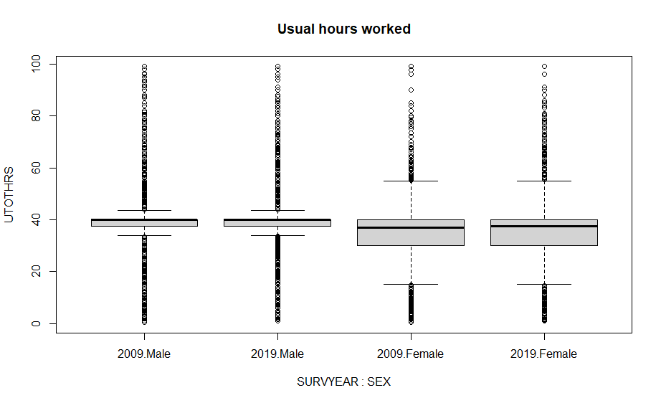

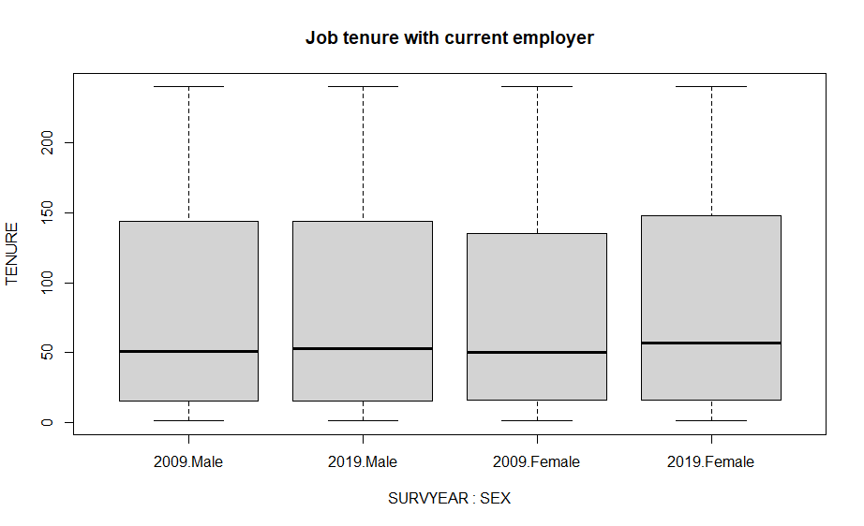

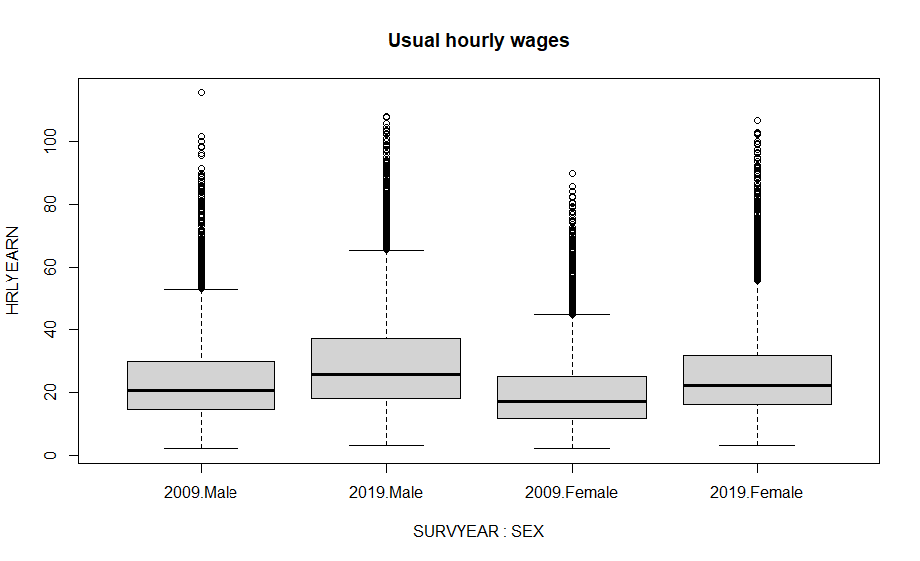

### Distribution of numeric variables

To verify normality of the quantitative variables, histograms and q-q plots were built, and Kolmogorov-Smirnov tests were run. Shapiro-Wilk’s method was not applied because is restricted to samples of size smaller than 5,000.

The histograms show the shape of the distribution and compare it to a curve that would follow a normal distribution with the same mean and standard deviation as the ones from the variable tested.

The q-q plot (or quantile-quantile plot) draws the correlation between a given sample and the normal distribution. A 45-degree reference line is also plotted. If both sets of quantiles come from the same distribution, we should see the points forming a line that is roughly straight. In contrast, if points form a curve instead of a straight line it usually means the sample data are skewed. Moreover, if the points fall along a line in the middle of the graph, but curve off in the extremities it is a sign that the data have more extreme values than would be expected if they truly came from a normal distribution.

The Kolmogorov-Smirnov test compares the observed distribution with a theoretically specified distribution, in this case, the normal distribution. It is important that this distribution has identical mean and standard deviation as the sample evaluated. The null hypothesis of the K-S test is that the distribution is normal, therefore, if p-value of the test is >0.05, we do not reject the null hypothesis and conclude that the distribution in question is not statistically different from a normal distribution.

#### Usual hours worked per week (UTOTHRS)

**Histograms**

|  |  |
| --- | --- |
| **Males 2009** | **Males 2019** |
|  |  |
| **Females 2009** | **Females 2019** |
|  |  |

**Q-Q Plots**

|  |  |
| --- | --- |
| **Males 2009** | **Males 2019** |
|  |  |
| **Females 2009** | **Females 2019** |
|  |  |

**Kolmogorov-Smirnov Tests**

|  |  |
| --- | --- |
| **Males 2009** | **Males 2019** |
| data: data.all.09.male$UTOTHRS  D = 0.266, p-value < 2.2e-16  alternative hypothesis: two-sided | data: data.all.19.male$UTOTHRS  D = 0.26344, p-value < 2.2e-16  alternative hypothesis: two-sided |
| **Females 2009** | **Females 2019** |
| data: data.all.09.fem$UTOTHRS  D = 0.21438, p-value < 2.2e-16  alternative hypothesis: two-sided | data: data.all.19.fem$UTOTHRS  D = 0.21143, p-value < 2.2e-16  alternative hypothesis: two-sided |

#### Job Tenure (TENURE)

**Histograms**

|  |  |
| --- | --- |
| **Males 2009** | **Males 2019** |
|  |  |
| **Females 2009** | **Females 2019** |
|  |  |

**Q-Q Plots**

|  |  |
| --- | --- |
| **Males 2009** | **Males 2019** |
|  |  |
| **Females 2009** | **Females 2019** |
|  |  |

**Kolmogorov-Smirnov Tests**

|  |  |
| --- | --- |
| **Males 2009** | **Males 2019** |
| data: data.all.09.male$TENURE  D = 0.16707, p-value < 2.2e-16  alternative hypothesis: two-sided | data: data.all.19.male$TENURE  D = 0.15484, p-value < 2.2e-16  alternative hypothesis: two-sided |
| **Females 2009** | **Females 2019** |
| data: data.all.09.fem$TENURE  D = 0.16497, p-value < 2.2e-16  alternative hypothesis: two-sided | data: data.all.19.fem$TENURE  D = 0.1523, p-value < 2.2e-16  alternative hypothesis: two-sided |

#### Usual Hourly Wages (HRLYEARN)

**Histograms**

|  |  |
| --- | --- |
| **Males 2009** | **Males 2019** |
|  |  |
| **Females 2009** | **Females 2019** |
|  |  |

**Q-Q Plots**

|  |  |
| --- | --- |
| **Males 2009** | **Males 2019** |
|  |  |
| **Females 2009** | **Females 2019** |
|  |  |

**Kolmogorov-Smirnov Tests**

|  |  |
| --- | --- |
| **Males 2009** | **Males 2019** |
| data: data.all.09.male$HRLYEARN  D = 0.098075, p-value < 2.2e-16  alternative hypothesis: two-sided | data: data.all.19.male$HRLYEARN  D = 0.10788, p-value < 2.2e-16  alternative hypothesis: two-sided |
| **Females 2009** | **Females 2019** |
| data: data.all.09.fem$HRLYEARN  D = 0.11895, p-value < 2.2e-16  alternative hypothesis: two-sided | data: data.all.19.fem$HRLYEARN  D = 0.12557, p-value < 2.2e-16  alternative hypothesis: two-sided |

Looking at the graphs and the results from Kolmogorov-Smirnov, we can conclude that none of the numeric variables are normally distributed.

Parametric tests usually required data to be normally distributed, though there are cases where they still can be applied when the sample size is large enough. Anyway, when parametric assumptions are violated non-parametric tests can be applied instead.

On the other hand, linear regression remains a statistically sound technique in studies of large sample sizes even when a dependent variable is not distributed normally. By the law of large numbers and the central limit theorem, the ordinary least squares (OLS) estimators in linear regression technique still will be approximately normally distributed around the true parameter values, which implies the estimated parameters and their confidence interval estimates remain robust. Hence, in a large sample, the use of a linear regression technique, even if the dependent variable violates the “normality assumption” rule, remains valid.

### Correlation

Pearson correlation measures linear relationships between two numerical variables:

|  |  |
| --- | --- |
| **Males 2009** | **Males 2019** |
| UTOTHRS TENURE HRLYEARN  UTOTHRS 1.00 0.11 0.14  TENURE 0.11 1.00 0.30  HRLYEARN 0.14 0.30 1.00 | UTOTHRS TENURE HRLYEARN  UTOTHRS 1.00 0.12 0.17  TENURE 0.12 1.00 0.30  HRLYEARN 0.17 0.30 1.00 |
| **Females 2009** | **Females 2019** |
| UTOTHRS TENURE HRLYEARN  UTOTHRS 1.00 0.18 0.20  TENURE 0.18 1.00 0.35  HRLYEARN 0.20 0.35 1.00 | UTOTHRS TENURE HRLYEARN  UTOTHRS 1.00 0.14 0.19  TENURE 0.14 1.00 0.34  HRLYEARN 0.19 0.34 1.00 |

Overall, we can see that there is no evidence of relationship between the variables, except for a moderate positive correlation between tenure and hourly wages, that is a little more accentuated for women than men.

Besides, Spearman test allows to include ordinal variable to analyse the correlation:

|  |
| --- |
| **Males 2009** |
| UTOTHRS TENURE HRLYEARN AGE_12 EDUC ESTSIZE FIRMSIZE AGYOWNK  UTOTHRS 1.00 0.10 0.14 0.13 -0.01 -0.04 -0.10 -0.13  TENURE 0.10 1.00 0.37 0.47 0.09 0.20 0.19 -0.14  HRLYEARN 0.14 0.37 1.00 0.31 0.37 0.27 0.24 -0.24  AGE_12 0.13 0.47 0.31 1.00 0.10 0.09 0.06 -0.04  EDUC -0.01 0.09 0.37 0.10 1.00 0.16 0.15 -0.16  ESTSIZE -0.04 0.20 0.27 0.09 0.16 1.00 0.60 -0.07  FIRMSIZE -0.10 0.19 0.24 0.06 0.15 0.60 1.00 -0.05  AGYOWNK -0.13 -0.14 -0.24 -0.04 -0.16 -0.07 -0.05 1.00 |
| **Males 2019** |
| UTOTHRS TENURE HRLYEARN AGE_12 EDUC ESTSIZE FIRMSIZE AGYOWNK  UTOTHRS 1.00 0.11 0.18 0.11 -0.02 0.02 -0.06 -0.12  TENURE 0.11 1.00 0.36 0.47 0.10 0.17 0.18 -0.12  HRLYEARN 0.18 0.36 1.00 0.26 0.39 0.28 0.25 -0.26  AGE_12 0.11 0.47 0.26 1.00 0.08 0.07 0.04 -0.02  EDUC -0.02 0.10 0.39 0.08 1.00 0.18 0.18 -0.17  ESTSIZE 0.02 0.17 0.28 0.07 0.18 1.00 0.61 -0.09  FIRMSIZE -0.06 0.18 0.25 0.04 0.18 0.61 1.00 -0.07  AGYOWNK -0.12 -0.12 -0.26 -0.02 -0.17 -0.09 -0.07 1.00 |
| **Females 2009** |
| UTOTHRS TENURE HRLYEARN AGE_12 EDUC ESTSIZE FIRMSIZE AGYOWNK  UTOTHRS 1.00 0.16 0.22 0.12 0.14 0.10 0.04 -0.05  TENURE 0.16 1.00 0.42 0.51 0.11 0.20 0.16 -0.08  HRLYEARN 0.22 0.42 1.00 0.27 0.48 0.34 0.26 -0.17  AGE_12 0.12 0.51 0.27 1.00 0.05 0.09 0.04 0.05  EDUC 0.14 0.11 0.48 0.05 1.00 0.16 0.13 -0.15  ESTSIZE 0.10 0.20 0.34 0.09 0.16 1.00 0.55 -0.05  FIRMSIZE 0.04 0.16 0.26 0.04 0.13 0.55 1.00 -0.04  AGYOWNK -0.05 -0.08 -0.17 0.05 -0.15 -0.05 -0.04 1.00 |
| **Females 2019** |
| UTOTHRS TENURE HRLYEARN AGE_12 EDUC ESTSIZE FIRMSIZE AGYOWNK  UTOTHRS 1.00 0.13 0.21 0.09 0.14 0.11 0.04 -0.05  TENURE 0.13 1.00 0.40 0.50 0.10 0.19 0.18 -0.07  HRLYEARN 0.21 0.40 1.00 0.20 0.48 0.33 0.27 -0.20  AGE_12 0.09 0.50 0.20 1.00 0.01 0.05 0.01 0.09  EDUC 0.14 0.10 0.48 0.01 1.00 0.18 0.14 -0.19  ESTSIZE 0.11 0.19 0.33 0.05 0.18 1.00 0.58 -0.06  FIRMSIZE 0.04 0.18 0.27 0.01 0.14 0.58 1.00 -0.05  AGYOWNK -0.05 -0.07 -0.20 0.09 -0.19 -0.06 -0.05 1.00 |

There are moderate positive correlations between Hourly Wages, Education and Tenure. This means that as the value of education and tenure increase, hourly wage tend to increase as well.

There is also a moderate positive correlation between Tenure and Age, meaning that as people grow old, they accumulate more years of experience working for their employer.

Besides, there is a strong positive correlation between establishment and firm size, which is to be expected since large firms usually will have offices or other workplaces locations with many employees.

### Hourly Wages Relationship to Other Variables

#### Numeric variables

Scatterplots were built to explore further the relationship between hourly wages, tenure and usual number of hours worked weekly.

LOWESS (Locally Weighted Scatterplot Smoothing), was used to create a smooth line through the scatter plot to help distinguish the relationship between variables. This a non-parametric smoother to find a curve of best fit without assuming the data must fit some distribution shape.

##### Usual Weekly Hours Worked

As we can see on the next graphs, hourly wages tend to increase as the hours worked per week do, but only while the hours worked are approximately less than 40. After the 40-hour mark, hourly wage would likely stabilize for men, and even decrease slightly for women.

|  |  |
| --- | --- |
| **Males 2009** | **Males 2019** |
|  |  |
| **Females 2009** | **Females 2019** |
|  |  |

##### Tenure

Hourly wages increase just slightly as tenure does. This specially noted at the beginning, when the tenure is around less than 50 months (or 2 years), and it is seen in both males and females, in 2009 and 2019.

|  |  |
| --- | --- |
| **Males 2009** | **Males 2019** |
|  |  |
| **Females 2009** | **Females 2019** |
|  |  |

#### Ordinal Variables

Boxplot were built to get better understanding of the relationship between hourly wages and ordinal variables.

##### Age

There seems to be a quadratic relationship between age and hourly wage, and it is apparently more pronounced for men than women. Hourly wages increase as age does, then it tends to peak in the groups of people between 40 and 50 years old and decreases afterwards.

|  |  |
| --- | --- |
| **Males 2009** | **Males 2019** |
|  |  |
| **Females 2009** | **Females 2019** |
|  |  |

##### Education

Hourly wages tend to increase with more years of education. This trend is accentuated for the groups with highest education, “Postsecondary certificate or diploma”, “Bachelor´s degree” and “Above bachelor´s degree”.

|  |  |
| --- | --- |
| **Males 2009** | **Males 2019** |
|  |  |
| **Females 2009** | **Females 2019** |
|  |  |

##### Establishment Size (Number of Employees)

Across all groups of year and gender the plots suggest that employees that work at locations with many coworkers might get higher hourly wages than the ones who work at smaller sites.

|  |  |  |  |
| --- | --- | --- | --- |
| **Males 2009** | **Males 2019** | **Females 2009** | **Females 2019** |
|  |  |  |  |

##### Firm Size (Number of Employees)

Employees of largest companies in terms of total number of employees tend to get higher hourly wages than the ones working at smaller firms.

|  |  |  |  |
| --- | --- | --- | --- |
| **Males 2009** | **Males 2019** | **Females 2009** | **Females 2019** |
|  |  |  |  |

##### Age of youngest child

For men, hourly wages by age of the youngest child in the household seem to follow a similar pattern as age groups. There seem to be a peak when the children are teenagers, and a decrement afterwards. However, women seem to have a stable hourly wage throughout the groups, until there is a decrease for the last group, when the youngest child is older than 24 or there are no children at all.

|  |  |  |  |
| --- | --- | --- | --- |
| **Males 2009** | **Males 2019** | **Females 2009** | **Females 2019** |
|  |  |  |  |

#### Nominal Variables

Next, an analysis for four nominal variables was done to explore if there is a possible relationship between them and hourly wages. The variables selected for this analysis were “Province”, “Marital status”, “Full/Part Time”, and “Job Permanency”. Note that all plots horizontal axis is ordered according to ascending median values of the categories.

Later, in Step 3 part of this document, there is a detailed analysis of the distribution of hourly wages by sector, industry, and occupations. Therefore, those nominal variables are not included in this section.

##### Province

From the plots and the medians comparison below it, we can say that the hourly wages vary across the provinces. For all the groups analyzed, the provinces that tend to have higher hourly wages are Alberta, British Columbia, Ontario, and Saskatchewan.

|  |  |
| --- | --- |
| **Males 2009** | **Males 2019** |
|  |  |
| **Females 2009** | **Females 2019** |
|  |  |

**Medians per group**

Top 3 provinces by median for each group are highlighted:

|  |  |
| --- | --- |
| Males 2009  Males 2019  Females 2009  Females 2019 | NL PEI NS NB QC ON MB SK AB BC  18.95 15.80 18.48 17.50 19.98 21.54 18.75 21.00 24.23 23.44  25.00 20.00 22.12 21.00 24.90 26.00 24.04 27.00 31.77 28.50  15.00 14.42 15.21 15.00 17.00 18.00 16.31 17.62 18.75 18.20  20.34 20.00 19.00 19.98 22.00 23.08 20.60 23.00 24.00 23.00 |

##### Marital Status

Married people tend to have higher wages compared to the other groups by marital status, whereas singles are the ones with lowest medians and their distributions by both year and gender are located at a slightly lower level compared to the rest.

|  |  |
| --- | --- |
| **Males 2009** | **Males 2019** |
|  |  |
| **Females 2009** | **Females 2019** |
|  |  |

**Medians per group**

The highest medians for each group are highlighted:

|  |  |
| --- | --- |
| Males 2009  Males 2019  Females 2009  Females 2019 | Married Common-law Widowed Separated Divorced Single, NM  24.00 21.63 20.00 22.00 22.00 15.00  30.00 27.20 23.17 28.00 27.50 19.69  19.23 17.00 16.45 18.00 19.23 12.51  24.92 23.00 20.00 24.00 22.67 17.95 |

##### Full time or Part Time Status

Full time employees usually earn more per hour than part timers, as we can see from the boxplots and the median comparisons:

|  |  |  |  |
| --- | --- | --- | --- |
| **Males 2009** | **Males 2019** | **Females 2009** | **Females 2019** |
|  |  |  |  |

**Medians per group**

The highest medians for each group are highlighted:

|  |  |
| --- | --- |
| Males 2009  Males 2019  Females 2009  Females 2019 | Full-time Part-time  22.0 10.5  27.46 15.00  19 12  24.06 16.00 |

##### Job Permanency

Permanent and temporary terms or contracts are the categories that seem to be related to highest hourly wages, for men and women alike.

|  |  |  |  |
| --- | --- | --- | --- |
| **Males 2009** | **Males 2019** | **Females 2009** | **Females 2019** |
|  |  |  |  |

**Medians per group**

The highest medians for each group are highlighted:

|  |  |
| --- | --- |
| Males 2009  Males 2019  Females 2009  Females 2019 | Permanent Temp. season Temp. contract Temp. casual  21.63 15.00 19.23 12.00  26.92 19.50 24.93 15.54  17.85 11.00 17.21 12.50  23.00 15.00 22.44 16.25 |

## Step 3: Hourly Wages by Sector, Industry and Occupation

To answer the second research question that inquiries about hourly wages evolution by gender and deep dive into the differences among sectors, industries and job occupations, a comparison between the distributions was performed. Given that the hourly wages variable is not normal, two non-parametric tests were applied, Mann-Whitney U test and Kruskal Wallis test.

### Mann-Whitney U Test

Mann-Whitney U test is a non-parametric method appropriate for examining the difference in medians for 2 independent populations. It examines the relationship between a numeric outcome variable and a categorical explanatory variable (with 2 levels). The following assumptions must be met:

1. One dependent variable that is measured at the continuous or ordinal level.
2. One independent variable that consists of two categorical, independent groups (i.e., a dichotomous variable).
3. Observations are independent, which means that there is no relationship between the observations in each group of the independent variable or between the groups themselves.

The null and alternative hypotheses are:

* H0: the distribution of the dependent variable for the two groups are equal
* HA: the distribution of the dependent variable for the two groups are not equal

Another way to express the alternative hypothesis is as follows:

* HA: the mean ranks of the two groups are not equal

### Kruskal Wallis Test

The Kruskal-Wallis is a non-parametric method for comparing 2 or more independent samples. It is roughly equivalent to a parametric one-way ANOVA with the data replaced by their ranks. It follows similar assumptions as Mann-Whitney U test:

1. One dependant variable at the continuous or ordinal scale
2. One independent variable with two or more levels (independent groups). The test is more commonly used when you have three or more levels.
3. Observations should be independent. In other words, there should be no relationship between the members in each group or between groups.
4. Provided the original observations are identically distributed this can be interpreted as testing for a difference between medians. But when observations represent quite different distributions Kruskal-Wallis is a test of dominance, much as the Wilcoxon-Mann-Whitney test is a test of dominance comparing just two samples. The test statistic is in fact identical to the Wilcoxon-Mann-Whitney statistic in the two-sample case.

The null and alternative hypotheses are:

* H0: the distributions of the dependent variable in the groups are equal. It can also be said that each group is equally likely to obtain values above and below the common mean rank.
* HA: the distributions of the dependent variable in the groups are not equal. It can also be said that two or more groups differ in their mean rank.

### Sector Analysis

There are two sectors, public and private. Next, the differences in the hourly wages over time for men and women are explored. Also, hourly wages of 2019 are compared by gender. To do these comparisons, we use the boxplot as well as the results of the Mann-Whitney U test.

#### Males

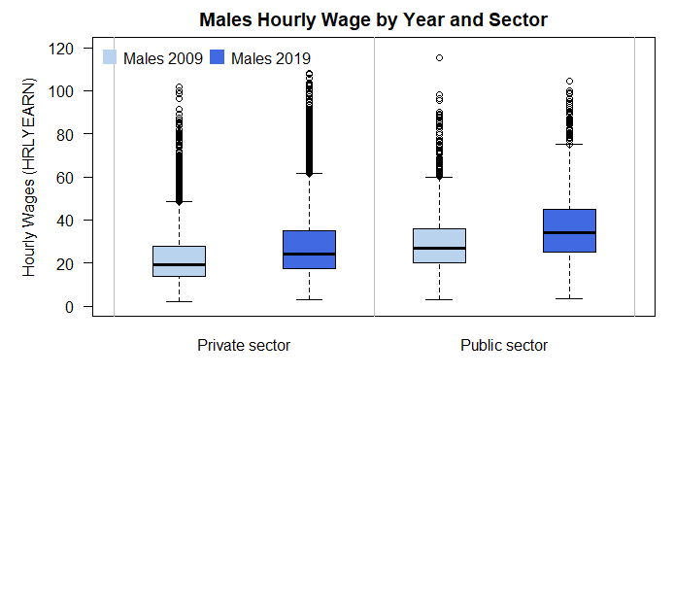

2009.Private sector 2019.Private sector 2009.Public sector 2019.Public sec

Lower Fence 2.140 3.00 3.13 3.25

Q1 13.615 17.31 20.00 25.00

Median 19.290 24.04 27.00 34.00

Q3 27.640 35.00 36.00 45.00

Upper Fence 48.580 61.49 60.00 75.00

|  |
| --- |
| **Males 2009 – Public v. Private** |
| wilcox.test(HRLYEARN ~ COWMAIN, data = data.all.09male, alt = "two.sided", conf.int = T)  Wilcoxon rank sum test with continuity correction  data: HRLYEARN by COWMAIN  W = 78664610, p-value < 2.2e-16  alternative hypothesis: true location shift is not equal to 0  95 percent confidence interval: 6.700064 7.270075  sample estimates: difference in location 6.999958 |
| **Males 2019 – Public v. Private** |
| wilcox.test(HRLYEARN ~ COWMAIN, data = data.all.19male, alt = "two.sided", conf.int = T)  Wilcoxon rank sum test with continuity correction  data: HRLYEARN by COWMAIN  W = 69385905, p-value < 2.2e-16  alternative hypothesis: true location shift is not equal to 0  95 percent confidence interval: 8.039925 8.999984  sample estimates: difference in location 8.500087 |

#### Females

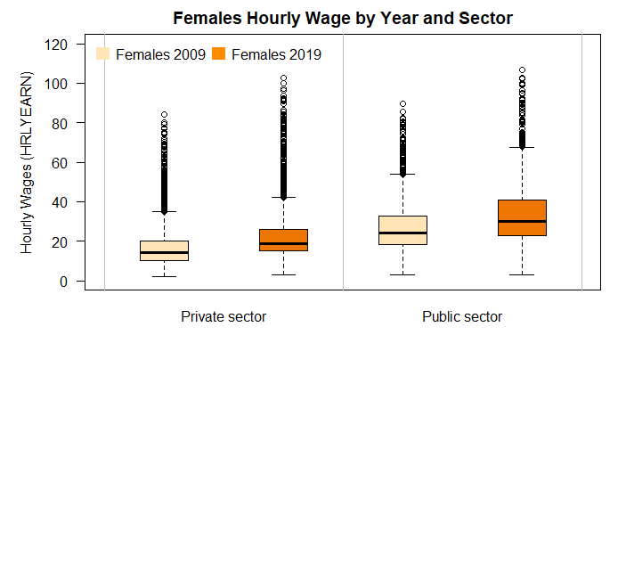

2009.Private sector 2019.Private sector 2009.Public sector 2019.Public sec

Lower Fence 2.00 3.13 3.070 3.07

Q1 10.00 15.00 18.500 23.00

Median 14.07 18.75 24.000 30.00

Q3 20.00 25.82 32.695 40.88

Upper Fence 35.00 42.05 53.850 67.31

|  |
| --- |
| **Females 2009 – Public v. Private** |
| wilcox.test(HRLYEARN ~ COWMAIN, data = data.all.09fem, alt = "two.sided", conf.int = T)  Wilcoxon rank sum test with continuity correction  data: HRLYEARN by COWMAIN  W = 133145579, p-value < 2.2e-16  alternative hypothesis: true location shift is not equal to 0  95 percent confidence interval: 8.959938 9.269923  sample estimates: difference in location 9.039943 |
| **Females 2019 – Public v. Private** |
| wilcox.test(HRLYEARN ~ COWMAIN, data = data.all.19fem, alt = "two.sided", conf.int = T)  Wilcoxon rank sum test with continuity correction  data: HRLYEARN by COWMAIN  W = 112929303, p-value < 2.2e-16  alternative hypothesis: true location shift is not equal to 0  95 percent confidence interval: 9.710015 10.109941  sample estimates: difference in location 9.999988 |

#### Gender Comparison

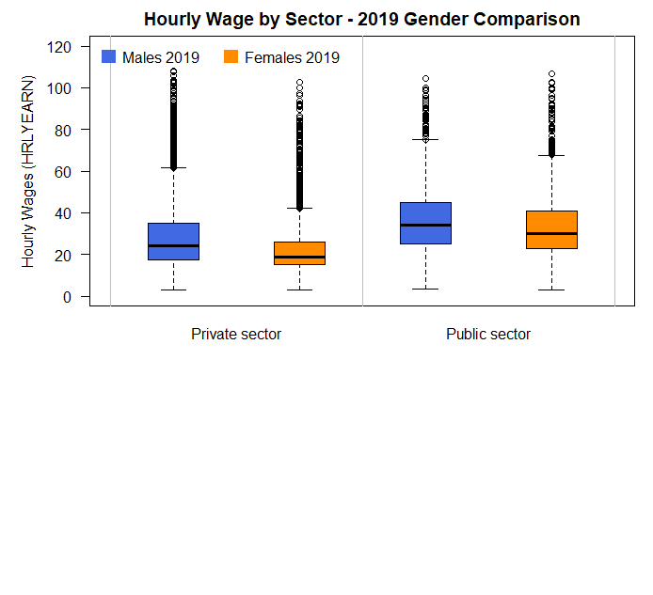

|  |
| --- |
| **Private Sector 2019 – Male v. Female** |
| wilcox.test(HRLYEARN ~ SEX, data = data.all[data.all$SURVYEAR == 2019 & data.all$COWMAIN == "Private sector",], alt = "two.sided", conf.int = T)  Wilcoxon rank sum test with continuity correction  data: HRLYEARN by SEX  W = 218257664, p-value < 2.2e-16  alternative hypothesis: true location shift is not equal to 0  95 percent confidence interval:  4.000026 4.499960  sample estimates:  difference in location  4.220031 |
| **Public Sector 2019 – Male v. Female** |
| wilcox.test(HRLYEARN ~ SEX, data = data.all[data.all$SURVYEAR == 2019 & data.all$COWMAIN == "Public sector",], alt = "two.sided", conf.int = T)  Wilcoxon rank sum test with continuity correction  data: HRLYEARN by SEX  W = 24650974, p-value < 2.2e-16  alternative hypothesis: true location shift is not equal to 0  95 percent confidence interval:  2.729960 3.609973  sample estimates:  difference in location  3.090046 |

#### Conclusions

The public sector tends to have higher hourly wages for both men and women, and this is consistent over the years. At the same time, men tend to have a higher hourly wage than women in both private and public sectors.

### Industry Analysis

First, the hourly wages for men by industry in 2009 and 2019 are displayed in two separate boxplots, and the results of Kruskal Wallis tests are highlighted to see if there is statistical evidence of differences among the industries. Next, the top industries in hourly wages are identified. Then, a comparison between years is presented with another boxplot graph and Mann-Whitney U tests results to verify whether the male’s wages in each industry changed over the years. Afterwards, same analysis is applied to women groups. Lastly, a comparison by gender in 2019 is shown alongside the result of Mann-Whitney U tests to confirm if there is evidence of differences in hourly wages for each industry.

When differences were confirmed by the Kruskal Wallis tests, a post-hoc analysis was performed to identify the industries where hourly wages are significantly different when compared one by one against the others. To save space, the results of post-hoc comparisons of industries are listed on the Appendix section of this document.

Abbreviations for the industries names were used to accommodate them in the graphs and summary of results:

* Agri = "Agriculture"
* Fores = "Forestry, Fishing, Mining, Oil and Gas"
* Utils = "Utilities"
* Const = "Construction"
* ManuD = "Manufacturing durables"
* ManuN = "Manufacturing non-durables"
* Whole = "Wholesale Trade"
* Rtail = "Retail Trade"
* Trans = "Transportation and Warehousing"
* Finan = "Finance, Insurance, Real Estate and Leasing"
* ProSc = "Professional, Scientific and Technical Services"
* Mngt = "Management, Administrative and Other Support"
* Educa = "Educational Services"
* Health = "Health Care and Social Assistance"
* Info = "Information, Culture and Recreation"
* AcFood = "Accommodation and Food Services"
* Other = "Other Services"
* PubAd = "Public Administration"

#### Males

Here are the boxplot results for males. Notice that the industries are ordered by ascending median in both the graph and the summary following it:

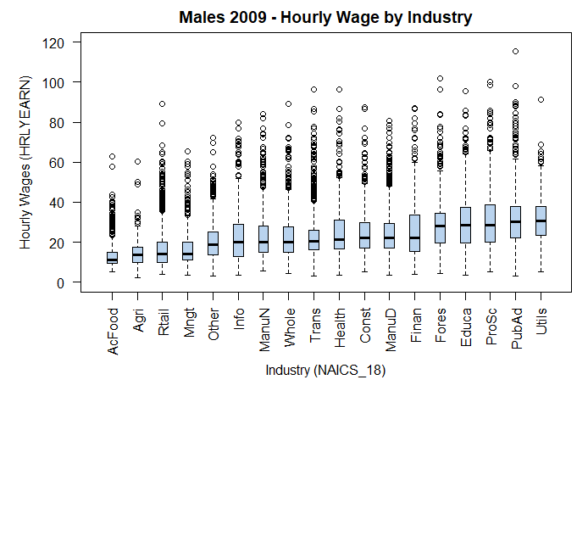

AcFood Agri Rtail Mngt Other Info ManuN Whole Trans Health

Lower Fence 5.00 2.14 3.79 3.33 3.13 3.380 5.45 4.25 3.210 3.300

Q1 9.35 10.00 10.00 11.00 13.70 13.000 15.00 15.00 16.000 16.465

Median 11.00 13.55 14.00 14.00 18.90 19.815 20.00 20.00 20.510 21.450

Q3 15.00 17.31 20.14 20.00 25.00 28.850 28.00 27.47 25.985 31.000

Upper Fence 23.08 28.00 35.20 33.00 41.83 51.920 47.16 46.15 40.870 52.200

Const ManuD Finan Fores Educa ProSc PubAd Utils

Lower Fence 5.10 3.48 3.75 4.44 3.610 5.00 3.13 5.13

Q1 17.00 17.00 15.34 19.78 19.700 20.19 22.03 23.50

Median 22.00 22.00 22.00 28.00 28.280 28.29 30.00 30.64

Q3 29.87 29.51 33.65 34.62 37.555 38.74 37.91 38.00

Upper Fence 49.15 48.08 60.00 55.77 64.100 65.93 61.54 58.24

kruskal.test(HRLYEARN ~ NAICS_18, data = data.all.09male) # Diff. among groups

Kruskal-Wallis rank sum test

data: HRLYEARN by NAICS_18

Kruskal-Wallis chi-squared = 6107.8, df = 17, p-value < 2.2e-16

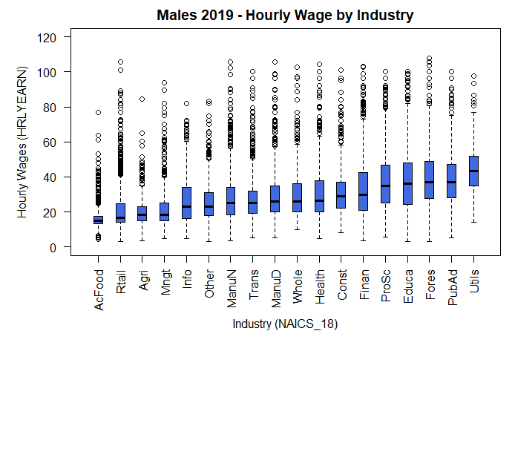

AcFood Rtail Agri Mngt Info Other ManuN Trans ManuD Whole

Lower Fence 6.92 3.040 3.30 4.56 4.62 3.000 3.53 5.00 5.29 9.62

Q1 13.15 14.000 15.00 15.00 16.00 18.000 18.50 19.35 20.00 20.00

Median 15.00 16.750 18.47 18.50 23.05 23.080 25.00 25.00 26.00 26.00

Q3 17.61 24.855 23.08 25.00 34.07 30.965 34.00 32.00 35.00 36.00

Upper Fence 24.18 41.080 35.00 40.00 60.22 50.000 56.54 50.96 57.50 58.50

Health Const Finan ProSc Educa Fores PubAd Utils

Lower Fence 4.81 8.170 3.53 5.77 3.25 3.21 5.13 14.000

Q1 20.00 22.000 21.00 25.00 24.22 27.78 28.00 35.000

Median 26.25 28.745 29.77 35.00 36.06 37.00 37.00 43.475

Q3 37.90 37.000 42.31 46.67 48.08 49.04 47.00 52.000

Upper Fence 63.37 58.000 72.92 78.85 82.05 80.77 75.00 76.920

kruskal.test(HRLYEARN ~ NAICS_18short, data = data.all.19male) # Diff. among groups

Kruskal-Wallis rank sum test

data: HRLYEARN by NAICS_18short

Kruskal-Wallis chi-squared = 6604, df = 17, p-value < 2.2e-16

##### Top 5 Industries

In 2019, the industries with highest median for men were:

1. Utilities
2. Public Administration
3. Forestry, Fishing, Mining, Oil and Gas
4. Educational Services
5. Professional, Scientific and Technical Services

These are the same industries in the top 5 of 2009. To see if there was a change in these industries hourly wages with respect to 2009, Man Whitney U tests were performed, and a graph with year comparison was built:

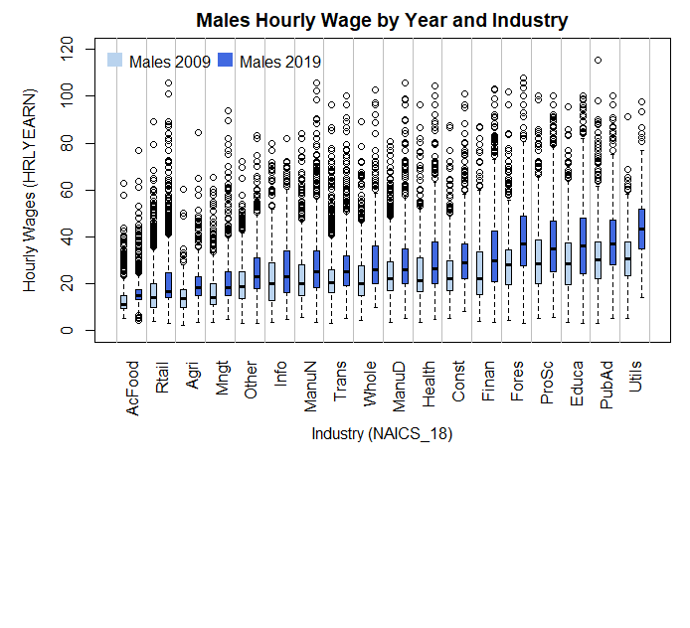

**Industry: Utilities - 2009 vs. 2019, Males**

wilcox.test(HRLYEARN ~ SURVYEAR, data = data.all[data.all$SEX == "Male" & data.all$NAICS_18short == "Utils",], alt = "two.sided", conf.int = T) # Top1

data: HRLYEARN by SURVYEAR

W = 44871, p-value < 2.2e-16

alternative hypothesis: true location shift is not equal to 0

95 percent confidence interval: -14.07003 -10.89997

sample estimates: difference in location -12.52998

**Industry: Public Administration – 2009 vs. 2019, Males**

wilcox.test(HRLYEARN ~ SURVYEAR, data = data.all[data.all$SEX == "Male" & data.all$NAICS_18short == "PubAd",], alt = "two.sided", conf.int = T) # Top2

data: HRLYEARN by SURVYEAR

W = 1116584, p-value < 2.2e-16

alternative hypothesis: true location shift is not equal to 0

95 percent confidence interval: -8.049964 -6.410015

sample estimates: difference in location -7.230063

**Industry: Forestry, Fishing, Mining, Oil and Gas – 2009 vs. 2019, Males**

wilcox.test(HRLYEARN ~ SURVYEAR, data = data.all[data.all$SEX == "Male" & data.all$NAICS_18short == "Fores",], alt = "two.sided", conf.int = T) # Top3

data: HRLYEARN by SURVYEAR

W = 502548, p-value < 2.2e-16

alternative hypothesis: true location shift is not equal to 0

95 percent confidence interval: -10.849993 -8.589955

sample estimates: difference in location -9.739952

**Industry: Educational Services – 2009 vs. 2019, Males**

wilcox.test(HRLYEARN ~ SURVYEAR, data = data.all[data.all$SEX == "Male" & data.all$NAICS_18short == "Educa",], alt = "two.sided", conf.int = T) # Top4

data: HRLYEARN by SURVYEAR

W = 677554, p-value < 2.2e-16

alternative hypothesis: true location shift is not equal to 0

95 percent confidence interval: -8.579975 -6.310040

sample estimates: difference in location -7.450054

**Industry: Professional, Scientific and Technical Services – 2009 vs. 2019, Males**

wilcox.test(HRLYEARN ~ SURVYEAR, data = data.all[data.all$SEX == "Male" & data.all$NAICS_18short == "ProSc",], alt = "two.sided", conf.int = T) # Top5

data: HRLYEARN by SURVYEAR

W = 554060, p-value < 2.2e-16

alternative hypothesis: true location shift is not equal to 0

95 percent confidence interval: -6.899933 -4.619922

sample estimates: difference in location -5.719948

#### Females

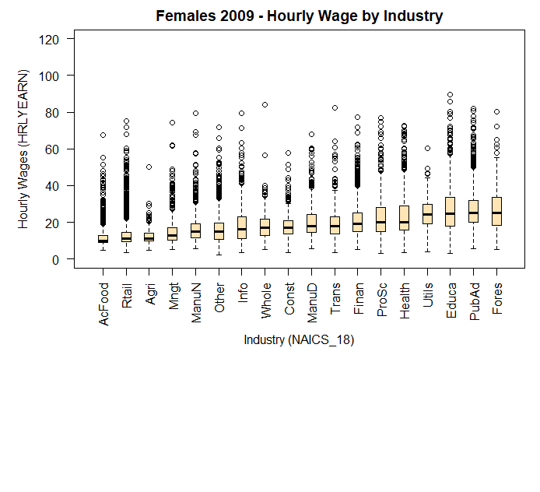

AcFood Rtail Agri Mngt ManuN Other Info Whole Const ManuD Trans

Lower Fence 4.77 3.66 4.81 5.03 5.77 2.00 3.55 5.13 3.50 5.490 3.55

Q1 9.00 9.50 9.70 10.30 11.50 10.53 11.00 13.00 13.85 14.420 13.50

Median 10.00 10.95 11.00 13.00 15.00 15.00 16.00 16.83 16.92 18.000 18.00

Q3 13.00 14.50 14.00 17.00 19.35 19.56 23.00 21.63 20.77 24.105 23.12

Upper Fence 19.00 22.00 20.00 27.00 31.00 32.97 40.87 34.00 30.29 38.460 37.33

Finan ProSc Health Utils Educa PubAd Fores

Lower Fence 5.22 3.08 3.50 3.90 3.07 5.49 5.00

Q1 15.00 15.00 15.87 19.00 18.00 20.00 18.46

Median 19.23 20.00 20.00 24.16 24.62 25.00 25.25

Q3 25.00 28.21 29.07 29.78 33.65 31.87 33.65

Upper Fence 40.00 47.99 48.73 44.00 57.05 49.60 55.27

kruskal.test(HRLYEARN ~ NAICS_18short, data = data.all.09fem) # Diff. among groups

Kruskal-Wallis rank sum test

data: HRLYEARN by NAICS_18short

Kruskal-Wallis chi-squared = 9226.4, df = 17, p-value < 2.2e-16

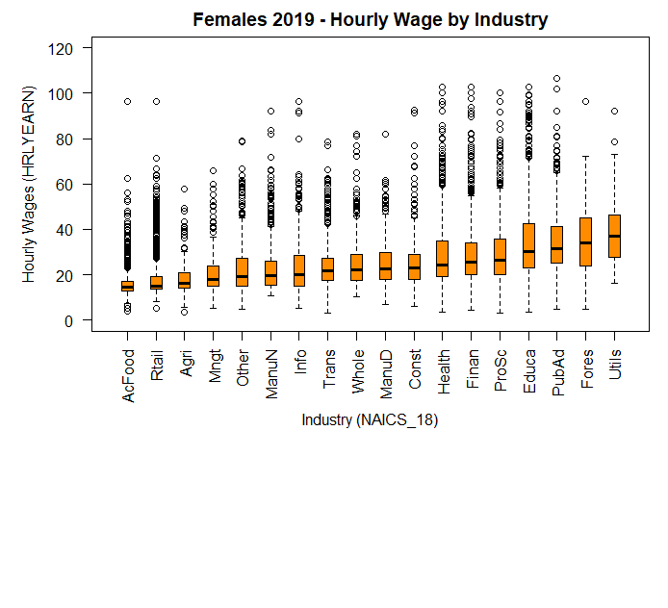

AcFood Rtail Agri Mngt Other ManuN Info Trans Whole ManuD

Lower Fence 7.41 8.25 5.770 5.26 4.81 10.50 5.00 3.070 10.30 6.92

Q1 13.00 13.50 14.000 14.77 15.00 15.34 15.00 17.465 17.50 18.03

Median 14.50 15.00 16.000 18.00 19.17 19.75 20.00 21.720 22.09 22.50

Q3 16.86 19.00 20.875 23.67 27.40 26.00 28.35 27.295 28.85 29.81

Upper Fence 22.50 27.25 30.000 36.54 45.05 41.03 48.21 42.000 45.67 46.77

Const Health Finan ProSc Educa PubAd Fores Utils

Lower Fence 6.07 3.50 4.360 3.13 3.48 4.810 4.730 16.07

Q1 18.00 19.00 19.975 20.00 23.00 25.295 23.875 27.85

Median 23.00 24.04 25.640 26.44 30.00 31.370 34.000 37.00

Q3 28.90 35.00 34.055 35.49 42.31 41.325 45.095 46.15

Upper Fence 45.00 59.00 54.950 58.00 71.15 65.000 72.120 72.82

kruskal.test(HRLYEARN ~ NAICS_18short, data = data.all.19fem) # Diff. among groups

Kruskal-Wallis rank sum test

data: HRLYEARN by NAICS_18short

Kruskal-Wallis chi-squared = 7815.6, df = 17, p-value < 2.2e-16

##### Top 5 Industries

In 2019, the industries with highest median for women were:

1. Utilities
2. Forestry, Fishing, Mining, Oil and Gas
3. Public Administration
4. Educational Services
5. Professional, Scientific and Technical Services

The only difference compared to the top 5 of 2009 for females is the inclusion of "Health Care and Social Assistance" instead of “Professional, Scientific and Technical Services” that we see in 2019. To verify if there were changes in the top industries hourly wages with respect to 2009, Man Whitney U tests were performed, and a graph with year comparison was built:

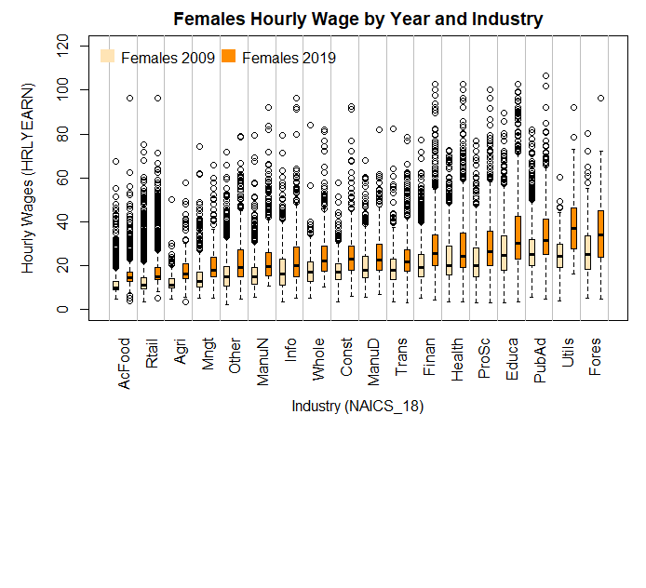

**Industry: Utilities - 2009 vs. 2019, Females**

wilcox.test(HRLYEARN ~ SURVYEAR, data = data.all[data.all$SEX == "Female" & data.all$NAICS_18short == "Utils",], alt = "two.sided", conf.int = T) # Top1

data: HRLYEARN by SURVYEAR

W = 3277.5, p-value = 3.859e-16

alternative hypothesis: true location shift is not equal to 0

95 percent confidence interval: -14.999966 -9.439992

sample estimates: difference in location -12.13

**Industry: Forestry, Fishing, Mining, Oil and Gas – 2009 vs. 2019, Females**

wilcox.test(HRLYEARN ~ SURVYEAR, data = data.all[data.all$SEX == "Female" & data.all$NAICS_18short == "Fores",], alt = "two.sided", conf.int = T) # Top3

data: HRLYEARN by SURVYEAR

W = 18717, p-value = 2.28e-10

alternative hypothesis: true location shift is not equal to 0

95 percent confidence interval: -10.649967 -5.650075

sample estimates: difference in location -8.030013

**Industry: Public Administration – 2009 vs. 2019, Females**

wilcox.test(HRLYEARN ~ SURVYEAR, data = data.all[data.all$SEX == "Female" & data.all$NAICS_18short == "PubAd",], alt = "two.sided", conf.int = T) # Top2

data: HRLYEARN by SURVYEAR

W = 1070692, p-value < 2.2e-16

alternative hypothesis: true location shift is not equal to 0

95 percent confidence interval: -7.280006 -5.999961

sample estimates: difference in location -6.669972

**Industry: Educational Services – 2009 vs. 2019, Females**

wilcox.test(HRLYEARN ~ SURVYEAR, data = data.all[data.all$SEX == "Female" & data.all$NAICS_18short == "Educa",], alt = "two.sided", conf.int = T) # Top4

data: HRLYEARN by SURVYEAR

W = 3546959, p-value < 2.2e-16

alternative hypothesis: true location shift is not equal to 0

95 percent confidence interval: -6.269986 -5.099947

sample estimates: difference in location -5.749971

**Industry: Professional, Scientific and Technical Services – 2009 vs. 2019, Females**

wilcox.test(HRLYEARN ~ SURVYEAR, data = data.all[data.all$SEX == "Female" & data.all$NAICS_18short == "ProSc",], alt = "two.sided", conf.int = T) # Top5

data: HRLYEARN by SURVYEAR

W = 404999, p-value < 2.2e-16

alternative hypothesis: true location shift is not equal to 0

95 percent confidence interval: -6.970001 -5.270070

sample estimates: difference in location -6.040043

#### Gender Comparison

To compare differences of hourly wages distribution in 2019, we look at the boxplot graph. Mann Whitney U tests were also ran and the ones with significant results are included after the visualization.

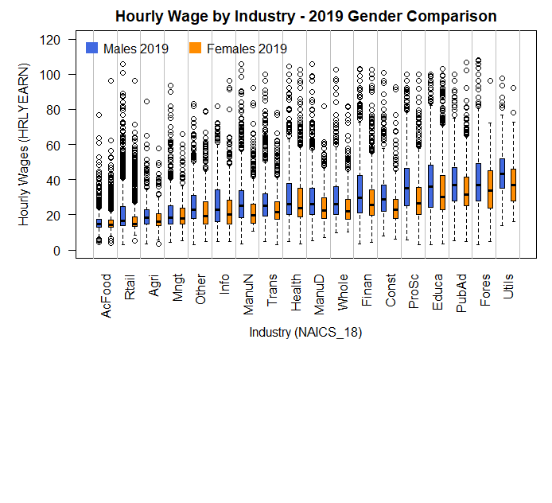

**Industry: Utilities – 2019 – Males vs. Females**

wilcox.test(HRLYEARN ~ SEX, data = data.all[data.all$SURVYEAR == 2019 & data.all$NAICS_18short == "Utils",], alt = "two.sided", conf.int = T)

data: HRLYEARN by SEX

W = 27312, p-value = 4.826e-05

alternative hypothesis: true location shift is not equal to 0

95 percent confidence interval: 3.089948 8.900052

sample estimates: difference in location 6.000049

**Industry: Forestry, Fishing, Mining, Oil and Gas – 2019 – Males vs. Females**

wilcox.test(HRLYEARN ~ SEX, data = data.all[data.all$SURVYEAR == 2019 & data.all$NAICS_18short == "Fores",], alt = "two.sided", conf.int = T)

data: HRLYEARN by SEX

W = 166042, p-value = 0.003606

alternative hypothesis: true location shift is not equal to 0

95 percent confidence interval: 1.000054 5.290070

sample estimates: difference in location 3.100048

**Industry: Public Administration – 2019 – Males vs. Females**

wilcox.test(HRLYEARN ~ SEX, data = data.all[data.all$SURVYEAR == 2019 & data.all$NAICS_18short == "PubAd",], alt = "two.sided", conf.int = T)

data: HRLYEARN by SEX

W = 1873268, p-value < 2.2e-16

alternative hypothesis: true location shift is not equal to 0

95 percent confidence interval: 3.380016 5.049965

sample estimates: difference in location 4.219966

**Industry: Educational Services – 2019 – Males vs. Females**

wilcox.test(HRLYEARN ~ SEX, data = data.all[data.all$SURVYEAR == 2019 & data.all$NAICS_18short == "Educa",], alt = "two.sided", conf.int = T)

data: HRLYEARN by SEX

W = 2383919, p-value = 2.516e-16

alternative hypothesis: true location shift is not equal to 0

95 percent confidence interval: 3.000094 4.999943

sample estimates: difference in location 4.000059

**Industry: Professional, Scientific and Technical Services – 2019 – Males vs. Females**

wilcox.test(HRLYEARN ~ SEX, data = data.all[data.all$SURVYEAR == 2019 & data.all$NAICS_18short == "ProSc",], alt = "two.sided", conf.int = T)

data: HRLYEARN by SEX

W = 1019833, p-value < 2.2e-16

alternative hypothesis: true location shift is not equal to 0

95 percent confidence interval: 6.169975 8.279945

sample estimates: difference in location 7.210066

**Industry: Construction – 2019 – Males vs. Females**

wilcox.test(HRLYEARN ~ SEX, data = data.all[data.all$SURVYEAR == 2019 & data.all$NAICS_18short == "Const",], alt = "two.sided", conf.int = T)

data: HRLYEARN by SEX

W = 1020349, p-value < 2.2e-16

alternative hypothesis: true location shift is not equal to 0

95 percent confidence interval: 3.999967 5.829932

sample estimates: difference in location 4.999997

**Industry: Finance, Insurance, Real Estate and Leasing – 2019 – Males vs. Females**

wilcox.test(HRLYEARN ~ SEX, data = data.all[data.all$SURVYEAR == 2019 & data.all$NAICS_18short == "Finan",], alt = "two.sided", conf.int = T)

data: HRLYEARN by SEX

W = 879092, p-value = 5.238e-12

alternative hypothesis: true location shift is not equal to 0

95 percent confidence interval: 2.469944 4.499994

sample estimates: difference in location 3.479976

**Industry: Wholesale Trade – 2019 – Males vs. Females**

wilcox.test(HRLYEARN ~ SEX, data = data.all[data.all$SURVYEAR == 2019 & data.all$NAICS_18short == "Whole",], alt = "two.sided", conf.int = T)

data: HRLYEARN by SEX

W = 327178, p-value = 8.746e-13

alternative hypothesis: true location shift is not equal to 0

95 percent confidence interval: 2.500003 4.500087

sample estimates: difference in location 3.499906

**Industry: Manufacturing durables – 2019 – Males vs. Females**

wilcox.test(HRLYEARN ~ SEX, data = data.all[data.all$SURVYEAR == 2019 & data.all$NAICS_18short == "ManuD",], alt = "two.sided", conf.int = T)

data: HRLYEARN by SEX

W = 699118, p-value = 1.544e-12

alternative hypothesis: true location shift is not equal to 0

95 percent confidence interval: 2.100034 3.950029

sample estimates: difference in location 3.000056

**Industry: Health Care and Social Assistance – 2019 – Males vs. Females**

wilcox.test(HRLYEARN ~ SEX, data = data.all[data.all$SURVYEAR == 2019 & data.all$NAICS_18short == "Health",], alt = "two.sided", conf.int = T)

data: HRLYEARN by SEX

W = 4094719, p-value = 4.884e-07

alternative hypothesis: true location shift is not equal to 0

95 percent confidence interval: 0.9999984 2.1500867

sample estimates: difference in location 1.599926

**Industry: Transportation and Warehousing – 2019 – Males vs. Females**

wilcox.test(HRLYEARN ~ SEX, data = data.all[data.all$SURVYEAR == 2019 & data.all$NAICS_18short == "Trans",], alt = "two.sided", conf.int = T)

data: HRLYEARN by SEX

W = 756647, p-value = 6.886e-12

alternative hypothesis: true location shift is not equal to 0

95 percent confidence interval: 1.929985 3.349944

sample estimates: difference in location 2.600061

**Industry: Manufacturing non-durables – 2019 – Males vs. Females**

wilcox.test(HRLYEARN ~ SEX, data = data.all[data.all$SURVYEAR == 2019 & data.all$NAICS_18short == "ManuN",], alt = "two.sided", conf.int = T)

data: HRLYEARN by SEX

W = 790826, p-value < 2.2e-16

alternative hypothesis: true location shift is not equal to 0

95 percent confidence interval: 3.550011 5.000051

sample estimates: difference in location 4.24996

**Industry: Information, Culture and Recreation – 2019 – Males vs. Females**

wilcox.test(HRLYEARN ~ SEX, data = data.all[data.all$SURVYEAR == 2019 & data.all$NAICS_18short == "Info",], alt = "two.sided", conf.int = T)

data: HRLYEARN by SEX

W = 500721, p-value = 9.825e-10

alternative hypothesis: true location shift is not equal to 0

95 percent confidence interval: 1.770008 3.499980

sample estimates: difference in location 2.549954

**Industry: Management, Administrative and Other Support – 2019 – Males vs. Females**

wilcox.test(HRLYEARN ~ SEX, data = data.all[data.all$SURVYEAR == 2019 & data.all$NAICS_18short == "Mngt",], alt = "two.sided", conf.int = T)

data: HRLYEARN by SEX

W = 346817, p-value = 0.001885

alternative hypothesis: true location shift is not equal to 0

95 percent confidence interval: 0.250000 1.499922

sample estimates: difference in location 0.9999967

**Industry: Agriculture – 2019 – Males vs. Females**

wilcox.test(HRLYEARN ~ SEX, data = data.all[data.all$SURVYEAR == 2019 & data.all$NAICS_18short == "Agri",], alt = "two.sided", conf.int = T)

data: HRLYEARN by SEX

W = 68024, p-value = 6.254e-05

alternative hypothesis: true location shift is not equal to 0

95 percent confidence interval: 0.9999976 2.5000029

sample estimates: difference in location 1.750036

**Industry: Retail Trade – 2019 – Males vs. Females**

wilcox.test(HRLYEARN ~ SEX, data = data.all[data.all$SURVYEAR == 2019 & data.all$NAICS_18short == "Rtail",], alt = "two.sided", conf.int = T)

data: HRLYEARN by SEX

W = 5449884, p-value < 2.2e-16

alternative hypothesis: true location shift is not equal to 0

95 percent confidence interval: 1.000037 1.500014

sample estimates: difference in location 1.25008

**Industry: Accommodations and Food Services – 2019 – Males vs. Females**

wilcox.test(HRLYEARN ~ SEX, data = data.all[data.all$SURVYEAR == 2019 & data.all$NAICS_18short == "AcFood",], alt = "two.sided", conf.int = T)

data: HRLYEARN by SEX

W = 1550054, p-value = 0.008176

alternative hypothesis: true location shift is not equal to 0

95 percent confidence interval: 4.414496e-05 4.999908e-01

sample estimates: difference in location 0.14998

#### Conclusions

From the visualizations and non-parametric tests, we can conclude that:

* There are differences in the hourly wages among industries, for both men and women.
* These differences have been persistent over time, and we found them in 2009 and 2019.
* The top 5 industries in 2019 are the same for men and women. It has not changed over time; we observed the same top 5 industries in 2009:
* Utilities
* Public Administration
* Forestry, Fishing, Mining, Oil and Gas
* Educational Services
* Professional, Scientific and Technical Services
* However, in the gender comparison we see that men tend to have higher hourly wages across all industries.
* The industries where this gap seems to be smallest are "Management, Administrative and Other Support" and "Accommodations and Food Services".

### Occupation Analysis

There are 10 main categories of job occupations, and the variation of hourly wages among them is explored. We start with a breakdown by year for men with boxplots and Kruskal Wallis tests to confirm significant differences. Then we compare results over time to see if men’s hourly wages changed from 2009 to 2019, using boxplots and Mann-Whitney U tests. Next, same sequence of analysis is presented for women. Afterwards, there is a comparison by gender for the 2019 data where boxplot and Mann-Whitney U tests are employed again to confirm if hourly wages are different for men and women performing same occupations.

Abbreviations for the occupations names were used to accommodate them in the graphs and summary of results:

* Mngt = "Management"
* BusFin = "Business, finance and administration"
* NatASc = "Natural and applied sciences"
* Health ="Health"
* EduLaw = "Education, law, community and government services"
* ArtCul = "Art, culture, recreation and sport"
* Sales = "Sales and service"
* Trades = "Trades, transport and equipment operators"
* NatAgri = "Natural resources and agriculture"
* ManUtil = "Manufacturing and utilities

#### Males

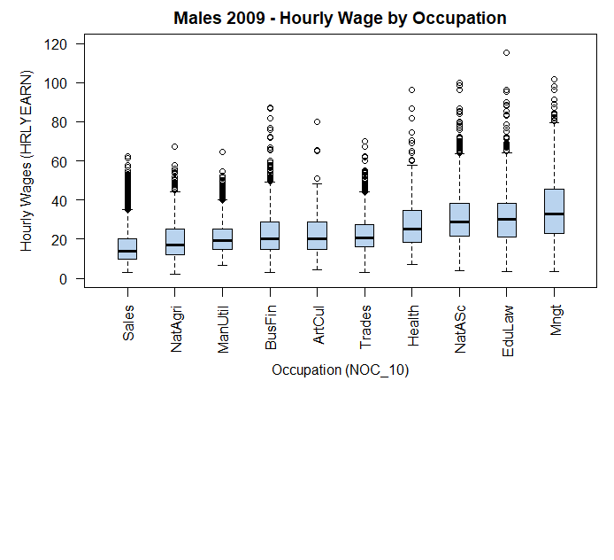

Sales NatAgri ManUtil BusFin ArtCul Trades Health NatASc EduLaw Mngt

LowFence 3.13 2.14 6.67 3.13 4.210 3.210 7.00 3.79 3.610 3.48

Q1 10.00 12.00 15.00 15.00 15.000 16.000 18.50 21.63 20.975 23.08

Median 14.00 17.00 19.50 20.19 20.295 20.675 25.00 28.85 30.000 33.00

Q3 20.00 25.18 25.00 28.69 28.850 27.300 34.59 38.41 38.460 45.64

UpFence 35.00 44.41 40.00 49.04 48.210 44.230 57.69 63.57 64.100 79.47

kruskal.test(HRLYEARN ~ NOC_10, data = data.all.09male) # Diff. among groups

Kruskal-Wallis rank sum test

data: HRLYEARN by NOC_10

Kruskal-Wallis chi-squared = 5740.1, df = 9, p-value < 2.2e-16

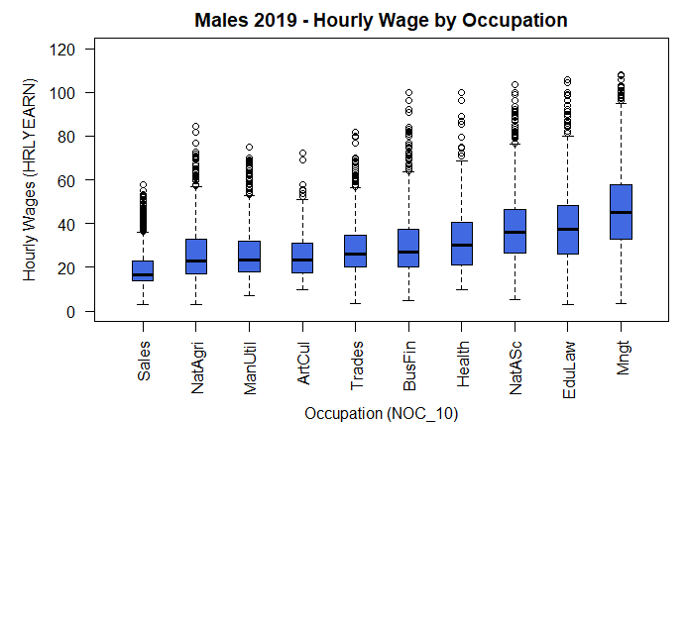

Sales NatAgri ManUtil ArtCul Trades BusFin Health NatASc EduLaw Mngt

LowFence 3.04 3.21 6.92 9.85 3.460 4.62 10.00 5.13 3.00 3.30

Q1 14.00 17.00 18.00 17.50 20.000 20.19 21.00 26.62 26.25 32.88

Median 16.50 23.00 23.36 23.50 26.000 27.00 30.00 36.06 37.50 45.00

Q3 23.00 33.00 32.00 31.25 34.625 37.50 40.49 46.63 48.08 57.69

UpFence 36.13 57.00 53.00 51.00 56.500 63.46 68.68 76.51 79.91 94.87

kruskal.test(HRLYEARN ~ NOC_10, data = data.all.19male) # Diff. among groups

Kruskal-Wallis rank sum test

data: HRLYEARN by NOC_10

Kruskal-Wallis chi-squared = 7220.2, df = 9, p-value < 2.2e-16

##### Top 3 Occupations

In 2009 and 2019, the occupations with highest median for men were:

1. Management
2. Education, law, community, and government services
3. Natural and applied sciences

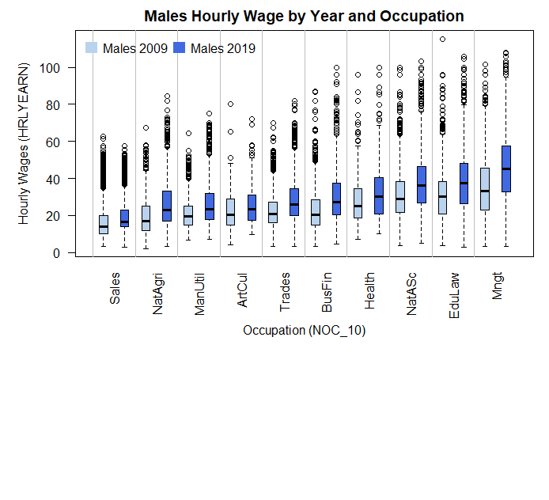

**Occupation: Management – 2009 vs. 2019, Males**

wilcox.test(HRLYEARN ~ SURVYEAR, data = data.all[data.all$SEX == "Male" & data.all$NOC_10short == "Mngt",], alt = "two.sided", conf.int = T) # Top1

data: HRLYEARN by SURVYEAR

W = 1120265, p-value < 2.2e-16

alternative hypothesis: true location shift is not equal to 0

95 percent confidence interval: -12.25999 -10.00005

sample estimates: difference in location -11.17997

**Occupation: Education, law, community, and government services – 2009 vs. 2019, Males**

wilcox.test(HRLYEARN ~ SURVYEAR, data = data.all[data.all$SEX == "Male" & data.all$NOC_10short == "EduLaw",], alt = "two.sided", conf.int = T) # Top2

data: HRLYEARN by SURVYEAR

W = 966244, p-value < 2.2e-16

alternative hypothesis: true location shift is not equal to 0

95 percent confidence interval: -8.059976 -6.049982

sample estimates: difference in location -7.05005

**Occupation: Natural and applied sciences – 2009 vs. 2019, Males**

wilcox.test(HRLYEARN ~ SURVYEAR, data = data.all[data.all$SEX == "Male" & data.all$NOC_10short == "NatASc",], alt = "two.sided", conf.int = T) # Top3

data: HRLYEARN by SURVYEAR

W = 2564647, p-value < 2.2e-16

alternative hypothesis: true location shift is not equal to 0

95 percent confidence interval: -7.489955 -6.020037

sample estimates: difference in location -6.770048

#### Females

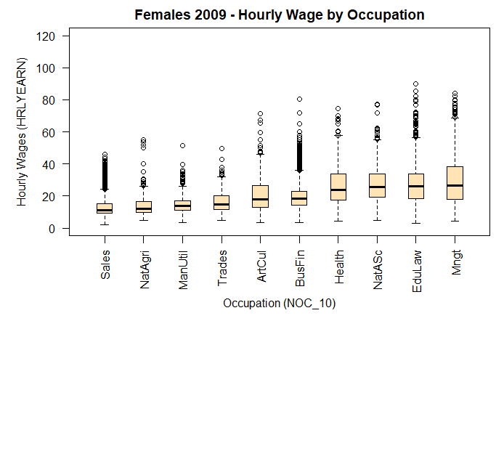

Sales NatAgri ManUtil Trades ArtCul BusFin Health NatASc EduLaw Mngt

LoFence 2.000 4.81 3.500 4.63 3.55 3.45 4.17 5.000 3.070 4.160

Q1 9.500 10.00 10.970 11.50 13.00 14.35 17.55 19.220 18.495 18.000

Median 11.000 12.00 13.685 15.00 18.00 18.50 23.90 25.640 26.000 26.555

Q3 15.365 16.50 17.150 20.00 26.39 23.08 33.65 33.685 33.750 38.460

UpFence 24.130 25.96 26.000 32.09 46.15 36.06 57.69 55.000 56.410 68.680

kruskal.test(HRLYEARN ~ NOC_10, data = data.all.09fem) # Diff. among groups

Kruskal-Wallis rank sum test

data: HRLYEARN by NOC_10

Kruskal-Wallis chi-squared = 9838.5, df = 9, p-value < 2.2e-16

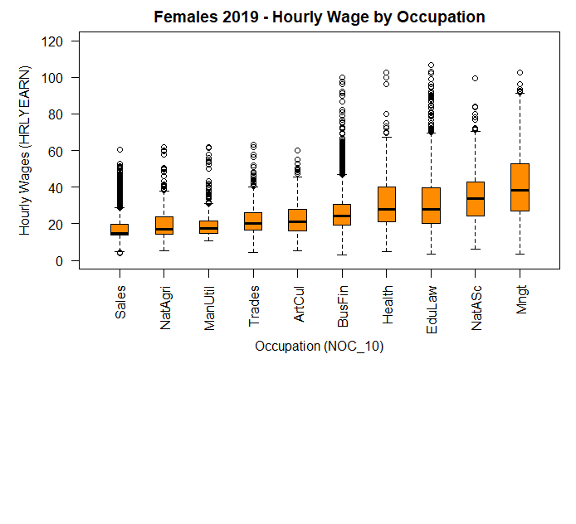

Sales NatAgri ManUtil Trades ArtCul BusFin Health EduLaw NatASc Mngt

LoFence 5.00 5.26 10.50 4.55 5.42 3.07 5.05 3.48 6.25 3.30

Q1 13.75 14.50 15.00 16.54 16.00 19.49 21.00 20.00 24.52 26.92

Median 15.00 17.00 17.50 20.00 21.00 24.34 27.79 27.88 33.64 38.46

Q3 19.79 23.97 21.45 26.00 27.89 30.53 40.00 39.90 43.00 52.88

UpFence 28.72 38.00 31.00 40.15 45.64 47.00 67.31 69.71 70.62 91.35

kruskal.test(HRLYEARN ~ NOC_10, data = data.all.19fem) # Diff. among groups

Kruskal-Wallis rank sum test

data: HRLYEARN by NOC_10

Kruskal-Wallis chi-squared = 8336.7, df = 9, p-value < 2.2e-16

##### Top 3 Occupations

In 2009 and 2019, the occupations with highest median for women were:

1. Management
2. Natural and applied sciences
3. Education, law, community, and government services

Only difference between years us the order, “Natural and applied sciences” jumped from the third to the second spot in 2019.

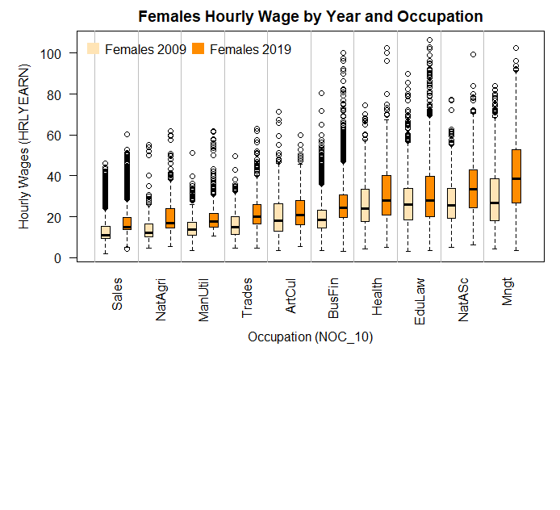

**Occupation: Management – 2009 vs. 2019, Females**

wilcox.test(HRLYEARN ~ SURVYEAR, data = data.all[data.all$SEX == "Female" & data.all$NOC_10short == "Mngt",], alt = "two.sided", conf.int = T) # Top1

data: HRLYEARN by SURVYEAR

W = 593358, p-value < 2.2e-16

alternative hypothesis: true location shift is not equal to 0

95 percent confidence interval: -12.019993 -9.619946

sample estimates: difference in location -10.81004

**Occupation: Natural and applied sciences – 2009 vs. 2019, Females**

wilcox.test(HRLYEARN ~ SURVYEAR, data = data.all[data.all$SEX == "Female" & data.all$NOC_10short == "NatASc",], alt = "two.sided", conf.int = T) # Top2

data: HRLYEARN by SURVYEAR

W = 208380, p-value < 2.2e-16

alternative hypothesis: true location shift is not equal to 0

95 percent confidence interval: -8.200015 -5.870033

sample estimates: difference in location -7.000035

**Occupation: Education, law, community, and government services – 2009 vs. 2019, Females**

wilcox.test(HRLYEARN ~ SURVYEAR, data = data.all[data.all$SEX == "Female" & data.all$NOC_10short == "EduLaw",], alt = "two.sided", conf.int = T) # Top3

data: HRLYEARN by SURVYEAR

W = 7142727, p-value < 2.2e-16

alternative hypothesis: true location shift is not equal to 0

95 percent confidence interval: -3.560001 -2.509974

sample estimates:ndifference in location -3.000021

#### Gender Comparison

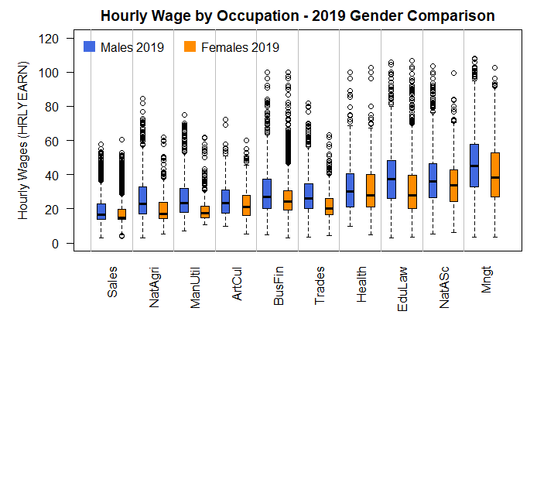

**Occupation: Management – 2019 – Males vs. Females**

wilcox.test(HRLYEARN ~ SEX, data = data.all[data.all$SURVYEAR == 2019 & data.all$NOC_10short == "Mngt",], alt = "two.sided", conf.int = T)

data: HRLYEARN by SEX

W = 1268072, p-value < 2.2e-16

alternative hypothesis: true location shift is not equal to 0

95 percent confidence interval: 4.809938 7.350044

sample estimates: difference in location 6.080045

**Occupation: Natural and applied sciences – 2019 – Males vs. Females**

wilcox.test(HRLYEARN ~ SEX, data = data.all[data.all$SURVYEAR == 2019 & data.all$NOC_10short == "NatASc",], alt = "two.sided", conf.int = T)

data: HRLYEARN by SEX

W = 1290381, p-value = 2.365e-08

alternative hypothesis: true location shift is not equal to 0

95 percent confidence interval: 1.950024 4.000029

sample estimates: difference in location 2.999974

**Occupation: Education, law, community and government services – 2019 – Males vs. Females**

wilcox.test(HRLYEARN ~ SEX, data = data.all[data.all$SURVYEAR == 2019 & data.all$NOC_10short == "EduLaw",], alt = "two.sided", conf.int = T)

data: HRLYEARN by SEX

W = 5310381, p-value < 2.2e-16

alternative hypothesis: true location shift is not equal to 0

95 percent confidence interval: 6.639996 8.200009

sample estimates: difference in location 7.430066

**Occupation: Health – 2019 – Males vs. Females**

wilcox.test(HRLYEARN ~ SEX, data = data.all[data.all$SURVYEAR == 2019 & data.all$NOC_10short == "Health",], alt = "two.sided", conf.int = T)

data: HRLYEARN by SEX

W = 1140716, p-value = 0.01428

alternative hypothesis: true location shift is not equal to 0

95 percent confidence interval: 0.1500462 2.1200176

sample estimates: difference in location 1.150062

**Occupation: Trades, transport and equipment operators – 2019 – Males vs. Females**

wilcox.test(HRLYEARN ~ SEX, data = data.all[data.all$SURVYEAR == 2019 & data.all$NOC_10short == "Trades",], alt = "two.sided", conf.int = T)

data: HRLYEARN by SEX

W = 2803271, p-value < 2.2e-16

alternative hypothesis: true location shift is not equal to 0

95 percent confidence interval: 4.080045 5.749970

sample estimates: difference in location 4.999944

**Occupation: Business, finance and administration – 2019 – Males vs. Females**

wilcox.test(HRLYEARN ~ SEX, data = data.all[data.all$SURVYEAR == 2019 & data.all$NOC_10short == "BusFin",], alt = "two.sided", conf.int = T)

data: HRLYEARN by SEX

W = 7312384, p-value < 2.2e-16

alternative hypothesis: true location shift is not equal to 0

95 percent confidence interval: 2.130060 3.169963

sample estimates: difference in location 2.709973

**Occupation: Art, culture, recreation and sport – 2019 – Males vs. Females**

wilcox.test(HRLYEARN ~ SEX, data = data.all[data.all$SURVYEAR == 2019 & data.all$NOC_10short == "ArtCul",], alt = "two.sided", conf.int = T)

data: HRLYEARN by SEX

W = 104442, p-value = 0.0001424

alternative hypothesis: true location shift is not equal to 0

95 percent confidence interval: 1.000031 3.500068

sample estimates: difference in location 2.219955

**Occupation: Manufacturing and utilities – 2019 – Males vs. Females**

wilcox.test(HRLYEARN ~ SEX, data = data.all[data.all$SURVYEAR == 2019 & data.all$NOC_10short == "ManUtil",], alt = "two.sided", conf.int = T)

data: HRLYEARN by SEX

W = 903084, p-value < 2.2e-16

alternative hypothesis: true location shift is not equal to 0

95 percent confidence interval: 4.500042 5.949957

sample estimates: difference in location 5.050023

**Occupation: Natural resources and agriculture – 2019 – Males vs. Females**

wilcox.test(HRLYEARN ~ SEX, data = data.all[data.all$SURVYEAR == 2019 & data.all$NOC_10short == "NatAgri",], alt = "two.sided", conf.int = T)

data: HRLYEARN by SEX

W = 269920, p-value < 2.2e-16

alternative hypothesis: true location shift is not equal to 0

95 percent confidence interval: 3.500010 5.710072

sample estimates: difference in location 4.619989

**Occupation: Sales and service – 2019 – Males vs. Females**

wilcox.test(HRLYEARN ~ SEX, data = data.all[data.all$SURVYEAR == 2019 & data.all$NOC_10short == "Sales",], alt = "two.sided", conf.int = T)

data: HRLYEARN by SEX

W = 22827094, p-value < 2.2e-16

alternative hypothesis: true location shift is not equal to 0

95 percent confidence interval: 0.9999802 1.1500083

sample estimates: difference in location 1.000046

#### Conclusions

* There are differences in the hourly wages among occupations. This is true regardless the gender and the year.
* Both men and women share the same Top 3 occupations in terms of highest hourly wages: "Management", "Education, law, community, and government services", and "Natural and applied sciences".
* These 3 occupations remained at the top from 2009 to 2019.
* The occupations that seem to have the smallest gender gaps are "Health" and "Art, culture, recreation and sport".

## Step 4: Multiple Regression Analysis

### Normalization

Numeric variables were normalized before applying the regression techniques to transform them to the same scale. This was the function used:

*normalize <- function(x) {return ((x - min(x)) / (max(x) - min(x)))}*

### Training and Test Set

The dataset was divided into 4 groups, by year and gender:

1. Year 2009, Males
2. Year 2009, Females
3. Year 2019, Males
4. Year 2019, Females

Each of these subsets was split into 70% training and 30% testing data, selecting observations randomly.

### Variables excluded

The next variables from the dataset were not included as predictors:

|  |  |  |
| --- | --- | --- |
| **VARIABLE** | **DESCRIPTION** | **REASON OF EXCLUSION** |
| **rec_num** | Order of record in file | Identification of record, unique |
| **survyear** | Survey year | One set value in each group (2009 or 2019) |
| **survmnth** | Survey month | One value (September) |
| **Sex** | Sex of respondent | One value in each group (Male or Female) |
| **Immig** | Immigrant status | Only 2019 records, no 2009 data |
| **noc_40** | Occupation at main job  (40 categories) | Only 2019 records, no 2009 data  (noc_10 was the variable included to analyse occupation) |

### Stepwise Regression

Stepwise regression (both directions) was the feature selection technique applied. Here is an example of the R code used to build the first model:

*full <- lm(HRLYEARN ~ FSSTAT+PROV+CMA+AGE_12+MARSTAT+EDUC+MJH+COWMAIN*

*+NAICS_18+NOC_10+FTPTMAIN+UTOTHRS+TENURE+UNION+PERMTEMP*

*+ESTSIZE+FIRMSIZE+SCHOOLN+EFAMTYPE+AGYOWNK, data = train.09male)*

*null <- lm(HRLYEARN ~ 1, data = train.09male)*

*model <- stepAIC(null, scope=list(lower=null, upper=full), direction= "both", trace=TRUE)*

To check the overall significance of the model built, we looked at the **F-statistic** and its p-value. The F-test follows these hypotheses:

* H0: Null hypothesis states that the model with no independent variables fits the data as well as your model.
* HA: Alternative hypothesis says that your model fits the data better than the intercept-only model, meaning that at least one of the independent variables in the model can explain some of the variance of the response variable.

If p-value is less or equal to 0.05, the null hypotheses is rejected to conclude that the regression model fits the data better than the model with no independent variables.

**R-squared** value was also checked. It indicates how well the model fits the data, measuring the strength of the relationship between it and the dependent variable.

Then, diagnostic plots were created to check regression assumptions:

* **Linearity of the data.** The relationship between the predictor (x) and the outcome (y) is assumed to be linear.
* **Normality of residuals.** The residual errors are assumed to be normally distributed.
* **Homogeneity of residuals variance.** The residuals are assumed to have a constant variance (homoscedasticity).
* **Independence of residuals error terms.**

The diagnostic plots employed to analyze model residuals were:

1. **Residuals vs Fitted.** Used to check the linear relationship assumptions. A horizontal line, without distinct patterns is an indication for a linear relationship.
2. **Normal Q-Q.** Used to examine whether the residuals are normally distributed. Residuals points should follow the straight dashed line.
3. **Scale-Location (or Spread-Location).** Used to check the homogeneity of variance of the residuals (homoscedasticity). Horizontal line with equally spread points is a good indication of homoscedasticity. Otherwise, we would say there is a heteroscedasticity problem.
4. **Residuals vs Leverage.** Used to identify influential cases, that is extreme values that might influence the regression results when included or excluded from the analysis. When data points are to the upper or lower right of the leverage plot, outside the Cook’s distance lines they have leverage meaning they are influential to the regression results.

After analyzing the diagnostic plots, if required, Box Cox transformation technique was employed to correct for errors nonnormality and other assumptions violations.

Lastly, once a model was determined, it was used to predict the response variable (hourly wages) on the test set. A histogram of the errors was plotted, and both the Root Mean Squared Errors (RMSE) and the Mean Absolute Error (MAE) were calculated. The percentage of predictions that were close to the real value was calculated as well with the next formulas:

> diff.percent <- 100*(abs(errors)/(y_real_values))

> diff.25 <- length(diff.percent[diff.percent<=25])/total_observations

These are the results for each group:

#### Year 2009, Males

**First Model**

Call:

lm(formula = HRLYEARN ~ NOC_10 + NAICS_18 + AGE_12 + PROV + EDUC +

TENURE + ESTSIZE + FIRMSIZE + AGYOWNK + PERMTEMP + FTPTMAIN +

UTOTHRS + UNION + MARSTAT + LFSSTAT + COWMAIN, data = train.09male)

Multiple R-squared: 0.4733, Adjusted R-squared: 0.4711

F-statistic: 219.1 on 77 and 18781 DF, p-value: < 2.2e-16

**Diagnostic Plots**

|  |  |
| --- | --- |
| **Residuals vs Fitted (Linearity Test)** | **Normal Q-Q (Residuals Normality Test)** |
|  |  |
| **Scale-Location (Homoscedasticity Test)** | **Residuals vs. Leverage (Outliers Test)** |
|  |  |

The conclusions of analyzing the diagnostics plots are:

1. Residuals vs Fitted: The red line is approximately zero and looks only slightly curved. We could say that linearity result is good, although not perfect.
2. Normal Q-Q: normality of the errors does not hold, as we can specially see from the points at the upper right corner.
3. Scale-Location: The line is not straight, and the variability of the residual points increases with the value of the fitted outcome variable, suggesting non-constant variances in the residuals.
4. Residuals vs Leverage: Data do not present any influential points. Cook’s distance lines (a red dashed line) are not shown on the Residuals vs Leverage plot because all points are within those limits.

**Box Cox Transformation**

Since the assumptions are not met, transformation of the dependant variable was applied. The best lambda estimation was 0.21. Here is the Maximum likelihood plot to visualize the best lambda estimation:

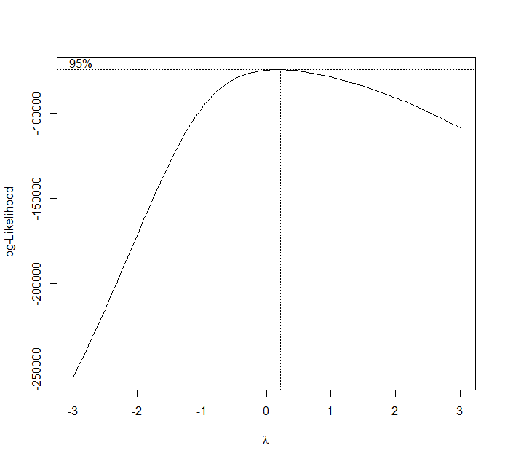

With the lambda value, a new model was built for the transformed dependent variable: (HRLYEARN)^0.21

**Final Model**

Call:

lm(formula = (HRLYEARN)^0.21 ~ NOC_10 + NAICS_18 + AGE_12 + PROV +

EDUC + TENURE + ESTSIZE + AGYOWNK + FIRMSIZE + PERMTEMP +

FTPTMAIN + UTOTHRS + MARSTAT + UNION + LFSSTAT + MJH, data = train.09male)

Multiple R-squared: 0.529, Adjusted R-squared: 0.5271

F-statistic: 273.9 on 77 and 18781 DF, p-value: < 2.2e-16

R-squared improved from 0.47 (First Model) to 0.53 (Final Model).

**Diagnostic Plots**

|  |  |
| --- | --- |
| **Residuals vs Fitted (Linearity Test)** | **Normal Q-Q (Residuals Normality Test)** |
|  |  |
| **Scale-Location (Homoscedasticity Test)** | **Residuals vs. Leverage (Outliers Test)** |
|  |  |

Comparing the diagnostics plots of the new model with the previous ones, we can see some improvement for linearity, normality, and homoscedasticity. The normality plot points still deviate from the dashed line on the extremes, specially as they approach the lower left corner. Nevertheless, there is an improvement in the level of skewness of the residuals:

> # Before Transformation:

> skewness(model$residuals)

[1] 1.105503

> # After Transformation

> skewness(new.model$residuals)

[1] -0.1655788

**Prediction**

The final model was applied to predict the hourly wages on the test data set. The next histogram shows the distribution of errors:

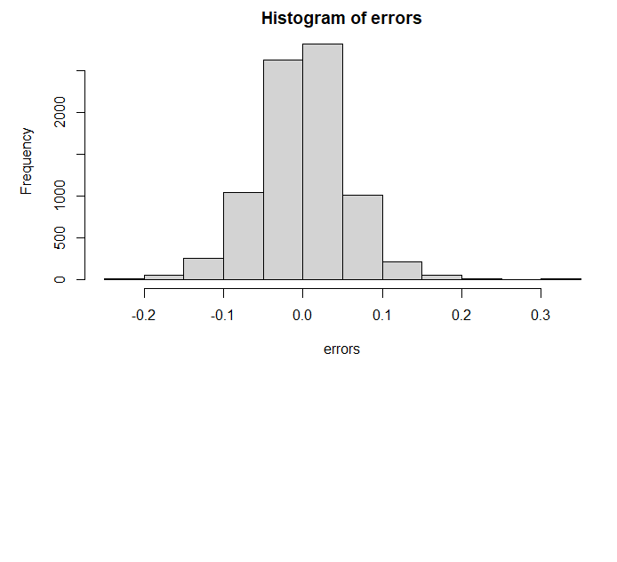

And here are the results for RMSE, MAE and proportion of predicted values close to real ones by 25% or less:

[1] "RMSE: 0.0555053839803959"

[1] "MAE: 0.0422321988304378"

[1] "Percentage of cases with less than 25% error: 99.0473833972535"

**Variables, Coefficients and Significance**

The final model equation with included variables, coefficients and significance is:

|  |  |  |  |  |  |
| --- | --- | --- | --- | --- | --- |
| Independent Variables | Estimate | Std  Error | t-value | p-value | Sig |
| (Intercept) | 0.7177 | 0.0056 | 128.24 | < 2e-16 | *** |
| NOC_10Business, finance & admin. | -0.0623 | 0.0020 | -30.60 | < 2e-16 | *** |
| NOC_10Natural & applied sciences | -0.0303 | 0.0020 | -14.90 | < 2e-16 | *** |
| NOC_10Health | -0.0205 | 0.0038 | -5.42 | 0.0000 | *** |
| NOC_10Educ., law, community & gov. serv. | -0.0302 | 0.0027 | -11.29 | < 2e-16 | *** |
| NOC_10Art, culture, recreation & sport | -0.0436 | 0.0039 | -11.20 | < 2e-16 | *** |
| NOC_10Sales & service | -0.0691 | 0.0018 | -37.41 | < 2e-16 | *** |
| NOC_10Trades, transport & equip. operator | -0.0572 | 0.0018 | -31.02 | < 2e-16 | *** |
| NOC_10Natural resources & agriculture | -0.0584 | 0.0031 | -18.95 | < 2e-16 | *** |
| NOC_10Manufacturing & utilities | -0.0757 | 0.0024 | -31.41 | < 2e-16 | *** |
| NAICS_18Forestry, Fishing, Min., Oil &Gas | 0.0492 | 0.0038 | 13.07 | < 2e-16 | *** |
| NAICS_18Utilities | 0.0531 | 0.0049 | 10.78 | < 2e-16 | *** |
| NAICS_18Construction | 0.0464 | 0.0040 | 11.51 | < 2e-16 | *** |
| NAICS_18Manufacturing durables | 0.0289 | 0.0041 | 7.05 | 0.0000 | *** |
| NAICS_18Manufacturing non-durables | 0.0211 | 0.0042 | 5.03 | 0.0000 | *** |
| NAICS_18Wholesale Trade | 0.0257 | 0.0043 | 6.04 | 0.0000 | *** |
| NAICS_18Retail Trade | -0.0023 | 0.0041 | -0.56 | 0.5769 |  |
| NAICS_18Transportation & Warehousing | 0.0150 | 0.0041 | 3.61 | 0.0003 | *** |
| NAICS_18Finance, Ins., Real Est. & Leas. | 0.0268 | 0.0044 | 6.06 | 0.0000 | *** |
| NAICS_18Prof., Scientific & Technical Serv. | 0.0456 | 0.0044 | 10.47 | < 2e-16 | *** |
| NAICS_18Management, Admin. & Support | -0.0026 | 0.0042 | -0.62 | 0.5343 |  |
| NAICS_18Educational Services | 0.0178 | 0.0045 | 3.99 | 0.0001 | *** |
| NAICS_18Health Care & Social Assistance | 0.0014 | 0.0046 | 0.31 | 0.7563 |  |
| NAICS_18Information, Culture & Recreation | 0.0137 | 0.0043 | 3.18 | 0.0015 | ** |
| NAICS_18Accommodation & Food Services | -0.0138 | 0.0043 | -3.20 | 0.0014 | ** |
| NAICS_18Other Services | 0.0137 | 0.0044 | 3.13 | 0.0018 | ** |
| NAICS_18Public Administration | 0.0438 | 0.0042 | 10.55 | < 2e-16 | *** |
| AGE_12.L | 0.0129 | 0.0034 | 3.80 | 0.0001 | *** |
| AGE_12.Q | -0.0528 | 0.0032 | -16.45 | < 2e-16 | *** |
| AGE_12.C | -0.0049 | 0.0028 | -1.77 | 0.0773 | . |
| AGE_12^4 | -0.0110 | 0.0025 | -4.32 | 0.0000 | *** |
| AGE_12^5 | -0.0080 | 0.0023 | -3.45 | 0.0006 | *** |
| AGE_12^6 | 0.0031 | 0.0021 | 1.47 | 0.1404 |  |
| AGE_12^7 | -0.0042 | 0.0018 | -2.33 | 0.0196 | * |
| AGE_12^8 | 0.0039 | 0.0016 | 2.51 | 0.0122 | * |
| AGE_12^9 | 0.0012 | 0.0014 | 0.83 | 0.4063 |  |
| AGE_12^10 | 0.0023 | 0.0013 | 1.80 | 0.0712 | . |
| AGE_12^11 | -0.0003 | 0.0012 | -0.26 | 0.7972 |  |
| PROVPEI | -0.0152 | 0.0034 | -4.45 | 0.0000 | *** |
| PROVNS | -0.0074 | 0.0029 | -2.55 | 0.0107 | * |
| PROVNB | -0.0069 | 0.0028 | -2.42 | 0.0154 | * |
| PROVQC | 0.0078 | 0.0025 | 3.14 | 0.0017 | ** |
| PROVON | 0.0177 | 0.0024 | 7.44 | 0.0000 | *** |
| PROVMB | 0.0038 | 0.0026 | 1.48 | 0.1390 |  |
| PROVSK | 0.0227 | 0.0027 | 8.39 | < 2e-16 | *** |
| PROVAB | 0.0393 | 0.0025 | 15.44 | < 2e-16 | *** |
| PROVBC | 0.0271 | 0.0026 | 10.56 | < 2e-16 | *** |
| EDUC.L | 0.0416 | 0.0020 | 20.34 | < 2e-16 | *** |
| EDUC.Q | 0.0044 | 0.0018 | 2.39 | 0.0170 | * |
| EDUC.C | 0.0025 | 0.0015 | 1.68 | 0.0929 | . |
| EDUC^4 | -0.0054 | 0.0013 | -4.02 | 0.0001 | *** |
| EDUC^5 | -0.0027 | 0.0010 | -2.70 | 0.0069 | ** |
| EDUC^6 | -0.0006 | 0.0011 | -0.50 | 0.6174 |  |
| TENURE | 0.0285 | 0.0014 | 20.04 | < 2e-16 | *** |
| ESTSIZE.L | 0.0150 | 0.0012 | 12.27 | < 2e-16 | *** |
| ESTSIZE.Q | 0.0026 | 0.0010 | 2.52 | 0.0118 | * |
| ESTSIZE.C | 0.0009 | 0.0009 | 1.02 | 0.3060 |  |
| AGYOWNK.L | -0.0054 | 0.0012 | -4.38 | 0.0000 | *** |
| AGYOWNK.Q | -0.0021 | 0.0013 | -1.58 | 0.1149 |  |
| AGYOWNK.C | -0.0007 | 0.0014 | -0.51 | 0.6080 |  |
| AGYOWNK^4 | -0.0035 | 0.0014 | -2.44 | 0.0149 | * |
| FIRMSIZE.L | 0.0100 | 0.0011 | 9.04 | < 2e-16 | *** |
| FIRMSIZE.Q | -0.0006 | 0.0011 | -0.59 | 0.5561 |  |
| FIRMSIZE.C | 0.0004 | 0.0011 | 0.36 | 0.7191 |  |
| PERMTEMPTemporary, seasonal | -0.0160 | 0.0019 | -8.61 | < 2e-16 | *** |
| PERMTEMPTemporary, term or contract | -0.0097 | 0.0018 | -5.36 | 0.0000 | *** |
| PERMTEMPTemporary, casual or other | -0.0131 | 0.0027 | -4.95 | 0.0000 | *** |
| FTPTMAINPart-time | -0.0257 | 0.0020 | -12.71 | < 2e-16 | *** |
| UTOTHRS | -0.0321 | 0.0056 | -5.70 | 0.0000 | *** |
| MARSTATLiving in common-law | -0.0009 | 0.0013 | -0.72 | 0.4743 |  |
| MARSTATWidowed | -0.0007 | 0.0058 | -0.12 | 0.9045 |  |
| MARSTATSeparated | -0.0004 | 0.0027 | -0.13 | 0.8933 |  |
| MARSTATDivorced | -0.0020 | 0.0023 | -0.89 | 0.3736 |  |
| MARSTATSingle, never married | -0.0082 | 0.0014 | -5.89 | 0.0000 | *** |
| UNIONNot a member but covered by a union contract | 0.0004 | 0.0028 | 0.14 | 0.8895 |  |
| UNIONNon-unionized | -0.0108 | 0.0011 | -10.14 | < 2e-16 | *** |
| LFSSTATEmployed, absent from work | -0.0035 | 0.0018 | -1.94 | 0.0525 | . |
| MJHMultiple jobholder | -0.0029 | 0.0022 | -1.32 | 0.1854 |  |

#### Year 2019, Males

**First Model**

Call:

lm(formula = HRLYEARN ~ NOC_10 + NAICS_18 + AGE_12 + PROV + EDUC +

TENURE + FIRMSIZE + MARSTAT + ESTSIZE + FTPTMAIN + UTOTHRS +

PERMTEMP + EFAMTYPE + SCHOOLN + CMA + UNION + AGYOWNK + MJH +

COWMAIN, data = train.1male)

Residual standard error: 0.09074 on 17749 degrees of freedom

Multiple R-squared: 0.4989, Adjusted R-squared: 0.4961

F-statistic: 178.5 on 99 and 17749 DF, p-value: < 2.2e-16

**Diagnostic Plots**

|  |  |
| --- | --- |
| **Residuals vs Fitted (Linearity Test)** | **Normal Q-Q (Residuals Normality Test)** |
|  |  |
| **Scale-Location (Homoscedasticity Test)** | **Residuals vs. Leverage (Outliers Test)** |
|  |  |

The conclusions of analyzing the diagnostics plots are:

1. Residuals vs Fitted: The red line is approximately zero, but looks slightly curved, specially towards the left side.
2. Normal Q-Q: normality of the errors does not hold, instead of a straight line we can see the pattern is curved, specially towards the top right corner.
3. Scale-Location: The line is not straight, and the variability of the residual points increases with the value of the fitted outcome variable, suggesting non-constant variances in the residuals.
4. Residuals vs Leverage: Data do not present any influential points. Cook’s distance lines (a red dashed line) are not shown on the Residuals vs Leverage plot because all points are within those limits.

**Box Cox Transformation**

Since the assumptions are not met, transformation of the dependant variable was applied. The best lambda estimation was -0.03. Here is the Maximum likelihood plot to visualize the best lambda estimation:

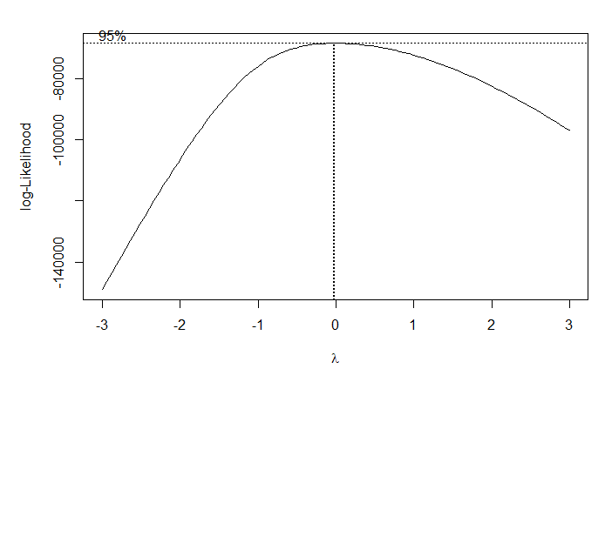

With the lambda value, a new model was built for the transformed dependent variable: (HRLYEARN)^-0.03

**Final Model**

Call:

lm(formula = (HRLYEARN)^-0.03 ~ NOC_10 + NAICS_18 + AGE_12 +

PROV + EDUC + TENURE + FIRMSIZE + MARSTAT + ESTSIZE + FTPTMAIN +

UTOTHRS + PERMTEMP + EFAMTYPE + SCHOOLN + CMA + UNION + AGYOWNK +

MJH + COWMAIN, data = train.19male)

Residual standard error: 0.01079 on 17749 degrees of freedom

Multiple R-squared: 0.552, Adjusted R-squared: 0.5495

F-statistic: 220.9 on 99 and 17749 DF, p-value: < 2.2e-16

R-squared improved from 0.49 (First Model) to 0.55 (Final Model).

**Diagnostic Plots**

|  |  |
| --- | --- |
| **Residuals vs Fitted (Linearity Test)** | **Normal Q-Q (Residuals Normality Test)** |
|  |  |
| **Scale-Location (Homoscedasticity Test)** | **Residuals vs. Leverage (Outliers Test)** |
|  |  |

Looking at the diagnostics plots of the new model we confirm that there are some improvements for linearity, normality, and homoscedasticity. The normality plot points still deviate from the dashed line on the top right corner. However, there is an improvement in the level of skewness of the residuals:

> # Before Transformation:

> skewness(model$residuals)

[1] 1.032538

> # After Transformation

> skewness(new.model$residuals)

[1] 0.4713438

**Prediction**

The final model was applied to predict the hourly wages on the test data set. The next histogram shows the distribution of errors:

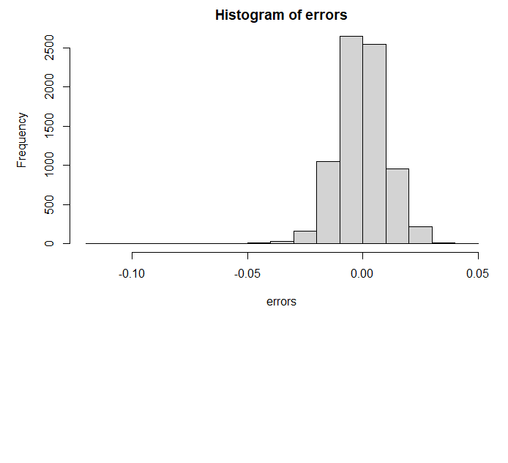

And here are the results for RMSE, MAE and proportion of predicted values close to real ones by 25% or less:

[1] "RMSE: 0.0110021049366726"

[1] "MAE: 0.00830950408353929"

[1] "Percentage of cases with less than 25% error: 100"

**Variables, Coefficients and Significance**

The final model equation with included variables, coefficients and significance is:

|  |  |  |  |  |  |
| --- | --- | --- | --- | --- | --- |
| Independent Variables | Estimate | Std. Error | t value | Pr(>|t|) | Sig |
| (Intercept) | 1.04E+00 | 1.34E-03 | 772.60 | < 2e-16 | *** |
| NOC_10Business, finance & admin. | 1.17E-02 | 4.30E-04 | 27.14 | < 2e-16 | *** |
| NOC_10Natural & applied sciences | 6.93E-03 | 4.14E-04 | 16.73 | < 2e-16 | *** |
| NOC_10Health | 6.63E-03 | 7.33E-04 | 9.04 | < 2e-16 | *** |
| NOC_10Educ., law, community & gov. serv. | 6.69E-03 | 4.90E-04 | 13.67 | < 2e-16 | *** |
| NOC_10Art, culture, rec. & sport | 1.26E-02 | 8.06E-04 | 15.65 | < 2e-16 | *** |
| NOC_10Sales & service | 1.68E-02 | 4.02E-04 | 41.90 | < 2e-16 | *** |
| NOC_10Trades, transport & equipm. Operat. | 1.22E-02 | 3.86E-04 | 31.54 | < 2e-16 | *** |
| NOC_10Natural resources & agriculture | 1.42E-02 | 6.20E-04 | 22.96 | < 2e-16 | *** |
| NOC_10Manufacturing & utilities | 1.50E-02 | 5.02E-04 | 29.83 | < 2e-16 | *** |
| NAICS_18Forestry, Fish., Min., Oil, Gas | -1.24E-02 | 7.51E-04 | -16.53 | < 2e-16 | *** |
| NAICS_18Utilities | -1.31E-02 | 1.07E-03 | -12.30 | < 2e-16 | *** |
| NAICS_18Construction | -8.59E-03 | 8.12E-04 | -10.58 | < 2e-16 | *** |
| NAICS_18Manufacturing durables | -4.16E-03 | 8.36E-04 | -4.98 | 6.51E-07 | *** |
| NAICS_18Manufacturing non-durables | -3.29E-03 | 8.59E-04 | -3.83 | 0.00013 | *** |
| NAICS_18Wholesale Trade | -6.06E-03 | 8.68E-04 | -6.98 | 3.02E-12 | *** |
| NAICS_18Retail Trade | 1.04E-03 | 8.21E-04 | 1.27 | 0.203213 |  |
| NAICS_18Transportation & Warehousing | -2.59E-03 | 8.34E-04 | -3.11 | 0.001888 | ** |
| NAICS_18Finance, Ins., Real E.,Leas. | -6.01E-03 | 8.76E-04 | -6.86 | 7.07E-12 | *** |
| NAICS_18Prof., Scientific & Technical Services | -7.57E-03 | 8.59E-04 | -8.82 | < 2e-16 | *** |
| NAICS_18Management, Admin. & Support | -6.33E-04 | 8.49E-04 | -0.75 | 0.456062 |  |
| NAICS_18Educational Services | -3.40E-03 | 9.49E-04 | -3.59 | 0.000335 | *** |
| NAICS_18Health Care & Social Assist. | 6.96E-04 | 9.35E-04 | 0.75 | 0.456521 |  |
| NAICS_18Information, Culture & Rec. | -2.47E-03 | 8.70E-04 | -2.83 | 0.0046 | ** |
| NAICS_18Accommodation & Food Serv. | 2.42E-03 | 8.74E-04 | 2.77 | 0.005627 | ** |
| NAICS_18Other Services | -3.38E-03 | 8.94E-04 | -3.78 | 0.000155 | *** |
| NAICS_18Public Administration | -5.90E-03 | 9.10E-04 | -6.49 | 9.08E-11 | *** |
| AGE_12.L | 3.41E-04 | 6.27E-04 | 0.54 | 0.586753 |  |
| AGE_12.Q | 7.59E-03 | 5.64E-04 | 13.46 | < 2e-16 | *** |
| AGE_12.C | 1.31E-03 | 4.60E-04 | 2.84 | 0.004563 | ** |
| AGE_12^4 | 5.06E-04 | 4.10E-04 | 1.23 | 0.217689 |  |
| AGE_12^5 | 1.66E-03 | 3.77E-04 | 4.40 | 1.08E-05 | *** |
| AGE_12^6 | -1.54E-04 | 3.46E-04 | -0.45 | 0.655704 |  |
| AGE_12^7 | 9.28E-04 | 3.13E-04 | 2.97 | 0.002991 | ** |
| AGE_12^8 | 3.33E-04 | 2.82E-04 | 1.18 | 0.237998 |  |
| AGE_12^9 | 5.23E-05 | 2.61E-04 | 0.20 | 0.84117 |  |
| AGE_12^10 | -6.96E-05 | 2.51E-04 | -0.28 | 0.781179 |  |
| AGE_12^11 | -1.91E-04 | 2.49E-04 | -0.77 | 0.4419 |  |
| PROVPEI | 3.53E-03 | 6.79E-04 | 5.20 | 1.98E-07 | *** |
| PROVNS | 2.37E-03 | 5.85E-04 | 4.05 | 5.17E-05 | *** |
| PROVNB | 3.30E-03 | 5.86E-04 | 5.63 | 1.84E-08 | *** |
| PROVQC | -1.54E-04 | 5.10E-04 | -0.30 | 0.763376 |  |
| PROVON | -2.43E-03 | 4.89E-04 | -4.98 | 6.45E-07 | *** |
| PROVMB | -9.36E-05 | 5.40E-04 | -0.17 | 0.862393 |  |
| PROVSK | -2.85E-03 | 5.48E-04 | -5.20 | 2.05E-07 | *** |
| PROVAB | -7.27E-03 | 5.18E-04 | -14.03 | < 2e-16 | *** |
| PROVBC | -4.70E-03 | 5.34E-04 | -8.79 | < 2e-16 | *** |
| EDUC.L | -7.63E-03 | 4.28E-04 | -17.84 | < 2e-16 | *** |
| EDUC.Q | -1.31E-03 | 3.95E-04 | -3.32 | 0.000905 | *** |
| EDUC.C | -3.13E-04 | 3.12E-04 | -1.01 | 0.314844 |  |
| EDUC^4 | 4.85E-04 | 3.00E-04 | 1.62 | 0.105728 |  |
| EDUC^5 | -1.21E-04 | 2.08E-04 | -0.58 | 0.560434 |  |
| EDUC^6 | -2.35E-04 | 2.68E-04 | -0.88 | 0.379268 |  |
| TENURE | -6.34E-03 | 2.89E-04 | -21.95 | < 2e-16 | *** |
| FIRMSIZE.L | -2.47E-03 | 2.30E-04 | -10.73 | < 2e-16 | *** |
| FIRMSIZE.Q | 3.82E-04 | 2.13E-04 | 1.79 | 0.073443 | . |
| FIRMSIZE.C | -3.35E-04 | 2.16E-04 | -1.55 | 0.120931 |  |
| MARSTATLiving in common-law | 2.67E-04 | 2.52E-04 | 1.06 | 0.288969 |  |
| MARSTATWidowed | 2.20E-03 | 1.20E-03 | 1.84 | 0.066055 | . |
| MARSTATSeparated | -4.21E-04 | 6.67E-04 | -0.63 | 0.527849 |  |
| MARSTATDivorced | -9.90E-04 | 5.78E-04 | -1.71 | 0.086697 | . |
| MARSTATSingle, never married | 1.71E-03 | 4.14E-04 | 4.12 | 3.76E-05 | *** |
| ESTSIZE.L | -2.40E-03 | 2.47E-04 | -9.75 | < 2e-16 | *** |
| ESTSIZE.Q | -8.07E-04 | 2.04E-04 | -3.95 | 7.75E-05 | *** |
| ESTSIZE.C | 2.60E-04 | 1.81E-04 | 1.44 | 0.151296 |  |
| FTPTMAINPart-time | 5.36E-03 | 4.21E-04 | 12.74 | < 2e-16 | *** |
| UTOTHRS | 5.10E-03 | 1.14E-03 | 4.45 | 8.51E-06 | *** |
| PERMTEMPTemporary, seasonal | 2.89E-03 | 4.07E-04 | 7.09 | 1.36E-12 | *** |
| PERMTEMPTemporary, term or contract | 7.42E-04 | 3.66E-04 | 2.03 | 0.042358 | * |
| PERMTEMPTemporary, casual or other | 2.26E-03 | 5.10E-04 | 4.44 | 9.10E-06 | *** |
| EFAMTYPEHWDENC | -7.46E-04 | 4.36E-04 | -1.71 | 0.087013 | . |
| EFAMTYPEHWDE17 | 7.81E-04 | 5.81E-04 | 1.34 | 0.179368 |  |
| EFAMTYPEHWDE24 | 1.25E-03 | 5.46E-04 | 2.30 | 0.021695 | * |
| EFAMTYPEHWSHNC | -1.10E-03 | 5.01E-04 | -2.19 | 0.028471 | * |
| EFAMTYPEHWSH17 | 9.80E-04 | 6.58E-04 | 1.49 | 0.136104 |  |
| EFAMTYPEHWSH24 | 4.95E-04 | 8.67E-04 | 0.57 | 0.568034 |  |
| EFAMTYPEHWSWNC | 1.69E-03 | 1.20E-03 | 1.41 | 0.158891 |  |
| EFAMTYPEHWSW17 | 1.46E-03 | 1.91E-03 | 0.77 | 0.443709 |  |
| EFAMTYPEHWSW24 | -5.55E-04 | 1.50E-03 | -0.37 | 0.710996 |  |
| EFAMTYPEHWNENC | 2.46E-03 | 9.11E-04 | 2.71 | 0.006812 | ** |
| EFAMTYPEHWNE17 | 7.11E-03 | 2.65E-03 | 2.68 | 0.007294 | ** |
| EFAMTYPEHWNE24 | -1.89E-04 | 2.23E-03 | -0.09 | 0.932427 |  |
| EFAMTYPESPE17 | -1.59E-04 | 6.98E-04 | -0.23 | 0.820329 |  |
| EFAMTYPESPE24 | 1.49E-03 | 7.60E-04 | 1.96 | 0.049558 | * |
| EFAMTYPESPN17 | -2.65E-04 | 1.61E-03 | -0.17 | 0.86908 |  |
| EFAMTYPESPN24 | 2.18E-03 | 1.86E-03 | 1.18 | 0.240192 |  |
| EFAMTYPEOther | 1.73E-03 | 3.80E-04 | 4.56 | 5.19E-06 | *** |
| SCHOOLNFull-time student | 8.40E-04 | 5.23E-04 | 1.61 | 0.108026 |  |
| SCHOOLNPart-time student | 3.04E-03 | 6.86E-04 | 4.43 | 9.66E-06 | *** |
| SCHOOLNUnknown | NA | NA | NA | NA |  |
| CMAToronto | 8.38E-04 | 5.96E-04 | 1.41 | 0.159738 |  |
| CMAVancouver | 2.16E-03 | 6.78E-04 | 3.19 | 0.001423 | ** |
| CMAOther | 5.70E-04 | 4.61E-04 | 1.24 | 0.216587 |  |
| UNIONNot a member but covered by a union contract | -7.65E-04 | 6.06E-04 | -1.26 | 0.206887 |  |
| UNIONNon-unionized | 1.92E-03 | 2.26E-04 | 8.49 | < 2e-16 | *** |
| AGYOWNK.L | 1.26E-03 | 5.53E-04 | 2.28 | 0.022569 | * |
| AGYOWNK.Q | 1.27E-03 | 3.76E-04 | 3.38 | 0.000721 | *** |
| AGYOWNK.C | 4.74E-04 | 4.22E-04 | 1.12 | 0.260905 |  |
| AGYOWNK^4 | 1.67E-04 | 3.98E-04 | 0.42 | 0.674359 |  |
| MJHMultiple jobholder | 7.44E-04 | 4.25E-04 | 1.75 | 0.079817 | . |
| COWMAINPrivate sector | 3.34E-04 | 3.97E-04 | 0.84 | 0.400269 |  |

#### Year 2009, Females

**First Model**

Call:

lm(formula = HRLYEARN ~ NOC_10 + NAICS_18 + EDUC + TENURE + ESTSIZE +

PROV + AGE_12 + COWMAIN + PERMTEMP + FIRMSIZE + FTPTMAIN +

UTOTHRS + UNION + AGYOWNK + SCHOOLN + CMA, data = train.09fem)

Residual standard error: 0.06268 on 19253 degrees of freedom

Multiple R-squared: 0.5226, Adjusted R-squared: 0.5207

F-statistic: 277.3 on 76 and 19253 DF, p-value: < 2.2e-16

**Diagnostic Plots**

|  |  |
| --- | --- |
| **Residuals vs Fitted (Linearity Test)** | **Normal Q-Q (Residuals Normality Test)** |
|  |  |
| **Scale-Location (Homoscedasticity Test)** | **Residuals vs. Leverage (Outliers Test)** |
|  |  |

The conclusions of analyzing the diagnostics plots are:

1. Residuals vs Fitted: The red line is approximately zero but looks curved.
2. Normal Q-Q: normality of the errors does not hold, we can see the marks do not follow a straight diagonal line, specially towards the top right corner.
3. Scale-Location: The line is not completely horizontal, it points upward. The variability of the residual points increases with the value of the fitted outcome variable, suggesting non-constant variances in the residuals.
4. Residuals vs Leverage: Data do not present any influential points. Cook’s distance lines (a red dashed line) are not shown on the Residuals vs Leverage plot because all points are within those limits.

**Box Cox Transformation**

Since the assumptions are not met, transformation of the dependant variable was applied. The best lambda estimation was -0.15. Here is the Maximum likelihood plot to visualize the best lambda estimation:

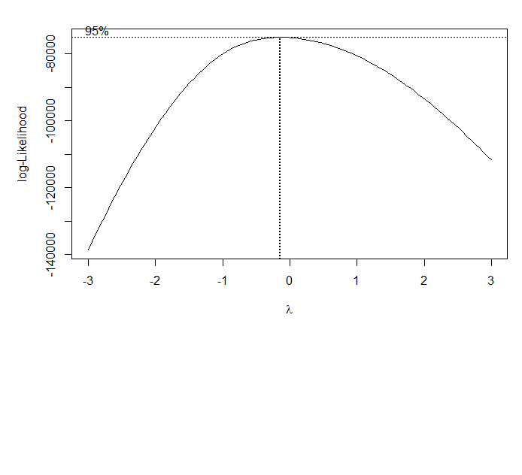

With the lambda value, a new model was built for the transformed dependent variable: (HRLYEARN)^-0.15

**Final Model**

Call:

lm(formula = (HRLYEARN)^-0.15 ~ NOC_10 + NAICS_18 + AGE_12 +

PROV + EDUC + TENURE + ESTSIZE + AGYOWNK + FIRMSIZE + PERMTEMP +

FTPTMAIN + UTOTHRS + MARSTAT + UNION + LFSSTAT + MJH, data = train.09fem)

Residual standard error: 0.07137 on 19252 degrees of freedom

Multiple R-squared: 0.5881, Adjusted R-squared: 0.5864

F-statistic: 356.9 on 77 and 19252 DF, p-value: < 2.2e-16

R-squared improved from 0.52 (First Model) to 0.58 (Final Model).

**Diagnostic Plots**

|  |  |
| --- | --- |
| **Residuals vs Fitted (Linearity Test)** | **Normal Q-Q (Residuals Normality Test)** |
|  |  |
| **Scale-Location (Homoscedasticity Test)** | **Residuals vs. Leverage (Outliers Test)** |
|  |  |

The transformation of the dependent variable helped to improve linearity, and we can see that the line on the plot is now fairly straight. There are some improvements for normality, and homoscedasticity. The normality plot points still deviate from the dashed line on the extremes, specially as they approach the top right corner. Still, there is an improvement in the level of skewness of the residuals:

> # Before Transformation:

> skewness(model$residuals)

[1] 1.181981

> # After Transformation

> skewness(new.model$residuals)

[1] 0.5286001

**Prediction**

The final model was applied to predict the hourly wages on the test data set. The next histogram shows the distribution of errors:

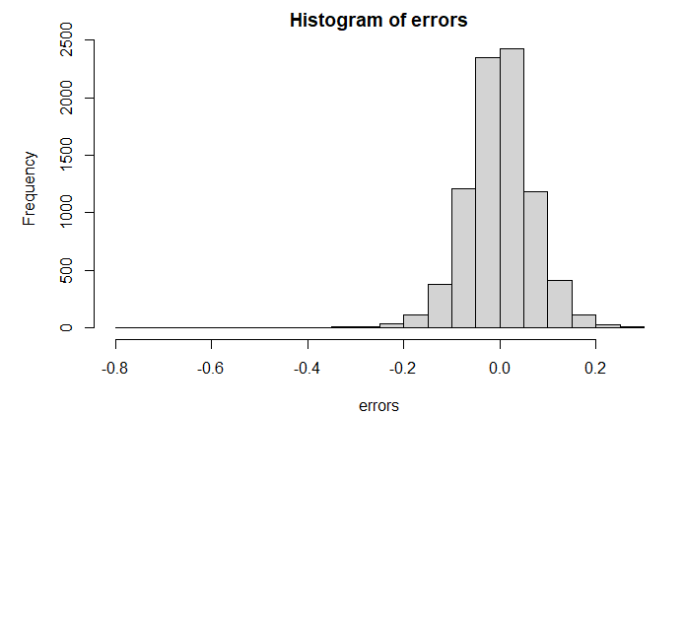

And here are the results for RMSE, MAE and proportion of predicted values close to real ones by 25% or less:

[1] "RMSE: 0.0727054261959815"

[1] "MAE: 0.0534999014295685"

[1] "Percentage of cases with less than 25% error: 99.8430709802028"

**Variables, Coefficients and Significance**

The final model equation with included variables, coefficients and significance is:

|  |  |  |  |  |  |
| --- | --- | --- | --- | --- | --- |
| Independent Variables | Estimate | Std. Error | t value | Pr(>|t|) | Sig |
| (Intercept) | 1.3541 | 0.0099 | 137.05 | < 2e-16 | *** |
| NOC_10Business, finance & administration | 0.0654 | 0.0025 | 26.19 | < 2e-16 | *** |
| NOC_10Natural & applied sciences | 0.0336 | 0.0040 | 8.46 | < 2e-16 | *** |
| NOC_10Health | 0.0159 | 0.0030 | 5.32 | 1.07E-07 | *** |
| NOC_10Educ., law, community & gov. serv. | 0.0313 | 0.0029 | 10.98 | < 2e-16 | *** |
| NOC_10Art, culture, recreation & sport | 0.0488 | 0.0044 | 11.09 | < 2e-16 | *** |
| NOC_10Sales & service | 0.0921 | 0.0026 | 35.67 | < 2e-16 | *** |
| NOC_10Trades, transport & equip. operator | 0.0885 | 0.0046 | 19.38 | < 2e-16 | *** |
| NOC_10Natural resources & agriculture | 0.0730 | 0.0079 | 9.29 | < 2e-16 | *** |
| NOC_10Manufacturing & utilities | 0.1105 | 0.0046 | 24.19 | < 2e-16 | *** |
| NAICS_18Forestry, Fishing, Min., Oil & Gas | -0.0910 | 0.0093 | -9.78 | < 2e-16 | *** |
| NAICS_18Utilities | -0.0805 | 0.0110 | -7.31 | 2.70E-13 | *** |
| NAICS_18Construction | -0.0625 | 0.0094 | -6.68 | 2.45E-11 | *** |
| NAICS_18Manufacturing durables | -0.0694 | 0.0090 | -7.73 | 1.14E-14 | *** |
| NAICS_18Manufacturing non-durables | -0.0402 | 0.0088 | -4.56 | 5.19E-06 | *** |
| NAICS_18Wholesale Trade | -0.0547 | 0.0090 | -6.06 | 1.41E-09 | *** |
| NAICS_18Retail Trade | -0.0022 | 0.0083 | -0.26 | 0.79342 |  |
| NAICS_18Transportation & Warehousing | -0.0493 | 0.0089 | -5.56 | 2.68E-08 | *** |
| NAICS_18Finance, Ins., Real E., Leas. | -0.0585 | 0.0084 | -6.94 | 4.17E-12 | *** |
| NAICS_18Prof., Scientific & Technical Services | -0.0630 | 0.0086 | -7.33 | 2.35E-13 | *** |
| NAICS_18Management, Admin. & Support | -0.0182 | 0.0086 | -2.11 | 0.03463 | * |
| NAICS_18Educational Services | -0.0580 | 0.0085 | -6.84 | 8.12E-12 | *** |
| NAICS_18Health Care & Social Assistance | -0.0365 | 0.0084 | -4.37 | 1.23E-05 | *** |
| NAICS_18Information, Culture & Recreation | -0.0384 | 0.0086 | -4.49 | 7.18E-06 | *** |
| NAICS_18Accommodation & Food Services | -0.0055 | 0.0084 | -0.65 | 0.51345 |  |
| NAICS_18Other Services | -0.0396 | 0.0086 | -4.62 | 3.88E-06 | *** |
| NAICS_18Public Administration | -0.0780 | 0.0085 | -9.22 | < 2e-16 | *** |
| AGE_12.L | -0.0126 | 0.0055 | -2.30 | 0.02175 | * |
| AGE_12.Q | 0.0483 | 0.0054 | 8.91 | < 2e-16 | *** |
| AGE_12.C | -0.0123 | 0.0048 | -2.57 | 0.01008 | * |
| AGE_12^4 | 0.0019 | 0.0042 | 0.45 | 0.65124 |  |
| AGE_12^5 | 0.0069 | 0.0036 | 1.89 | 0.05873 | . |
| AGE_12^6 | -0.0073 | 0.0031 | -2.34 | 0.01934 | * |
| AGE_12^7 | 0.0065 | 0.0026 | 2.49 | 0.01274 | * |
| AGE_12^8 | -0.0035 | 0.0022 | -1.64 | 0.10203 |  |
| AGE_12^9 | -0.0006 | 0.0018 | -0.34 | 0.73106 |  |
| AGE_12^10 | -0.0007 | 0.0016 | -0.45 | 0.65218 |  |
| AGE_12^11 | 0.0017 | 0.0015 | 1.17 | 0.2421 |  |
| PROVPEI | 0.0011 | 0.0042 | 0.26 | 0.79482 |  |
| PROVNS | -0.0051 | 0.0036 | -1.42 | 0.1562 |  |
| PROVNB | 0.0004 | 0.0036 | 0.10 | 0.91714 |  |
| PROVQC | -0.0209 | 0.0031 | -6.75 | 1.54E-11 | *** |
| PROVON | -0.0333 | 0.0030 | -11.18 | < 2e-16 | *** |
| PROVMB | -0.0183 | 0.0033 | -5.56 | 2.80E-08 | *** |
| PROVSK | -0.0340 | 0.0034 | -9.98 | < 2e-16 | *** |
| PROVAB | -0.0603 | 0.0033 | -18.49 | < 2e-16 | *** |
| PROVBC | -0.0410 | 0.0032 | -12.77 | < 2e-16 | *** |
| EDUC.L | -0.0686 | 0.0030 | -23.21 | < 2e-16 | *** |
| EDUC.Q | -0.0140 | 0.0027 | -5.27 | 1.37E-07 | *** |
| EDUC.C | -0.0056 | 0.0021 | -2.64 | 0.00828 | ** |
| EDUC^4 | 0.0047 | 0.0018 | 2.53 | 0.01147 | * |
| EDUC^5 | 0.0071 | 0.0013 | 5.34 | 9.26E-08 | *** |
| EDUC^6 | 0.0029 | 0.0015 | 1.95 | 0.05069 | . |
| TENURE | -0.0496 | 0.0019 | -26.27 | < 2e-16 | *** |
| ESTSIZE.L | -0.0251 | 0.0015 | -16.44 | < 2e-16 | *** |
| ESTSIZE.Q | -0.0007 | 0.0013 | -0.53 | 0.59692 |  |
| ESTSIZE.C | 0.0003 | 0.0012 | 0.24 | 0.81171 |  |
| AGYOWNK.L | 0.0017 | 0.0016 | 1.08 | 0.27855 |  |
| AGYOWNK.Q | -0.0025 | 0.0016 | -1.51 | 0.13118 |  |
| AGYOWNK.C | 0.0002 | 0.0017 | 0.13 | 0.89598 |  |
| AGYOWNK^4 | -0.0029 | 0.0017 | -1.72 | 0.08529 | . |
| FIRMSIZE.L | -0.0108 | 0.0014 | -7.97 | 1.66E-15 | *** |
| FIRMSIZE.Q | 0.0009 | 0.0014 | 0.65 | 0.51598 |  |
| FIRMSIZE.C | -0.0021 | 0.0015 | -1.47 | 0.14102 |  |
| PERMTEMPTemporary, seasonal | 0.0178 | 0.0033 | 5.43 | 5.72E-08 | *** |
| PERMTEMPTemporary, term or contract | 0.0089 | 0.0022 | 4.13 | 3.68E-05 | *** |
| PERMTEMPTemporary, casual or other | 0.0115 | 0.0026 | 4.38 | 1.22E-05 | *** |
| FTPTMAINPart-time | 0.0187 | 0.0022 | 8.53 | < 2e-16 | *** |
| UTOTHRS | 0.0203 | 0.0091 | 2.24 | 0.02544 | * |
| MARSTATLiving in common-law | 0.0011 | 0.0017 | 0.62 | 0.53455 |  |
| MARSTATWidowed | 0.0092 | 0.0042 | 2.21 | 0.02689 | * |
| MARSTATSeparated | 0.0012 | 0.0029 | 0.43 | 0.66826 |  |
| MARSTATDivorced | 0.0003 | 0.0022 | 0.12 | 0.90279 |  |
| MARSTATSingle, never married | 0.0035 | 0.0017 | 2.08 | 0.03718 | * |
| UNIONNot a member but covered by a union contract | -0.0002 | 0.0039 | -0.04 | 0.96695 |  |
| UNIONNon-unionized | 0.0208 | 0.0015 | 14.09 | < 2e-16 | *** |
| LFSSTATEmployed, absent from work | 0.0022 | 0.0019 | 1.14 | 0.25286 |  |
| MJHMultiple jobholder | 0.0003 | 0.0024 | 0.11 | 0.91514 |  |

#### Year 2019, Females

**First Model**

Call:

lm(formula = HRLYEARN ~ NOC_10 + EDUC + TENURE + NAICS_18 + PROV +

ESTSIZE + AGE_12 + COWMAIN + PERMTEMP + FIRMSIZE + FTPTMAIN +

UTOTHRS + EFAMTYPE + LFSSTAT + SCHOOLN + MARSTAT, data = train.19fem)

Residual standard error: 0.077 on 17711 degrees of freedom

Multiple R-squared: 0.516, Adjusted R-squared: 0.5135

F-statistic: 209.8 on 90 and 17711 DF, p-value: < 2.2e-16

**Diagnostic Plots**

|  |  |
| --- | --- |
| **Residuals vs Fitted (Linearity Test)** | **Normal Q-Q (Residuals Normality Test)** |
|  |  |
| **Scale-Location (Homoscedasticity Test)** | **Residuals vs. Leverage (Outliers Test)** |
|  |  |

The conclusions of analyzing the diagnostics plots are:

1. Residuals vs Fitted: The red line is approximately zero, although is curved to the sides, which is not favorable for the linearity assumption.
2. Normal Q-Q: the errors do not seem to be normally distributed. The marks do not follow a straight line.
3. Scale-Location: The line is not completely horizontal, it points upward, which implies non-constant variances in the residuals.
4. Residuals vs Leverage: Data do not present any influential points.

**Box Cox Transformation**

Since the assumptions are not met, transformation of the dependant variable was applied. The best lambda estimation was -0.15. Here is the Maximum likelihood plot to visualize the best lambda estimation:

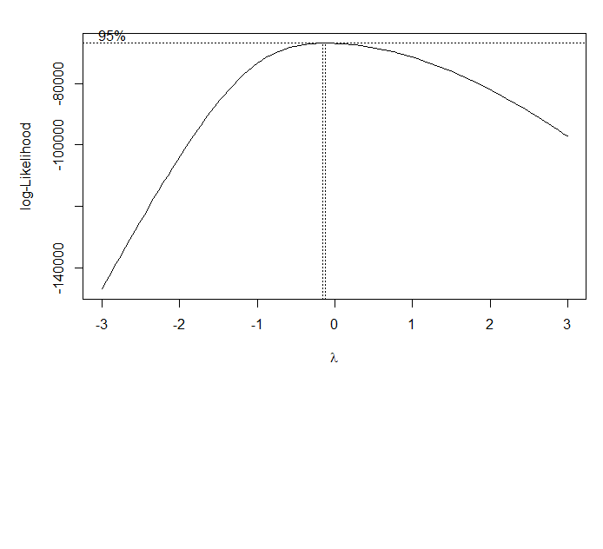

With the lambda value, a new model was built for the transformed dependent variable: (HRLYEARN)^-0.15

**Final Model**

Call:

lm(formula = (HRLYEARN)^-0.15 ~ NOC_10 + EDUC + TENURE + NAICS_18 +

PROV + ESTSIZE + AGE_12 + COWMAIN + PERMTEMP + FIRMSIZE +

FTPTMAIN + UTOTHRS + EFAMTYPE + LFSSTAT + SCHOOLN + MARSTAT,

data = train.19fem)

Residual standard error: 0.06251 on 17711 degrees of freedom

Multiple R-squared: 0.5654, Adjusted R-squared: 0.5632

F-statistic: 256.1 on 90 and 17711 DF, p-value: < 2.2e-16

R-squared improved from 0.51 (First Model) to 0.56 (Final Model).

**Diagnostic Plots**

|  |  |
| --- | --- |
| **Residuals vs Fitted (Linearity Test)** | **Normal Q-Q (Residuals Normality Test)** |
|  |  |
| **Scale-Location (Homoscedasticity Test)** | **Residuals vs. Leverage (Outliers Test)** |
|  |  |

Looking at the first plot, we can see that linearity has improved substantially. Normality and homoscedasticity have improved as well, though not completely. The QQ plot still shows that the marks are not following a straight line on the extremes. Nevertheless, there is an improvement in the level of skewness of the residuals:

> # Before Transformation:

> skewness(model$residuals)

[1] 1.290823

> # After Transformation

> skewness(new.model$residuals)

[1] 0.7025932

**Prediction**

The final model was applied to predict the hourly wages on the test data set. The next histogram shows the distribution of errors:

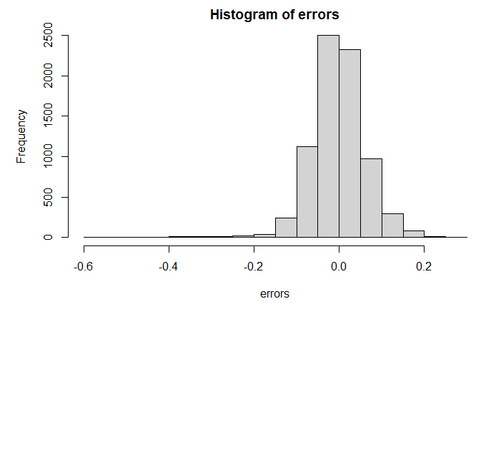

And here are the results for RMSE, MAE and proportion of predicted values close to real ones by 25% or less:

[1] "RMSE: 0.0642458061529313"

[1] "MAE: 0.0470490092790988"

[1] "Percentage of cases with less than 25% error: 99.8951507208388"

**Variables, Coefficients and Significance**

The final model equation with included variables, coefficients and significance is:

|  |  |  |  |  |  |
| --- | --- | --- | --- | --- | --- |
| Independent Variables | Estimate | Std. Error | t value | Pr(>|t|) | Sig |
| (Intercept) | 1.2645 | 0.0097 | 130.38 | < 2e-16 | *** |
| NOC_10Business, finance & administration | 0.0632 | 0.0024 | 26.39 | < 2e-16 | *** |
| NOC_10Natural & applied sciences | 0.0278 | 0.0035 | 7.97 | 1.63E-15 | *** |
| NOC_10Health | 0.0266 | 0.0028 | 9.61 | < 2e-16 | *** |
| NOC_10Educ., law, community & gov. serv. | 0.0488 | 0.0026 | 18.81 | < 2e-16 | *** |
| NOC_10Art, culture, recreation & sport | 0.0663 | 0.0042 | 15.79 | < 2e-16 | *** |
| NOC_10Sales & service | 0.0944 | 0.0025 | 37.70 | < 2e-16 | *** |
| NOC_10Trades, transport & equip. operator | 0.0732 | 0.0041 | 17.81 | < 2e-16 | *** |
| NOC_10Natural resources & agriculture | 0.0629 | 0.0074 | 8.50 | < 2e-16 | *** |
| NOC_10Manufacturing & utilities | 0.1068 | 0.0045 | 23.96 | < 2e-16 | *** |
| EDUC.L | -0.0658 | 0.0032 | -20.37 | < 2e-16 | *** |
| EDUC.Q | -0.0156 | 0.0030 | -5.22 | 1.80E-07 | *** |
| EDUC.C | -0.0143 | 0.0024 | -6.06 | 1.41E-09 | *** |
| EDUC^4 | 0.0082 | 0.0020 | 4.10 | 4.19E-05 | *** |
| EDUC^5 | 0.0049 | 0.0014 | 3.63 | 0.000283 | *** |
| EDUC^6 | 0.0005 | 0.0016 | 0.30 | 0.761548 |  |
| TENURE | -0.0512 | 0.0017 | -29.88 | < 2e-16 | *** |
| NAICS_18Forestry, Fishing, Min., Oil & Gas | -0.0990 | 0.0085 | -11.67 | < 2e-16 | *** |
| NAICS_18Utilities | -0.0949 | 0.0107 | -8.84 | < 2e-16 | *** |
| NAICS_18Construction | -0.0598 | 0.0089 | -6.75 | 1.56E-11 | *** |
| NAICS_18Manufacturing durables | -0.0649 | 0.0089 | -7.27 | 3.84E-13 | *** |
| NAICS_18Manufacturing non-durables | -0.0492 | 0.0088 | -5.60 | 2.14E-08 | *** |
| NAICS_18Wholesale Trade | -0.0645 | 0.0089 | -7.24 | 4.61E-13 | *** |
| NAICS_18Retail Trade | -0.0187 | 0.0083 | -2.24 | 0.025049 | * |
| NAICS_18Transportation & Warehousing | -0.0442 | 0.0087 | -5.06 | 4.20E-07 | *** |
| NAICS_18Finance, Ins., Real E. & Leas. | -0.0696 | 0.0084 | -8.27 | < 2e-16 | *** |
| NAICS_18Prof., Scientific & Technical Services | -0.0635 | 0.0085 | -7.48 | 7.75E-14 | *** |
| NAICS_18Management, Admin. & Support | -0.0341 | 0.0085 | -4.00 | 6.39E-05 | *** |
| NAICS_18Educational Services | -0.0446 | 0.0085 | -5.23 | 1.68E-07 | *** |
| NAICS_18Health Care & Social Assistance | -0.0312 | 0.0083 | -3.74 | 0.000183 | *** |
| NAICS_18Information, Culture & Recreation | -0.0365 | 0.0086 | -4.24 | 2.29E-05 | *** |
| NAICS_18Accommodation & Food Services | -0.0229 | 0.0084 | -2.72 | 0.006637 | ** |
| NAICS_18Other Services | -0.0395 | 0.0086 | -4.61 | 3.98E-06 | *** |
| NAICS_18Public Administration | -0.0600 | 0.0085 | -7.06 | 1.68E-12 | *** |
| PROVPEI | 0.0082 | 0.0038 | 2.17 | 0.02989 | * |
| PROVNS | 0.0202 | 0.0033 | 6.11 | 1.01E-09 | *** |
| PROVNB | 0.0172 | 0.0034 | 5.10 | 3.47E-07 | *** |
| PROVQC | -0.0040 | 0.0029 | -1.39 | 0.164415 |  |
| PROVON | -0.0147 | 0.0028 | -5.29 | 1.26E-07 | *** |
| PROVMB | 0.0067 | 0.0031 | 2.17 | 0.03025 | * |
| PROVSK | -0.0067 | 0.0031 | -2.13 | 0.033308 | * |
| PROVAB | -0.0299 | 0.0030 | -9.88 | < 2e-16 | *** |
| PROVBC | -0.0184 | 0.0029 | -6.26 | 3.95E-10 | *** |
| ESTSIZE.L | -0.0142 | 0.0014 | -10.34 | < 2e-16 | *** |
| ESTSIZE.Q | -0.0019 | 0.0011 | -1.62 | 0.106111 |  |
| ESTSIZE.C | 0.0015 | 0.0011 | 1.40 | 0.162469 |  |
| AGE_12.L | 0.0112 | 0.0039 | 2.87 | 0.004056 | ** |
| AGE_12.Q | 0.0348 | 0.0034 | 10.12 | < 2e-16 | *** |
| AGE_12.C | 0.0090 | 0.0029 | 3.06 | 0.002238 | ** |
| AGE_12^4 | -0.0003 | 0.0026 | -0.11 | 0.910013 |  |
| AGE_12^5 | 0.0083 | 0.0024 | 3.50 | 0.000475 | *** |
| AGE_12^6 | 0.0003 | 0.0021 | 0.13 | 0.893695 |  |
| AGE_12^7 | 0.0052 | 0.0019 | 2.78 | 0.005525 | ** |
| AGE_12^8 | 0.0021 | 0.0017 | 1.26 | 0.206423 |  |
| AGE_12^9 | -0.0009 | 0.0015 | -0.61 | 0.540125 |  |
| AGE_12^10 | -0.0003 | 0.0014 | -0.18 | 0.858006 |  |
| AGE_12^11 | -0.0011 | 0.0014 | -0.76 | 0.448722 |  |
| COWMAINPrivate sector | 0.0276 | 0.0017 | 15.94 | < 2e-16 | *** |
| PERMTEMPTemporary, seasonal | 0.0185 | 0.0032 | 5.82 | 6.04E-09 | *** |
| PERMTEMPTemporary, term or contract | 0.0085 | 0.0020 | 4.34 | 1.41E-05 | *** |
| PERMTEMPTemporary, casual or other | 0.0160 | 0.0024 | 6.80 | 1.07E-11 | *** |
| FIRMSIZE.L | -0.0099 | 0.0013 | -7.68 | 1.69E-14 | *** |
| FIRMSIZE.Q | 0.0007 | 0.0012 | 0.55 | 0.582668 |  |
| FIRMSIZE.C | -0.0005 | 0.0013 | -0.39 | 0.693809 |  |
| FTPTMAINPart-time | 0.0194 | 0.0018 | 10.72 | < 2e-16 | *** |
| UTOTHRS | 0.0367 | 0.0072 | 5.11 | 3.31E-07 | *** |
| EFAMTYPEHWDENC | 0.0009 | 0.0024 | 0.36 | 0.716525 |  |
| EFAMTYPEHWDE17 | 0.0006 | 0.0024 | 0.25 | 0.806441 |  |
| EFAMTYPEHWDE24 | 0.0041 | 0.0026 | 1.58 | 0.114401 |  |
| EFAMTYPEHWSHNC | 0.0085 | 0.0071 | 1.20 | 0.229702 |  |
| EFAMTYPEHWSH17 | 0.0102 | 0.0062 | 1.65 | 0.099388 | . |
| EFAMTYPEHWSH24 | -0.0132 | 0.0083 | -1.58 | 0.113947 |  |
| EFAMTYPEHWSWNC | 0.0048 | 0.0030 | 1.61 | 0.106624 |  |
| EFAMTYPEHWSW17 | 0.0107 | 0.0041 | 2.61 | 0.009197 | ** |
| EFAMTYPEHWSW24 | 0.0144 | 0.0055 | 2.60 | 0.009464 | ** |
| EFAMTYPEHWNENC | 0.0131 | 0.0059 | 2.21 | 0.027448 | * |
| EFAMTYPEHWNE17 | 0.0186 | 0.0153 | 1.21 | 0.225868 |  |
| EFAMTYPEHWNE24 | 0.0038 | 0.0138 | 0.28 | 0.780926 |  |
| EFAMTYPESPE17 | 0.0059 | 0.0023 | 2.59 | 0.009608 | ** |
| EFAMTYPESPE24 | 0.0087 | 0.0035 | 2.48 | 0.01334 | * |
| EFAMTYPESPN17 | 0.0055 | 0.0109 | 0.51 | 0.611402 |  |
| EFAMTYPESPN24 | 0.0134 | 0.0110 | 1.21 | 0.22626 |  |
| EFAMTYPEOther | 0.0083 | 0.0022 | 3.74 | 0.000186 | *** |
| LFSSTATEmployed, absent from work | 0.0029 | 0.0017 | 1.72 | 0.086171 | . |
| SCHOOLNFull-time student | 0.0087 | 0.0025 | 3.40 | 0.000685 | *** |
| SCHOOLNPart-time student | 0.0011 | 0.0030 | 0.37 | 0.710844 |  |
| SCHOOLNUnknown | NA | NA | NA | NA |  |
| MARSTATLiving in common-law | -0.0009 | 0.0015 | -0.61 | 0.539187 |  |
| MARSTATWidowed | 0.0030 | 0.0043 | 0.69 | 0.492362 |  |
| MARSTATSeparated | -0.0093 | 0.0033 | -2.79 | 0.005228 | ** |
| MARSTATDivorced | 0.0003 | 0.0029 | 0.12 | 0.905203 |  |
| MARSTATSingle, never married | 0.0027 | 0.0022 | 1.23 | 0.219413 |  |

#### Conclusions

##### Calls Comparison

Here are the formulas to create the model of each group:

|  |  |  |  |
| --- | --- | --- | --- |
| **Year 2009, Males** | **Year 2019, Males** | **Year 2009, Females** | **Year 2019, Females** |
| lm(formula = (HRLYEARN)^0.21 ~  NOC_10  + NAICS_18  + AGE_12  + PROV  + EDUC  + TENURE  + ESTSIZE  + AGYOWNK  + FIRMSIZE  + PERMTEMP  + FTPTMAIN  + UTOTHRS  + MARSTAT  + UNION  + LFSSTAT  + MJH  , data = train.09male) | lm(formula = (HRLYEARN)^-0.03 ~  NOC_10  + NAICS_18  + AGE_12  + PROV  + EDUC  + TENURE  + FIRMSIZE  + MARSTAT  + ESTSIZE  + FTPTMAIN  + UTOTHRS  + PERMTEMP  + EFAMTYPE  + SCHOOLN  + CMA  + UNION  + AGYOWNK  + MJH  + COWMAIN  , data=train.19male) | lm(formula = (HRLYEARN)^-0.15 ~  NOC_10  + NAICS_18  + AGE_12  + PROV  + EDUC  + TENURE  + ESTSIZE  + AGYOWNK  + FIRMSIZE  + PERMTEMP  + FTPTMAIN  + UTOTHRS  + MARSTAT  + UNION  + LFSSTAT  + MJH  , data = train.09fem) | lm(formula = (HRLYEARN)^-0.15 ~  NOC_10  + EDUC  + TENURE  + NAICS_18  + PROV  + ESTSIZE  + AGE_12  + COWMAIN  + PERMTEMP  + FIRMSIZE  + FTPTMAIN  + UTOTHRS  + EFAMTYPE  + LFSSTAT  + SCHOOLN  + MARSTAT  , data = train.19fem) |

If we compare the four different calls, we can see that:

* Occupation (NOC_10), industry (NAICS_18), age (AGE_12), and province (PROV) are the variables that appear to have more impact
* Education (EDUC) and tenure are also important, especially for women in 2019.

##### Independent Variables Coefficients

The dependant variable was transformed to improve the models for all four groups. In all cases, the transformation required to power the hourly wages to a fraction, meaning that the value changed to a root of the original one. Also, is important to notice that only the model for the Males 2009 population employed a positive exponent, while the rest of the models used negative exponents. This has an effect in the way to interpret the sign of the coefficients.

The sign of a regression coefficient tells whether there is a positive or negative correlation between each independent variable the dependent variable. Usually, a positive coefficient indicates that as the value of the independent variable increases, the mean of the dependent variable also tends to increase. However, when the dependant variable is transformed applying a negative power, the relationship with the coefficients is inversed. That is, a coefficient with a positive sign decreases the value of the dependant variable, and a coefficient with a negative sign increases the value of the dependant variable.

Next, we can see the list of top 10 variable coefficients that help to increment or reduce hourly wages. Only variables that are significant according to the t test are included. Besides, different colors were applied to cells to help identify variables and easily distinguish if they appear in several models and compare their position.

**Top variable coefficients that increase Hourly Wages**

|  |  |  |  |  |  |  |  |
| --- | --- | --- | --- | --- | --- | --- | --- |
| **Year 2009, Males** | | **Year 2019, Males** | | **Year 2009, Females** | | **Year 2019, Females** | |
| Ind. Var. | Est. | Ind. Var. | Est. | Ind. Var. | Est. | Ind. Var. | Est. |
| NAICS_18Utils | 0.053 | NAICS_18Utils | -0.013 | NAICS_18Fores | -0.091 | NAICS_18Fores | -0.099 |
| NAICS_18Fores | 0.049 | NAICS_18Fores | -0.012 | NAICS_18Utils | -0.081 | NAICS_18Utils | -0.095 |
| NAICS_18Const | 0.046 | NAICS_18Const | -0.009 | NAICS_18PubAd | -0.078 | NAICS_18Finan | -0.070 |
| NAICS_18ProSc | 0.046 | EDUC.L | -0.008 | NAICS_18ManuD | -0.069 | EDUC.L | -0.066 |
| NAICS_18PubAd | 0.044 | NAICS_18ProSc | -0.008 | EDUC.L | -0.069 | NAICS_18ManuD | -0.065 |
| EDUC.L | 0.042 | PROVAB | -0.007 | NAICS_18ProSc | -0.063 | NAICS_18Whole | -0.064 |
| PROVAB | 0.039 | TENURE | -0.006 | NAICS_18Const | -0.062 | NAICS_18ProSc | -0.064 |
| NAICS_18ManuD | 0.029 | NAICS_18Whole | -0.006 | PROVAB | -0.060 | NAICS_18PubAd | -0.060 |
| TENURE | 0.028 | NAICS_18Finan | -0.006 | NAICS_18Finan | -0.059 | NAICS_18Const | -0.060 |
| PROVBC | 0.027 | NAICS_18PubAd | -0.006 | NAICS_18Educa | -0.058 | TENURE | -0.051 |

From the list above, we can see that:

* Overall, industries provide the biggest increments across all four groups:
  + “Utilities” and “Forestry, fishing, mining, oil and gas” are the top industries that increase hourly wages for both men and women.
  + “Construction” is also relevant, mainly for men.
  + “Finance, Insurance, Real estate and Leasing” gain relevance among women in 2019.
  + “Professional, Scientific and Technical Services” also rises hourly wages for both genders.
  + “Manufacturing durables” is also relevant, though it lost impact in the Males 2019 group, whereas “Wholesale Trade” appear in the top for 2019 groups.
* Education has a positive linear relationship with hourly wages in all four groups, as we expected after seeing the boxplot analysis from Step 2.
* Alberta is the province that seems to provide the largest boost to wages for all groups except Females 2019.

**Top variable coefficients that decrease Hourly Wages**

|  |  |  |  |  |  |  |  |
| --- | --- | --- | --- | --- | --- | --- | --- |
| **Year 2009, Males** | | **Year 2019, Males** | | **Year 2009, Females** | | **Year 2019, Females** | |
| Ind. Var. | Est. | Ind. Var. | Est. | Ind. Var. | Est. | Ind. Var. | Est. |
| NOC_10ManUtil | -0.076 | NOC_10Sales | 0.017 | NOC_10ManUtil | 0.111 | NOC_10ManUtil | 0.107 |
| NOC_10Sales | -0.069 | NOC_10ManUtil | 0.015 | NOC_10Sales | 0.092 | NOC_10Sales | 0.094 |
| NOC_10BusFin | -0.062 | NOC_10NatAgri | 0.014 | NOC_10Trades | 0.088 | NOC_10Trades | 0.073 |
| NOC_10NatAgri | -0.058 | NOC_10ArtCul | 0.013 | NOC_10NatAgri | 0.073 | NOC_10ArtCul | 0.066 |
| NOC_10Trades | -0.057 | NOC_10Trades | 0.012 | NOC_10BusFin | 0.065 | NOC_10BusFin | 0.063 |
| AGE_12.Q | -0.053 | NOC_10BusFin | 0.012 | NOC_10ArtCul | 0.049 | NOC_10NatAgri | 0.063 |
| NOC_10ArtCul | -0.044 | AGE_12.Q | 0.008 | AGE_12.Q | 0.048 | NOC_10EduLaw | 0.049 |
| UTOTHRS | -0.032 | EFAMTYPE HWNE17 | 0.007 | NOC_10NatASc | 0.034 | UTOTHRS | 0.037 |
| NOC_10NatASc | -0.030 | NOC_10NatASc | 0.007 | NOC_10EduLaw | 0.031 | AGE_12.Q | 0.035 |
| NOC_10EduLaw | -0.030 | NOC_10EduLaw | 0.007 | UNIONNon-uni. | 0.021 | NOC_10NatASc | 0.028 |

From the table, we observe that:

* Many of the variables that can have a negative impact in hourly wages are occupations:
  + “Manufacturing and utilities” are the occupations with highest coefficients that decreases hourly wages. Of note, “Utilities” was previously identified as the one of the industries that provides a positive impact in hourly wages. These results tell us that, probably, within that industry other type of occupations are the ones receiving the highest wages.
  + “Sales and services” occupations also tend to point to lower hourly wages.
  + “Natural resources and agriculture” as well as “Trades, transport and equipment operators” also appear to decrease the dependent variable.
  + The only occupations that are not listed are “Management” and “Health”.
* There is negative quadratic relationship between age and hourly wages, as we could see in the boxplot analysis on Step 2, where hourly wages tend to increase with age at the beginning, then there is a peak and a subsequent decrement as the employees get older. These seem to be especially noticeable in male groups.

## Step 5: Gender Proportions by Sector, Industry and Occupation

Last research questions require an analysis and comparison of the proportions of men and women by sector, industry, and job occupation. To solve these inquiries, two proportions z-test were performed.

### Two Proportions Z-Test

This test is used to compare two observed proportions. The null hypothesis is defined as follow:

* H0: Two proportions are the same, equal

And there are two possible alternative hypotheses:

* HA: Two proportions are not the same, unequal (two-tailed test), or
* HA: One proportion is greater or less than the other (one-tailed test)

The test statistic (z-test) it is calculated using the proportions from each group or sample, and the overall proportions p and q, where:

* p = sum of successes in both samples / sum of both samples (n1 + n2)
* q = 1 – p

The significance level alpha can be set at 0.05 or 5%, to get 95% confidence level. If the p-value of the test is less than the significance level alpha, we can conclude that the proportions of the two compared groups are significantly different.

This z-test is valid only when the sample sizes are large enough, meaning that all next calculations should result in a number greater or equal to 5:

|  |  |
| --- | --- |
| * Sample n1 * p * Sample n1 * q * Sample n2 * p * Sample n2 * q | >= 5 |

Other conditions to perform this test are:

* Randomness: Randomly selected observations
* Normality: number of successes and failures in each of the sample must be at least 10
* Independence: sampling with replacement or sample size is no longer than 10% of the population.

#### Large Sample Assumption Test

To verify that the sample size of each subset is large enough to do the z-test, the required calculations were performed considering the proportion of women in each group. All results were greater than 5, as can be seen in the table below.

**Column Names:**

* n1 = Sample 2009
* n2 = Sample 2019
* p = Overall proportion of women (sum of women cases in 2009 and 2019, divided by sum of samples)
* q = 1 – p

|  |  |  |  |  |  |  |  |  |
| --- | --- | --- | --- | --- | --- | --- | --- | --- |
|  | **Samples** | | **Overall**  **Proportions** | | **>= 5 Check** | | | |
| **Variable** | **n1** | **n2** | **p** | **q** | **n1*p** | **n1*q** | **n2*p** | **n2*q** |
| **SECTOR** |  |  |  |  |  |  |  |  |
| Private sector | 40,123 | 37,231 | 0.45 | 0.55 | 18,236 | 21,887 | 16,922 | 20,309 |
| Public sector | 14,434 | 13,700 | 0.64 | 0.36 | 9,178 | 5,256 | 8,711 | 4,989 |
| **INDUSTRY** |  |  |  |  |  |  |  |  |
| Accommodation & Food Serv. | 3,947 | 3,540 | 0.63 | 0.37 | 2,489 | 1,458 | 2,233 | 1,307 |
| Agriculture | 718 | 709 | 0.33 | 0.67 | 238 | 480 | 235 | 474 |
| Construction | 3,590 | 3,746 | 0.12 | 0.88 | 422 | 3,168 | 441 | 3,305 |
| Educational Services | 4,574 | 4,465 | 0.69 | 0.31 | 3,174 | 1,400 | 3,099 | 1,366 |
| Finance, Ins., Real Est. & Leas. | 2,794 | 2,506 | 0.63 | 0.37 | 1,748 | 1,046 | 1,567 | 939 |
| Forest., Fishing, Min., Oil & Gas | 1,566 | 1,481 | 0.16 | 0.84 | 244 | 1,322 | 231 | 1,250 |
| Health Care & Social Assist. | 7,280 | 7,432 | 0.85 | 0.15 | 6,156 | 1,124 | 6,284 | 1,148 |
| Information, Culture & Rec. | 2,185 | 1,858 | 0.48 | 0.52 | 1,057 | 1,128 | 899 | 959 |
| Management, Admin. & Support | 1,813 | 1,621 | 0.43 | 0.57 | 785 | 1,028 | 702 | 919 |
| Manufacturing durables | 3,245 | 2,736 | 0.20 | 0.80 | 634 | 2,611 | 535 | 2,201 |
| Manufacturing non-durables | 2,783 | 2,308 | 0.36 | 0.64 | 998 | 1,785 | 828 | 1,480 |
| Other Services | 2,056 | 1,716 | 0.54 | 0.46 | 1,103 | 953 | 921 | 795 |
| Prof., Scientific & Technical S. | 2,160 | 2,494 | 0.48 | 0.52 | 1,041 | 1,119 | 1,201 | 1,293 |
| Public Administration | 3,758 | 3,550 | 0.50 | 0.50 | 1,893 | 1,865 | 1,789 | 1,761 |
| Retail Trade | 7,149 | 6,125 | 0.56 | 0.44 | 4,033 | 3,116 | 3,455 | 2,670 |
| Transportation & Warehousing | 2,537 | 2,559 | 0.27 | 0.73 | 679 | 1,858 | 685 | 1,874 |
| Utilities | 633 | 495 | 0.23 | 0.77 | 143 | 490 | 112 | 383 |
| Wholesale Trade | 1,769 | 1,590 | 0.30 | 0.70 | 523 | 1,246 | 470 | 1,120 |
| **JOB OCCUPATION** |  |  |  |  |  |  |  |  |
| Art, culture, recreation & sport | 952 | 861 | 0.59 | 0.41 | 561 | 391 | 508 | 353 |
| Business, finance & admin. | 9,822 | 8,085 | 0.75 | 0.25 | 7,320 | 2,502 | 6,026 | 2,059 |
| Educ., law, community & gov. s. | 5,143 | 6,371 | 0.72 | 0.28 | 3,677 | 1,466 | 4,556 | 1,815 |
| Health | 3,923 | 4,077 | 0.86 | 0.14 | 3,361 | 562 | 3,492 | 585 |
| Management | 3,587 | 2,956 | 0.43 | 0.57 | 1,529 | 2,058 | 1,260 | 1,696 |
| Manufacturing & utilities | 2,825 | 2,589 | 0.27 | 0.73 | 756 | 2,069 | 693 | 1,896 |
| Natural & applied sciences | 3,380 | 3,583 | 0.23 | 0.77 | 767 | 2,613 | 813 | 2,770 |
| Natural resources & agriculture | 1,581 | 1,572 | 0.19 | 0.81 | 298 | 1,283 | 297 | 1,275 |
| Sales & service | 14,578 | 12,782 | 0.59 | 0.41 | 8,544 | 6,034 | 7,492 | 5,290 |
| Trades, transport & equipm. op. | 8,766 | 8,055 | 0.07 | 0.93 | 572 | 8,194 | 525 | 7,530 |

#### Normality Assumption Test

Both total number of observations for men and women are greater than 10 in all groups:

|  |  |  |  |  |
| --- | --- | --- | --- | --- |
|  | **Female** | | **Male** | |
| **Value** | **2009** | **2019** | **2009** | **2019** |
| **SECTOR** |  |  |  |  |
| Private sector | 18,508 | 16,650 | 21,615 | 20,581 |
| Public sector | 9,107 | 8,782 | 5,327 | 4,918 |
| **INDUSTRY** |  |  |  |  |
| Accommodation & Food Services | 2,518 | 2,204 | 1,429 | 1,336 |
| Agriculture | 221 | 252 | 497 | 457 |
| Construction | 381 | 482 | 3,209 | 3,264 |
| Educational Services | 3,114 | 3,159 | 1,460 | 1,306 |
| Finance, Insurance, Real Est. & Leas. | 1,823 | 1,492 | 971 | 1,014 |
| Forestry, Fishing, Min., Oil & Gas | 236 | 239 | 1,330 | 1,242 |
| Health Care & Social Assistance | 6,213 | 6,227 | 1,067 | 1,205 |
| Information, Culture & Recreation | 1,079 | 877 | 1,106 | 981 |
| Management, Admin. & Support | 821 | 666 | 992 | 955 |
| Manufacturing durables | 640 | 529 | 2,605 | 2,207 |
| Manufacturing non-durables | 1,007 | 819 | 1,776 | 1,489 |
| Other Services | 1,127 | 897 | 929 | 819 |
| Prof., Scientific & Technical Services | 1,074 | 1,168 | 1,086 | 1,326 |
| Public Administration | 1,878 | 1,804 | 1,880 | 1,746 |
| Retail Trade | 4,155 | 3,333 | 2,994 | 2,792 |
| Transportation & Warehousing | 677 | 687 | 1,860 | 1,872 |
| Utilities | 140 | 115 | 493 | 380 |
| Wholesale Trade | 511 | 482 | 1,258 | 1,108 |
| **JOB OCCUPATION** |  |  |  |  |
| Art, culture, recreation & sport | 576 | 493 | 376 | 368 |
| Business, finance & administration | 7,388 | 5,958 | 2,434 | 2,127 |
| Educ., law, community & gov. services | 3,664 | 4,569 | 1,479 | 1,802 |
| Health | 3,398 | 3,455 | 525 | 622 |
| Management | 1,546 | 1,243 | 2,041 | 1,713 |
| Manufacturing & utilities | 800 | 649 | 2,025 | 1,940 |
| Natural & applied sciences | 748 | 832 | 2,632 | 2,751 |
| Natural resources & agriculture | 266 | 329 | 1,315 | 1,243 |
| Sales & service | 8,695 | 7,341 | 5,883 | 5,441 |
| Trades, transport & equipment operators | 534 | 563 | 8,232 | 7,492 |

#### Independence Assumption Test

The population of employees was estimated by multiplying the total population of Canada of age 15 or older by the percentages of employed people in the data set (LFSSTAT = "Employed, at work", or "Employed, absent from work").

|  |  |  |
| --- | --- | --- |
|  | **2009** | **2019** |
| Total Canadian Population 15 years or older | 28,008,741 | 31,574,973 |
| Employed Percentage  (LFSSTAT = "Employed, at work", or "Employed,absent from work") | 60% | 56% |
| **Total Employed Estimate** | **16,911,247** | **17,641,170** |

Then, population estimates for each group were calculated multiplying the different proportions observed by sector, industry, and job occupation. All sub-sample sizes were less than 10% of the estimated total population:

|  |  |  |  |  |  |  |  |  |  |  |
| --- | --- | --- | --- | --- | --- | --- | --- | --- | --- | --- |
|  | **% of**  **Employed** | | **Population Estimate** | | **10% of Estimate** | | **Sample Size** | | **Sample Size > 10%** | |
|  | **‘09** | **‘19** | **‘09** | **‘19** | **‘09** | **‘19** | **‘09** | **‘19** | **‘09** | **‘19** |
| **Total Employed**  **Estimate** | **100%** | **100%** | **16,911,247** | **17,641,170** | **1,691,125** | **1,764,117** | **54,557** | **50,931** | **F** | **F** |
| **SECTOR** |  |  |  |  |  |  |  |  |  |  |
| Private sector | 74% | 73% | 12,437,084 | 12,895,847 | 1,243,708 | 1,289,585 | 40,123 | 37,231 | F | F |
| Public sector | 26% | 27% | 4,474,164 | 4,745,323 | 447,416 | 474,532 | 14,434 | 13,700 | F | F |
| **INDUSTRY** |  |  |  |  |  |  |  |  |  |  |
| Accommodation & Food Serv. | 7% | 7% | 1,223,467 | 1,226,164 | 122,347 | 122,616 | 3,947 | 3,540 | F | F |
| Agriculture | 1% | 1% | 222,561 | 245,579 | 22,256 | 24,558 | 718 | 709 | F | F |
| Construction | 7% | 7% | 1,112,806 | 1,297,517 | 111,281 | 129,752 | 3,590 | 3,746 | F | F |
| Educational Services | 8% | 9% | 1,417,821 | 1,546,560 | 141,782 | 154,656 | 4,574 | 4,465 | F | F |
| Finance, Ins., Real Est. & Leas. | 5% | 5% | 866,067 | 868,013 | 86,607 | 86,801 | 2,794 | 2,506 | F | F |
| Forest., Fishing, Min., Oil & Gas | 3% | 3% | 485,419 | 512,980 | 48,542 | 51,298 | 1,566 | 1,481 | F | F |
| Health Care & Social Assist. | 13% | 15% | 2,256,610 | 2,574,251 | 225,661 | 257,425 | 7,280 | 7,432 | F | F |
| Information, Culture & Rec. | 4% | 4% | 677,293 | 643,563 | 67,729 | 64,356 | 2,185 | 1,858 | F | F |
| Management, Admin. & Support | 3% | 3% | 561,983 | 561,472 | 56,198 | 56,147 | 1,813 | 1,621 | F | F |
| Manufacturing durables | 6% | 5% | 1,005,865 | 947,679 | 100,587 | 94,768 | 3,245 | 2,736 | F | F |
| Manufacturing non-durables | 5% | 5% | 862,657 | 799,431 | 86,266 | 79,943 | 2,783 | 2,308 | F | F |
| Other Services | 4% | 3% | 637,306 | 594,378 | 63,731 | 59,438 | 2,056 | 1,716 | F | F |
| Prof., Scientific & Technical Se. | 4% | 5% | 669,544 | 863,857 | 66,954 | 86,386 | 2,160 | 2,494 | F | F |
| Public Administration | 7% | 7% | 1,164,882 | 1,229,627 | 116,488 | 122,963 | 3,758 | 3,550 | F | F |
| Retail Trade | 13% | 12% | 2,216,004 | 2,121,540 | 221,600 | 212,154 | 7,149 | 6,125 | F | F |
| Transportation & Warehousing | 5% | 5% | 786,404 | 886,371 | 78,640 | 88,637 | 2,537 | 2,559 | F | F |
| Utilities | 1% | 1% | 196,213 | 171,455 | 19,621 | 17,146 | 633 | 495 | F | F |
| Wholesale Trade | 3% | 3% | 548,344 | 550,735 | 54,834 | 55,073 | 1,769 | 1,590 | F | F |
| **JOB OCCUPATION** | |  |  |  |  |  |  |  |  |  |
| Art, culture, recreation & sport | 2% | 2% | 295,095 | 298,228 | 29,510 | 29,823 | 952 | 861 | F | F |
| Business, finance & admin. | 18% | 16% | 3,044,564 | 2,800,433 | 304,456 | 280,043 | 9,822 | 8,085 | F | F |
| Educ., law, community & gov. s. | 9% | 13% | 1,594,196 | 2,206,748 | 159,420 | 220,675 | 5,143 | 6,371 | F | F |
| Health | 7% | 8% | 1,216,028 | 1,412,166 | 121,603 | 141,217 | 3,923 | 4,077 | F | F |
| Management | 7% | 6% | 1,111,876 | 1,023,881 | 111,188 | 102,388 | 3,587 | 2,956 | F | F |
| Manufacturing & utilities | 5% | 5% | 875,676 | 896,762 | 87,568 | 89,676 | 2,825 | 2,589 | F | F |
| Natural & applied sciences | 6% | 7% | 1,047,712 | 1,241,058 | 104,771 | 124,106 | 3,380 | 3,583 | F | F |
| Natural resources & agriculture | 3% | 3% | 490,069 | 544,500 | 49,007 | 54,450 | 1,581 | 1,572 | F | F |
| Sales & service | 27% | 25% | 4,518,800 | 4,427,351 | 451,880 | 442,735 | 14,578 | 12,782 | F | F |
| Trades, transport & equipm. op. | 16% | 16% | 2,717,231 | 2,790,042 | 271,723 | 279,004 | 8,766 | 8,055 | F | F |

*Note: F = FALSE*

Next, the results of analysing gender distribution by Sector, Industry, and Occupation. Each section includes a summary of findings, graphs to show the proportions by group and the z-test results.

Note that all the graphs and tables are sorted according to female proportion, in ascending order. Also, the alternative hypotheses chosen depended on whether women participation increased or decreased from 2009 to 2019.

### Sector Analysis

The following breakdown shows that there is a larger female presence in the public sector than in the private sector. In the public sector 6 out of 10 employees are women. Besides, the proportion of women in this sector increased by 1% between years. In contrast, the participation of women in the private sector decrease slightly from 46% in 2009 to 45% in 2019.

|  |  |
| --- | --- |
| **Sector** | **Test Results** |
| Private | X-squared = 15.371, df = 1, p-value = 4.417e-05  alternative hypothesis: greater  95 percent confidence interval:  0.008155203 1.000000000  sample estimates:  prop 1 prop 2  0.4612816 0.4472080 |
| Public | X-squared = 3.0416, df = 1, p-value = 0.04058  alternative hypothesis: less  95 percent confidence interval:  -1.0000000000 -0.0005711443  sample estimates:  prop 1 prop 2  0.6309408 0.6410219 |

### Industry Analysis

The industries mostly dominated by men are: “Construction”, "Forestry, Fishing, Mining, Oil and Gas", and "Manufacturing durables". In these industries, 8 to 9 out of 10 employees are men. Other examples of industries were male presence is prominent are “Utilities”, "Transportation and Warehousing", "Wholesale Trade", "Manufacturing non-durables" and "Agriculture".

On the opposite side, the industries with large proportion of female employees are: "Health Care and Social Assistance", "Educational Services", and "Accommodation and Food Services".

From 2009 to 2019, these are the industries were women participation rose:

* Agriculture, from 31% to 36%
* Educational services, from 68% to 71%
* Construction, from 11% to 13%

Meanwhile, these were the ones where female presence decreased significantly:

* Finance, Insurance, Real Estate and Leasing, from 65% to 60%
* Management, Administrative and Other Support, from 45% to 41%
* Retail Trade, from 58% to 54%
* Professional, Scientific and Technical Services, from 50% to 47%
* Health Care and Social Assistance, from 85% to 84%

More details are provided in the next graphs and tests results. The visual analysis of industries was divided in three graphs to accommodate text.

|  |  |
| --- | --- |
| **Industry** | **Test Results** |
| Construction | X-squared = 8.7586, df = 1, p-value = 0.001541  alternative hypothesis: less  95 percent confidence interval:  -1.000000000 -0.009921907  sample estimates:  prop 1 prop 2  0.1061281 0.1286706 |
| Forestry, Fishing, Mining, Oil and Gas | X-squared = 0.58053, df = 1, p-value = 0.2231  alternative hypothesis: less  95 percent confidence interval:  -1.00000000 0.01162354  sample estimates:  prop 1 prop 2  0.1507024 0.1613774 |
| Manufacturing Durables | X-squared = 0.11841, df = 1, p-value = 0.3654  alternative hypothesis: greater  95 percent confidence interval:  -0.01337678 1.00000000  sample estimates:  prop 1 prop 2  0.1972265 0.1933480 |
| Utilities | X-squared = 0.13892, df = 1, p-value = 0.3547  alternative hypothesis: less  95 percent confidence interval:  -1.00000000 0.03201062  sample estimates:  prop 1 prop 2  0.2211690 0.2323232 |
| Transportation and Warehousing | X-squared = 0.0096919, df = 1, p-value = 0.4608  alternative hypothesis: less  95 percent confidence interval:  -1.00000000 0.01918169  sample estimates:  prop 1 prop 2  0.2668506 0.2684642 |
| Wholesale Trade | X-squared = 0.75298, df = 1, p-value = 0.1928  alternative hypothesis: less  95 percent confidence interval:  -1.0000000 0.0122707  sample estimates:  prop 1 prop 2  0.2888638 0.3031447 |
| Manufacturing non-durables | X-squared = 0.23825, df = 1, p-value = 0.3127  alternative hypothesis: greater  95 percent confidence interval:  -0.01560947 1.00000000  sample estimates:  prop 1 prop 2  0.3618397 0.3548527 |
| Agriculture | X-squared = 3.4405, df = 1, p-value = 0.03181  alternative hypothesis: less  95 percent confidence interval:  -1.000000000 -0.005276911  sample estimates:  prop 1 prop 2  0.3077994 0.3554302 |
| Management, Administration and Support | X-squared = 5.9742, df = 1, p-value = 0.007258  alternative hypothesis: greater  95 percent confidence interval:  0.01358235 1.00000000  sample estimates:  prop 1 prop 2  0.4528406 0.4108575 |
| Professional, Scientific and Technical Services | X-squared = 3.7569, df = 1, p-value = 0.0263  alternative hypothesis: greater  95 percent confidence interval:  0.00431574 1.00000000  sample estimates:  prop 1 prop 2  0.4972222 0.4683240 |
| Information, Culture and Recreation | X-squared = 1.826, df = 1, p-value = 0.0883  alternative hypothesis: greater  95 percent confidence interval:  -0.004620229 1.000000000  sample estimates:  prop 1 prop 2  0.4938215 0.4720129 |
| Public Administration | X-squared = 0.48639, df = 1, p-value = 0.2428  alternative hypothesis: less  95 percent confidence interval:  -1.00000000 0.01108627  sample estimates:  prop 1 prop 2  0.4997339 0.5081690 |
| Other Services | X-squared = 2.3303, df = 1, p-value = 0.06344  alternative hypothesis: greater  95 percent confidence interval:  -0.001929488 1.000000000  sample estimates:  prop 1 prop 2  0.5481518 0.5227273 |
| Retail Trade | X-squared = 18.252, df = 1, p-value = 9.675e-06  alternative hypothesis: greater  95 percent confidence interval:  0.0226837 1.0000000  sample estimates:  prop 1 prop 2  0.5812002 0.5441633 |
| Finance, Insurance, Real Estate and Leasing | X-squared = 18.143, df = 1, p-value = 1.025e-05  alternative hypothesis: greater  95 percent confidence interval:  0.03481883 1.00000000  sample estimates:  prop 1 prop 2  0.6524696 0.5953711 |
| Accommodation and Food Services | X-squared = 1.8235, df = 1, p-value = 0.08845  alternative hypothesis: greater  95 percent confidence interval:  -0.003296079 1.000000000  sample estimates:  prop 1 prop 2  0.6379529 0.6225989 |
| Educational Services | X-squared = 7.4584, df = 1, p-value = 0.003157  alternative hypothesis: less  95 percent confidence interval:  -1.0000000 -0.0105416  sample estimates:  prop 1 prop 2  0.6808045 0.7075028 |
| Health Care and Social Assistance | X-squared = 6.7094, df = 1, p-value = 0.004795  alternative hypothesis: greater  95 percent confidence interval:  0.005639885 1.000000000  sample estimates:  prop 1 prop 2  0.8534341 0.8378633 |

### Occupation Analysis

The job occupations dominated by men are “Trades, transport, and equipment operators”, “Natural resources and agriculture”, “Natural and applied sciences”, and “Manufacturing and utilities”.

On the other hand, the occupations were women have their largest participation are “Health”, “Business, finance, and administration”, “Education, law, community, and government services”.

Over the course of the decade, the presence of women grew significantly in:

* Natural resources and agriculture from 17% to 21%
* Trades, transport, and equipment operators from 6% to 7%

At the same time, the female proportion decreased significantly in the next occupations:

* Manufacturing and utilities from 28% to 25%
* Sales and services, from 60% to 57%
* Business, finance, and administration, from 75% to 74%
* Health from 87% to 85%

All results are provided in the next graphs and tables. Occupations are shown in two separate graphs to accommodate text.

|  |  |
| --- | --- |
| **Job Occupation** | **Test Results** |
| Trades, transport, and equipment operators | X-squared = 5.403, df = 1, p-value = 0.01005  alternative hypothesis: less  95 percent confidence interval:  -1.000000000 -0.002573939  sample estimates:  prop 1 prop 2  0.06091718 0.06989448 |
| Natural resources and agriculture | X-squared = 8.4056, df = 1, p-value = 0.00187  alternative hypothesis: less  95 percent confidence interval:  -1.0000000 -0.0175078  sample estimates:  prop 1 prop 2  0.1682479 0.2092875 |
| Natural and Applied Sciences | X-squared = 1.1179, df = 1, p-value = 0.1452  alternative hypothesis: less  95 percent confidence interval:  -1.000000000 0.005891185  sample estimates:  prop 1 prop 2  0.2213018 0.2322076 |
| Manufacturing and utilities | X-squared = 7.1194, df = 1, p-value = 0.003813  alternative hypothesis: greater  95 percent confidence interval:  0.01237363 1.00000000  sample estimates:  prop 1 prop 2  0.2831858 0.2506759 |
| Management | X-squared = 0.68827, df = 1, p-value = 0.2034  alternative hypothesis: greater  95 percent confidence interval:  -0.01000759 1.00000000  sample estimates:  prop 1 prop 2  0.4310008 0.4205007 |
| Art, culture, recreation, and sport | X-squared = 1.8359, df = 1, p-value = 0.08771  alternative hypothesis: greater  95 percent confidence interval:  -0.006708564 1.000000000  sample estimates:  prop 1 prop 2  0.605042 0.572590 |
| Sales and service | X-squared = 13.65, df = 1, p-value = 0.0001101  alternative hypothesis: greater  95 percent confidence interval:  0.01223069 1.00000000  sample estimates:  prop 1 prop 2  0.5964467 0.5743233 |
| Education, law, community, and government services | X-squared = 0.28984, df = 1, p-value = 0.2952  alternative hypothesis: less  95 percent confidence interval:  -1.000000000 0.009369943  sample estimates:  prop 1 prop 2  0.7124247 0.7171559 |
| Business, finance, and administration | X-squared = 5.3661, df = 1, p-value = 0.01027  alternative hypothesis: greater  95 percent confidence interval: 0.004375397 1.000000000  sample estimates:  prop 1 prop 2  0.7521890 0.7369202 |
| Health | X-squared = 5.5633, df = 1, p-value = 0.00917  alternative hypothesis: greater  95 percent confidence interval: 0.005612905 1.000000000  sample estimates:  prop 1 prop 2  0.8661738 0.8474368 |

# Conclusions

Here are the answers to the research questions.

***What variables were relevant to explain hourly wages by gender when the decade started?***

***After 10 years, are these variables still important?***

***Are they the same for women and for men?***

According to the regression analysis performed and the subsequent models obtained, the variables that have more impact on hourly wages regardless year and gender are occupation (NOC_10), industry (NAICS_18), age (AGE_12), and province (PROV). Besides, education (EDUC) and tenure are important, especially for women in 2019.

Particularly, industries like "Utilities", "Forestry, Fishing, Mining, Oil and Gas", show a positive influence on hourly wages for both genders throughout the years. Also, "Construction" was mainly beneficial for men, and "Finance, Insurance, Real Estate and Leasing" for women.

Education has a linear relationship with hourly wages, which tend to increase as the former does.

Meanwhile, age has a quadratic relationship, where wages tend to increase and peak when individuals are 40 to 50 years old and begin to decrease afterwards. Also, among provinces, Alberta is the one that seems to have the most positive effect.

In contrast, some occupations tend to reflect negatively on hourly wages, especially “Manufacturing and utilities” and “Sales and Services”. Since “Utilities” was previously identified as one of the industries with positive impact, these results might imply that in this industry other type of occupations are the ones receiving the highest wages. Of note, the only occupations that did not appear among the variables with biggest diminishing effect on hourly wages were "Management" and “Health”.

***What were the sectors, industries, and job occupations with highest hourly wages by gender at the beginning of the decade?***

***Are these the same by the end of 2019?***

***Which of these groups show more equality in wages by gender?***

There are two sectors, public and private. Between them the one that tend to offer the highest hourly wages is the public sector for both genders over time. Anyway, men out earn women in both sectors.

The industries with distributions at the higher end of hourly wages are "Utilities", "Public Administration", "Forestry, Fishing, Mining, Oil and Gas", "Educational Services" and "Professional, Scientific and Technical Services". These remained the same through time. Men tend to get higher hourly wages than women overall, and the smallest gaps are found in "Management, Administrative and Other Support" and "Accommodation and Food Services".

Among occupations, the top ones by hourly wages are “Management”, “Educational Services”, and “Natural and Applied Sciences”. Again, these were consistent over the course of the decade. Males tend to have higher hourly wages, and the smallest gaps by gender are observed on occupations in “Health” and "Art, culture, recreation and sport".

***What is the gender distribution by sector, industry, and job occupation?***

***What groups are more uneven?***

***Was there a change in the distribution over time?***

Public sector has most female employees, around 6 out of 10 employees are women, and their participation grew from 2009 to 2019. On the other hand, private sector is almost even, and female proportion decreased slightly through the decade.

Industries that are dominated by men are “Construction”, "Forestry, Fishing, Mining, Oil and Gas", and "Manufacturing durables", “Utilities”, "Transportation and Warehousing", and "Wholesale Trade". In contrast, the industries where women are majority are: "Health Care and Social Assistance", "Educational Services", and "Accommodation and Food Services".

The industries where women participation rose over time are “Agriculture”, “Educational services”, and “Construction”. And the ones were the proportion decreased the most were “Finance, Insurance, Real Estate and Leasing”, “Management, Administrative and Other Support”, and “Retail Trade”.

Lastly, regarding job occupation, the ones dominated by men are “Trades, transport, and equipment operators”, “Natural resources and agriculture”, “Natural and applied sciences”, and “Manufacturing and utilities”. Meanwhile the occupations with more women are “Health”, “Business, finance, and administration”, “Education, law, community, and government services”.

Female participation became more common in “Natural resources and agriculture” and “Trades, transport, and equipment operators” occupations from 2009 to 2019. On the other hand, the female proportion decreased the most in “Manufacturing and utilities” and “Sales and services”.

# Appendix

## Post-Hoc Analysis

Comparisons that are NOT significant were highlighted in gray color.

### Industry

#### Males 2009

> dunnTest(HRLYEARN ~ NAICS_18short, data = data.all.09male, method = "bonferroni")

Dunn (1964) Kruskal-Wallis multiple comparison

p-values adjusted with the Bonferroni method.

Comparison Z P.unadj P.adj

1 AcFood - Agri -4.5099351 6.484745e-06 9.921660e-04

2 AcFood - Const -37.7674843 0.000000e+00 0.000000e+00

3 Agri - Const -20.0447500 2.243056e-89 3.431876e-87

4 AcFood - Educa -42.3702745 0.000000e+00 0.000000e+00

5 Agri - Educa -25.8376551 3.349067e-147 5.124072e-145

6 Const - Educa -11.8969838 1.227023e-32 1.877344e-30

7 AcFood - Finan -29.2143292 1.275422e-187 1.951396e-185

8 Agri - Finan -17.7710667 1.184175e-70 1.811787e-68

9 Const - Finan -0.3792241 7.045215e-01 1.000000e+00

10 Educa - Finan 8.7340372 2.457401e-18 3.759824e-16

11 AcFood - Fores -41.0747855 0.000000e+00 0.000000e+00

12 Agri - Fores -25.3003738 3.164115e-141 4.841096e-139

13 Const - Fores -11.1578304 6.557231e-29 1.003256e-26

14 Educa - Fores 0.3085226 7.576847e-01 1.000000e+00

15 Finan - Fores -8.2913240 1.119947e-16 1.713520e-14

16 AcFood - Health -29.7847894 6.149310e-195 9.408445e-193

17 Agri - Health -17.8655628 2.187150e-71 3.346340e-69

18 Const - Health -0.1125725 9.103695e-01 1.000000e+00

19 Educa - Health 9.2261127 2.806318e-20 4.293667e-18

20 Finan - Health 0.2234733 8.231672e-01 1.000000e+00

21 Fores - Health 8.7568708 2.007455e-18 3.071407e-16

22 AcFood - Info -23.4295596 2.136269e-121 3.268491e-119

23 Agri - Info -13.0269075 8.602409e-39 1.316169e-36

24 Const - Info 7.5361437 4.840733e-14 7.406321e-12

25 Educa - Info 16.0131327 1.034666e-57 1.583038e-55

26 Finan - Info 6.2909461 3.155369e-10 4.827714e-08

27 Fores - Info 15.3987377 1.668955e-53 2.553501e-51

28 Health - Info 6.2163107 5.089797e-10 7.787389e-08

29 AcFood - ManuD -37.4270624 1.418558e-306 2.170394e-304

30 Agri - ManuD -20.3726198 2.925987e-92 4.476760e-90

31 Const - ManuD -1.1738112 2.404707e-01 1.000000e+00

32 Educa - ManuD 10.5409332 5.594102e-26 8.558977e-24

33 Finan - ManuD -0.4539006 6.499004e-01 1.000000e+00

34 Fores - ManuD 9.8785308 5.158362e-23 7.892294e-21

35 Health - ManuD -0.7422397 4.579421e-01 1.000000e+00

36 Info - ManuD -8.1842671 2.739659e-16 4.191678e-14

37 AcFood - ManuN -29.2603684 3.314235e-188 5.070780e-186

38 Agri - ManuN -15.8625561 1.151119e-56 1.761211e-54

39 Const - ManuN 5.4537016 4.933197e-08 7.547791e-06

40 Educa - ManuN 15.1969136 3.706788e-52 5.671385e-50

41 Finan - ManuN 4.3892938 1.137194e-05 1.739906e-03

42 Fores - ManuN 14.4824941 1.563205e-47 2.391703e-45

43 Health - ManuN 4.2669192 1.981909e-05 3.032321e-03

44 Info - ManuN -2.6492314 8.067508e-03 1.000000e+00

45 ManuD - ManuN 6.2474806 4.171262e-10 6.382030e-08

46 AcFood - Mngt -10.7344702 7.012001e-27 1.072836e-24

47 Agri - Mngt -3.7986455 1.454890e-04 2.225982e-02

48 Const - Mngt 20.8518073 1.467729e-96 2.245626e-94

49 Educa - Mngt 27.5375599 6.236695e-167 9.542143e-165

50 Finan - Mngt 17.0873946 1.842227e-65 2.818608e-63

51 Fores - Mngt 26.7299537 2.112084e-157 3.231489e-155

52 Health - Mngt 17.2648998 8.645375e-67 1.322742e-64

53 Info - Mngt 11.3134000 1.126384e-29 1.723367e-27

54 ManuD - Mngt 21.1331322 3.944908e-99 6.035710e-97

55 ManuN - Mngt 15.0413425 3.934883e-51 6.020372e-49

56 AcFood - Other -19.9172536 2.883802e-88 4.412217e-86

57 Agri - Other -10.8783977 1.461086e-27 2.235462e-25

58 Const - Other 9.7081699 2.782886e-22 4.257816e-20

59 Educa - Other 17.5669688 4.411211e-69 6.749153e-67

60 Finan - Other 8.1836290 2.754212e-16 4.213944e-14

61 Fores - Other 16.9688359 1.396735e-64 2.137004e-62

62 Health - Other 8.1489250 3.671735e-16 5.617754e-14

63 Info - Other 2.2227781 2.623077e-02 1.000000e+00

64 ManuD - Other 10.2750259 9.131989e-25 1.397194e-22

65 ManuN - Other 4.9492725 7.449140e-07 1.139718e-04

66 Mngt - Other -8.6691671 4.352926e-18 6.659976e-16

67 AcFood - ProSc -41.5224239 0.000000e+00 0.000000e+00

68 Agri - ProSc -26.5288259 4.508432e-155 6.897902e-153

69 Const - ProSc -13.4007115 5.988628e-41 9.162601e-39

70 Educa - ProSc -2.3677253 1.789782e-02 1.000000e+00

71 Finan - ProSc -10.3371712 4.784527e-25 7.320326e-23

72 Fores - ProSc -2.6058010 9.165971e-03 1.000000e+00

73 Health - ProSc -10.8217299 2.716020e-27 4.155510e-25

74 Info - ProSc -17.1634486 4.986293e-66 7.629029e-64

75 ManuD - ProSc -12.1673354 4.639828e-34 7.098937e-32

76 ManuN - ProSc -16.3998441 1.917295e-60 2.933461e-58

77 Mngt - ProSc -27.9592280 5.091681e-172 7.790273e-170

78 Other - ProSc -18.6200554 2.209853e-77 3.381075e-75

79 AcFood - PubAd -49.3334070 0.000000e+00 0.000000e+00

80 Agri - PubAd -29.6707283 1.832678e-193 2.803997e-191

81 Const - PubAd -18.2579525 1.788743e-74 2.736777e-72

82 Educa - PubAd -4.4351282 9.201750e-06 1.407868e-03

83 Finan - PubAd -13.0667428 5.100305e-39 7.803467e-37

84 Fores - PubAd -4.6443285 3.411843e-06 5.220119e-04

85 Health - PubAd -13.7310960 6.612562e-43 1.011722e-40

86 Info - PubAd -20.9272479 3.024630e-97 4.627684e-95

87 ManuD - PubAd -16.4999676 3.670896e-61 5.616470e-59

88 ManuN - PubAd -20.8994697 5.414311e-97 8.283895e-95

89 Mngt - PubAd -32.8157234 3.513473e-236 5.375614e-234

90 Other - PubAd -22.2413990 1.366295e-109 2.090432e-107

91 ProSc - PubAd -1.5698229 1.164563e-01 1.000000e+00

92 AcFood - Rtail -12.6163940 1.714959e-36 2.623887e-34

93 Agri - Rtail -3.5261348 4.216723e-04 6.451586e-02

94 Const - Rtail 31.3060019 3.866308e-215 5.915452e-213

95 Educa - Rtail 36.6854413 1.246455e-294 1.907076e-292

96 Finan - Rtail 21.9154038 1.852445e-106 2.834241e-104

97 Fores - Rtail 35.1816700 3.813268e-271 5.834301e-269

98 Health - Rtail 22.4220798 2.397189e-111 3.667699e-109

99 Info - Rtail 15.1385577 9.016963e-52 1.379595e-49

100 ManuD - Rtail 30.8441456 6.711616e-209 1.026877e-206

101 ManuN - Rtail 21.1733968 1.680014e-99 2.570422e-97

102 Mngt - Rtail 1.0363160 3.000547e-01 1.000000e+00

103 Other - Rtail 11.5499518 7.386185e-31 1.130086e-28

104 ProSc - Rtail 35.7364794 1.073060e-279 1.641782e-277

105 PubAd - Rtail 45.0525901 0.000000e+00 0.000000e+00

106 AcFood - Trans -29.4477419 1.345623e-190 2.058803e-188

107 Agri - Trans -15.8636141 1.131884e-56 1.731783e-54

108 Const - Trans 5.6696311 1.431053e-08 2.189512e-06

109 Educa - Trans 15.4665636 5.833927e-54 8.925908e-52

110 Finan - Trans 4.5240362 6.067134e-06 9.282714e-04

111 Fores - Trans 14.7340540 3.896151e-49 5.961110e-47

112 Health - Trans 4.4059008 1.053452e-05 1.611781e-03

113 Info - Trans -2.5689704 1.020012e-02 1.000000e+00

114 ManuD - Trans 6.4625799 1.029327e-10 1.574871e-08

115 ManuN - Trans 0.1184802 9.056872e-01 1.000000e+00

116 Mngt - Trans -15.0645812 2.769148e-51 4.236796e-49

117 Other - Trans -4.8902660 1.006998e-06 1.540707e-04

118 ProSc - Trans 16.6451239 3.282858e-62 5.022773e-60

119 PubAd - Trans 21.2666469 2.312302e-100 3.537822e-98

120 Rtail - Trans -21.3468864 4.167997e-101 6.377036e-99

121 AcFood - Utils -34.5189151 4.173790e-261 6.385898e-259

122 Agri - Utils -24.6699310 2.249349e-134 3.441504e-132

123 Const - Utils -12.4423806 1.538492e-35 2.353893e-33

124 Educa - Utils -4.3447751 1.394184e-05 2.133101e-03

125 Finan - Utils -10.6325226 2.103446e-26 3.218273e-24

126 Fores - Utils -4.5139364 6.363531e-06 9.736202e-04

127 Health - Utils -10.9793525 4.803543e-28 7.349421e-26

128 Info - Utils -15.9668762 2.174045e-57 3.326288e-55

129 ManuD - Utils -11.6243437 3.099662e-31 4.742483e-29

130 ManuN - Utils -14.9918027 8.306759e-51 1.270934e-48

131 Mngt - Utils -24.6692896 2.285284e-134 3.496485e-132

132 Other - Utils -17.2929157 5.319241e-67 8.138439e-65

133 ProSc - Utils -2.4203115 1.550722e-02 1.000000e+00

134 PubAd - Utils -1.4151453 1.570259e-01 1.000000e+00

135 Rtail - Utils -28.7492567 9.253465e-182 1.415780e-179

136 Trans - Utils -15.1434995 8.364188e-52 1.279721e-49

137 AcFood - Whole -27.1432118 3.045119e-162 4.659033e-160

138 Agri - Whole -15.3741342 2.440846e-53 3.734494e-51

139 Const - Whole 4.5608481 5.094743e-06 7.794957e-04

140 Educa - Whole 13.7067661 9.248910e-43 1.415083e-40

141 Finan - Whole 3.8767445 1.058634e-04 1.619710e-02

142 Fores - Whole 13.1095053 2.904871e-39 4.444453e-37

143 Health - Whole 3.7409380 1.833347e-04 2.805021e-02

144 Info - Whole -2.6942361 7.055016e-03 1.000000e+00

145 ManuD - Whole 5.3204910 1.034876e-07 1.583360e-05

146 ManuN - Whole -0.2599357 7.949134e-01 1.000000e+00

147 Mngt - Whole -14.2665621 3.535849e-46 5.409849e-44

148 Other - Whole -4.8539725 1.210125e-06 1.851492e-04

149 ProSc - Whole 15.0203171 5.404853e-51 8.269425e-49

150 PubAd - Whole 18.7229109 3.220606e-78 4.927528e-76

151 Rtail - Whole -19.1594368 8.074212e-82 1.235354e-79

152 Trans - Whole -0.3700849 7.113192e-01 1.000000e+00

153 Utils - Whole 14.1827829 1.171088e-45 1.791765e-43

#### Males 2019

dunnTest(HRLYEARN ~ NAICS_18short, data = data.all.19male, method = "bonferroni") # Post Hoc

Dunn (1964) Kruskal-Wallis multiple comparison

p-values adjusted with the Bonferroni method.

Comparison Z P.unadj P.adj

1 AcFood - Agri -8.28835953 1.148211e-16 1.756762e-14

2 AcFood - Const -40.58853323 0.000000e+00 0.000000e+00

3 Agri - Const -17.40120727 8.078227e-68 1.235969e-65

4 AcFood - Educa -43.05676910 0.000000e+00 0.000000e+00

5 Agri - Educa -22.56317389 9.970615e-113 1.525504e-110

6 Const - Educa -10.90898810 1.044121e-27 1.597505e-25

7 AcFood - Finan -33.60189100 1.574159e-247 2.408463e-245

8 Agri - Finan -16.86767516 7.779861e-64 1.190319e-61

9 Const - Finan -2.25964582 2.384324e-02 1.000000e+00

10 Educa - Finan 6.59285511 4.314476e-11 6.601148e-09

11 AcFood - Fores -45.84930897 0.000000e+00 0.000000e+00

12 Agri - Fores -24.82225983 5.155853e-136 7.888455e-134

13 Const - Fores -14.66570181 1.069061e-48 1.635663e-46

14 Educa - Fores -3.32443977 8.859637e-04 1.355524e-01

15 Finan - Fores -9.63296487 5.803046e-22 8.878661e-20

16 AcFood - Health -30.73637062 1.860008e-207 2.845813e-205

17 Agri - Health -14.05182606 7.507299e-45 1.148617e-42

18 Const - Health 2.88206029 3.950841e-03 6.044787e-01

19 Educa - Health 11.37416148 5.624077e-30 8.604837e-28

20 Finan - Health 4.18601878 2.838899e-05 4.343515e-03

21 Fores - Health 14.49462440 1.310171e-47 2.004561e-45

22 AcFood - Info -22.22851216 1.820694e-109 2.785662e-107

23 Agri - Info -8.57178333 1.018947e-17 1.558988e-15

24 Const - Info 10.53666269 5.853952e-26 8.956546e-24

25 Educa - Info 17.53453771 7.808202e-69 1.194655e-66

26 Finan - Info 10.38076401 3.033378e-25 4.641069e-23

27 Fores - Info 20.42859365 9.314622e-93 1.425137e-90

28 Health - Info 6.66230978 2.695571e-11 4.124224e-09

29 AcFood - ManuD -34.38131524 4.796908e-259 7.339269e-257

30 Agri - ManuD -14.45017730 2.500414e-47 3.825633e-45

31 Const - ManuD 4.58905794 4.452508e-06 6.812338e-04

32 Educa - ManuD 13.85382049 1.206220e-43 1.845517e-41

33 Finan - ManuD 5.47490712 4.377412e-08 6.697440e-06

34 Fores - ManuD 17.34938442 1.993691e-67 3.050348e-65

35 Health - ManuD 0.81853081 4.130542e-01 1.000000e+00

36 Info - ManuD -6.70212956 2.054038e-11 3.142678e-09

37 AcFood - ManuN -28.73533937 1.381142e-181 2.113148e-179

38 Agri - ManuN -11.85017875 2.147323e-32 3.285404e-30

39 Const - ManuN 7.52746795 5.173370e-14 7.915256e-12

40 Educa - ManuN 15.63082401 4.489595e-55 6.869080e-53

41 Finan - ManuN 7.77685113 7.435202e-15 1.137586e-12

42 Fores - ManuN 18.84932372 2.976228e-79 4.553628e-77

43 Health - ManuN 3.56792855 3.598146e-04 5.505163e-02

44 Info - ManuN -3.60507603 3.120616e-04 4.774542e-02

45 ManuD - ManuN 3.24822810 1.161261e-03 1.776730e-01

46 AcFood - Mngt -12.68110854 7.525988e-37 1.151476e-34

47 Agri - Mngt -1.55069642 1.209745e-01 1.000000e+00

48 Const - Mngt 21.22621904 5.468948e-100 8.367490e-98

49 Educa - Mngt 26.73019453 2.098515e-157 3.210727e-155

50 Finan - Mngt 19.11965392 1.732533e-81 2.650775e-79

51 Fores - Mngt 29.50545833 2.450287e-191 3.748938e-189

52 Health - Mngt 15.78236506 4.114766e-56 6.295592e-54

53 Info - Mngt 8.73897385 2.352373e-18 3.599131e-16

54 ManuD - Mngt 16.89634135 4.787026e-64 7.324150e-62

55 ManuN - Mngt 13.15827510 1.525283e-39 2.333683e-37

56 AcFood - Other -20.82190322 2.740806e-96 4.193433e-94

57 Agri - Other -8.13350708 4.170457e-16 6.380799e-14

58 Const - Other 10.08687550 6.314756e-24 9.661577e-22

59 Educa - Other 16.85794133 9.172882e-64 1.403451e-61

60 Finan - Other 10.12011387 4.498919e-24 6.883346e-22

61 Fores - Other 19.62017409 1.039964e-85 1.591146e-83

62 Health - Other 6.55960474 5.395059e-11 8.254440e-09

63 Info - Other 0.22318801 8.233892e-01 1.000000e+00

64 ManuD - Other 6.54376419 5.998937e-11 9.178373e-09

65 ManuN - Other 3.65045998 2.617711e-04 4.005098e-02

66 Mngt - Other -8.11967399 4.674376e-16 7.151796e-14

67 AcFood - ProSc -43.48585293 0.000000e+00 0.000000e+00

68 Agri - ProSc -22.79603167 5.020164e-115 7.680851e-113

69 Const - ProSc -11.28240245 1.603073e-29 2.452701e-27

70 Educa - ProSc -0.26244195 7.929807e-01 1.000000e+00

71 Finan - ProSc -6.85994790 6.888566e-12 1.053951e-09

72 Fores - ProSc 3.07762801 2.086552e-03 3.192425e-01

73 Health - ProSc -11.67262056 1.759194e-31 2.691567e-29

74 Info - ProSc -17.83448583 3.815434e-71 5.837613e-69

75 ManuD - ProSc -14.21439308 7.459535e-46 1.141309e-43

76 ManuN - ProSc -15.96496852 2.241548e-57 3.429568e-55

77 Mngt - ProSc -27.05681925 3.175212e-161 4.858074e-159

78 Other - ProSc -17.13736948 7.810512e-66 1.195008e-63

79 AcFood - PubAd -50.05247341 0.000000e+00 0.000000e+00

80 Agri - PubAd -26.07686093 6.673344e-150 1.021022e-147

81 Const - PubAd -16.90002649 4.497045e-64 6.880479e-62

82 Educa - PubAd -3.93321219 8.381818e-05 1.282418e-02

83 Finan - PubAd -10.63342957 2.083084e-26 3.187119e-24

84 Fores - PubAd -0.32689716 7.437457e-01 1.000000e+00

85 Health - PubAd -15.97351064 1.954676e-57 2.990655e-55

86 Info - PubAd -22.17301208 6.257944e-109 9.574654e-107

87 ManuD - PubAd -19.59333730 1.762495e-85 2.696618e-83

88 ManuN - PubAd -20.87833653 8.427511e-97 1.289409e-94

89 Mngt - PubAd -31.85273431 1.206413e-222 1.845812e-220

90 Other - PubAd -21.13907470 3.478303e-99 5.321804e-97

91 ProSc - PubAd -3.66941512 2.431060e-04 3.719522e-02

92 AcFood - Rtail -12.09650690 1.102014e-33 1.686081e-31

93 Agri - Rtail 0.92637367 3.542518e-01 1.000000e+00

94 Const - Rtail 35.52779969 1.829994e-276 2.799891e-274

95 Educa - Rtail 37.97409013 0.000000e+00 0.000000e+00

96 Finan - Rtail 27.19444312 7.556062e-163 1.156077e-160

97 Fores - Rtail 41.18765667 0.000000e+00 0.000000e+00

98 Health - Rtail 23.75275139 1.029114e-124 1.574544e-122

99 Info - Rtail 14.33946062 1.240155e-46 1.897438e-44

100 ManuD - Rtail 27.71464342 4.651086e-169 7.116162e-167

101 ManuN - Rtail 21.20473421 8.635704e-100 1.321263e-97

102 Mngt - Rtail 3.59988096 3.183629e-04 4.870952e-02

103 Other - Rtail 13.12691720 2.308651e-39 3.532236e-37

104 ProSc - Rtail 38.47749480 0.000000e+00 0.000000e+00

105 PubAd - Rtail 46.44076198 0.000000e+00 0.000000e+00

106 AcFood - Trans -29.23520649 6.924158e-188 1.059396e-185

107 Agri - Trans -11.45908476 2.117405e-30 3.239629e-28

108 Const - Trans 9.35483503 8.373028e-21 1.281073e-18

109 Educa - Trans 17.42963392 4.915969e-68 7.521432e-66

110 Finan - Trans 9.03924198 1.577620e-19 2.413758e-17

111 Fores - Trans 20.77129398 7.870915e-96 1.204250e-93

112 Health - Trans 4.71310081 2.439754e-06 3.732824e-04

113 Info - Trans -2.85240756 4.338943e-03 6.638583e-01

114 ManuD - Trans 4.60680472 4.089037e-06 6.256226e-04

115 ManuN - Trans 1.03147241 3.023193e-01 1.000000e+00

116 Mngt - Trans -12.81733875 1.311242e-37 2.006200e-35

117 Other - Trans -2.93572647 3.327676e-03 5.091344e-01

118 ProSc - Trans 17.79262966 8.060670e-71 1.233282e-68

119 PubAd - Trans 23.21280955 3.380486e-119 5.172144e-117

120 Rtail - Trans -21.57983720 2.778444e-103 4.251019e-101

121 AcFood - Utils -36.52497457 4.452330e-292 6.812065e-290

122 Agri - Utils -24.11756293 1.635629e-128 2.502512e-126

123 Const - Utils -14.85599154 6.361963e-50 9.733803e-48

124 Educa - Utils -7.68707808 1.505333e-14 2.303159e-12

125 Finan - Utils -12.03695878 2.271772e-33 3.475811e-31

126 Fores - Utils -5.39525541 6.842615e-08 1.046920e-05

127 Health - Utils -15.33781111 4.273641e-53 6.538670e-51

128 Info - Utils -19.67601083 3.462043e-86 5.296926e-84

129 ManuD - Utils -16.77541906 3.692449e-63 5.649448e-61

130 ManuN - Utils -18.10651340 2.831220e-73 4.331766e-71

131 Mngt - Utils -26.15147778 9.481096e-151 1.450608e-148

132 Other - Utils -19.32439609 3.348796e-83 5.123658e-81

133 ProSc - Utils -7.52434189 5.298653e-14 8.106939e-12

134 PubAd - Utils -5.37313123 7.738097e-08 1.183929e-05

135 Rtail - Utils -31.47661611 1.815283e-217 2.777383e-215

136 Trans - Utils -19.13185665 1.371031e-81 2.097678e-79

137 AcFood - Whole -29.35351872 2.154785e-189 3.296821e-187

138 Agri - Whole -13.37481241 8.486753e-41 1.298473e-38

139 Const - Whole 3.61098251 3.050392e-04 4.667100e-02

140 Educa - Whole 11.81910528 3.109788e-32 4.757976e-30

141 Finan - Whole 4.75824437 1.952840e-06 2.987845e-04

142 Fores - Whole 14.87023778 5.143035e-50 7.868844e-48

143 Health - Whole 0.68237248 4.950035e-01 1.000000e+00

144 Info - Whole -5.88731236 3.925264e-09 6.005654e-07

145 ManuD - Whole -0.02490314 9.801322e-01 1.000000e+00

146 ManuN - Whole -2.76876074 5.626994e-03 8.609301e-01

147 Mngt - Whole -14.84228444 7.805201e-50 1.194196e-47

148 Other - Whole -5.83008235 5.540003e-09 8.476204e-07

149 ProSc - Whole 12.11160070 9.168720e-34 1.402814e-31

150 PubAd - Whole 16.31467944 7.761254e-60 1.187472e-57

151 Rtail - Whole -22.25827122 9.379515e-110 1.435066e-107

152 Trans - Whole -3.84308098 1.214994e-04 1.858940e-02

153 Utils - Whole 15.65709670 2.971561e-55 4.546489e-53

#### Females 2009

dunnTest(HRLYEARN ~ NAICS_18short, data = data.all.09fem, method = "bonferroni") # Post Hoc

Dunn (1964) Kruskal-Wallis multiple comparison

p-values adjusted with the Bonferroni method.

Comparison Z P.unadj P.adj

1 AcFood - Agri -1.985620744 4.707545e-02 1.000000e+00

2 AcFood - Const -16.896256590 4.793910e-64 7.334683e-62

3 Agri - Const -9.337097328 9.901124e-21 1.514872e-18

4 AcFood - Educa -61.060837033 0.000000e+00 0.000000e+00

5 Agri - Educa -21.506799824 1.344671e-102 2.057346e-100

6 Const - Educa -13.038381009 7.401198e-39 1.132383e-36

7 AcFood - Finan -39.411403383 0.000000e+00 0.000000e+00

8 Agri - Finan -15.059728267 2.980094e-51 4.559544e-49

9 Const - Finan -5.026972405 4.982840e-07 7.623746e-05

10 Educa - Finan 14.394074379 5.637458e-47 8.625310e-45

11 AcFood - Fores -24.157639898 6.206493e-129 9.495934e-127

12 Agri - Fores -16.080780293 3.479684e-58 5.323916e-56

13 Const - Fores -8.640667679 5.588545e-18 8.550474e-16

14 Educa - Fores -0.120048644 9.044446e-01 1.000000e+00

15 Finan - Fores -6.253140174 4.022808e-10 6.154896e-08

16 AcFood - Health -57.107896437 0.000000e+00 0.000000e+00

17 Agri - Health -17.673558052 6.703248e-70 1.025597e-67

18 Const - Health -7.963631139 1.670628e-15 2.556061e-13

19 Educa - Health 13.087244905 3.894806e-39 5.959053e-37

20 Finan - Health -5.148461423 2.626318e-07 4.018266e-05

21 Fores - Health 4.455025911 8.388306e-06 1.283411e-03

22 AcFood - Info -23.564888366 8.834307e-123 1.351649e-120

23 Agri - Info -9.725970343 2.336668e-22 3.575102e-20

24 Const - Info 1.197730151 2.310221e-01 1.000000e+00

25 Educa - Info 22.052954487 8.948676e-108 1.369147e-105

26 Finan - Info 9.230757231 2.687254e-20 4.111498e-18

27 Fores - Info 10.953631840 6.383568e-28 9.766860e-26

28 Health - Info 14.908353697 2.908353e-50 4.449780e-48

29 AcFood - ManuD -25.543938342 6.411814e-144 9.810075e-142

30 Agri - ManuD -12.707606357 5.365165e-37 8.208703e-35

31 Const - ManuD -3.121239490 1.800915e-03 2.755400e-01

32 Educa - ManuD 11.651649662 2.250593e-31 3.443408e-29

33 Finan - ManuD 1.767411970 7.715926e-02 1.000000e+00

34 Fores - ManuD 6.746598558 1.513513e-11 2.315674e-09

35 Health - ManuD 5.259424958 1.445066e-07 2.210951e-05

36 Info - ManuD -5.478713176 4.284302e-08 6.554982e-06

37 AcFood - ManuN -18.843057870 3.350383e-79 5.126086e-77

38 Agri - ManuN -7.582675801 3.384999e-14 5.179049e-12

39 Const - ManuN 3.761360768 1.689915e-04 2.585570e-02

40 Educa - ManuN 25.761554033 2.392682e-146 3.660803e-144

41 Finan - ManuN 12.974313569 1.711225e-38 2.618174e-36

42 Fores - ManuN 13.025291074 8.786538e-39 1.344340e-36

43 Health - ManuN 19.032607263 9.158076e-81 1.401186e-78

44 Info - ManuN 3.534305638 4.088480e-04 6.255375e-02

45 ManuD - ManuN 8.470545525 2.442464e-17 3.736970e-15

46 AcFood - Mngt -12.334117586 5.933538e-35 9.078314e-33

47 Agri - Mngt -4.702858954 2.565436e-06 3.925118e-04

48 Const - Mngt 6.986775199 2.812764e-12 4.303529e-10

49 Educa - Mngt 29.077420051 6.929006e-186 1.060138e-183

50 Finan - Mngt 17.041926314 4.012935e-65 6.139790e-63

51 Fores - Mngt 15.554720619 1.477988e-54 2.261321e-52

52 Health - Mngt 22.981774973 7.092856e-117 1.085207e-114

53 Info - Mngt 7.810681691 5.687950e-15 8.702563e-13

54 ManuD - Mngt 12.043781265 2.091446e-33 3.199912e-31

55 ManuN - Mngt 4.399430035 1.085356e-05 1.660594e-03

56 AcFood - Other -18.525675772 1.281837e-76 1.961210e-74

57 Agri - Other -7.131407581 9.934765e-13 1.520019e-10

58 Const - Other 4.469272880 7.848595e-06 1.200835e-03

59 Educa - Other 27.975983928 3.184789e-172 4.872728e-170

60 Finan - Other 14.462780811 2.082127e-47 3.185655e-45

61 Fores - Other 13.698492970 1.036534e-42 1.585896e-40

62 Health - Other 21.162323338 2.124901e-99 3.251099e-97

63 Info - Other 4.542624196 5.555824e-06 8.500411e-04

64 ManuD - Other 9.431718667 4.034237e-21 6.172382e-19

65 ManuN - Other 0.890655284 3.731141e-01 1.000000e+00

66 Mngt - Other -3.666830756 2.455752e-04 3.757301e-02

67 AcFood - ProSc -35.257291866 2.652663e-272 4.058574e-270

68 Agri - ProSc -15.510087612 2.964741e-54 4.536053e-52

69 Const - ProSc -5.972606846 2.334921e-09 3.572429e-07

70 Educa - ProSc 9.933438805 2.978042e-23 4.556405e-21

71 Finan - ProSc -1.897049885 5.782135e-02 1.000000e+00

72 Fores - ProSc 5.002237294 5.666878e-07 8.670323e-05

73 Health - ProSc 1.941657192 5.217861e-02 1.000000e+00

74 Info - ProSc -9.918665741 3.453416e-23 5.283726e-21

75 ManuD - ProSc -3.087514247 2.018381e-03 3.088123e-01

76 ManuN - ProSc -13.276718628 3.159383e-40 4.833856e-38

77 Mngt - ProSc -17.024973214 5.361700e-65 8.203402e-63

78 Other - ProSc -14.562972805 4.831039e-48 7.391490e-46

79 AcFood - PubAd -56.367605614 0.000000e+00 0.000000e+00

80 Agri - PubAd -22.208002465 2.874351e-109 4.397757e-107

81 Const - PubAd -14.056727326 7.005158e-45 1.071789e-42

82 Educa - PubAd -2.812295477 4.918929e-03 7.525962e-01

83 Finan - PubAd -15.409572636 1.411422e-53 2.159475e-51

84 Fores - PubAd -1.072354845 2.835607e-01 1.000000e+00

85 Health - PubAd -14.032300186 9.889129e-45 1.513037e-42

86 Info - PubAd -22.544431494 1.522871e-112 2.329993e-110

87 ManuD - PubAd -12.843444189 9.361507e-38 1.432311e-35

88 ManuN - PubAd -26.014201105 3.421035e-149 5.234183e-147

89 Mngt - PubAd -29.229467676 8.190471e-188 1.253142e-185

90 Other - PubAd -27.990479751 2.121725e-172 3.246240e-170

91 ProSc - PubAd -11.336005774 8.702654e-30 1.331506e-27

92 AcFood - Rtail -7.113867123 1.128358e-12 1.726388e-10

93 Agri - Rtail -0.584576872 5.588323e-01 1.000000e+00

94 Const - Rtail 13.995120227 1.669471e-44 2.554291e-42

95 Educa - Rtail 61.462317073 0.000000e+00 0.000000e+00

96 Finan - Rtail 36.746428376 1.325821e-295 2.028506e-293

97 Fores - Rtail 21.891263318 3.146718e-106 4.814479e-104

98 Health - Rtail 58.354280854 0.000000e+00 0.000000e+00

99 Info - Rtail 19.836233795 1.449169e-87 2.217229e-85

100 ManuD - Rtail 22.398234300 4.094884e-111 6.265173e-109

101 ManuN - Rtail 14.887301332 3.985338e-50 6.097567e-48

102 Mngt - Rtail 8.274749282 1.287262e-16 1.969511e-14

103 Other - Rtail 14.419491780 3.902052e-47 5.970139e-45

104 ProSc - Rtail 32.289056166 9.963572e-229 1.524427e-226

105 PubAd - Rtail 55.347377569 0.000000e+00 0.000000e+00

106 AcFood - Trans -23.589754785 4.910168e-123 7.512557e-121

107 Agri - Trans -11.384104313 5.018119e-30 7.677722e-28

108 Const - Trans -1.443613907 1.488476e-01 1.000000e+00

109 Educa - Trans 14.507632366 1.083979e-47 1.658488e-45

110 Finan - Trans 4.237532037 2.259902e-05 3.457650e-03

111 Fores - Trans 8.245540493 1.644153e-16 2.515555e-14

112 Health - Trans 8.100630424 5.467511e-16 8.365292e-14

113 Info - Trans -3.341542576 8.331424e-04 1.274708e-01

114 ManuD - Trans 1.986371906 4.699204e-02 1.000000e+00

115 ManuN - Trans -6.412248098 1.433892e-10 2.193855e-08

116 Mngt - Trans -10.123598590 4.341533e-24 6.642545e-22

117 Other - Trans -7.348328609 2.007006e-13 3.070719e-11

118 ProSc - Trans 5.373410904 7.726099e-08 1.182093e-05

119 PubAd - Trans 15.556446045 1.438688e-54 2.201192e-52

120 Rtail - Trans -20.305897725 1.140411e-91 1.744829e-89

121 AcFood - Utils -18.935697807 5.794283e-80 8.865253e-78

122 Agri - Utils -13.932402676 4.025811e-44 6.159491e-42

123 Const - Utils -7.239059407 4.518071e-13 6.912649e-11

124 Educa - Utils -0.090061123 9.282386e-01 1.000000e+00

125 Finan - Utils -4.928881381 8.270176e-07 1.265337e-04

126 Fores - Utils 0.003041285 9.975734e-01 1.000000e+00

127 Health - Utils -3.453328170 5.537149e-04 8.471839e-02

128 Info - Utils -8.758871192 1.972153e-18 3.017394e-16

129 ManuD - Utils -5.503301605 3.727439e-08 5.702982e-06

130 ManuN - Utils -10.439980964 1.628434e-25 2.491503e-23

131 Mngt - Utils -12.560975566 3.460396e-36 5.294406e-34

132 Other - Utils -10.939481014 7.462587e-28 1.141776e-25

133 ProSc - Utils -3.998587698 6.372157e-05 9.749400e-03

134 PubAd - Utils 0.849056918 3.958496e-01 1.000000e+00

135 Rtail - Utils -17.044441720 3.843970e-65 5.881274e-63

136 Trans - Utils -6.710044392 1.945652e-11 2.976848e-09

137 AcFood - Whole -18.842558230 3.382164e-79 5.174710e-77

138 Agri - Whole -9.625102889 6.264420e-22 9.584563e-20

139 Const - Whole 0.215451142 8.294156e-01 1.000000e+00

140 Educa - Whole 15.132132029 9.942144e-52 1.521148e-49

141 Finan - Whole 5.948655855 2.703534e-09 4.136407e-07

142 Fores - Whole 9.279768480 1.698472e-20 2.598663e-18

143 Health - Whole 9.450019472 3.387677e-21 5.183145e-19

144 Info - Whole -1.057613656 2.902316e-01 1.000000e+00

145 ManuD - Whole 3.650298082 2.619362e-04 4.007623e-02

146 ManuN - Whole -3.896850841 9.745160e-05 1.491009e-02

147 Mngt - Whole -7.427618872 1.105700e-13 1.691721e-11

148 Other - Whole -4.692802384 2.694878e-06 4.123163e-04

149 ProSc - Whole 6.898546308 5.253736e-12 8.038217e-10

150 PubAd - Whole 16.122333990 1.777666e-58 2.719828e-56

151 Rtail - Whole -15.669353674 2.450587e-55 3.749398e-53

152 Trans - Whole 1.826593310 6.776094e-02 1.000000e+00

153 Utils - Whole 7.652828804 1.966056e-14 3.008065e-12

#### Females 2019

> dunnTest(HRLYEARN ~ NAICS_18short, data = data.all.19fem, method = "bonferroni") # Post Hoc

Dunn (1964) Kruskal-Wallis multiple comparison

p-values adjusted with the Bonferroni method.

Comparison Z P.unadj P.adj

1 AcFood - Agri -5.14494721 2.675960e-07 4.094219e-05

2 AcFood - Const -21.42172806 8.382100e-102 1.282461e-99

3 Agri - Const -9.45537683 3.218605e-21 4.924466e-19

4 AcFood - Educa -57.63233126 0.000000e+00 0.000000e+00

5 Agri - Educa -19.20899094 3.112572e-82 4.762235e-80

6 Const - Educa -10.68221908 1.232887e-26 1.886318e-24

7 AcFood - Finan -39.05486409 0.000000e+00 0.000000e+00

8 Agri - Finan -14.20139142 8.981129e-46 1.374113e-43

9 Const - Finan -4.43159366 9.353916e-06 1.431149e-03

10 Educa - Finan 9.23760420 2.520780e-20 3.856794e-18

11 AcFood - Fores -25.30349906 2.923191e-141 4.472483e-139

12 Agri - Fores -15.29597062 8.133906e-53 1.244488e-50

13 Const - Fores -8.16624953 3.181249e-16 4.867311e-14

14 Educa - Fores -1.84370034 6.522682e-02 1.000000e+00

15 Finan - Fores -5.94019857 2.846770e-09 4.355559e-07

16 AcFood - Health -50.12363773 0.000000e+00 0.000000e+00

17 Agri - Health -14.00958999 1.361889e-44 2.083691e-42

18 Const - Health -3.49363784 4.764869e-04 7.290250e-02

19 Educa - Health 16.35206621 4.204771e-60 6.433299e-58

20 Finan - Health 2.32463304 2.009159e-02 1.000000e+00

21 Fores - Health 7.29550157 2.975485e-13 4.552492e-11

22 AcFood - Info -19.42144023 5.084388e-84 7.779114e-82

23 Agri - Info -6.06186191 1.345547e-09 2.058687e-07

24 Const - Info 5.32204545 1.026069e-07 1.569886e-05

25 Educa - Info 21.59200471 2.135462e-103 3.267256e-101

26 Finan - Info 12.54863093 4.044422e-36 6.187966e-34

27 Fores - Info 12.98943131 1.404669e-38 2.149144e-36

28 Health - Info 12.94631456 2.465072e-38 3.771560e-36

29 AcFood - ManuD -22.35663975 1.040586e-110 1.592097e-108

30 Agri - ManuD -9.67165790 3.978794e-22 6.087556e-20

31 Const - ManuD -0.08349097 9.334612e-01 1.000000e+00

32 Educa - ManuD 11.00747225 3.517339e-28 5.381529e-26

33 Finan - ManuD 4.48443566 7.310716e-06 1.118540e-03

34 Fores - ManuD 8.22177175 2.005185e-16 3.067934e-14

35 Health - ManuD 3.53116854 4.137280e-04 6.330039e-02

36 Info - ManuD -5.57700586 2.446936e-08 3.743812e-06

37 AcFood - ManuN -18.87458996 1.845506e-79 2.823625e-77

38 Agri - ManuN -5.97313133 2.327424e-09 3.560959e-07

39 Const - ManuN 5.30836685 1.106118e-07 1.692361e-05

40 Educa - ManuN 21.09338908 9.146823e-99 1.399464e-96

41 Finan - ManuN 12.34636009 5.096560e-35 7.797738e-33

42 Fores - ManuN 12.93258380 2.947443e-38 4.509588e-36

43 Health - ManuN 12.64247815 1.231116e-36 1.883607e-34

44 Info - ManuN 0.06134563 9.510840e-01 1.000000e+00

45 ManuD - ManuN 5.55760060 2.735083e-08 4.184678e-06

46 AcFood - Mngt -12.30549576 8.461527e-35 1.294614e-32

47 Agri - Mngt -2.73121658 6.310099e-03 9.654451e-01

48 Const - Mngt 8.91338940 4.949577e-19 7.572853e-17

49 Educa - Mngt 24.75208163 2.944351e-135 4.504858e-133

50 Finan - Mngt 16.42017372 1.371734e-60 2.098754e-58

51 Fores - Mngt 15.63711618 4.067349e-55 6.223044e-53

52 Health - Mngt 17.12601899 9.493258e-66 1.452468e-63

53 Info - Mngt 4.49958500 6.808625e-06 1.041720e-03

54 ManuD - Mngt 9.24265333 2.404590e-20 3.679023e-18

55 ManuN - Mngt 4.37522225 1.213088e-05 1.856025e-03

56 AcFood - Other -17.50080079 1.412689e-68 2.161415e-66

57 Agri - Other -4.92300233 8.522644e-07 1.303964e-04

58 Const - Other 6.80003818 1.045914e-11 1.600249e-09

59 Educa - Other 23.95757558 7.704329e-127 1.178762e-124

60 Finan - Other 14.58501715 3.498341e-48 5.352461e-46

61 Fores - Other 14.15080730 1.846256e-45 2.824771e-43

62 Health - Other 15.37850230 2.281646e-53 3.490918e-51

63 Info - Other 1.73256138 8.317366e-02 1.000000e+00

64 ManuD - Other 7.10138435 1.235133e-12 1.889754e-10

65 ManuN - Other 1.64067180 1.008656e-01 1.000000e+00

66 Mngt - Other -2.91288590 3.581054e-03 5.479013e-01

67 AcFood - ProSc -37.65046582 0.000000e+00 0.000000e+00

68 Agri - ProSc -14.69275448 7.173738e-49 1.097582e-46

69 Const - ProSc -5.27368178 1.337137e-07 2.045819e-05

70 Educa - ProSc 6.91666213 4.624092e-12 7.074860e-10

71 Finan - ProSc -1.36482736 1.723073e-01 1.000000e+00

72 Fores - ProSc 5.07852971 3.803669e-07 5.819614e-05

73 Health - ProSc -3.77363412 1.608867e-04 2.461566e-02

74 Info - ProSc -13.14343985 1.855941e-39 2.839590e-37

75 ManuD - ProSc -5.34746015 8.919704e-08 1.364715e-05

76 ManuN - ProSc -12.95083633 2.324082e-38 3.555846e-36

77 Mngt - ProSc -16.85761617 9.223477e-64 1.411192e-61

78 Other - ProSc -15.08115654 2.154614e-51 3.296560e-49

79 AcFood - PubAd -54.77966723 0.000000e+00 0.000000e+00

80 Agri - PubAd -20.77484012 7.310708e-96 1.118538e-93

81 Const - PubAd -12.91268538 3.817516e-38 5.840800e-36

82 Educa - PubAd -4.73453857 2.195540e-06 3.359176e-04

83 Finan - PubAd -12.28513251 1.088665e-34 1.665657e-32

84 Fores - PubAd -0.23288912 8.158475e-01 1.000000e+00

85 Health - PubAd -18.58444733 4.294004e-77 6.569827e-75

86 Info - PubAd -23.41409141 3.071029e-121 4.698675e-119

87 ManuD - PubAd -13.28431993 2.854400e-40 4.367231e-38

88 ManuN - PubAd -22.94614978 1.609855e-116 2.463078e-114

89 Mngt - PubAd -26.35826474 4.126591e-153 6.313684e-151

90 Other - PubAd -25.60555774 1.322918e-144 2.024064e-142

91 ProSc - PubAd -10.02704896 1.159297e-23 1.773724e-21

92 AcFood - Rtail -7.03843286 1.944139e-12 2.974533e-10

93 Agri - Rtail 2.27899522 2.266735e-02 1.000000e+00

94 Const - Rtail 18.13869260 1.577390e-73 2.413407e-71

95 Educa - Rtail 56.63381089 0.000000e+00 0.000000e+00

96 Finan - Rtail 35.83075647 3.667394e-281 5.611113e-279

97 Fores - Rtail 22.84777930 1.537603e-115 2.352532e-113

98 Health - Rtail 48.88123145 0.000000e+00 0.000000e+00

99 Info - Rtail 15.33965892 4.153717e-53 6.355187e-51

100 ManuD - Rtail 18.99882977 1.743895e-80 2.668159e-78

101 ManuN - Rtail 14.85048710 6.906500e-50 1.056695e-47

102 Mngt - Rtail 8.26695353 1.374255e-16 2.102610e-14

103 Other - Rtail 13.28954094 2.662064e-40 4.072958e-38

104 ProSc - Rtail 34.39185505 3.337551e-259 5.106453e-257

105 PubAd - Rtail 52.89214308 0.000000e+00 0.000000e+00

106 AcFood - Trans -22.09996952 3.162804e-108 4.839091e-106

107 Agri - Trans -8.46672954 2.523792e-17 3.861402e-15

108 Const - Trans 1.87623214 6.062341e-02 1.000000e+00

109 Educa - Trans 15.05671560 3.119019e-51 4.772099e-49

110 Finan - Trans 7.45353065 9.087488e-14 1.390386e-11

111 Fores - Trans 10.08724002 6.291357e-24 9.625776e-22

112 Health - Trans 6.88159837 5.918468e-12 9.055257e-10

113 Info - Trans -3.73474661 1.879043e-04 2.874936e-02

114 ManuD - Trans 2.01810756 4.358006e-02 1.000000e+00

115 ManuN - Trans -3.73559708 1.872703e-04 2.865236e-02

116 Mngt - Trans -7.75209259 9.039045e-15 1.382974e-12

117 Other - Trans -5.37597632 7.616880e-08 1.165383e-05

118 ProSc - Trans 8.25654839 1.499454e-16 2.294165e-14

119 PubAd - Trans 17.25460932 1.033182e-66 1.580768e-64

120 Rtail - Trans -18.43518357 6.858557e-76 1.049359e-73

121 AcFood - Utils -20.57540441 4.559119e-94 6.975452e-92

122 Agri - Utils -14.44858620 2.558844e-47 3.915032e-45

123 Const - Utils -8.58478224 9.100865e-18 1.392432e-15

124 Educa - Utils -3.88240058 1.034303e-04 1.582484e-02

125 Finan - Utils -6.80685231 9.975725e-12 1.526286e-09

126 Fores - Utils -2.15772792 3.094899e-02 1.000000e+00

127 Health - Utils -7.71198020 1.238804e-14 1.895369e-12

128 Info - Utils -12.02601158 2.593916e-33 3.968692e-31

129 ManuD - Utils -8.60810398 7.427887e-18 1.136467e-15

130 ManuN - Utils -12.00688268 3.269381e-33 5.002153e-31

131 Mngt - Utils -14.10129994 3.728379e-45 5.704420e-43

132 Other - Utils -12.87224600 6.449892e-38 9.868334e-36

133 ProSc - Utils -6.19468598 5.840134e-10 8.935406e-08

134 PubAd - Utils -2.37944272 1.733884e-02 1.000000e+00

135 Rtail - Utils -18.71304134 3.876108e-78 5.930445e-76

136 Trans - Utils -9.94913482 2.543851e-23 3.892092e-21

137 AcFood - Whole -20.45485120 5.438795e-93 8.321357e-91

138 Agri - Whole -8.82995848 1.047146e-18 1.602133e-16

139 Const - Whole 0.75475045 4.503987e-01 1.000000e+00

140 Educa - Whole 11.67643989 1.681934e-31 2.573359e-29

141 Finan - Whole 5.35955357 8.342785e-08 1.276446e-05

142 Fores - Whole 8.78078888 1.623320e-18 2.483680e-16

143 Health - Whole 4.52195934 6.126983e-06 9.374284e-04

144 Info - Whole -4.46459616 8.021991e-06 1.227365e-03

145 ManuD - Whole 0.85558579 3.922269e-01 1.000000e+00

146 ManuN - Whole -4.46148723 8.139280e-06 1.245310e-03

147 Mngt - Whole -8.10040063 5.477849e-16 8.381109e-14

148 Other - Whole -5.93917830 2.864542e-09 4.382749e-07

149 ProSc - Whole 6.17172622 6.754839e-10 1.033490e-07

150 PubAd - Whole 13.86088228 1.093222e-43 1.672630e-41

151 Rtail - Whole -17.14101835 7.335462e-66 1.122326e-63

152 Trans - Whole -1.05797559 2.900666e-01 1.000000e+00

153 Utils - Whole 9.05325046 1.387745e-19 2.123250e-17