# Ceci est un test. lev1= level 1 title

Add paragragh with page break

## Title for level 2. Below is for creating table

| **x** | **y** |
| --- | --- |
| MONDAY | EAT SOMETHING |
| TUESDAY | DON'T EAT |

This is foot not with font size of 9 by default

## This a test Plot- Used plot. ggplot could be inserted

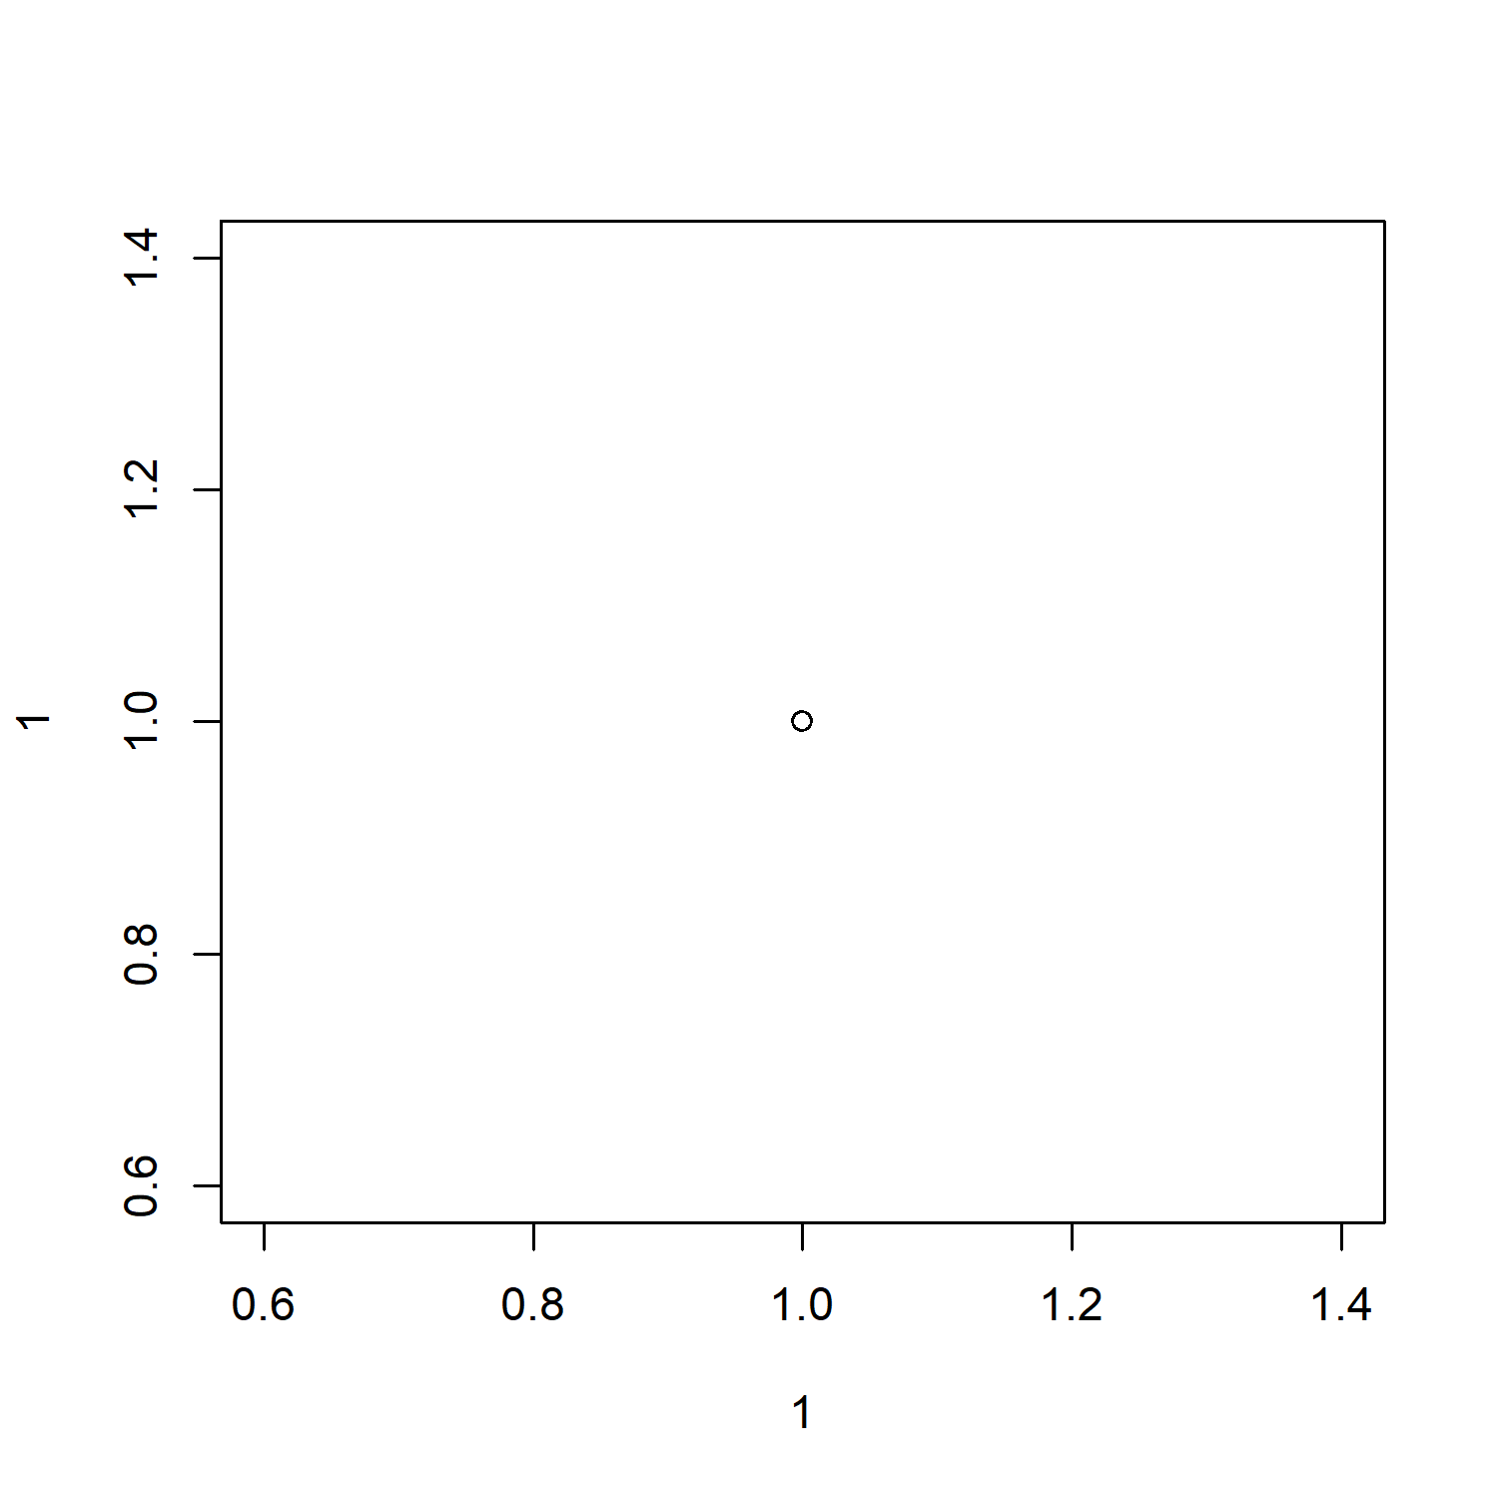

## This a test Image imported from folder and inserted in doc

***This is***  X2***bold***fwb*this****fsti*** AUC++0-12h++I think I made it **Oh My GOD, how is it so wonderful, I just want to get out and scream out loud that I'm so smart HAHAHAH**I can edit anything for example: the AUC++inf++and the C max