**Prandtl-Meyer Expansion**[1]

*Simulation Course*

*Escola Tècnica Superior d'Enginyeria de Telecomunicacions i Aeroespacial de Castelldefels*

*Universitat Politecnica de Catalunya*

León Enrique Prieto Bailo [leon.enrique.prieto@estudiantat.upc.edu](mailto:leon.enrique.prieto@estudiantat.upc.edu) Verónica Sastre Rojo [veronica.sastre@estudiantat.upc.edu](mailto:veronica.sastre@estudiantat.upc.edu)

**Description of the problem**

The Prandtl-Meyer expansion is the process that occurs when a supersonic flow turns around a convex corner, forming a divergent fan consisting of an infinite number of Mach waves. A two-dimensional, inviscid and supersonic flow will be analyzed in this project.

Across the expansion fan, the flow accelerates so, the Mach number increases and the static pressure, temperature and density decreases.

Since the flow turns in small angles and the changes across each expansion wave are small, the whole process is isentropic. Due to the fact that the whole process is isentropic, the stagnation pressure, temperature and density remain constant across the fan. This fact simplifies the calculations of the flow properties significantly.

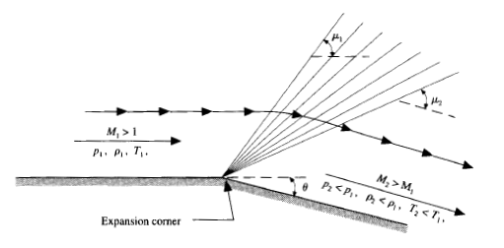

*Figure 1. Prandtl Meyer expansion wave.*[1]

Due to the fact that the inviscid flow must easily notice the shape of the surface over which it is flowing, it is vital to couple the surface boundary condition into the flow-field calculation. For this reason, a numerical mathematics adjustment will be done.

The space marching technique that will be applied for the solution of the two-dimensional supersonic flow problem is MacCormack's. It is a second order discretization scheme for the numerical solution of hyperbolic partial differential equations.

**Relevance: Why this simulation is important?**

The relevance of the project lies in the understanding of the physical phenomenon. It is important to know how the fluid behaves when certain geometric conditions are met. The Prandtl Meyer expansion can be found in any type of aircraft, rocket or object that moves in a supersonic regime.

That is why it is of vital importance and of great help to use numerical methods to represent the phenomenon and simulate the behavior of the flow for a geometry of interest, as well as to obtain the properties and magnitudes of the flow in this scenario.

**Prandtl-Meyer Expansion: Mathematical Analysis**

The angles of the expansion wave with respect to the horizontal component is denoted as , the upper and lower angle boundaries of the wave are denoted and , respectively. Therefore, we can define:

The Prandtl-Meyer function for a calorically perfect gas, denoted as , follows:

This allows us, by implicitly solving (trial and error), to find the Mach number along the wave. The process is as follows: is calculated by adding to the previous expression, then, for a given , is computed and finally, by solving implicity, is found.

Once the Mach number is found, the pressure, temperature and density downstream can be found from the isentropic flow relations.

The governing Euler equations for a steady, two-dimensional flow can be expressed in the generic form of hyperbolic partial differential equation, due to isentropic flow consideration, the value of is equal to zero.

In order to solve the previous equation, the MacCormack’s predictor-corrector explicit finite-difference method will be applied.

and are the column vectors whose values are defined as follows:

An initial data line will be set for and then the solution will be carried out by marching in steps of

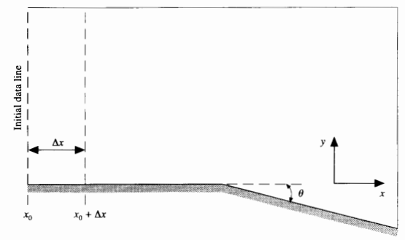

*Figure 2. Geometry of the problem.*[1]

Primitive variables can be obtained by applying the following expressions with the column vector.

And the column vectors can be obtained from the primitive and column vectors as follows:

To simplify the computational problem, a computational plane has to be generated from the physical one, then find the primitive variables and revert the change to the physical plane.

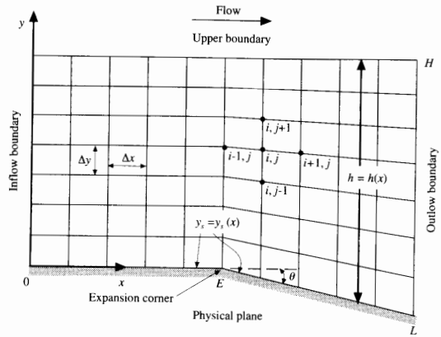 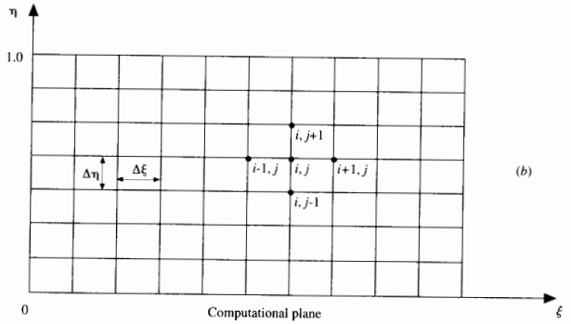

*Figure 3. Physical and computational plane.*[1]

The change of variable to be performed is:

The coordinate corresponding to the lower boundary is denoted as , this value will be and then, after the expansion corner, it will start decreasing. The height or the distance between and the is defined as .

For

For

Then, the value of can be written as:

Then, the continuity, x-momentum, y-momentum and energy governing flow differential equations that must be solved in the computational plane follow:

Now, the problem is fully set up and the differential equations can be solved by using MacCormack’s method.

**Predictor step: Written using forward differences.**

The discontinuity tends to produce oscillations in the solution of the flow field, these can be eliminated by including artificial viscosity in the solution.

The predicted values of are obtained as follows:

With the predicted values, predicted column vector can be obtained by finding the value of .

then is found by:

**Corrector step: Written using rearward differences:**

Forming the average derivatives:

In this corrector step it is also needed to add the artificial viscosity, thus:

And then, it’s finally possible to recover , where the primitive variables can be recovered from.

Boundary conditions: The same process is repeated for the boundaries, for the rearward differences are changed to forward differences and for the forward differences are changed to backwards. The artificial viscosity (computed by using central differences) is not used for the boundaries.

Sketch of the velocity vectors in the boundary:

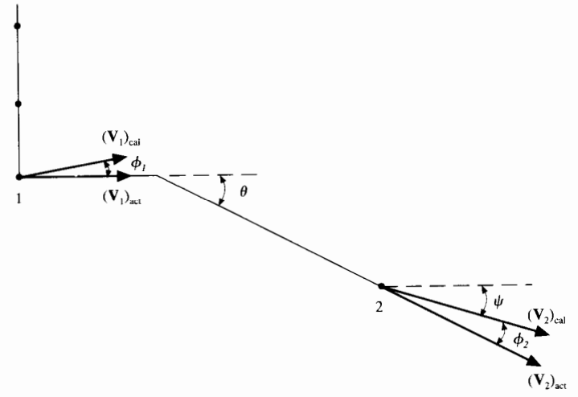

*Figure 4. Boundary velocity vectors before and after the expansion corner.*[1]

The direction of the resultant velocity at the wall will not necessarily be tangent to the wall due to numerical inaccuracy. This can be quantified and corrected. The angle between the velocity vector and the wall before the expansion corner is denoted as whose value is:

The calculated Mach number at the wall will be:

Before the, there could be a rotation of the velocity vector through the Prandtl-Meyer expansion wave where the deflection angle through the wave is , this yields to a new velocity vector which is assumed to be the actual velocity tangent to the wall. This can be computed by finding the associated Mach number obtained implicitly from the Prandtl-Meyer relationship.

Solving by trial and error, and obtaining the Mach number derives us into finding the primitive actual variables as follows:

The same thing happens after the expansion wave, the velocity vector is rotated to the angle , and then the Prandtl-Meyer function becomes:

Where:

Finally, the computation of the downstream marching step size can be obtained by:

**Software design: describe objects, databases, method for visualization of results**

1. **Class description**

The code will be divided into three clasees:

* Cell: in this class every cell of the grid will be created and each cell will have
* Rules:
* Grid:

1. **Forms description**

The project will have only one window form in which the simulation can take place. This form will have four buttons: Introduction, Simulation, Video Tutorial and About us. Every button is associated to a particular grid and if the user presses the button the grid associated with it will be the one on the screen.

* **Introduction Button Pressed**: A short introduction to the topic and a scheme of the phenomenon is presented.

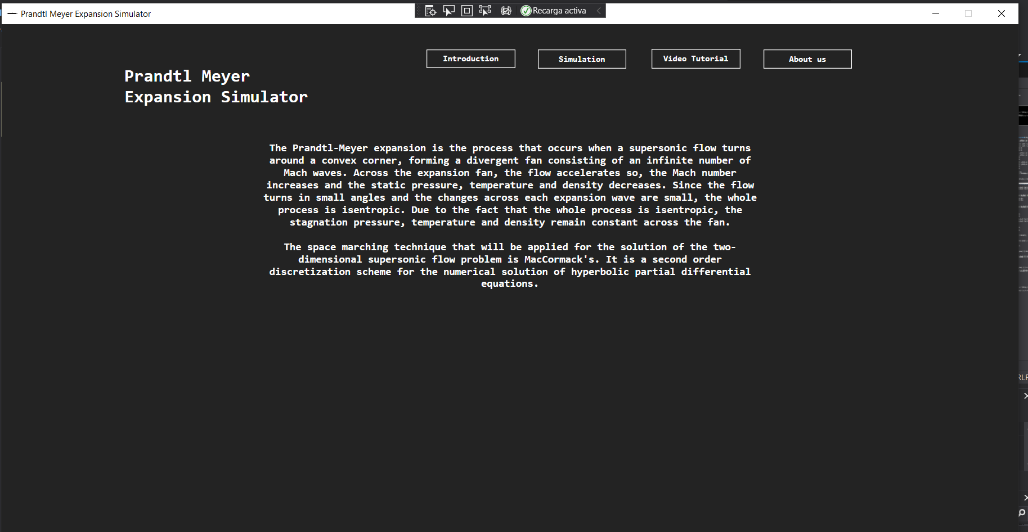

Draw

* **Simulation Button Pressed**: grid in which the simulation takes place.

The simulation parameters can be selected and with it the boundary and horizontal divisions of the canvas can be plotted.

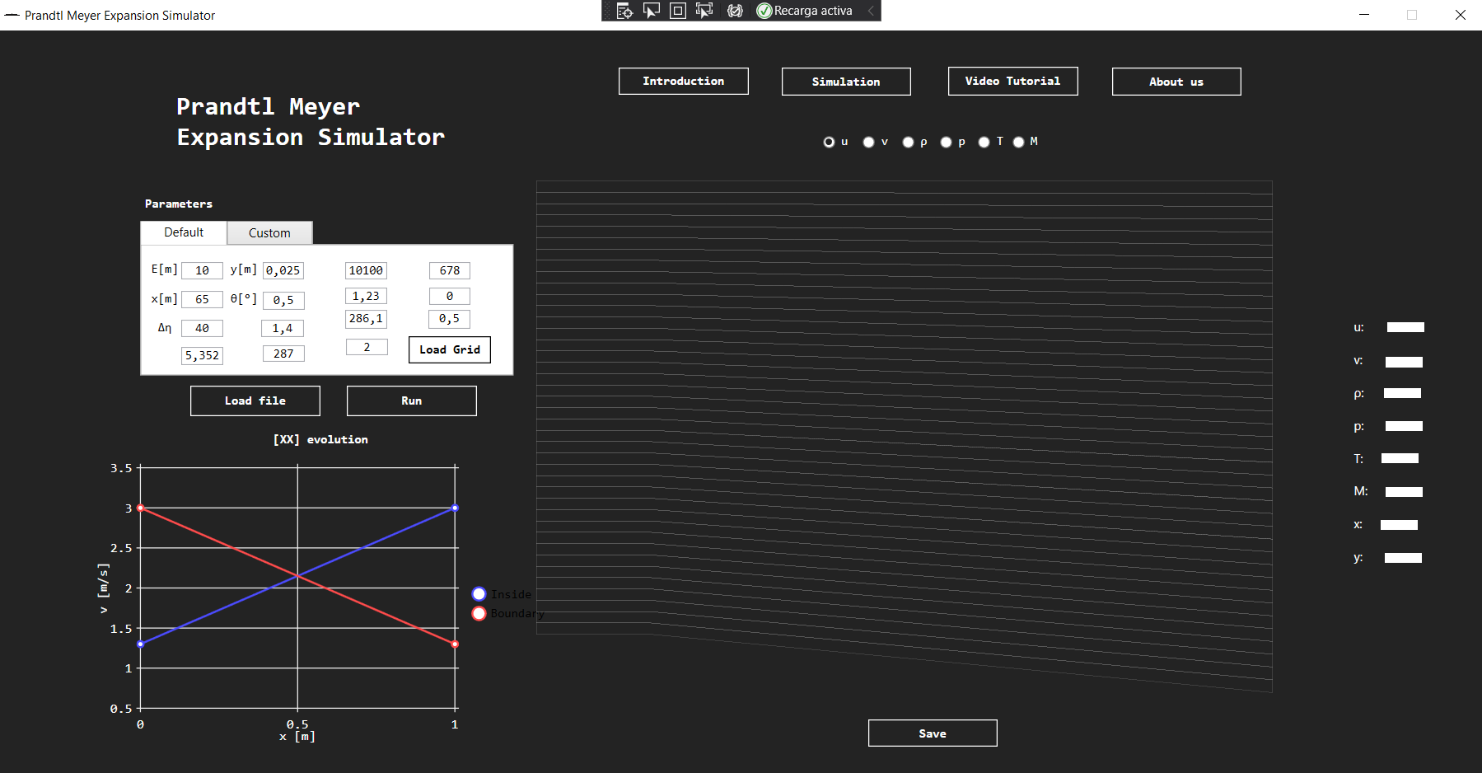

The simulation can be done by pressing the button “Run”. Once the user presses the button, a canvas will appear.

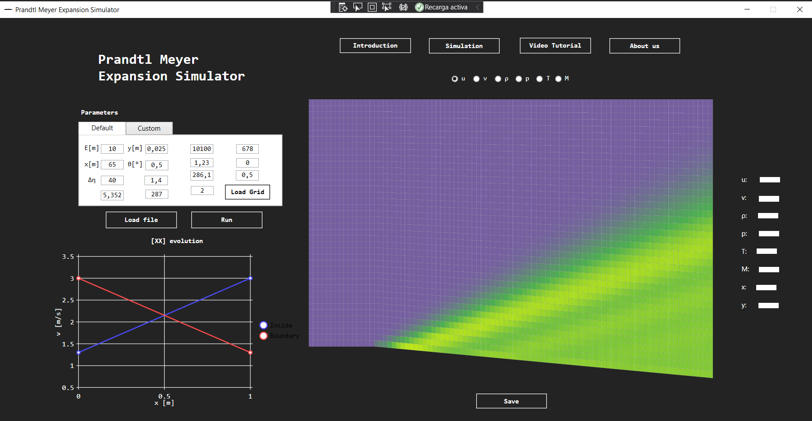

The variable plotted into the canvas can be selected with the radio buttons and the values of each variable can be seen at the right side of the canvas when the user put the mouse over a cell of the canvas. Also, the Anderson values will be shown there in order to compare it with our values.

The user can load a simulation file and also save the simulation in a txt file with the buttons “Load file” and “Save”.

Also, some interesting information as for example the evolution of each variable in the lower boundary will be plotted into the graph at the screen left side.

* **Video tutorial**: grid in which a video of how to use the simulator will be presented.

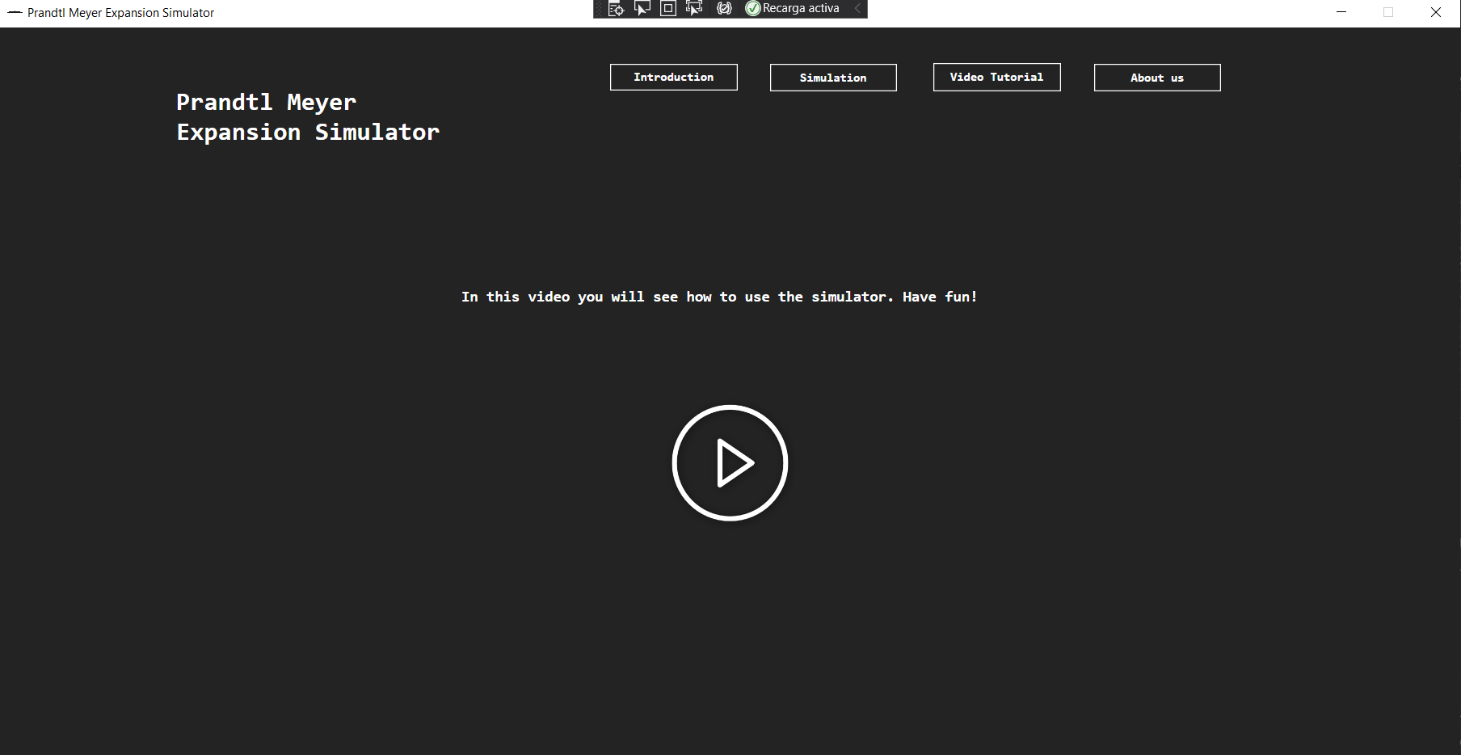

* **About us**: grid in which developers contact information can be seen.

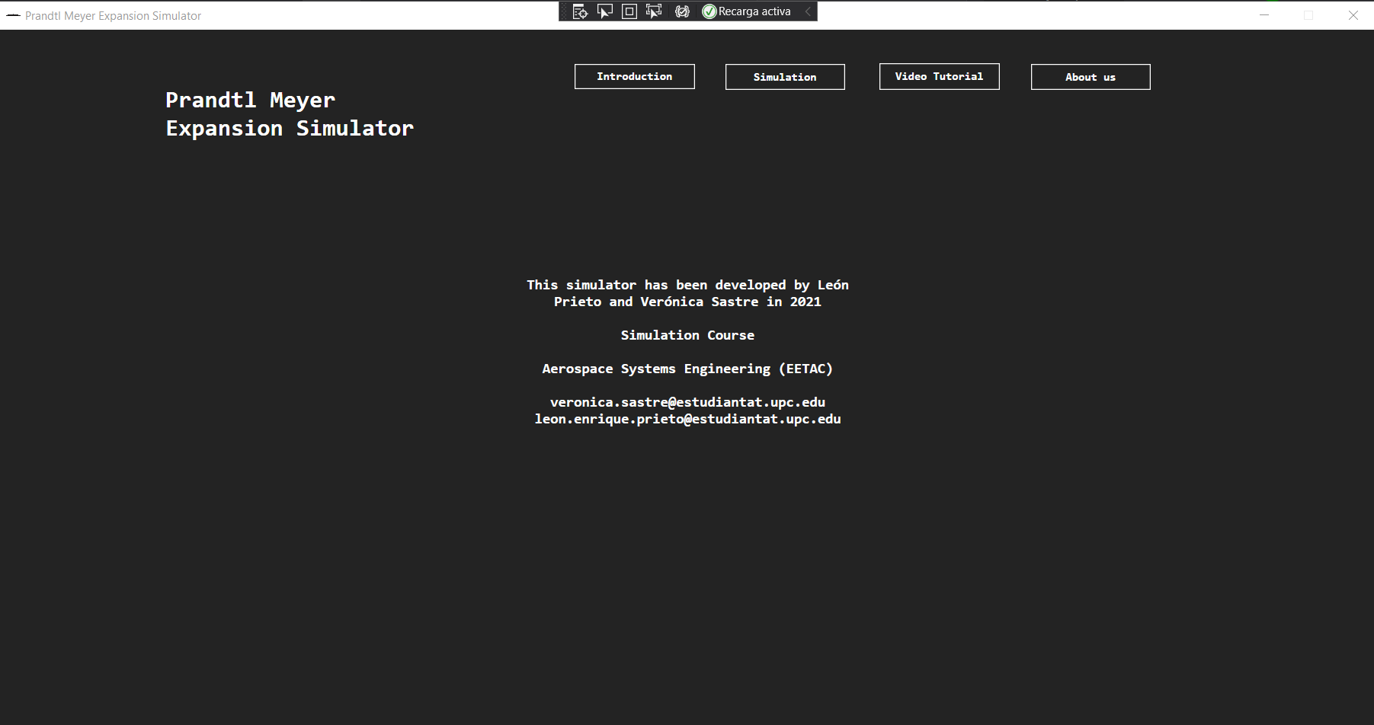

1. **Result strategy**

As said, the results for each variable will be plotted into a canvas and also into labels. The results can be saved into a txt file.

1. **Challenge**

One of the most challenging things developing the software design was the canvas since each vertical division has its own length due to the variable and also due to the fact that it has a corner with a concrete angle.

Another difficult thing was to implement a color gradient with three colors in order to plot the canvas. We have developed our color gradient with three colors (purple, green and yellow) and linear distribution between each primary color. (RGB).

Talking about the whole project, the most difficult thing for us was to do the math development due to its complexity.

Although all of this, we can say that we have reached coherent values for the simulation and we have really enjoyed the project. We have learned a lot of the math and physics involved into the phenomenon.

References:

[1] J. Anderson, “Computational Fluid Dynamics: The Basics with Applications. 1995,” *McGrawhill Inc*, 1995.