Thellier Tool

written by Roman Leonhardt with support David Krása and Christoph Heunemann.

(Department of Earth and Environmental Sciences, Geophysics section, Ludwig-Maximilians-Universität, Theresienstr. 41, 80333 München, Germany)

- Description
The Thellier Tool is a program for analysing paleointensity data. It was developed to analyse Thellier-type paleointensity determinations and several modifications of this method. This software was written for paleomagnetists who have experience in paleointensity determination.

- System requirements
ThellierTool requiresWindows 95/98/NT/2000/XP and at least 2.5 MB disk space.

- Views

  - The main window

The main window (see Figure 1) is splitted and shows a graph with the selected plot on the left side. The form view on the right side contains the results and several options regarding the data analysis.

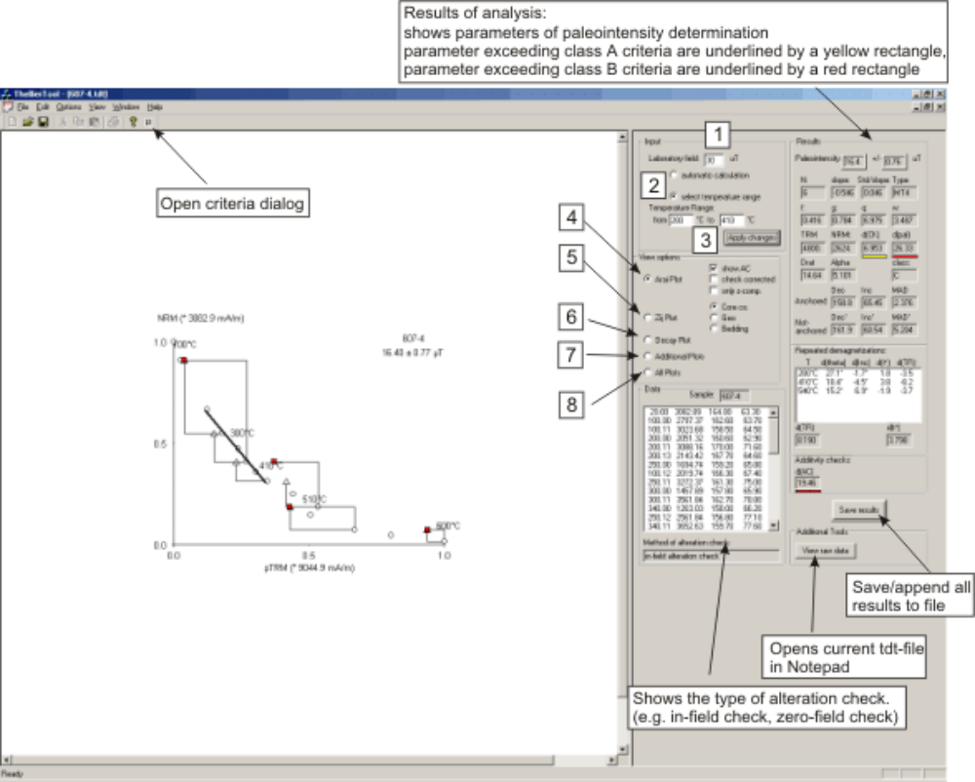
Fig. 1: The main view of the Thellier program. The left side shows the selected plot (Radio buttons 4 to 8). The right side shows results and options.

The upper left inset on this form view shows the applied laboratory field (1) and the type of calculation method (2) : The default option when opening a new file is automatic calculation (see section 6). If manual calculation is selected, the two edit boxes for choosing the temperature range for the linear fit calculation are enabled (3).

The middle left inset contains view options.
Thellier plot (4) shows the NRM/TRM diagram. Additional options for the Thellier plot are (a) the plotting of additivity checks (section 5), (b) check corrections (section 5) and (c) z-component only (section 5).
Zijderveld plot (5) shows the orthogonal projection of the demagnetisation data. If “in-situ” (Geo) data and/or bedding data is provided in the data file these plots can also be shown. The mean direction calculated in the selected temperature interval by PCA is also shown.
Decay diagram (6) shows the decay of the intensity during demagnetisation. If repeated demagnetisations are used then this data is also shown in the diagram (as black rectangles).
Additional plots (7) shows depending on the used modification of the Thellier experiment up to four plots. Plot (a) shows the difference between the applied field direction and the direction of the acquired pTRM*. Plot (b) shows the individual CK-errors (see 5.5.). If check correction is applied and additivity checks were measured, then the AC-errors are shown. Plot (c) shows the tail of the pTRM* (5.7.) and plot (d) show the intensity difference between first demagnetisation and repeated demagnetisation (5.7.).
All plots (8) shows all the above described plots for printing on one page.

The upper right part shows the obtained paleointensity value, as well as statistical parameters and calculation values. If one of the obtained parameters is not conform to the criteria of a class A determination, a small yellow rectangle appears below this value. Red rectangles indicate that this value exceeds the class B criteria. Calculation criteria can be edited in the criteria dialog.

The lower part of the form view shows the data file and the sample name. The “Save results” button writes or appends (if the selected file already exists) all calculation results in an ascii (section 4). The “View raw data” button opens the data file with notepad.

  - The criteria dialog

The criteria dialog is shown in Figure 2.
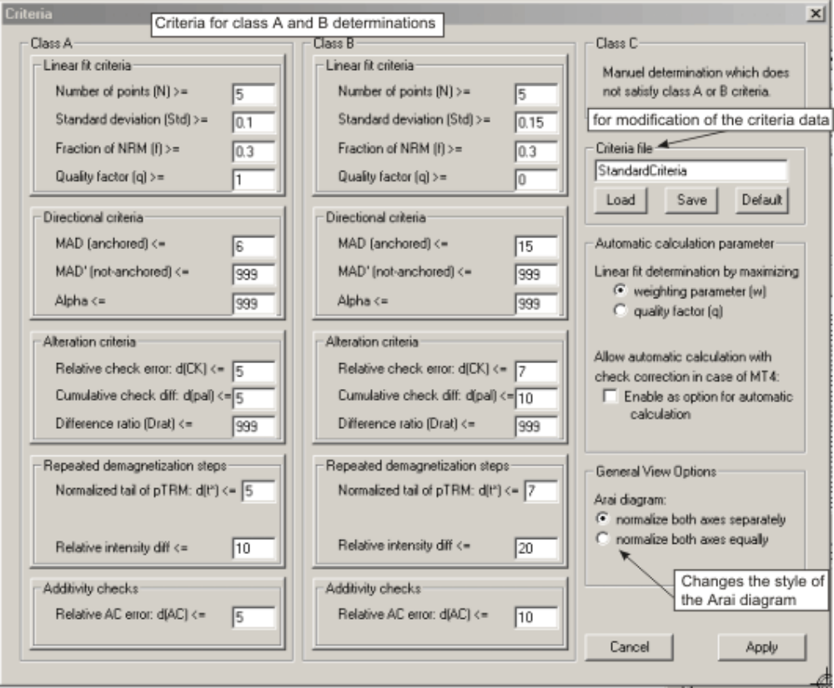
Fig. 2: The criteria dialog. Shows the criteria for class A and class B determiniations. Criteria can be changed and saved to a file. Other options are related to the automatic calculation, which could search for a slope with either maximal w or maximal q. In case of a MT4 experiment (section 5.6) check corrected analysis can be included to the automatic algorithm. The style of the aria diagram (equal or non-equal intensity axes) can be changed as well.

- Data Format

The program reads ascii-data of the following format:

Thellier-tdt
30.000000 0.0 0.0 0.0 0.0
635-4 20.00 4126.316002 58.700001 49.099998
635-4 100.00 3634.210804 62.099998 45.599998
635-4 100.11 3846.052595 56.799999 48.700001
635-4 200.00 3106.579128 63.000000 39.900002
635-4 200.11 3592.105379 60.299999 50.099998
635-4 200.13 3090.789493 67.500000 41.700001
635-4 250.00 2755.263166 65.300003 38.099998
635-4 100.12 2927.631673 68.000000 43.299999
635-4 250.11 3546.052746 70.900002 54.099998
635-4 300.00 2528.947410 65.300003 36.700001
635-4 300.11 3490.789425 57.099998 58.099998
635-4 340.00 2165.789624 68.300003 39.400002
635-4 250.12 2875.000092 67.800003 55.400002
635-4 340.11 3501.315982 68.000000 65.599998
635-4 100.14 3205.263341 69.900002 61.299999
635-4 380.00 1823.684349 75.599998 38.500000
635-4 380.11 3576.315744 67.000000 67.500000

The file should be space or tab delimited. The first line of the header contains the file information: Thellier file with extension *.tdt. If this information is found, then the second header line will be used.
The second line contains in the following order the laboratory field (μT), bearing, plunge, dip and direction of dip. The directional information only affects the orthogonal projection and certainly does not change the results. Plunge and bearing are used to obtain “in situ” coordinates, dip and direction of dip decipher the bedding correction.

The data is divided in 5 columns: Column 1 contains the sample name (maximum length of 16 characters), column 2 the temperature (°C) and type of step, column 3 the intensity (mA/m), column 4 the declination and column 5 the inclination in core coordinates.
The file should be either tab or space delimited. The digits of the temperature value (column 2) indicate the type of the step:
.00 (or .0) for first thermal demagnetisation
.11 (or .1) for acquisition of pTRM*
.12 (or .2) for pTRM*-check
.13 (or .3) for repeated demagnetisation
.14 (or .4) for additivity check

Data without the two header lines is also accepted! In this case the laboratory field has to be inserted in the edit box on the upper left side of the form view.

The output file format (Save results) is a tab-delimited text-file with default extension .thl. If a new “.thl” is saved, a header line with the description of the saved values is created. If a “.thl” file already exists, the results are appended to the end of the file.

- Calculations

The software calculates several parameters which are used in paleointensity determinations. All calculations are done using full vector subtraction. For comparison with results from the pmag thellier analysis program [Tauxe, 1998] this has to be regarded for. Selecting “z-component only” (see 5.10) will results in similar calculations as used for the pmag program.
The selection of some view options changes the calculations and leads two different parameters.

  - The fraction of NRM (f), gap factor (g) and quality factor (q)
These parameters are calculated according to Coe et al. [1978].

  - The weighting factor (w)
According to Prévot et al. (1985).

  - True NRM (NRMt) and TRM
NRMt is the intersection between linear fit and y-axis. TRM is the intersection between linear fit and x-axis.

  - Directional analysis
Declination and inclination are determined by PCA. The maximum angular deviation is calculated according to Kirchvink [1980]. Two directional analyses are conducted. One anchored to the origin (Inc, Dec, MAD) and a free line analysis (Inc’, Dec’ and MAD’). Alpha is the angle between free and anchored direction.

  - Class
The class of the determination is determined by comparing the results with the criteria. If manual determination is selected and the results are not conform with criteria A and B values, then the determination is termed to be off class C. The class is extended by a star (e.g. A*) if check correction is selected.

  - Type of measurement
Five different types, depending on the used checks and measurement steps are automatically set:
MT0: Thellier-type method without any checks
MT1: “Field-off first” method with pTRM*-checks
MT2: “Field-on first” method with pTRM*-checks
MT3: repeated demagnetisations after field-on step
MT4: additivity checks

  - pTRM*-checks and alteration error
Three parameters are used to quantify the order of alteration during laboratory treatment:
a) Delta(CK) is calculated by subtracting the pTRM*-check value from the corresponding pTRM*-acquisition value. This value is then normalized to the true TRM. This method does not overemphasize low temperature steps where the pTRM acquired is rather small. Additionally, it does not tolerate large check errors if the selected segment is long, as it is the case when using the length
of the selected segment as normalizer [Drat, Selkin and Tauxe, 2000].
b) Delta(pal) is related to the cumulative difference of the individual checks from room temperature up to the maximum used temperature for the best fit line.
The cumulative difference C is:

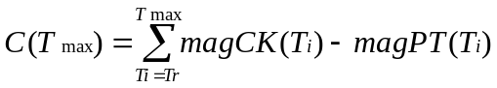

T_{r} is the room temperature. magCK and magPT represent the magnetizations of alteration check and pTRM* step, respectively.
This parameter is used to estimate the overall alteration, since even small individual differences between checks and pTRM values can sum up to significant alteration errors. To quantify the effect of the cumulative alteration difference, the correction method of Valet et al. [1996], which uses the cumulative sum of alteration differences, is applied to the selected segment and the check corrected paleointensity value is compared to the non-corrected value. Thus, the corrected pTRM values are determined by:

Corr_pTRM(Ti) = pTRM(Ti) – C(Ti)

Corr_pTRM is the check corrected pTRM value.
Then the slope for the selected segment is determined both using Corr_pTRM and pTRM values. For delta(pal) the normalized difference of the slopes (or paleointensities) is calculated:

Delta(pal) = (Paleointensity(corrected) - Paleointensity(uncorrected))*100/ Paleointensity(uncorrected).

(For calculation of d(pal) and d(CK) see also Leonhardt et al. [2003].

c) The difference ratio (Drat) is calculated similar to delta(CK) using not the TRM but the length of the selected segment as normalizer (Selkin and Tauxe, 2000).

  - Repeated demagnetisation and pTRM*-tail checks
The relative intensity difference for pTRM*-tail checks [Riisager and Riisager, 2001] is normalized to the true NRM (NRMt), resulting in delta(TR). The shown value for delta(TR) is the maximum value below and within the linear segment. Delta(t*) is normalized value of the true tail, which is calculated according to Leonhardt et al. [in press]. This value regards for the angular difference between applied laboratory field and NRM. The given value is the maximum value of the whole experiment.

  - Additivity checks
See Krása et al. [2003] and Leonhardt et al. [in press].

  - Standard deviation, slope, etc.
For the calculation of these parameters it is referred to standard mathematical books.

  - View option “z-comp only”
If this option is selected, the vector subtraction is done by using only the values for the measured z-component (assuming that the applied field is parallel to the core coordinate z-component of the sample). All parameters are recalculated.

  - View option “check corrected”
The pTRM*-acqusition values are corrected with the cumulative sum of the alteration (pTRM*) checks [Valet et al., 1996]. Delta(CK), Delta(pal) and Drat are obviously zero in this case.

- Automatic Calculation

If a new data file is opened, an algorithm is used to find automatically the best linear segment for the available data. At the first instance, the data file is searched for a paleointensity determination, which satisfies the criteria of class A. From the possible solutions the one with the maximum weighting factor is determined. The used weighting factor can be either w or q and is selected in the criteria dialog. If no solution is found for class A, then the algorithm tries to find a best fit line satisfying class B criteria. If no solution is found, then all results are set to zero. In case of measurements with additivity checks (and only in this case!) it is also possible to include check corrected analysis to the automatic analysis (a check box appears). First a non-corrected results satisfying class A will be searched. Then check correction is applied and either a result with higher weighting factor or a result at all is searched satisfying class A criteria without CK-error and CK-diff. If unsuccessful the calculation is repeated with class B criteria values.

- Bugs and errors
please contact leon@geophysik.uni-muenchen.de

- Acknowledgements

We would like to thank Peter Riisager, Fabio Donadini and Yongxin Pan for constructive comments on earlier versions of the ThellierTool.

References

Coe, R.S., S. Grommé, and E.A. Mankinen, Geomagnetic paleointensities from radiocarbon-dated lava flows on Hawaii and the question of the Pacific nondipol low, J. Geophys. Res., 83, 1740-1756, 1978.
Kirschvink, J.L., The least-squares line and plane and the analysis of paleomagnetic data, Geophys. J. R. astr. Soc., 62, 699-718, 1980.
Krása, D., C. Heunemann, R. Leonhardt, and N. Petersen, Experimental procedure to detect multidomain remanence during Thellier-Thellier experiments, Phys. Chem. Earth, 28, 681-687, 2003.
Leonhardt, R., D. Krása, and R.S. Coe, Multidomain behavior during Thellier paleointensity experiments: A phenomenological model, Phys. Earth Planet. Inter., in press.
Leonhardt, R., J. Matzka, and E.A. Menor, Absolute paleointensities and paleodirections of miocene and pliocene lavas from Fernando de Noronha, Brazil, Phys. Earth Planet. Inter., 139, 285-303, 2003.
Riisager, P., and J. Riisager, Detecting multidomain magentic grains in Thellier paleointensity experiments, Phys. Earth Planet. Inter., 125, 111-117, 2001.
Selkin, P.A., and L. Tauxe, Long-term variations in paleointensity, Phil. Trans. R. Soc. Lond., 358, 1065-1088, 2000.
Tauxe, L., Paleomagnetic principles and practice, 299 pp., 1998.
Valet, J.-P., J. Brassart, I.L. Meur, V. Soler, X. Quidelleur, E. Tric, and P.-Y. Gillot, Absolute paleointensity and magnetomineralogical changes, J. Geophys. Res., 101 (B11), 25029-25044, 1996.

