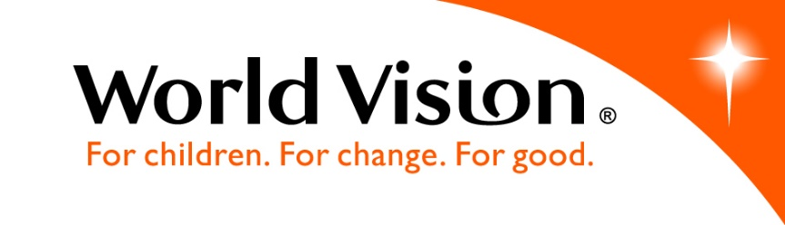
MIS779 – Decision Analytics in Practice
Optimizing Donor Communication Journeys for Enhanced Engagement at World Vision Australia


Group 17
22/05/2025
​
Table of Contents
Executive summary 3
Introduction 3
Approach 4
Data analysis 5
Diagnostic Question 1​ 7
Insights 7
Interpretation 7
Recommendations 7
Diagnostic Question 2 8
Insights 8
Interpretation 8
Recommendations 9
Diagnostic Question 3 9
Insights 9
Interpretation 10
Recommendations 10
Diagnostic Question 4 11
Insights 11
Interpretation 12
Recommendations 12

Executive summary
This report investigates supporter engagement effectiveness within World Vision Australia’s Bounceback campaigns, specifically addressing whether communications are being sent in the right number, right order, right time, and through the right channels. Using diagnostic analysis across six key campaigns—Christmas, Birthday, and Education initiatives from FY21 and FY22—we examined supporter behaviour across both online and offline journeys.
The analysis draws on over multiple datasets, covering supporter demographics, contact history, and donation fulfilment. We constructed a unified dataset using Power BI and Power Query, calculating journey-level engagement, drop-off rates, channel effectiveness, and timing gaps. Key diagnostic questions focused on communication sequence performance, stage-wise disengagement, timing sensitivity, and channel preferences across age groups and personas.
Results showed that online journeys consistently retained more supporters, with average drop-off rates around 15%, while offline journeys experienced higher attrition, particularly between EDM1 and EDM2 stages. Timing analysis revealed that most supporters engage within 10–15 days after initial contact, yet several campaigns deployed follow-ups too early or too late, missing this optimal response window. Channel effectiveness also varied: Direct Mail resonated more with older age groups (60+), while EDM channels proved more effective among younger segments.
Based on these findings, four key recommendations are proposed: (1) streamline offline journeys by removing or refining low-performing stages like EDM2 and SMS; (2) realign timing gaps to better match proven response windows; (3) personalise channel delivery based on age and segment profiles; and (4) adopt a data-led A/B testing strategy to continuously monitor performance across journeys.
By addressing inefficiencies in journey design, timing, and channel targeting, World Vision can significantly improve supporter conversion rates while reducing communication fatigue—thereby enhancing both operational effectiveness and donor experience.

Introduction
World Vision Australia (WVA) is a leading humanitarian organization dedicated to improving the lives of vulnerable children and communities through sustainable development, emergency relief, and advocacy. A crucial component of WVA’s operational model is donor engagement, which sustains its mission through regular contributions from a committed supporter base. The organization relies on strategic communication to maintain and grow this support, utilizing structured campaigns to drive donor participation and retention.
As part of its broader funding and engagement strategy, WVA runs the BounceBack campaigns, a series of targeted communication journeys aimed at reactivating lapsed donors and reinforcing relationships with active supporters. These campaigns utilize multi-channel outreach comprising EDMs, SMS, direct mail, and web portals to guide donors through re-engagement pathways. Effective donor journey management within these campaigns is vital for maximizing return on investment and achieving long-term fundraising goals.
The central business problem is the need to optimize the donor journey by determining the ideal communication timing, frequency, and channel strategy to maximize supporter engagement, satisfaction, and contributions.

Approach
To address this challenge, our approach focused on a layered analytical methodology that moves from descriptive to diagnostic insights. We first performed a detailed descriptive analysis to identify high-level engagement patterns, channel performance, and drop-off points across different phases and segments. This laid the foundation for identifying more granular performance issues.
We then applied diagnostic analysis to investigate key friction points within the journey and determine the effectiveness of communication timing, channel choice by donor segment, and phase-wise conversions. Comparative insights were drawn across attributes such as campaign type, supporter demographics (age and Helix persona), and journey channels (online vs offline) to reveal nuanced performance differences.
Rather than beginning with assumptions, we reverse-engineered the solution space starting from what success (i.e., high engagement and conversions) looks like and tracing backward to identify what journey structures, communication touchpoints, or timing models led to those outcomes. This allowed us to formulate data-backed, action-oriented recommendations that directly align with the business goal of enhancing donor communication strategies for maximum impact.

Limitations

While the analysis provides meaningful insights, there are two key limitations to note:
- Missing Data – EDM3 (Online Campaigns)
Data for the EDM3 stage in online journeys was not available for campaigns, which limited our ability to fully assess late-stage online engagement. As a result, we were unable to evaluate long-term retention or effectiveness beyond the second touchpoint for certain digital sequences.
- Campaign Gaps – Incomplete Year Coverage
Some campaigns did not have complete data across all financial years (e.g., certain Education or Birthday phases were missing for FY20 or FY22). This incomplete coverage may affect the accuracy of year-on-year comparisons and limits our ability to observe full performance trends over time.
These limitations were considered when drawing conclusions, and the analysis focused only on the most consistent and complete sections of the dataset to ensure reliability.

Assumptions
To support a more accurate and meaningful analysis, we made the following practical assumptions based on data limitations and campaign logic:
- Adjusting the Order of Offline Communications
According to WVA’s intended communication structure, the offline journey should follow the sequence: Direct Message → EDM1 → EDM2 → SMS. However, in the dataset, the timestamp for SMS often appeared earlier than EDM2, which didn’t align with the expected campaign flow. To address this inconsistency during our timing analysis (especially in Question 3), we assumed that this was a data recording issue and treated SMS as coming after EDM2 to better reflect the intended communication structure.
- Filtering for Relevant Geography
Since the campaign is designed primarily for Australian supporters, we excluded data from donors located outside Australia. This step ensured that our findings were directly relevant to WVA’s local engagement strategy and not influenced by external regions with different communication environments.
- Interpreting the Starting Points of Journeys
The dataset only provided “Offline Main” and “Online Main” as the initial contact points, without explicitly naming them as DM1 or EDM1. Based on the timing of the messages and standard campaign design, we interpreted “Offline Main” as the first direct mail (DM1) and “Online Main” as the first email (EDM1). This interpretation allowed us to align the data more accurately with the actual supporter journey structure.

Data analysis
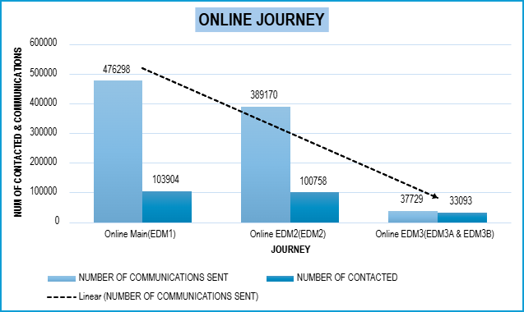
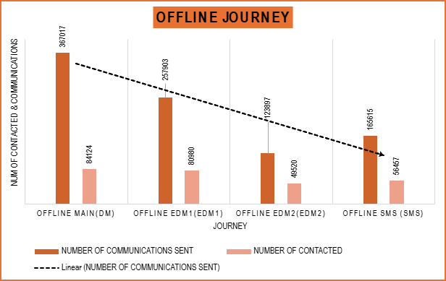
The donation rates across each stage show clear differences in effectiveness.
Figure 2. Drop in Engagement Across Online Journey Stages
Figure 1. Drop in Engagement Across Offline Journey Stages
For the online journey, only 18% donated after the first EDM, but those who reached EDM3 converted at a much higher rate—90%. This shows that while early online engagement is low, those who stay are more likely to donate.
In the offline journey, around 30% of people donated after the first DM. This increased slightly to 36% at EDM1, suggesting that follow-up emails were more persuasive. But by the SMS stage, the donation rate dropped to 25%, indicating some loss of interest.
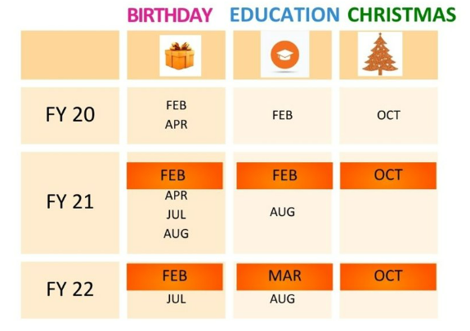
These patterns suggest the journey can be improved by adjusting the timing and content of key messages, focusing more on the stages that work, and rethinking those that don’t.
As shown in the figure, World Vision Australia has run a series of targeted campaigns over three financial years (FY20–FY22), across three major themes: Birthday, Education, and Christmas. Each campaign was delivered via both online and offline journey streams. For the purposes of this analysis, we have focused on the six most recent and relevant campaigns—highlighted in the calendar—where sufficient data was available to examine supporter behaviour across multiple touchpoints. All diagnostics, findings, and recommendations in this report are based on these campaigns, ensuring the insights reflect current communication strategies and audience responses.
Figure 3. Timeline For Three Campaigns
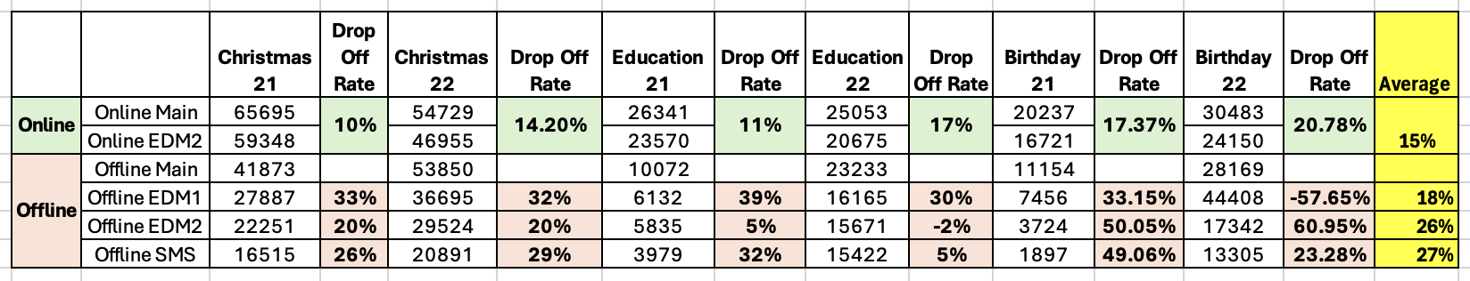
The table above presents a detailed comparison of supporter volumes and drop-off rates across six key campaigns, segmented by online and offline journey streams. Each row reflects a stage in the supporter journey—such as Online Main, EDM1, EDM2, and SMS—and highlights how many supporters progressed or disengaged at each communication touchpoint.
Figure 4. Drop-Off Rates by Campaign and Channel
A key insight from this analysis is that online journeys consistently show lower drop-off rates, averaging around 15%, suggesting higher efficiency and supporter retention. In contrast, offline journeys exhibit more significant drop-offs, particularly in the transitions from EDM1 to EDM2 and from EDM2 to SMS. For instance, Birthday 22's offline journey shows a cumulative drop-off rate exceeding 60% across those stages. This signals possible issues such as message fatigue, timing misalignment, or ineffective content in those later stages.
Conversely, a few exceptions—such as Education 22’s offline journey—demonstrate unusually low or even negative drop-off rates, which may point to data anomalies or supporters re-engaging after prior inactivity. These edge cases are important to identify, as they may either highlight potential data quality issues or uncover strategic timing patterns worth replicating.
Overall, this analysis reinforces the importance of reviewing the number, order, and channel mix of communications being sent. The variability in drop-off patterns across campaigns and channels provides a strong diagnostic foundation to recommend where the communication strategy can be optimised. In the following section, we translate these findings into targeted, actionable recommendations to improve supporter engagement and journey effectiveness.
Diagnostic Analysis:

Diagnostic Question 1: Are we sending the optimal number of communications in each journey, or are some audiences being over/under-contacted?​
Ensuring optimal communication frequency is critical for World Vision Australia to maximize donor engagement, satisfaction, and retention. Sending too many communications could lead to donor fatigue, while insufficient touchpoints may reduce potential contributions. This question directly impacts donor satisfaction and the ROI from campaign communications, central to the stated business problem of optimizing the donor communication journey.

Insights
The analysis reveals notable disparities in conversion rates between the online and offline campaign channels. The offline journey exhibits significantly higher overall conversion rates (49%) compared to the online journey (19%), highlighting its effectiveness across all campaign types.
When examining specific campaign types, the Birthday campaigns FY21 and FY22 consistently outperform Education and Christmas campaigns in both online and offline channels. Particularly, the Birthday 2021 offline campaign achieved a 66% conversion rate in the Offline Main phase alone, substantially outperforming comparable phases in other campaigns.

Interpretation
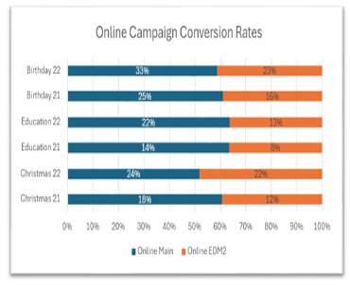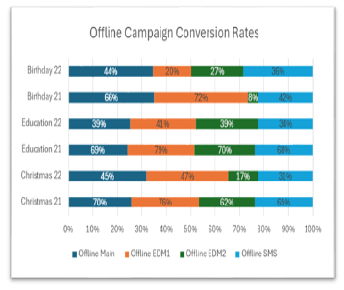
Figure 6. Offline Campaign Conversion Rates
Figure 5. Online Campaign Conversion Rates
The initial theory anticipated balanced effectiveness across channels; however, the data strongly validates the superiority of offline communication channels for certain audiences. A surprising insight emerged from the Christmas 2022 campaign, which, despite traditionally lower responses, showed a relatively robust conversion rate of 45% in its initial offline phase. This suggests an opportunity to strengthen this campaign further by tailoring communication strategies specifically for this audience segment.

Recommendations
- Prioritize Offline Campaigns
- Allocate additional budget and resources to scale up offline channels, particularly focusing on the Birthday campaigns due to their high conversion rates. Immediately initiate a review of current offline strategies to enhance their effectiveness further.
- Enhance Online Engagement
- Immediately implement additional digital touchpoints such as SMS follow-ups or new EDM1 phases to mirror successful offline structures. Set clear KPIs to evaluate the effectiveness of these additional steps.
- Pilot Hybrid Journey Strategies
- Launch a pilot project combining digital and physical communication methods. Track results closely and refine the hybrid approach based on clear performance metrics, adapting swiftly to scale successful elements across broader campaign initiatives.

Diagnostic Question 2: Are we sending the optimal number of communications in each journey, or are some audiences being over/under-contacted?
Early-stage conversions are crucial as they significantly influence overall campaign effectiveness and ROI. Ensuring compelling first touches reduces donor drop-offs and sustains engagement throughout subsequent phases. Addressing this effectively contributes directly to World Vision Australia’s objective of optimizing donor communication journeys to enhance satisfaction and retention.

Insights
Comparatively, the data indicates the offline journey maintains higher early-stage conversion effectiveness than the online journey. Specifically, the offline journey showed stronger retention from the Main phase (100%) through EDM1 (81.62%), compared to the online journey’s lower retention at EDM1 (85%). This demonstrates the offline channel’s relative effectiveness in capturing early donor engagement.

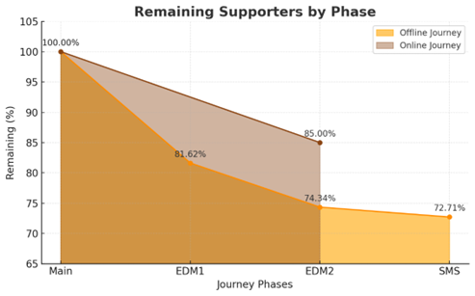
Figure 7. Supporter Retention Across Journey Phases

Interpretation
The theory suggesting potential issues in early-stage communications is validated by lower retention rates in the early online phases compared to offline. Surprisingly, the offline SMS phase retained a relatively strong 72.71% of supporters, challenging the assumption that this late-stage touchpoint might be less valuable. This suggests that late-stage communications could still hold substantial value if strategically executed.

Recommendations
- Strengthen Early Online Communications
- Immediately enhance early-stage online communications by optimizing the calls-to-action (CTAs) and timing of EDM2. Consider introducing an additional follow-up communication to reinforce engagement.
- Review Late-Stage Offline Communications
- Conduct an immediate review of the SMS phase’s effectiveness in the offline journey. Decide whether to continue, optimize, or eliminate this touchpoint based on its cost-benefit analysis.
- Focus on High-Performing Early Touchpoints
- Immediately allocate additional resources to enhance Offline Main and EDM1 phases, which show strong early conversions. Develop targeted content and timing strategies to further amplify their effectiveness.

Diagnostic Question 3: Are we contacting customers at the right time intervals, or do our delays​ between communications hurt engagement?​
Timing plays a vital role in donor engagement. Poorly timed communication can lead to disinterest or inaction among potential supporters. Understanding the ideal timing between touchpoints is essential to maximizing response rates and ensuring a strong return on investment.

Insights
To diagnose the role of timing, we measured the number of days between the campaign start and each supporter’s First Fulfillment Date (i.e., the date of their first donation during the campaign). This measure helps us understand how long it takes for supporters to respond after initial contact. The data was segmented into response bins and analysed separately for online and offline campaigns.
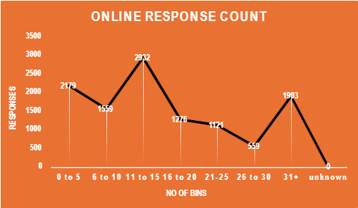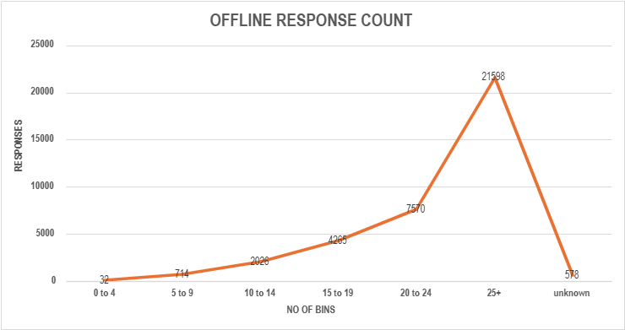
Figure 8. Online Supporter Responses Count
Figure 9. Offline Supporter Responses Count

​As seen in Figure 8, online responses followed a two-phase trend—an early peak between days 11–15, and a later surge after day 31+ days (1,903 responses). An initial spike also occurred in the 0–5 day range (2,179), suggesting strong early engagement after the first communication. However, response numbers dropped significantly during the 21–30 day period (only 559 responses), indicating that longer delays between touchpoints may suppress supporter interest or cause them to disengage.
Conversely, offline campaign responses (Figure 9) followed a different pattern. Engagement grew steadily over time, culminating in a significant spike in the 25+ day range, where over 21,598 responses were recorded. This indicates that offline channels, such as direct mail, may naturally require longer lead times for response due to postal delays and a slower decision-making process among certain demographics.

Interpretation
These contrasting trends suggest that timing strategies should be channel-specific:
- Online supporters respond best when communications are timely and closely spaced, especially within the first two weeks of a campaign.
- Offline supporters, on the other hand, are more responsive after a longer lead-in, meaning these journeys should be planned to build momentum gradually.
A lack of timely follow-up may explain the significant drop in engagement midway through the online campaign, as evidenced by the sharp decline in responses during days 21–30. For offline campaigns, a delayed response is not a failure—it may simply reflect the longer absorption and response cycle.

Recommendations
Based on the diagnostic analysis of supporter response timing across online and offline campaigns, several actionable strategies are recommended to improve engagement efficiency and maximize campaign impact:
- Align Messaging with Peak Engagement Windows
- Maintain a 11–15 day gap between key online touchpoints (e.g., Online Main → EDM1 → EDM2) to align with peak supporter responses. Avoid gaps exceeding 20 days, which showed a drop in engagement.
- Re-Engage Late Responders
- Introduce re-engagement messages at 30–35 days (via SMS or email) to capture late converters. Use softer content like testimonials to reignite interest without pressure.
- Space Out Offline Touchpoints Strategically
- Plan offline journeys with 20–25 day intervals between communications to match natural response cycles. This allows time for delivery and decision-making, while avoiding supporter fatigue.
- Trigger Follow-Ups Based on Engagement
- Introduce behaviour-driven follow-ups—for instance, send a reminder if no action is taken within three weeks. This ensures personalized pacing and reduces irrelevant outreach. Automation tools can support this at scale.

Diagnostic Question 4: Are we using the right communication channels for each audience segment, and​ should channel choice be personalized by age or Helix group?​
For multichannel campaigns like BounceBack, it’s essential to understand how different audience groups engage with online versus offline channels to ensure resources are used effectively. Using the wrong channel for a given audience can lower conversion rates and result in inefficient communication spending. By segmenting donors by age group and Helix Community type, we can uncover underlying patterns and make targeted adjustments to improve engagement and ROI.

Insights
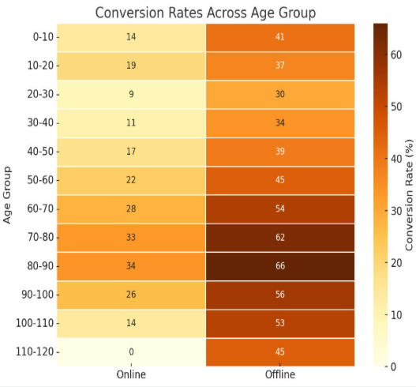
Figure 10. Conversion Rates Across Age
Two heatmaps were developed to visualize the average conversion rates across age groups and Helix communities, segmented by online vs offline campaign type:

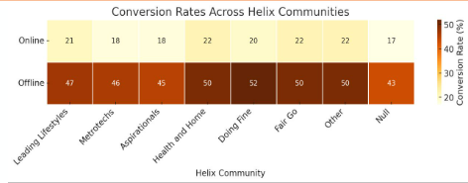
Figure 11. Conversion Rates Across Helix
1. Age-Based Conversion Trends (Figure 10)
- Offline campaigns consistently outperform online across all age groups above 20 years old.
- The highest offline conversion rates were found among:
80–90 years old (66%), 70–80 years old (62%), 90–100 years old (56%)
- In contrast, online engagement across all age bands was low (ranging from 9% to 34%), with a noticeable drop in the 20–30 age group (only 9%).
This strongly suggests that older supporters prefer offline channels, while younger groups are less responsive overall, especially to online communication.
2. Helix Community-Based Trends (Figure 11)
- Offline outperforms online in every Helix segment.
- The "Health and Home", "Doing Fine" and "Fair Go" communities showed the highest offline conversion rates (50–52%), whereas the same groups only converted at around 20–22% online.
- Online conversion rates across all Helix communities remained relatively flat and low, with the highest being only 22%.

Interpretation
These trends clearly indicate that:
- Supporter preferences for communication channels differ widely between age groups and Helix profiles, and these preferences should inform the design of future supporter journeys.
- Offline channels are far more effective for older age brackets and certain Helix personas such as “Fair Go” and “Doing Fine”.
- The low online conversion even among younger demographics suggests that WVA’s current online approach may require rethinking format, tone, or platform to better resonate.
The steep drop in online conversion among the 20–30 age group stands out as a critical area for improvement, suggesting that younger supporters may need entirely different engagement strategies (e.g., social media, mobile-first design, gamification, etc.).

Recommendations
Conversion trends clearly demonstrate that older age groups (60+) and Helix communities such as “Health and Home”, “Fair Go”, and “Doing Fine” respond significantly better to offline channels. In contrast, digitally native audiences under 30 show poor engagement across both channels, indicating the need for experimentation.
- Match Channels to Audience Segments
- Use offline journeys for older supporters (60+) and high-performing Helix groups like Fair Go and Doing Fine. For younger audiences (under 30), test digital-first approaches with stronger CTAs and mobile-friendly content.
- Improve Online Journey Design
- Redesign EDMs with more visual, concise, and engaging content. Add SMS reminders or richer formats, and test longer nurturing sequences for slower-to-convert segments.
- Adopt Hybrid Touchpoints
- Combine offline and online channels (e.g., mail followed by EDM or SMS) to reinforce messages and expand reach, especially for mid-performing segments needing multiple prompts.

