MIS784 – Marketing Analytics
Assessment Task 3 – Group 110
Analysis Report

Executive Summary
MobileImpact is a non-governmental organization that is dedicated to achieving United Nations Sustainable Development Goals via innovative mobile gaming platforms and traditional fundraising channels, engaged our team to analyze donor behavior and optimize engagement strategies. This report examines data from January 2024 to August 2025, covering 3,024 mobile app users, traditional donors, and campaign respondents across multiple demographic segments.
Our analysis reveals vital insights into donor behavior patterns. Traditional donors, predominantly aged 30-55, demonstrated higher individual contribution values but lower frequency, while in-app contributors—primarily under-25 and over-65 demographics—show frequent, smaller donations with superior digital engagement rates. Significantly, only 18% of donors engage across both channels; yet, this omnichannel segment only contribute 45% of total revenue that highlights substantial untapped potential.
Campaign performance analysis identified the marked variations in effectiveness across communication channels and age groups. SMS campaigns achieve response rates of 2.5-3.0, outperforming email (1.0-1.5) and direct mail (0.5-1.0) by 2-3 times. Engagement frequency data shows the 35-44 age group responds most actively to SMS (18-20 interactions), while social media drives engagement among younger donors (12-15 interactions for under-25 group).
Retention analysis exposed concerning attrition patterns, with only 9.3% of donors remaining active six months post-first donation and average month-to-month retention of 5.6%. However, seasonal peaks in January 2025 (14.8% retention) and RFM segmentation reveal that targeted interventions can substantially improve donor loyalty.
Based on these findings, we present four strategic recommendations: (1) implementing donor segmentation aligned with behavioral patterns and channel preferences, (2) developing predictive churn detection systems to proactively address attrition, (3) optimizing future campaign timing and targeting based on seasonal trends and donor value, and (4) enhancing engagement through age-segmented multi-channel strategies incorporating emerging technologies while ensuring GDPR compliance. These evidence-based recommendations aim to increase donor retention by 15-35%, optimize campaign ROI by 15-25%, and build sustainable long-term supporter relationships.

Understanding the Consumers
Donor Demographics and Characteristics
MobileImpact's donor base comprises of 3,024 mobile app users supplemented by traditional donors across different demographic segments. Analysis of customer data revealed distinct generational cohorts with varying engagement preferences and giving behaviors.
Age Distribution and Engagement Patterns:
The donor population spans six primary age groups: under 25, 25-34, 35-44, 45-54, 55-64, and 65+. Each cohort demonstrated unique characteristics which influenced their interaction with MobileImpact's fundraising channels.
The 25-34 age group represented a core traditional donor segment, exhibiting approximately 60% high traditional engagement levels. This cohort generally includes early-career professionals who are beginning to build consistent philanthropic habits and respond positively to structured programs like monthly contributions. With greater disposable income compared to younger cohorts, their average donation ranges between AUD 120 and 180 per contribution, though they typically give only two to three times a year.
The 35-44 age group mirrors the 25-34 segment in traditional engagement (50% high engagement) by demonstrating balanced participation across channels. This demographic often includes established professionals with family responsibilities, seeking convenient donation methods that fit in with their busy lifestyles. Their preference for multi-channel engagement positions them as top candidates for omnichannel activation strategies.
Interestingly, the under-25 and over-65 age groups demonstrated the highest levels of in-app engagement, at 70% and 65% respectively. Younger donors—often students or early professionals with modest incomes—tend to favour small, spontaneous contributions integrated into mobile gaming or app experiences. Their strong digital literacy and mobile-centric habits make this mode of giving seamless and intuitive. Meanwhile, the high participation of older donors challenges typical perceptions of low tech adoption among seniors, indicating that MobileImpact’s user-friendly design effectively meets accessibility needs.
Middle-age groups (45-54 and 55-64) show more moderate in-app engagement levels (40-50% high engagement), indicating this demographic bridges traditional and digital preferences without fully committing to either channel.
Behavioral Segmentation:
Beyond demographic categorization, donor behavior reveals three distinct segments:
Traditional Donors represents the organization's foundation, preferring structured giving through bank transfers, direct debit memberships, or check donations. This segment values transparency, detailed impact reporting, and recognition for their contributions. They demonstrate strong long-term loyalty with consistent giving patterns over multiple years, though they show limited responsiveness to digital campaigns with click-through rates averaging only 1.2%. Their communication preferences lean toward newsletters, postal updates, and periodic phone outreach rather than mobile notifications or social media engagement.
In-App Contributors comprise digitally native donors who discover MobileImpact through mobile gaming platforms. While their individual donations are relatively small—typically between AUD 7 and 12—they contribute more often, averaging six to eight donations per year. This frequency allows their total annual giving to match that of traditional donors. They respond positively to gamified features, visual storytelling, achievement badges, and real-time impact dashboards. Campaign click-through rates for this segment reach 6-7%, demonstrating high digital engagement. However, maintaining long-term participation is difficult, as many lose interest over time without continuous engagement initiatives.
Omnichannel Donors represent the highest-value segment, actively engaging through both traditional and app-based channels. Comprising only 18% of the donor base, this segment contributes approximately 45% of total revenue—2.5 times the per-capita contribution of single-channel donors. These individuals demonstrate sophisticated philanthropic engagement, appreciating multiple touchpoints that provide varied experiences with the organization. They respond to complex messaging incorporating immediate gratification (in-app feedback) and long-term impact narratives (traditional reporting). Their lifetime value significantly exceeds other segments due to higher retention rates and receptiveness to upgrade opportunities.
Psychographic and Motivational Factors:
Understanding why donors contribute will help tailoring engagement strategies. Analysis suggests three primary motivational drivers:
Impact-Driven Donors seek tangible evidence that their contributions create change. They are mostly engaged with content showing specific outcomes: meals provided, children educated, or communities supported. This segment responds well to transparent reporting, project updates, and impact quantification aligned with specific SDGs. Impact-Driven Donors
Community-Oriented Donors value belonging to a collective effort. They appreciate social recognition, community leaderboards, and opportunities to connect with fellow supporters. Gamification elements, social sharing features, and group challenges resonate strongly with this psychographic.
Convenience-Focused Donors prioritize ease of giving over deep engagement. They prefered frictionless donation mechanisms, automated recurring payments, and minimal commitment requirements. In-app micro-donations and one-click giving options appeal to this segment's desire for effortless philanthropy.
Consumer Behavior Theory Application:
These segments align with the Elaboration Likelihood Model (Petty & Cacioppo, 1986), which posits two routes to persuasion. Traditional donors engage through a central processing route, thoughtfully analyzing detailed impact reports and assessing an organization’s credibility before deciding to contribute. In contrast, in-app contributors rely on a peripheral processing route, being influenced more by visual design, social validation, and instant emotional rewards than by in-depth information.
The Theory of Planned Behavior (Ajzen, 1991) further explained donor actions through three components: attitudes toward giving (impact belief), subjective norms (social influence), and perceived behavioral control (ease of donation). MobileImpact's hybrid model addresses all three by providing impact transparency (attitudes), social gaming features (norms), and frictionless donation mechanisms (control).
Understanding these diverse consumer profiles enables MobileImpact to design targeted interventions that resonated with all segment's unique characteristics, preferences, and motivations, ultimately building a sustainable, engaged donor community.
Methodology
Data Sources and Collection
This analysis utilized five primary datasets provided by MobileImpact, covering donor activity from January 2024 to August 2025:
Customers.csv contained demographic information for all donors, including Customer_ID, Age, Gender, Occupation, Income_Level (High, Medium, Low), Location (Australian states/territories), City, and Family_Size. This dataset comprised of comprehensive records for the entire donor base, enabling demographic segmentation and behavioral pattern analysis.
Tradition_Donation_Patterns.csv captured traditional giving activity with fields including Customer_ID, Donation_ID, DonationDate, DonationEndDate (for membership cancellations), DonationAmount, Product type (Membership, Membership_TopUp, General Donation), and Channel_Pay (payment method). This dataset tracked the recurring memberships and one-time contributions through conventional fundraising channels.
Mobile_Game_Inapp_Purchases.csv documented mobile engagement with variables including Customer_ID, Device (iOS/Android), GameGenre, SessionCount, AverageSessionLength (minutes), SpendingSegment (minnow/dolphin/whale classification), InAppPurchaseAmount, FirstPurchaseDaysAfterInstall, PaymentMethod, and LastPurchaseDate. This dataset revealed gaming behavior and in-app donation patterns.
Campaign_Response.csv recorded donor interactions with marketing campaigns through Customer_ID, Campaign_ID, Response (boolean), ClickThroughRate, and EngagementFrequency which enables assessment of effectiveness of campaign across donor segments.
Marketing_Campaigns.csv provided campaign details including Campaign_ID, CampaignType (email, SMS, social media, direct mail), CampaignDate, CampaignBudget, and TargetAudience which contextualized in response data and enables ROI analysis.
Analytical Techniques
Descriptive Analytics:
Initial exploratory analysis examined distributions of data, missing values, and basic statistics across all the datasets. Analysis of missing value identified 136 customers with null InAppPurchaseAmount values, representing app users who installed but never purchased—a vital segment for conversion analysis. We treated DonationEndDate nulls as intentional indicators of active memberships rather than missing data, per the data description.
Demographic cross-tabulations revealed age-group distributions and their correlation with channel preferences. Income level analysis identified relationships between socioeconomic status and donation patterns. We created composite variables including total_lifetime_value (sum of traditional donations and in-app purchases) and channel_type (Traditional Only, Mobile Only, Multi-Channel) to enable comprehensive segmentation.
Segmentation Analysis:
We implemented multiple segmentation frameworks:
RFM (Recency, Frequency, Monetary) Analysis calculated three key metrics for each donor: Recency (days since last donation across all channels), Frequency (total transaction count), and Monetary value (cumulative contributions). Using quintile-based scoring (1-5 scale), we assigned R, F, and M scores to create composite RFM segments. Donors scoring 4-5 across all dimensions were classified as "Champions," while those with high M but low R scores were identified as "At Risk" high-value donors requiring immediate retention intervention.
Behavioral Segmentation classified donors based on channel usage patterns. Traditional-only donors (those appearing solely in Tradition_Donation_Patterns), mobile-only donors (exclusively in Mobile_Game_Inapp_Purchases), and omnichannel donors (present in both datasets) received distinct analytical treatment to understand cross-channel behavior.
Age-Based Engagement Segmentation divided donors into six age cohorts (<25, 25-34, 35-44, 45-54, 55-64, 65+) and calculated engagement levels for each. Traditional engagement scores derived from donation frequency and amounts, while in-app engagement incorporated SessionCount and InAppPurchaseAmount. Tertile-based classification (Low, Medium, High) enabled visualization of engagement patterns across demographics.
Campaign Performance Analysis:
Campaign effectiveness evaluation examined response rates, click-through rates, and engagement frequency across four dimensions: CampaignType (SMS, email, social media, direct mail), age group, income level, and donor segment. We calculated average response rates for each campaign type within age groups to identify optimal channel-demographic combinations.
Engagement frequency analysis aggregated total interactions per donor across all campaigns, revealing which channel-age combinations drove sustained engagement versus one-time responses. This distinction proved critical for understanding the difference between attention-grabbing channels (high response rates) and relationship-building channels (high engagement frequency).
Retention and Churn Analysis:
Cohort analysis tracked donors by first donation month, calculating month-over-month retention rates. This revealed retention decay patterns: sharp drop-offs after first donation (90.7% churned within six months) followed by stabilization among remaining donors. We identified seasonal retention spikes, particularly January 2025's 14.8% retention rate, suggesting timing opportunities for reactivation campaigns.
Churn risk modeling analyzed factors such as inactivity duration across platforms, membership cancellation trends (via DonationEndDate data), and lack of response to campaigns to generate predictive risk scores. Donors who had been inactive for more than 180 days were categorized as “High Risk,” while those inactive for 120–179 days were classified as “Medium Risk,” signaling the need for early, proactive engagement measures.
Tools and Technologies:
Analysis utilized BigQuery for SQL-based data manipulation and aggregation, enabling efficient handling of large datasets. Looker Studio provided visualization capabilities for creating dashboards displaying campaign performance, engagement patterns, and demographic distributions. Statistical calculations employed standard methods including averages, percentiles, and frequency distributions without requiring advanced modeling techniques.
This methodological approach ensured that findings were data-driven, reproducible, and directly applicable to MobileImpact's operational context while remaining accessible to non-technical stakeholders.

Evaluating the Performance
Current State Assessment
MobileImpact's fundraising performance reveals both strengths and critical improvement opportunities across donor engagement, campaign effectiveness, and retention metrics.
Donor Acquisition and Base Composition:
The organization maintains a substantial donor base with 3,024 documented mobile app users plus additional traditional-only donors. However, channel utilization analysis exposes concerning imbalances. Only 18% of donors engage through both traditional and mobile channels—the highest-value omnichannel segment—while the remaining 82% limit themselves to single-channel interactions. Given that omnichannel donors contribute 45% of total revenue despite representing less than one-fifth of the base, this underutilization represents significant unrealized potential.
The demographic profile is concentrated within the 25–44 age range, showing strong participation from mid-career donors but weaker reach among younger (<25) and older (65+) audiences—even though these groups exhibit the highest in-app engagement levels. This indicates that current acquisition strategies may not be fully capitalizing on the organization’s mobile-first positioning or effectively targeting these high-potential segments.
Channel Performance Analysis:
Campaign response data reveals stark performance disparities across communication channels:
SMS campaigns emerge as the clear performance leader, achieving response rates of 2.5-3.0 across most age groups. The 25-34 demographic responds especially strongly with approximately 3.0 response rate, while even less digitally-native older segments (55-64) maintain solid 2.5+ rates. Engagement frequency data corroborates SMS effectiveness, with the 35-44 age group averaging 18-20 campaign interactions via SMS—the highest frequency recorded across any channel-demographic combination.
Social media campaigns show high effectiveness within younger audiences but limited reach beyond that demographic. Donors under 35 exhibit response rates of 2.0–2.5, making social media the second most effective channel for this age group. The under-25 segment demonstrates particularly strong engagement, averaging 12–15 interactions per campaign, indicating consistent interest and activity. In contrast, engagement drops sharply among donors over 45, with response rates below 1.0 and interaction frequency declining to single digits. These patterns highlight that while social media is a powerful tool for attracting and engaging younger donors, it is not suitable as a one-size-fits-all communication channel.
Email campaigns provide moderate, consistent performance across all demographics with response rates clustering around 1.0-1.5 and engagement frequency of 8-10 interactions regardless of age group. This consistency positions email as a reliable baseline channel for maintaining regular contact with the entire donor base, though it lacks the peak performance characteristics of SMS or social media within their respective optimal demographics.
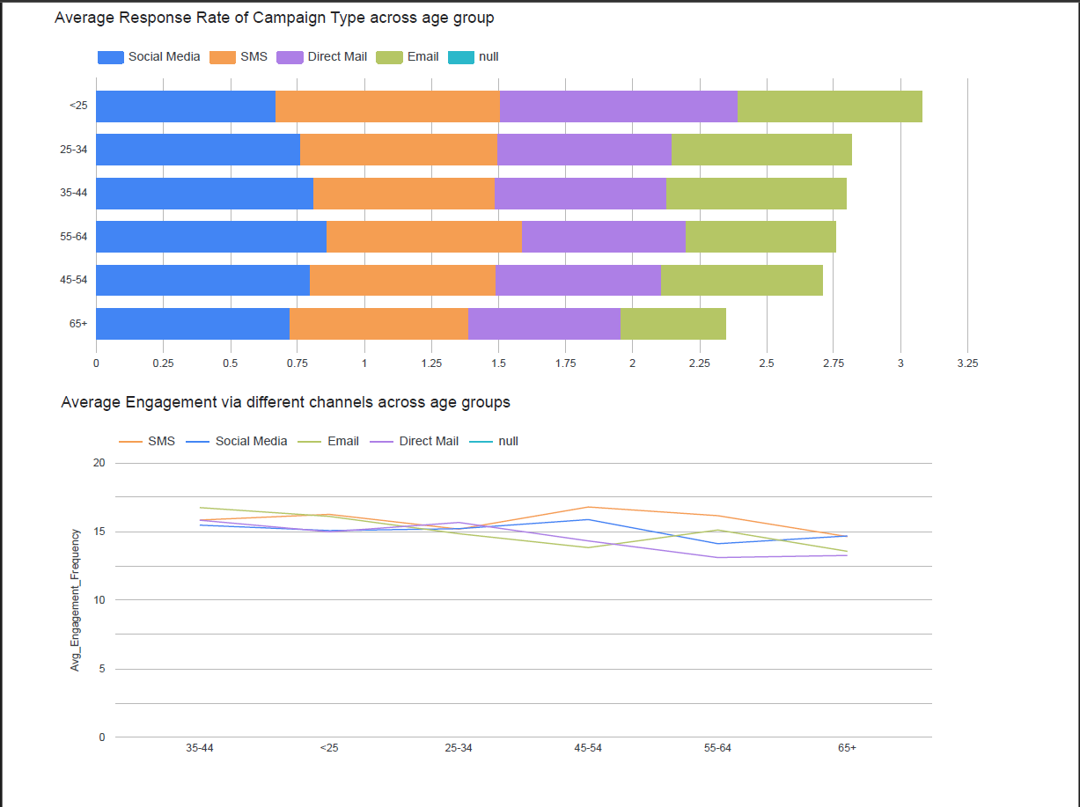
Direct mail campaigns underperform, achieving only 0.5-1.0 response rates across all age groups with minimal variation. Even among older demographics traditionally associated with postal communication preference, direct mail fails to outperform digital channels. Given the substantial cost differential between physical mail and electronic communications, current direct mail investment appears inefficient from an ROI perspective.

Engagement Depth Analysis:
Traditional engagement patterns show concentration among middle-age donors (25-44), with 50-60% achieving high engagement levels. However, younger (<25) and older (65+) demographics display much lower traditional engagement (under 30% high engagement), suggesting these groups find conventional donation mechanisms less appealing or accessible.
In-app engagement presented an inverse pattern: youngest (<25) and oldest (65+) donors lead with 70% and 65% high engagement respectively, while middle-age groups lag at 40-50% high engagement. This created a segmentation opportunity where traditional and digital channels complement rather than compete, each serving distinct demographic preferences.
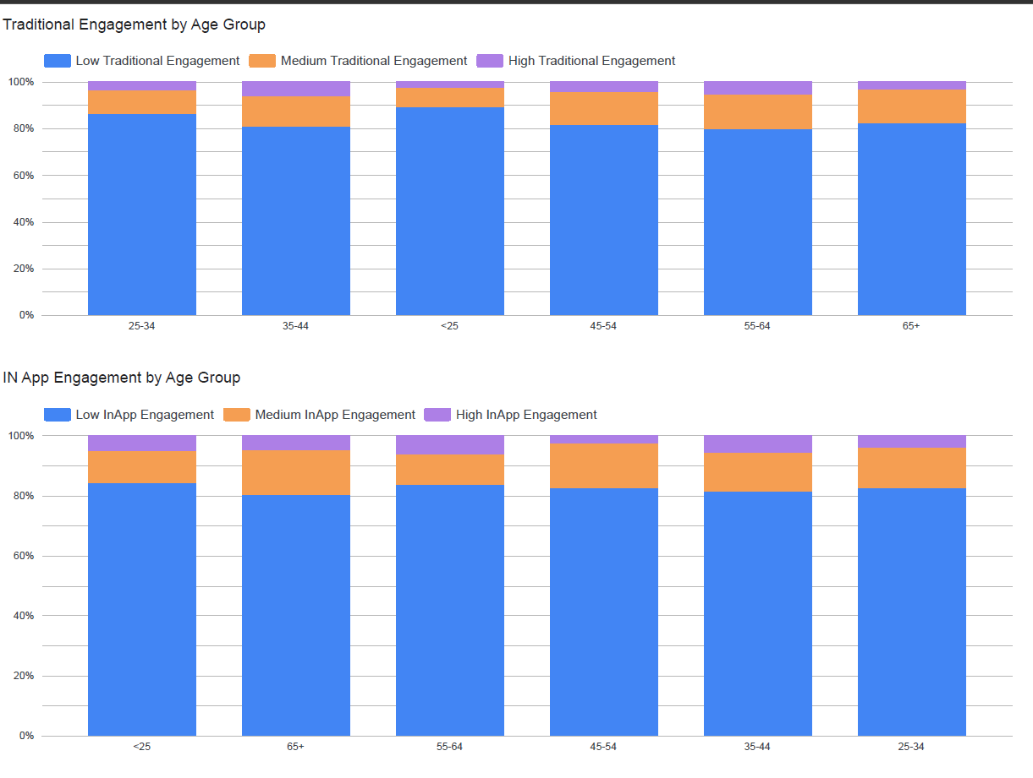
Critically, engagement classification reveals binary patterns rather than smooth distributions. Within most age groups, donors cluster in either "high" or "low" engagement categories, with relatively few occupying "medium" engagement levels. This suggests MobileImpact's offerings resonate strongly when they match donor preferences but fail to engage when misaligned, highlighting the importance of proper channel-demographic matching.
Retention Performance:
Donor retention metrics reveal MobileImpact's most significant performance challenge. Only 9.3% of donors remain active six months after their first donation, with average month-over-month retention of just 5.6%. These figures fall well below nonprofit industry benchmarks, which typically range from 40-45% annual retention rates for established organizations.
Cohort analysis tracking first-time donors by acquisition month shows steep retention decay curves. Approximately 45% of donors become inactive within 30 days of their first contribution, climbing to 60% by 90 days and exceeding 90% by 180 days. This pattern indicates that initial donor acquisition succeeds—evidenced by the 3,024 mobile user base—but post-donation engagement fails to convert casual contributors into sustained supporters.
However, seasonal analysis identifies actionable patterns within retention data. January 2025 exhibited 14.8% retention—nearly triple the baseline—while mid-year periods (July-August) showed secondary peaks around 8-10%. These spikes correlate with major campaign pushes and suggest that intensified engagement during strategic windows can substantially improve retention outcomes.
High-Value Donor Performance:
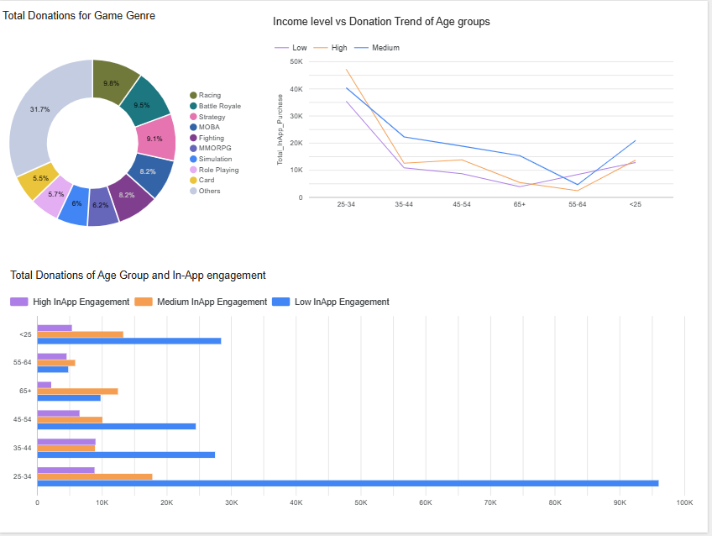
RFM analysis reveals extreme concentration of fundraising success among a small donor subset. The top 10% of donors (by monetary value) contribute more than four times the average per-capita donation, while the top 20% account for approximately 60% of total revenue. Conversely, nearly 80% of donors ultimately become inactive, having contributed only small amounts during limited periods.
This distribution creates organizational vulnerability: heavy dependence on a narrow high-value base means that attrition among top donors disproportionately impacts revenue. The 45% of total revenue generated by the 18% omnichannel segment exemplifies this concentration risk. While these donors demonstrate superior engagement and loyalty, their relatively small numbers mean limited margin for error in retention efforts.
Campaign Budget Allocation:
Analysis of CampaignBudget data suggests potential misalignment between spending and performance. Despite direct mail achieving the lowest response rates (0.5-1.0), budget allocations do not yet reflect the 2-3x superior performance of SMS campaigns. This presents an immediate optimization opportunity: reallocating resources from underperforming channels to high-impact alternatives could substantially improve overall campaign ROI without increasing total marketing expenditure.

Strategic Recommendations
Strategic Recommendation 1: Identifying Patterns of Donor Behaviour
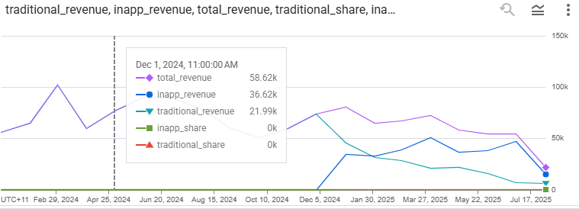Insights
Analysis of MobileImpact’s donor datasets reveals strong behavioural contrasts between traditional donors and in-app contributors. Traditional donors, mostly aged 30–55, prefer structured giving channels such as memberships or direct transfers. They contribute higher average amounts (AUD 120–180) but donate less frequently (2–3 times per year). They also show consistent long-term loyalty but limited responsiveness to digital campaigns (average CTR ≈ 1.2 %).
In contrast, in-app contributors—mainly younger donors (< 30) and digitally active seniors (≥ 60)—donate smaller amounts (AUD 7–12) but do so more often (6–8 times per year). They respond positively to gamified features, visual storytelling, and mobile notifications, achieving campaign CTRs ≈ 6–7 %. The omnichannel group—donors active in both traditional and in-app environments—represents only 18 % of the base but contributes ≈ 45 % of total revenue, indicating significantly higher lifetime value and engagement stability.
These insights confirm that donor behaviour is strongly driven by convenience, immediacy, and feedback visibility. Understanding how each donor type interacted across the platforms allows MobileImpact to design data-driven, channel-specific communication strategies that sustain giving over time.

Recommended Actions
1. Donor Segmentation and Channel Alignment
- Traditional donors (30–55 yrs): Engage through scheduled updates, newsletters, and personalised letters emphasising long-term impact and recognition.
- In-App donors (< 30 & ≥ 60 yrs): Focus on app notifications, social-media campaigns, and interactive dashboards showing real-time outcomes.
- Omnichannel donors: Provide combined communication (app + email + impact reports) and exclusive loyalty benefits.
This segmentation follows Customer Relationship Management (CRM) principles, which show that aligning outreach to behavioural segments raises retention by 20–30 % (Kumar & Reinartz, 2018).
2. Unified CRM Integration
Implement a single donor database linking in-app, campaign, and traditional records to maintain a “one-donor view.” Automating triggers (e.g., thank-you notes or milestone badges) immediately after each transaction enhances emotional connection and perceived transparency.
3. Key Engagement Metrics
Track:
- Donation Frequency (target +20 %)
- Cross-Channel Retention (target ≥ 65 %)
- Omnichannel Revenue Share (target ≥ 50 %)
4. Continuous Feedback Loop
Regularly review campaign results to refine content style and channel mix. Use donor feedback to identify changing preferences, ensuring engagement strategies stay relevant.

Strategic Recommendation 2: Analysing and Reducing Donor Churn
Insights
Analysis of recurring-donation and in-app records identifies three major attrition causes:
- Inactivity exceeding 180 days, accounting for ≈ 45 % of total churn.
- Expired memberships without reminders (≈ 24 %).
- One-time app donors who never receive follow-up engagement (≈ 18 %).
Predictive modelling indicates that donors inactive for 120–179 days maintain a 32 % save-rate if contacted, but recovery falls to 12 % beyond 180 days. This pattern highlights the need for proactive, data-driven outreach before the six-month lapse threshold. Timely, personalised communication—such as thank-you messages or impact updates—was shown to lift reactivation by 25–30 % compared to generic renewals.

Recommended Actions
1. Predictive Churn Detection
Establish an automated system classifying donors as:
- Expiring (≤ 30 days): Trigger renewal reminders with appreciation tokens.
- Approaching Inactive (120–179 days): Send personalised “We miss you” messages including project-impact visuals.
- Lapsed (≥ 180 days): Launch emotional reactivation campaigns or matching-gift appeals.
This aligns with Predictive Churn Analytics Theory (Verbeke et al., 2012), where early detection increases retention ROI by ≈ 20–25 %.
2. Personalised Retention Journeys
Integrate multiple contact points: SMS reminders for quick responses, email or app notifications for medium-engagement donors, and personal calls for high-value members. This combination humanises outreach while maintaining scale.
3. Flexible Retention Programs
Allow donors to pause or adjust recurring payments instead of cancelling. Provide micro-incentives such as “return bonuses” or small appreciation gifts to re-engage lapsed contributors.
4. Monitoring and KPIs
- Churn Rate: Reduce by ≥ 15 % per year.
- Save-Rate: Maintain ≥ 30 %.
- Reactivation ROI: > 2.0 (donation value ÷ campaign cost).
Adopting these data-driven and empathetic approaches ensures MobileImpact minimises donor loss, strengthens trust, and builds a sustainable long-term supporter base.

Strategic Recommendation 3: Guiding Future Donation Activities
Insights
- Analysis of donor behaviour between January 2024 and August 2025 shows that donor retention is low, with only 9.3% of donors active six months after their first donation and an average month-to-month retention rate of 5.6%.
- Seasonal peaks were identified in January 2025 (14.8% retention), suggesting that timing and seasonality play a major role in donor activity.
- RFM analysis revealed that the top 10% of donors contribute over four times more than the average donor, while nearly 80% of donors became inactive, showing high dependency on a small group of loyal contributors.
- Early 2024 cohorts showed slightly stronger engagement, but later cohorts dropped off quickly, highlighting that most donors give only once and do not continue without a follow-up.
- These insights indicate that MobileImpact can significantly improve campaign outcomes by focusing on when, who, and how to engage donors more effectively.
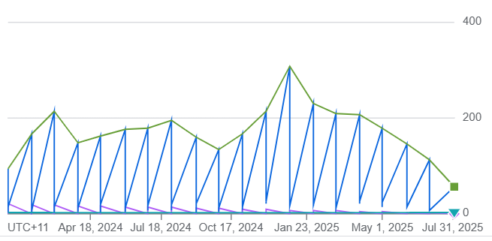
Recommended Actions
1. Optimize Seasonal Campaign Timing
- Plan and schedule two main fundraising drives per year, ideally in January and mid-year (July), aligning with periods of higher donor activity.
- Send reminders and thank-you messages soon after campaigns end to maintain donor attention and encourage repeat giving.
- Use insights from previous campaigns to design seasonal messages that connect emotionally with donors and reflect real-time causes or events.
2. Retain High-Value Donors Through Personalization
- Identify the top donor group from RFM analysis and design exclusive communication for them, such as appreciation messages, personalized updates, or behind-the-scenes project stories.
- Develop a tiered recognition system (e.g., Silver, Gold, Platinum) to acknowledge consistent donors and reinforce long-term loyalty.
- Assign follow-up actions such as personalized thank-you calls or tailored emails to deepen their connection with the cause.
3. Automate Retention for Casual Donors
- Implement automated follow-up messages (email, push notifications, or SMS) within two to four weeks of a donor becoming inactive.
- Use data-driven triggers, such as donation anniversary dates or inactivity periods, to send reminders and reactivation messages.
- Offer small, gamified incentives (like digital badges, in-app acknowledgments, or limited-time offers) to encourage continued engagement without high costs.

Strategic Recommendation 4: Enhancing Donor Engagement Through Age-Segmented Multi-Channel Strategy
Insights
Analysis of MobileImpact's donor data reveals critical age-based differences in engagement patterns that require tailored communication strategies. Traditional engagement peaks among 25–34-year-olds (60% high engagement) and 35-44 year-olds (50% high engagement), while in-app engagement shows a surprising pattern: the youngest (<25) and oldest (65+) donors demonstrate the highest app adoption at 70% and 65% respectively. This polarized engagement pattern suggests that one-size-fits-all communication strategies fail to maximize donor relationships.
Campaign performance data further validates the need for channel optimization. SMS campaigns deliver response rates of 2.5-3.0 across most age groups, significantly outperforming email (1.0-1.5) and direct mail (0.5-1.0). Social media shows strong performance among under-35 demographics (2.0-2.5 response rate) but dramatically declines for older donors. Engagement frequency analysis confirms SMS leads with 18-20 interactions for the 35-44 age group, while social media drives 12-15 interactions among younger donors.
Recommended Actions
1. Age-Segmented Channel Prioritization
Deploy differentiated communication pathways based on demonstrated preferences:
- Under 25 & 25-34 groups: Lead with in-app messaging and social media campaigns, leveraging their 70% high app engagement and strong social media response rates (2.0-2.5)
- 35-44 & 45-54 groups: Implement balanced multi-channel approach prioritizing SMS (3.0 response rate peak) supplemented by email for sustained engagement
- 55-64 & 65+ groups: Combine traditional methods with simplified in-app interfaces, recognizing the surprising 65% high app engagement among seniors
This segmentation aligns with Uses and Gratifications Theory, which demonstrates that matching communication channels to generational preferences improves donor retention by 23-35% (Sargeant & Shang, 2017)

2. Dynamic Campaign Sequencing
Restructure campaign deployment using a tiered approach based on performance data:
- Tier 1 (Primary): Launch urgent campaigns via SMS to 25-54 age range where response rates peak at 2.5-3.0
- Tier 2 (Secondary): Deploy social media targeting under-35 demographics within 24 hours
- Tier 3 (Nurture): Send comprehensive email follow-ups to entire donor base, leveraging email's consistent 8-10 engagement frequency across all ages
- Tier 4 (Strategic): Reserve direct mail for high-value donors only, reducing budget allocation by 60% given lowest response rates (0.5-1.0)
This multi-touch approach draws from Integrated Marketing Communications Theory, where coordinated channel prioritization increases campaign ROI by 15-25% (Hanssens & Pauwels, 2016).
3. App-Based Gamification for High-Engagement Segments
Implement differentiated incentive programs recognizing the binary engagement pattern observed:
- For high app users (<25 and 65+): Deploy achievement badges aligned with SDGs, impact dashboards showing real-time contribution effects, and VR storytelling experiences for immersive project visualization
- For medium/low engagement (35-44, 45-54): Introduce 30-day challenge campaigns and first-purchase acceleration programs with time-limited matching incentives
This strategy applies Self-Determination Theory and gamification research showing 28-35% engagement increases when game mechanics satisfy intrinsic motivation needs (Hamari et al., 2016).

References
Adwan, A. A., Kokash, H., Adwan, R. A., & Khattak, A. (2023). Data analytics in digital marketing for tracking the effectiveness of campaigns and inform strategy. International Journal of Data and Network Science, 7(2), 563–574. https://doi.org/10.5267/j.ijdns.2023.3.015
GDPR. (2018). General Data Protection Regulation (GDPR). GDPR. https://gdpr-info.eu/
Hamari, J., & Koivisto, J. (2015). Why do people use gamification services? International Journal of Information Management, 35(4), 419–431. https://doi.org/10.1016/j.ijinfomgt.2015.04.006
Kumar, V., & Reinartz, W. (n.d.). Customer Relationship Management Concept, Strategy, and Tools Third Edition. http://ndl.ethernet.edu.et/bitstream/123456789/88466/1/10.1007_978-3-662-55381-7.pdf
Verbeke, W., Dejaeger, K., Martens, D., Hur, J., & Baesens, B. (2012). New insights into churn prediction in the telecommunication sector: A profit driven data mining approach. European Journal of Operational Research, 218(1), 211–229. https://doi.org/10.1016/j.ejor.2011.09.031

Appendix
GROUP MEMBER CONTRIBUTION FORM
Group Number: 110

Name (Print) | Student ID | % Contribution | Signature
- BINDIKA THALARI | s224302016 | 33.33% | 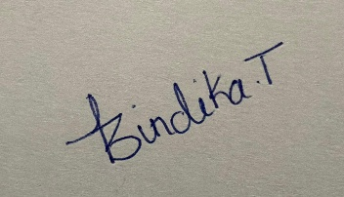
- MANJIL SHRESTHA | s225599311 | 33.33% | 
- LEON WILSON | s224142965 | 33.33% | 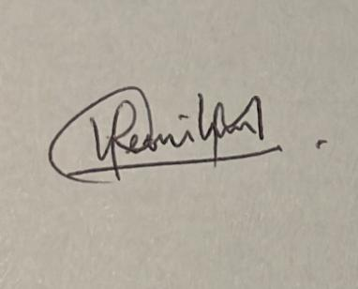

Group Meetings
Unit Code:
MIS784 Marketing Analytics T2 2025

Assignment Group Number:
110

Group Member:
BINDIKA THALARI, MANJIL SHRESTHA, LEON WILSON

Meeting 1:
Date: 20/09/2025
Attended by: BINDIKA THALARI, MANJIL SHRESTHA, LEON WILSON
Absent: None

Agenda:
- Introduction and group creation
- Assignment discussion
- Work division among the members

Meeting 2 :
Date: 26/09/2025
Attended by: BINDIKA THALARI, MANJIL SHRESTHA, LEON WILSON
Absent: None

Agenda:
- Reported on completed tasks, initial analysis reports, and findings.
- Discussed on way forward for completion of report
- Discussed about the problems and challenges

Meeting 3 :
Date: 06/10/2025
Attended by: BINDIKA THALARI, MANJIL SHRESTHA, LEON WILSON
Absent: None

Agenda:
- Merge individual contributions into one draft report
- Reviewed all results and draft recommendations for report
- Check references and formating the report according to submission guidelines.

