Requirements Engineering

Restaurant System

Submitted By: Yit How Wong (T00198005)
Computing with Software Development

Date Submitted: 21/5/2019
Table of Contents
1. Introduction/overview 4
2. Functional Components 5
3. User Requirements 6
3.1. Restaurant OrderSys will perform a restaurant menu management. 6
3.1.1. Restaurant OrderSys will add a new food type into the menu. 6
3.1.2. Restaurant OrderSys will add a new food item into the menu. 6
3.1.3. Restaurant OrderSys will change a food item. 6
3.2. Restaurant OrderSys will perform restaurant administration system. 6
3.2.1. Restaurant OrderSys will add a new staff. 6
3.2.2. Restaurant OrderSys will modify a staff detail. 6
3.2.3. Restaurant OrderSys will perform revenue analysis. 6
3.2.4. Restaurant OrderSys will perform food item analysis. 6
3.3. Restaurant OrderSys will perform a dining restaurant order system. 6
3.3.1. Restaurant OrderSys will perform order placement. 6
3.3.2. Restaurant OrderSys will alter the order 6
3.3.3. Restaurant OrderSys will a allow customer to pay the bill. 6
4. System Requirements 7
4.1. System Level Use Case Diagram 7
4.2. Manage Food 8
4.2.1. Add Food Type 8
4.2.2. Add food item 11
4.2.3. Change Food Item 14
4.3. Administration 17
4.3.1. Add Staff 17
4.3.2. Modify Staff 20
4.3.3. Revenue Analysis 23
4.3.4. Food Analysis 27
4.4. Order Food 31
4.4.1. Place Order 31
4.4.2. Alter Order 37
4.4.3. Pay Bill 40
5. System Model 43
5.1. Level-0 DFD 44
5.2. Level-1 DFD 45
5.3. Level-2 DFD (Process P1: Manage Food) 46
5.4. Level-2 DFD (Process P2: Perform Administration) 47
5.5. Level-2 DFD (Process P3: Manage Order) 48
6. Data Model (Class Diagram) 49
6.1. Class Diagram 50
6.2. Relational Schema 51
6.3. Database Schema 52
7. Conclusion 54
8. Appendices 55
8.1. Appendix A – Listing 55
8.2. Appendix B – Report 57

Introduction/overview
During the old days, a restaurant might order the food from a customer by writing down the orders, passing the order copy to the kitchen and calculate the bill by people. This might bring some conflict in between restaurant staff and customer due to illegible writing, misleading price or missing order record.

With the help of computer, it has easier the life of human beings’ by being able to multitask without any mistake. Nowadays most of the businesses are adapting from the traditional business model to computer-based system, which allowed accurate data to be saved, retrieved and processed much more efficiently and is easy to learn and use.

This project is to simulate a system related to restaurant business model. It allows the managers to add staff information, food information and perform monthly analysis. It also allows the staff to take order from the customer and process the transaction correctly.

Functional Components
The section of the document shows the functional components of the proposed software system.
There are 3 main components in the proposed system.

User Requirements

Restaurant OrderSys will perform a restaurant menu management.

Restaurant OrderSys will add a new food type into the menu.

Restaurant OrderSys will add a new food item into the menu.

Restaurant OrderSys will change a food item.

Restaurant OrderSys will perform restaurant administration system.

Restaurant OrderSys will add a new staff.

Restaurant OrderSys will modify a staff detail.

Restaurant OrderSys will perform revenue analysis.

Restaurant OrderSys will perform food item analysis.

Restaurant OrderSys will perform a dining restaurant order system.

Restaurant OrderSys will perform order placement.

Restaurant OrderSys will alter the order

Restaurant OrderSys will a allow customer to pay the bill.

System Requirements
The following system level use case diagram defines the communications between actors and the system. The actors involve in the Restaurant OrderSys are Manager, Staff and Customer. Each actor is involved in at least one task to achieve the system’s goal.

System Level Use Case Diagram
The following system level uses case diagram illustrates the high-level system requirements.

Restaurant OrderSys

Manage Food
Manager

Customer
Perform Administration Task

Staff
Process Orders

Manage Food
This module contains function of adding food type, adding food item and change food item.

Add Food Type
Description: Every food item in the restaurant has a food type, which allows the manager to analyse the food item sales and the staff to find food on the system more easily. This function adds a food type and its description on the system.

Use case diagram:
Display food type error
<<excludes>>
Manager
Add food type
Use case narratives:
Use Case Name | Add food type
Use Case Id | 1.1
Priority | High
Source | Manager
Primary Business Actor | Manager
Other Participating Actors | None
Description | This function adds a food type in the system.
Preconditions | None
Trigger | None
Expected Scenario | Actor Action | System Response
 | Step 1: Manager invokes Add Food Type function  Step 3: Manager enters food type details:  - Food type  - Description  Step 4: Manager confirms the food type is to be set | Step 2: The system displays the UI  Step 5: System validates food type details:  - All field must be entered  - Food type must only contain one alphabetic character  - Food type must NOT already be registered  Step 6: Display a confirmation message  Step 7: Save food type details in Food Types File:  - Food Type  - Description  Step 8: Clear the UI
Alternate Scenarios | Actor Action | System Response
Invalid Data Entered |  | Step 5: Invalid data detected  Step 6: Display appropriate error message and return to step 3.
Conclusions | Food type is now registered in the Food File.
Post conditions | Food type can be assigned to food item.
Business Rules
Implementation Constraints

Add food item
Description: Each food item available for sale is identified by a unique ItemID, which is assigned by the system. This function stores the details of each food item available for sale on the system.

Use case diagram:
Manager
Add food item
<<includes>>
Validate food item
Display Food Item Error
<<excludes>>
Use case narratives:
Use Case Name | Add food item
Use Case Id | 1.2
Priority | High
Source | Manager
Primary Business Actor | Manager
Other Participating Actors | None
Description | This function adds a food item in the system.
Preconditions | None
Trigger | None
Expected Scenario | Actor Action | System Response
 | Step 1: Manager invokes Add Food Item function  Step 5: Manager enters food item details:  - Name  - Description  - Food Type  - Price  Step 6: Manager confirms the food item is to be added. | Step 2: The system retrieves all food types from the Food Types file.  Step 3: The system generates the next ItemId.  Step 4: The system displays the UI  Step 7: System validates food item details:  - All field must be entered  - Food Item name must not longer than 15 characters  - Description must not longer than 30 characters  - Price value must be numeric and greater than 0  Step 8: The system determines the next ItemId .  Step 9: Save food item details in Food Items File:  - ItemId  - Name  - Description  - Food Type  - Price  - Status  Step 10: Display a confirmation message  Step 11: Clear the UI
Alternate Scenarios | Actor Action | System Response
Invalid Data Entered |  | Step 6: Invalid data detected  Step 7: Display appropriate error message and return to step 3.
Conclusions | Food item is now registered in the Food File.
Post conditions | Staff can place food order from the till.
Business Rules
Implementation Constraints

Change Food Item
Description: A food item might have its detail changed or will not be served during season. A food item which is not available will have its status changed to unavailable (‘U’). This function changes a food item attribute in the system.

Use case diagram:
Manager
Change food item
<<includes>>
Validate food Item
Display error message
<<excludes>>
Use case narratives:
Use Case Name | Change Food Item
Use Case Id | 1.3
Priority | High
Source | Manager
Primary Business Actor | Manager
Other Participating Actors | None
Description | This function changes the details of a food Item
Preconditions | None
Trigger | None
Expected Scenario | Actor Action | System Response
 | Step 1: Manager invokes Change Food Item function  Step 4: Manager choose food type  Step 6: Manager choose food item  Step 8: Manager changes food item details:  - Name  - Description  - Food Type  - Price  - Status  Step 9: Manager confirms the food item is to be changed | Step 2: The system retrieves details of all food types from the Food Type file and loads on the UI  Step 3: The system displays the UI  Step 5: The system retrieves a summary of all Food Items of the selected type from the Food Item File in order of name and displays on UI  Step 7: System retrieve all details of the selected food item from the Food Items file and displays on UI for changing  Step 10: System validates food item details:  - All field must be entered  - Food Item name must not longer than 15 characters  - Description must not longer than 30 characters  - Price value must be numeric and greater than 0  Step 11: System updates the food item details in the Food Items file.  Step 12: Display a confirmation message.  Step 13: Clear the UI
Alternate Scenarios | Actor Action | System Response
Invalid Data Entered |  | Step 11: Invalid data detected  Step 12: Display appropriate error message and return to step 8.
Conclusions | Food item is now changed in the Food File.
Post conditions | Waiter can place the latest the food order on the system.
Business Rules
Implementation Constraints

Administration
This module contains function of adding staff, modifying staff, removing staff, performing revenue analysis and food analysis.

Add Staff
Description: Before a staff able to order an order from customer, a staff must be registered in the system by the manager. This function adds a new staff and name into the system.
Manager
Add Staff
Validate Staff Detail
<<includes>>
<<excludes>>
Display Error Message
Use Case Name | Add Staff
Use Case Id | 2.1
Priority | High
Source | Manager
Primary Business Actor | Manager
Other Participating Actors | None
Description | This function adds a new staff detail into the system.
Preconditions | None
Trigger | None
Expected Scenario | Actor Action | System Response
 | Step 1: Staff invokes the Add Staff function.  Step 4: Manager enters staff detail:  - Staff Name  - Staff Status  Step 5: Manager confirm the staff is to be set. | Step 2: The system generates the next StaffId.  Step 3: The system displays the UI.  Step 6: The system validates the staff detail:  - All field must be entered.  - Staff name must contain less than 30 alphabetical characters.  Step 7: The system displays a confirmation message.  Step 8: The system saves the staff details into Staffs File:  - StaffId  - Staff Name  - Staff Status  Step 9: The system clears the UI.
Alternate Scenarios | Actor Action | System Response
Invalid Data Entered |  | Step 10: System detected invalid data input.  Step 11: System displays appropriate error messages and back to Step 3.
Conclusions | A table is successfully added to system.
Post conditions | A staff is able to take the order for the customer.
Business Rules
Implementation Constraints

Modify Staff
Description: A staff may have his or her name changed. This function changes the detail of a staff.
Manager
Modify Staff
Validate Staff Detail
<<includes>>
<<excludes>>
Display Error Message
Use Case Name | Modify Staff
Use Case Id | 2.2
Priority | Low
Source | Manager
Primary Business Actor | Manager
Other Participating Actors | None
Description | This function changes the detail of a staff.
Preconditions | None
Trigger | None
Expected Scenario | Actor Action | System Response
 | Step 1: Staff invokes the Modify Staff function.  Step 4: Manager choose staff to Modify.  Step 6: Manager changes staff details:  - Staff Name  - Staff Status  Step 7: Manager confirm staff details to be changed. | Step 2: The system retrieves all the staff name from the Staffs File.  Step 3: The system displays the staff name in order of name on the UI.  Step 5: The system retrieves the corresponding staff detail from the Staffs File and display on the UI for changing.  Step 8: The system validates the staff details.  Step 9: The system displays a confirmation message.  Step 10: The system saves the updated staff details the Staffs File.  Step 11: The system clears the UI.
Alternate Scenarios | Actor Action | System Response
Invalid data entered |  | Step 9: System detected invalid data entered.  Step 10: System displays appropriate error messages and back to Step 5.
Conclusions | A staff details is updated and saved to Staffs File.
Post conditions
Business Rules
Implementation Constraints

Revenue Analysis
Description: This function generates a revenue report on the system that analysed the total revenue in the restaurant for each year, month and week. The report may be printed if required.
Manager
Revenue Analysis

Use Case Name | Revenue Analysis
Use Case Id | 2.3
Priority | High
Source | Manager
Primary Business Actor | Manager
Other Participating Actors | None
Description | This function generates revenue report on the system that analysed the total revenue in the restaurant for each year, month and week. The report may be printed if required.
Preconditions | None
Trigger | None
Expected Scenario | Actor Action | System Response
 | Step 1: Manager invokes Revenue Analysis function  Step 3: Manager specifies the year to be viewed on annual revenue report.  Step 5: Manager specifies the month to be viewed on monthly revenue report.  Step 7: Manager specifies the week to be viewed on weekly revenue report.  Step 9: Manager requests a print copy of the report  Step 11: Manager requests to reset UI | Step 2: System retrieves all order total cost details from Orders File, calculate it and generates a revenue report and display them in order of week on UI.  Step 4: System retrieves each order total cost details from Orders File, calculate it and generates an annual revenue report in the selected year and display them in order of months on UI.  Step 6: System retrieves each order total cost details from Orders File, calculate it and generates a monthly revenue report in the selected month and display them in order of week on UI.  Step 8: System retrieves each order total cost details from Orders File, calculate it and generates a weekly revenue report in the selected week and display them in order of day on UI.  Step 10: System confirms that the print job has been sent  Step 12: System resets UI
Alternate Scenarios | Actor Action | System Response
Conclusions | Revenue analysis report is generated or printed.
Post conditions
Business Rules | Report is displayed and cannot be amended or deleted.
Implementation Constraints

 | 2019 Annual Revenue Report
Year | Month | Week | Day | Cost
2019 | 1 |  |  | 5794.65
2019 | 2 |  |  | 7812.90
2019 | 3 |  |  | 6020.60
2019 | 4 |  |  | 6598.10
2019 | 5 |  |  | 6300.98

Annual Report Example

 | 2019 April Monthly Revenue Report
Year | Month | Week | Day | Cost
2019 | 4 | 1 |  | 1200.80
2019 | 4 | 2 |  | 1300.65
2019 | 4 | 3 |  | 1237.60
2019 | 4 | 4 |  | 1809.35

Monthly Report Example

 | 2019 April Week 1 Revenue Report
Year | Month | Week | Day | Cost
2019 | 4 | 1 | 1 | 250.30
2019 | 4 | 1 | 2 | 300.50
2019 | 4 | 1 | 3 | 200.10
2019 | 4 | 1 | 4 | 400.80
2019 | 4 | 1 | 5 | 324.80

Weekly Report Example

Food Analysis
Description: This function generates a food analysis report on the system that analysed the quantity of each food item with the given food type sold in the restaurant. The report may be printed if required.
Manager
Food Analysis

Use Case Name | Food Analysis
Use Case Id | 2.4
Priority | High
Source | Manager
Primary Business Actor | Manager
Other Participating Actors | None
Description | This function generates a food analysis report on the system that analysed the quantity of each food item with the give food type sold in the restaurant. The report may be printed if required.
Preconditions | None
Trigger | None
Expected Scenario | Actor Action | System Response
 | Step 1: Manager invokes Food Analysis function  Step 3: Manager specified the year, month and food type to be viewed on the food analysis sale report.  Step 5: Manager requests a print copy of the report  Step 8: Manager requests to reset UI | Step 2: System retrieves each order items sale details from OrderItems File, calculate the total sale quantity and display them in order of total sale quantity.  Step 4: System retrieves order details from Orders File, and its corresponding order item details of only the specified time and specified Food Type from Orders File, Order Items File and Food Item File, and displays the quantity of each food item sold on UI in order of sold quantity.  Step 6: System generates a print file based on the displayed data and sends to the default print device  Step 7: System confirms that the print job has been sent  Step 9: System resets UI
Alternate Scenarios | Actor Action | System Response
Conclusions | Food analysis report is generated or printed.
Post conditions
Business Rules | Food analysis report is displayed and cannot be amended or deleted.
Implementation Constraints

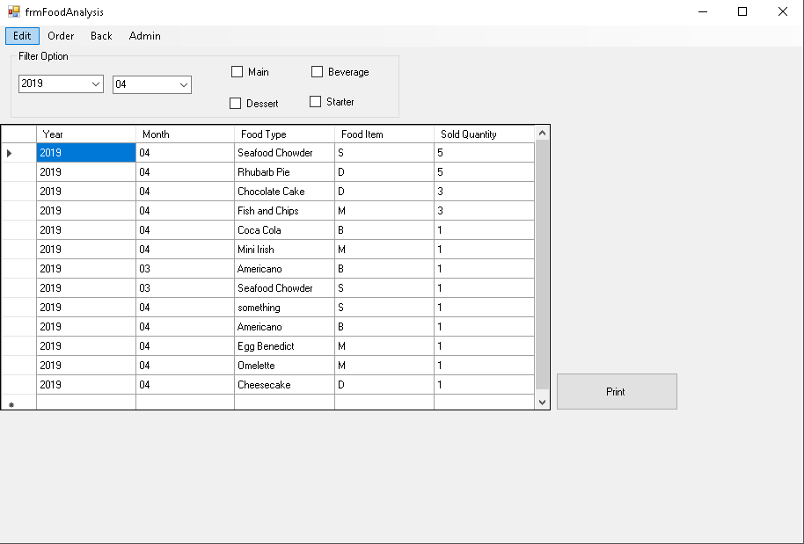
Snapshot of Annual Food Analysis Report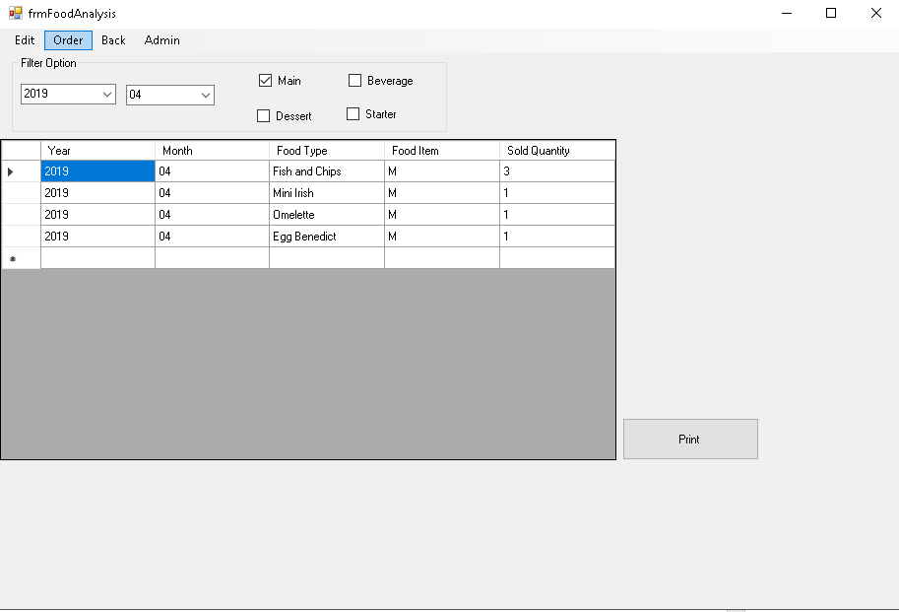
Snapshot of Monthly Food Analysis Report, Main Food Type Selected

Order Food

Place Order
Description: A staff must be logged in to the system before ordering a table. A staff can take a food order from a table, which the order will be storing in the Table Order File before the bill is payed. Each order is identified by an OrderNo which is assigned by the system. Every Food Item ordered will be stored and identified by the Order No and the ItemID. A staff can only order the food that are available on the menu. This function places an order of a table.

Use case diagram:
Remove Unwanted Food
<<excludes>>
Staff
Place Order
Display Order Function
<<includes>>
Customer
Activity Diagram:
Staff | System
Invoke Order Function  Select Table  Retrieve food type and available food item  Display Table UI  Display order UI  Retrieve Order and Order Item Details  Has Order?  Retrieve selected table order item details  Select food type  Select food item  Enter food quantity  Confirm Food Item  Y  More food?  N  Place Order  Add order and order items to table  Save order details  Assign new order no | Y  N  Has Order?  Calculate the total cost and display on UI  Adds food item to order  N  Y

Use case narratives:
Use Case Name | Place Order
Use Case Id | 3.2
Priority | High
Source | Staff
Primary Business Actor | Staff
Other Participating Actors | Customer
Description | This function places an order of a table in the system.
Preconditions | Staff must be signed in on the system.
Trigger | None
Expected Scenario | Actor Action | System Response
 | Step 1: Staff invokes the Order function.  Step 3: Staff select table to go into Order Food Interface.  Step 8: Staff choose the food type  Step 10: Staff choose the food item.  Step 13: Staff confirms the food order. | Step 2: System retrieves all the order details from Orders File, and its corresponding order item details. The table will display the total current price of the order under the table button which indicate the table currently has order.  Step 4: The system displays the table interface.  Step 5: The system retrieves the order of the corresponding table from Orders File and Order Items File.  Step 6: The system retrieves the available food item for sale from Food Items file.  Step 7: The system displays the food order UI.  Step 9: System change the menu to the corresponding food type.  Step 11: The system updates and displays the food basket for each food order  - Quantity will be shown when a number button is pressed  - If no quantity is pressed before the food item is pressed, quantity will be assigned as one automatically  - Data grid will move on to next row when a food item is pressed.  Step 12: The system calculates the cost of the food and adds it to the total cost of the table.  Step 14:  The system saves the order item details into Order Items File.  - System assigns a new OrderNo if there is no order on the current tale.  - Save the Food Item, Quantity, Unit Price and Total Price in Order Items File.  Step 15:  The system saves the order details into Orders File.  - System set the corresponding Order No from the one in Order Items File, in Orders File.  - Set the Order Date as System Date in Orders File  - Assign the Table No as current table number in Orders File.  - Set the StaffId as the Id of the staff who took the order in Orders File.  - Set the Order Status to ‘U’ in Orders File.  - System calculate the total value and save in Orders File.
Alternate Scenarios | Actor Action | System Response
Remove unwanted food item | Step 13: Staff choose to remove selected food item on selected data grid. | Step 14: Food item on selected grid will be removed.  Step 15: The system recalculates the total cost of the table and display it.
Conclusions | Food order is placed to the corresponding table number.
Post conditions | Food order can be altered and the table can be paid.
Business Rules
Implementation Constraints

Alter Order
Description: A table might add on or cancel food after they have ordered. This function will retrieve that table previous order and change its attribute after the ordered is altered.
Use case diagram:
Staff
Delete Order
Display Order Function
<<includes>>
Customer

<<excludes>>
Add On Food Orders

Use Case Name | Alter Order
Use Case Id | 3.3
Priority | 3
Source | Staff
Primary Business Actor | Staff
Other Participating Actors | Customer
Description | This function alters an order of a table in the system.
Preconditions | A staff must be signed in to the system.  A table must have an existing unpaid order.
Trigger | None
Expected Scenario | Actor Action | System Response
 | Step 1: Staff invokes the Order function.  Step 3: Staff choose table number.  Step 7: Staff selects the food item grid row to be deleted and confirm delete. | Step 2: The system displays the table interface.  Step 4: The system retrieves the order of the corresponding table from Orders File and Order Items File.  Step 5: The system retrieves the available food item for sale from Food Items file.  Step 6: The system displays the food order UI.  Step 8: The system updates and remove the grid of the corresponding food order.  Step 9: System removed the Food Item, update the Order Items File and Orders File.
Alternate Scenarios | Actor Action | System Response
Add on food order | Step 9: Staff choose food item  Step 12: Staff confirms the food order. | Step 10: The system updates and displays the grid for each food order  - Quantity will be shown when a number button is pressed  - If no quantity is pressed before the food item is pressed, quantity will be assigned as one automatically  - Data grid will move on to next row when a food item is pressed.  Step 11: The system updates the order time, calculates the cost of the food and adds it to the total cost of the table.  Step 13: The system adds the order details and updates into Orders File and Order Items File.
Conclusions | Food item order is altered from the corresponding table number.
Post conditions
Business Rules
Implementation Constraints

Pay Bill
Description: A table must pay the bill before they leave the restaurant. The cost of that table and the quantity of food ordered will be stored for administration uses. This function allows the customer to pay the bill.
<<excludes>>
Print Receipt
Staff
Pay Bill
Display Order Function
<<includes>>
Customer

Use Case Name | Pay Bill
Use Case Id | 3.3
Priority | High
Source | Staff
Primary Business Actor | Staff
Other Participating Actors | Customer
Description | This function allows the customer to pay the bill.
Preconditions | A staff must be signed into the system.  A table must have at least one order of food item.
Trigger | None
Expected Scenario | Actor Action | System Response
 | Step 1: Staff invokes the Order function.  Step 3: Staff choose table number.  Step 6: Staff select the pay bill function. | Step 2: The system displays the table interface.  Step 4: The system retrieves the order details and total order cost of the corresponding table from Orders File and Order Items File.  Step 5: The system displays the order UI.  Step 7: The system updates the Orders File:  - Set the corresponding table order status to ‘P’  Step 8: The system displays a confirmation message.  Step 9: The system prints out a bill by generating a print file based on the Order Items and sends to the default print device.
Alternate Scenarios | Actor Action | System Response
Print receipt | Step 6: Staff select the print bill function. | Step 7: The system prints out a bill by generating a print file based on the Order Items and sends to the default print device.
Conclusions | A table is successfully paid.
Post conditions | A table can accept the new customer order.
Business Rules
Implementation Constraints

System Model
The following dataflow diagrams have been produced for the system:
DFD Elements:
External Entities:
Customer
Data Stores:
D1 Food Type File
D2 Food Item File
D3 Staff File
D4 Order File
D5 Order Items File

Processes:
P1 Manage Food
P1.1 Add Food Type
P1.2 Add Food Item
P1.3 Change Food Item
P2 Perform Administration
P2.1 Add Staff
P2.2 Modify Staff
P2.3 Revenue Analysis
P2.4 Food Analysis
P3 Manage Order
P3.1 Change Menu
P3.2 Place Order
P3.3 Alter Order
P3.4 Pay Bill

Level-0 DFD
Customer
Orders
Invoke
Restaurant System
(RestSys)
Customer
Food Type Details

Level-1 DFD
Food Item Details
Order Item Details
Order Item Details
Order Details
Order Details
Order Details
Staff Details
Table Details
Food Item Details
P2
Perform Administration
P3
Manage Order
Order Item File
D5
Order File
D4
Staff File
D3
Food Item File
D2
Food Type File
D1
P1
Manage Food

Level-2 DFD (Process P1: Manage Food)
Food Type Details
Food Type Details
Food Type Details
Food Item Details
Food Item Details
Food Item Details
P1.2
Add Food Item
P1.1
Add Food Type
Food Item File
D2
Food Type File
D1
P1.3
Change Food Item

Level-2 DFD (Process P2: Perform Administration)
Cost Details
Order Item Details
Order Details
Staff Details
Staff Details
Staff Details
Staff Details
Staff Details
Order File
D4
P2.5
Food Analysis
Order Item File
D5
P2.4
Revenue Analysis
P2.3
Delete Staff
P2.2
Modify Staff
P2.1
Add Staff
Staff File
D3

Level-2 DFD (Process P3: Manage Order)
Food Details
Food Details
P3.1
Change Menu
Staff File
D3
Customer
Food Details
Order Details
Order Details
Order Details
Order Details
Bill Details
Staff Details
Order Details
Order Details
P3.3
Alter Order
Order Item File
D5
Food Item File
D2
Order File
D4
Customer
P3.4
Pay Bill
P3.2
Place Order

Data Model (Class Diagram)
Data models define how the logical structure of a database is modelled. Data Models are fundamental entities to introduce abstraction in a DBMS. Data models define how data is connected to each other and how they are processed and stored inside the system. (From https://www.tutorialspoint.com/dbms/dbms_data_models.htm)

For this project, an Entity-Relationship (ER) Model is used. Entity-Relationship Model is based on the notion of real-world entities and relationships among them. While formulating real-world scenario into the database model, the ER Model creates entity set, relationship set, general attributes and constraints. The notation used for this project to produce the ER diagrams is the Unified Modelling Language (UML) Class Diagram.

An entity in an ER Model is a real-world entity having properties called attributes. For example, a food item in a restaurant is considers as an entity. A food item has various attributes like name, price, type, etc.

The logical association among entities is called relationship. Relationships are mapped with entities in various ways. Mapping cardinalities define the number of associations between two entities. It could be one to one, one to may many to one and many to many.

Class Diagram

Restaurant System UML Diagram:

Food Type
Food Type (PK)
Description
Order
OrderNo
OrderDate
OrderTime
TableNo
Value
Status
Food Item
ItemID (PK)
Name
Description
Price
Status
Order Item
Qty
Price
Staff
StaffID(PK)
StaffName

Orders
Refers to
Refers to
Belongs to
1
1
0…*
1…*
0…*
1
0…*
1

Relational Schema

Relational Schema:
FoodTypes (FoodType, Description)
FoodItems (ItemID, Name, Description, FoodType, Price, Status)
Orders (OrderNo, OrderDate, OrderTime, TableNo, Value, StaffId, Status)
OrderItems (OrderNo, FoodItem, Qty, Price)
Staff (StaffID, StaffName)

Database Schema

Relation: Food Types
Attributes: FoodType char(1)
Description char(30) NOT NULL
PRIMARY KEY: FoodType

Relation: Food Items
Attributes: ItemID numeric(2)
Name char(15) UNIQUE NOT NULL
Description char(30) NOT NULL
FoodType char(1) NOT NULL
Price decimal(5,2) NOT NULL
Status char(1) DEFAULT ‘A’
PRIMARY KEY: ItemID
FOREIGN KEY: FoodType REFERENCES Food Types (FoodType)

Relation: Staff
Attributes: StaffID numeric(1)
StaffName char(30) NOT NULL UNIQUE
PRIMARY KEY: StaffID

Relation: Orders
Attributes: OrderNo numeric(5)
OrderDate DATE DEFAULT ‘CURRENT_DATE’
OrderTime TIME DEFAULT’CURRENT_TIME’
TableNo numeric(2) NOT NULL
Value decimal(6,2) NOT NULL
StaffID numeric(1) NOT NULL
Status char(1) DEFAULT ‘U’
PRIMARY KEY: OrderNo
FOREIGN KEY: StaffID REFERENCES Staff (StaffId)

Relation: Order Items
Attributes: OrderNo numeric(5)
FoodItem numeric(2)
Qty numeric(2) NOT NULL
Price decimal(6,2) NOT NULL
PRIMARY KEY: OrderNo, FoodItem
FOREIGN KEY: OrderNo REFERENCES Orders (Staffs)
FoodItem REFERENCES Food Items(ItemID)

Assumptions:
Food Item Status is either ‘A’ (Available) or ‘U’ (Unavailable)
Order Status is either ’U’(Unpaid) or ‘P’(Paid)
OrderDate is in format of DD-MM-YYYY
OrderTime is in format of HH:MI:SS

Conclusion
In short, the Restaurant System allows a restaurant owner/manager to register a food type, food item, change the food item details. It also allows the owner/manager to add a staff and changed the staff details. Besides, the staff registered in the system also able to take order from customer and alter the order after an order is taken. A customer can ask to pay the bill and a receipt will be generated and be printed out to them. Lastly, the system can generate monthly revenue analysis report and monthly food analysis report which can be printed out.

Appendices

Appendix A – Listing
Food Item List
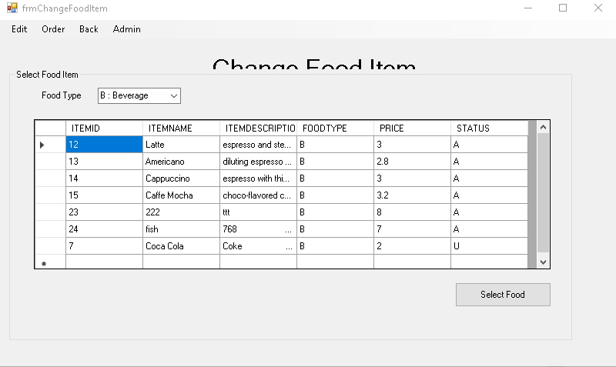
Order Cart List
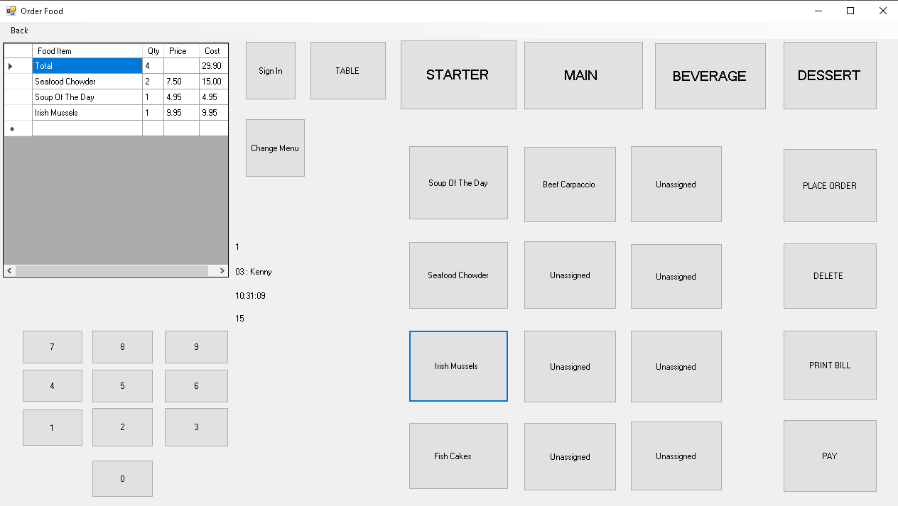

Appendix B – Report
Revenue Analysis
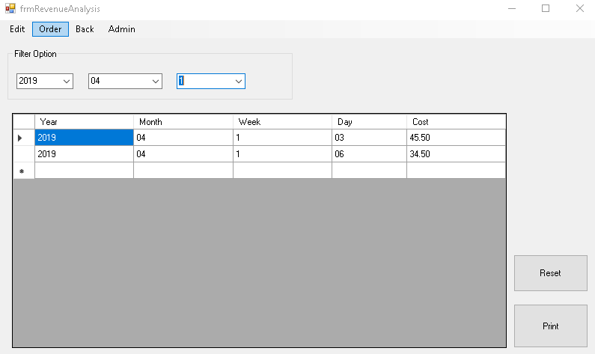

Food Analysis