2. a. (i)

For k = 3

Total SSE of each clustering run

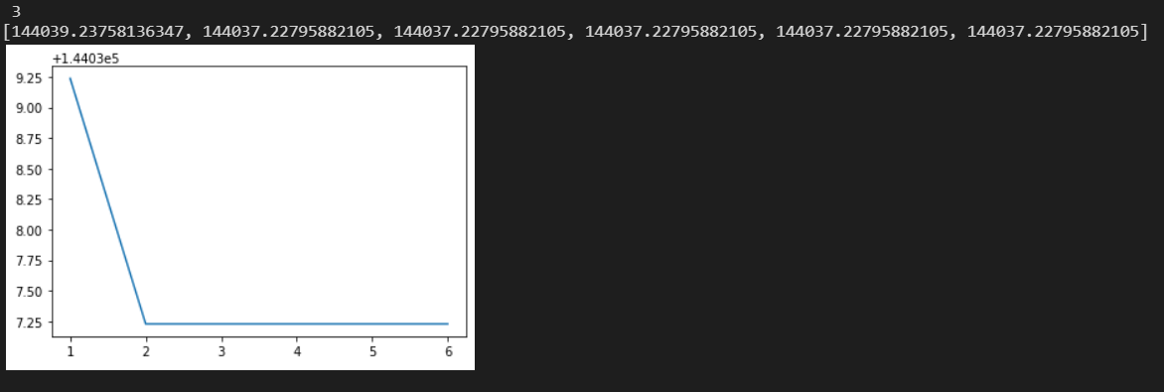

For k = 5

Total SSE of each clustering run

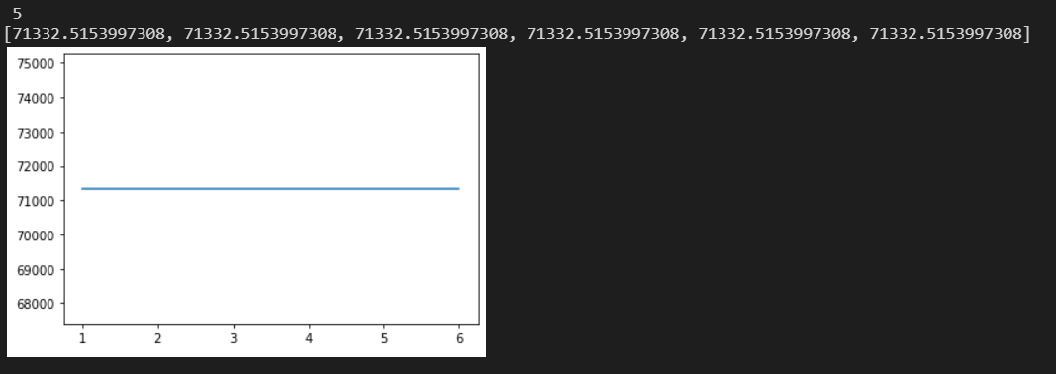

For k = 7

Total SSE of each clustering run

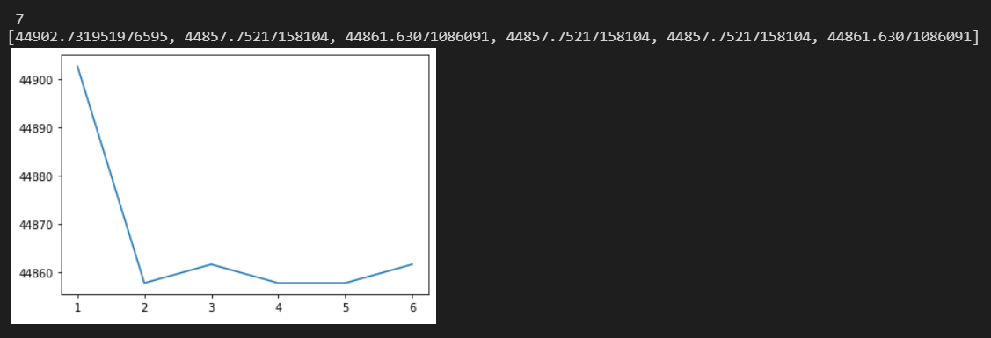

For k = 9

Total SSE of each clustering run

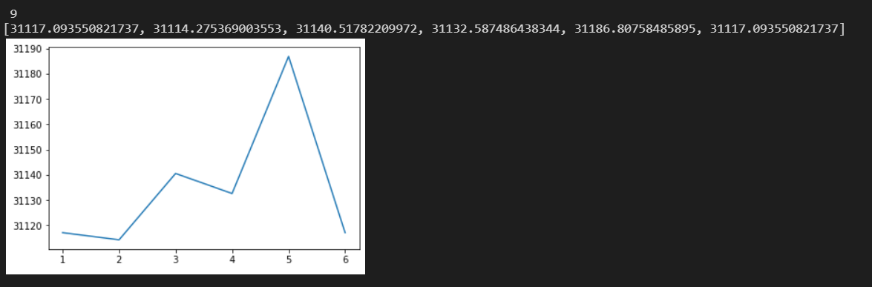

For k = 11

Total SSE of each clustering run

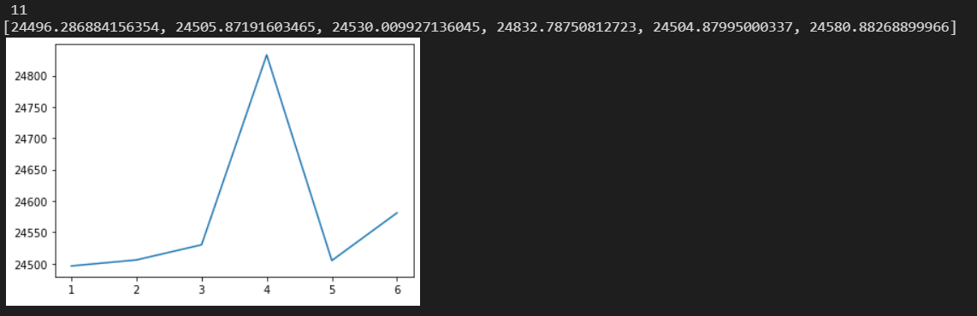

(ii)Average SSE for each k

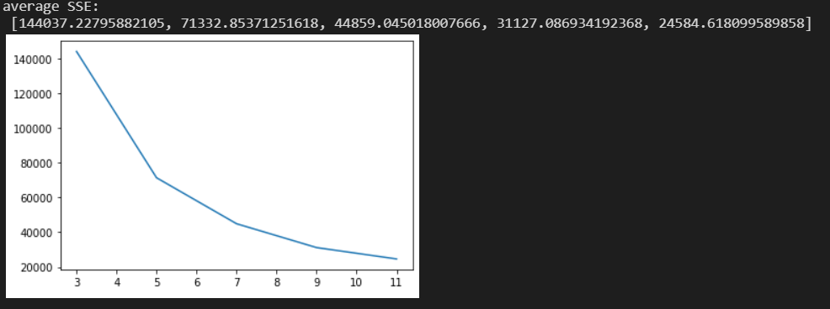

Standard deviation of SSE for each k

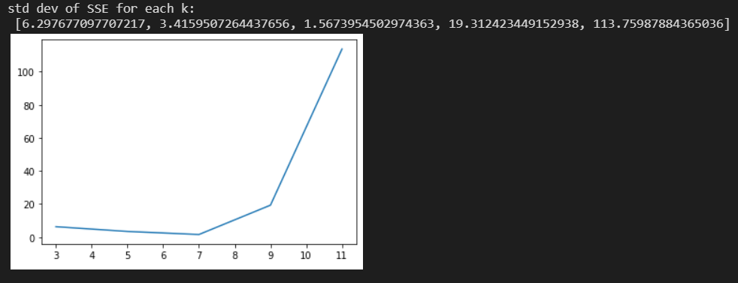

(iii) Min and max SSE for each k

Max SSE for each k

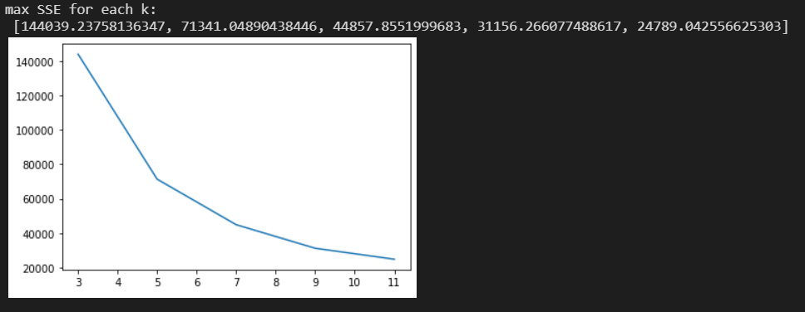

Min SSE for each k

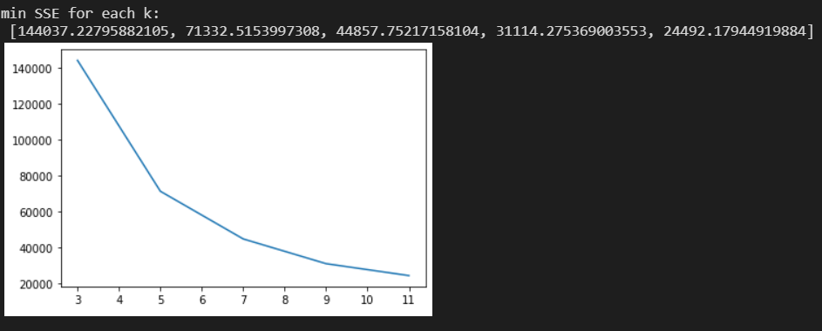

b.

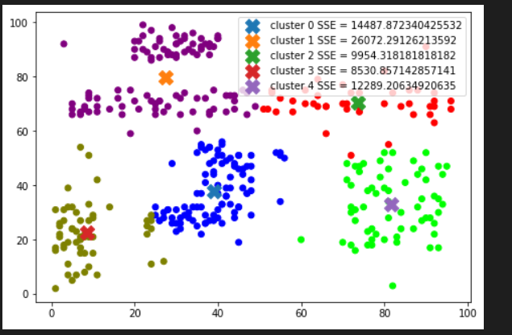

c.

The top cluster should be separated with the belt cluster, and the belt region in the middle should be in a single cluster.

Because the Euclidean distance is used, kmeans cannot correctly cluster the belt region in the middle. This proved that the k means clustering doesn’t work well if the data is not spherically distributed.

d.

These data can be classified with linear boundaries, since the margin between each cluster is rathe large.

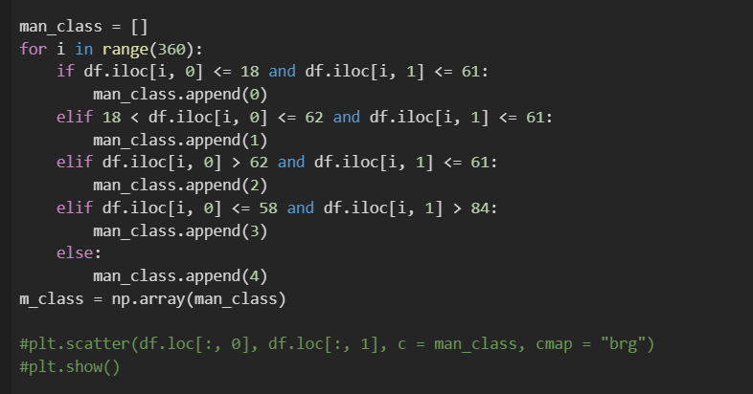

e.

Construct a contingency matrix, which is symmetric

k_means = cluster

manual clustering = class

nij = intersection(class i, cluster j)

nij = nji

class/cluster 0 1 2 3 4

0 n00 n01 n02 n03 n04

1 n11 n12 n13 n14

2 n22 n23 n24

3 n33 n34

4 n44

rand_idx = (a + d) / (a + b + c + d)

a = sigma(comb(nij, 2)

b = sigma(comb(ni., 2)) - sigma(comb(nij, 2))

c = sigma(comb(n.j, 2)) - sigma(comb(nij, 2))

d = comb(N, 2) - a - b – c

N is the total number of data points

**rand index = (a + d) / (a + b + c + d) = 0.8963478799133395**

The rand index represents the accuracy of the target clustering, which is kmeans in this case. (Or the similarity between two clustering.)

