虚拟语气”脑中想象的”

1. 表不可能假设
2. 与现在事实相反

从句：过去式 主句：would+do

Case 1

If I were you, I wouldn’t do it.

Case2

If I saw the rabbit now, I would tell you

1. 与将来事实相反 可能性很小

从句：should do 主句：would do

Case1

If I should see the rabbit tomorrow, I would bite him.

1. 与过去事实相反  
   从句 had 过去分词 主句would have 过去分词

Case1

If I had seen the rabbit yesterday, I would have bitten him.

|  |  |  |  |
| --- | --- | --- | --- |
|  | 现在事实相反 | 未来事实相反 | 过去事实相反 |
| 从句 | 过去式 | Should do | had done过去分词 |
| 主句 | Would 动词原形do | Would do | Would have done |

1. 表愿望、请求、建议、命令等 即希望某动作/事件发生
2. 对现在的愿望 wish (=would rather 宁愿)+过去式

Case1

I wish (that) I didn’t eat the carrot

I wish I were a rabbit

2 对过去的愿望 wish +had done/would have done

Case1

I wish I had eaten the rabbit

3 对未来的愿望 wish+ would/could/should/might do

Case1

I wish that I could eat a rabbit

Would rather

I would rather that you didn’t eat(对现在的愿望) the carrot

希望现在没吃

I would rather that you hadn’t eaten(对过去的愿望) the carrot

希望过去没吃 实际已经吃了

Demand ,suggest,insist,order等 +（should）do

I demanded you should give me a carrort

非谓语

1. 不定式
2. 不定式做主语

Case1

To eat a carrot every day is good for the rabbit

=it is good for the rabbit to eat a carrot every day it做形式主语

1. 不定式做宾语

The rabbit likes to eat carrots

I consider it easy to learn English it做形式宾语

1. 不定式做表语

The rabbit’s dream is to eat every kind of carrot in the word

1. 不定式做定语？

The rabbit have a lot of carrots to eat 存在动宾关系 ？

1. 不定式做状语：原因、目的和结果

原因

I was surprised to get a thumbs-up

目的

I will do anything to get a thumbs-up

结果

I got enough thumbs-up to make another video

1. 不定式做补语

The rabbit expected the wolf to eat a carrot

注意;使役动词后不定式做宾补时可以省略to

Make let，see，find，watch，have

The wolf helped the rabbit (to)grow carrots

1. 动名词 [名词属性]
2. 动名词做主语

Eating carrots is healthy for rabbits

1. 动名词做宾语

The rabbit likes eating carrots

注意：enjoy，avoid，advice，consider，escape，mind, practice, insist on, give up, feel like, put off,

注意：与不定式做宾语的区别

The wolf forgot to invite the rabbit to her part forget to do:忘记去做（没做）

The rabbit forgot accepting the wolf’s invitation. Forget doing 忘记做过（做了）

1. 动名词做表语

The rabbit’s dream is growing corrots

1. 动名词做定语

Case

动名词与现在分词做定语的区别

A sleeping pill =a pill for sleeping 用来表示（pill）性质，功能和用途

A sleeping rabbit !=a rabbit for sleeping 此时sleeping相当于形容词而非名词 修饰rabbit状态（没有时间信息）

介词+动名词（宾语）

The rabbit is fond of eating carrots

The rabbit is looking forward to（to是介词）(动词短语) seeing（动名词） the wolf

1. 现在分词 （形容词属性）不一定自带“现在”属性
2. 现在分词做表语

The rabbit is charming

The story is interesting

1. 现在分词做定语

同动名词做定语区别

1. 现在分词做状语 时间状语中有时间属性，但不知道是现在还是过去以及将来

Case时间状语

Hearing the news, the rabbit became excited

When he hear the news, the rabbit became excited

Case原因状语

Not knowing what to eat, the rabbit skipped lunch

1. 现在分词做补语 含有时间属性

与不定式做宾补区别：

The wolf saw the rabbit eating（“正在”） a carrot

The wolf saw the rabbit (to)eat(全程) a carrot

不定式做宾补表示一个动作自始至终的过程 强调动作已经发生

现在分词做宾补表示动作正在进行中，强调动作进行的状态

1. 过去分词
2. 过去分词做表语

与现在分词做表语的区别

I am interesting 现在分词做表语表示主动，我引起某人兴趣

I am interested 过去分词做表语表示被动，我被某人/某物引起了兴趣

1. 过去分词做状语

Seen from the hill, the carrot(seen的逻辑主语) field looks beautiful

与逻辑主语是被动关系

1. 过去分词做补语

The rabbit fond the rabbit stolen

独立主格（逻辑主语与真主语相对独立）

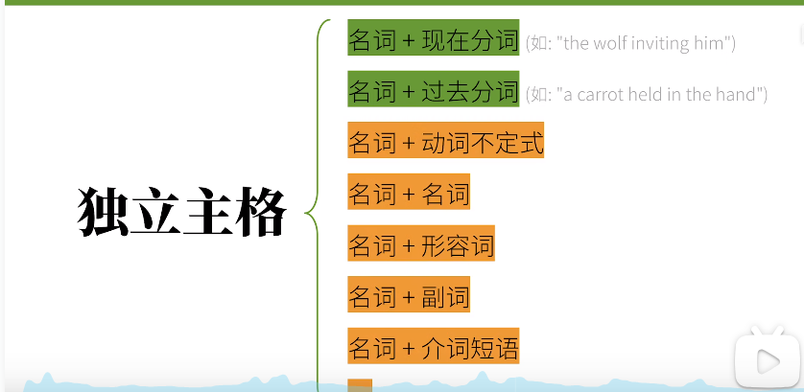

名词+现在分词：主动/进行(非谓语动词就逻辑主语而言)

名词+过去分词：被动/完成

名词+动词不定式：将要

1. 名词+现在分词

独立主格对从句的简化

The wolf(逻辑主语) inviting him, the rabbit（主语） dicided to go to the part

=because the wolf invited him, the rabbit dicided to go to the part

If the weather permits, the rabbit will go out

=the weather permitting, the rabbit will go out

1. 名词+过去分词

After the work was finished, the rabbit went home

=the work finished, the rabbit went home

1. 名词+不定式

The rabbit to come, the wolf overjoyed.

1. 名词/代词+名词

Many animals went to the party, some of them(不定代词短语) rabbits and wolfs

1. 名词/代词+形容词

Many animals went to the party, some of them(不定代词短语) happy

1. 名词/代词+副词

The rabbit sat on a chair, head down(副词)

1. 名词/代词+介词短语

The rabbit came in, carrot in hand

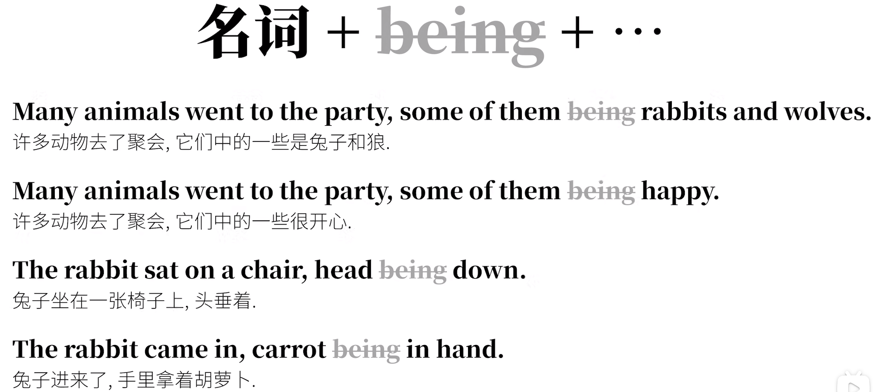

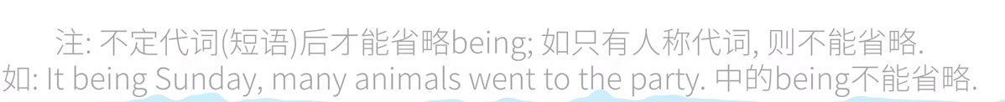

With+宾语+宾补 构成的独立主格

the work finished, the rabbit went home

=(with) the work finished, the rabbit went home