Region | Division | School
Region V-Bicol | SDO-Camarines Norte | Camarines Norte National High School
Title of the Activity | Date/Time | Place/Venue/ Platform
2025- 2026 Student Election for SSLG (Supreme Secondary  Learning Government) | February 11, 2026 7:30am | Camarines Norte National Highschool at the Schools Computer  Laboratory using Google Form
DETAILS OF THE ACTIVITY
(Rationale & Objectives)
- Rationale
Accomplishment Report of (COMEA) Learners Government — Commission on Election and Appointment.
The conduct of the 2026–2027 Student Election for the Supreme Secondary Learner Government (SSLG) aims to promote democratic participation and leadership among students of Camarines Norte National High School. Through this activity, students are given the opportunity to exercise their right to vote and select capable student leaders who will represent their interests and initiate programs that contribute to the improvement of the school community.

This election also encourages students to become responsible citizens by understanding the importance of leadership, accountability, and active involvement in school governance. The use of a digital voting platform through Google Forms ensures an organized, efficient, and transparent election process while promoting responsible use of technology among learners.

Furthermore, the activity strengthens student engagement and cooperation in school organizations such as SSLG which play vital roles in implementing programs related to student welfare and environmental awareness. Through this election, the school ensures that student representation remains active, inclusive, and responsive to the needs of the learners.
- Objectives
  - To conduct a fair, honest, and organized election for the selection of Supreme Secondary Learner Government (SSLG) officers for School Year 2026–2027.
  - To encourage students to actively participate in school governance through responsible voting.
  - To develop leadership, responsibility, and cooperation among students through participation in student organizations.
  - To promote awareness of the importance of democratic processes and environmental responsibility in the school community.
  - To utilize digital technology such as Google Forms to ensure a systematic and efficient election process.

Highlights
The 2026–2027 Student Election for SSLG was successfully conducted on February 11, 2026 at the Computer Laboratory of Camarines Norte National High School using Google Forms as the official voting platform. Students from different grade levels in high school participated actively in the election, demonstrating enthusiasm and cooperation throughout the activity. The election process was organized and supervised by the adviser of the Organization and student officers of COMEA to ensure fairness and transparency. Students were oriented on the proper voting procedures before the activity started. The use of an online voting system made the process faster, more convenient, and well- organizational, with this activity it helped the students understand the value of leadership, responsibility, and participation in school governance. It also strengthened students' awareness of the importance of choosing responsible leaders who will serve the school community.

Even after facing some challenges such as the limited designated area that is available for catering the enthusiastic voters of Camarines Norte National High school. The officers and members of the said organization showcase their ability to give clear communication and think of a strategic system for them to cater all of the enthusiastic high school voters. The voting day was held successfully and every objective of the event was accomplished and fulfilled with great participation from the officers and members of the organization of COMEA. Overall, the activity was conducted smoothly and achieved its intended objectives with active participation from the learners.
Financial Accomplishment/Liquidation Report (if any)
NONE
Recommendation/s:
- It is recommended that future SSLG and YES-O elections continue to utilize digital voting platforms such as Google Forms to ensure a faster, more organized, and transparent election process.
- It is recommended that the school provide a more reliable internet connection and additional computer units or laptops during future student elections to improve the efficiency and accessibility of the digital voting process.
- It is also recommended that students be given prior orientation regarding the roles and responsibilities of SSLG and YES-O officers to help them choose qualified and responsible leaders.
- The school may continue to strengthen student participation in future elections by encouraging active involvement from all grade levels.
- Continuous supervision and proper coordination among teachers and student officers are also recommended to maintain the credibility and orderliness of the election process.

Prepared by

Mariel D. Paular
LG-COMEA student Chairperson

Maria Zaira L. Rivera
LG-COMEA student Secretary

Noted by:

MELISSA M. MELENDREZ MA. LOURDES M. BALANE, HT-III
LG-COMEA Electoral Commissioner. LG-COMEA Screening and Validation Commissioner

RAY DUOVANI N. REGONDOLA IVY DENICE M. ABOGADO, RGC
LG-COMEA Electoral Co-commissioner. LG-COMEA GRIEVANCE Commissioner

WILSON ANGEL H. VILLARIN, ASP-II
LG-COMEA Appointed Commissioner

Approved by:

FRANCISCO D. TORRERO, SSP-II
School head/ LG-COMEA Chief Commissioner

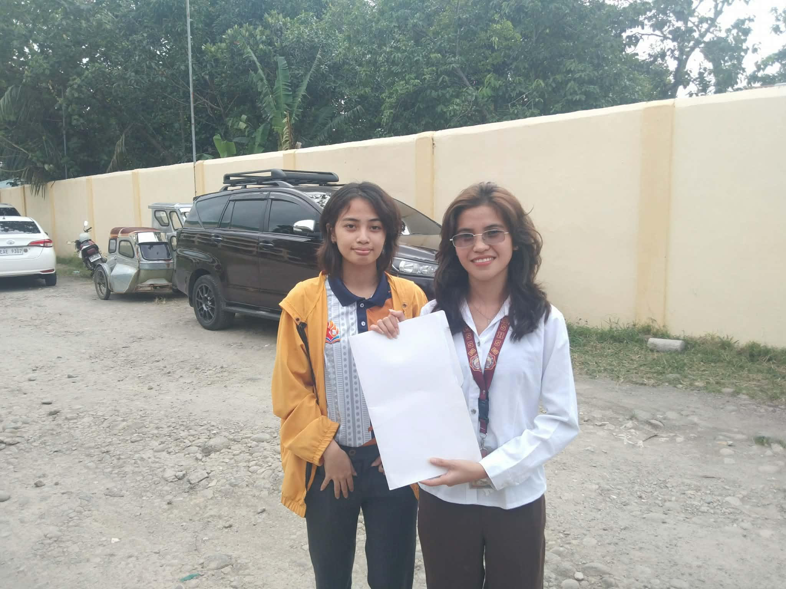
Approval of Candidacy: The Chairperson and Vice Chairperson gathered all of applications for the upcoming SSLG and YES-O

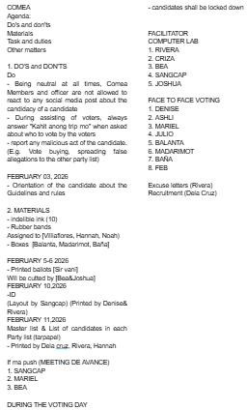

Minutes of the Meeting : The minutes of the meeting that was taken by the organization

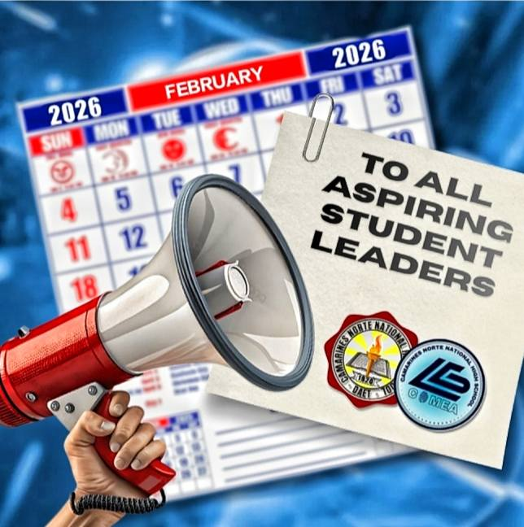
Announcement for Aspiring Leaders of SSLG and YES-O

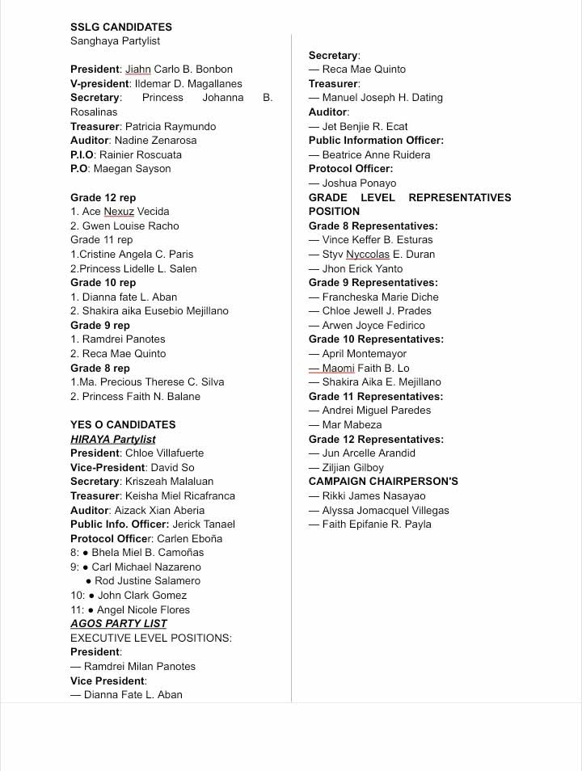

SSLG and YES-O Candidates

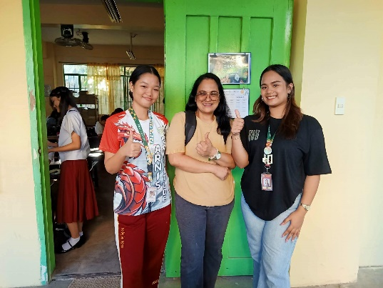
Our Officers spoke with Ms. Guia to ask permission to use the computer laboratory and computers for the SSLG and YES-O elections
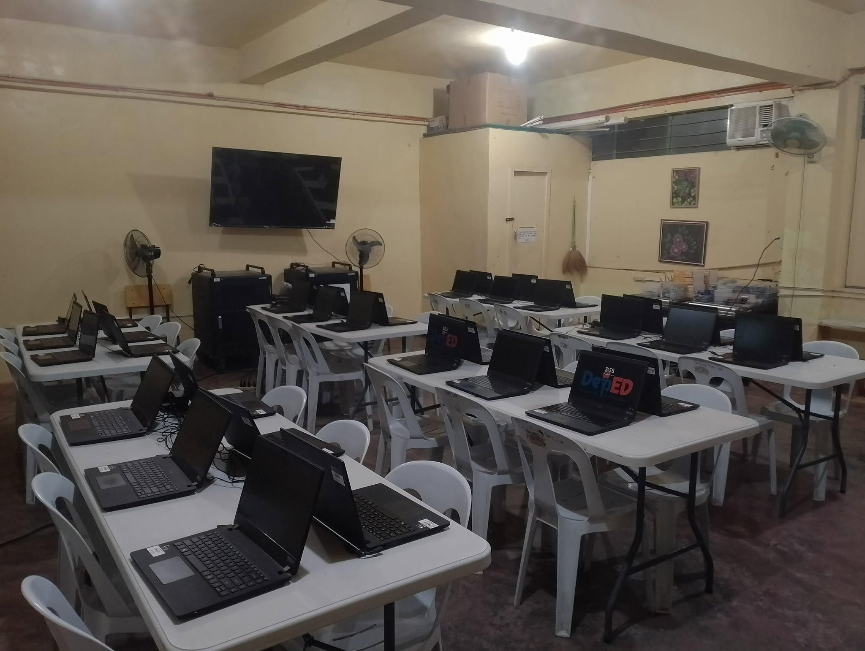
The setup of the Compute Laboratory a night before the Election

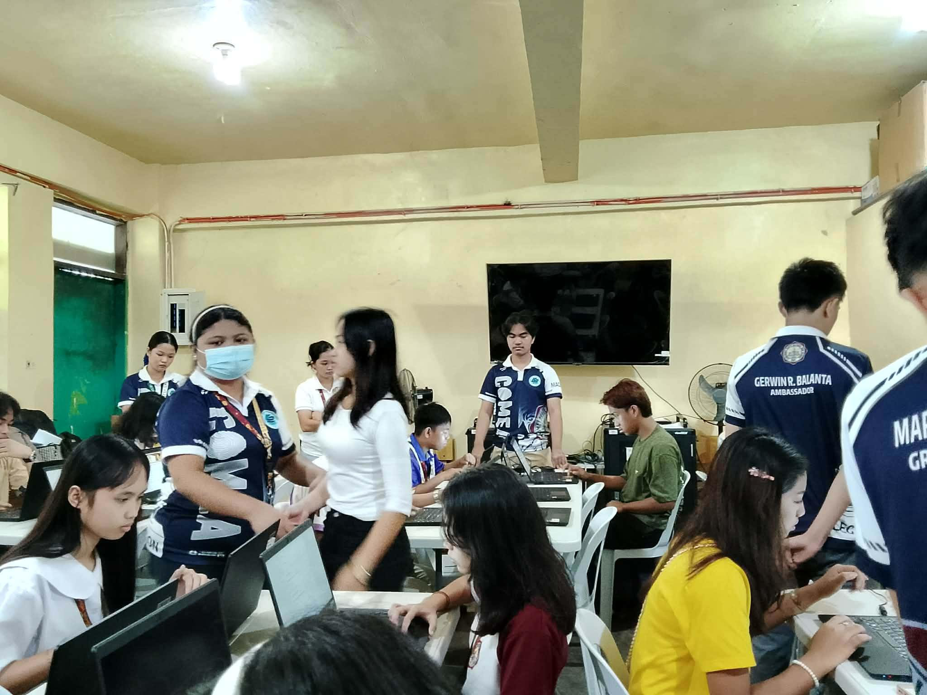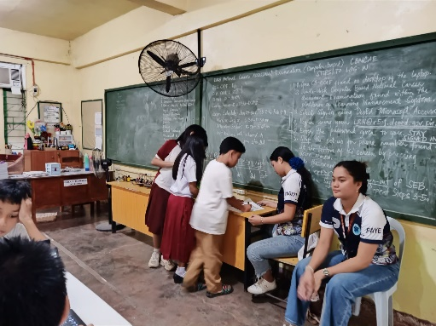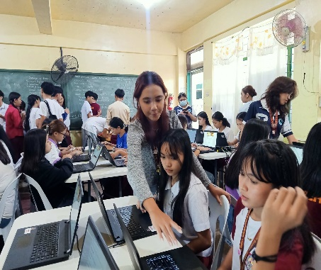

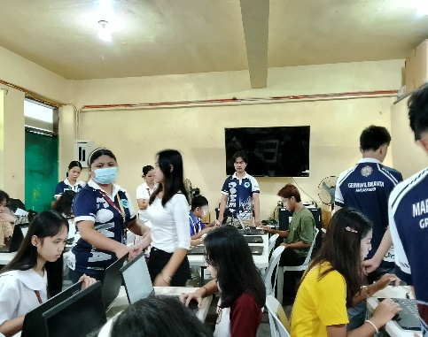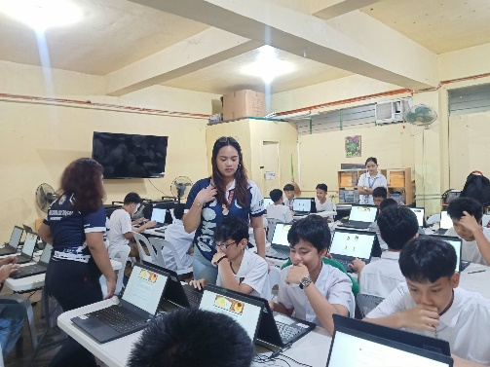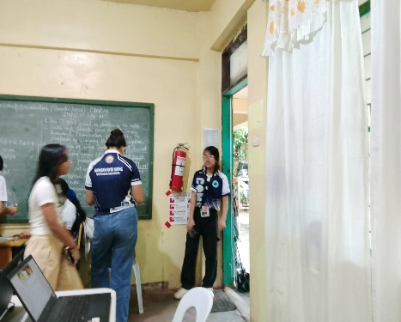

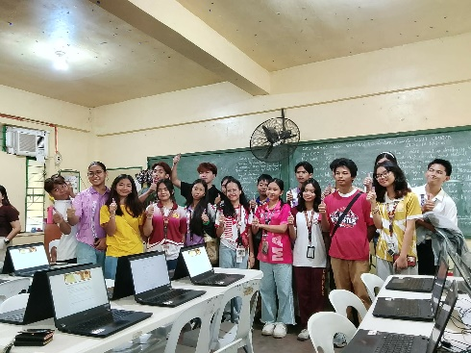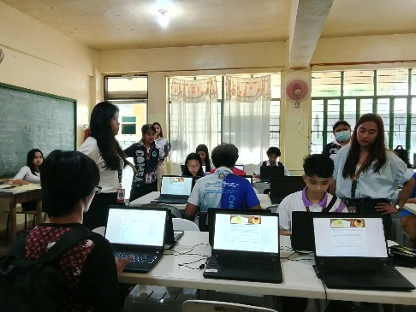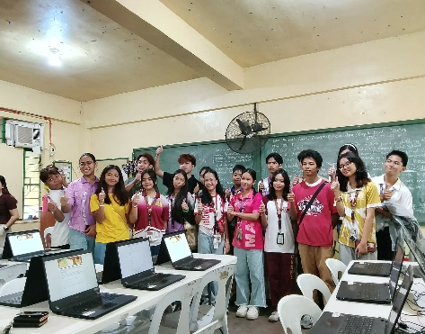

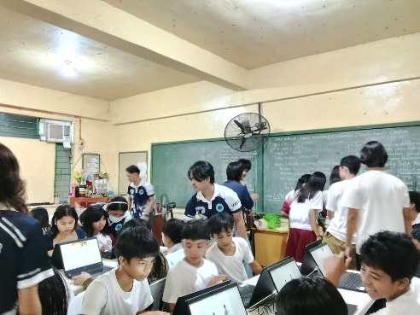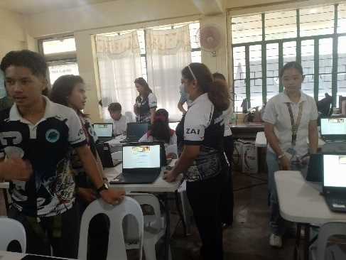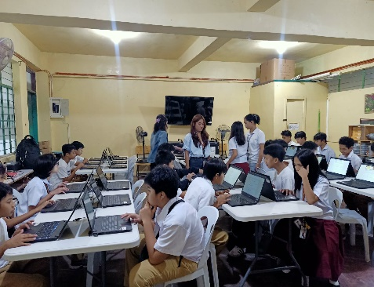

Actual Election day: The officers and the members start to facilitate effectively the election.

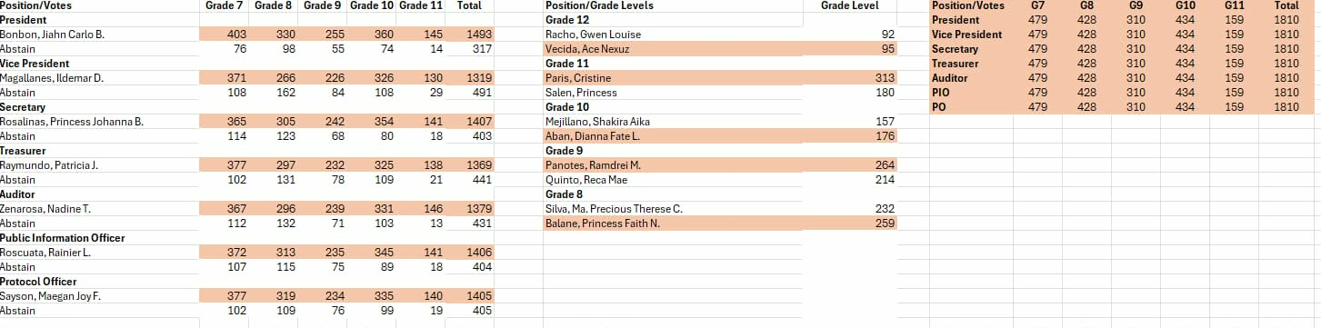
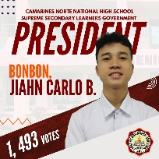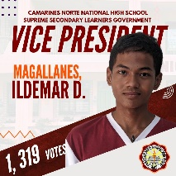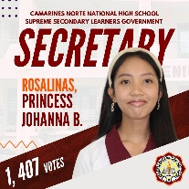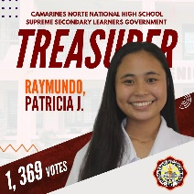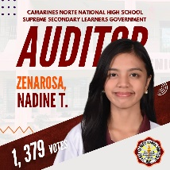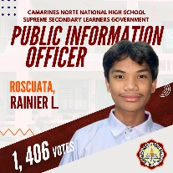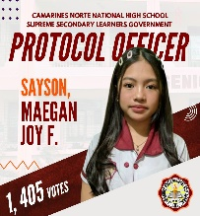

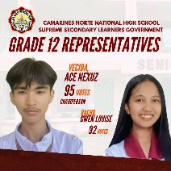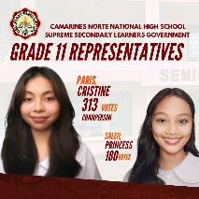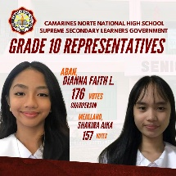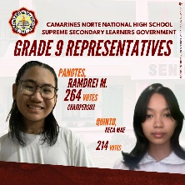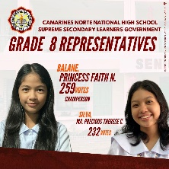

The Result of the Election and Elected Candidates for Supreme Secondary Learners Government (SSLG) Election.

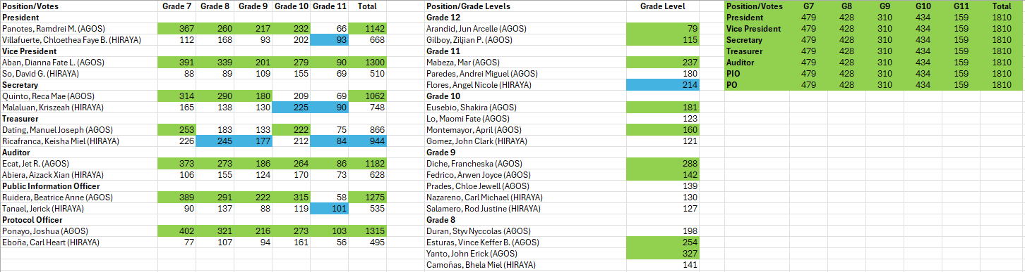
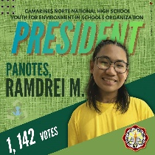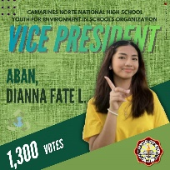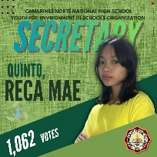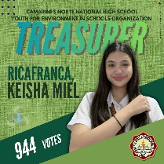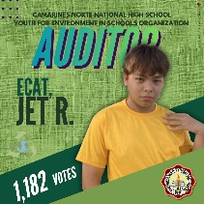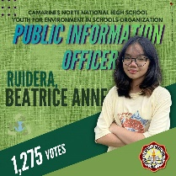

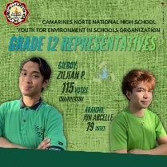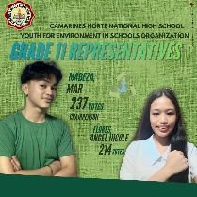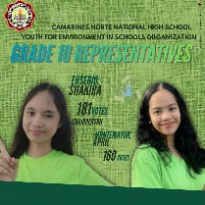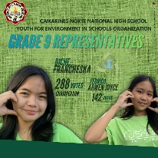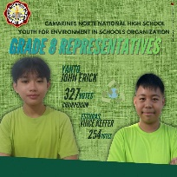

The Result of the Election and Elected Candidates for YES-O Election

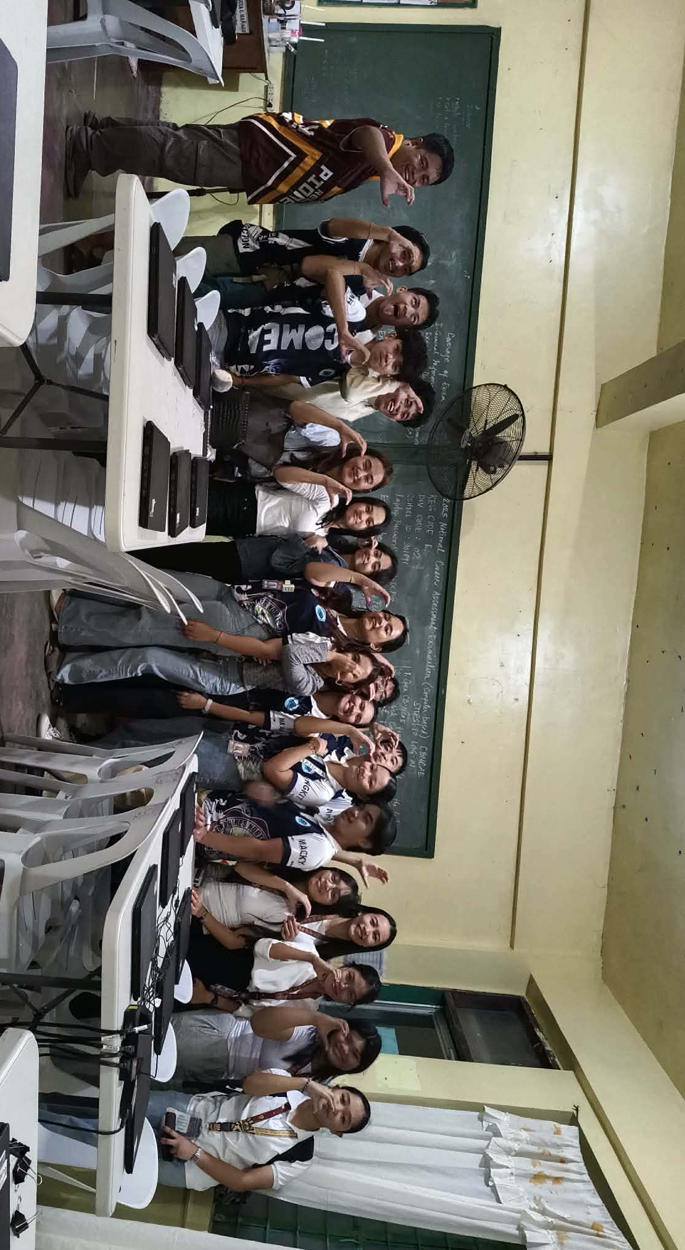

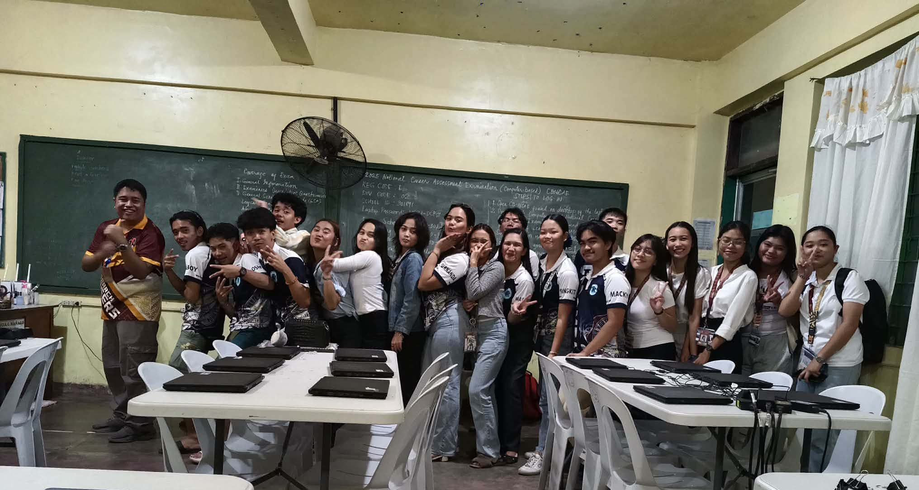
LG-COMEA After Facilitating the Election for SSLG and YES-O Election

