**Name: R. Vaishnavi**

**SRN: PES1UG21CS466**

**H sec**

**Roll No: 27**

<!DOCTYPE html>

<html lang="en">

<head>

    <title>WT assignment</title>

    <script>

    </script>

    <style>

        img

        {

            float: left;

            align : left;

            margin-left: 10px;

            margin-bottom: 5px;

            border: solid black 1px;

            padding:2px

        }

        div

        {

            margin-left: 500px;

            margin-right: 300px;

            display:block;

            text-align:left;

            position:relative

        }

    </style>

</head>

<body>

    <img src="C:\Users\DELL\Downloads\img1.jpg" height="400" width="400"></img>

    <div >

        <h1>Halo 2 video game</h1>

        <p id="p1">Price $50.00</p>

        <nav>

            <a>write a review</a>|

            <a >read all review</a>

        </nav>

        <svg height="110" width="50">

            <polygon points="22,30 10,60 45,40 0,40 40,58" fill="yellow

            "/>

            Sorry, your browser does not support inline SVG.

          </svg>

          <svg height="110" width="70">

            <polygon points="22,30 10,60 45,40 0,40 40,58" fill="yellow

            "/>

            Sorry, your browser does not support inline SVG.

          </svg><svg height="110" width="70">

            <polygon points="22,30 10,60 45,40 0,40 40,58" fill="yellow

            "/>

            Sorry, your browser does not support inline SVG.

          </svg><svg height="110" width="70">

            <polygon points="22,30 10,60 45,40 0,40 40,58" fill="yellow

            "/>

            Sorry, your browser does not support inline SVG.

          </svg><svg height="110" width="70">

            <polygon points="22,30 10,60 45,40 0,40 40,58" fill="yellow

            "/>

            Sorry, your browser does not support inline SVG.

          </svg>

        <form action="post">

        <textarea id="suggestions" name="suggestions" cols="50" rows="5"></textarea><br>

        <h3 style="color:red">Only 9 left</h3>

        <audio controls src="C:\Users\DELL\Downloads\music.mp3.mp3" ></audio>

    </div>

    <script>

        header=document.getElementsByTagName('h1')[0]

        para=document.getElementById('p1')

        para.addEventListener('click',function(e)

        {

            e.target.style.color="red"

            e.target.style.fontSize="50px"

        },true)

        header.addEventListener('click',function()

        {

            alert("the discount sale is going to end")

        },true)

    </script>

</body>

</html>

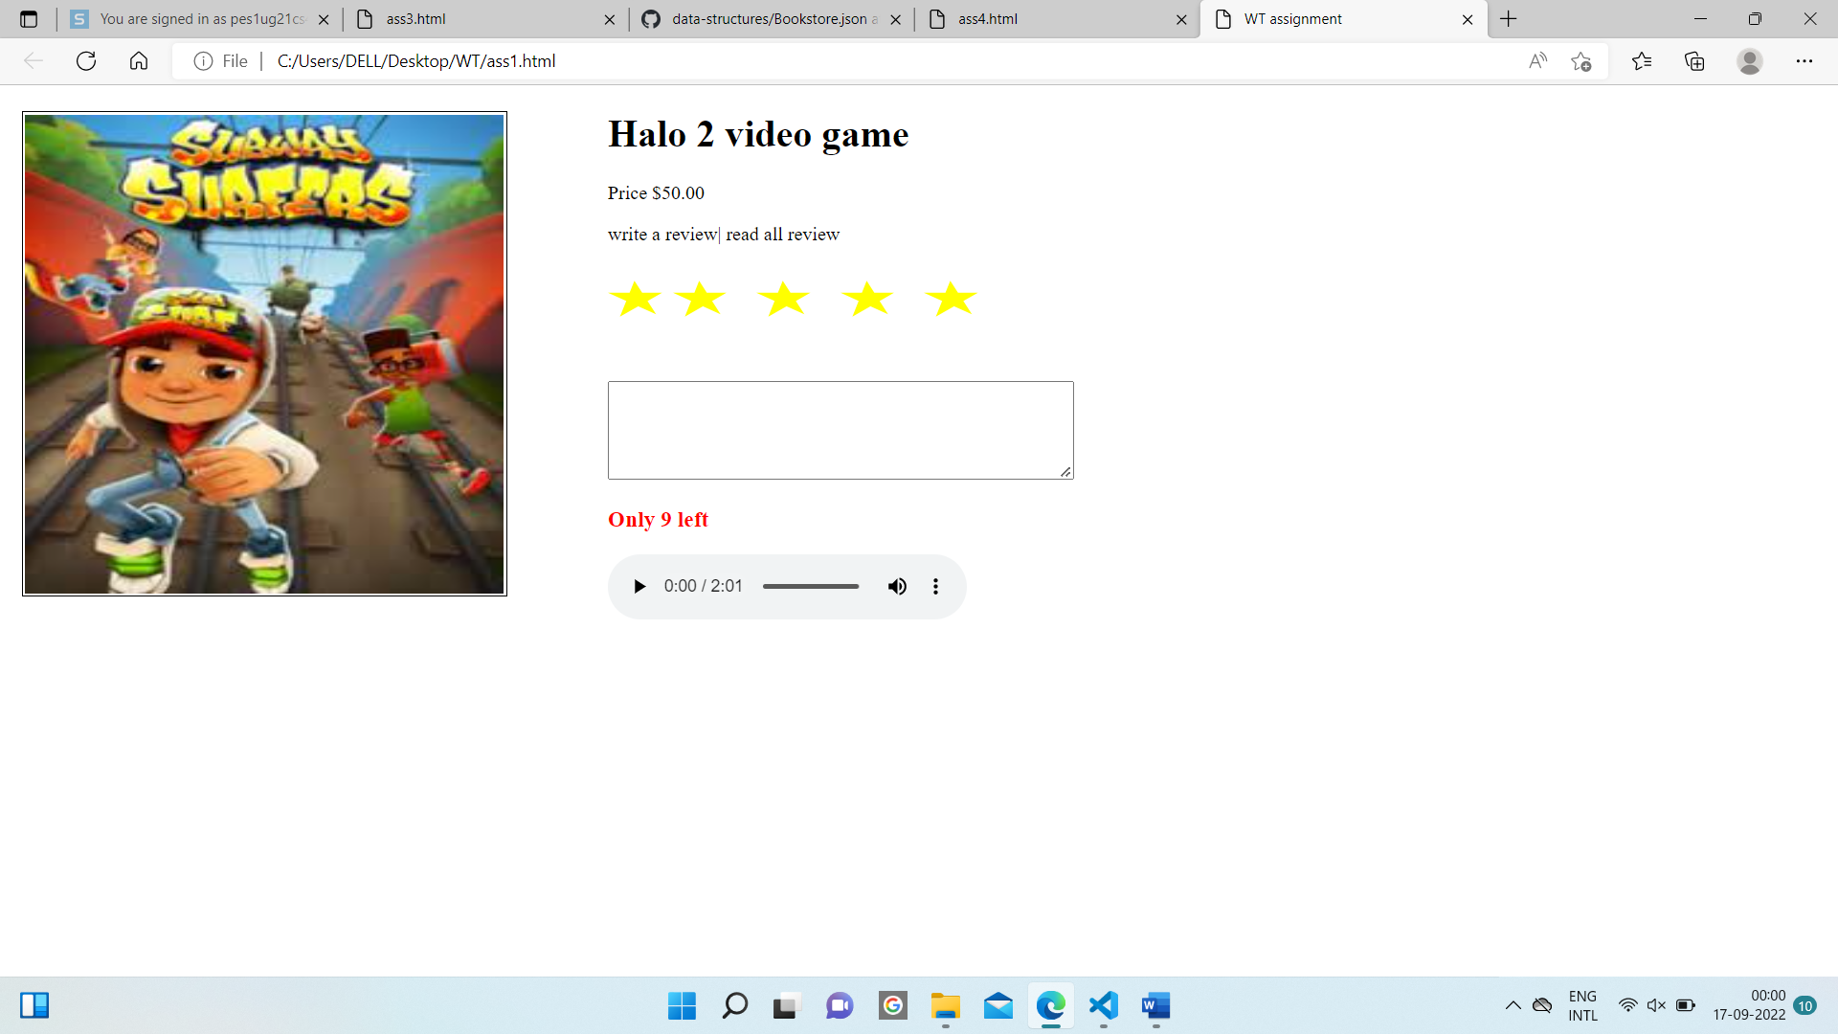//2

<html>

    <head>

        <title>JQUERY</title>

        <style>

            .div1

            {

                border: 5px solid blue;

                padding-top: 10px;

                padding-bottom: 10px;

            }

            .div2

            {

                border: 5px solid green;

                padding-top: 10px;

                padding-bottom: 10px;

            }

        </style>

        <script src="https://code.jquery.com/jquery-3.6.1.js" integrity="sha256-3zlB5s2uwoUzrXK3BT7AX3FyvojsraNFxCc2vC/7pNI=" crossorigin="anonymous"></script>

        <script>

            $(document).ready(init)

            function init()

            {

                new_b = document.createElement("b")

                $(new_b).html("I love jQuery!!!")

                $("#para1").append(new_b)

                $("div.div1").click(function()

                {

                    $("div.div1").hide()

                })

            }

        </script>

    </head>

    <body>

        <p id = "para1"></p>

        <div class = "div1">

            <p> One of the most dynamic and exciting developments in information

                and communications technology is the advent of the Internet of Things (IoT).

                Although networking technologies have become increasingly ubiquitous over the past two decades,

                until recently they have largely been restricted to connecting traditional end-user devices, such as mainframes,

                desktop and laptop computers, and, more recently, smartphones and tablets.

            </p>

            (click to hide)

        </div>

        <br>

        <br>

        <div class = "div2">

            Recent years have witnessed the attachment of a much broader range of devices to the network.

            These have included vehicles, household appliances, medical devices, electric meters and controls, street lights,

            traffic controls, smart TVs and digital assistants such as Amazon Alexa and Google Home.

            Industry analysts estimate that there are currently more than eight billion such devices connected to the network and

            project that this number will expand to more than 25 billion by 2020.

            The increasing deployment of these devices has enabled new use cases for network technologies.

            Some experts project that the IoT may generate as much as US$13 trillion in revenue by 2025.

        </div>

        <br>

        <br>

        <div class = "div1">

            Industry analysts estimate that there are currently more than eight billion such devices connected to the network and

            project that this number will expand to more than 25 billion by 2020.

            <br>(click to hide)</br>

        </div>

    </body>

</html>

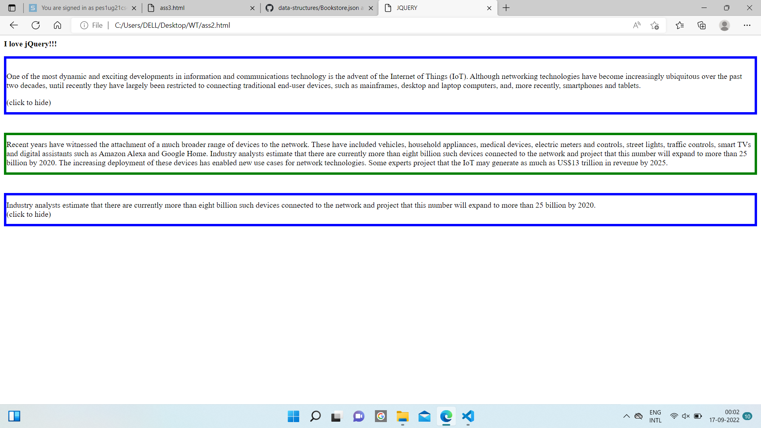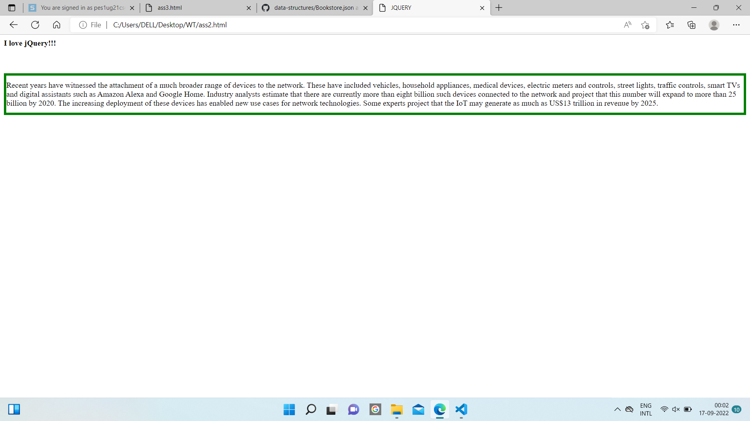<!DOCTYPE html>

<html>

    <head>

        <script>

            function init()

            {

                ol = document.querySelector("ol")

                var xhr = new XMLHttpRequest()

                xhr.open("get","book.json")

                xhr.onreadystatechange = showdata

                xhr.responseType = "text"

                xhr.send()

                function showdata()

                {

                    if(this.readyState == 4 && this.status == 200)

                    {

                        json_obj = JSON.parse(this.response)

                        console.log(typeof json_obj[1].author, json_obj[1].author, json_obj[2])

                        authors = new String()

                        for(i = 0; i<json_obj.length; i++)

                        {

                            li = document.createElement("li")

                            li.innerHTML = json_obj[i].author

                            ol.appendChild(li)

                        }

                    }

                }

            }

        </script>

    </head>

    <body onload = "init()">

        <h1>Authors</h1>

        <ol type = "1"></ol>

    </body>

</html>

{ "Books":

  [

    { "ISBN":"ISBN-0-13-713526-2",

      "Price":85,

      "Edition":3,

      "Title":"A First Course in Database Systems",

      "author":[ "Jeffrey", "Ullman",

                  "Jennifer", "Widom" ] }

    ,

    { "ISBN":"ISBN-0-13-815504-6",

      "Price":100,

      "Remark":"Buy this book bundled with 'A First Course' - a great deal!",

      "Title":"Database Systems:The Complete Book",

      "Authors":[ "Hector", "Garcia-Molina",

                  "Jeffrey", "Ullman",

                  "Jennifer", "Widom" ] }

  ],

  "Magazines":

  [

    { "Title":"National Geographic",

      "Month":"January",

      "Year":2009 }

    ,

    { "Title":"Newsweek",

      "Month":"February",

      "Year":2009 }

  ]

}

