Unit 2: HTML5, JQuery And Ajax

JavaScript events

## Submit & Reset Buttons

Buttons are defined by changing the input element’s type attribute. There is two different kinds of buttons – the submit button and the reset button. Submit and Reset buttons help the user tell the browser what to do with a form on the website.

The INPUT element defines an input field. When specify "submit" (or "reset") for the type attribute of this element, a submit button (or a reset button) is created.

<input type="submit" value="Submit">

<input type="reset" value="Reset">

|  |  |  |
| --- | --- | --- |
| **Attribute** | **Value** | **Explanation** |
| type=" " | submit | the type of input field submit : creates a submit button reset : creates a reset button |
| reset |
| name=" " | button name | a unique name for the button |
| value=" " | button text | the text displayed on the button |

**type="submit"**

Creates a submit button on the form.

When this button is clicked, the form data is submitted to the server.

**type="reset"**

Creates a reset button on the form.

When this button is clicked, the input is reset.

**name=""**

The button name is used to identify the clicked submit button.

**value=""**

Value is the text displayed on the button.

## CODE:

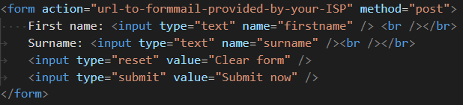

## OUTPUT:

