Unit 2: HTML5, JQuery and Ajax

## HTML5 <audio> tag

It is used to play audio in html pages. It takes the below basic format in its simplest form:

**<audio src="my_music.mp3" controls></audio>**

With the above structure, when the html page loads the page requests for the audio file listed in the "src" attribute and the “controls” attribute displays the browser default audio player for controlling playback.

## CODE:

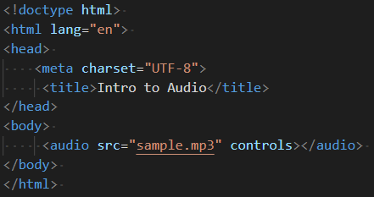

Results:

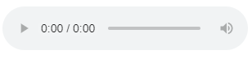

The <audio> tag comes with many inline global attributes that help in modifying its behaviour. Some of the attributes are:

1. autoplay
2. buffered
3. controls
4. loop
5. muted
6. played
7. preload
8. src
9. Volume

Some of the attributes, values and description are given below:

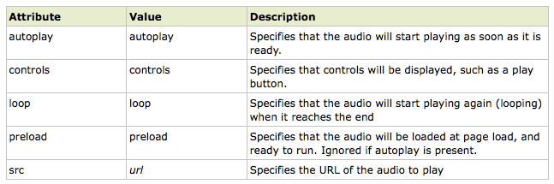

## HTML 5 <video> Tag

The HTML 5 <video> tag is used to specify video on an HTML document. For example, it can be embed in a music video on web page for visitors to listen to and watch. The <video> tag was introduced in HTML 5.

The HTML 5 <video> tag accepts attributes that specify how the video should be played. Attributes include preload, autoplay, loop and more.

Any content between the opening and closing <video> tags is fallback content. This content is displayed only by browsers that don't support the <video> tag.

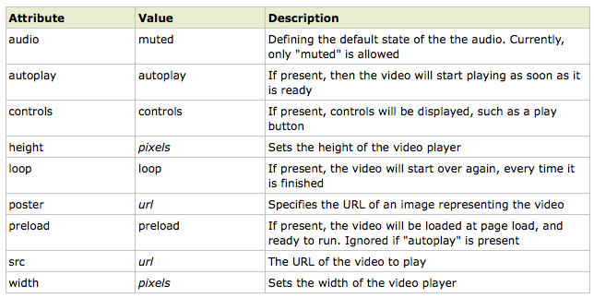

## CODE:



Results:



## HTML 5 <progress> Tag

The <progress> element is used to create a progress bar to serve as a visual demonstration of progress towards the completion of task or goal. The max and value attributes are used to define how much progress (value) has been made towards task completion (max).

It can be indeterminate progress bar, which can be either in the form of spinning wheel or a horizontal bar. In this mode, the bar only shows cyclic movements and do not provide the exact progress indication. This mode is usually used at the time when the length of the time is not known.

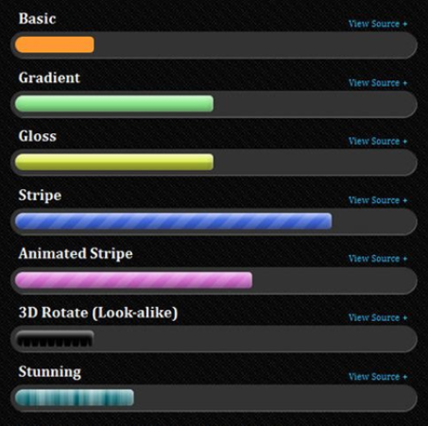

## CODE:



Results:



**Reference Link for styling progress elements:**

<https://css-tricks.com/html5-progress-element/>